University of Wales Trinity Saint David
School of Engineering


Group Industrial Project Title
Technical Report
Group Industrial Project
ACMA5000

Andrew Stephen Madelin
2218888
19/10/2024

Abstract
The project aim was to create a digital permit to work system which could cater for the needs across multiple industrial applications.
Research was undertaken to build the business case including health and safety legislation, budget, data protection considerations, and, equipment and software requirements. A permit to work system was created using the Microsoft Power platform integrating with Microsoft Forms, Microsoft Word, Microsoft Automate, SharePoint and Microsoft Power BI. The system was tested and reviewed with stakeholders to improve on design and meet stakeholder requirements.
The project resulted in a working application which was generic enough for use across multiple applications but accurate enough to account for risk associated with high risk work. The automated flows ensured permit to work sign off with accountability which was audit trackable. The data dashboard allows for greater visibility of live and historic permits but also the analytical data within the permits.
The report highlights issues with operational change for bringing in new systems but highlighted the benefits of a digital permit to work system for improving legal compliance, speed of approval processes and availability of analytical data.

Contents Page
1 Abstract 2
2 Contents Page 3
3 Introduction 5
1.1 Core Objectives 5
4 Literature Review 6
1.2 Healthy and Safety Legislation and Frameworks 6
1.3 Digital Permit to Work Systems 7
1.4 Digital Permit to Work Design 7
1.5 Data Governance 7
5 Methodology 8
1.6 Project Management 8
1.7 Project Plan 8
1.8 Stakeholder Interviews and Workflow Analysis 8
1.9 User Interface Design 9
1.10 Development Tools 9
1.11 Mobile Accessibility 9
1.12 Risk Assessment 9
1.13 Performance Metrics Tracking 10
1.14 User Feedback 10
6 Results 11
1.15 Front End 11
1.16 SharePoint 11
1.17 Automated Works Flow 1 - Approval Process 11
1.18 Automated Works Flow 2 – Permit Closure 12
1.19 Permit to Work 13
1.20 Permit Management System 13
1.21 Data Visualisation 14
1.22 Beta Testing and Feedback 14
1.22.1 Usability 15
1.22.2 Product Satisfaction 15
1.22.3 Qualitative Feedback 16
1.22.4 Feedback Result 16
7 Conclusion 17
8 Self-Evaluation 18
1.23 Reflection on Role 18
1.24 Technical Knowledge 18
1.24.1 Microsoft Forms and Microsoft Power Platform 18
1.24.2 Workflow Automation 18
1.24.3 Permit to Work 18
1.25 Personal Growth 19
9 References 20
10 Appendices 21

Table of Figures
Figure 1 - Permit to Work System - Gantt Chart 8
Figure 2 - QR Code for Permit To Work 11
Figure 3 - Permit To Work Form 11
Figure 4 - SharedPoint Lists 12
Figure 5 - Microsoft Automate - Flow 1 - Permit Approval 12
Figure 6 - Microsoft Teams - Approvals 13
Figure 7 - Complete Permit to Work 13
Figure 8 - Microsoft Apps – Permit to Work Management System 14
Figure 9 - Permit to Work System Management - Permit Overview 14
Figure 10 - Permit to Work System Management - Open Permits Table 15
Figure 11 - Permit to Work System Management - Data Dashboard 15
Figure 12 - Feedback - Where you able to complete the permit to work with ease? 16
Figure 13 - Feedback – How well did the system meet your needs for creating/managing permits? 16
Figure 14 - Feedback - How would you rate your overall satisfaction with the digital permit to work system? 17

Introduction
Industrial companies such as Enersys, Dwr Cymru Welsh Water, and tata Steel UK currently operate with a paper-based permit to work (PTW) system. The report reviews the issues with paper based PTW systems and identifies how a digital permit to work system can be beneficial. These drawbacks afford errors and delays of process but also, due to the centralised nature, add challenges to data storage, accessibility and analytics. Combined, these issues increase the risk of compliance against Healthy and Safety legislation leaving employees, contractors, customers and companies at risk.
The project scope is to develop a digital PTW system utilising an array of Microsoft software to address the challenges present with paper based PTW systems whilst focusing on stakeholders to not only develop a replacement product which improves indsurty Health & Safety compliance but improve the user experience and company overall benefits through data visualisation.

Core Objectives
- Increase the efficiency of the Permit-to-Work process:
  - Permit Creation Time
  - Approval Process
  - Management of Permits
- Improve risk management, accuracy and responsiveness in risk assessments.
- Enhance monitoring with availability
  - Permits available, based on requirement, to all stakeholders
  - Notifications and real time tracking
  - Ease of audit compliance

Literature Review
A permit to work system is a formal written procedure used to control work that is potentially hazardous (Health and Safety Executive, 2013). When creating an electronic PTW system an essential area of research must include the UK health and safety frameworks and legislation to ensure the design covers legal requirements by assisting with developing, documenting and communicating risk management whilst assigning accountability. Research is also required into industry standards, technology and future market trends to ensure the product not only works effectively but has longevity and adaptability in current and future markets.

Healthy and Safety Legislation and Frameworks
The Health and Safety at Work Act 1974 provides the framework for workplace safety in the UK, often referred to as the “umbrella act” as it provides a framework for health and safety legislation within the UK (Health and Safety Executive, 2020). Other regulations such as Management of Health and Safety at Work Regulations 1999 and Control of Substances Hazardous to Health (COSHH) Regulations 2002 further elaborate on specific requirements and responsibilities. Legislation should be reviewed before completing high risk activities to familiarise the persons on the correct ways to manage risk.
The Health and Safety at Work Act 1974 act places legal responsibility on all persons involved with work to ensure safety and absence of risk to health in the workplace (HASAWA, 1974). Whilst the Management of Health and Safety at Work Regulations 1999 (MHSWR) requires employers to conduct thorough risk assessments and implement safety controls before commencing any hazardous work. It makes sense for companies to adopt a permit to work system to meet the legal requirements to ensure safety, as backed up by the Health and Safety Executive (2020) which offers advice and guidance on permit to work systems and promotes that doing so increases safety, compliance and accountability. A permit to work should encompass clear definitions of work types like hot work, electrical maintenance and working from height (Health and Safety Executive, 2020). However, a permit to work is only effective if those planning, supervising and undertaking the work coordinate together and are trained, experienced and deemed competent to risk assess the task effectively (Health and Safety Executive, 2005) so the permit to work must ensure by clearly stating that the person submitting and reviewing the permits are trained and competent to do so with a clear hierarchy (Health and Safety Executive, 2013). The research shows that for a company to be compliant with legislation a permit to work system must clearly identify and document hazards and mitigation for the work task involved whilst the approval process requires management to ensure the process is complete and monitored by competent individuals.
As Mousavi (2020) further highlights the permit to work system is good for accountability of work and safety but can have limitations but is not suitable alone for hazard identification and assessment as experience and competency are defining factors. This needs to be considered and managed when designing the electronic permit to work system,

Digital Permit to Work Systems
According to Reddy and Reddy (2015, p. 533), a survey by HSE in the UK revealed that one-third of all accidents in the chemical industry were linked to maintenance, with the primary cause being the absence or inadequacy of permit-to-work systems. Where Jones (2024) argues that manual entry and data processing in paper based permit systems increases risk of error, misinterpretation or oversight of hazards or risk. Whilst Rogers (2024) states the belief that physical nature of paper renders it less accessible than its electronic counterparts as the storage and retrieval of paper permits necessitate physical space and can be labour-intensive and time-consuming for transportation, audits or reviews. This has been highlighted in Welsh Water as due to the vast geographical coverage of assets, there is a requirement for competent approvers to travel to multiple assets a day to sign approvals causing delay in work. A digital permit to work system would speed up approval processes and allow work to be opened and closed off more efficiently.

Digital Permit to Work Design
A digital permit to work system design must consider the development and usability of such systems. Desktops, laptops, tablet and mobile access capabilities further enhance flexibility by enabling workers personnel to access, review, and approve permits from remote locations, improving responsiveness and reducing downtime (Marzouk, 2017).
Microsoft power platform will be used which allows the user to create applications with minimal coding and using pre-assigned functions to speed up the development process. Microsoft power platform integrates with Microsoft tools such as SharePoint and Power Automate which allows for ease of integration when developing systems using familiar Microsoft interface (Microsoft, 2023).

Data Governance
When handling stored digital data, the governance of such data must comply with Data Protection Act 2018 as part of UK legislation. This states that organisations must handle personal data in a way that ensures appropriate security, including protection against unauthorised processing and access and used in a way that is adequate, relevant and limited to only what is necessary (Data Protection Act, 2024). The data requested as part of the permit to work shouldn’t request personal data that isn’t required. Name, Company, Contact Number and Email address will be the only relevant information required and stored securely.

Methodology

Project Management
A hybrid project management style was utilised, this combined the benefits of waterfall method to plan and structure the project against the scope as clear project requirements and tasks were identified and required to be complete within a defined timeline. A Gantt chart was created to assist with task assignment and project tracking. Distribution of roles and responsibilities were discussed and assigned based on expertise, experience and availability.
The agile framework was used within the project with iterations of scrums as weekly meeting to help achieve tasks if split into subtasks. This was utilised more during the digital permit to work system development as this included iterative design.
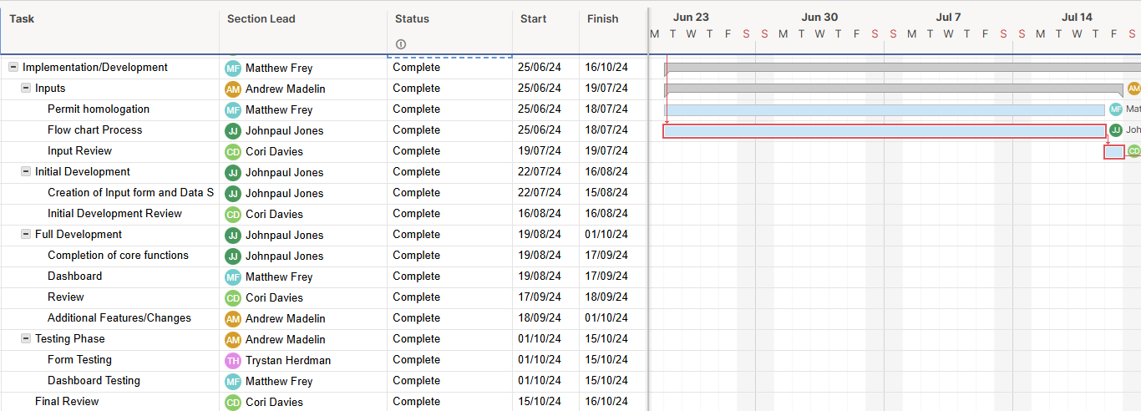
Figure 1 - Permit to Work System - Gantt Chart

Project Plan
The project was set out sequentially:
- Project Idea generation, analysis, selection
- Project Definition
- Project Planning: Resource Allocation, Budget Planning and Risk Management
- Market Research: Market needs, competitor analysis and benchmarking, requirements and preferences
- Feasibility Study: Technical, economic, legal and regulatory compliance
- Stakeholder Analysis: Identification, Requirements, Communication Plan
- App Development: Structure Planning, System Design, Coding and Development, Testing and Debugging
- Final Review & Deployment
- Project Review & Close

Stakeholder Interviews and Workflow Analysis
Stakeholder engagement was a core principle of the project.
Interviews were undertaken with stakeholders to gather feedback on how existing permit to work systems worked to understand perceived issues and areas of improvement. This information was fed back into the design objectives of the digital PTW and was crucial when designing the PTW system’s workflow to ensure stakeholder needs were met.
Stakeholders were engaged during the testing phase of the app development. This was achieved using a Microsoft teams form to allow for unbiased feedback.

User Interface Design
The design of the digital PTW should have an aesthetic which is generic enough to suit all industrial applications whilst the interface was aimed to be simple to ensure ease of useability.
The permit input options were designed around example paper copies of permit to work forms and iterations of internal and stakeholder testing allowed for targeted improvements.
Due to using Microsoft Apps for the management side of the system, the aim was to have a readily customisable interface. This was prominent with the Power BI data display as a variety of data could be displayed graphically for ease of interpretation. Being a highly popular Microsoft application online content of tutorials, training and support are readily available.

Development Tools
The development tools used were Microsoft Apps and Power Automate. Microsoft Apps was used to develop the interface for the permit system back end to navigate between permits and data dashboards. Power Automate was used to automate the workflows for the permit approval, notification, reminders and permit closing processes. Power BI was used to generate the data dashboards. These dashboards include real-time reports to track permits, monitoring risk assessments and evaluating system performance.

Mobile Accessibility
The digital permit to work system was designed to meet the requirements of the stakeholders where the permit to work system can be accessed for input, approval and review remotely. Using the Microsoft suit allows users to access the system from mobile phones, tablets, laptop and desktop devices with network access. Overcoming paper based issues causing delays due to point of work and approval personnel distribution.

Risk Assessment
The Permit to Work system incorporated automated risk assessment prompts to ensure that the input user was acknowledging that hazards were identified and risk assessments were complete as part of the permit to work. Identified hazards associated with work scenarios are highlighted on the Power BI dashboard for data visualisation. This data visualisation is important to allow stakeholders to further monitor and develop hazard mitigations and improve on safety.

User Feedback
Collected user feedback through Microsoft forms surveys to assess the system’s usability and identify areas for further improvement.

Results

Front End
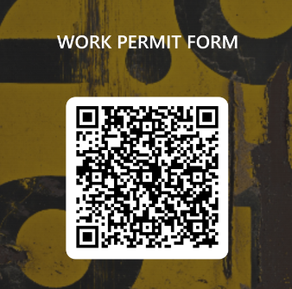
The digital permit to work form is accessible using a webpage link or a QR Code. This can access the Microsoft form developed where the user can input data on the work task which include: Company Name, Responsible Person, Contact Details, Additional Personnel, Description of Work Activity, Location, Start Date & Time, End Date & Time.
Figure 2 - QR Code for Permit To Work
The form then prompts the users to identify the hazards, in which case further questions are presented to gather information and ensure risk assessment has been complete. Presenting QR codes speeds up accesibility to work permit forms wich enabled the users to be reminded through posters around high risk activity areas to assist in promoting and reminding employees to develop a positive safety culture.
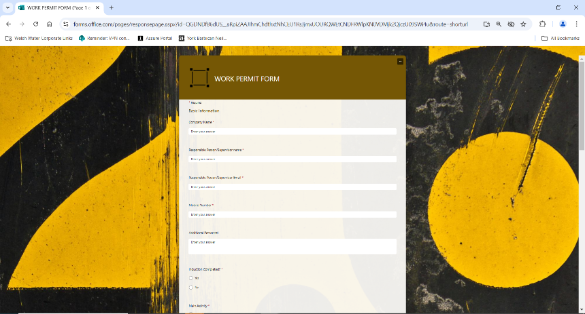
Figure 3 - Permit To Work Form

SharePoint
The database used is SharePoint lists, this is to comply with the Data Protection Act 2018 requirements identified in the research by segregating the stored data in a secure environment with access controls to ensure that personal data including contractor names and contact details are secure.
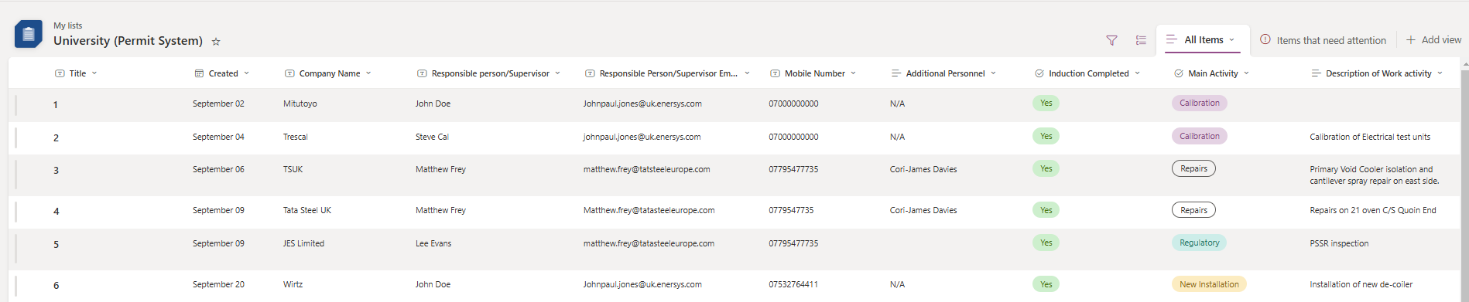
Figure 4 - SharedPoint Lists

Automated Works Flow 1 - Approval Process
Once the form is submitted, the automated work flow triggers actions to get details from the form and input the data into SharePoint database. From the database a permit to work Microsoft word template is created and populated with the data input. An email confirmation is sent to the originator to inform of the submission’s success and a Microsoft Teams notification and email are sent to the approver. The approver can approve or deny the permit to work. There is a template email for each which, dependent on if approved or not, emails the originator informing them.
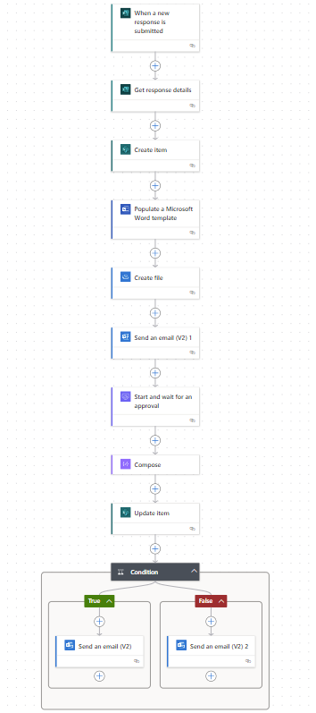
Figure 5 - Microsoft Automate - Flow 1 - Permit Approval

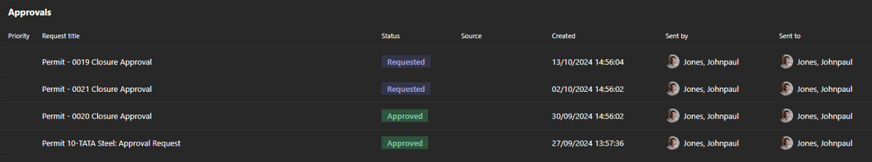
Figure 6 - Microsoft Teams - Approvals

Automated Works Flow 2 – Permit Closure
On a trigger, which can be customised by the customer, a works flow was created to review the data within the SharePoint list to filter for open permits based on whether closed or not and comparison between current time and date and permit data time and date of proposed closure. This starts another approval process of notifying the approver to contact the responsible person to ensure the work has been complete and review process to ensure it is closed. The response will then update the permit in the database to close the permit.

Permit to Work
Following form submission, an automated Word template is generated as the permit document including the form details. This automation significantly streamlines the permit documentation process, this can be stored online, emailed or saved to local servers, improving the storage aspects of the PTW systems.
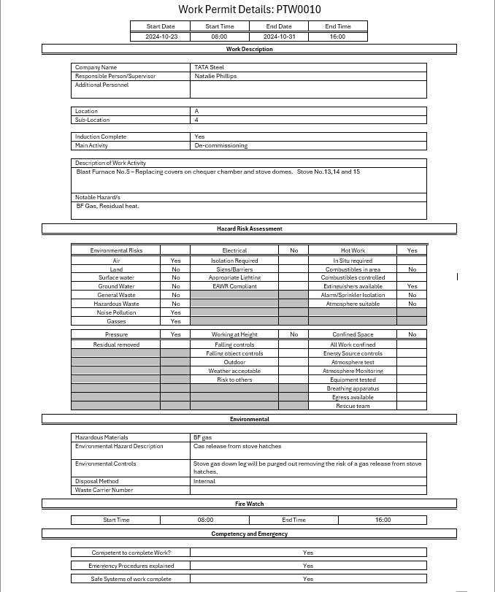
Figure 7 - Complete Permit to Work

Permit Management System
The Microsoft Apps developed back end of the permit to work system was designed to allow quick and clear visualisation of open live and historical permits and the data analytics on the permit dashboard. The app is purposefully customisable to align with stakeholder needs.
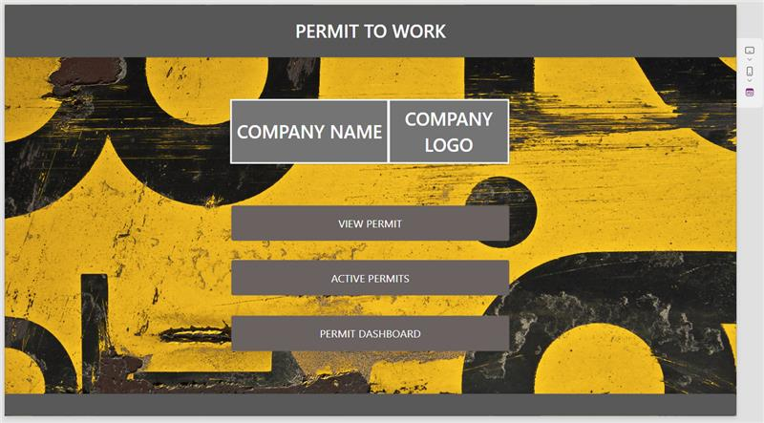
Figure 8 - Microsoft Apps – Permit to Work Management System
The permit overview can be searched by permit number, company, main activity or location to speed up navigation and accessibility.
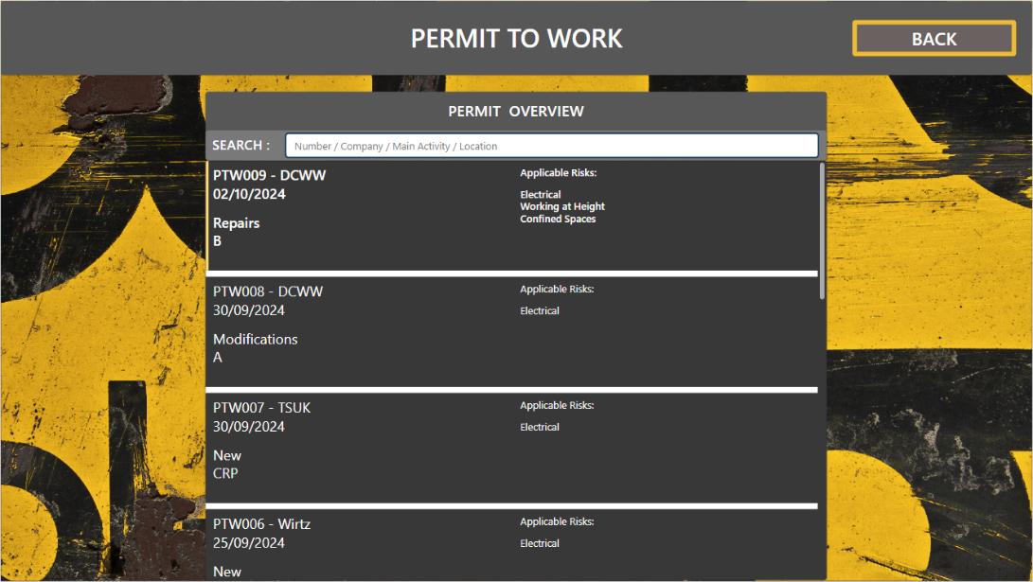
Figure 9 - Permit to Work System Management - Permit Overview

The live permit window gives a live display and information of current open permits to work.
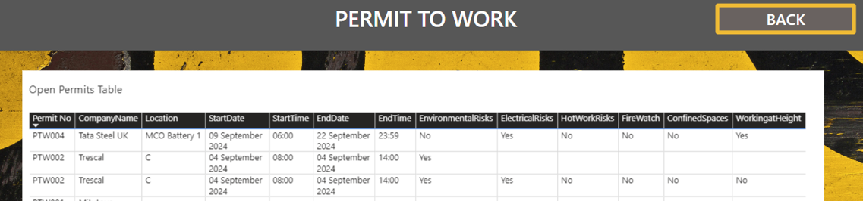
Figure 10 - Permit to Work System Management - Open Permits Table
The Microsoft suite has features and information, including the time it takes to complete the permitting process, run time estimations, and averages for workflow completion to help identify improvements to the system.

Data Visualisation
The permit dashboard is a customisable dashboard that was developed from stakeholder feedback. The benefit of digital permit to work systems is the ability to quickly display and analyse data in a way which allows the stakeholders to build up understanding of what high risk activities are being conducted, what the risk and hazards are, how often they are being undertaken and in which locations. This information can be used to help understand why and where high-risk activities are usually carried out and undertake root cause analysis to further mitigate against risk or reduce occurrence of high-risk activities.
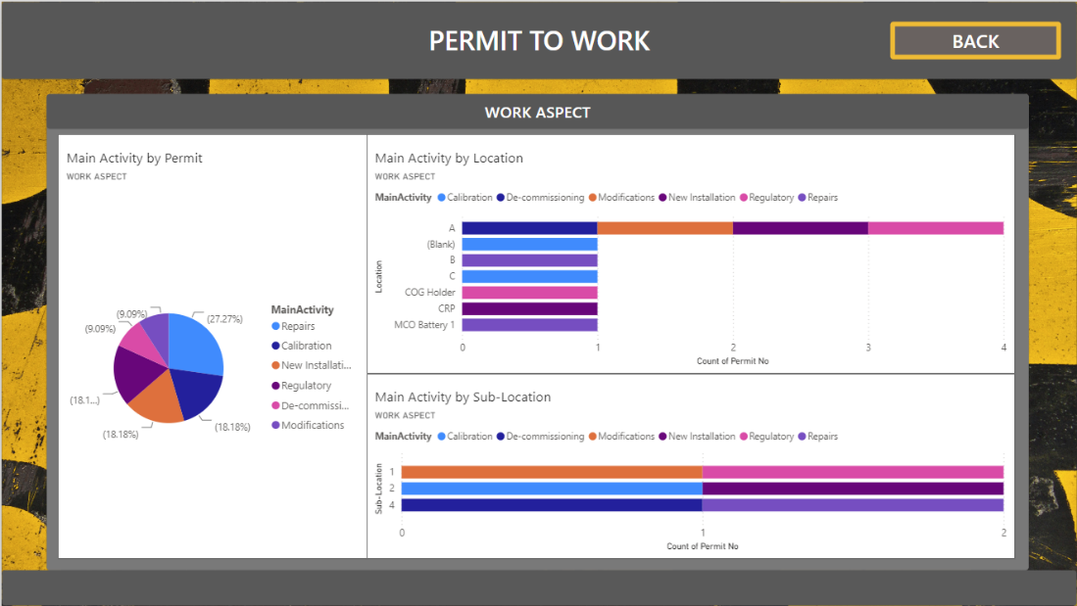
Figure 11 - Permit to Work System Management - Data Dashboard

Beta Testing and Feedback
Beta testing was undertaken using Microsoft forms to develop feedback surveys to assess the usability of the developed system. Representatives from associated companies were asked to complete a permit to work form and conduct a survey. The survey aimed to acquire qualitative and quantitative data on the permit to work..

Usability
The results show that most users could fill in the form without issue whilst 25% indicated that they required minor assistance and 19% were unable to complete required help. This negative results is likely related to the results of the user’s familiarity with digital literacy and permit to work systems as 13% fed back that they very rarely use permit to work systems whilst a further 13% considered them at a beginner level with using digital tools and systems. This data highlights that introducing the permit to work system into business will require some level of tutorial and training to ensure the entire workforce are able to use the system. The data also highlighted technical issues not apparent which required addressing.
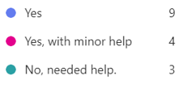
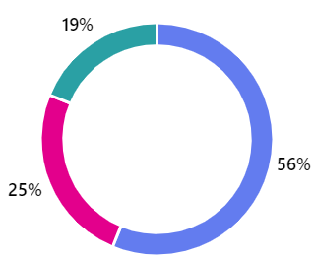
Figure 12 - Feedback - Where you able to complete the permit to work with ease?

Product Satisfaction
From the feedback, when asked how well the system met their needs at creating and managing permits; no feedback was that it did not meet their needs whilst 50% believed that the system exceeded their expectations.
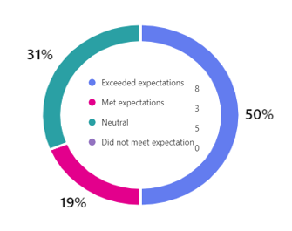
Figure 13 - Feedback – How well did the system meet your needs for creating/managing permits?

When asked “How would you rate your overall satisfaction with the digital permit to work system?” only one of the 16 people who took part in the survey were dissatisfied. The majority of respondents were very positive in their feedback resulting in a successful beta test.
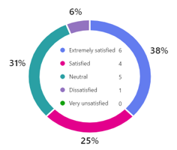
Figure 14 - Feedback - How would you rate your overall satisfaction with the digital permit to work system?

Qualitative Feedback
Some notable qualitative feedback included:
"The paper system has no issues. We can see benefits with Welsh Water due to the coverage area, which allows us to be anywhere, so remote does help”
This shows the issues with operational change that will occur for adoption by companies even whilst being able to see the positive impact it will have.
Other feedback included future development ideas:
"I would like to see text box options that would allow me to expand on the individual hazards
"Photo upload to reference when taking the team through the permit would be very useful. "
Whilst the project target to speed up the system was proven to be successful:
"I found this far easier to write over the old paper-based permit. This process was far quicker "

Feedback Result
The survey fed back several highlights including reduced processing times for permit approvals, improved tracking and improved accuracy of data. Satisfactions levels were generally positive, there were however technical issues which required addressing. The main concerns were around perceived difficulty in moving away from the status quo of paper permit to work systems, however concerns were generally accompanied with positive feedback on the benefits of the digital system. The operational change to digital permits, if managed effectively, would produce benefits in the long term.
Receiving qualitative feedback allowed for greater detail of feedback where the design of the form was amended to allow for additional information on hazards, the capabilities to add photos has not been included due to the scope creep but could be implemented in future development.
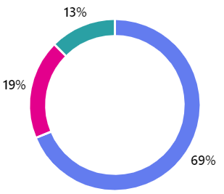


Conclusion
The digital permit to work created is successful as a procedure used to document work that is potentially hazardous. The core objectives were to increase efficiency in process, improve risk management and compliance and develop a system with enhanced monitoring and data availability.
The increased efficiencies were aimed at reducing permit creation time, approval process time and improving management of permits. The permit creation time reviewed from the results was that for most technology literate individuals the permit was easy and quick to use, which would only increase with familiarity. Even more so if an effective operational change process was complete to manage operational change to a digital system. Access to create permits was improved by having remote access via tablets, mobile phones and laptops. This remote access and the utilisation of features of the Microsoft suite allows for notifications and quick approval processes, this is a feature benefit highlighted by the survey results from Welsh Water representatives resolving the issue of geographical spread of assets and personnel. The efficiencies for reviewing and collating permits to work have been dramatically increased by digitising the forms, this makes audit data collection easier.
The digital permit to work system aimed to improve risk management, accuracy and responsiveness in risk assessments. With the structure of the form to help highlight risks and hazards and prompt response on how these were mitigated it forms the risk assessment and management.
The digital permit to work system dashboard allows required stakeholders to monitor permits. This availability of data allows companies to track and build understanding of high-risk activities being undertaken within the work place. This information can be used to reduce high risk activities or review and improve methodologies undertaken.
The project was planned and managed successfully with only minor slippage within the app development stages. This was because the complexities in integrating all the Microsoft systems and having them work correctly was underestimated during the planning stage.
If the project was to be taken further there were features, some highlighted in stakeholder feedback, which could improve on the system. This would to be attach more detail on hazards such as photos and more detailed risk assessments which could provide a scoring matrix to measure risk before and after mitigations have been put in place.
Overall the project has met its objectives and improved on an existing process by bringing it into the digital age.

Self-Evaluation

Reflection on Role
Working on the project to develop a digital permit to work system has been a generally positive experience from a personal and technical perspective. My primary contributions to the project including conducting research, developing input forms and assisting in the creation of automated workflows.

Technical Knowledge

Microsoft Forms and Microsoft Power Platform
Having no prior experience creating Microsoft Forms or using Microsoft Power Apps & Automation before there was a lot to be gained from undertaking the project. Having interfaced with Microsoft Forms and had presentations which utilised Power BI within my place of work, not having the experience or understanding was a blocker from utilised the software to assist with my role.
I have gained experience in how to create clear Microsoft Forms to gather relevant date and manage it accordingly by creating and structuring a SharePoint list and developing automated works flow using Power Automate. Understanding works flow on Power Automate relates to my role as a PLC and SCADA engineer using logic flow processes to achieve the desired results. Acquiring the data and being able to present it effectively with Power BI will change how I present data and findings in the future. I have identified aspects of my role where I can utilise the knowledge gained in these areas to benefit myself and my place of work.

Workflow Automation
Assisting in the development automated workflows allowed me to apply my knowledge from process engineering to a digital permit process. Understanding basic low level code functions which build up processes allowed designed flows to integrate various tasks, notifications via email and team and approval processes. I was able to identify additional capabilities of Microsoft Power Automate to include the reminder feature which allows the Permit to Work System to send notification reminders to indicate when a work task has not been closed out in accordance with the close time information provided.

Permit to Work
Conducting research to inform our design gave me clear understanding of how a paper permit to work system worked, although not utilised within my role I understand better the legal compliance implications and importance of risk management and approval processes. For process engineering, risk is predominantly to process as opposed to personnel. Systems are currently in place to manage approvals which are not automated, the work complete within this project can be utilised to raise issues, identify improvements, inform of work times and durations, identify process risk and manage approvals and change audits within my role.

Personal Growth
Group projects pose time management, collaboration and communication challenges on top of the workload of the project. Within this project, unlike work projects, due to my lack of expertise and confidence it took me longer to feel confident to share input on subject matters I didn’t fully understand. As the project developed, I believe my communication abilities within the team to ask questions and challenge ideas helped build understanding enabled myself to contribute more effectively. My ability to identify solutions and assess requirements whilst automating workflows made me more comfortable in an environment I was more familiar with.
Developing knowledge and skills in the Microsoft software suite that I was not previously conversant with has built my self confidence in myself in my ability to acquire new skills and confidently apply them elsewhere.
Having to be adaptable within a group projects requires understanding of the team involved, learning about individuals personal lives can help break down barriers in understanding availability and better adapt expectations and whilst building relationships makes asking approaching issues more comfortable.

References
Data Protection Act 2018 (2024) Available at: https://www.legislation.gov.uk/ukpga/2018/12/contents/enacted (Accessed 21 October 2024)
Health and Safety at Work Act (HASAWA) 1974. Available at: https://www.legislation.gov.uk/ukpga/1974/37 (Accessed 20 October 2024).
Health and Safety Executive (2005) Guidance on permit-to-work systems – a guide for the petroleum, chemical and allied industries. Available at: https://books.hse.gov.uk/gempdf/hsg250.pdf (Accessed 20 June 2024)
Health and Safety Executive (2013). Permit to Work Systems. Available at: https://www.hse.gov.uk/legislation/hswa.htm (Accessed 20 October 2024)
Health and Safety Executive (2020). Healthy and Safety at Work Act 1973. Available at: https://www.hse.gov.uk/legislation/hswa.htm (Accessed 20 October 2024)
Jones, D., 2024. Conversation with Matthew Frey [Interview] (08 April 2024).
Marzouk, M & El-Haggers, S (2017) “Smart Construction Management, An Overview of Emerging Trends.” Journal of Construction Engineering and Management
Microsoft (2023) Microsoft Power Platform. Available at https://microsoft.com.com/en-us/power-platform (Accessed 21 October 2024)
Mousavi, S.M. et al. (2020) ‘Factors Affecting Performance of Permit to Work System: A Case Study in an Oil Refinery’, Archives of occupational health, 4(4), pp. 863–869. Available at: https://doi.org/10.18502/aoh.v4i4.4512.
Rogers, K., 2024. Conversation with Andrew Madelin [Interview] (14 April 2024).

