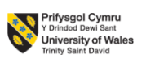

Master of Business Administration
LCMB7023: Human Capital Management
Assessment component 1: Individual report – Unilever
Lecturer: Gladius David Kulothungan

Student Name Id: 2437157

Table of Contents
1. Introduction 3
2. Unilever’s Organisational Culture 4
2.1 Schein’s Three-Level Model 4
2.1.1 Organisational Artefacts (Visible Elements) 4
2.1.2 Espoused Values (Stated Principles) 5
2.1.3 Underlying Assumptions (Deep Beliefs) 5
2.2 Application of the Competing Values Framework 6
3. Current organisational culture supporting strategic development 6
4. Current Working Environment and Strategic Goal Achievement 8
4.1 Flexible and hybrid working model 8
4.2 Agile structure and high-performance work system 9
4.3 Inclusiveness and well-being culture 9
4.4 Potential risks and hindrances 10
5. Job satisfaction, job engagement, and career development 10
5.1 Job Satisfaction 11
5.2 Job engagement 12
5.3 Career development 12
5.4 Personal Reflection 13
6. Recommendations 13
7. Conclusion 14
8. References 16

1. Introduction
Unilever is a leading international customer goods organisation and its headquarters is situated in London. The firm has a diversified product base in the personal care, home care and food sectors and operates in more than 190 countries(Unilever, 2025a). Moreover, Unilever is operating a large workforce of 125000 workers worldwide that is recognised as global in human capital management(Unilever, 2025a).It operates in a variety of sectors such as personal care, home care, and food products, with an employee base of 125000 and is widely recognised for its commitment to sustainability, innovation and employee growth. The organisational culture and work environment are key in establishing behaviour, engagement and performance of employees, and assisting the strategies of the firm in the global competitive business environment(Aman, 2019). Understanding these dimensions at Unilever gives insights into the contribution of culture and workplace practises to organisational effectiveness and long-term strategic development.
The report critically evaluates the Unilever’s organisational culture and how it aligns with the company’s strategic goals, assesses the nature of the working environment, and evaluates the implications of the working environment to employee satisfaction, engagement, and career development. The report uses theoretical frameworks such as including Schein’s Three-Level Model, Herzberg’s Two-Factor Theory, and the Job Characteristics Model to critically discuss the practises of Unilever. The report ends with providing evidence-based suggestions for improving organisational culture and the working environment to support strategic goals and employee outcomes.

Figure 1: Unilever Brand Logo(Source: Unilever, 2025b)

2. Unilever’s Organisational Culture
The current organisational culture of Unilever is a purpose-led, performance-driven and innovation-focused, which is deeply rooted in values such as respect, responsibility and integrity(Unilever, 2025c). The organisation also emphasises on attaining measurable outcomes and maintaining high quality through streamlined designs, flattened hierarchies and responsibility at all levels. In addition to that, Unilever promotes an internal culture called “brighten everyday life” which empowers its employees to match corporate and personal missions, fostering engagement and collaboration(Unilever, 2025d). To analyse this in detail, Schein’s Three-Level Model (2010) is applied, as this model differentiates between visible practises (artefacts), so-called stating values and deep underlying assumptions(Schein, 2010).

2.1 Schein’s Three-Level Model
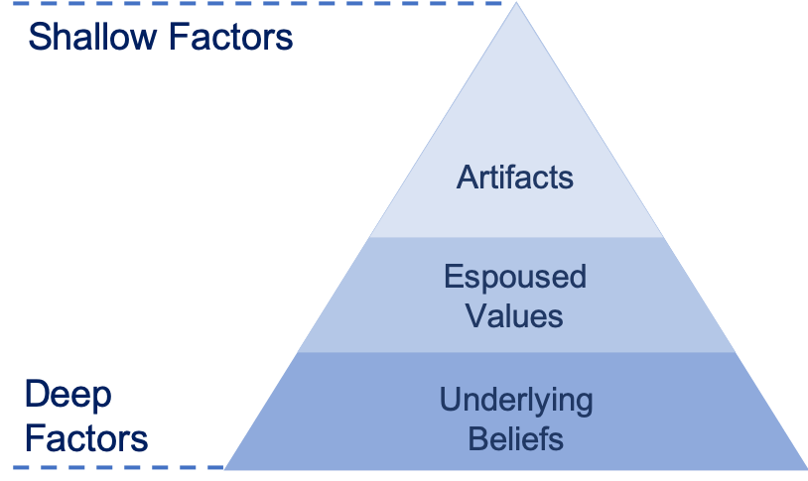
Fig: Schein’s Three-Level Model(Schein, 2010)

2.1.1 Organisational Artefacts (Visible Elements)
The visible layer of Unilever’s culture includes:
- The Unilever Sustainable Living Plan, which is later changed to the Compass Strategy, indicates environmental and social priorities(Unilever, 2020).
- Unilever Future Leaders Programme (UFLP), facilitating leadership growth and internationalisation(Unilever, 2025e).
- Hybrid working models such as U-Work, flexible roles, and wellbeing programmes(Unilever, 2025e; Wittenberg-Cox, 2021).
- Digital innovation platforms and IDEATrophy which promote creativity and entrepreneurial behaviour(Unilever, 2024).
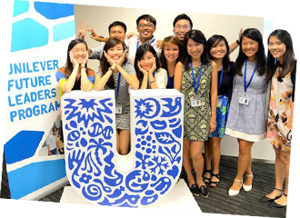
Fig: Unilever Future Leaders Programme(Source: Unilever, 2025e)
These artefacts convey a culture of innovation, independence, sustainability and employee development.

2.1.2 Espoused Values (Stated Principles)
Unilever claims to priotitise integrity, respect, collective responsibility, consumer focus and sustainability(Unilever, 2025c).

2.1.3 Underlying Assumptions (Deep Beliefs)
Historically, Unilever has been operating on the principle that commercial success is achieved through long-term sustainability. Nevertheless, the trend in the recent decisions, including reducing sustainability targets and removing ESG metrics from the executive compensatio), points to the possibility of the Unilever underlying assumptions moving towards the direction of a market-controlling, performance-focused orientation(Davies, 2024). This shift is an indication of cultural drift, in which underlying assumptions tend to evolve away from previously entrenched values(Mesoudi, 2016).

2.2 Application of the Competing Values Framework
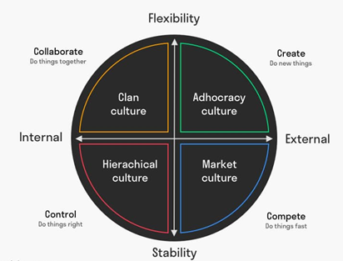
Fig: Competing Values Framework(Cameron, 2011)
Unilever exhibits aspects of:
- Clan culture via collaboration, wellbeing program and employee development.
- Adhocracy culture through innovation programmes, experimentation and autonomy.
- Market culture by putting more focus on accountability, performance measurements and competitive brand strategies.

This overlap of these cultural types creates hybrid strengths but also tensions, in particular, where purpose-based identity collides with rising performance pressures.

2.3 Application of Hofstede’s Six Cultural Dimensions
The six cultural dimensions by Hofstede also offer another perspective for understanding the organisational culture of Unilever, especially with its extensive international operations(Hoftede, Hofstede, & Minkov, 2010).
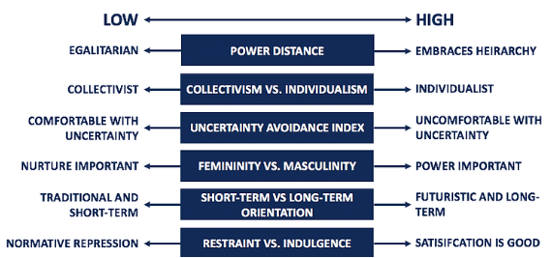
Fig: Hofstede’s six cultural dimensions(Hoftede et al., 2010)
- Power Distance: Unilever exhibits a fairly low power distance, which is visible in flatter organisations, open communication channels and focus on employee empowerment and participative leadership.
- Individualism vs. Collectivism: The organisation has a high level of individualism orientation, promoting personal initiatives, responsibility and self-directed career growth, especially through leadership and rotational programmes.
- Uncertainty Avoidance: Unilever has moderate uncertainty avoidance combining structured performance management systems with openness to innovation, experimentation, and calculated risk-taking.
- Long-Term Orientation: Unilever has a high level of long-term orientation as demonstrated by its emphasis on sustainable growth, brand longevity and investment in human capital and environmental responsibility.
- Masculinity vs. Femininity: The organisation is closer to a feminine culture with cooperative approach, inclusiion, employee wellbeing and work-life balance oriented as opposed to aggressive competition.
- Indulgence: Unilever is showing restrained indulgence as it encourages flexible working and wellbeing programs but does not lessen its performance discipline.

Thus, the cultural identity of Unilever is strong, yet, the presence of cultural fragmentation implies the need for cultural realignment to prevent employee scepticism and reputational damage.

3. Current organisational culture supporting strategic development
The organisational culture of Unilever significantly supports its strategic development promoting alignment over agility, innovation, purpose and stakeholder preferences. The purpose-led culture of the company fastened in its “Sustainable Living Plan” and realigned with its Growth Action Plan that adapts sustainability with organisational targets(Unilever, 2025f). This activates strategic emphasis on four main principles such as nature, climate, plastics and livelihoods, strengthening innovation and brand superiority. Strategic actions such as forging emission-reduction partnerships highlight how the organisational collaborative culture reflects ESG ambitions and supply chain.
The shift to a performance-centred and agile model fosters strategic objectives. Unilever enhanced speed, responsibility and market responsiveness by giving business groups with business-based OKRs, organisational reviews in quarters and dedicated agile teams(Danoesastro and Zeegers, 2023). These are the key things to its "market-making success" agenda. This cultural and structural change improves the ability to measure innovations and compete in dynamic markets.
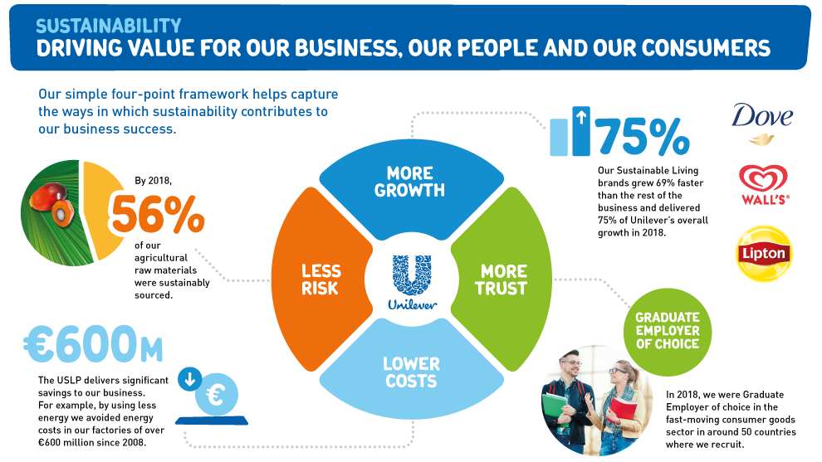
Figure 3: Unilever’s ESG Ambitions(Source: Parekh, 2019)
In addition, the culture of innovation and creativity highlights its strategic brand establishment in the market. The organisational initiatives guided by the Creative Council of Unilever nurture rapid experimentation and bold marketing that aligns with strategic focuses for customer-centric differentiation and “unmissable brand superiority”(Unilever, 2025f).
However, the organisational strategic modifications results in cultural coherence. For example, under the leadership of its CEO, Hein Schumacher, the company redeveloped its sustainability targets that scales back some ambitions and disconnecting them from executive bonuses to adjust investor profitability and expectations(Davies, 2024). According to cultural congruence theory (O’Reilly & Chatman, 1996), the lack of congruence between proclaimed values and the implemented values lowers the trust of the employees, weakening strategic implementation capacity(O'Reilly III, Chatman, & Caldwell, 1991).
Thus, Unilever’s culture highly supports strategic objectives, especially innovation and brand leadership, but misalignment between purpose and performance will influence strategic legitimacy. Strengthening authenticity is therefore important for the company.

4. Current Working Environment and Strategic Goal Achievement
Unilever’s working environment consists of flexible working, performance systems, wellbeing initiatives and leadership practises. This section applies theories to evaluate strategic impact.

4.1 Flexible and hybrid working model
Unilever has adopted flexible and hybrid working practises across geographies. Through its U-Work initiative, employees can choose assignment-based work while retaining benefits(Unilever, 2025g). Global hybrid principle expects employees to be in the office for around 40% of the working time that focuses on outcomes rather than the precise location where all work is performed. In this context, in New Zealand, the trial of a 4-day work in a week enhanced work-life balance and well-being for over two-thirds of respondents(Sophia, 2025).
Using the Job Characteristics Model, hybrid working improves(Ali et al., 2014):
- Autonomy (control of time and place)
- Task importance (sustainability goal contributions)
- Skill variety through cross-functional collaboration
The factors enhance interaction and productivity, which enhances strategic agility.

4.2 Agile structure and high-performance work system
Unilever shifted to a streamlined company minimising business units, cutting senior-level jobs by 15%, and into five core groups to improve responsiveness and responsibility(Sophia, 2025). This flat structure motivates speed, clarity and performance adaption with strategic preferences. In addition, the organisation promotes a performance-led culture by setting transparent objectives and connecting rewards and feedback directly to results. As an example, Unilever gives three business-related and one personal development objective for each employee. The company also utilises digital tools such as the IdeaTrophy platform and AI‑powered FLEX Experiences that encourage in innovation and cross-functional collaboration which also enables measurement of efficient initiatives and piloting programs including rapid experimentation(Sophia, 2025).
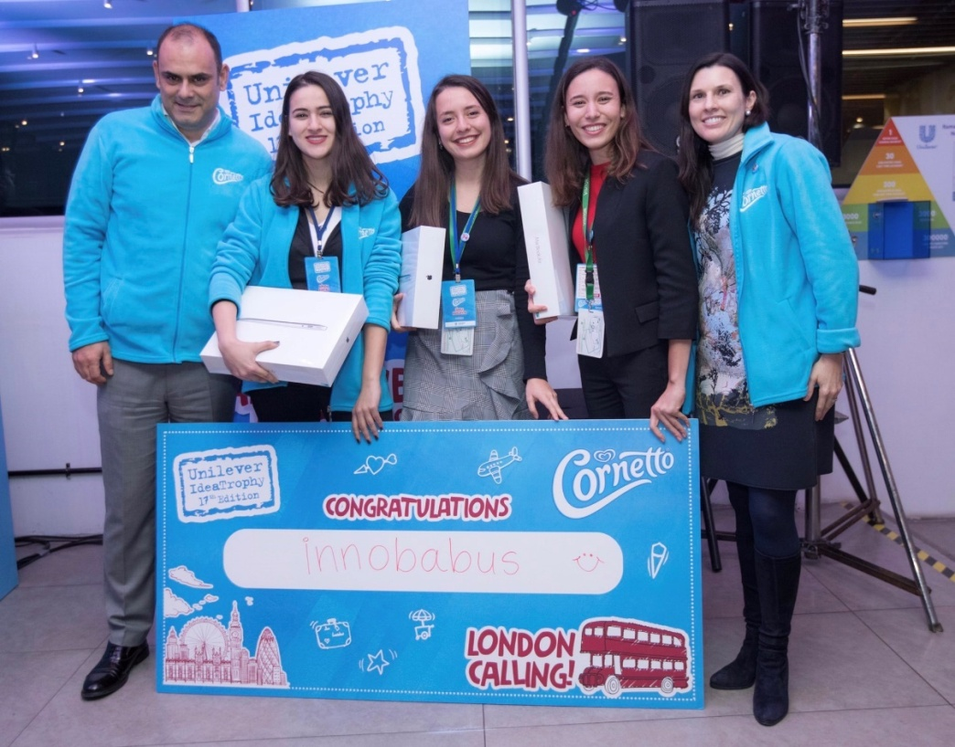
Figure 4: Unilever’s IdeaTrophy celebration(Source: X, 2025)

4.3 Inclusiveness and well-being culture
Unilever’s wellbeing model addresses mental, physical and emotional health with over 57000 employees participating in purpose-driven workshops(Unilever, 2025h). Safety initiatives such as the “BeSafe” program in manufacturing units strengthen a health-first approach(Unilever, 2016). In the global context, supporting structures for reskilling, hybrid work balance and mental health well-being adjust HR goals of retention and sustainability.
Psychological Safety Theory highlights that well-being and trust form environments that are conducive towards innovation, which is the focus of the Unilever strategy(Edmondson & Lei, 2014).

4.4 Potential risks and hindrances
Despite these positives, there are some challenges that threaten strategic alignment.
- Significant job cuts in Europe [3200 roles at the end of 2025] and redesigning of sustainability advisory have reduced psychological safety and trust(Naidu and Anilkumar, 2024).
- Employee reviews highlight inconsistent recruitment, managerial quality and excessive workloads(Glassdoor, 2024).
- Hybrid working is not being applied equally, which establishes a disparity across roles.
The working environment supports strategic aims through enhanced flexibility, wellbeing and innovation. Nevertheless, excessive workload, restructuring and uneven managerial habits demoralise trust, reducing strategic alignment and damaging long-term competence.

5. Job satisfaction, job engagement, and career development
Culture and working environment are important factors that influence the experience of the employees in an organisation(Shenoy & Uchil, 2018). At Unilever, a purpose-led identity, learning-focused culture and flexible working arrangements offer employees a strong foundation for satisfaction, engagement and growth. But restructuring, performance demands and inconsistent management habits present problems. This section analyses these dynamics using major organisational behaviour theories.

5.1 Job Satisfaction
Job Satisfaction is brought about by intrinsic and extrinsic aspects. According to Herzberg’s Two-Factor Theory (1968), intrinsic factors (meaningful work, achievement and development) bring about satisfaction, whereas hygienic factors (pay, working conditions and job security) prevent dissatisfaction(Herzberg, 1966).
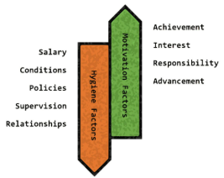
Fig: Herzberg’s Two-Factor Theory(Herzberg, 1966)
Unilever has a powerful presence of motivators. Employees, in turn are proud of having a role to play towards sustainability objectives, social impact projects, and established brands(Indeed, 2025). Intrinsic motivation is also boosted by the company’s focus on learning and has a wide range of opportunities in its global development (e.g., UFLP, rotations across functions). There is also autonomy and ownership in hybrid working and flexible arrangements that enhance personal fulfilment.
There are a number of hygiene factors, which decrease satisfaction. Workloads, fast-paced expectations and stress, especially in selling and marketing jobs, are often mentioned in employee reviews(Glassdoor, 2025). More recent layoffs of workers in Europe have increased the feeling of uncertainty and job insecurity(Naidu & Anilkumar, 2024). In certain markets, their compensation is regarded as lower than what is in the industry. As Herzberg framework suggests, such hygiene issues can overshadow strong motivators, explaining mixed satisfaction levels among employees

5.2 Job engagement
Engagement describes the emotional, cognitive and physical commitment of employees to the work that they do. Two models are particularly applicable, the Job Characteristics Model (JCM) and the Social Exchange Theory.

Under the JCM, engagement is enhanced when work has an element of autonomy, skill variety, task identity, task significance and clear feedback(Ali et al., 2014). Unilever scores well in these dimensions:
- High task significance from sustainability, purpose-driven work and global impact.
- Skill variety through cross-functional teams, international exposure and digital innovation challenges.
- Autonomy is ensured with hybrid working policies.
- Regular feedback is enabled through OKRs and performance cycles.

Nevertheless, motivational potential is undermined with role ambiguity caused by restructuring and work-related pressure in performance-based teams. When employees lack time or clarity to fully exercise autonomy, their engagement diminishes despite structured support.
Engagement can also be explained by using Social Exchange Theory: employees return the organisational support with loyalty and diligence(Cook, Cheshire, Rice, & Nakagawa, 2013). The well-being programmes, inclusive culture and developmental investments of Unilever create great perceptions of support. However, reorganisation and shifting sustainability commitments can minimise trust, undermining reciprocity and leading to disengagement with some employees

5.3 Career development
Unilever is known to have a well-developed development system, making career growth one of the strengths of the employee value proposition. Programmes like the UFLP, leadership academies and internal mobility culture are offering employees enormous chances to acquire skills and develop their careers(Unilever, 2025e). This greatly aligns with the Human Capital Theory, which argues that organisations benefit when they invest in the development of employee competencies(Wuttaphan, 2017). However, several constraints limit the consistency of career growth experiences. Employee feedback points at vague promotion standards, varying management styles and politics within certain divisions. Moreover, not all local markets will allow upward mobility due to budget constraints, influencing long-term career satisfaction(Vizard, 2017).
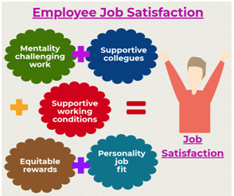
Figure 5: Employee Job satisfaction elements(Source: Rawat, 2019)

Overall, Unilever is an organisation that has a supportive environment with a strong motivation level, meaningful work and learning opportunities. These measures boost job satisfaction, engagement and career growth. These benefits will, however, be affected by the workload intensity, job insecurity due to restructuring and uneven managerial capability.

5.4 Personal Reflection
If I were an employee at Unilever, the organisation’s purpose-based identity, flexibility of working, international exposure and lifelong learning would improve my job satisfaction and engagement. Nonetheless, job security, performance demands, and unreliable manager support can prevent my satisfaction and career motivation. The conflict aspect of purpose and performance would play a major role in my long-term commitment and engagement.

6. Recommendations
Based on the analysis of Unilever’s organisational culture and working environment, there are a number of areas that require strategic focus for better cultural alignment, employee experience and improved organisational performance in the long term. The recommendations below attempt to fill the gaps detected in the culture, engagement, job satisfaction and career development.

Rebuild Cultural Consistency and Trust: Unilever needs to strengthen its purpose-led identity by reviving open sustainability commitments and clearly reporting strategic priorities. The cultural alignment of organisational trust and authentic culture is improved by the consistency between the espoused values and actions.

Strengthen Managerial Capability for Psychological Safety: Managers should receive training in inclusive communication, coaching and feedback to enhance psychological safety(Mission Diverse, 2023).. This plays a crucial role in a hybrid and fast-paced setting, and it is directly related to employee engagement, innovation and wellbeing.

Redesign High-Pressure Roles Using Job Characteristics Model: The redesign of roles must also be considered and modified to enhance autonomy, clarity in tasks and manageable workloads, especially in task-intensive groups. Improving core job characteristics will enhance motivation, reduce burnout and support long-term performance.

Improve Fairness in Promotion and Career Advancement: To enhance procedural fairness, Unilever should use systematic promotion policies, transparent grading programs and interviewer training(Ezeafulukwe et al. 2024). Fairness should be augmented to boost motivation, retention and career satisfaction.

Expand Flexible Work Models with Data-Driven Evaluation: Unilever should expand effective hybrid and reduced-hours programs using performance and well-being data to evaluate their success(Sophia, 2025).

7. Conclusion
From the above analysis, it can be concluded that the organisational culture of Unilever is deeply rooted in agility, purpose and innovation which plays an essential role in highlighting its global competitiveness and strategic development. Furthermore, its inclusive policies, flexible working environment and performance-driven focuses largely foster employee satisfaction, career development and engagement. Despite this, there are some challenges such as managerial inconsistency, high work pressure and changing ESG ambitions that pose concerns to employee well-being and objectives alignment. Unilever can further reinforce its internal culture and working environment by incorporating its flexible work practises, refining leadership practises and strengthening ethical recruitment processes and reskilling practises. Overall, the organisation can enhance both employee experience and operational excellence by ensuring strategic resilience and cultural cohesion.

8. References
- Adeniyi, I.S., Al Hamad, N.M., Adewusi, O.E., Unachukwu, C.C., Osawaru, B., Onyebuchi, C.N., Omolawal, S.A., Aliu, A.O. and David, I.O. (2024) ‘Organisational culture and leadership development: A human resources review of trends and best practises’. Magna Scientia Advanced Research and Reviews, 10(1), pp.243-255.
- Ali, S. A. M., Said, N. A., Yunus, N. a. M., Abd Kader, S. F., Ab Latif, D. S., & Munap, R. (2014). Hackman and Oldham's job characteristics model to job satisfaction. Procedia-Social and Behavioral Sciences, 129, 46-52.
- Aman, M. K. (2019). The effect of employee engagement and organisation culture on company innovation capability. International Journal of Contemporary Accounting, 1(1), 13-22.
- Brunetto, Y., Farr-Wharton, R., & Shacklock, K. (2012). Communication, training, well-being, and commitment across nurse generations. Nursing outlook, 60(1), 7-15.
- Cameron, K. S. (2011). Diagnosing and changing organisational culture: Based on the competing values framework. In: John Wiley & Sons.
- Cook, K. S., Cheshire, C., Rice, E. R., & Nakagawa, S. (2013). Social exchange theory. In Handbook of social psychology (pp. 61-88): Springer.
- Danoesastro, M. and Zeegers, M. (2023) How Unilever Elevated Agile. [online] Danoesastro, and Zeegers,. Available at: https://www.bcg.com/publications/2023/elevating-agile-principles-to-help-enterprise-sized-companies [Accessed 04 July 2025].
- Davies, R. (2024) Unilever to scale back environmental and social pledges. [online] Davies. Available at: https://www.theguardian.com/business/2024/apr/19/unilever-to-scale-back-environmental-and-social-pledges [Accessed 04 July 2025].
- Edmondson, A. C., & Lei, Z. (2014). Psychological safety: The history, renaissance, and future of an interpersonal construct. Annu. Rev. Organ. Psychol. Organ. Behav., 1(1), 23-43.
- Ezeafulukwe, C., Onyekwelu, S.C., Onyekwelu, N.P., Ike, C.U., Bello, B.G. and Asuzu, F.O. (2024) ‘Best practises in human resources for inclusive employment: An in-depth review’. International Journal of Science and Research Archive, 11(1), pp.1286-1293.
- Glassdoor. (2024) Recruitment process @ Unilever. [online] Glassdoor. Available at: https://www.glassdoor.com/Reviews/Employee-Review-Unilever-E3513-RVW6575982.htm [Accessed 04 July 2025].
- Glassdoor. (2025) Unilever. [online] Glassdoor. Available at: https://www.glassdoor.co.in/Reviews/Unilever-India-Reviews-EI_IE3513.0,8_IL.9,14_IN115.htm&countryRedirect=true [Accessed 04 July 2025].
- Herzberg, F. I. (1966). Work and the Nature of Man.
- Hoftede, G., Hofstede, G. J., & Minkov, M. (2010). Cultures and organizations: software of the mind: intercultural cooperation and its importance for survival. McGraw-Hill.
- Indeed. (2025) Unilever. [online] Indeed. Available at: https://uk.indeed.com/cmp/Unilever/reviews?fcountry=ALL&ftext=role [Accessed 04 July 2025].
- Mesoudi, A. (2016). Cultural evolution: a review of theory, findings and controversies. Evolutionary biology, 43(4), 481-497.
- Mission Diverse. (2023) Psychological Safety Training. [online] Mission Diverse. Available at: https://missiondiverse.org/psychological-safety-training/ [Accessed 04 July 2025].
- Naidu, R. and Anilkumar, R. (2024) Unilever to cut a third of office jobs in Europe. [online] Naidu and Anilkumar. Available at: https://www.reuters.com/business/retail-consumer/unilever-cut-third-office-jobs-europe-ft-reports-2024-07-12/ [Accessed 04 July 2025].
- O'Reilly III, C. A., Chatman, J., & Caldwell, D. F. (1991). People and organisational culture: A profile comparison approach to assessing person-organisation fit. Academy of management journal, 34(3), 487-516.
- Parekh, D. (2019) Embedding ESG Principles (Part 2). [online] Parekh. Available at: https://medium.com/the-esg-chronicles/embedding-esg-principles-part-2-7c632a94ced0 [Accessed 04 July 2025].
- Rawat, A. (2019) 6 Ways to improve Employee Job Satisfaction. [online] Rawat. Available at: https://medium.com/@rawat.ahana16/6-ways-to-improve-employee-job-satisfaction-6e89c5b2a94 [Accessed 04 July 2025].
- Schein, E. H. (2010). Organisational culture and leadership (Vol. 2): John Wiley & Sons.
- Shenoy, V., & Uchil, R. (2018). Influence of Cultural Environment Factors in Creating Employee Experience and Its Impact on Employee Engagement: An Employee Perspective. International Journal of Business Insights & Transformation, 11(2).
- Sophia. (2025) Case Study: Unilever’s Performance Culture. [online] Sophia. Available at: https://app.sophia.org/tutorials/case-study-unilevers-performance-culture [Accessed 04 July 2025].
- Stern, S. (2025) Has corporate purpose lost its purpose?. [online] Stern. Available at: https://www.ft.com/content/ed0fb762-5407-4e7f-a1d9-a4ae1d67aa66 [Accessed 04 July 2025].
- Unilever. (2016) Strategic Report 2015. [online] Unilever. Available at: https://www.unilever.com/files/origin/1d2c3be1027716e4ab9bd2fddd0aafacdde15ca3.pdf/strategic_report_ar15.pdf [Accessed 04 July 2025].
- Unilever. (2020). The Unilever Compass: our next game-changer for business. Available at: https://www.unilever.com/news/news-search/2020/the-unilever-compass-our-next-game-changer-for-business [Last Accessed: 12/10/2025].
- Unilever. (2021) Preparing people to adapt and thrive in changing times. [online] Unilever. Available at: https://www.unilever.com/news/news-search/2021/preparing-people-to-adapt-and-thrive-in-changing-times/ [Accessed 04 July 2025].
- Unilever. (2024) IdeaTrophy. [online] Unilever. Available at: https://landmark.unilever.com.tr/ideatrophy/what.html#:~:text=Unilever%20IdeaTrophy%20is%20a%20creative,all%20participants%20at%20all%20stages. [Accessed 04 July 2025].
- Unilever. (2025a) We are Unilever. [online] Unilever. Available at: https://www.unilever.com/our-company/ [Accessed 04 July 2025].
- Unilever. (2025b) Our brands. [online] Unilever. Available at: https://www.unilever.com/brands/ [Accessed 04 July 2025].
- Unilever. (2025c) Purpose, values & principles. [online] Unilever. Available at: https://www.unilever.co.uk/sustainability/purpose-values-principles/ [Accessed 04 July 2025].
- Unilever. (2025d) Engaging with stakeholders. [online] Unilever. Available at: https://www.unilever.com/sustainability/responsible-business/engaging-with-stakeholders/ [Accessed 04 July 2025].
- Unilever. (2025e) Unilever Future Leaders Programme. [online] Unilever. Available at: https://careers.unilever.com/unilever-future-leaders-programme [Accessed 04 July 2025].
- Unilever. (2025f) Brighten everyday life for all. [online] Unilever. Available at: https://www.unilver.com/our-company/strategy/ [Accessed 04 July 2025].
- Unilever. (2025g) Leading in the next era of corporate sustainability. [online] Unilever. Available at: https://www.unilver.com/sustainability/ [Accessed 04 July 2025].
- Unilever. (2025h) Employee health and wellbeing. [online] Unilever. Available at: https://www.unilever.com/sustainability/responsible-business/employee-wellbeing/ [Accessed 04 July 2025].
- Vizard, S. (2017) Unilever plots big cuts to marketing but says effectiveness is not at risk. [online] Vizard. Available at: https://www.marketingweek.com/unilever-cuts-marketing/ [Accessed 04 July 2025].
- Wittenberg-Cox, A. (2021) Flexibility For All: Unilever’s Vision Of The Future Of Work. [online] Unilever. Available at: https://www.forbes.com/sites/avivahwittenbergcox/2021/05/23/flexibility-for-all--unilevers-vision-of-the-future-of-work/ [Accessed 04 July 2025].
- Wuttaphan, N. (2017). Human capital theory: The theory of human resource development, implications, and future. Life Sciences and Environment Journal, 18(2), 240-253.
- X. (2025) Ideatrophy. [online] X. Available at: https://x.com/ideatrophy/status/1073625507013554177 [Accessed 04 July 2025].

