curtis gwyther

Abstract
The drill press is a common sight in the manufacturing industry with its primary use being to drill, counter sink or chamfer holes, with the popularity of cordless drills being not only used in industry but being used in households too this drill press aims to appeal to both of these markets by designing a drill press that can hold the cordless drill within the drill press to be used as a pillar drill. This report will discuss the considerations and design of the drill press main sliding unit which will hold the cordless drill in place.
Engineering Design Project
Drill Press Main Sliding Unit
M4X01160

Introduction
This report will look at the development of a new drill press main sliding unit which will be taken to market. The required volume is 1000 units per week and the material must be of a polymeric material over metal in order to minimise the cost of production. In the report considerations are made regarding the requirements of the drill press as a whole and the drill press main sliding unit as an individual part also the type of polymeric material that is best suited for the production of the part and finally the manufacturing process that can meet the desired number of parts per week to the correct tolerances, giving a finished functional product for a relatively low cost. The report will also look at what design considerations will need to be made to suit the manufacturing process that is selected to make sure that the final product is suitable for production.

Table of contents
Contents
Introduction 1
Table of contents 1
Main body 1
Requirements 1
Manufacturing method 1
Material 2
Design considerations 2
Final design 3
Works Cited 4

Main body

Requirements
For any product to be successful it must meet the functional requirements of the market for example the product should be relatively low cost, it should be safe to use, and that the product gives good value for money, the required material type must be a polymeric plastic. The other requirements of this product are that the drill press is durable and able to withstand the force placed upon it by drilling and countersinking operations and that it can bear the weight of the hand drill once secured in the holder. The manufacturing requirements of the product are that it can be produced in high quantities per week while retaining the quality of the part, all sharp edges should be filleted for a better feeling product and less chance of a customer cutting themselves on the part and the drill press main sliding unit should fit to the rest of the assembly easily and slide along the drill press main shaft smoothly without snatching.

Manufacturing method
The manufacturing method that best suits the requirements of the product is plastic injection moulding. Plastic injection moulding is the process of melting plastic and injecting that plastic into a mould or cavity to form the desired shape. Once the desired shape is formed the plastic is cooled and ejected from the mould/cavity you have a functional and finished part.
The advantages of injection moulding are:
Repeatability and accuracy – the same shape can be produced millions of times and it will be produced to the same quality and tolerances consistently.
Functionality- It is possible through injection moulding to design various features into the part including complex geometry that would be difficult to produce with other forms of manufacturing processes.
Surface finish- With different injection mould processes and different tooling a wide range of surface finishes can be achieved, from smooth glossy finishes to textured or knurled finishes or simulated natural fibres
Cost and weight – When producing parts in high volume injection moulding is perfect, the main cost for this form of manufacturing is the initial tooling cost. Once this initial investment has been made the cost to produce individual parts is a fraction of the cost of other forms of manufacturing.
(Rosti, n.d.)

Material
When looking at material choice for the drill press main sliding unit is was important to consider the requirements of the product for industry and for everyday use. The material choice should cover all or at least most of the requirements of the desired market for the product, with this in mind the material selected was polyetherimide. Polyetherimides are a relatively new set of speciality plastic materials that have been developed to overcome the challenges associated with polyimides which are not readily melt processable and the finished parts are usually expensive. (SpecialChem, 2018)
Polyetherimide is an amorphous engineering thermoplastic and is known to exhibit high temperature resistance with excellent mechanical and electrical properties, this polymer also exhibits a high tensile strength, good flame resistance and low smoke emissions making it the ideal choice for industrial applications. Other key properties of polyetherimide are that this resin is has a high deflection temperature of 200 degrees Celsius, high tensile strength and flexural modulus of 480,000 psi and has very good retention of its mechanical properties at elevated temperatures. It has a combination of high specific strength, rigidity, flexibility and very good dimensional strength, the resin also displays good hydrolytic stability and is inherently flame resistant without the use of additives. Polyetherimide resin is available in different grades these are, unreinforced grade for general purpose processing methods, as a transparent resin and as a standard or custom coloured resin, it is also available in four glass fibre reinforced grades, bearing grades and several high temperature grades. For the drill press main sliding unit the grade that will be used will be the unreinforced grade as the other grades are more expensive and there is a need to keep cost down as polyetherimide is already limited by relatively high cost for a plastic/resin. (SpecialChem, 2018) (U. Sathya, 2020)

Design considerations
With the manufacturing method of injection moulding being selected as the optimal process considerations on the design of the drill press main sliding unit must be made.
Sharp corners are a concern for the final product as not only are they less visually appealing and they can be uncomfortable when handling the product from a consumer’s point of view. At the manufacturing side sharp corners are a source of stress concentrations which can result in weaker parts fillets and corner radii maintain a good material flow. This will increase the life expectancy of the part from fatigue or creep loading. (hubs, n.d.)
Draft angles should be included on the part for easy removal from the mould, a draft angle should be added to all vertical walls. Without draft angles the part will have drag marks on the surface due to the friction of the mould during ejection a minimum draft angle of 2 degrees is recommended for smooth surfaces and larger draft angles are should be used if a textured surface finish is required to minimise friction. (hubs, n.d.)
Thick sections can lead to defects in the part such as warping and sinking, maintaining a constant thin wall thickness in the design will minimise the risk of warping and sinking then designing ribs in the hollow sections to keep the strength and stiffness of the structure. (hubs, n.d.)

Final design
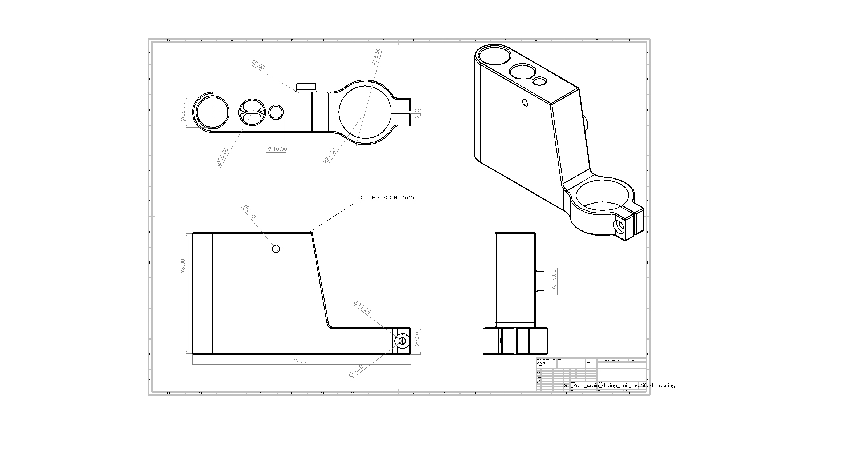
In the final design the incorporation of filleted edges to reduce the number of sharp corners as much as possible has been implemented in the design, the fillets also make the part more visually appealing and will give a smoother feel compared to sharp corners and edges. The main concern for this part whilst injection moulding will be the cooling process as there are thick sections in the main body of the part which could lead to warping because of inconsistent wall thicknesses and sink marks from the interior of the part solidifying before its surface which will cause a recess in the flat surfaces of the part. Although because of the holes going through the drill press main sliding unit I believe that the potential for sinking and warping is minimal in most areas therefore the part will meet the required standards and requirements set by the task thanks also to the manufacturing process and material that has been selected with minimal hand work needed on the part after the injection moulding process.

Works Cited
hubs, 3., n.d. Injection molding: the manufacturing & design guide. [Online]
Available at: https://www.3dhubs.com/guides/injection-molding/#design-for-injection-molding
Rosti, n.d. rosti technologies. [Online]
Available at: https://www.rosti.com/technologies/plastic-injection-moulding/?gclid=EAIaIQobChMIp7eG26bF5wIVF-DtCh0-sQ7HEAAYASAAEgIv4fD_BwE
[Accessed 2020].
SpecialChem, 2018. omnexus the material selection platform. [Online]
Available at: https://omnexus.specialchem.com/selection-guide/polyetherimide-pei-high-heat-plastic
[Accessed 2020].
U. Sathya, M. N. K., 2020. Fabrication and Characterisation of Fine-Tuned Polyetherimide (PEI)/WO3 Composite Ultrafiltration Membranes for Antifouling Studies. chemical physics letters.

