Within this essay, there will be many different topics that will be covered. These topics can include how the pandemic has effected a destination, the change in visitor numbers and how staycation has become more popular. While many different destinations around the world and the United Kingdom have been affected by the pandemic, Birmingham has seen a major affect happen to its destination. Birmingham is a popular destination that many different types of tourists go to visit each year. However, in 2019 a pandemic hit the world massively and changes were made to every destination in the whole world including Birmingham. The pandemic called Coronavirus hit big destinations that attract different tourists like Birmingham hard.

Coronavirus was first heard on the 31st of December 2019 where the world heath organisation was informed. From hearing of coronavirus, it was leaving most countries within the United Kingdom worried on what will happen to their countries as most countries were going on lockdown where they had to stay in their homes and only allowed to leave for shopping and doctors appointments. ‘23 March 2022:First UK lockdown announced’(Gov, 2022). Following from this it shows that when the first lockdown happened, it meant not many people were allowed to travel outside of the UK and businesses within the UK had to close. ‘ By 16 April 2021, the recorded number of death related to COVID-19 had reach over 127,00 in the UK’ (Zhou.M,Kan.M, 2021). By having read this it shows that it had a massive impact on the United Kingdom health.
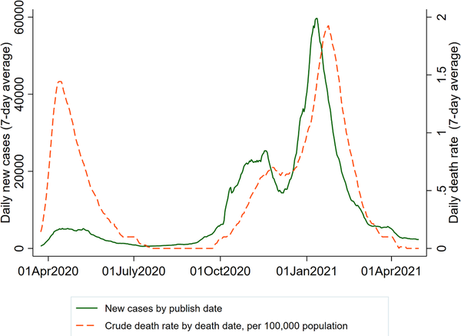
(Zhou.M,Kan.M, 2021)

Birmingham is a popular destination within England that brings in not only domestic tourist but also inbound tourists. Birmingham has been ranked as one of the most popular regional city for meetings, conferences and events’ (Hernborg.A). Following on from what Hernborg.A has said it shows that Birmingham is one of the most affective destinations to go to when having meetings and conferences for the tourism industry. Birmingham has a massive population of 856,000 people within their area. This shows that Birmingham is a very well-liked area to go and visit. ‘The reign welcomed more than 2 million international visits in 2019.@ (Herborg.A). Following on from this it shows that before lockdown started to impact the United Kingdom they had brought more international visitors to Birmingham to explore their destination. ‘In April 2020, only 19,862 passenger vehicles travelled, compared with 227.393 in the same month of 2019, a decrease of 19.3%’ (Roberts.D,2021). Following the results from what Roberts.D has stated it shows that Birmingham inbound tourist was massively affect as it had massive decrease in the numbers from bringing in 2 million tourist in to only hitting the thousands. Here is a graph to shows impact of the visitor number of the decrease that has happened in Birmingham.

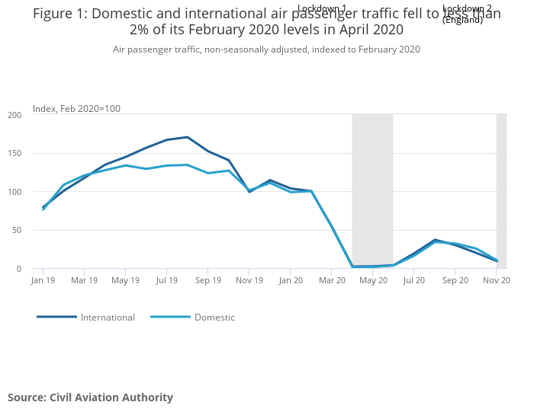(Roberts.D, ”021)

During the coronavirus everyone was unable to travel overseas or mix with other people. This had a massive effect on not only the country but on the tourism sector itself. All hotels, restaurants and outdoor tourism actives were forced to close to help stop the spreading of coronavirus. One of the major typologies that has impacted Birmingham is their transport. Due to the number of cases rising rapidly throughout the pandemic, transports such as buses and trains had to tape of one seat which can sit 2 people on so that only one of the passenger were able to sit there. This was a massive impact as buses and trains had to turn away passengers to stop the rise of the virus to make sure that they were staying within the rules and regulations that were provided by the government in order to maintain their jobs. This did not only Apply to buses, but it always applies to all other different public transport due to the spread of the pandemic. All passengers and transport drivers had to maintain wearing masks and if the passenger did not have one, they were turned away unless they had an exempt badge. ‘As a result, transportation revenues dropped significantly, therefore, transport workers’ wages were deducted, other transport working were laid off, and some transport companies closed due to bankruptcy.’ (Lo-ftf council, 2020). After reading this, it shows that transport companies were hit massively and were struggling to keep their staff to do the jobs that were required and lead to only doing half of their job timetables due to less staff working for companies.
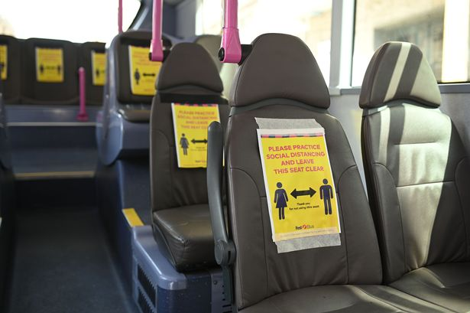
When Covid-19 rules and regulations started to lift organisations within the tourism sector, the sectors began to open but only allowed certain number of customers in at the time which meant that they were only having a small amount of income coming in to keep their organisations going. When they started to lift restrictions, and you were only allowed to travel within the location where people lived so many customers turned to staycation to get away instead of booking a holiday abroad. Staycation become very popular, and many people were doing this meaning that there was kip more income going back into Birmingham’s economy. “As now 46% of people are more likely to consider a staycation than prior to covid-19" (Chrllis.L, 2021) As a result of this, staycation still now after covid-19 is still going on it continuing to grow rapidly as more holidays overseas are getting more expensive and customers prefer to stay in the Birmingham area rather than paying loads to travel further.

Before coronavirus hit Birmingham, visitors had more expectations and better experiences compared to nowadays as they were able to experience the tourism sector in person whereas now more tourism has turned into online. This is where they have had to experience more tours online which happens in Birmingham. “Due to the complexity of the tourism activity, there are high levels of expectations regarding the experience that will be encounter-higher than in other sectors such as banking, for example, in which the advantages and benefits are more tangible.”(Pereira et al.2017). According to Pereira et al, he believes that customers these days have a higher level of exceptions within the tourism the sector to have the best experience as they can have.

Birmingham have had many impacts from the coronavirus and continue to worry about the virus. There are still some cases around, and they will have to follow the rules and regulations of track and trace that can cause more stress for businesses. “The lower footfall in places will continue to impact business, footfall dropped by 46% over the 12 mouths to Junes. This could mean on going difficulty with the return of retail and hospitality to levels of 2019.”(Riley.R, 2021) following on from Riley.R, it shows that tourism business is still now trying to get their business back to how they were back before coronavirus hit the United Kingdom. There’s still a drop within businesses around Birmingham. Following on from this, businesses are still trying to get back to normal. Since covid-19 there has been a massive impact on the economy in Birmingham and tourism businesses. “Many people have been made redundant as a result of employers needing to reduce their staff to cut cost.” (Putterman.T,2021). According to Putterman.T, many businesses have had to cut their staff due to less amount of economy coming into different businesses leaving them with less staff to co-operate their business. This also leaves members of staff with less money which will affect them massively. By having the less staff to look after a company it has impacted them as many businesses have had to close as they simply do not have the money to maintain their organisation let alone keep paying their staff if the amount of money in Birmingham is low now. Companies all around Birmingham had gone into liquidation due to the pandemic and it created less jobs and less income for families and harder for people to survive off the small income that they had coming into their homes every month.

In conclusion, there have been major impacts to Birmingham from the pandemic. Some of the points above show that not only have the tourism sector had a massive impact but destinations like Birmingham have had the negative impacts as well. Businesses are still trying now to get back to normal as covid-19 is still going on, but it is not as effective as it was in 2019. The short-term impacts that Birmingham have is that they still must be aware of the rules and regulations that have been in place in the beginning of coronavirus. Although the pandemic has not fully disappeared yet, cases have a raised again. Another short-term impact that Birmingham have is that they know what to expect next time round rather than knowing nothing at all. A long-term effect that Birmingham have is that more business is closing due to not having enough economy in the area. A different long-term effect is that business that have closed are now looking for new jobs and not many businesses are employing new staff due to the economy being so low and not being able to afford to pay the correct wage to staff. This is a major impact as not only are people out of jobs, but businesses can get their company back to their high standard before the pandemic happened.

For the future of Birmingham and the future of the destinations stakeholders, they can reduce the number of negative impacts that happen within the tourism sectors and become more sustainable within Birmingham. Stake holders can also use different technology equipment when doing meetings and conferences and take their laptops with them instead of them using paper and printing to get their notes ready for their meetings. Birmingham can encourage their stakeholders to become more sustainable when travelling to work by getting them to measure out how much carbon footprint they would use and use an eco-friendly way instead to get to and from one destination to another.

References
- De Lima, M.M., Mainardes, E.W. and Rodrigues, R.G.(2020) ‘ Tourist expectations and perceptions of service providers: a Brazilian perspective’, Service business,14(1),pp. 131-166.Available at:
- Dzinzi.M (2020) outbreak at leads fist bus depot as drivers test positives for coronavirus(image). Available at: https://www.google.co.uk/amp/s/www.leeds-live.co.uk/news/leeds-news/outbreak-leeds-first-bus-depot-19214806.amp Accessed on:25th November 2022.
- Gov.uk.(2022) Statistics relating to passenger arrivals in United Kingdom since the Covid- !9 outbreak. Available at: https://www.gov.uk/government/statistics/statistics-relating-to-passenger-arrivals-since-the-covid-19-outbreak-august-2022/statistics-relating-to-passenger-arrivals-in-the-united-kingdom-since-the-covid-19-outbreak-august-2022 Accessed on:24th November 2022
- Hernborg.A (2022) 40+ Birmingham Tourism Statistics, Numbers and Trends. Available at: https://www.tripplo.com/uk/birmingham-tourism-statistics-and-trends Accessed on:25th November 2022
- Lo-ftf council, (2020) Impact of the Covid 19 on the transport Industry. Available at: https://www.ituc-csi.org/IMG/pdf/impact_of_covid-19_on_tranportation.pdf Accessed on: 25th November 2022
- Riley.R,(2021) Future Trends post-covid and their impact on Birmingham. Available at: https://blog.bham.ac.uk/cityredi/future-trends-post-covid-and-their-impact-on-birmingham/ Accessed on:25th November 2022
- Riley.R. (2021) Birmingham on the world stage: the attractiveness of the city before and after the pandemic. Available on: https://blog.bham.ac.uk/cityredi/birmingham-on-the-world-stage-the-attractiveness-of-the-city-before-and-after-the-pandemic/ Accessed on: 23rd November 2022
- UK Health Security Agency.(2020). Covid-19:background information's. Available at: https://www.gov.uk/government/publications/wuhan-novel-coronavirus-background-information Accessed on: 25th November 2022
- Yourgpcycle(2021) Covid-19 and it’s impact on Birmingham. Available at: https://yourgpcircle.co.uk/covid-19-and-its-impact-on-birmingham/ Accessed on: 25 November 2022

