PROGRAMME: LEADERSHIP AND MANAGEMENT SKILLS FOR THE WORKPLACE
MODULE: STRATEGIC MANAGEMENT FOR BUSINESS
MODULE CODE: LCLM 6001
STUDENT: BRANDUSA PANDELE
STUDENT ID NUMBER:
LECTURER’S NAME:
ASSIGNMENT TITLE: INDIVIDUAL REPORT
STRATEGIC GROWTH AND SUSTAINABLE DEVELOPMENT IN UK SMES: A CASE STUDY OF MEDICINE BAKERY

TABLE OF CONTENT
NO | DESCRIPTION | PAGES
1. | EXECUTIVE SUMMARY | 3
2. | INTRODUCTION OF THE ORGANISATION | 3 - 4
3. | APPRAISAL OF CURRENT STRATEGIC DIRECTION AND GOALS | 4 - 5
4. | ENVIRONMENTAL SCAN AND COMPETITIVE POSITIONING | 5 - 9
5. | STRATEGIC GROWTH CHOICES AND SUSTAINABLE STRATEGY PROPOSAL | 9 - 11
6. | STAKEHOLDER ANALYSIS AND EVALUATION | 11 - 13
7. | STRATEGIC RECOMMENDATIONS FOR FUTURE DEVELOPMENT AND IMPLEMENTATION | 13 - 14
8. | CONCLUSION | 14 - 15
9. | REFERENCES | 16 - 17

EXECUTIVE SUMMARY
Medicine Bakery has three locations:Birmingham ,Wolverhampton and Codsall. It is an artisan café and bakery that is known for using local products and making delicious baked goods. This report refers to a strategic look at the business and both the company's strengths and weaknesses. The company's strengths include its authentic brand, high-quality goods, and loyal customers.
Its weaknesses include its limited growth potential and lack of digital marketing. The most important things that affect performance are economic pressures, the level of competition, and technical possibilities, as shown by PESTEL and Porter's Five Forces.
The report uses SWOT, the Ansoff Matrix, and Porter's Generic Strategies to show that coming up with new ideas and going digital are key to Medicine Bakery's future growth. The plan is mainly about expanding the market by providing online delivery services, making smart links with nearby suppliers, and involving customers more through loyalty and social media programs.
Some ideas are to use technology to make operations run more smoothly, bring in new customers with new goods, and keep the business eco-friendly by buying products in an ethical way and cutting down on waste. When Medicine Bakery does these things, it can make sure it stays profitable over time, get ahead of the competition, and grow in a way that is good for the UK food service business.

INTRODUCTION OF THE ORGANISATION
Medicine Bakery opened in Birmingham, UK and it is a new independent café and craft bakery brand . It also has shops in Codsall and Wolverhampton. Business owners James Connolly and Siobhan Ferguson began the business in 2011. Like other businesses in the UK's bakery and hotel industries, it makes pastries, sourdough bread, cakes, and brunch foods with ingredients from the area. The name "Medicine" comes from the fact that the company's Birmingham branch is in an old hospital building that has been fixed up. Quality, innovation, and community ideals have helped the company build a loyal customer base in this unique historical setting ( Medicine, no date).
The business idea behind the company is based on a structure called "vertically integrated," which combines production, retail, and dining under one name. By keeping an eye on both the making process and the customer service area, Medicine Bakery makes sure that all of its goods are the same and up to high standards. It has a special quality because it combines traditional workmanship with the culture of a modern café. People who live in cities who want beauty, authenticity, and sustainability will like it.
The company also cares about the environment and works with local suppliers to cut down on waste and buy things in an ethical way. This is in line with the UK trend of shopping in a more environmentally friendly way. Why does Medicine Bakery stand out in the small business dining sector? Its mix of history, quality, and sustainability makes it unique.

APPRAISAL OF CURRENT STRATEGIC DIRECTION AND GOALS
Medicine Bakery has a clear strategy goal that includes making handmade goods of high quality, giving back to the community, and running the business in an eco-friendly way. According to Medicine (no date), the company's brand identity makes it clear that its goal is to make real, hand-crafted baked goods using traditional methods and ingredients that are found in a responsible way. Mintel (2024) argue that the UK hospitality industry is becoming more and more interested in sustainable and ethical food production. This unspoken goal shows a commitment to quality, originality, and working with local businesses.
To make places that are both comfortable and respect the past, the company might be seen as trying to combine traditional craftsmanship with modern café culture. Its main goals are to give customers a great experience, keep processes running smoothly, and make sure that growth can be sustained without losing its identity. The company's growth from Birmingham to Wolverhampton and now Codsall shows how important it is to have a well-thought-out plan based on quality assurance, brand image, and community trust. This idea is like many small and medium-sized businesses in the UK that are successful because they focus on being unique over the long term instead of growing quickly or keeping prices low (Johnson, Scholes, and Whittington, 2020).
Medicine Bakery sets its sights on being a high-end café bakery, competing with names like Gail's Bakery and The Early Bird Bakery. It stands out from the others by serving better food, having a unique interior design, and creating meals that are inspired by the area. This gives it an edge in a niche market (Porter, 1985). Positioning itself in this way helps it reach its main goals of long-term customer trust and steady growth. Still, not having a clear goal and vision could make it harder for everyone in the company to work together and talk to each other. Clear strategic statements could help workers feel like they belong to the company and give everyone a goal to work towards.
Medicine Bakery has a clear plan for the future that includes being real, making good products, and being environmentally friendly. It doesn't lose any market share because of these parts, and their growth is good for the UK hospitality business as it changes.

ENVIRONMENTAL SCAN AND COMPETITIVE POSITIONING
An in-depth analysis of the environment helps Medicine bread learn more about its strengths and weaknesses, as well as the outside issues that make it less competitive in the UK bread and café business. This part uses SWOT and Value Chain analysis to look at the organization's internal environment. It then uses PESTEL and Porter's Five Forces to look at the organization's outward environment.
SWOT analysis
Medicine Bakery has a few very good points. It has a strong brand identity, makes high-quality goods by hand, and has unique cafés in restored historic buildings that set it apart from its competitors (Medicine, no date).
People want to buy local and eco-friendly goods, which is why the company focusses on skilled work, community involvement, and ethical sources (Mintel, 2024).
It's hard for the company to grow, it charges more than other businesses in the same area, and it depends on people walking around city centres. The company also has a small marketing budget and bad digital infrastructure, which makes it hard to get in touch with people online.
Externally, there are growth opportunities. For example, more people want to experience high-end cafés. There are also opportunities to open new sites in the UK and to boost e-commerce through partnerships that allow purchasing and delivery online (IBISWorld, 2025). Inflation, rising food prices, and tough competition from chain cafés and small, independent cafes are all risks. (ONS, 2024).
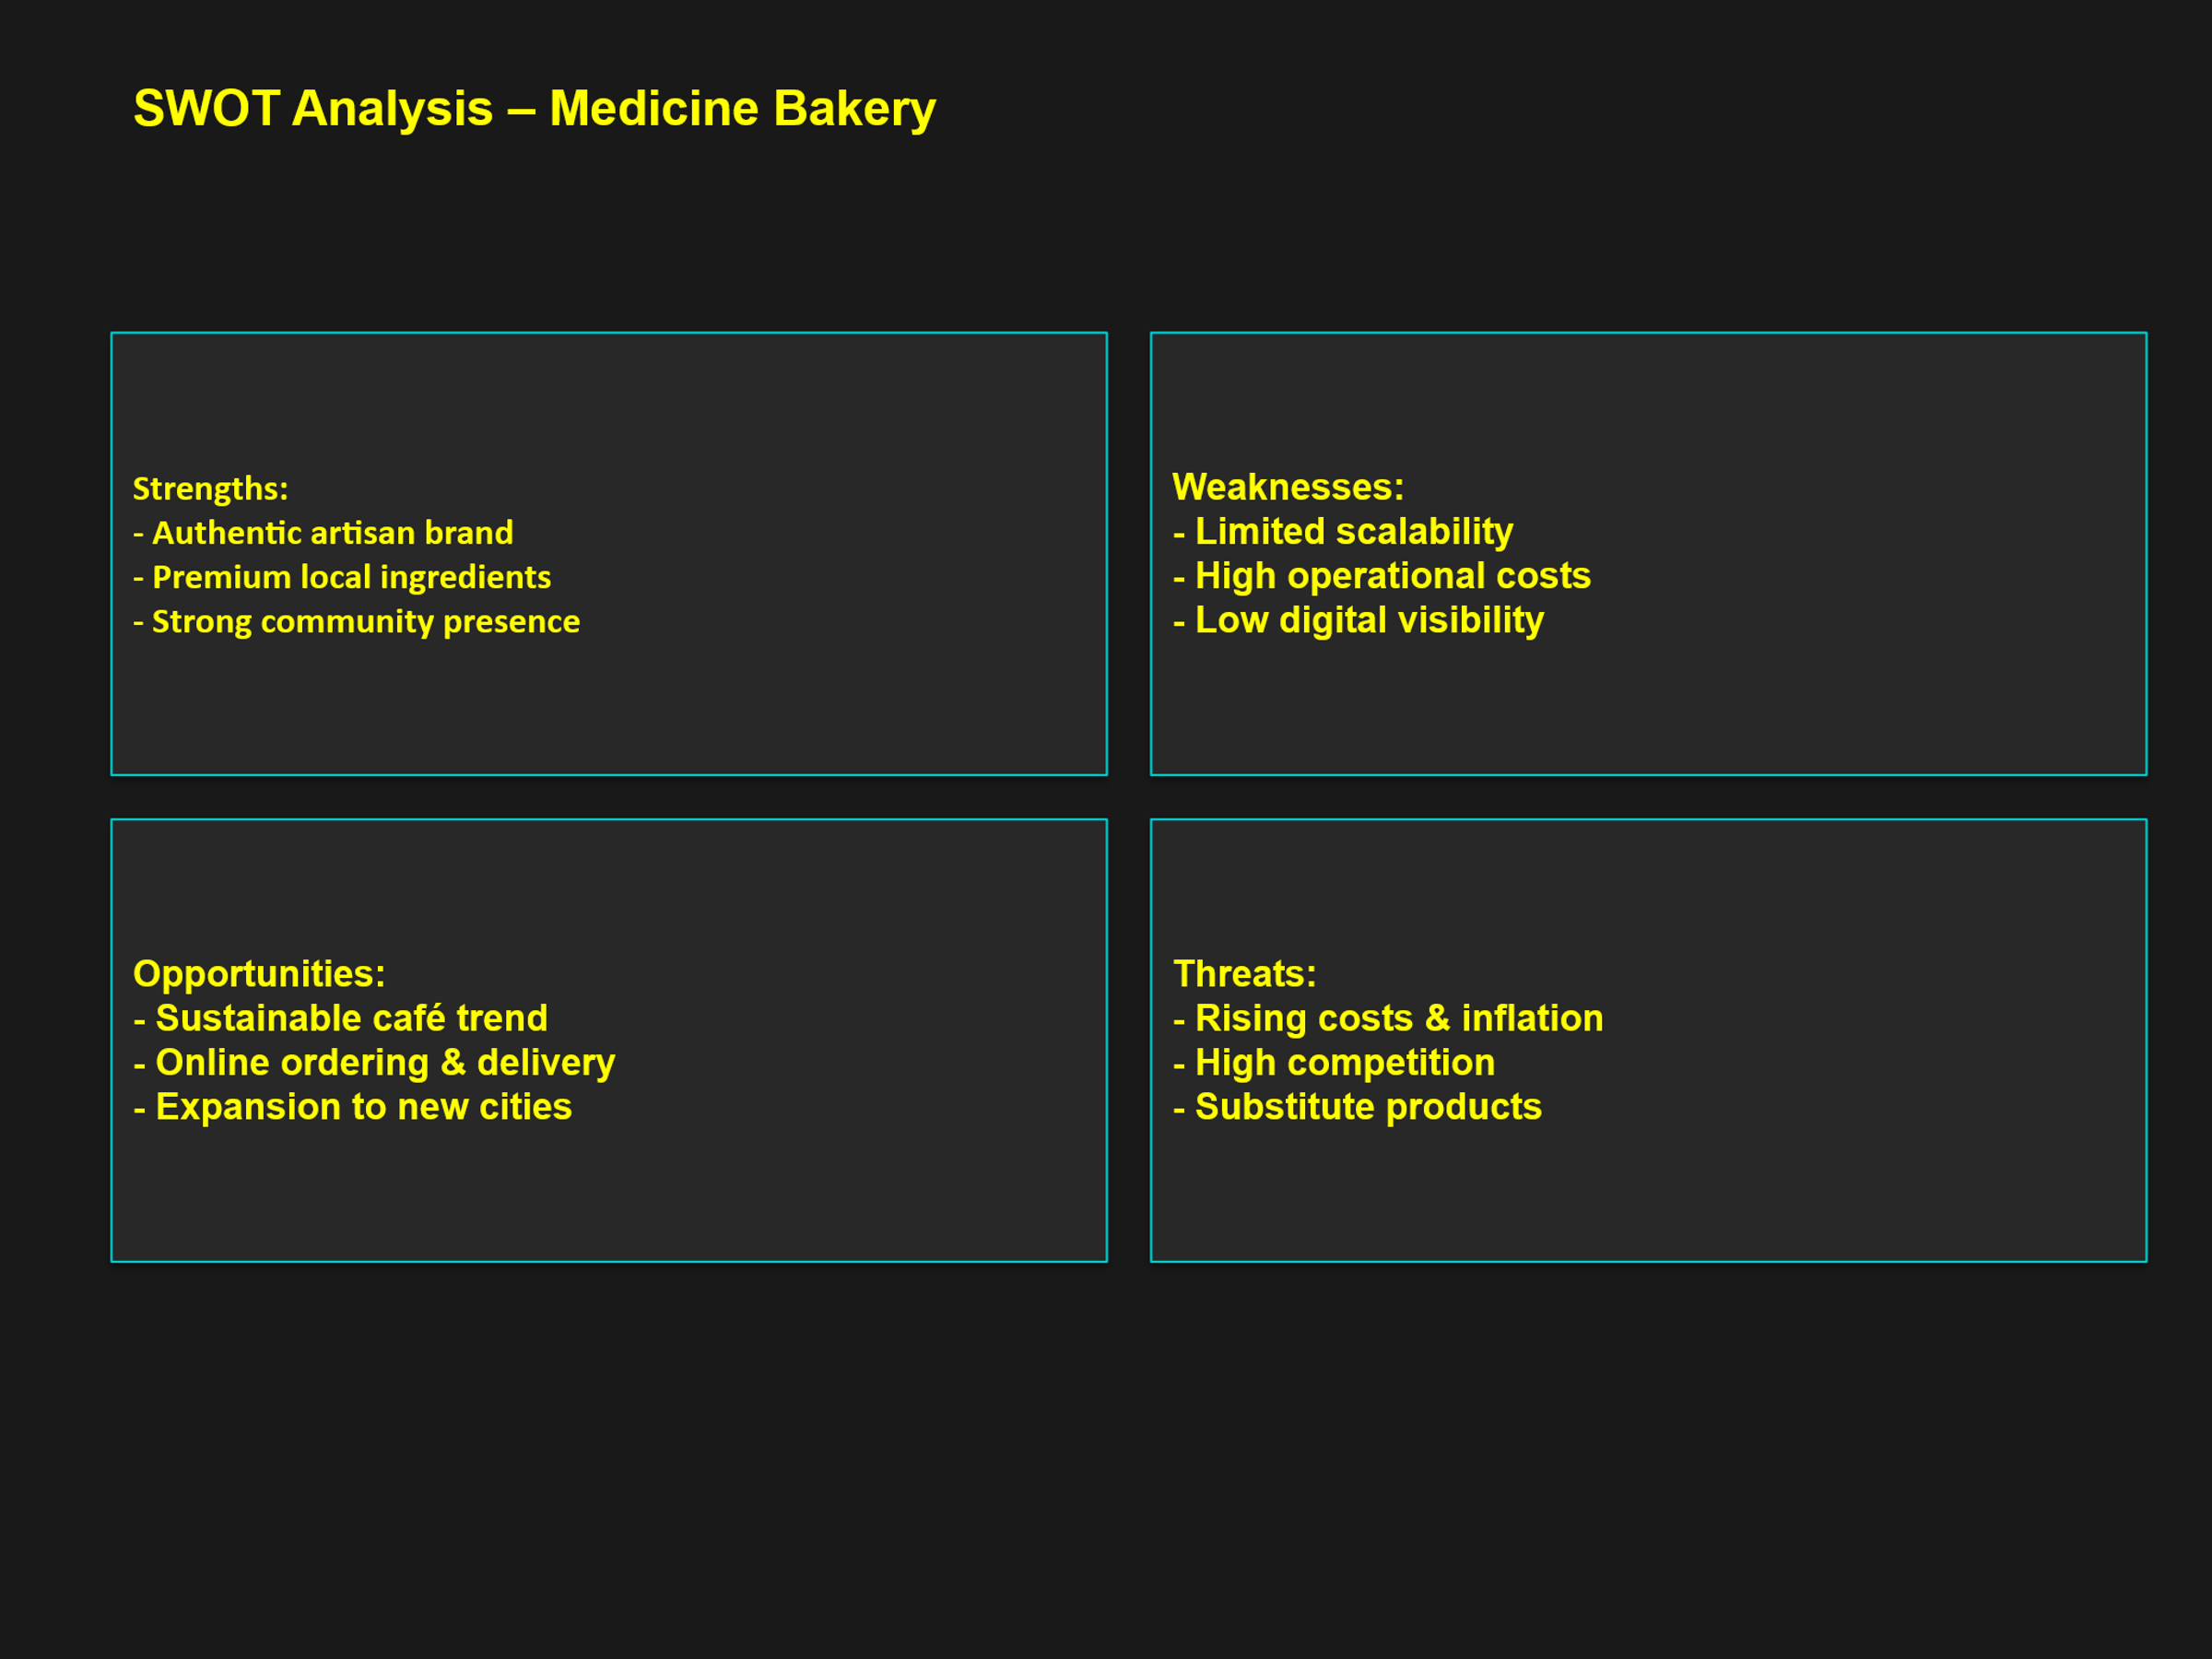
The Value Chain
Porter (1985) argues that value chain analysis helps companies find tasks that make their products more valuable and give them an edge over their rivals. The most important things that Medicine Bakery does are management and logistics for incoming goods. To make sure the food is fresh and to support local farmers, the company gets high-quality goods grown nearby. The fact that it is baked and prepared by hand in-house gives it a unique value. The teams that work on outgoing logistics and customer service are directly with customers. They create a warm and sensual experience with their café-style decor and customer-focused approach.
Buying things, handling people, and making new technologies are all very important support tasks that help the business stay open for a long time. Medicine Bakery has spent money to train its workers and keep its goods in an honest way. But it might be even more efficient if inventory and online shopping systems are linked together (Chaffey and White, 2022). If the company works to improve its digital infrastructure, it will run more easily and grow in a way that is good for the air.
PESTEL analysis
The cost of running a business and the process of importing speciality foods are both affected by politics. These include the UK's food rules, the changes to trade after Brexit, and local company taxes.
High inflation, energy prices, and problems with the supply chain are all economic factors that make it more expensive to make things and leave less room for profit (ONS, 2024).
People care more about honesty, quality, and sustainability these days, which is good for Medicine Bakery's reputation as an honest, community-focused company (Mintel, 2024).
New digital payment systems, mobile apps, and social media marketing make it easier to connect with customers and make more sales online.
Concerns for the environment: In today's café business, customers expect things like eco-friendly materials, recyclable packaging, and less trash. Even though Medicine Bakery already uses eco-friendly methods, it could make a bigger difference if it kept track of its carbon footprint (Bocken et al., 2019).
Legal issues: It's very important to follow the rules for food safety, job law, and data protection (GDPR) to keep your good name and avoid fines.
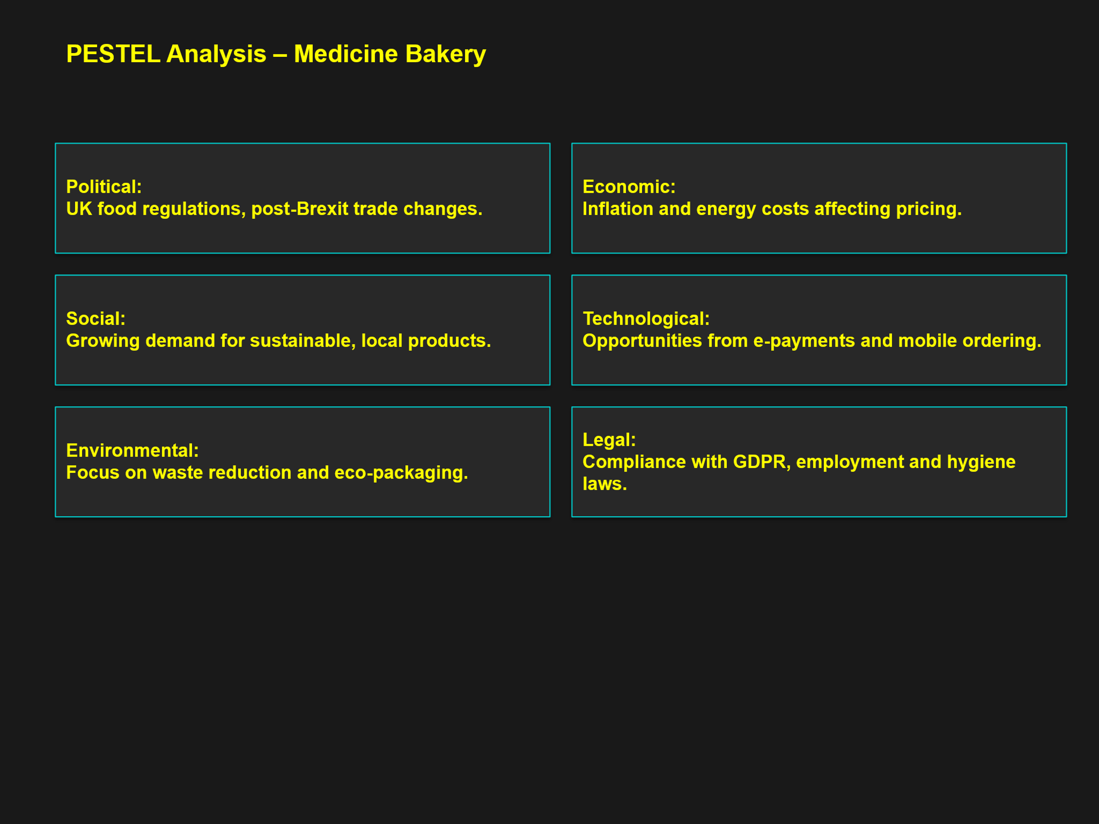
Porter's Five Forces
According to Porter (1980), five competitive forces determine how desirable a business is. Medicine Bakery has a lot of competition because there are many bakeries and cafés that want the same customers. It's not a big deal when new people come in because it's easy to get in and hard to stand out and make a good name for yourself. Because they depend on local makers, suppliers don't have a lot of negotiating power because of inflation. Because buyers can easily move from one café to another, they have a lot of negotiating power.
Finally, there is still a strong threat of replacements like grocery store bakers and home baking, but Medicine Bakery's high-end brand image and unique experience make this less of a worry.
Overall, the environmental scan shows that Medicine Bakery's strengths and practices that are good for the environment are a good match for options outside the company. In the long run, though, staying successful still means coming up with new digital ideas and keeping costs low.
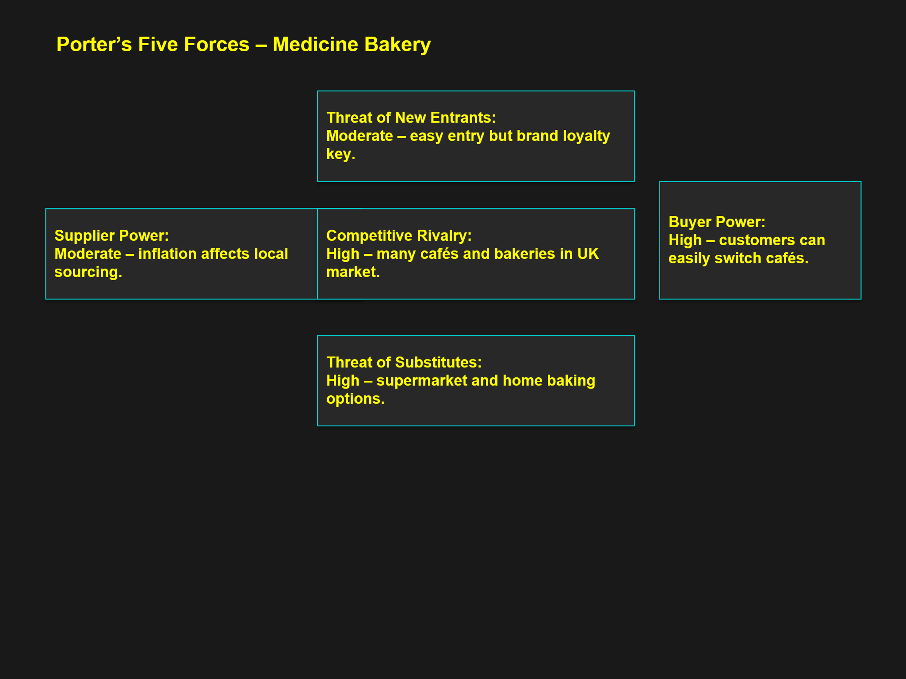

STRATEGIC GROWTH CHOICES AND SUSTAINABLE STRATEGY PROPOSAL
To stay ahead of the competition in the UK café market, Medicine Bakery needs to find ways to be different while also using new technology. You can make your small business stand out from the rest by not just giving lower prices, but also better quality, design, and customer service. This way helps brands connect emotionally with customers and keep their loyalty over time, even when the market is already full (Kotler and Keller, 2022). Medicine Bakery has a unique place in the market because it stays true to itself, makes high-quality goods, and creates a craft atmosphere.
If the company wants to grow in a way that lasts, it should use market and product growth strategies that work with the Ansoff Matrix.
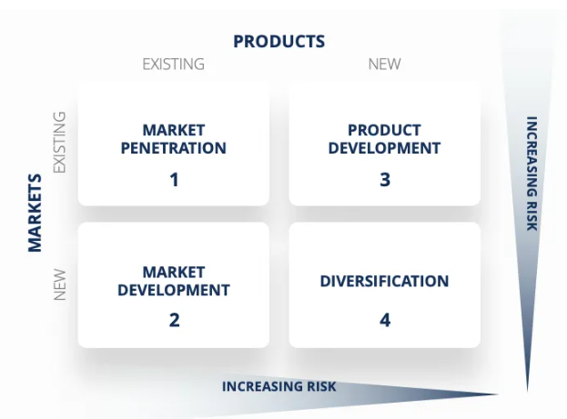
Image 1: Peterdy, (no date)
This matrix helps Medicine Bakery grow its customer base by letting it send its goods online to places besides Birmingham, Wolverhampton, and Codsall. They also make new goods by adding vegan, seasonal, and allergen-free options. These ideas help the business grow without losing its crafty feel, and they also help it reach more customers.The business can get its name out there in new places and make more money from other sources with this plan (Johnson, Whittington, and Scholes, 2020). Product development, on the other hand, is all about adding more allergen- and plant-free options to the menu to meet the UK's growing demand for food choices that are both healthy and accessible.
Digital development is also important for long-term growth. By adding digital loyalty programs, mobile ordering, and customer data analysis, business would run more easily and be able to tailor its marketing (Laudon and Laudon, 2020). By using technology that fits with its craft brand, Medicine Bakery can change how it talks to customers without giving up on its core values.
How to be sustainable is also, a big challenge. The company has a better image because it buys food in an ethical way, wastes less food, and has equipment that uses less energy. This proves the business is run honestly. In the long run, businesses that care about the environment and people tend to have more loyal customers and make more money (Hill, Jones, and Schilling, 2017).
Finally, Medicine Bakery can make sure its growth lasts by blending uniqueness with digital and product innovation. This approach strikes a good balance between bringing the brand up to date and keeping its history alive. It shows that the company values quality work and gets it ready to be strong in a market that is getting tougher.
STAKEHOLDER ANALYSIS AND EVALUATION
It's important for Medicine Bakery to keep its good name, run its business well, and grow in a way that will last. There are people or groups called stakeholders who have a say in or are affected by the strategic decisions that a business makes. Freeman (2010) argues that for a company to do well and stay stable over time, it must know what all of its stakeholders want and figure out how to give it to them.
The Mendelow’s Matrix can help the company to figure out who clients are and which ones are the most important. Four groups are made: high power/high interest, high power/low interest, low power/high interest, and low power/low interest. This helps the company figure out the best ways to get people engaged.
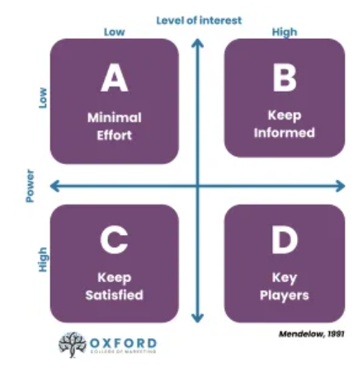
Image 2: Oxford College of Marketing, (no date).
The high power/high interest group is made up of owners and top managers. Their job is to decide on strategy, how to use resources, and growth plans for the future. They make a direct difference because they are in charge of running the business, keeping it financially stable, and keeping the brand's reputation safe. They need to report often and make clear decisions if they want to keep their support.
They are in the group of people with high interest and low power. Even though they play a big role in service quality, customer happiness, and running the business smoothly, they don't have a lot of decision-making power. A company can encourage its workers to stay with the business and do more work by giving them fair pay, training, and good ways to talk to each other. Kew and Stredwick (2017) say that when workers get along, they work better together and leave less often, especially in service businesses.
The customer is interested, but not very strong. Their feedback and the things they buy have a direct effect on your image and profits. The company can keep this group interested by always giving good service, making new items, and doing business in an honest way. You can keep customers by giving them better digital experiences and reward schemes.
Stakeholders include suppliers and neighbourhood partners. They have a lot of power but not much interest. They affect the availability of things and the stability of prices through how much they cost and how reliable they are. Quality and quantity stay steady when you sign long-term contracts. Contracts that are clear and ethical sourcing help to keep confidence and the environment (Crane and Matten, 2016).
The last group is made up of people with little power or interest: officials and local governments. It's not always clear how they work, but how people see them shapes how real a brand is. When a business helps local projects and follows the law, it has a better social license to operate (Daft, 2021).
Overall, Medicine Bakery can use Mendelow's Matrix to help them decide how to best communicate with and share resources with their most important partners. Open communication, accountable management, and ongoing involvement all help a business stay in business and keep stakeholders happy.
STRATEGIC RECOMMENDATIONS FOR FUTURE DEVELOPMENT AND IMPLEMENTATION
Small businesses like Medicine Bakery have trouble staying in business, handling their money, and developing leaders. They also have trouble coming up with new ideas. The company needs to take smart steps that balance its desire to grow with its ability to deal with problems in order to stay competitive in the UK café market, which is always changing.
1.Investment efficiency and financial management
Small and medium-sized businesses (SMEs) often can't grow or update because they can't get the money they need (OECD, no date). In order to grow over the long term, Medicine Bakery can look into hybrid financing choices like small business grants, community investment partnerships, or loans with low interest rates. Putting in place tools to track costs every month and cash flow reports every three months would help people understand their budgets better and make smart investment decisions.
2. Workforce empowerment and leadership development
To be successful, small businesses need strong leadership and workers who are interested in their jobs (Storey, 2016). Medicine Bakery might help people become better leaders by teaching them how to use technology, run a business in a way that doesn't harm the environment, and talk to people. A culture of responsibility and new ideas grows when people make choices and work together across roles. Employees would be more dedicated if they met with the team regularly and got feedback. This would also make sure that service is the same at all branches.
3. Sustainable and innovation operations
Gov.uk (2025) states that innovation is a key part of making sure that small and medium-sized businesses (SMEs) can adapt and follow the times. When Medicine Bakery thinks about digital innovation, they should make an all-in-one online buying system, loyalty apps, and data-based sales forecasts. For the same reason, the company could improve its image as being eco-friendly by buying goods from nearby farms, wasting less food, and using recyclable packaging. This would bring in people who care about doing the right thing.
Medicine Bakery may be able to grow and stay strong for a long time if they combine good money management, leadership growth, and long-term new ideas.
CONCLUSION
Medicine Bakery's study shows that to be successful in the long run, it needs to stay true to itself while also being open to new technologies and caring about the environment. There is a good chance that the company will stand out in a busy market because of its strong brand recognition, focus on high-quality handcrafted goods, and community involvement. But limitations on growth and lack of digital exposure are still big issues that need to be fixed with technology and smart management.
Adding digital reward programs, online shopping, and online delivery will help you connect with more customers and do a better job of keeping in touch with them. At the same time, the company supports the growing trend of ethical shopping in the UK by boosting eco-friendly practices such as using local materials, packaging that can be recycled, and processes that use less energy. Medicine Bakery might be able to make money and do good at the same time by mixing these programs with smart money management and leadership that includes everyone.
For long-term success, it needs to be constant innovation, collaboration with partners, and the ability to keep running even when things go wrong. By combining traditional craftsmanship with digital change and sustainability, Medicine Bakery could stay an example of how small businesses and hotels in the UK can grow in a way that doesn't harm the environment.

REFERENCES
Bocken, N., Short, S., Rana, P. and Evans, S. ,(2019). Sustainable Business Models: Organising for Innovation and Impact. London: Routledge.
Chaffey, D. and White, G. ,(2022). Digital Business and E-Commerce Management, 7th ed. Harlow: Pearson.
Crane, A. and Matten, D. ,(2016). Business Ethics: Managing Corporate Citizenship and Sustainability in the Age of Globalization, 4th ed. Oxford: Oxford University Press.
Daft, R.L. (2021) Management, 14th edn. Boston: Cengage Learning.
Freeman, R.E. ,(2010). Strategic Management: A Stakeholder Approach. Cambridge: Cambridge University Press.
Gov.uk,(2025). SME Digital Adoption Taskforce: final report.Available at: https://www.gov.uk/government/publications/sme-digital-adoption-taskforce-final-report. (accessed: 12/10/2025).
Hill, C., Jones, G. and Schilling, M.,(2017). Strategic Management: Theory – An Integrated Approach. 12th ed. Boston: Cengage Learning.
IBISWorld,(2025).Cafes and Coffee Shops in the UK - Market Research Report (2015-2030).Available at: https://www.ibisworld.com/united-kingdom/industry/cafes-coffee-shops/6242/. (accessed: 11/10/2025).
Johnson, G., Whittington, R. and Scholes, K. (2020) Exploring Strategy, 12th ed. Harlow: Pearson.
Kew, J. and Stredwick, J. ,(2017). Business Environment: Managing in a Strategic Context, 3rd ed. London: CIPD Publishing.
Kotler, P. and Keller, K.L. ,(2022). Marketing Management, 16th ed. Harlow: Pearson.
Laudon, K.C. and Laudon, J.P. ,(2020). Management Information Systems: Managing the Digital Firm, 16th ed. Harlow: Pearson.
Medicine, (no date). About us. Available at: About us - Medicine Bakery + Kitchen, (accessed: 10/10/2025).
Mintel ,(2024). UK Cafés and Coffee Shops Market Report 2024. Available at: https://store.mintel.com/report/uk-coffee-shops-market-report. (Accessed: 10/10/2025).
OECD,(no date). OECD SME and Entrepreneurship Outlook. Available at: https://www.oecd.org/en/publications/serials/oecd-sme-and-entrepreneurship-outlook_11c3425f.html. (accessed: 12/10/2025).
Office for National Statistics (ONS),(2024). Consumer price inflation, UK: December 2024. Available at: https://www.ons.gov.uk/economy/inflationandpriceindices/bulletins/consumerpriceinflation/december2024. (accessed: 11/10/2025).
Oxford College of Marketing, (no date). What Is Mendelow’s Matrix And How Is It Useful? Available at: https://blog.oxfordcollegeofmarketing.com/2018/04/23/what-is-mendelows-matrix-and-how-is-it-useful/. (accessed: 11/10/2025).
Peterdy, K.,(no date). Available at: https://corporatefinanceinstitute.com/resources/management/ansoff-matrix/. (accessed: 11/10/2025).
Porter, M.E. (1980) Competitive Strategy: Techniques for Analysing Industries and Competitors. New York: Free Press.
Porter, M.E. ,(1985). Competitive Advantage: Creating and Sustaining Superior Performance. New York: Free Press.
Storey, D.J. ,(2016). Understanding the Small Business Sector. London: Routledge.

