LCLM6003 – Leading and Implementing Change

Strategic Change Management at Volkswagen AG:
Leading Digitalisation for Innovation, Platform Coherence, and Organisational Performance

Student: Andrei Valentin Gavrila
Student ID: 2311201
Word count: 4008

Executive Summary

This report lays out a strategic change management approach for Volkswagen AG as it responds to the rapidly accelerating digitalisation of the global automotive sector. With competition from software-based entrants, traditional customers experiencing growing expectations for effective digital journeys, the push to software defined vehicles; fundamentally even smaller manufacturing businesses are experiencing sky pier awards of value across design, manufacturing, sales, and aftersales services. Our [analysis go on] to show how legacy IT architectures, multi-brand governance, and organisational inertia keep VW from achieving its digital future - though it invests heavily in #industry4.0, #platformisation, and #data driven.
The report assesses the usefulness of different change management models and claims linear approaches fall short in contexts of ongoing digital transformation. There are five key components of effective change: leadership mobilisation, alignment of strategy to operating model, workforce adoption, and dynamic capability building. The biggest enabler of digital is leadership style and culture. Transformational, adaptive and ambidextrous leadership behaviours, supported by a learning culture and psychological safety, are needed to institutionalise agile ways of working and platform governance at scale.
A structured digital change management plan is proposed to facilitate Volkswagen AG’s digital transformation with clearly defined objectives, investment drivers, communication channels, and KPIs tracking senior management with project leaders quarterly. Implemented, Volkswagen can increase innovation speed and operational performance, creating seamless digital experiences across brands while improving governance, cybersecurity and trust in data across a software-driven automotive universe.

Contents

1. Introduction to Volkswagen AG 4
2. Analysis of Recent History and Digitalisation Impacts 5
3. Evaluation of Change Management Models and Strategic Change 9
4. Leadership Style and Organisational Culture in Managing Digital Change 15
5. Proposed Digital Change Management Plan 18
6. Conclusion 22
References 23

1. Introduction to Volkswagen AG

Volkswagen AG (VW) is a multi-brand automotive group including Volkswagen Passenger Cars, Audi, Škoda, SEAT/CUPRA, Porsche, and commercial vehicle businesses that is competing in a rapidly changing world, faced with requirements for electrification, connectivity, data driven services, and new mobility business models. Digitalisation thus becomes a strategic capability rather than a mere support function influencing vehicle design and development, production processes, how the vehicles are sold, and vehicles’ updates across their life (Bharadwaj et al., 2013; Hess et al., 2016).
For VW, [digitalisation] goes beyond the outward-facing face into smart manufacturing, integrated supply chains, software-defined vehicles and platform-based. VW’s increasingly, they need [to be onboard] the ability to automate, and to have 4.0-style capabilities, things like IoT, cyber-physical systems, real-time. Those improvements in productivity and quality and responsiveness that Industry 4.0 technologies promise. If you think about that, it makes sense. Simultaneously, you see the digital customer journeys and the obviously sort of omnichannel expectations now, too, and the ability to configure products quickly, finance them quickly, deliver them, and so on (Verhoef et al., 2021).
However, large, complex organisations like VW face significant challenges in executing digital transformation at scale; legacy IT, siloed structures, cultural resistance, skills and software-data capability gaps and difficulty in aligning governance across brands and regions (Kane et al., 2015; Westerman, Bonnet&McAfee, 2014). The endgame for the Change Manager is to formulate a change plan that increases VW’s digital maturity—“the extent to which an organization aligns its strategy, people, and processes with digital technologies” - so that VW improves innovation outcomes and organisational performance, while fulfilling the Group’s overall ambitions in a software- and data-intensive automotive ecosystem (Vial, 2019; Sebastian et al., 2017).

2. Analysis of Recent History and Digitalisation Impacts

Over the last decade, Volkswagen AG (VW) has navigated an automotive landscape facing disruptive change from digitalisation, electrification, connectivity and platform-based business models, with the balance of power shifting as tech companies and digitally native entrants launch software-enabled vehicles, over-the-air updates and data-driven services against a backdrop of historically manufacturing-led competition (Bharadwaj et al., 2013; Verhoef et al., 2021). In line with this, VW have set out a transition toward becoming a “software-driven mobility provider” (Volkswagen, 2021) having realised that digital capabilities would be fundamental to future competitiveness.
Industry 4.0 has transformed automotive manufacturing by cyber-physical systems, IoT-enabled production lines, and real-time data analytics of production. Smart factories allow for predictive maintenance, quality monitoring and flexible production scheduling, improving productivity and time-to-market (Kagermann, Wahlster and Helbig, 2013; Lasi et al., 2014).
VW’s size and footprint also present challenges; even while digital technologies can standardise platforms and enable economies of scope, legacy plants, heterogeneous IT landscapes and long asset lifecycles slow transformation (Hess et al., 2016). The integration of digital twins and data platforms can improve productivity, but uneven digital maturity across sites may compromise overall performance improvements.
Consumer expectations for effortless digital journeys through configuration, financing, ordering, and post-sale services have increased. Omnichannel experiences and software-defined features (subscriptions, updates) will increasingly become competitive differentiators (Verhoef et al., 2021; Sebastian et al., 2017). VW’s dealer-centric business model will also need to integrate digital channels without alienating its partners, leading to governance and change management issues.
Finally, the shift to online-first touchpoints demands deeper software integration of CRM, vehicle telemetry and service tools—a limited wringing-out of capabilities that are often complex to implement in legacy architectures and at risk of data-siloing (Kane et al., 2015; Westerman et al., 2014).
The automotive value chain is becoming increasingly platforms-based across software, cloud services, charging and mobility platforms. Dynamic capabilities - sensing of digital opportunities, seizing them through investment, and transforming of organisational assets - are critical when competing against software-focused players (Teece, 2014). For VW, creating in-house software capabilities and achieving coherence in governance across the brands is necessary but hard.
As coordination costs rise with scale and brand autonomy, so does the challenge of standardising digital platforms and architectures (Sebastian et al., 2017). Without platform coherence there is a risk of redundancy, long lead times to deploy products and services, and variety in experiences delivered to customers.
Digitalisation increases vulnerability to cybersecurity risks and data protection requirements. The connectivity of vehicles involves the generation of vast quantities of data, creating issues of governance, privacy, and compliance. As such, digital transformation will take place only where strong data governance systems, secure architectures, and organisational accountability are implemented (Kane et al., 2015). Regulations related to software safety and data protection and sustainability reporting complicate VW’s transformation agenda, which requires cross-functional coordination between IT, legal, compliance, and operations (Hess et al., 2016).
Big companies are laden with culture and history that slow their progress in going from product-centric engineering to software-centric digital products. Research into digital maturity points out that becoming more mature means changing the behaviours of leaders, ways of working and talent models, to say nothing of decision rights, not merely spending on technology (Westerman et al. 2014, Kane et al. 2015).
VW’s brand portfolio and the matrix structures that result make quick all-enshrouding decisions a problem. Silo-ed incentives and performance measures may make abstract the longer-term software capability building, even in the face of changes to culture, thereby slowing overall velocity of innovation (Sebastian et al. 2017).
Digital supply chains rely on analytics and real-time visibility to enhance resilience as well as coordination. Platform-based integration with suppliers and logistics partners improves forecasting accuracy as well as sensitivity to shocks (Verhoef et al., 2021). However, heterogeneous systems across suppliers and regions compromise end-to-end visibility, and for VW, expanding digital supply chain capabilities requires common standards, data interoperability, and governance mechanisms that local responsiveness (Hess et al., 2016).
Taken together, these forces illustrate how digitalisation at VW is more than just a product or technical change but typically a far wider change challenge embracing products, processes, platforms, culture and governance. The risk of a piecemeal change is a patchy customer experience, slower than market innovation and partly realised benefits from digital investments.
The opportunity is software defined differentiation, quicker penetration into the market, operational excellence through smart factories, data led revenues and so on. All of which points to the merits of a properly structured strategic change programme to align leadership, culture, operating model and technology architecture to drive VW’s digital DNA and business performance (Vial, 2019).
Alongside product, platform, and manufacturing digitalisation, this transformation also has ramifications for organisational design, partnerships, and performance management. As software and data become central to value creation, previously coherent functional structures (around engineering, production, and sales) become increasingly inefficient to coordinate. Digital work requires that “agile product teams, cross-functional”, develop products integrating software development, UX, cybersecurity, data analytics, and operations. The move to product-centric operating models disrupts existing governance and role clarity, as well as performance metrics, causing tension between legacy functions and agile teams (Sebastian et al., 2017; Verhoef et al., 2021).
Digitalisation reshapes partnerships and ecosystem(s) as well. Use of partnerships with cloud providers, software vendors, and platform partners (auto firms as partners), to lower costs and access scarce digital talent. Faster on the uptake but more dependent anytime/hat’s run by other people. Need to negotiate ownership of IP generated. Data and its owners, and making sure partners [external and internal] can play nicely together. Should VW AG develop platforms all in-house or build capabilities internally but partner with other firms on platforms.
Avoid vendor lock-in with those you partner with. Own the platform (Gawer and Cusumano, 2014) as well as be able to negotiate terms of access with other users when it comes to the service-based architecture established by use of ‘APIs', "Control of the interfaces themselves allows a firm to • coordinate the activities of internal teams and external partners, • preserve its flux of design and development, whereas the lack of an effective platform governance mechanism can restrict design partners’ and downstream entrepreneurs’ participation." (Nambisan et al., 2017).
Digitalisation impacts how performance is measured and managed: automotive KPIs focus on volume, quality defects and unit cost; digital businesses need KPIs around release frequency, platform adoption, customer digital engagement, data quality, and so on (Hess et al., 2016; Kane et al., 2015). If incentives and KPIs do not align to digital outcomes, organisations will chronically under-invest in platform coherence and software quality, creating fragmented digital endpoints and longer innovation cycles. Leaders must therefore adapt performance management systems to reward cross-brand collaboration, reuse, and improvement in software delivery.
Finally, digitalisation transforms workforce expectations and employee experience. Software talent craves autonomy, modern tooling, and agility. This clashes with the hierarchy itself, and bureaucracy around decisions, typical of any big and traditional manufacturing firms. Volkswagen AG wants to attract and retain digital talent, it needs to create attractive tech careers, modern engineering practices, and cultural norms around learning and experimentation. Else they risk all digital initiatives stalling through lack of talent, and poor adoption (cutting away efforts from the actual transformation agenda) (Edmondson, 2018; Westerman et al., 2014).

3. Evaluation of Change Management Models and Strategic Change

Strategic change at VW AG in the face of digitalisation. VW is undergoing a continuous state of change rather than discrete digital transformation projects like app and website upgrade projects. Various change models help structure VW’s digital transformation journey, aligning actors to create a digital ecosystem, and managing risks associated with legacy systems, silos and inertia (Hess et al. 2016, Westerman et al. 2014).
Kotter’s Eight-Step Model most supports VW’s plan to create the urgency they need, build a coalition and a cross-brand platform, articulate a vision and enable action and anchor change in culture. Every brand and region in VW needs a compelling vision of digitalisation, all brands need to create a different kind of coalition when platform-level standardisation means they all must go in the same direction, and, in the shortest of terms they will regularly show there can be “short-term wins” through agile releases of new software and through running pilot “digital factories”. None of Kotter’s leadership steps alone describe the ideal approach to a widely distributed and agile job: such as digitalisation where the benefits of intensive engagement can occur thanks to iterative development sprints that release in continuous deployment. In digital the experience points to, “cyclical learning loops rather than one-off change programmes” (Kane et al., 2015; Sebastian et al., 2017).

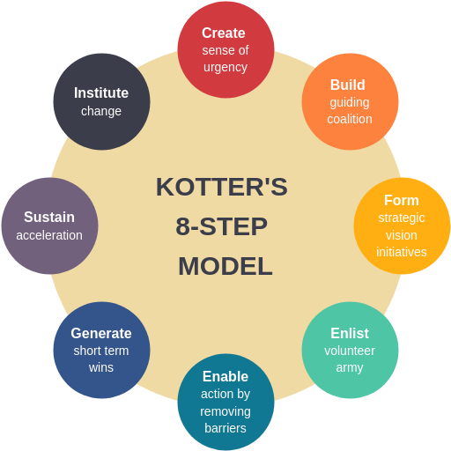
Lewin’s Three-Stage Model (unfreeze–change–refreeze) helps make sense of the incremental nature of organisational change by highlighting the need to disrupt existing routines before implementing new practices and rooting them within the organisation’s norms. In VW’s case, “unfreezing” involves breaking down product-centric engineering mindsets and waterfall development approaches in favour of agile software-first ones. Critics question “refreezing” in digital contexts, arguing that organisations can never settle down, and must focus on dynamic capabilities and continuous adaptability (Teece, 2014; Vial, 2019). For VW, this suggests that digitalisation requires an ongoing capability-building initiative rather than a time-constrained programme.

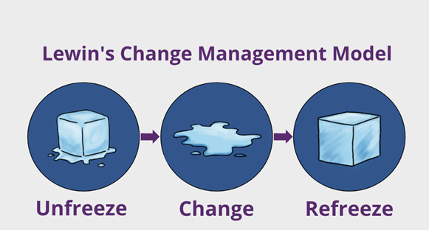
The McKinsey 7S Framework is used to diagnose organization alignment across strategy, structure, systems, skills, staff, style, and shared values. In relation to VW, the 7S approach highlights a fairly common type of misalignment in digital transformation - the strategy emphasises platformisation, systems are fragmented, skills in software and data lack behind the strategy, and leadership style does not embrace agile methods of working. The 7S model is useful in a diagnostic context, but less so prescriptively; it provides limited help with sequencing or leading change in an agile environment like a fast-moving digital transformation (Hess et al., 2016).

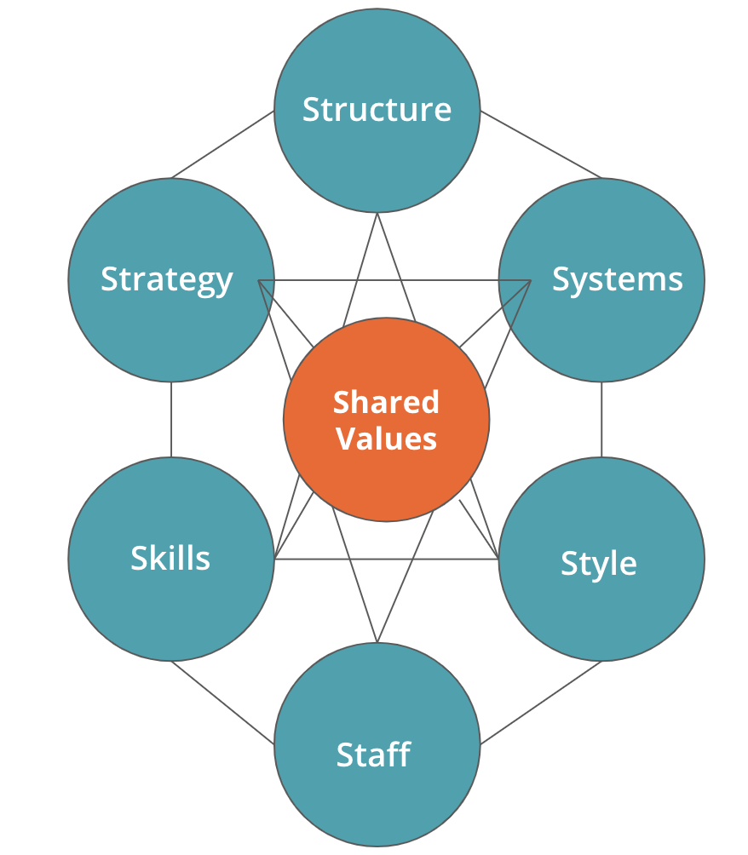

ADKAR puts the emphasis on the readiness of individuals to change (awareness, desire, knowledge, ability, reinforcement). In many large organisations, such as VW, employees’ uptake of digital tools (agile methods, data platforms, etc.) have been a significant bottleneck to progress. Although ADKAR helps to formalise the mechanisms for developing and reinforcing capabilities, and should lead to effective outcomes will only work if it is accompanied by significant redesign of work organisation and changes in the governance of the relations of production, to deal with the structural impediments to digital scale (Kane et al., 2015).

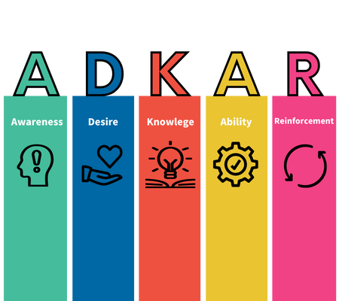
Digital transformation literature stresses ambidextrous change: exploiting operational excellence while also exploring new digital business models. Teece’s dynamic capabilities framework highlights the need to sense digital opportunities, seize them through investment and transform organisational assets (Teece, 2014). For VW, this implies doing both, maintaining manufacturing excellence and software platform development — in some cases operating two separate models for digital exploration (through digital units) and exploitation (through their core manufacturing and sales operations). Digital units can easily become disconnected from their core unless they are connected by strong governance and shared digital architecture. (Sebastian et al., 2017)
Successful digital transformation involves not just tools but also decisions about rights, funding, and ownership. These changes are related to governance of platforms—platform governance (i.e. standardize architecture, allow local innovation—but what do you standardize?), discussed in the FAQs for the VW case, and to complicate matters, VW has many brands and brands are invest $ in a big way. Enabling coordinated topline metrics for digital value realization, and metrics across brands that would allow do that are hard to generate and enforce when execution is decentralized. Stage-gate style governance works against speed; agile portfolio, project/centres of funding/ownership are better aligned with ongoing digital delivery (Hess et al., 2016).
VW end up concluding that no single model is sufficient, and that they are going to have to take a hybrid change approach to achieve their ambitions. “To make the change stick we need Kotter, for leadership mobilization and shipping urgency, 7S for systems alignment and transparency about trade-offs, ADKAR for across-the-board adoption of the change, and dynamic capabilities to make sure that we continue the evolution of the digital revolution” (HBR, 2021). The main reason is to overcome the limitations of a linear change context in the messy digital realm and get leaders, culture, operating model and tech architecture aligned to achieve lasting digitalisation at scale going forward (Bharadwaj et al., 2013; Vial, 2019).

4. Leadership Style and Organisational Culture in Managing Digital Change

Leadership and organisational culture are critical enabling factors in VW’s digital transformation journey. Digitalisation not only demands the capabilities and tools enabled by technology, but also requires a change in the leadership behaviours, decision-making structures and cultural attitudes that inform how employees adopt new ways of working (Westerman, Bonnet and McAfee, 2014; Kane et al., 2015). In automotive firms re-engineering from product-focused engineering to software-defined mobility, leadership must solve the complementarity of operational discipline with agility and experimentation found in digital organisations.
Transformational leadership is particularly important in digital contexts. It rallies employees around an inspiring digital vision and legitimises experimentation and learning. Leaders who convince employees of the importance of software platforms, service-based data, and customer journeys can frame digitalisation as a source of value rather than disruption (Hess et al., 2016). At VW, transformational behaviours - vision-setting, intellectual stimulation, and empowerment - are essential to changing legacy mindsets and bringing diverse brands around a common digital architecture. Digital transformation also requires adaptive leadership: leaders need to navigate the uncertainty intrinsic to digital; make devastating trade-offs in the face of future uncertainty; and support iterative learning cycles. This contrasts with traditional hierarchical leadership structures developed for stable, predictable routines.
VW’s digital agenda requires leaders capable of ambidextrous behaviour: concurrently optimising core manufacturing operations for electrified drivetrains while also enabling exploration of software platforms and digital services. Research into organisational ambidexterity suggests that leaders must create structural separation for digital innovation—such as dedicated digital units—but also “robust integrations” to scale innovations across the enterprise (O’Reilly&Tushman, 2016). Without strong integration, digital initiatives risk remaining isolated pilots. Effective leaders create shared digital platforms, enterprise architectures, and cross-brand governance to convert local innovation into group performance (Sebastian et al., 2017).
Organisational culture mediates how leadership intent shapes digital outcomes. Cultures promoting learning, transparency, and psychological safety empower employees to experiment with new tools, share data from new places, and question legacy behaviours (Edmondson, 2018). Cultures which blame individuals stifle innovation and delay digitalisation. For VW, fostering a learning-oriented culture will enable agile workflows, continuous integration, and rapid feedback loops—key capabilities for software defined vehicles and platform ecosystems (Verhoef et al., 2021). Leaders shape culture by exemplifying digital behaviours (eg data-informed risk taking), recognising cross-functional collaboration, and legitimising iterative experimentation.
Digital transformation depends on attracting and cultivating software, data and product management capabilities. Leaders must demonstrate the importance of digital talent and reshape career trajectories, incentives, and learning systems to reinforce new agile roles and product ownership (Kane et al. 2015). Cultural frictions can arise from clashes between historic engineering identity and software-enabled practices, and leaders need to manage this identity transition actively, helping people to embrace cross-disciplinary collaboration and a greater sense of joint purpose around digital value creation (Hess et al. 2016).
Middle management are the individuals who take a strategy set at an executive level and translate it into change in operational practice, and the style of their leadership behaviour determines whether for example agile methods and digital platform standards are consistently applied across brands and plants. Investment in middle-management as product owners and change champions speeds the diffusion of digital, whilst command and control leadership will halt the clock for digital transformation (Westerman et al. 2014), investment in development for the leaders of the future in a digital age - agile governance, data literacy and platform thinking - enhances VW’s capacity to lead change.
Digitalisation creates additional governance challenges around data, cybersecurity, and AI. Credibility of leaders and external governance frameworks are needed for employees to trust and support whatever digital initiatives are planned (Kane et al., 2015; Executives struggle...). Accountability for using data, stewardship of data, and security increases the chance that whatever is declared on paper is trusted in practice by employees and other stakeholders; and, over time, reinforces the cultural reasons why everyone should want to take responsible risks.
In VW’s case, unless leaders (transformational, adaptive and ambidextrous) engender a culture of learning and psychological safety, then even major investments in digital platforms could easily under-deliver. With leaders, VW can unlock innovation faster, improve their overall organisational performance and compete headlong into its new automotive software- and data-centric ecosystem. (Bharadwaj et al., 2013; Vial, 2019).

5. Proposed Digital Change Management Plan

Seismic culture change plan for Volkswagen AG aims to accelerate Volkswagen AG’s digitalisation of products, manufacturing, and customer journeys with aligned leadership, operating model, and culture. The change hypothesis prioritises platform coherence, agile delivery, data governance, and workforce capability development to facilitate internalisation of higher velocity innovation and enhance organisational performance (Sebastian et al., 2017; Verhoef et al., 2021).
These strategic priorities are tangible manifestations of Volkswagen AG’s vision, with clear ownership and timelines for execution. Platform coherence aims to resolve fragmentation across brands by establishing a common set of APIs and architectures, enabling faster reuse of digital components and a more consistent experience for customers. Scaling agile software delivery reflects the need to embed product centric ways of working and establish faster release cycles to support software-defined vehicle capabilities. Smart manufacturing investments are about ensuring improvements in productivity and quality through data-driven optimisation, while data governance initiatives encompass compliance, cybersecurity, and enabling trust in connected services. Investing in talent and culture supports sustainable change through practices such as aligning leadership behaviours, incentives, and skills development with agile and data-driven operating models.

Table 1: Strategic Digital Change Objectives
Objective | Description | Timescale | Owner
Platform Coherence | Standardise group-wide digital platforms and APIs | 12–18 months | Group CIO
Software Delivery | Scale agile product teams and CI/CD pipelines | 9–12 months | CTO / Digital
Smart Manufacturing | Expand IoT, digital twins, predictive maintenance | 12–24 months | Head of Production
Data Governance | Implement group data standards and stewardship | 6–12 months | CDO
Talent&Culture | Upskill leaders and teams in agile&data literacy | 12 months | CHRO

The indicative budget invests in foundational digital capabilities that will drive widespread transformation, not localized pilots. Spending on cloud and platform modernization supports interoperability across brands and frees resources to pay down technical debt. An investment in DevOps toolchains makes releases more reliable—and enhances the release process overall. The smart factory programs create measurable operational improvements through predictive maintenance and a boost in OEE. In the carmaker space, investment in logical governance and security protects against rising risk through regulatory tightrope walking on customer and vehicle data. Committing budget to talent and change enablement recognizes that digital transformation is a people problem; investments in technology will not yield sustainable returns without skills being developed and the change being actually adopted.

Table 2: High-Level Financial Plan (Indicative)
Investment Area | Estimated Budget (€m) | Expected Benefit
Cloud&Platform Modernisation | 320 | Faster time-to-market, scalability
Software Toolchains (DevOps) | 95 | Release reliability, velocity
Smart Factory (IoT/Digital Twins) | 210 | OEE gains, downtime reduction
Data Governance&Security | 60 | Compliance, trust
Talent&Change Enablement | 45 | Adoption, skills depth
Total | 730 | Digital ROI, performance uplift

This communication plan seeks to maintain alignment across our different governance levels and operating units by targeting messages as required to stakeholder need and decision rights. By continuing the board reviews, we maintain strategic visibility and prioritisation of our digital investments and by continuing the leadership forums the company aligns consistent changes to operating model on how our brands engage with their consumers and how we govern our platforms, thus reducing duplication and reducing fragmentation of effort. And by continuing our communities of practice the company activates a peer learning and standardising of agile method and tooling to accelerate diffusion of best practice among our people. By consistently conducting the partner briefings the company helps ensure the dealer and ecosystem engagement that is critical for all and the omnichannel integration thus maintained for all fresh sales programs from strategic restructuring and beyond. Cadence and two-way pulses maintain transparency, build confidence, and thus strengthen the take up of our new digital ways of working.

Table 3: Communication&Engagement Plan
Audience | Message | Channel | Cadence
Board | Digital KPIs, platform progress | Exec reviews | Monthly
Leaders | Operating model&governance | Leadership forums | Monthly
Teams | Ways of working, tooling | Communities of practice | Fortnightly
Dealers/Partners | Omnichannel integration | Partner briefings | Quarterly

Evaluation frameworks tie these digital initiatives to deliverables that cross-firm stakeholders can own. Release frequency and cycle time reflect the velocity and responsiveness gains from improvements in software delivery. Platform adoption is a measure of standardisation and reuse across brands, the biggest source of scale economies from digital platforms. OEE reflects the operational benefits realized from smart manufacturing. Digital skills certification tracks the extent to which the organization is upskilling its workforce, a leading indicator of sustainable transformation. Together, these KPIs present portfolio-level governance, evidence-based prioritisation, and warning signals for remedial action should digital investments fail to deliver.

Table 4: Evaluation&KPIs
KPI | Measure | Target
Release Frequency | Deployments/month | +40% in 12 months
Platform Adoption | % brands on common APIs | 70% in 18 months
OEE (Factories) | Production uptime | +8–10%
Cycle Time | Lead time for changes | –30%
Digital Skills | Certification completion | 85%

6. Conclusion

This report derived a change plan for Volkswagen AG to address the multiple challenges related to the digitalisation of all aspects of products, manufacturing and customer journeys. Exploiting legacy IT, complex governance of multiple brands, and cultural inertia constrains velocity and coherence of innovation. Reviewed change models show that linear approaches are inadequate for continuous digital transformation, and VW should choose a hybrid plan that mobilises leaders, aligns priorities systemically, builds workforce adoption and dynamic capability.
Leadership style and organisational culture will be central to digital success. Transformational, adaptive, and ambidextrous leadership—empowered with a learning-oriented culture and psychological safety—fosters greater agility ways of working (agile platforms), platform governance and inter-brand collaboration. The plan proposes digital priorities, investment allocation, communication protocols and performance KPIs, as well as defining approaches for accelerating VW’s digital maturity and organisational performance. If implemented properly, the plan gives VW a significant advantage in the fast-evolving world of software-defined vehicles and applications, leveraging innovation speed, operational excellence and customer experience while also protecting for governance/cybersecurity/data trust.

References

Bharadwaj, A., El Sawy, O.A., Pavlou, P.A. and Venkatraman, N. (2013) ‘Digital business strategy: Toward a next generation of insights’, MIS Quarterly, 37(2), pp. 471–482.
Brennen, J.S. and Kreiss, D. (2016) ‘Digitalization’, in Jensen, K.B., Rothenbuhler, E.W., Pooley, J.D. and Craig, R.T. (eds.) The International Encyclopedia of Communication Theory and Philosophy. Chichester: Wiley, pp. 1–11.
Davenport, T.H. and Redman, T.C. (2020) ‘Digital transformation comes down to talent in 4 key areas’, Harvard Business Review, 98(3), pp. 26–29.
Edmondson, A.C. (2018) The Fearless Organization. Hoboken, NJ: Wiley.
Fitzgerald, M., Kruschwitz, N., Bonnet, D. and Welch, M. (2014) ‘Embracing digital technology: A new strategic imperative’, MIT Sloan Management Review, 55(2), pp. 1–12.
Gawer, A. and Cusumano, M.A. (2014) ‘Industry platforms and ecosystem innovation’, Journal of Product Innovation Management, 31(3), pp. 417–433.
Hanelt, A., Bohnsack, R., Marz, D. and Antunes Marante, C. (2021) ‘A systematic review of the literature on digital transformation’, Journal of Management Studies, 58(5), pp. 1159–1197.
Henfridsson, O. and Bygstad, B. (2013) ‘The generative mechanisms of digital infrastructure evolution’, MIS Quarterly, 37(3), pp. 907–931.
Hess, T., Matt, C., Benlian, A. and Wiesböck, F. (2016) ‘Options for formulating a digital transformation strategy’, MIS Quarterly Executive, 15(2), pp. 123–139.
Kagermann, H., Wahlster, W. and Helbig, J. (2013) Recommendations for Implementing the Strategic Initiative INDUSTRIE 4.0. Munich: Acatech.
Kane, G.C., Palmer, D., Phillips, A.N., Kiron, D. and Buckley, N. (2015) ‘Strategy, not technology, drives digital transformation’, MIT Sloan Management Review, 14(1), pp. 1–25.
Lasi, H., Fettke, P., Kemper, H.-G., Feld, T. and Hoffmann, M. (2014) ‘Industry 4.0’, Business&Information Systems Engineering, 6(4), pp. 239–242.
Matt, C., Hess, T. and Benlian, A. (2015) ‘Digital transformation strategies’, Business&Information Systems Engineering, 57(5), pp. 339–343.
Nambisan, S., Lyytinen, K., Majchrzak, A. and Song, M. (2017) ‘Digital innovation management’, MIS Quarterly, 41(1), pp. 223–238.
O’Reilly, C.A. and Tushman, M.L. (2016) Lead and Disrupt. Stanford, CA: Stanford University Press.
Rogers, D.L. (2016) The Digital Transformation Playbook. New York: Columbia University Press.
Sebastian, I.M., Ross, J.W., Beath, C., Mocker, M., Moloney, K.G. and Fonstad, N.O. (2017) ‘How big old companies navigate digital transformation’, MIS Quarterly Executive, 16(3), pp. 197–213.
Singh, A. and Hess, T. (2017) ‘How chief digital officers promote the digital transformation of their companies’, MIS Quarterly Executive, 16(1), pp. 1–17.
Teece, D.J. (2014) ‘The foundations of enterprise performance: Dynamic and ordinary capabilities’, Academy of Management Perspectives, 28(4), pp. 328–352.
Tilson, D., Lyytinen, K. and Sørensen, C. (2010) ‘Digital infrastructures’, Information Systems Research, 21(4), pp. 748–761.
Vargo, S.L. and Lusch, R.F. (2016) Service-Dominant Logic 2025. Cambridge: Cambridge University Press.
Verhoef, P.C., Broekhuizen, T., Bart, Y., Bhattacharya, A., Qi Dong, J., Fabian, N. and Haenlein, M. (2021) ‘Digital transformation: A multidisciplinary reflection’, Journal of Business Research, 122, pp. 889–901.
Vial, G. (2019) ‘Understanding digital transformation: A review and a research agenda’, The Journal of Strategic Information Systems, 28(2), pp. 118–144.
Wade, M. and Shan, J. (2020) ‘Covid-19 has accelerated digital transformation, but may have made it harder not easier’, MIS Quarterly Executive, 19(3), pp. 213–220.
Westerman, G., Bonnet, D. and McAfee, A. (2014) Leading Digital: Turning Technology into Business Transformation. Boston, MA: Harvard Business Review Press.
Yoo, Y., Henfridsson, O. and Lyytinen, K. (2010) ‘The new organizing logic of digital innovation’, MIS Quarterly, 34(4), pp. 725–735.
Zott, C., Amit, R. and Massa, L. (2011) ‘The business model: Recent developments and future research’, Journal of Management, 37(4), pp. 1019–1042.

