

5CO02: Evidence-based practice
Level 5 Associate Diploma in
People Management,
Organisational Learning and Development

Joanne Roberts
CIPD Learner Number: 82901007
Centre Number: 669
Centre Name: University of Wales Trinity Saint David
Section 1 – Report
Introduction
This report focuses on the use of evidence-based practice and data analysis in the workplace and its relevance to people professionals. This will enable departmental heads to understand the concept, use this in practice, and produce reports for the senior management team on how their department contributes to business performance.
  - Evaluate the concept of evidence-based practice in the workplace including how it can be applied to decision-making in people practice.
The concept of evidence-based practice (EBP) is being able to make good quality decisions in the workplace based on a combination of effective thinking and quality evidence, whilst considering how trustworthy the evidence is.
As defined by Barends, Rousseau and Briner (2014, p. 3): “Most management decisions are not based on the best available evidence. Instead, practitioners often prefer to make decisions rooted solely on their personal experience.”
When making decisions in the workplace, you need to validate a judgement with credible evidence.
It is important when using EBP to ensure you achieve your goal and decide what is the best evidence available to you through multiple sources. This evidence is critically analysed to make better-informed decisions. Always define the research topic before you begin looking for evidence, for example: how do we increase staff retention levels in the workplace?
What counts as evidence?
Barends, Rousseau and Briner (2014, P. 3) state: “When we say ‘evidence’, we mean information, facts or data supporting (or contradicting) a claim, assumption or hypothesis.”
Evidence comes from the following four sources:
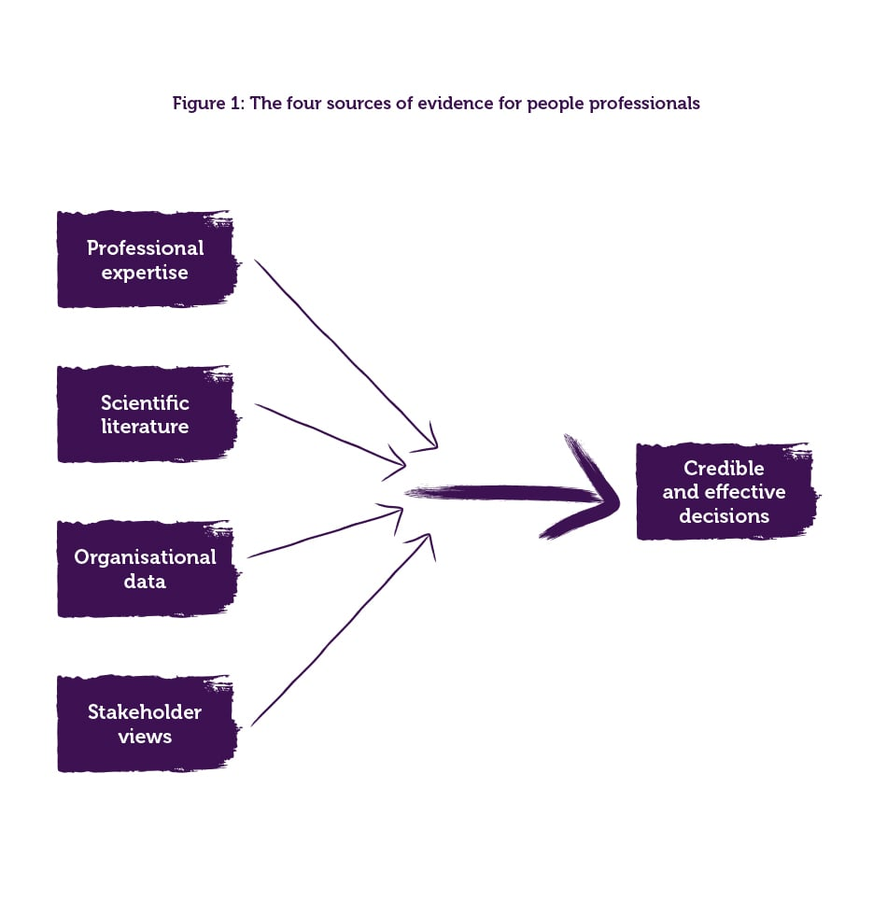
Professional expertise – evidence provided from professional experience and judgement from managers.
Scientific literature – looking for evidence from academic studies or journals. This is called secondary data, as it has been discovered previously.
Organisational data – data that comes straight from our organisation and can be quantitative or qualitative. This is called primary data as it has not been captured before.
Stakeholder views – looking at stakeholder values and concerns from both inside and outside the organisation.

Ref: (CIPD, 2023a)
We need to understand that while the sources listed above are useful, none is enough on its own – CPID (2023a) states “every source of evidence has its limitations and its weaknesses”. During the EBP method, we must analyse the evidence, questioning and checking the validity of the sources. This includes being aware of bias.
When gathering and analysing evidence, according to Briner (2022) we should be:
“Conscientious – you really try to gather evidence”
“Judicious –you judge the quality”
“Explicit –you write it down, you codify, you share with other people”
Following the six steps framework, illustrated below, allows you to gather and quantify evidence in a more structured way.
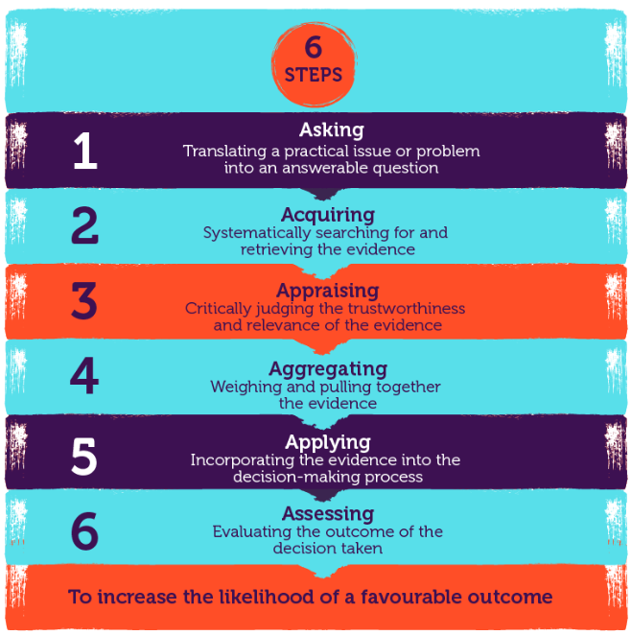
(CIPD, 2023a, diag)
The benefits to EBP, according to Chigwell (2016, para 7), are: “More informed and effective decision-making, improved credibility for the discipline of human resource practice and policies, and [also] practice can be based on what works, rather than what is thought to work.”
Overall, the aim is to make better, more effective decisions to help organisations achieve their goals (CIPD, 2023a).
You can apply this method to all areas of people practice. Firstly, be clear in the subject matter by translating a practical issue or problem into an answerable question (CIPD, 2023a) - for example, how do we reduce absence levels across the company?
Then work through the steps systematically, until you can incorporate all the evidence in the decision-making process, having judged the trustworthiness and relevance of all sources (CIPD, 2023a).

  - Evaluate a range of analysis tools and methods including how they can be applied to diagnose organisational issues, challenges, and opportunities.
Pestle Analysis Tool
Analysis tools can help identify and evaluate issues in the workplace before strategies are set. There are several analysis tools available, such as SWOT and Porter’s Five Forces, but in this report, I will explain the PESTLE method.
A PESTLE analysis is a management framework and diagnostic tool. The outcome of the analysis will help understand factors external to your organisation which impact upon strategy and influence business decisions (CIPD, 2024).
PESTLE is split into six key external factors for consideration (illustrated below) and the impact they may have on a business. The impacts can include opportunities and challenges.
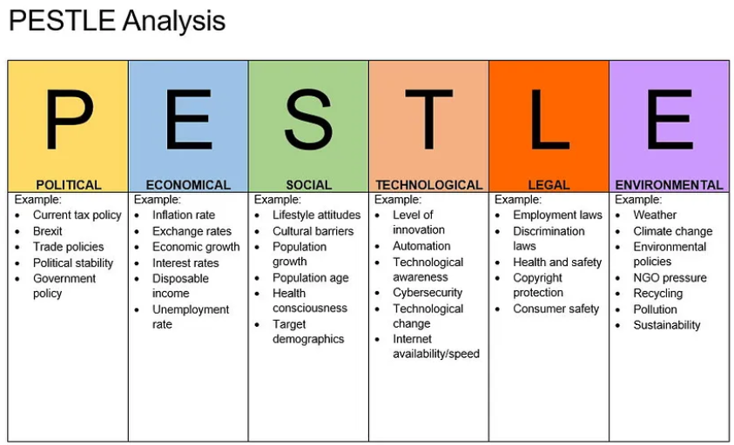
(Medium.com, 2023, diag)
Once you are familiar with the factors, it is a good idea to have more than one person gathering data to bring diverse evidence and perspectives (CIPD, 2024).
To be effective, a PESTLE analysis needs to be completed regularly. This can help an organisation spot trends early and provide a competitive advantage (CIPD 2024), although this can be a disadvantage if the resource within the workplace cannot accommodate the ongoing workload required to make analysis effective. However, it can enable an organisation to anticipate future business threats and take action to avoid or minimise impact (CIPD, 2024).
Once you have sourced and analysed data, score appropriately (low, medium or high), factoring in the importance to the organisation, and then draw meaningful conclusions.
It is recommended that a PESTLE analysis is kept simple and concise. This guarantees you will focus on relevant information to ensure the report will contain specific, actionable ideas.
Interviews (analysis method)
Horn (2012. P. 6) describes interviews as “a common method of investigation using a qualitative data collection method, therefore capturing the thoughts and feelings of employees”.
Interviews are a method of collecting in-depth data allowing researchers to gather specific details, opinions and views (Taylor and Woodhams, 2022).
The data from interviews can be critically analysed - looking for trends, themes or patterns that may need addressing - and used to present recommendations.
Interviews are advantageous as they can capture a significant amount of detail when investigating a small number of issues (Taylor and Woodhams, 2022), but can be time-consuming to conduct and analyse. Taylor and Woodhams (2022, p. 129) state: “Researchers need to decide whether the time commitments involved are offset by the potential benefits of gathering more detailed data.”
  - Explain the principles of critical thinking including how you apply these to your own and others’ ideas.
Critical thinking is the process of analysing and evaluating the quality of ideas, theories and concepts to establish the degree to which they are valid and supported by the evidence, and the extent to which they are biased (Armstrong and Taylor, 2014, p. 570). Howlett (CIPD, 2019) states: “Critical thinking is the ability to think well, and to critically reflect on the ideas, opinions, and arguments of others.”
Howlett (CIPD, 2019) also says: “There are three key principles to critical thinking for people professionals: critiquing the ideas, opinions and arguments of others, how they construct arguments and opinions themselves, and to identify others using critical thinking techniques that impact how people professionals are making a case.”
When using critical thinking, it is important to check the validity of the source and evidence, by carefully and systematically assessing its trustworthiness and relevance (Barends, Rousseau and Briner, 2014, p. 9) to decide whether this evidence provides a well-reasoned argument and can increase the likelihood of an effective decision. This can be achieved through research and evaluation of organisational reports.
When applying critical thinking to your ideas and those of others, be aware of the bias of both parties, both conscious and unconscious. Within people practice, we face a barrage of often contradictory insights and wild claims about what works in organisations and what does not (CIPD, 2023b). When judgements and decisions are influenced by unconscious bias, we are, in effect, using an incomplete and inaccurate evidence base. This will lead to poor decisions (SafeWorkforce, 2023).
  - Explain a range of decision-making processes:
There are several decision-making processes that can be used within people processes to ensure effective outcomes. Here are three examples:
Force Field Analysis
Force Field analysis is a powerful strategic technique which helps you weigh up the forces for and against change and represents them in a visually clear way (MindTools, 2024c). University of Cambridge (2016) says force field analysis is “widely used in change management and can be used to help understand most change processes in organisations”.
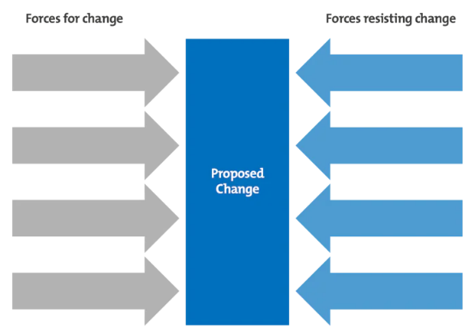
(MindTools, 2024c, diag)
In people practice, this approach can be used when trying to implement a change of policy – for example a new remote working policy - to identify the driving and resisting forces which weigh up the outcome decision.
De Bono (six thinking hats)
According to MindTools (2024a), De Bono’s six thinking hats is “a way of investigating an issue from a variety of perspectives, but in a clear, conflict-free way”. This method can be used individually or as a group.
The technique involves six different coloured hats which represent different perspectives, so when faced with people practice issues, the model uses six distinct types of thinking.
MindTools (2024a) notes: “By wearing each of the six thinking hats in turn, you can gain a real understanding of the organisation issues and encourage everyone to be involved in the decision-making process.”
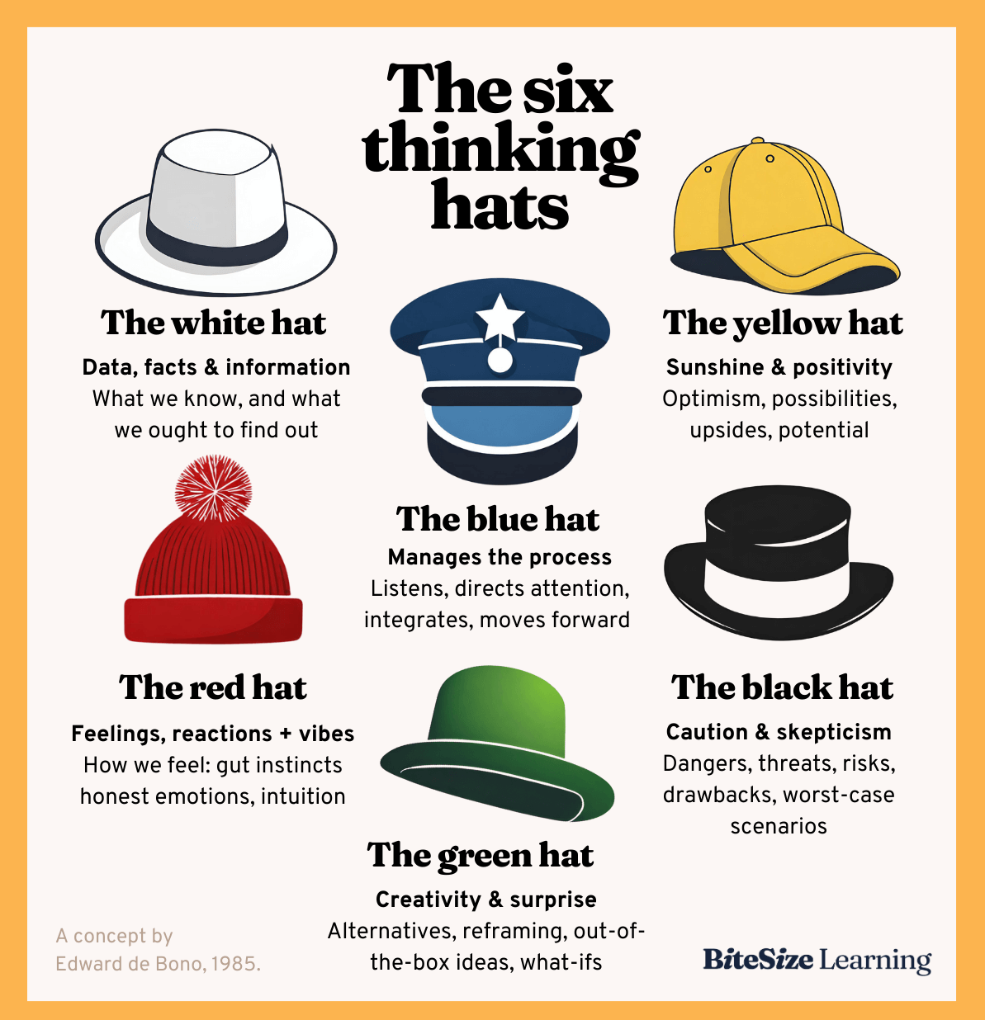
(BiteSize Learning, nodate, diag)
This method could be used when evaluating the implications on a business should a high-performing worker submit a flexible working request to reduce hours.
Evaluating the request through different perspectives can help produce an informed decision on the best way to proceed, considering the views of all parties.
Caution should be used when using the black hat, as this is one of the most powerful. MindTool (2024a) states: “You need to ensure your team can justify any critical or cautionary comments, so that this mode of thinking doesn’t dominate your decision-making.”
Kepner-Tregoe’s Model
This model, illustrated below, is not a single method or template but focuses on four main processes to add structure to the way we think, ensuring we take the rational approach using fact rather than relying on assumptions and gut feelings (Kepner, 2024).
Using this method, Mulder (2023) explains that we reflect on four fundamental questions: situation analysis (what happened?), problem analysis (why did it happen?), decision analysis (how should we act?) and potential problem analysis (what will the result be?).
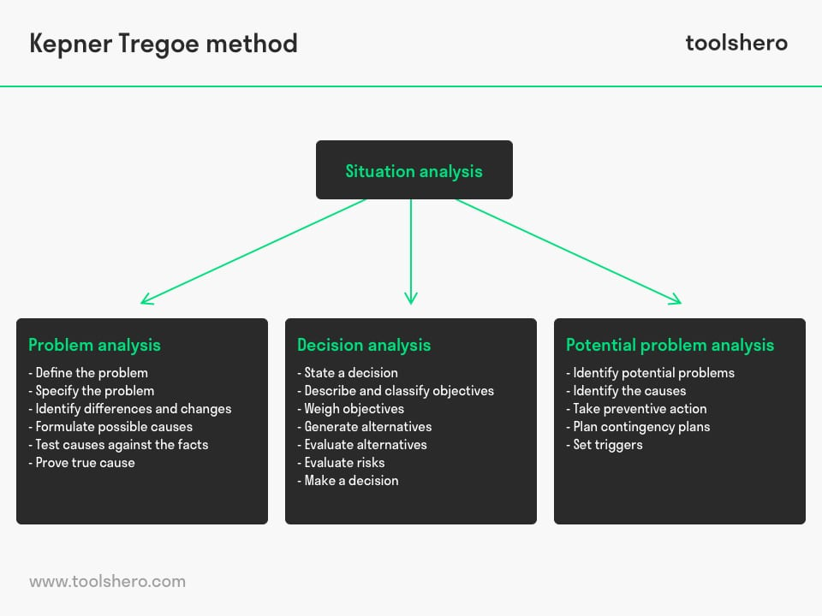
(toolshero, 2023, diag)
Working through each stage of the process above will help you establish the best possible choice as the end goal, given your knowledge and understanding of the issues (MindTools, 2024b).
This approach could be used in people practice addressing issues, once they have been identified. Each stage then guides you through detailed analysis in a disciplined, systematic way.

AC 1.5 Assess how different ethical perspectives can influence decision-making.
Utilitarianism Theory
Utilitarianism is an ethical framework which says doing the right thing in any situation will produce the best outcome, measured by impact on all involved (CEBE, no date). Armstrong and Taylor (2014, p. 97) state: “Actions are justified when they result in the greatest good to the greatest number of people.”
The utilitarianism theory is not without criticism. Armstrong and Taylor (2024, P. 97) say “it fails to respect individual rights” so needs to be used in the right situation to ensure, for example, it does not discriminate against anyone with a protected characteristic under The Equality Act 2010. It can, however, be used effectively when applied to the right situation and enhance decision-making.
As utilitarianism looks at a positive impact for the greatest number of employees, in people practice, it can be applied when writing workplace policies and procedures and promoting diversity and inclusion. For example, if you wanted to maximise overall health and well-being of employees, you could invest in an Employee Assistance Programme, which delivers mental health and well-being solutions accessible to all staff. This could lead to a healthier and more productive workforce.
Deontological Theory
Deontological theory is an ethical theory which incorporates principles of fairness and justice. Unlike utilitarianism, it focuses on the importance of rules and moral principles, rather than just the outcome. As explained by Armstrong and Taylor (2024, p. 97): “One should follow the principle that what is right for one person is right for everyone.”
As the deontological theory follows the principles of fairness, this theory can be applied to recruitment to ensure a fair process. Potential candidates should be evaluated based on their ability and potential contributions, ensuring a fair and unbiased selection process that respects each person as an individual (vq solutions, 2024).
Stakeholder Theory
In accordance with the ideas of Freeman (1984), stakeholder theory is about how a business works. Freeman (2014) explained: “For any business to be successful, it must create value for customers, suppliers, employees, communities and shareholders. You can’t look at any one of those individually, their interests must go together.”
Using stakeholder theories within people practice, we can focus on employees. If a business has a high sickness level, as employees do not enjoy being at work, Freeman (1984) states “that is a business in decline”. It would be the focus of people practice to conduct research into the issues causing the high absence levels and make recommendations based on findings.

AC 3.1 Appraise different ways organisations measure financial and non-finance performance.
Financial data
Stobierski (2020) states: “With a better understanding of how your organisation measures financial performance, you can take steps to provide additional value in your daily activities.”
Examples of financial performance:
Revenue
Gross profits
Net profits
Cash flow
Return on investment

For this report, I will be appraising net profits.
Net profit margin is the profitability ratio that measures what percentage of revenue and other income is left after subtracting all costs for the business (Stobierski, 2020).
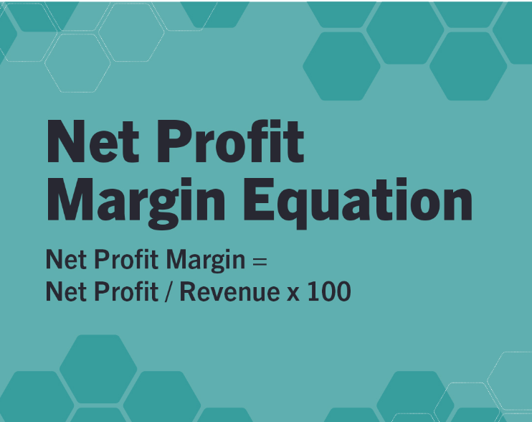
(Stobierski, 2020, diag)
The advantage of basing business decisions on net profits rather than gross profits is that this measures the overall profitability of a business, as it considers all areas and not just the cost of services. If you are using this tool to benchmark your company, Corporate Finance Institute (2024) recommends you “compare only companies in the same sector with similar business modules”, as net profit ratios can differ greatly in companies in different industries.
Non-financial data
Non-financial data can be used as an indication of an organisation’s performance. Indeed (2023) states: “These measurements avoid using monetary values to denote success or failure. Instead, they focus on other business areas and typically look at the company’s prospects.”
Examples of non-financial data:
Customer feedback
Legal compliance
Staff feedback
Customer retention
Staff retention and turnover

For this report, I will be appraising staff turnover.

Staff turnover data looks at the number of employees who leave an organisation over a set period and is a measurement non-financial performance. High levels of staff turnover have significant effects on an organisation, including cost implications of recruitment plus the detrimental impact on colleagues who may have to take on additional responsibilities before a new employee can be sourced. Staff turnover can affect both the public and private sectors, as ultimately it affects the bottom line of a business.
As stated on CIPD (2024b): “A resource and talent planning survey in 2022 found that only 17% of respondents calculate the cost of labour turnover and 12% collect data to evaluate and improve retention initiatives.”
These figures suggest the practice of analysing staff turnover is not commonly used in the workplace, and yet the impact of staff turnover affects the financial performance of a business. Therefore I would recommend that staff turnover is monitored regularly.
It is useful to consider multiple sources of evidence before deciding on retention initiatives and strategies. There is a need to understand avoidable turnover, which Taylor and Woodhams (2022) explain “is where some form of avoidable dissatisfaction results in staff leaving”.
Analysing reasons for avoidable turnover and implementing relevant retention initiatives can have an impact on financial and non-financial performance. Ultimately it can save the business money when staff are retained.
It is also important to remember that, as stated by Taylor and Woodhams (2022): “Not all turnover is bad, however a certain amount of ‘churn’ may mean that under-performers are leaving. This allows progression for other employees and helps create a performance culture.”
Therefore, when analysing staff turnover data, it is important to use both quantitative data (percentage of staff turnover) and qualitative data (for example performance data and exit interviews) to understand the reason an employee is leaving before making decisions.
A.C 3.2 Explain how people practices add value in an organisation and identify two methods that might be used to measure the impact of people practices.
People practices are processes and approaches used across the employee lifecycle (CIPD, 2024a) which shape the success of an organisation. Success is achieved through deliverable, people-oriented strategies and by adding value. According to Personnel Today (2012), adding value focuses the mind on the outcome of HR’s contribution.
Several methods can be used to measure the impact of people practices through adding value. In this report, I have identified two methods.
Return on Investment:
Return on investment (ROI) is a metric used to understand the profitability of an investment and can measure financial performance. It is a simple ratio (illustrated below) which divides net profit or loss from an investment by its cost and is then presented as a percentage (Forbes, 2022).
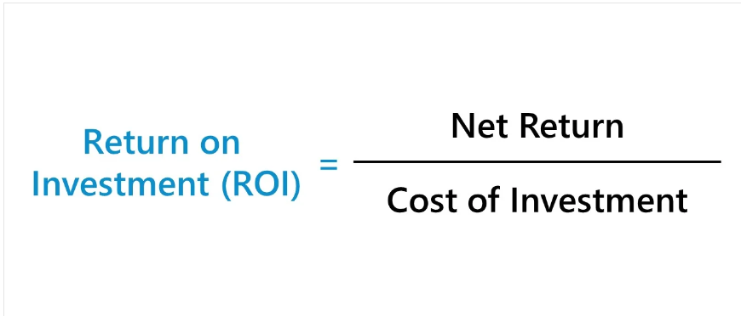

(Wall Street Prep, 2024, diag)
ROI can be used to understand the effectiveness of budgets within individual areas of people practice - for example, training and development costs.
You must ascertain whether training budgets are being used effectively. To measure the success of training, you would assess its impact on performance and knowledge within the workforce.
This could be done through supervisions assessing competency and knowledge.
The measurement could substantiate whether training is providing a return on investment and therefore adding value.
In contrast, some people practice initiatives would be difficult to quantify using ROI, such as intangible benefits. Phillips and Phillips (2004 p. 4) state: “The difficulty lies in determining intangible benefits in monetary terms.”
However, Phillips and Phillips (2014 p. 4) also state: “The ROI process is seeing tremendous success in HR in both private and public sectors, as analytical techniques can be used to determine money values with high degrees of accuracy.”
In cases of intangible benefits, expert input is used to assign monetary values derived from programmes (Phillip and Phillips, 2014).
Cost-benefit analysis:
Cost-benefit analysis (CBA) is a decision-making technique used in businesses to analyse resource and make more informed decisions. Juma (2023) states: “It is a method that can help you decide whether a certain action is worth pursuing or not.”
In people practice, cost-benefit analysis can be applied to recruitment. Firstly, set the objective, then use the CBA to analyse cost versus benefit to decide whether the objective is financially viable.
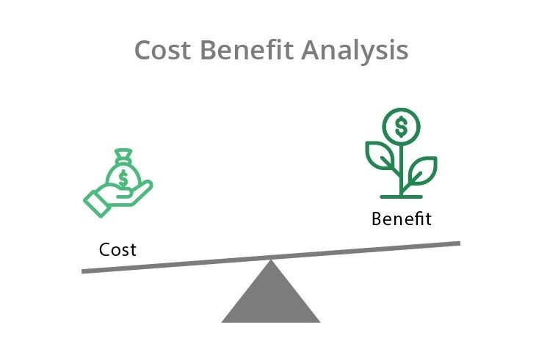
(Indeed, 2024, diag)
If a company wants to make a new hire, they must calculate total cost of the investment. To do this, list costs and benefits and their monetary values.
Costs | Benefits
Recruitment | Income generation
Training | Increased productivity leading to increased revenue
Wages and employee benefits | Easing teamwork load resulting in reduced turnover
Overheads | Easing teamwork load resulting in less absence

Benefits can come with numerous intangible costs, but it is important to consider the monetary value associated with these costs when using CBA (for example, easing teamwork load will reduce turnover which is a cost to the business). Analysis of costs versus benefits will provide evidence to support whether a new hire is financially viable and can be implemented.
Section 2 - Quantitative and qualitative analysis review.
Introduction:
In this report, we interpret and analyse raw organisational data to enable us to make justifiable recommendations (if any) based on the evaluation. We will use both qualitative and quantitative data.
The quantitative data is represented through numbers and statistics using areas of Equality, Diversity, Inclusion and Salary.
We then use qualitative data from employee engagement surveys on hybrid working practices.
Research 1: Quantitative Data:
(AC2.1) – With reference to a people practice issue, interpret analytical data using appropriate analysis tools and methods.

Row Labels | Count of Gender | Count of Gender2
Female | 118 | 45%
Male | 140 | 54%
Non-binary | 2 | 1%
Grand Total | 260 | 100%

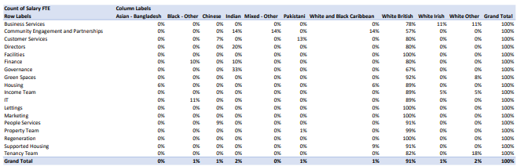

Row Labels | Count of Disability status
Disabled | 21
Not disabled | 239
Grand Total | 260

Count of Disability status | Column Labels
Row Labels | Disabled | Not disabled | Grand Total
Business Services | 0% | 100% | 100%
Community Engagement and Partnerships | 14% | 86% | 100%
Customer Services | 20% | 80% | 100%
Directors | 0% | 100% | 100%
Facilities | 0% | 100% | 100%
Finance | 20% | 80% | 100%
Governance | 0% | 100% | 100%
Green Spaces | 8% | 92% | 100%
Housing | 11% | 89% | 100%
Income Team | 5% | 95% | 100%
IT | 22% | 78% | 100%
Lettings | 10% | 90% | 100%
Marketing | 0% | 100% | 100%
People Services | 18% | 82% | 100%
Property Team | 5% | 95% | 100%
Regeneration | 0% | 100% | 100%
Supported Housing | 0% | 100% | 100%
Tenancy Team | 9% | 91% | 100%
Grand Total | 8% | 92% | 100%

D) Salary difference across genders:
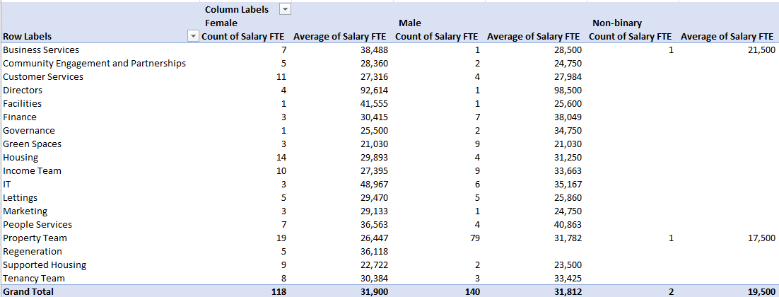

Overall average salary paid by the organisation:
Sum of Salary FTE | Sum of Number of Employees | Average Salary
8256940 | 260 | 31757.46

AC 2.2 Present key finding for stakeholders from people practice activities and initiatives.
A). Percentage of each gender by type:

The graph represents the percentage of gender by type across the company. Within a total of 260 employees, men make up more than half the workforce at 54%, women 45% and non-binary has the lowest percentage.
Further investigation shows the positions held by non-binary employees are:
Non-binary
Administrator
Trades Apprentice
Grand Total

The two non-binary employees hold junior positions in the company.
B). Ethnicity as a percentage per team:

The organisation has a range of ethnicities. Of 260 employees, 237 (91%) are white British with 23 (9%) classed as non-white British.
The community engagement and partnership team have the lowest number of white British employees (57%), with 43% made up of Indian, mixed (other) and white and black Caribbean.
Marketing, facilities, lettings and the property team do not feature any ethnic groups other than white British.
C). Disability percentage as an organisational whole and by teams:
The graph shows the disability percentage as an organisational whole. With a total of 260 employees, 92% (231) are not disabled as opposed to 8% (21) who are disabled.

The graph below breaks down the disability percentage by team:

The IT department has the largest proportion of disabled employees, followed by Customer Services and Finance.
We would need to do further investigation of the data and its impacts as it mistakenly shows that most of the employees within the organisation do not have a disability. This would provide us with more meaningful insights into the data before any recommendations are made.
D) Salary difference across genders:

Women achieve the highest salaries with more women at senior levels.

Males earn more than females in the lower income group (under 30k), raising questions about potential pay disparities based on gender.
E). Overall average salary paid by the organisation:

There is evidence in the graph above that we are paying below the national average salary.
In April 2023, The Office for National Statistics (2023) reported that median gross annual earnings in the UK for full-time employees was £34,963.
Assuming our company data is based on full-time employees, our average earnings are 9% lower than the UK national average.
However, the 9% figure could be challenged as the company data does not specify whether employees are full or part time, making it difficult to come to a conclusion.
The company figures also include the higher earners, which can lead to distortion of the overall average figures.

(AC 2.3) Make justified recommendations based on the evaluation of the benefits, risks and financial implications of potential solutions.
Recommendation 1: Create development plans for employees in lower-grade positions, with a goal to progress the staff members into higher-grade positions.
Follow the deontological approach when recruiting to ensure there is a fair and unbiased selection process which respects each person as an individual. This makes us compliant with the Equality Act 2010.
Benefits: Company inclusivity, attracting a wider gender audience and increasing capabilities of staff. Increase in staff retention and productivity.
Risks: Not following deontological approach could result in a failure to abide by the Equality Act 2010, as it is unlawful to discriminate against a person with a protected characteristic.
Lack of staff development can lead to higher turnover rate, with employees looking for career development within other companies.
Financial Implications: Additional direct costs for personal development plans and training of staff. But the additional costs could turn into a return on investment because a rise in employee productivity - as they feel the company has invested in them - can lead to additional revenue generation.

Recommendation 2: Conduct a full analysis of average salary paid by the organisation to ascertain if we are paying below the national average. We do not have enough credible or factual raw data to effectively evaluate the average salaries.
Benefits: Paying above the national average salary boosts company brand and reputation, leads to better staff productivity and motivation in the workplace. It would also help to recruit a better quality of candidate into the company.
Risk: Paying below the average salary can contribute to higher levels of staff turnover, decreased employee productivity and increase absence levels.
Financial Implications: Should the evidence support that we are paying less than the national average and a decision is made to increase staff earnings, this could have a direct impact on the company’s net profits. However, we also need to consider intangible non-financial benefits against financial benefits.

Table 2 – Feedback scores from a recent employee survey on hybrid working practices.
With a focus on qualitative data, a staff survey was conducted concentrating on hybrid working practices.
We obtained feedback from 300 employees using 14 questions, to see if we could identify any patterns or trends.
(AC2.1) – With reference to a people practice issue, interpret analytical data using appropriate analysis tools and methods.

AC 2.2 Present key finding for stakeholders from people practice activities and initiatives.

In response to the statement, “I feel less stressed when away from the workplace”, 83% of employees strongly disagreed.

48% of employees strongly disagreed that working from home allowed them to meet their targets. This is almost half of the workforce that work from home.

You could argue the responses to this question contradict the answers to the two previous questions.
54% of employees fully agreed that hybrid working practices support their work-life balance and well-being.
(AC 2.3) Make justified recommendations based on the evaluation of the benefits, risks and financial implications of potential solutions.
Taylor and Woodhams (2014) state the disadvantage with qualitative surveys is that they do not allow for researchers to prompt individuals to provide more information. This has been apparent in the survey we conducted across several areas.
Recommendation 1: Conduct further research into the barriers which are preventing employees reaching targets when working at home with a view to overcoming these barriers.
Benefits: Increased well-being and employee productivity, resulting in improved profitability for the company when employees are hitting targets.
Risks: Not investigating further will result in continued poor performance from employees, decreased productivity and well-being. Also, loss of revenue and net profit for business with employees not hitting targets.
Financial implications: Additional data collection can be costly and time-consuming. However, interviewing only a proportion of employees would speed up the process and be less costly.
Recommendation 2: Conduct further research into why 83% of employees feel more stressed when away from the workplace.
Benefits: Improvement in employees’ well-being, leading to enhanced productivity, improved organisational culture and improved profitability.
Risks: Not investigating further will lead to continued decreased productivity and poor well-being for staff.
Financial implications: Additional direct costs to conduct further investigations, as well as increased overheads if more employees needed to return to the workplace on a regular basis.

References:
Armstrong, M. and Taylor, S. (2014) Armstrong’s handbook of human resource management practice. 13th edition. London: Kogan Page.
Barends, E. Rousseau, D.M., and Briner, R.B. (2014). Evidence-Based Management: The Basic Principles. Amsterdam: Centre for Evidence-Based Management.
BiteSize Learning (no date) Take a look at a problem from all sides with Six Thinking Hats technique. Avaialble at: https://www.bitesizelearning.co.uk/resources/six-thinking-hats-technique (Accessed 1 June 2024)
Briner, R. (2022) What is EVIDENCE Based Practice?! – with Rob Briner. Available at: https://www.youtube.com/watch?v=tSfo2XhEWkE (Accessed: 13 May 2024)
CEBE (no date) Ethical theory – utilitarianism Available at: https://conciseencyclopedia.org/entries/ethical-theory-utilitarianism/ (Accessed: 22 May 2024).
Chigwell, B. (2016) Evidence based management in HR, 11 November 2016. Available at: https://www.ciphr.com/blog/evidence-based-management-hr (Accessed 16 May 2024).
CIPD (2019). CIPD. [podcast]. Podcast 154: Critical thinking. Available at: https://www.cipd.org/uk/knowledge/podcasts/critical-thinking/ (Accessed 3 June 2024).
CIPD (2023a) Evidence-based HR: Making better decisions and step up your influence. Available at: https://www.cipd.org/uk/knowledge/guides/evidence-based-profession/ (Accessed: 13 May 2024).
CIPD (2023b) Building an evidence-based people profession. Avaialble at: https://www.cipd.org/uk/views-and-insights/thought-leadership/insight/evidence-based-profession (Accessed: 13 May 2024).
CIPD (2023c) Ethical practice and the role of people professionals. Available at: https://www.cipd.org/uk/knowledge/factsheets/ethics-role-hr-factsheet/#what-is-ethical-practice-in-organisations (Accessed: 6 June 2024).
CIPD (2024), PESTLE analysis. Available at: https://www.cipd.org/uk/knowledge/factsheets/pestle-analysis-factsheet/#what-is-a-pestle-analysis (Accessed 20 May 2023).
CIPD (2024a) People practice. Available at: https://www.cipd.org/uk/the-people-profession/the-profession-map/explore-the-profession-map/core-knowledge/people-practice/ (Accessed 12 June 2024).
CIPD (2024b) Benchmarking employee turnover: what are the latest trends and insights. Avaialble at: https://www.cipd.org/uk/views-and-insights/thought-leadership/cipd-voice/benchmarking-employee-turnover (Accessed 23 May 2024).
Corporate Finance Institute (2024) Net profit margin Available at: https://corporatefinanceinstitute.com/resources/accounting/net-profit-margin-formula/ (Accessed 3 June 2024).
Forbes (2022) Return on Investment 28 September 2022. Available at: https://www.forbes.com/advisor/investing/roi-return-on-investment/ (Accessed: 10 June 2024).
Howell, W and Coburn, T (2019) Critical thinking podcast, Avaialble at: www.cipd.co.uk/podcasts/criticalthinking. (Accessed 24 May 2024).
Horn, R. (2012) Researching and writing dissertations: a complete guide for business. 2nd ed. London: Chartered Institute of Personnel and Development. Armstrong.
Juma. A (2023) Cost-benefit analysis (CBA): examples, benefits and steps. Avaialble at: https://www.indeed.com/career-advice/career-development/cost-benefit-analysis-example (Accessed 03 June 2024).
Kepner-Tregoe (2024), Tregoe FAQs: What is the Kepner-Tregoe method. Available at: https://kepner-tregoe.com/gbr/faqs/ (Accessed: 1 June 2024).
Indeed (2023) 6 examples of non-financial measure of performance, 23 March 2023. Available at: https://uk.indeed.com/career-advice/career-development/non-financial-measures-of-performance (Accessed: 10 June 2023).
Indeed (2024) Making informed business decisions: unleashing the benefits of cost-benefit analysis. Avaialble at: https://www.linkedin.com/pulse/making-informed-business-decisions-unleashing-benefits-abbas Accessed (10 June 2023).
M. and Taylor, S. (2014) Armstrong’s handbook of human resource management practice. 13th edition. London: Kogan Page.
Medium (2023) Navigating business success: the power of the pestle analysis. Avaialble at: https://medium.com/@echempraise/navigating-business-success-the-power-of-pestle-analysis-0c50c4d66c74 (Accessed: 20 May 2024).
MindTools (2024a) Six thinking hats. Available at: https://www.mindtools.com/ajlpp1e/six-thinking-hats (Accessed 1 June 2024)
MindTools (2024b) The Kepner-Tregoe Matrix Avaialble at: https://www.mindtools.com/atznth6/the-kepner-tregoe-matrix (Accessed 01 June 2024).
MindTools (2024c) Force Field Analysis Avaialble at: https://www.mindtools.com/a23ewmr/force-field-analysis (Accessed 01 June 2024).
Mulder, P. (2023) Kepner Tregoe method of problem solving, 27 December 2023. Avaialble at: https://www.toolshero.com/problem-solving/kepner-tregoe-method/ (Accessed 01 June 2024).
Personnel Today (2012) How can HR prove it really adds value? 3 September 2021. Avaialble at: https://www.personneltoday.com/hr/how-can-hr-prove-it-really-adds-value/ (Accessed 13 June 2024).
Phillis, J. and Phillips P (2004) The business case for ROI: measuring the return on investment in human resources. Available at: https://roiinstitute.net/wp-content/uploads/2018/03/BUSINESS-CASE-IN-HR-Website-12-2004.pdf (Accessed 1 June 2024).
SafeWorkforce (2023) Unveiling the hidden judge: understanding unconscious bias and its impact in the workplace 24 July 2024. Available at: https://www.joinsafeworkforce.com/insights/blog/understanding-unconscious-bias-impact-workplace/#:~:text=There%20are%202%20key%20risks,the%20subjects%20of%20this%20bias (Accessed 22 May 2024).
Stobierski, T. (2020) 13 financial performance measure managers should monitor, 5 May 2023. Available at: 13 Financial Performance Measures Managers Should Monitor (hbs.edu) (Accessed 13 June 2024).
Taylor, S and Woodhams, C (2022) Studying human resource management: a guide to the study, context and practice of HR. 3rd edn. London: Kogan page
The Office for National Statistics (2023) Employee earning in the UK: 2023 Avaialble at: https://www.ons.gov.uk/employmentandlabourmarket/peopleinwork/earningsandworkinghours/bulletins/annualsurveyofhoursandearnings/2023 (Accessed 10 June 2024).
Toolshero (2023) Kepner Tregoe method of solving problems Avaialble at: https://www.toolshero.com/problem-solving/kepner-tregoe-method/ (Accessed 01 June 2024).
University of Cambridge (2016) Force Field Analysis Available at: https://www.ifm.eng.cam.ac.uk/research/dstools/force-field-analysis/ (Accessed 01 June 2024).
Vq solution (2024) An introduction to deontology. CIPD Level 5: ethical perspectives and moral decision making. Available at: https://www.vqsolutions.co.uk/page/show/9468?p=cipd-level-5-ethical-perspectives-and-moral-decision-making (Accessed: 22 May 2024).
Wall Street prep (2024) Return on investment (ROI). Avaialble at: https://www.wallstreetprep.com/knowledge/roi-return-on-investment/ (Accessed 10 June 2024).

