International Business
LCMB7014
Student name: Mandeep kaur saggu
Student ID: 2218282
Lecturer: Lan dang
Submission date: 28/07/2023
Word count: 5000
Title:
SAMSUNG's
INTERNATIONAL BUSINESS AND STRATEGIES

Table of Contents
Introduction 3
Internationalization strategy: Polycentric Approach 5
PESTEL Analysis 6
Political Factors 7
Economic Factors 10
Social Factors 13
Technological Factors 15
Legal Factors 17
Environmental Factors 19
Conclusion 22
Recommendation’s 22
References 24

Introduction
Among the world's top electronic device manufacturers, Samsung is one of the largest companies in South Korea that produces electronic devices. The Samsung Group, which is a subsidiary of Samsung Electronics, specializes in the production of a wide range of consumer and industrial electronics, including appliances, digital media devices, semiconductors, memory chips, and integrated systems. A fifth of South Korea's exports are produced by this company, making it one of the most recognizable companies in the technology industry (Bondarenko, 2023).In addition, Samsung has achieved remarkable success on the global stage by diversifying its portfolio of businesses, which include electronics, telecommunications, transportation, and many others. Samsung is one of the most important players in the international arena and its expansion outside of its home country has been the result of careful planning and strategic decision-making on the part of the company. The company's flagship product is its smartphones, which are the company's main focus. According to the number of users of smartphones, China has the largest market for smartphones, followed by India, and the United States (Bondarenko, 2023).
Due to the growth in the global smartphone market as well, Samsung has been able to maintain its position as the global market leader despite a relatively flat market. It is estimated that in 2022 alone, the Korean electronics giant will ship around 258 million smartphones around the world, which is 21.6 percent of the total number of smartphones shipped worldwide that year (Laricchia, 2023).

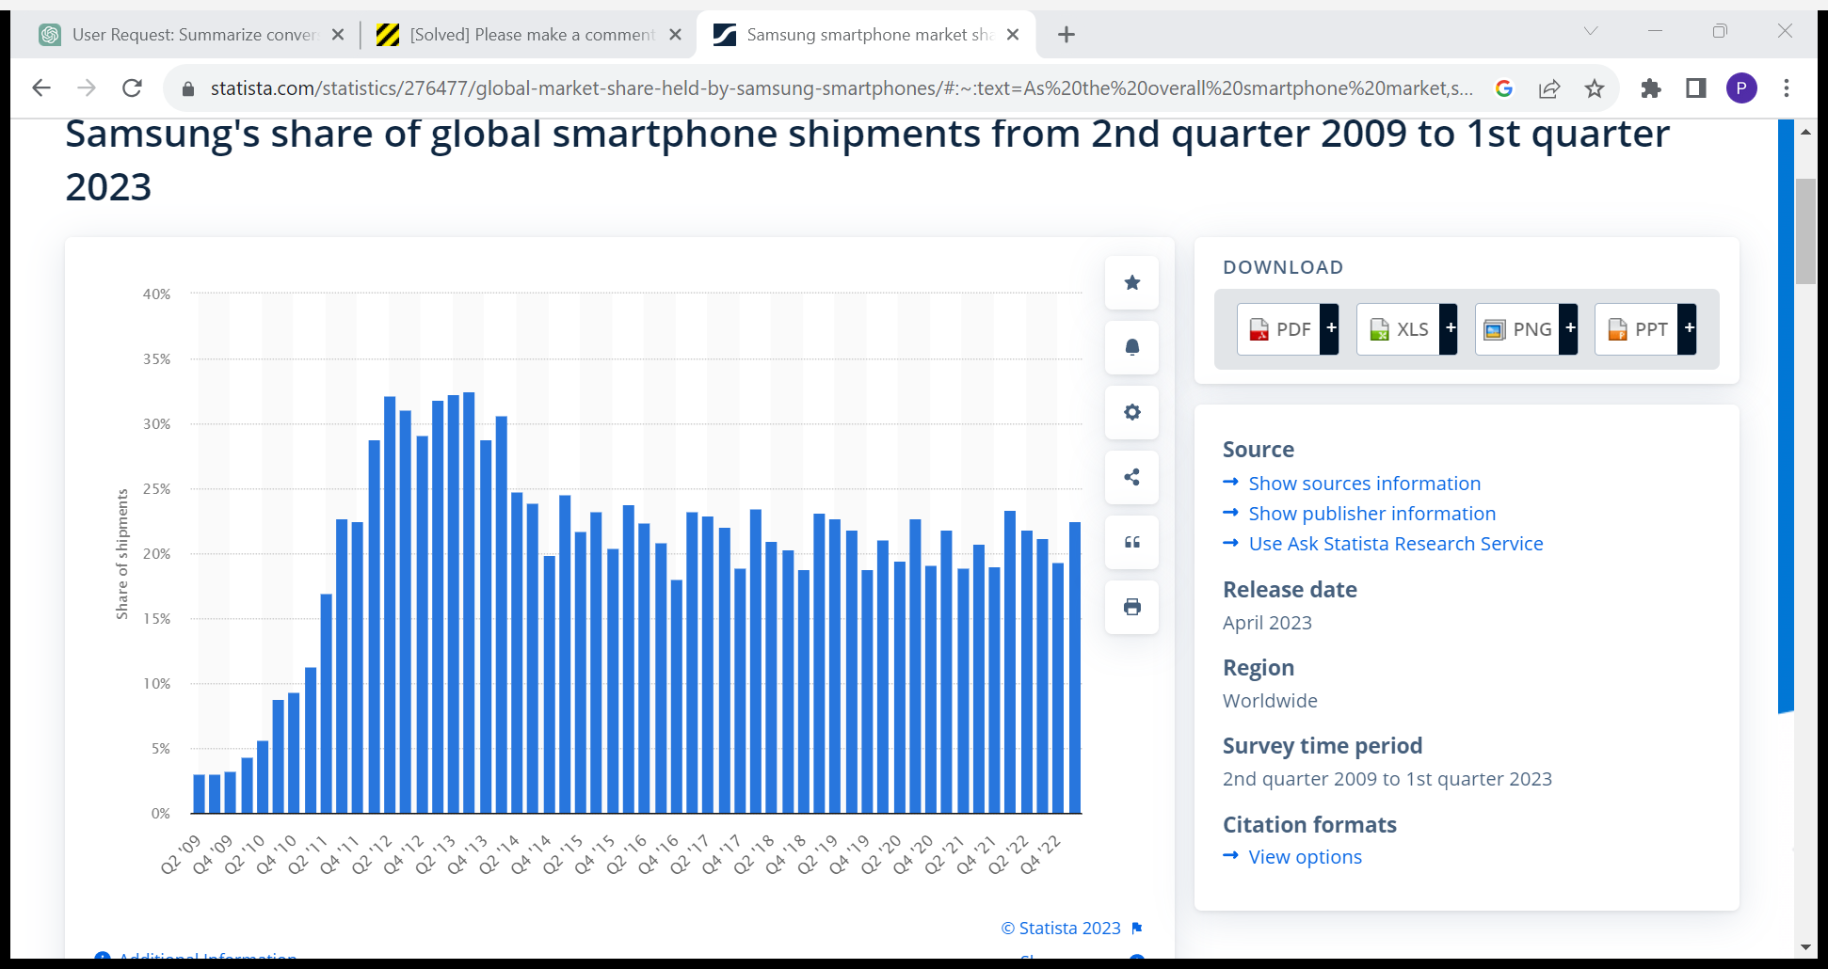
Samsung Share of Global Smartphone: (Laricchia, 2023)
There is an emphasis in this report on the polycentric approach adopted by Samsung for its foreign subsidiaries to critique its internationalization strategy critically. As part of Samsung's global expansion strategy, the polycentric approach, characterized by the decentralized decision-making process and the localization of operations, has played a pivotal role. Using this approach, the company enables its subsidiaries operating in a variety of countries to customize their strategies, products, and services according to the unique requirements of the local market so that they can continue to grow and succeed. A further part of the report explains how Samsung selected the polycentric approach as a result of several factors that influenced its decision. A comprehensive analysis will involve considering contextual factors, using the PESTLE model to provide a comprehensive analysis. Using the PESTLE analysis, Samsung's internationalization strategy has been shaped by a combination of factors, including political climates, economic conditions, social and cultural influences, technological advancements, legal requirements, and environmental considerations.

Internationalization Strategy: Polycentric Approach
Taking a polycentric approach to internationalization means decentralizing decision-making to the divisions in different host countries to facilitate internationalization. This approach calls for each subsidiary to operate independently and to adjust its strategies and practices to local market conditions and cultural differences. Parent companies (in this case Samsung's headquarters in South Korea) take a more hands-off approach to their subsidiaries in terms of managing their operations, allowing subsidiaries to have a higher level of autonomy in the way they do so (Choi, 2022).
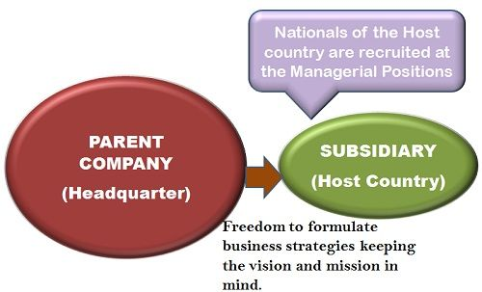
Polycentric approach
The polycentric approach has been incorporated into Samsung's internationalization strategy in several different ways, including:
- Local Decision-Making: It is Samsung's policy to allow its subsidiaries in different countries to decide what is best for the local market conditions and consumer preferences according to their local market conditions. As a result of this flexibility, subsidiaries can respond more quickly and effectively to opportunities and challenges at the local level without having to wait for approval from the headquarters (ET, 2020).
- Recruitment of Local Talent: When Samsung establishes a foreign subsidiary, it hires local employees to fill top management positions at the business. With this strategy, the company has the benefit of the insights and expertise of individuals with a solid understanding of the local business environment and who can navigate cultural nuances effectively (Simonin, 2014).
- Customization of Products and Services: To cater to the specific needs and preferences of consumers in different regions, Samsung tailors its products and services by a polycentric approach that includes regionalization. To be able to achieve this goal, it is necessary to make sure that product features, design, and marketing strategies are adapted to local cultural norms and tastes (Simonin, 2014).
- Market Research and Analysis: To gain a deep understanding of consumer behaviour, market trends, and competition, Samsung adopts a polycentric approach which involves conducting market research and analysis in each country. By using data-driven decision-making at the local level, the company can make better-informed decisions at the company's level (Simonin, 2014).
By adopting a polycentric approach, Samsung can be highly adaptable to the local market conditions, which enables it to become more competitive and relevant in different parts of the world. Furthermore, Samsung can demonstrate cultural sensitivity by empowering subsidiaries to customize products and services, resulting in a greater sense of customer loyalty and acceptance.

PESTEL Analysis
Organizations use PESTEL analysis as a strategic tool to understand and evaluate the external macroenvironmental factors that can impact their business operations, decision-making, and overall success of their operations, to understand and evaluate the factors that can affect their success. As part of its analysis, the report looks at six key dimensions: political, economic, social, technological, environmental, and legal factors. A PESTEL analysis allows businesses to identify opportunities and threats that may arise from these factors, allowing them to develop strategies and responses that are effective in navigating the complex external environment that they are facing (Çitilci, 2019).
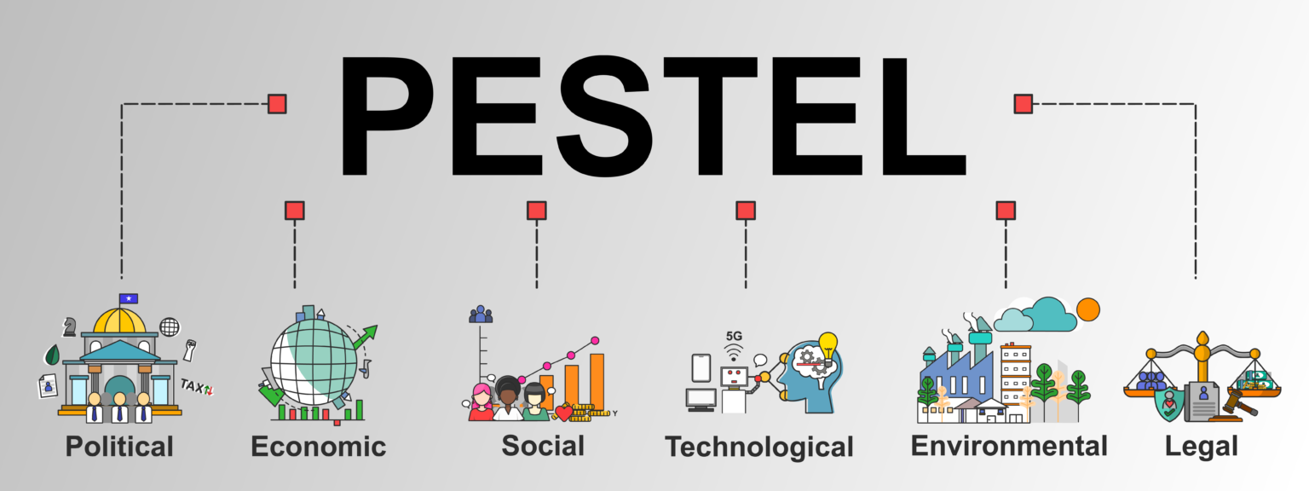

Political Factors
In the context of politics, factors such as government policies, political stability, and the overall political climate play a significant role in the performance of businesses. The political factors which have a significant impact on the overall performance of Samsung include the following:
Political Stability: For an organization to be successful, it is crucial to maintain political stability. Having a conducive political environment is crucial to the success of a company if it wishes to thrive. The only major irritant Samsung has faced in India is a few minor irritants, but its reputation has been tarnished in African and Latin American countries due to political pressures. If the political environment is unstable in a country, and the government structure is susceptible to volatile changes in the future, then business disruptions and loss of business are likely to occur as a result (Jaewon, 2022). Moreover, It has been quite a while since Samsung's home country South Korea experienced major drawbacks as a result of its strained relations with North Korea (Banka, 2020). There are more than 80 countries in which Samsung operates at present, and fear of terrorism is another major challenge that may affect the smooth functioning of the business in the future. There is, however, a favourable business environment in countries such as China and India that help the company to be able to make the most of the opportunities that these emerging economies may offer to it.
Government Policies: Samsung's operations can be significantly impacted by the government policies of the countries in which the company operates. Many factors can influence Samsung's business strategies, such as tax policies, labour laws, environmental regulations, trade restrictions and tariffs, and political stability. During the year 2017, the Chinese government implemented several regulatory systems that had a substantial impact on the smartphone industry, including Samsung's operations in that country. Regulations have been introduced by the Chinese government on the recycling and disposal of electronic products, including smartphones, in response to concerns about the environmental impact of electronic waste. To meet the new environmental standards, Samsung's smartphone product line may have had to undergo modifications as a result of the regulatory changes (Maizland, 2021). As a result, launches of new products or changes to existing models may have been delayed or altered as
this instance, Samsung's smartphone sales have been affected by changes in Chinese regulations as a result of the country's regulatory changes. This is a clear illustration of how government policies can have a direct impact on a company's operations, market positioning, and strategic decisions in a particular country. Multinational companies like Samsung must stay abreast of regulatory developments and be able to change their business practices by evolving government policies in different markets as they evolve.
International Relations: The international relations between South Korea and the other countries are of significant importance to Samsung, as a multinational corporation.
The tensions and conflicts that arise from political tensions and conflicts can result in trade restrictions or boycotts that harm Samsung's sales. As an example of how political tensions between countries can impact a multinational corporation like Samsung, the THAAD (Terminal High Altitude Area Défense) dispute between South Korea and China is a good example. A missile defense system called THAAD is designed to prevent North Korean missile threats from reaching South Korea (BOROWIEC, 2023). As a result of South Korea's agreement to host the THAAD system in 2016, there has been a heightened level of tension between China and South Korea. Samsung is one of the world's largest multinational corporations, with its major products, including smartphones, consumer electronics, and home appliances, based heavily on the Chinese market. China, however, imposed unofficial sanctions on South Korean businesses as a result of South Korea's decision to deploy THAAD, affecting Samsung's operations and sales in China as a result (Byung-yeul, 2023).

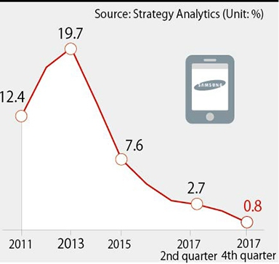
The decline in Samsung sales due to THAAD (Hani, 2018)
There is no doubt that the incident demonstrates the importance of companies taking into account the potential risks of political developments and international relations when formulating their business strategies and managing their operations on global markets to avoid unforeseen risks.

Economic Factors
To perform a PESTEL analysis, it is necessary to include economic factors; they play a crucial role in influencing businesses and multinational corporations such as Samsung, and they are essential to a successful PESTEL analysis. An economic factor refers to a broad range of circumstances and trends that can affect a company's operations, financial performance, and how it makes strategic decisions. The following are some of the key economic factors that have an impact on Samsung:
Global Economic Conditions: As a multinational corporation, Samsung is influenced by the economic conditions of the countries in which it operates. Samsung's products may become less desirable as a result of economic recessions or booms in these countries, thereby affecting consumers' purchasing power and demand for Samsung's products (Sodani, 2021). An example of this would be the outbreak of the COVID-19 pandemic in late 2019 and the subsequent global spread of the disease had a profound impact on the world economy, which in turn affected multinational corporations such as Samsung's business operations. There was a reduction in consumer spending on non-essential items, such as consumer electronics, because countries-imposed lockdowns and people faced financial uncertainty. As a result, Samsung's products were not in high demand due to this (Sodani, 2021).

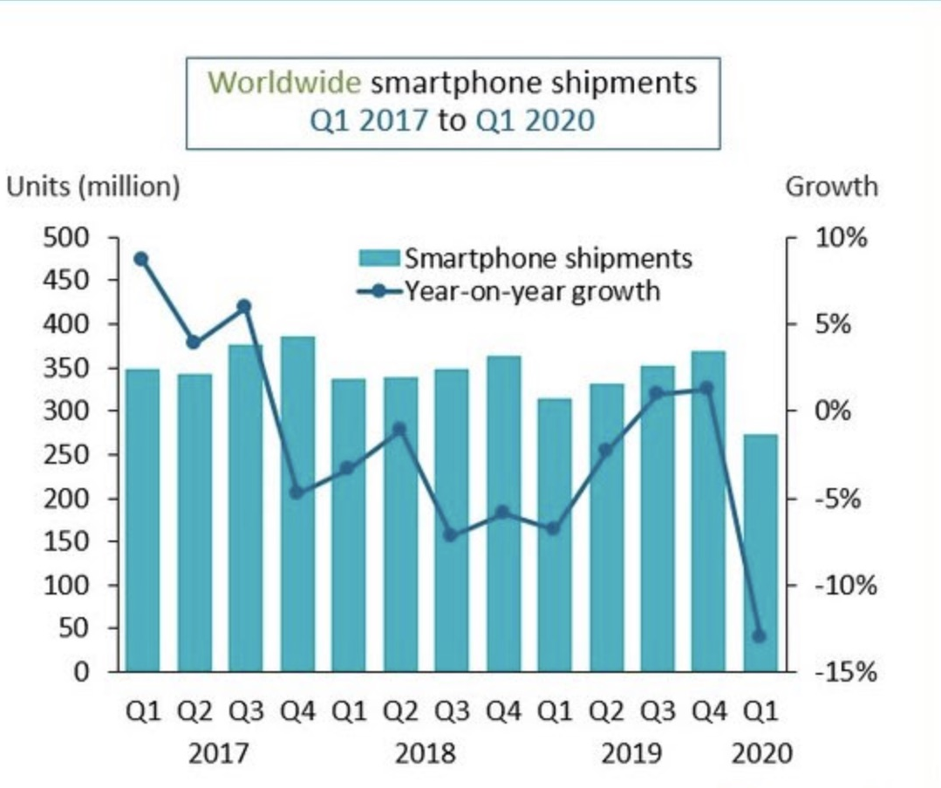
(Heater, 2020)
Samsung's sales and business operations have been significantly impacted by the COVID-19 pandemic because of global economic conditions, which were driven by external events such as the pandemic. Samsung needs to maintain resilience and competitiveness in the global marketplace by remaining agile and adaptable in response to rapidly changing economic conditions as a multinational corporation.
Inflation Rates: Samsung products are in high demand in certain countries due to high inflation rates, resulting in consumers being unable to purchase Samsung products because of lower purchasing power. In contrast, when inflation is low, Samsung's products may be in more demand due to an increase in purchasing power and an increase in buying power. Samsung's smartphone pricing and economic factors can be considerably affected by Argentina's inflationary environment, as inflationary rates can have a significant impact on the costs of raw materials, components, and labour used in the manufacturing process of smartphones in Argentina. There is some concern that Samsung may have a difficult time managing these rising production costs, which will impact its profit margins in the country. Samsung might have to adjust its pricing strategy for smartphones in Argentina to maintain profitability and cover rising costs if it wants to remain competitive. The company will likely need to increase the prices of its devices more frequently compared to markets with lower inflation. This may affect consumer affordability as well as demand for the devices (Lu, 2017).
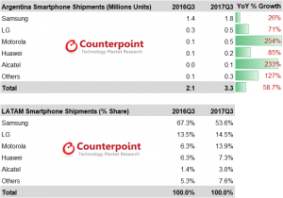
Argentina Smartphone Shipments Ranking and Market Share (Lu, 2017)
In this example, Samsung's operations are clearly illustrated by how inflation impacts their operations, even in the future.
Interest Rates: As a result of interest rates, Samsung's costs may be affected. It is possible, for example, that if Samsung was to take out loans for its operations or expansion, higher interest rates would cause them to be more expensive. There has been a decline in demand for Samsung's smartphones and the semiconductors it supplies to rivals such as Apple, especially in recent times because of rising global interest rates and the cost of living (Aljazeera, 2023). Based on this evidence, we can also conclude that increases or decreases in interest rates are another main factor that impacts Samsung's operations throughout the world.
Unemployment Rates: As a result of high unemployment rates, consumer spending typically decreases, which in turn can reduce Samsung's sales. In contrast, Samsung's products could potentially be in high demand if there is a decrease in unemployment rates.
Legal Stability: The stability of the legal system plays a crucial role in maintaining political stability. The legal systems of countries with strong and stable economies provide Samsung with an environment that is favourable to its business operations. A stable legal framework ensures that property rights, contracts, and intellectual property are protected, allowing Samsung to operate in these markets with confidence knowing that their intellectual property is secure (Lindquist & Martinek, 2010).

Social Factors
As a result of this factor, there are differences between groups from one group to another when it comes to customs, traditions, and practices. There are differences in social status that affect demand for the products and also the willingness of the people to work for the company.
Consumer Preferences: Consumer preferences are changing rapidly, and this change can have a positive impact on one business and a negative impact on the other. It can have both positive and negative impacts on both businesses. There are several socio-cultural forces that brands like Samsung have to take into account to strategize their marketing efforts. Samsung has been able to adapt well to the demands for large-screen smartphones and mobile gadgets within the market for smartphones and tablets for some time now. The company's Galaxy series has been highly popular across several different markets across the globe at the same time. The Samsung Galaxy Note series, according to a 2021 survey conducted the most popular Samsung mobile device among Samsung users, with more than 30 percent of respondents picking this model as the top choice. Nearly 20 percent of respondents preferred the Galaxy Note over the Galaxy A series when it came to respondent preferences (Laricchia, 2020)
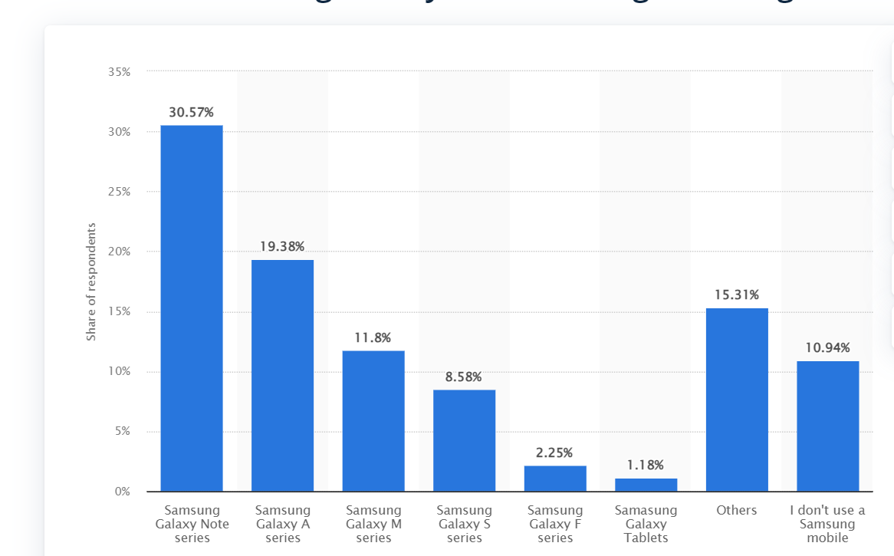
Users' preferred Samsung Galaxy series in June 2021: (Laricchia, 2020)

Lifecycle Trends: Samsung's products can experience a decline in demand as a result of changes in lifestyle trends. It is likely that wearable technology like Samsung's smartwatches, which offer health-tracking features due to an increasing emphasis on health and fitness, will become increasingly popular in the future (Eadicicco, 2023). In addition to this, Samsung has also announced plans to launch a new smartwatch based on the customers' focus on a healthier lifestyle. Samsung's new software will make the sleep scores more visible on the watch's sleep insights screen and make sleep coaching more accessible via the wrist. Based on the sleep patterns a wearer displays, sleep coaching assigns an animal mascot based on those patterns based on patterns they display (Eadicicco, 2023).
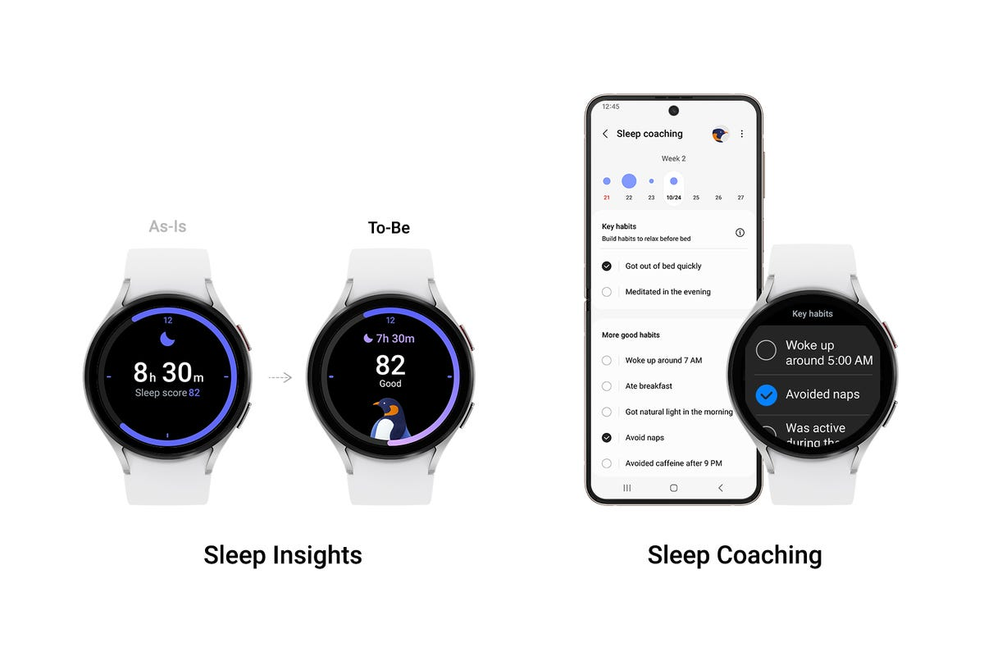
(Eadicicco, 2023)
Demographics: Several factors can impact the market for Samsung, such as the population, the age structure, the income level, and the level of education. Younger populations, for example, may have a greater probability of adopting new technology products quickly than older ones. Samsung, for example, developed the Galaxy A series smartphones to meet the needs of the youth demographic to create a mid-range offering with features aligned with their preferences. The Galaxy A series is positioned as a mid-range offering that offers a blend of performance and affordability. Samsung's Galaxy A series targeting the youth demographic illustrates the importance of demographic factors in the development of products, marketing campaigns, and business strategies of the company (Tantuah, et al., 2022).
Cultural Differences: When it comes to designing and marketing products, Samsung needs to take into account the different preferences and needs of different cultures. Colour symbolism varies from culture to culture, meaning Samsung's color options in different countries might differ depending on the symbolism of color in those cultures.

Technological Factors
Many legal factors can have a negative influence on the operations and decision-making processes of a business, such as laws, regulations, and legal frameworks. As these factors are shaped by the legal systems of the different countries, they can have significant implications for both companies operating on the domestic market as well as for those who operate abroad.
Technological Innovation: There has been a rapid development of technology in the electronics industry in recent years. For Samsung to keep up with the latest technology, it must constantly invest in R&D to keep up with the advancements in screen technology (like OLED and Micro-LED), artificial intelligence, 5G, Internet of Things, etc. To communicate a unique image of a brand, for instance, today's most successful brands are always striving to harness the power of technology to communicate their brand to its maximum potential. It has been Samsung's ability as a technology company to drive innovation to its competitive advantage that has enabled it to remain competitive. To remain competitive in the market, this visionary company has launched numerous innovative products constantly (Fritts, 2021).
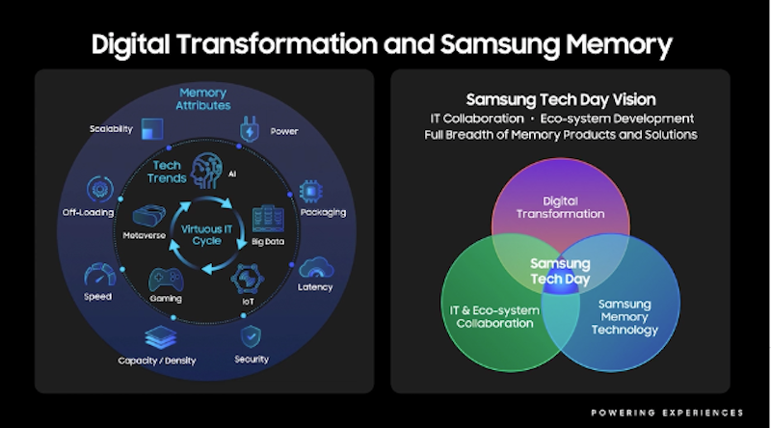
(Fritts, 2021)
Technological Infrastructure: A market's technical infrastructure is one of the factors that can affect Samsung's sales in that market. The roll-out of 5G networks in a region, for instance, can have a significant impact on the demand for smartphones that can support 5G signals. In addition, South Korea has been at the forefront of the deployment of 5G networks in the country and is committed to adopting and expanding 5G technology across the country in a broader sense. A recent example of how Samsung's sales of 5G-enabled smartphones can be affected by the rapid roll-out of 5G networks in South Korea provides a practical example of how technological infrastructure can contribute to sales of 5G-enabled smartphones (Sinha, 2022).
Cybersecurity: A significant concern with the increased digitization and connectivity that we are experiencing today is cybersecurity threats. For Samsung to maintain a strong security presence in its products and protect its information systems from cyber-attacks, it must ensure robust security features (Arghire, 2022). It was revealed in July 2022 that Samsung had fallen victim to a cyberattack that resulted in the personal information of US customers being compromised, as a result of the attack. This particular incident, according to the lawsuit, could have been prevented. Such kind of security issues have also affected Samsung International's operations on a national level (Arghire, 2022).

Legal Factors
It is important to note that legal factors are external forces that can negatively affect the environment in which a company operates. It is important to understand that legal factors are specifically referred to as laws, regulations, and regulatory frameworks that must be adhered to by a company during its operations. The following is a breakdown of how legal factors have an impact on Samsung's PESTEL analysis:
Data Protection and Privacy Laws: The fact that Samsung's devices store or process personal data means that Samsung must comply with several laws relating to data privacy and protection, such as the General Data Protection Regulation (GDPR) in the European Union. As an example, Samsung has been subjected to heavy penalties for imitating Apple's products such as iPads and iPhones by copying them. In the minds of the consumers, the act led to a deterioration of the perception of the brand as well as its image. It is safe to say that the ugly legal battle, which has been ongoing for more than six years, has ended on a positive note for Apple, with them receiving $790 million in 2012 and $120 million in 2017 (Zibreg, 2020). It was a sour turn for the company when its Galaxy Note 7 started exploding all over the world when it first went on sale. There has been a lawsuit filed against the company by 527 dissatisfied customers from South Korea. Some diseased customers are seeking compensatory damages because they have to exchange their devices and they have been psychologically harmed by using a dangerous phone for a long period. Employment and tax laws have to be followed by the company, otherwise, the brand might have to face serious consequences as a result. If a business is not in compliance with the rules, then it may be enjoined to pay fines that can cause huge losses to the company. There have been several documents prepared by Samsung regarding the rules and regulations governing staff and other areas of the workplace (Zibreg, 2020).
Intellectual Property laws: A tech company such as Samsung must make sure that its innovations are protected using patents, trademarks, and copyrights. Furthermore, it should take steps to ensure that its IP rights do not infringe on anyone else's IP rights, as that could trigger a legal dispute in the future. There was a case, for example, in the past when Apple and Samsung filed a lawsuit against each other, alleging that Samsung's smartphones and tablets violated several of Apple's design patents and utility patents, which were alleged to have been infringed upon (Albasoos & Musallami, 2020). Samsung was accused by Apple of copying elements of the iPhone and iPad, such as the design of icons, use of the user interface, and hardware features that were found on the iPhone and iPad. In conclusion, the results of this analysis indicate that leadership factors are also significant for Samsung's operations. In addition to ensuring that their innovations are protected through patents, trademarks, and copyrights, companies such as Samsung must also remain vigilant to ensure that they do not infringe upon others' intellectual property rights. For tech companies to be able to avoid costly legal disputes and maintain their position as industry leaders, a proactive approach to IP protection and respect for the IP rights of their competitors is crucial (Lawson, 2011).
Environmental Laws: Various environmental laws and regulations have to be adhered to for Samsung to meet its responsibilities regarding waste disposal, recycling, energy use, and pollution. Due to Samsung's position as a major manufacturer of electronics, this is of particular importance to our discussion (Korea, 2022). There is a growing demand for more sustainable practices from governments and consumers, for example. For Samsung to develop a sustainable energy strategy and reduce its carbon footprint, environmental laws that promote the use of renewable energy and set carbon neutrality goals are important factors (Korea, 2022). It is in line with this that environmental laws impose guidelines on how electronic waste. (E-Waste) should be handled, disposed of, and recycled according to applicable laws. It is Samsung's responsibility to ensure that it complies with these laws and to minimize the impact of its end-of-life products on the environment by using responsible waste management practices (Korea, 2022).

Environmental Factors
In this context, environmental factors refer to the external factors that have an impact on a business about the natural environment as a whole. Considering the environmental impact of the products and operations of a company like Samsung is essential as well as the responsibility of companies like Samsung to address global concerns regarding sustainability and climate change.
Climate Change: Samsung's supply chain and manufacturing processes can be negatively affected by climate change, especially in terms of the company's supply chain. A climate-related disaster, for instance, can disrupt the supply chain, and regulations that are put in place in response to climate change (such as carbon pricing) can increase the costs of operating a business. Among other things, Samsung has implemented several environmental sustainability programs to tackle climate change and reduce its carbon footprint (Samsung, 2022). Samsung has set ambitious targets for reducing its greenhouse gas emissions across the company's entire operations. The company is continually working to enhance the energy efficiency of its products, which include smartphones, tablets, TVs, and home appliances, as well as its manufacturing, office, and logistics operations. Additionally, Samsung aims to reduce the amount of carbon dioxide emitted from its manufacturing facilities, offices, and logistics operations. Samsung helps consumers reduce the amount of energy they consume and the amount of greenhouse gasses they release each year by designing energy-efficient devices (Samsung, 2022).

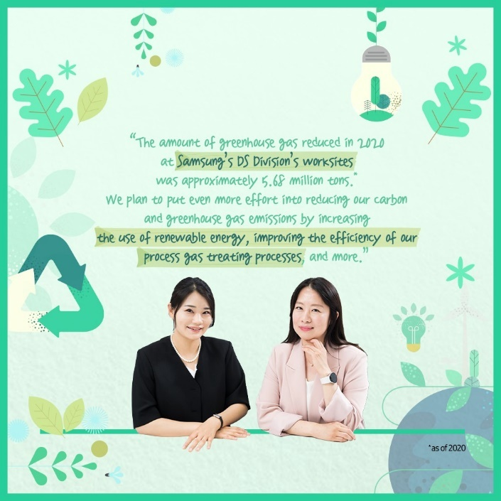
(Samsung, 2022)
Green Products: As the number of "green" products with a lower environmental impact continues to grow, there is a growing market for them. By designing products with lower environmental impact, including recycled materials, Samsung will be able to capture the demand for these products. The Samsung Electronics company, for example, maintains a strict policy of not compromising environmental issues, which ensures that environmentally sensitive substances are closely managed. As part of our commitment to complying with tighter international environmental regulations, we have established the 'Standards for Controlling Substances Used in Products' and have been conducting thorough preliminary inspections and managing the following materials regularly (Samsung, 2022).
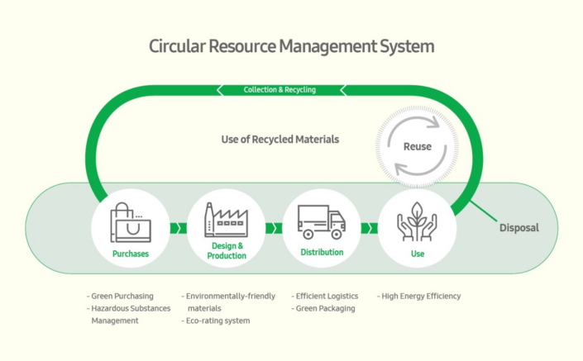
Social Pressure: Consumers, as well as society in general, are becoming increasingly concerned about environmental concerns, and companies are expected to demonstrate their environmental responsibilities as well. The brand image and customer loyalty of Samsung can be influenced by the company's environmental reputation (Moisescu & Gică, 2020). There is an increasing trend among consumers for brands to source their products sustainably and continuously strive to reduce their carbon footprint to satisfy their customers (Shetty & Bhat, 2022).
Environmental Regulations: Samsung's operations, product design, and marketability can be impacted by regulations related to environmental issues (such as carbon emissions, e-waste, energy efficiency, etc.). There has been a successful monitoring of energy costs and indicators at all workstations of the company which has been achieved by installing energy management systems. Besides that, the brand has a policy in place regarding the management of chemical substances that have been outlined and enforced. As a result of the company's commitment to reducing greenhouse gas emissions considerably throughout the product's lifecycle, the company has set very specific targets to meet. Additionally, they have developed a framework that has been well-established for managing the GHG emissions that are associated with product logistics, business travel, etc. Besides this, they also monitor the greenhouse gas emissions of their suppliers, as well as their own (Strategy story, 2022).

Conclusion
After analyzing Samsung's internationalization strategy as well as the impact of contextual factors, as well as considering legal, environmental, and other factors relevant to the case, this study sheds light on the complexities and challenges facing Samsung in the global market today, as well as the approach it has taken in the past. To maintain corporate culture and values across Samsung's international subsidiaries, the company has adopted an ethnocentric approach to internationalization, which involves key decisions being taken at its South Korean headquarters, which has allowed the company to maintain control and preserve its corporate culture across its global subsidiaries. As part of the study, the PESTLE analysis was used to analyze the context of the study and it showed how political, economic, social, technological, legal, and environmental factors can have an important effect on the internationalization strategy of Samsung.

Recommendation’s
Based on the above analysis, we recommend the following recommendations for Samsung's future internationalization and business strategy based on the findings:
Continuous Market Research: Samsung should continue to invest in market research and contextual analysis to remain informed about what is happening in its target markets in terms of political, economic, social, technological, legal, and environmental changes. Samsung will be better able to meet local demands if it understands these factors to develop products and strategies that are appropriate.
Economic agility: During economic downturns, Samsung needs to build resilience into its business by implementing flexible cost management and diversifying its product portfolio to be able to cater to changing consumer preferences as well as meet the needs of changing economic conditions.
Sustainable Innovation: Samsung should continue to be committed to sustainability and eco-friendly practices as a part of its corporate culture. A company that integrates sustainable product designs, eco-packaging, and responsible waste management will not only reduce the impact on the environment but will also enhance its reputation among customers who care about the environment.
Legal Compliance and IP Protection: To ensure robust protection of its intellectual property rights, Samsung must remain vigilant about adhering to legal regulations and adhering to its legal obligations. To maintain Samsung's dominant position in the market, proactive measures can be taken to avoid infringing on the IP rights of competitors and help prevent legal disputes from occurring.
To maintain its commitment to sustainability and responsible business practices, Samsung must adopt these recommendations if it is to ensure long-term success in the global market and ensure its success in the age of globalization, while also strengthening its international presence and maintaining positive consumer perception.

References
Albasoos, H. & Musallami, N. A., 2020. The conflict between Apple and Samsung over patents and copyrights. Bussecon Review of Social Sciences, pp. 1-17.
Aljazeera, 2023. Samsung says it expects the lowest quarterly profit in 8 years. [Online]
Available at: https://www.aljazeera.com/economy/2023/1/6/samsung-says-it-expects-lowest-quarterly-profit-in-8-years
[Accessed 6 JAN 2023].
Arghire, B., 2022. Samsung Sued Over Recent Data Breaches. [Online]
Available at: https://www.securityweek.com/samsung-sued-over-recent-data-breaches/#:~:text=Scroll%20to%20continue%20reading.,claims%2C%20could%20have%20been%20prevented.
[Accessed 27 Sep 2022].
Banka, N., 2020. Explained: Why have North Korea and South Korea stopped talking?. [Online]
Available at: https://indianexpress.com/article/explained/explained-why-has-communication-stopped-between-north-korea-and-south-kore
[Accessed 19 june 2020].
Bondarenko, P., 2023. Samsung. [Online]
Available at: https://www.britannica.com/topic/Samsung-Electronics
[Accessed 26 july 2023].
BOROWIEC, S., 2023. THAAD missile system agitates South Korea-China ties. [Online]
Available at: https://asia.nikkei.com/Politics/International-relations/THAAD-missile-system-agitates-South-Korea-China-ti
[Accessed 22 june 2023].
Byung-yeul, B., 2023. Why aren't Samsung smartphones selling in China?. [Online]
Available at: https://www.koreatimes.co.kr/www/tech/2023/07/129_260437.html
Choi, k., 2022. International Staffing and Expatriate Management:A Case of Samsung Electronics. [Online]
Available at: https://onstarplus.com/archives/3163
[Accessed 4 march 2022].
Çitilci, M. A., 2019. The-Importance-of-PESTEL-Analysis-for-Environmental-Scanning-Process. Research on Decision-Making Techniques in Financial Marketing, pp. 336-357.
Eadicicco, L., 2023. New Galaxy Watches coming later this year will be the first to get Samsung's new software, which is full of sleep and wellness updates.. [Online]
Available at: https://www.cnet.com/tech/mobile/samsung-teases-new-sleep-and-health-features-for-upcoming-galaxy-watches/
[Accessed 5 may 2023].
ET, 2020. Samsung to focus on local R&D, undertake new manufacturing initiatives. [Online]
Available at: https://economictimes.indiatimes.com/industry/cons-products/electronics/samsung-to-focus-on-local-rd-undertake-new-manufacturing-initiatives/articleshow/79646471.cms
[Accessed 9 dec 2020].
Fritts, H., 2021. Samsung Tech Day 2021 Highlights New Technology, Innovation and Collaboration. [Online]
Available at: https://www.storagereview.com/news/samsung-tech-day-2021-highlights-new-technology-innovation-and-collaboration
[Accessed 27 NOV 2021].
Hani, 2018. Samsung Electronics’ share of Chinese smartphone market drops below 1%. [Online]
Available at: https://english.hani.co.kr/arti/english_edition/e_business/839497.html
Heater, B., 2020. Smartphone shipments dropped 13% globally, and COVID-19 is to blame. [Online]
Available at: https://techcrunch.com/2020/04/30/smartphone-shipments-dropped-13-globally-and-covid-19-is-to-blame/
[Accessed 1 MAY 2020].
Jaewon, K., 2022. Samsung braces for prolonged geopolitical and economic fallout. [Online]
Available at: https://asia.nikkei.com/Business/Technology/Samsung-braces-for-prolonged-geopolitical-and-economic-fallout
[Accessed 28 april 2022].
Korea, 2022. Samsung Electronics Announces New Environmental Strategy. [Online]
[Accessed 22https://news.samsung.com/global/samsung-electronics-announces-new-environmental-strategy sep 2022].
Laricchia, F., 2020. Preferred Samsung Galaxy series among Samsung users as of June 2021. [Online]
Available at: https://www.statista.com/statistics/1298436/samsung-galaxy-model-preference/
[Accessed 27 JUNE 2020].
Laricchia, F., 2023. Samsung's market share of global smartphone shipments 2009-2023, by quarter. [Online]
Available at: https://www.statista.com/statistics/276477/global-market-share-held-by-samsung-smartphones/#:~:text=As%20the%20overall%20smartphone%20market,smartphone%20shipments%20worldwide%20in%202022.
[Accessed 15 june 2023].
Lawson, S., 2011. Apple sues Samsung, says it copied iPad. [Online]
Available at: https://www.computerworld.com/article/2743572/apple-sues-samsung--says-it-copied-ipad.html
[Accessed 19 april 2011].
Lindquist, S. & Martinek, W. L., 2010. Legal Stability and Economic Growth. Research gate, pp. 1-10.
Lu, T., 2017. Strong Macroeconomic Conditions Are Driving Argentina’s Smartphone Market Growth. [Online]
Available at: https://www.counterpointresearch.com/strong-macroeconomic-conditions-driving-argentinas-smartphone-market-growth/
[Accessed 15 dec 2017].
Maizland, L., 2021. China’s Fight Against Climate Change and Environmental Degradation. [Online]
Available at: https://www.cfr.org/backgrounder/china-climate-change-policies-environmental-degradation
[Accessed 19 MAY 2021].
Moisescu, O.-I. & Gică, O.-A., 2020. The Impact of Environmental and Social Responsibility on Customer Loyalty: A Multigroup Analysis among Generations X and Y. Int J Environ Res Public Health. , pp. 1-12.
Samsung, 2022. Only One Earth: Samsung’s Efforts To Reduce Carbon Emissions, As Told by Samsung Employees ②. [Online]
Available at: https://news.samsung.com/global/only-one-earth-samsungs-efforts-to-reduce-carbon-emissions-as-told-by-samsung-employees-2
[Accessed 10 JUNE 2022].
Samsung, 2022. Our Environmentally Conscious products make for a healthy planet. [Online]
Available at: https://www.samsung.com/us/aboutsamsung/sustainability/environment/eco-conscious-products/
Shetty, K. A. & Bhat, S., 2022. Advancement and Contribution of Mobile Smartphones to the Consumer. Research gate, pp. 1-11.
Simonin, D., 2014. International Strategy: The Strategy of Samsung Group. Research gate, pp. 1-9.
Sinha, M., 2022. What India can learn from South Korea on 5G. [Online]
Available at: https://www.businesstoday.in/opinion/columns/story/what-india-can-learn-from-south-korea-on-5g-321552-2022-02-05
[Accessed 5 feb 2022].
Sodani, P., 2021. How COVID-19 is Affecting the Smartphone Industry. [Online]
Available at: https://www.latentview.com/blog/how-covid-19-is-affecting-the-smartphone-industry/
[Accessed 21 FEB 2021].
Strategy story, 2022. Samsung PESTEL Analysis. [Online]
Available at: https://thestrategystory.com/blog/samsung-pestel-analysis/#:~:text=Inflation%20Rates%3A%20High%20inflation%20rates,rates%20can%20impact%20Samsung's%20costs
Tantuah, b. N. N., Satria, H. W. & Azzahra, G., 2022. Advertising Strategy for Samsung Galaxy Series Mobile Phones on Through the Line Media during The COVID-19 Pandemic in Indonesia †. Proceedings, pp. 1-11.
Zibreg, C., 2020. Samsung straight up stole Apple’s Face ID icon. [Online]
Available at: https://www.idownloadblog.com/2020/01/07/samsung-steals-face-id-icon/
[Accessed 7 JAN 2020].

