Name: Emmanuel Awose Oamhen
Student ID: 1709489
Course title: Effective Team Working and Communication
Lectural name: Richard Small

EFFECTIVE TEAMWORK AND COMMUNICATION
Executive summary
This report focuses on the significance of effective communications which are discussed in details in this study. Additionally, the theory and the models of efficient communications are discussed and its effect on the particular organizations performed when it is applied. The company Tesco is therefore applicable to make the study more effective. Lastly the appropriate outcome along with the advantage of the effective teamwork and the communications are determined.

Table of Contents

Introduction 4
Effective communication in definition 4
Verbal and nonverbal communication 5
Workplace communication theories 5
Effective communication to improve productivity 9
Conclusion 11
Reference list 12

Introduction
The communications is the efficient tool which is further used in an organization to conduct the conduct the messages efficiently. Additionally, the theory and the models of efficient communications are discussed and its effect on the particular organizations performed when it is applied. The company Tesco is therefore applicable to make the study more effective. Lastly the appropriate outcome along with the advantage of the effective teamwork and the communications are determined. The importance of communication and teamwork convey out the proper result towards the organization. It helps to develop the productivity and the fundamentals of the organization. Moreover in the report, a detailed definition of the efficient communication will be displayed along with the benefits towards the firm. Furthermore, a various different type of non-verbal as well as verbal communications will be detailed with the provided example. The theory of the workplace communications of Shannon and Belbin waver model of the communications will further add some value to the process of making decision. The main motive of the study is to analyze the advantage which is provided by the communications and the teamwork to organizations to struggle some of the challenges and bring some development in the performance. Thus, at the end of the report, the role and the result which the effective communication and the teamwork will play will be detailed in the conclusion.(Sherman et al. 2017).

Effective communication in definition
Effective communication is a mutual skill and it is a process by which the messages are transmitted towards the receiver as well as it is learned in such a way it was calculated. Therefore the communications in such determined way with an objective to make sure that the messages are understood by the receiver and the sender. In a particular organization, it is significant to convey the efficient communications as it permits the organizations to run them significantly and to develop the productivity. Efficient communications serves the efficient advantage to the team a sit permits the team members to learn the responsibility and the important role to the other members of the team.
On the other side the efficient communications are also valuable for working cooperatively develops the huge range of various ways to work with the other organization to improve the quality of the service and the product. Therefore, it is also important to solve some issues related to the classified activities, which share the responsibility and the ownership and thus it also decreases the personnel and make the fundamentals more effective. In Tesco, the efficient communication with the customers serves the identical advantage towards the firm to increase the profit and therefore develop the loyalty in between the customers. Additionally, the organization also launched late type of software to communicate dynamically with the suppliers to develop the quality of the service.

Verbal and nonverbal communication
Verbal communications refers to the exchange of certain information among the customers by using some valuable words as well as speech. Some significant examples of the verbal communications involve interview and the meetings. In order to develop or negotiate the idea, the verbal communications refers to an identical tool. It also provides some of the efficient advantage to decrease the confusion and achieve a huge range of idea which is much valuable for the business. A team consists of various numbers of people and thus it brings the different and the valuable form of the idea. By an efficient negotiation within the team, one can get across the latest ideas that can hence develop the entire performance. The new strategy and idea develop the group negotiation supports the organization helps the organization the quality of the service (Driskell et al. 2017).
Non-verbal Communication
It is the exchange of cerate information in between the people by receiving and sending the wordless clues. The various visual clues are used to cooperate during the non-verbal communications such as the facial expressions, body language, shaking hands and so on. The advantage and non-verbal communications serves a short and the brief, save the time, to some extent of the time and many more. Therefore, the primary key benefits that the non-verbal communications serves to communicate in the further place where there are very much important to maintain it in silence. (Neill, 2017)
Verbal communication and non verbal communication both are practiced in the workplace of the organization Tesco. The verbal communication such as face to face communication, meeting supports to communicate significant information within the workplace.

Workplace communication theories
For the efficient communications within the workplace, the Tesco Company has been selected to make a efficient making discussions. Furthermore, the weakness of these team might be the tendency to be intensive and in making the decision and discussion to maintain uncommitted position. The Belbin theory plays the relevant role to understand the strength and weakness which organization comprises of. Furthermore, by effective determining the firm can effectively bring improvement to the performance if the team. The theory of Belbin is the categories in the nine subheadings such as Investigator, Coordinator, Plant, Monitor Evaluator, Specialist, Shaper, Implementer and Completer Finisher. In this report, the main focus will be done by the team worker as well as the coordinator subheading of the belbin theory. Hence this theory will provide some important support to the Tesco to bring the development in the work as well as maximize the performance of the team.
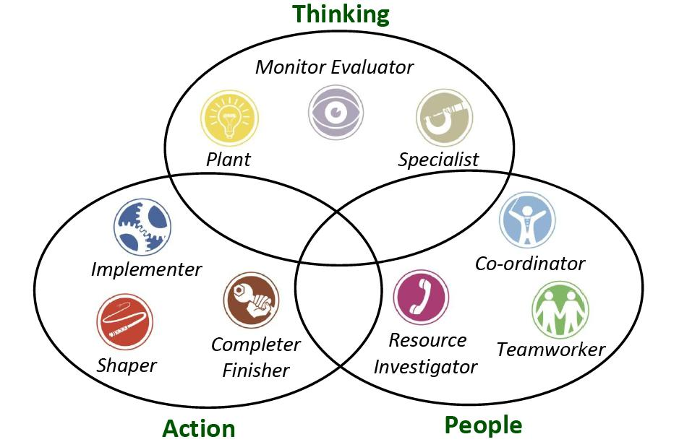
“
Figure 1.1: Belbin Theory of team structure
(Source: Bolman and Deal, 2017)

Group dynamic theories
The group dynamic theories are very essential factors as it supports the ideology to enhance organizational behavior. It emphasizes on the development of communication skills of the employees who work in an organization. It also helps in conveying appropriate messages and information to the service users. There are various aspects of the group dynamic theory which are followed in a particular organization and result in good productivity. This also enhances the communication skills of the staff members inside an organization.
In accordance to Bolman and Deal (2017), in Tesco, the apprehension the workplace lays a great impact on the employees. They are provided with proper guidance about tackling the customers without misconception.
Working in a team leads to the better performance of the organization and the employees working inside. These theories contribute in establishing the authenticated goals of the organization. This also develops the mutuality among the staff members and motivates them to inculcate the upgraded strategies into their performance in order to satisfy their customers. This also helps in time management
Thus, it can be stated that group dynamic theories are the most crucial implementation which has to be inculcated in an organization in order to achieve heights.
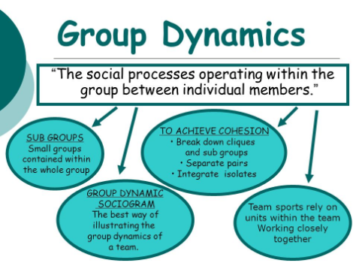
Figure 1.2: Group Dynamics
Source Mathieu (2017)

As opined by Shannon Weaver model of communication, the under laid concepts must be followed in an organization in order to enhance the communication skills of the work apprehension (Mathieu et al. 2017).
Sender- senders are the person who takes the initiative to make messages and choose an appropriate channel to send it. Example: businessman.
Encoder- these are the person who converts the messages into binary language using machine into the appropriate language so that it is understood by the receiver. Example: Telecom Company.
Channel- it is referred to as the medium through which the message can be conveyed. For instance: mobile network.
Decoder- decoder is a machine which is able to convert the binary data into the message for the convenience of the receiver (Ghaferi and Dimick, 2016).
Receiver- it is referred to the person who is about to receive the message. Once the receiver gets the message, they are supposed to provide appropriate feedback through a channel based on the message they receive.
Noise- in accordance to (Grosset al. 2016).it can be stated as the physical disturbance in the context of the message and this throws a great impact on the receiver
By acknowledging the Shannon Weaver model of communication, Tesco is able to improve their strategic analysis in the context of their communicating skills and put efforts to enhance them.

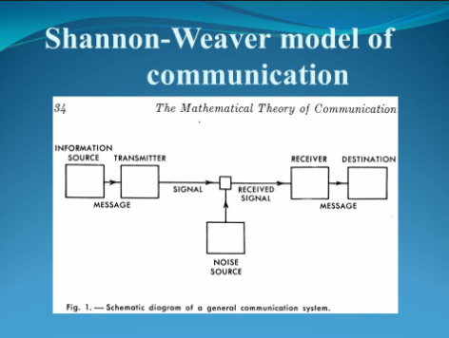
Figure 1.3: Shannon Weaver Model of Communication
(Source: Yadava , 2016)

Berol’s model of communication also plays a major role in upbringing the efficiency of the organization. This model comprises of four different categories sender, message, channel and the receiver. This model also contributes in increasing the efficiency of communication skills. As it throws a major impact on the receiver and yield Tesco the golden opportunities to enhance their productivity (Yadava et al. 2017).

Effective communication to improve productivity
Effective communication results in efficient teamwork and achievement in authenticated organizational goals. According to (Hassell and Cotton, 2017), communication skills of an organization contribute in higher productivity as the employees have clear perception of the information in context of the task they are required to perform. It also results in accountability among the employees. In order to enhance the communicational skills of the organization, it is necessary to develop the interpersonal skills of the employees such as the way of carrying themselves, behavior, personality etc. In accordance to (Culache, 2017), communication skills throws a great impact on the organization as it plays a crucial role in improving the productivity and the amount of customer satisfaction. This also increases the profit margin of the organization. Communication skills must be developed in the writing field also.
Written communication also helps in reaching the authenticated goals and this helps the employees in much better way. They get a clear perception about the information which are being provided to them. In general, communication is of two type, verbal and written. Both the forms of communication provide a greater help in achieving goals. There are no such problems faced with the verbal communication that of the syntax cal error or the grammatical mistake while these can result in misconception and bewildering. Communication can be conducted with various levels of people either the employees or the service users.

Benefits of effective communication
Effective communication is the key factor in an organization to enhance its productivity. In the words of (Brock et al. 2017) good and flexible communication results in better performance of the employees in a team. It makes the decision making process easier and avoid misinterpretation of information. Along with this, the employees feel at ease and have the sense of job satisfaction. Additionally, misconceptions are lessened and hence productivity is increased and also lessens the burden of the employees.
Inside an organization, there are also various barriers to the communication which often works as hurdles in productivity. To enhance the work efficiency of the organization, the relationship among the employees must be strengthened and flexible communication must be maintained. It provides nourishment to the efficiency of the employees and improves their skills and develops their knowledge. Along with this, it is also necessary to maintain peace at the workplace as it provides mental relief to the employees.
Furthermore, it is very important for the management to admire the efficient means of enhancing the productivity of their organization. In the words of Mesmer et al. (2017), the team must be guided by an efficient leader and they must maintain a flexible and clear form of communication so that employees are able to perform accordingly.

Conclusion
It has been concluded from the above study that efficient communicative skills are essential in order to reach authenticated organizational goals and profit maximization. Here, it has also been highlighted about customer satisfaction which is a major responsibility of an organization. Here, in context to Tesco, the various theories of communication and the benefits of their implementation are also discussed. Along with this, up gradation of various strategies are also focused on. The adaptations of various strategies in order to satisfy the customers and fulfill their requirements are the foremost responsibility of an organization. In this study, the communicational theories are elaborated in order to explain their implementation in an organization. Here, it has also been focused on the importance of teamwork which greatly contributes in the success of an organization with efficient productivity and customer satisfaction. Thus, it can state that communication is the vital factor of every organization.

Reference list
Bolman, L.G. and Deal, T.E., 2017. Reframing organizations: Artistry, choice, and leadership. John Wiley & Sons.
Brock, S.E., Brock, S.E., McAliney, P.J., McAliney, P.J., Ma, C.H., Ma, C.H., Sen, A. and Sen, A., 2017. Toward more practical measurement of teamwork skills. Journal of Workplace Learning, 29(2), pp.124-133.
Burgoon, J.K., Guerrero, L.K. and Floyd, K., 2016. Nonverbal communication. Routledge.
Burke, W.W., 2017. Organization change: Theory and practice. Sage Publications.
Culache, O., 2017. SHIFTING FROM CHANNELS AND CODES TO MODES: A RECONCEPTUALIZATION OF BRAND COMMUNICATION VIA MULTIMODALITY. TICS, p.717.
Driskell, T., Driskell, J.E., Burke, C.S. and Salas, E., 2017. Team Roles: A Review and Integration. Small Group Research, p.1046496417711529.
Enns, L.N., Barrieau, L.E., Stack, D.M., Serbin, L.A., Ledingham, J.E. and Schwartzman, A.E., 2016. Verbal and nonverbal communication in at-risk mother-child dyads: Implications for relationship quality and developing positive social behaviours in middle-childhood. European Journal of Developmental Psychology, 13(1), pp.1-19.
Ghaferi, A.A. and Dimick, J.B., 2016. Importance of teamwork, communication and culture on failure‐to‐rescue in the elderly. British Journal of Surgery, 103(2).
Gross, A.H., Leib, R.K., Tonachel, A., Tonachel, R., Bowers, D.M., Burnard, R.A., Rhinehart, C.A., Valentim, R. and Bunnell, C.A., 2016. Teamwork and Electronic Health Record Implementation: A Case Study of Preserving Effective Communication and Mutual Trust in a Changing Environment. Journal of oncology practice, 12(11), pp.1075-1083.
Hassell, M.D. and Cotton, J.L., 2017. Some things are better left unseen: Toward more effective communication and team performance in video-mediated interactions. Computers in Human Behavior, 73, pp.200-208.
Kasasbeh, M.A.M., McCabe, C. and Payne, S., 2017. Action learning: an effective way to improve cancer‐related pain management. Journal of clinical nursing.
Mathieu, J.E., Hollenbeck, J.R., van Knippenberg, D. and Ilgen, D.R., 2017. A century of work teams in the Journal of Applied Psychology. Journal of Applied Psychology, 102(3), p.452.
Mesmer-Magnus, J., Mesmer-Magnus, J., Niler, A.A., Niler, A.A., Plummer, G., Plummer, G., Larson, L.E., Larson, L.E., DeChurch, L.A. and DeChurch, L.A., 2017. The cognitive underpinnings of effective teamwork: a continuation. Career Development International, 22(5), pp.507-519.
Neill, S., 2017. Classroom nonverbal communication. Routledge.
Reising, D.L., Carr, D.E., Gindling, S., Barnes, R., Garletts, D. and Ozdogan, Z., 2017. Team Communication Influence on Procedure Performance: Findings From Interprofessional Simulations with Nursing and Medical Students. Nursing education perspectives, 38(5), pp.275-276.
Sherman, J.M., Chang, T.P., Ziv, N. and Nager, A.L., 2017. Barriers to Effective Teamwork Relating to Pediatric Resuscitations: Perceptions of Pediatric Emergency Medicine Staff. Pediatric emergency care.
Sweet, B.V., Madeo, A., Fitzgerald, M., House, J.B., Pardee, M., Zebrack, B., Sweier, D., Hornyak, J., Arslanian-Engoren, C., Mattison, D. and Dubin, L., 2017. Moving from individual roles to functional teams:.
Wang, N. and Li, B., 2017, June. Proceedings a Model of Deceitful Information Communication: Some Views on Theory and Practice of Semantic Information. In Multidisciplinary Digital Publishing Institute Proceedings (Vol. 1, No. 3, p. 127).
Weller, J. and Civil, I., 2017. Teamwork and healthcare simulation. Healthcare Simulation Education: Evidence, Theory and Practice, pp.127-134.
Yadava, U., Eswara, H.E. and Rahim, A., 2017. Unit-2 Models of Communication.

