
Social Trends & Consumerism (M5X01285)
Todor Stoykov 1702643
With reference to established Marketing concepts, critically evaluate the opportunities and challenges being presented to the Motorsport industry by the growth of social networking.
Abstract
Nowadays, social networking is a lot more than just a platform where we communicate with people online. Moreover, it has changed people’s approach to their daily lives and the way we keep in touch with each other. (Smith, 2010) Since technological advancements are constant, so does the social networking growth. Furthermore, this has resulted in organizations using social networking to learn more about their potential customers. The constantly emerging new ways of using social networking and the growing number of users’ means there is an increase in the online information all the time. The time people spend online is growing, so how we protect the information we have online and share is from significant importance nowadays. (Smith, 2010) Firms need to plan the best way to use this data when reaching customers online. Social graph is becoming the online symbol of people’s personalities, that’s why a unique social graph is from key importance for all new organizations in the online world nowadays. The full potential of social networking is yet to be discovered. In order we need to understand how we open new contents, collect information and use it in the online world. (Smith, 2010)
Introduction
Thanks to the growth of social networking motorsport fans online today, have access to more content than ever, with live streams, analysis, statistics and information. Social networking has an enormous impact on the motorsport industry in terms of advertisement, broadcasting, social media, sponsorship and merchandise. Furthermore, this work will address the impact of social networking on the motorsport industry by reviewing some of the key challenges that the online world has brought to the industry and the solutions that were made to maximize the potential of social networks usage since 2011.
Motorsports Industry
Nowadays, motorsports is a $5 billion international industry. (The Industry at a Glance , 2017) Study journals show that the motorsports earnings have grown by 12 percent and since the year of 2011 the overall return has increased by $1 billion. (The Industry at a Glance , 2017) Moreover, in 2017 the motorsports industry has accounted nearly $6 billion in annual income globally. (The Industry at a Glance , 2017)To continue with, the revenue in this industry is influenced by a big number of factors. The most important elements that generate the global motorsports industry income include sponsorship, advertising, media and broadcasting as well as event attendance and merchandise. (The Industry at a Glance , 2017) Here is how the annual revenue soared in the last years:
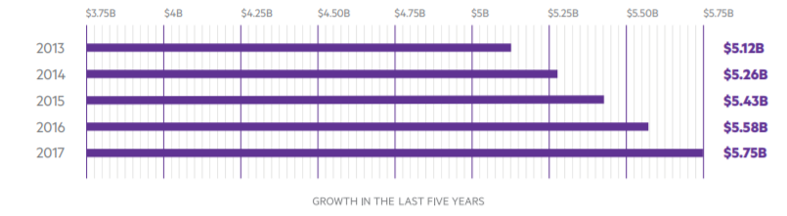
Sponsors in Motorsports
Sponsorship is distinguished as a key part of the motorsports industry that drives the sport forwards. (The Industry at a Glance , 2017) The industry has become so popular through the years that non-endemic sponsors are part of the sport as much as the endemic sponsors. Furthermore, motorsports has an enthusiastic fan base that sees the importance that sponsors provide for the sport, which really makes the motorsport fan base the most brand-loyal amongst other types of sports and entertainment. For brands that are investing in the sport there are a couple of different points where they can build a connection with the fans including investments in teams, drivers, racing circuits or broadcasting media. (The Industry at a Glance , 2017)
Advertising in Motorsports
There are other methods of investing in motorsports other than investing in a team, driver, track or venue. Moreover, brands can purchase the broadcast rights of racing series or inventory, for instance commercial advertising or advertising on race venues with branded content on the circuit. Furthermore, these can be seen as just general time buy or just sponsorship during the broadcast.
Commercial Trends in Motorsports
Just like right holders and brands investing in any professional sport in today’s world, motorsport’s stakeholders are working in a new changed world of marketing. (Commercial trends in Motorsport, 2017) The current market state led by technology advancements is established as a period of rapid changes and great competition for attention. Furthermore, it’s a period where customers matter more than ever. With the growth of social networking, fans of the sport want the ability to watch what they want, in the way they want and wherever they want. (Commercial trends in Motorsport, 2017)Moreover, this results in stakeholders and sponsoring brands in motorsport having to adapt to the new customer driven market and online world. Nowadays the motorsport industry has to fight to keep the fans attention and interest as new technological developments emerge like the virtual reality, the fast growing interest for eSports (Electronic Sports) and the disintegrating media views. In the last year the eSports industry is known to reach almost $1 billion revenue. (Gray, 2018)
IP owners taking control
We are living in a world where everyone has the opportunity to create and distribute their own product. A good example for this is the purchase of Formula One by Liberty Media. (Commercial trends in Motorsport, 2017) In an era where anyone cloud broadcast online, the quality of the content is gaining great value. This is why partnerships between right holders and different brands are being made over content. The goal is to establish a stronger and better connection with the fan base interested in the sport and to deliver the access that fan base is seeking for venues, drivers and teams. In the motorsport industry Red Bull is famous for setting the standard for brands producing inside content. In 2017 Monster Energy generated new partnership with NASCAR as well as sponsoring Formula One’s world champion Lewis Hamilton. (Commercial trends in Motorsport, 2017) To continue with, the fast growing social networking will affect approved broadcasters by making them more open for branded content with sponsors. In this rapidly changing environment, understanding the customers demand could be a key factor for success. (Commercial trends in Motorsport, 2017)

Audience challenge
Today’s viewers’ habits are changing fast, now having great world connection and more demands on their time and of course the rising competition for their investment in the product. (Commercial trends in Motorsport, 2017) To continue with, stakeholders and sponsoring companies are already seeking for new audience and at the same time trying everything they can to retain the existing ones. Moreover, a successful right holder is agile and willing to comply with the new customers’ demands, in terms of media plan as well as the overlook of their product. In this industry that could result in changes of the race venue formats, fans featuring experiences or even drivers getting interviewed during races. Brands, stakeholders and broadcasters are constantly seeking for new better formats of venues. In that manor NASCAR introduced stage racing from the 2017 season which divided the actual race into 3 parts with natural break after every stage for advertising. (Commercial trends in Motorsport, 2017) Furthermore, flexibility and understanding the changing fans demand are looking to be the key features in stakeholders’ plan. The new successful strategy should balance between the changes made to improve the product and still making sure to keep the current audience. Here is a look of the media type that was mostly used by fans around the world in 2013 and 2016:
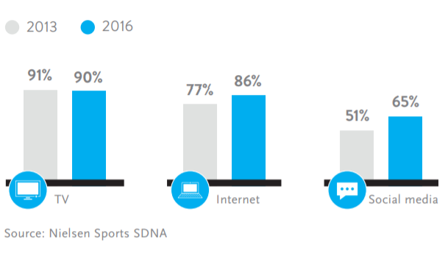
Entertainment
As an industry driven by the loyalty of the fans, motorsports right holders and event organizers are always looking for an improvement of the fans’ experience at the venues by adding some entertaining elements like live concerts before venues or during endurance races, other elements include more fans access in the pits and near drivers and teams. (Commercial trends in Motorsport, 2017) Furthermore, at the 2016 United States Formula One Gran Prix, Taylor Swift performed the night before the race. Live performances have become a common part of motorsports venues nowadays with NASCAR having a pre-race concert tradition for the last decades which not only makes the experience better for the audience, but also develops an opportunity for extended coverage of the event which, if organized properly makes a room for more advertisement activities for partnership brands. (Commercial trends in Motorsport, 2017) These events can also be seen as an opportunity to attract new younger audience. Furthermore, investments in this area are likely to continue and grow because of the success they carry. Moreover, the American racing team Chip Ganassi Racing started hosting series of special concerts for their fans at the teams’ base in Indycar and NASCAR venues. (Commercial trends in Motorsport, 2017) As social networking keeps making the world more connected the demand from the audience and companies for a more exposed behind the scenes look and experience in the big motorsport venues. More and more events are being made as big festivals with live music, celebrity guests, fan zones and ceremonies. Capital city centers are becoming the perfect stage for motorsport venues in terms of advertising the sport by making car demonstrations and fan activities. City racing is getting more and more popular thanks to Formula E. (Sustainabilty of Formula E, 2016) Moreover, the fully electric cars don’t cause any pollution at all and also making the sport more attractive to watch and easier for the audience to reach. (Sustainabilty of Formula E, 2016)Here is a look on the motorsports fans interests in entertainment activities:
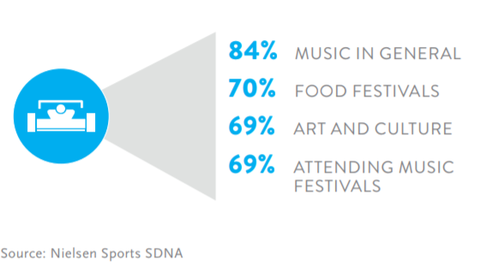
Motorsports growth in social media
Thanks to advancements in technology and the growing social networking, fans’ expectations grow as well. Nowadays’ audience expects quality live broadcasting, on demand coverage and available information with statistics and analysis. (Commercial trends in Motorsport, 2017) To continue with, most of the leading motorsport series are still relying on the classic live broadcast audience and copy rights income. Moreover, new opportunities emerge for the right holders which include direct delivery of the content to the customers. Furthermore, NASCAR’s Race View and MotoGP’ Video Pass are pretty clear examples of indoor product delivery. (Commercial trends in Motorsport, 2017) On the other hand Formula One has made a decision to pay television in different key markets which is also making room for more branded content and new sponsorship deals. The challenge lying on rights holders in the modern world is to balance the product selling between free to air broadcast, the paid television broadcast and the indoor digital platforms and social media. Moreover, famous drivers have their social media accounts where they share their experiences around the championships and also their personal life. Star drivers’ accounts are followed by large fan base, increasing all the time.
Fans connection with the sport
With nowadays’ social networking level the connection between fans and motorsports can be established in the social medias Twitter, Facebook and Instagram where people can follow their favorite series, teams and drivers. Moreover, in the recent years Snapchat, 360 videos and the introduction of VR become new ways to engage fans. The mobility of today’s first world shows massive potential for new income opportunities. Furthermore, these platforms are on their own different level of development and they constantly evolve so the successful investors already started working on ways to take advantage of this. For example, brands can be featured in live stream videos posted on social media as the partnership between Visa and the FIA Formula E series is. To continue with, the live streaming features in Facebook and Twitter bring the opportunity for the teams to come up with additional content for example Formula One made its first social media live broadcast with Facebook at the Abu Dhabi Grand Prix back in 2016. Moreover, McLaren has developed their own live app which gives the fans and exclusive live view of the car telemetry directly broadcasted from the pits during a race. After Formula One was bought by Liberty Media, the new owners softened the restrictions on drivers and teams uploading content on the social media. The better data collection because of the closer interaction between the customers and the brands leads to enhanced and more than ever personalized content and new revenue streams.
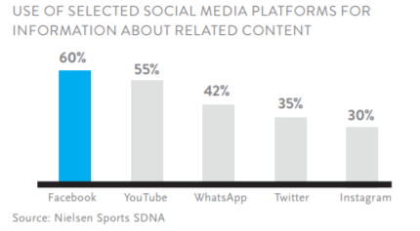
The growing force of eSports
The fast growing eSports industry is being discussed a lot, as the electronic sports have big fan base and in long term plan, motorsports may clash with eSports in competition for the fans attention and sponsor acquisition. (Commercial trends in Motorsport, 2017) Furthermore, eSports are still in an early development process in terms of advertisement but some motorsport organizations view this as a way to engage a younger audience. For example Nissan partnership with PlayStation brought to life the GT Academy together giving opportunity to young talented drivers to become professional racing drivers. (Commercial trends in Motorsport, 2017) Moreover this program showed great success turning gamers into race winners in the real world. To continue with Formula E organizes parallel eSports venues during all of the series races. Moreover, there was also an event in Las Vegas where gamers went against the Formula E drivers in a full virtual race. The most important organization in motorsports, the FIA developed a full licensed racing series and events together with the simulator Gran Turismo Sport which is the same game responsible for the GT Academy. (Commercial trends in Motorsport, 2017) Game publishers are set to be the key to future revenues as the eSports industry and market is gaining more ground. For stakeholders and brands in the motorsports industry, eSports represents a good chance to gain access to an important new demographic. Here is the level of interest registered by motorsport fans in eSports in percentage terms:
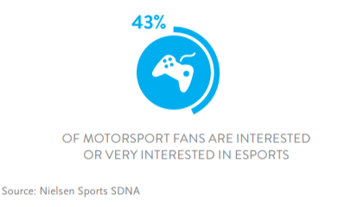
Conclusion
To conclude, the growth in social networking has brought great opportunities for new revenue streams as well as some big challenges between rights holders in the motorsport industry with the emerge of eSports being the biggest. To continue with, the virtual world of motorsport is obviously way more accessible than the real, which makes it more and more popular. The rise of the environment social awareness is giving eSports a rolling start in the battle with the motorsports industry because the right holders need to balance the social responsibility with providing and maintaining the risky spectacle of racing. (Commercial trends in Motorsport, 2017)

Bibliography
(2017). Commercial trends in Motorsport. Nielsen .
Gray, A. (2018, July 3). The explosive growth of eSports. Retrieved 11 10, 2018, from World Economic Forum: https://www.weforum.org/agenda/2018/07/the-explosive-growth-of-esports/
Smith, D. A. (2010). The New Generation. In Social Networks (pp. 01-03).
Sustainabilty of Formula E. (2016). (Formula E) Retrieved July 3, 2018, from Formula E : http://info.fiaformulae.com/sustainability/
The Industry at a Glance . (2017). On The Right Track .

