University of Wales Trinity Sain David
Cert HE Business Skills for the Workplace

Employability and Career Development
LCLM4005

Portfolio of Written Tasks

Yaroslav Zhenchuk 2514092
Lecturer: Inderjit Grewal
Job Adverts
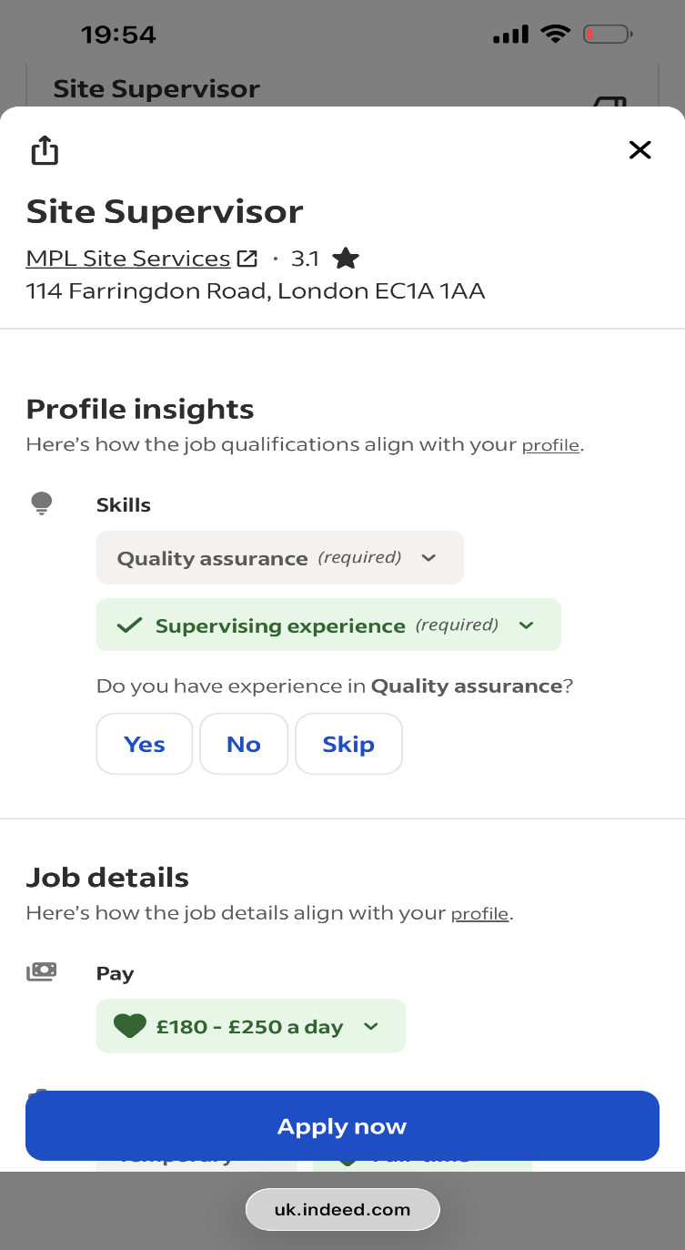
Job 1:
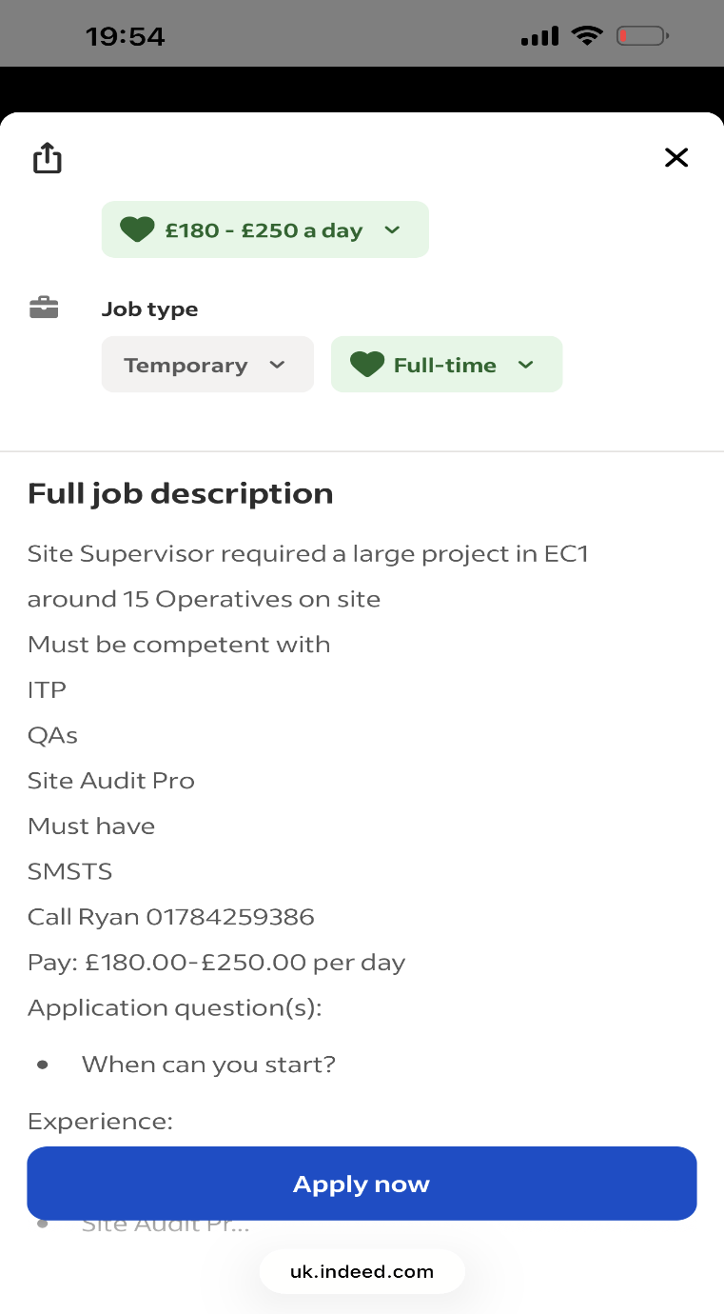
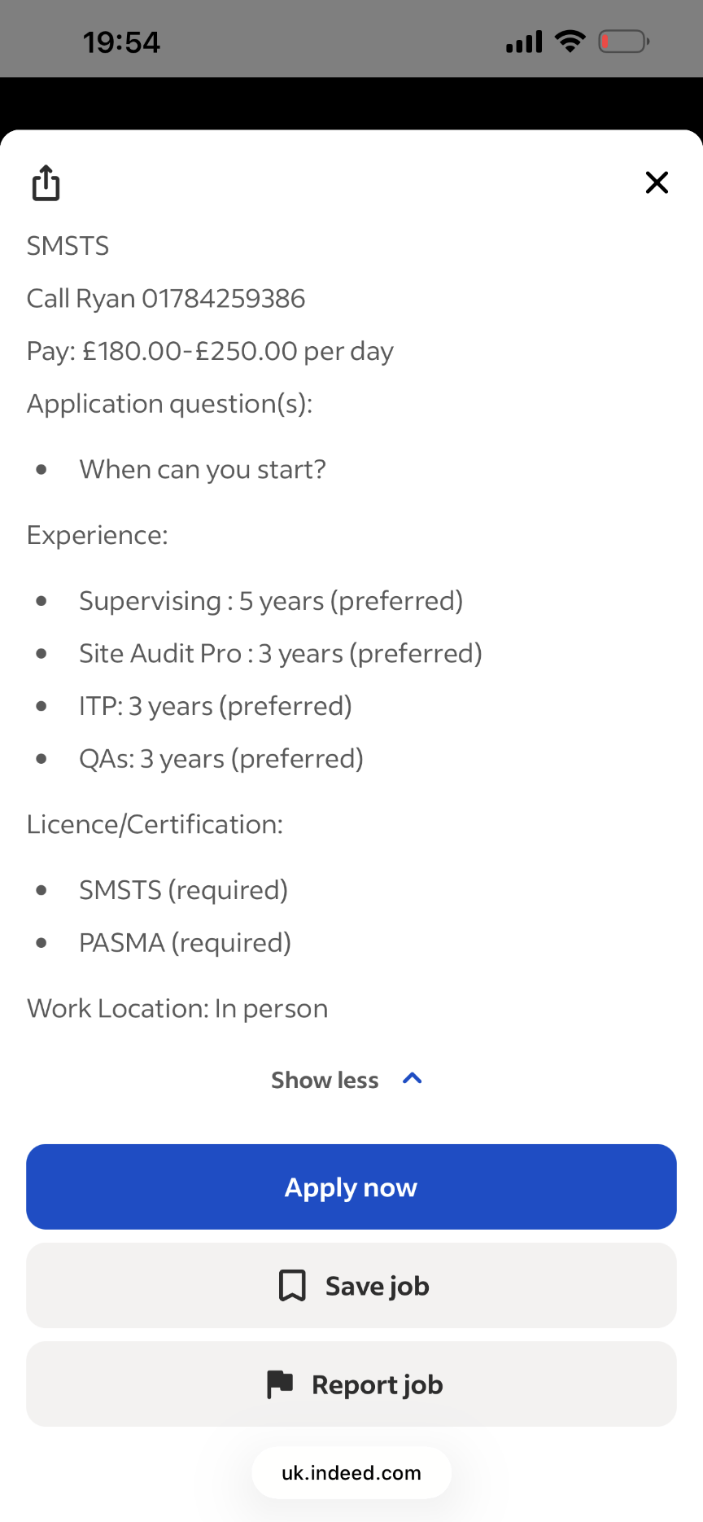

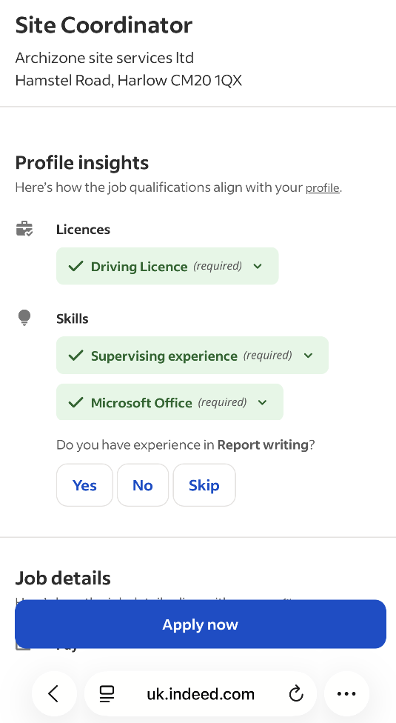
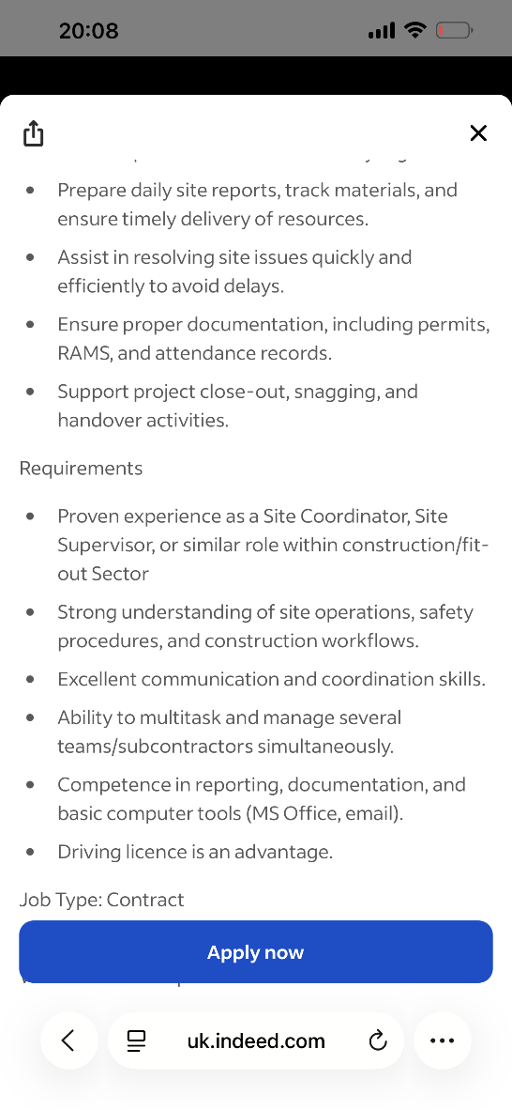
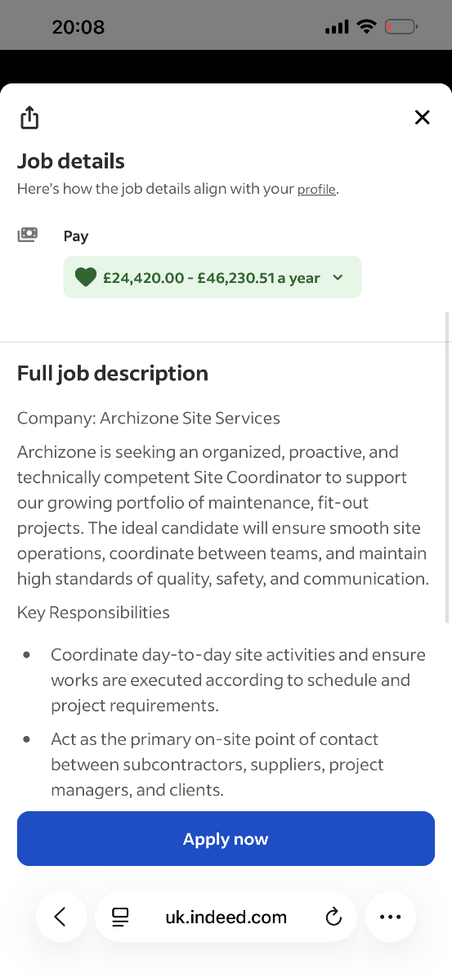
Job 2

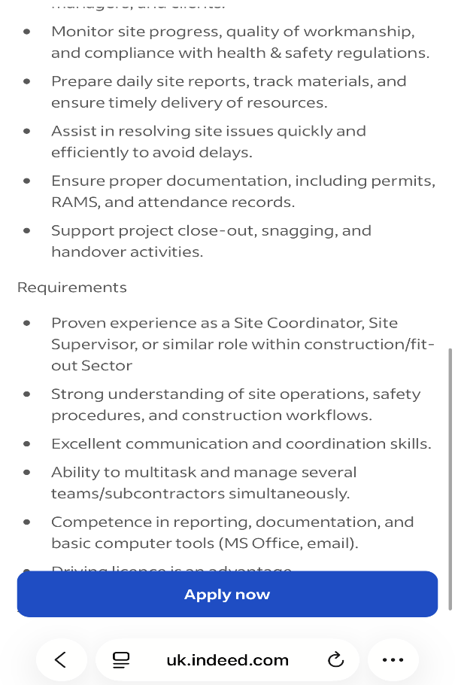
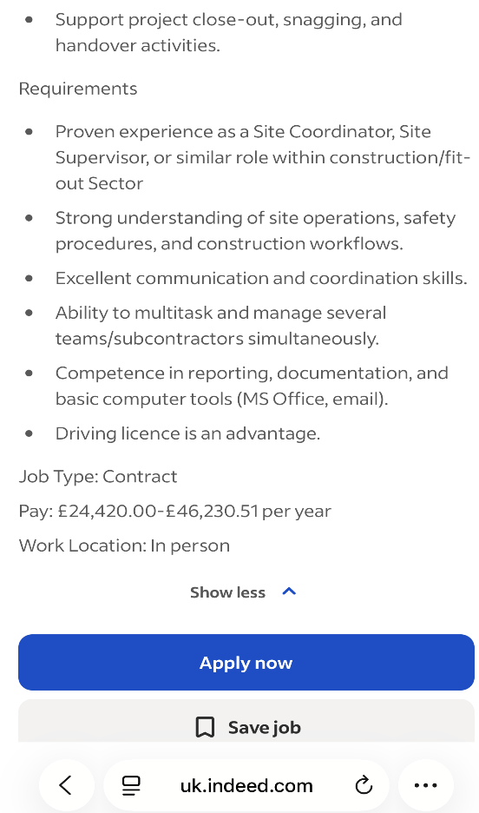

Task 1: Job Advert Analysis
My chosen career goal is to become a Site Supervisor in the construction industry. To identify the skills and knowledge required for this position, I have compared two job advertisements: a Site Supervisor Position with MPL Site Services in London and Site Coordinator position with Archizone Site services in Harlow. Both positions are related to construction site management and provide useful information about the requirements of working in this area.
The MPL Site Services advertisement requires a Site Supervisor to manage a large project with approximately fifteen operatives on site. Important skills include supervising, quality assurance, site auditing and knowledge of ITPs (inspection and text plan) and QAs Quality Assurance). The advert states that five years of supervising experience is preferred. In addition, SMSTS (Site Management Safety Training Scheme and PASMA certification are required. These requirements show that a Site Supervisor needs both leadership skills and technical knowledge related to quality, safety and site procedures.
The Archizone Site Services advertisement focuses on the role of a Site Coordinator and includes several similar requirements. The candidate needs to coordinate daily site activities and communicate with a subcontractors, suppliers, project managers and clients. The role also involves monitoring site progress and quality, preparing daily reports, tracking materials, maintaining documentation and resolving site issues. The advertisement identifies communication, coordination, multitasking, reporting and Microsoft Office as important skills. It also requires knowledge of site operations, safety procedures and construction workflows.
There are several common skills and knowledge areas between the two advertisements. A Site Supervisor requires knowledge of construction, leadership skills, the ability to work with others and good organisational skills (National Careers Service, 2026) Both positions require supervisory or coordination experience, knowledge of construction site operations, attention to quality, health and safety awareness and the ability to organise work effectively. However, the Site Supervisor advertisement places greater emphasis on quality assurance, auditing, ITPs, QAs and specific construction certifications. In comparison, the Site Coordinator advertisement places greater emphasis on communication, reporting, documentation and coordination between different people involved in a project.
Two shared skills that is particularly important for my chosen profession is communication and coordination. Communication and coordination are important transferable skills because they support effective cooperation between workers and other stakeholders (CIPD, 2025). A Site Supervisor needs to communicate clearly with operatives, subcontractors, managers and other people on site. Effective communication helps ensure that instructions are understood and work is completed according to projects requirements. Coordination is also important when managing several activities and workers at the same time. Therefore, strong communication and coordination skills would help me manage site activities effectively, solve problems quickly and contribute to the successful completion of construction projects. Effective communication ensures health and safety rules are always followed and helps to keep teams together. I must develop and use effective communication in my future role to be a good team leader and ensure that all job is done due to health and safety.

Task 2: Reflective Self-Assessment and SWOT analysis
A SWOT analysis is a useful tool for evaluating my current employability and identifying areas that I need to develop to achieve my career goal of becoming a Site Supervisor. SWOT analysis can be used as a tool to identify strengths and weaknesses and consider opportunities and threats when planning development (Chermack and Kasshanna, 2007). The analysis considers my strengths and weaknesses, as well as the opportunities and threads that may influence my future career development. My self-assessment is based on the skills identified in the job advertisements analysed in the two job advertisements analysed in Task 1, particularly supervision, communication, coordination, health and safety, quality control and reporting.
Strengths
One of my main strengths is my interest in developing a career in the construction industry and progressing towards a Site Supervision Position. My current studies have help me develop skills that can be transferred to the workplace, including communication, organisation and written communication. These skills are important because a Site Supervisor needs to communicate with different stakeholders and keep information organised often in a busy environment.
Another strength is my ability to work with other people and contribute to a team. Construction projects require cooperation between operatives, subcontractors, suppliers, managers and clients so that projects can be completed on time and to a high standard that meets legal requirements. I believe that being able to communicate with different people is important for maintaining good working relationships and ensuring that the work is completed effectively.
My previous experience in BTS Company as a Supervisor has also helped me developed practical knowledge and workplace skills. For example, quality control and health and safety awareness. This experience has given me a better understanding of the importance of following instructions, working safely and completing tasks to an appropriate standard. I intend to continue developing this good practice in my professional life.
Weaknesses
One level I need to improve is my level of formal knowledge and experience in some of the technical requirements identified in the Site Supervisor vacancy. The MPL Site Services advertisement requires experience with ITPs, QAs and Site Audit Pro, as well as SMSTS and PASMA certifications and areas of experience, this represents a gap between my current skills and the requirements of my target position.
Another weakness is limited experience with limited knowledge of site auditing. A Site Supervisor may need to manage several activities and workers simultaneously and without this experience I won’t be able to develop in my future career development. So, I need to continue developing my confidence in leadership, decision making and coordination.
I also need to improve my knowledge of supervising a large team. Identifying this weakness is important because it allows me to create realistic development goals rather than assuming that my current skills are sufficient for a supervisory position.
Opportunities
There are several opportunities available to support my career development. One important opportunity is gaining additional construction-related qualifications, particularly those relevant to site supervision. Working towards qualifications such as SMSTS or PASMA, where appropriate, could help me meet the requirements identified in the Site Supervisor advertisement.
Another opportunity is to gain more practical supervisory experience. I could ask for additional responsibilities at work, such as helping to coordinate other workers, checking progress or assisting with documentation. This would allow me to develop leadership and communication skills in a practical environment.
My university studies are also an opportunity to improve my employability. Completing my current programme can demonstrate commitment to personal development and provide evidence that I am actively preparing for future employment. I can also use feedback from colleagues to identify specific areas where I need to improve.
Threats
One potential threat is the level of experience required for Site Supervisor positions. For example, the MPL Site Services advertisement prefers five years of supervising experience and three years of experience with several site systems. This means that candidates with more extensive experience may be more competitive when applying for similar positions.
Another threat is the need to keep up with health and safety requirements and industry expectations. Construction is a highly responsible environment, so a lack of relevant knowledge or certification could reduce my employment opportunities. Competition for supervisory positions may also make it difficult to progress immediately into my target role.
However, identifying these threats allows me to take action rather than ignore them. By gaining relevant qualifications, increasing my practical experience and improving my communication, leadership and technical knowledge, I can gradually reduce the gap between my current position and my long-term career goal.
SWOT Summary
Strength | Weaknesses
Communication skills | Limited supervisory experience
Teamwork | Limited experience with ITPs/QAs
Current education | Need additional qualifications
Interest in construction | Need to develop technical knowledge

Opportunities | Threats
Gain SMSTS/PASMA where appropriate | Strong competition
Gain supervisory experience | Experience requirements
Develop technical knowledge | Health & safety responsibilities
Use feedback for development | Lack of relevant certification

Overall, the SWOT analysis shows that I have a good foundation for developing a career as a Site Supervisor, but I still need to strengthen my practical supervisory experience, technical knowledge and relevant qualifications. The analysis also shows that my weaknesses can be addressed through targeted development and practical experience. This will improve my employability and prepare me for greater responsibility within the construction industry.
Task 3: Employment goals and Personal Development Plan
My career goal is to become a Site Supervisor in the construction industry. The SWOT analysis identified several areas that I need to improve, particularly my supervisory experience, technical knowledge and relevant qualifications. Setting short-term and long-term employment goals will help me address these weaknesses and gradually prepare for Site Supervisor position.
My short-term goals are to improve my knowledge of construction site management and gain more practical experience in supervising and coordinating workers. I aim to develop my understanding of areas such as ITPs, quality assurance, health and safety procedures, site reporting and documentation. I will also seek opportunities at work to take an additional responsibility and develop my communication, coordination and leadership skills. This goal is important because the job advertisements analysed in Task 1 show that these skills are expected from candidates working in supervisory positions. Developing My skills, knowledge and qualifications will help me progress towards a Construction Site Supervisor role (Skills England, 2022).
My long – term goal is to progress into a Site Supervisor position within the construction industry. To achieve this objective, I need to build sufficient practical supervisory experience and obtain relevant qualifications, such as SMSTS and PASMA where appropriate. Achieving these goals will improve my employability and help me take greater responsibility for site operations, workers, quality and health and safety.

Personal Development Plan

Area to improve | Action | Time | Resources | Measurement
Supervisory experience | Help manage workers and take more responsibility | 6-12 month | Work, management support | Positive feedback from my manager, more independence in communication.
Technical knowledge | Learn ITP, QA, H@S procedures | 3-6 months | Work at BTS Company, study in UWTSD | Can explain and use processes correctly
Qualifications | Complete SMSTS/PASMA | 6-12 months | UDEMY | Receive certificates in: How to manage and influence your team.
Communications | Communicate more with team and subcontractors | Ongoing | With colleagues, lecturers, clients and managers | Fewer mistakes, better feedback from managers

Following this development plan will help me improve the weaknesses identified in my SWOT analysis and prepare for my future career as a Site Supervisor. I will review my progress regularly and use feedback from managers and colleagues to identify further areas for improvement. By gaining experience, developing my technical knowledge and obtaining relevant qualifications I aim to become more confident and prepare for a supervisory role.

References

Chermack, T.J. and Kasshanna, B.K. (2007) The use and misuse of SWOT analysis and implications for HRD professionals. Human resource Development International, 10(4), pp. 383-399.
CIPD (2025) Skills development in the UK workplace. Available at: CIPD – Skills Development in the UK Workplace (Accessed: 14 August 2026)
National Careers Service (2026) Construction site supervisor. Available at: National Careers Service – Construction Site Supervisor (Accessed: 14 August 2026)
Skills England (2022) Construction site supervisor. Available at: Skills England – Construction Site Supervisor (Accessed: 14 August 2026)

