[Date]
Samuel Kargbo (2423977)
[company name]
Networks And Cyber Security Essentials

student name: samuel momoh kargbo
student id: 2423977
module name: Networks and cybersecurity essentials
module code: acca4024
lecturer: dr kwame assa agyei
university of wales trinity saint david london campus

Table of Contents
Abstract 1
Introduction 2
Identification of Modern Threats 2
Modern Security Policies 7
Technical Mitigation Measures 16
Proactive Monitoring and Incident Response 23
Continuous Training and Awareness 28
Conclusion 33
References 34
Appendix A: Screenshot of the Board of Directors PowerPoint presentation: 34
Appendix B: Screenshot of the Badge 34

Abstract
The number of complex cyber threats keeps growing because organizations now use cloud services and hybrid work systems and numerous mobile and SaaS applications. Financial services organizations face a high risk of attack because their sensitive data holds great value while sophisticated attackers who seek financial gain continue to grow in number. Sierra Network which operates as a financial services provider of medium size has faced two security incidents since their last security assessment which included sophisticated phishing attacks that bypassed standard security measures and a ransomware attack attempt. The current security models which depend on perimeter defense systems prove insufficient for protecting today's distributed IT systems. The paper recommends Sierra Network to establish a complete Zero Trust security system which follows "never trust, always verify" principles and implements least-privilege access and continuous monitoring. The framework protects against both internal and external threats through its combination of identity-based security systems and device health checks and network partitioning and immediate threat identification capabilities. The proposed approach will achieve its goals by following established standards and best practices which will strengthen Sierra Network's defense against modern cyber threats while safeguarding important financial information and enabling secure business activities in today's sophisticated digital environment.

Introduction
Modern organizations face cyber security as their main worldwide threat because cybercrime operations have become more complex and extensive. The combination of hybrid work models and cloud service dependency has created larger attack surfaces for organizations. Financial services institutions face elevated security risks because they handle important and confidential financial information. Financially driven threat actors use sophisticated methods to attack organizations through multi-stage phishing attacks and credential-stealing malware and ransomware attacks. The financial services organization VTAM faces modern cyber threats because it has experienced multiple security incidents which demonstrate its vulnerability to current cyber threats. The organization faced a successful phishing attack which defeated its email filtering system before attackers tried to launch a ransomware attack which security measures stopped at the beginning. The security incidents at VTAM revealed weaknesses in its current security system because it depends on outdated perimeter defences and outdated security measures. The Board of Directors has issued a formal directive which demands the creation of an advanced security framework based on Zero Trust principles to replace the current security system. Your role as IT Security Manager requires you to create this framework which must handle the challenges of remote work and cloud computing and mobile devices and SaaS applications and social engineering attacks. The Zero Trust framework needs to establish better protection for financial data and essential infrastructure against attacks from outside and inside the organization. [1]

Identification of Modern Threats
Modern cyber threats operate at a high pace because digital transformation and cloud adoption and hybrid work environments have created this situation. Organizations face complex multi-directional cyber attacks which target their human elements and technological systems and their supply chain networks. The following section describes the main security threats which organizations need to address in their current environment. [2]

1. Ransomware-as-a-Service (RaaS) – External Threat
The cybercrime world has evolved through the development of Ransomware-as-a-Service which allows attackers to obtain pre-built ransomware kits from criminal marketplaces. The new model makes it easier for unskilled cyber attackers to execute destructive cyber attacks.

Characteristics: Subscription-based ransomware, profit-sharing models, constant version updates.

The threat landscape shows rising attack numbers and faster spreads of threats which results in higher financial losses and reputational damage.

Example risks: Data encryption, data exfiltration, double/extortion schemes.

2. AI-Powered Social Engineering (e.g., Vishing) – External & Internal Threat Vector

The development of AI technology enables attackers to create fake versions of employees and executives and trusted stakeholders through sophisticated voice-based phishing (vishing) attacks.

The technology enables attackers to create fake voices which exactly match human speech patterns and vocal characteristics.

The main targets include financial teams and helpdesk personnel and HR staff members and users who hold privileged access.

The main security risks include unauthorized system access and fraudulent financial transactions and stolen user credentials and unauthorized system usage.

The internal threat occurs when an employee receives false information which leads them to perform unauthorized actions that result in organizational damage.

3. Supply Chain Compromises – External Threat Through Trusted Relations

Third-party vendors and partners and software providers become attack targets through supply chain attacks which reveal their system weaknesses. The attackers use a trusted external entity to gain access to their target organization.

The attack vectors include software update vulnerabilities and insecure API interfaces and managed service provider vulnerabilities and hardware security breaches.

The widespread nature of modern interconnected systems enables threats to spread across multiple networks.

The main security risks include data breaches and backdoor installations and system integrity modifications and organizational system disruptions.

4. Cloud Adoption Risks – External and Internal Threats

The fast adoption of cloud services including SaaS and PaaS and IaaS has created new security risks for organizations. The combination of weak identity controls and misconfigured systems and shared responsibility misunderstandings leads to cyber threats.

External threats:

Cloud account compromise

API exploitation

Attackers use cloud resources to move laterally through systems.

Internal threats:

Storage buckets remain exposed to threats because of incorrect settings.

Users who have excessive permissions create security risks.

The implementation of access control systems fails to provide adequate security.

Cloud platforms operate as multi-tenant systems which enable threats to spread at faster rates than traditional on-premises networks.

5. Hybrid Work Risks – Internal Threat Expansion

The implementation of hybrid work models creates new security risks because staff members access corporate systems through unsecured home networks and personal devices.

The main security risks include successful phishing attacks because employees receive too many messages and their devices lack proper security measures and users access systems with weak credentials and use unsecured remote connections.

The main security risks include data exposure through unauthorized applications and storage solutions.

The security measures of enterprise networks do not apply to home environments which makes them more vulnerable to attacks.

6. Insider Threats – Internal (Malicious and Accidental)

The security of an organization depends on its ability to protect itself from both intentional and unintentional attacks made by its employees and partners.

The malicious insider category includes two types of threats: data theft and sabotage and credential selling.

The accidental insider category includes two types of threats: successful phishing attacks and system misconfiguration and data mishandling.

The combination of privileged access and social engineering tactics and organizational trust relationships makes insider threats persistent.

7. Advanced Persistent Threats (APTs) – Highly Sophisticated External Threats

Nation-state actors and highly organized criminal organizations perform extended stealth operations to target vital infrastructure and financial institutions and sensitive organizational data.

The attacks consist of multiple stages which use zero-day exploits while attackers use stealthy techniques to move laterally and maintain their presence for extended periods.

The main security threats include strategic data theft and essential service disruptions and espionage activities.

8. Zero-Day Exploits – External Technical Threat

The lack of vendor knowledge about zero-day vulnerabilities makes them unpatchable which gives attackers a major advantage in their attacks.

The attack method allows attackers to remain undetected while they gain system control and elevate privileges before security teams discover the breach.

Modern Security Policies
Modern Security Policies Aligned with Zero Trust, NIST CSF & ISO 27001
1. Purpose

The security policies of this organisation use Zero Trust Architecture (ZTA) principles to protect information assets while following NIST CSF and NIST SP 800-207 and ISO/IEC 27001:2022 standards. The security policies work to decrease security threats and fulfill regulatory requirements and protect system data and services from unauthorized access.

2. Scope

These security policies apply to all employees and contractors and partners and third-party service providers who access the organisation.

All organisational information systems and networks and cloud services and data assets fall under this policy.

The security policies apply to all access points which include on-premises locations and cloud-based systems and remote work environments and hybrid work setups.

3. Policy Principles

Modern cybersecurity depends on continuous verification systems and least privilege access controls and identity-based security measures. The policies establish their foundation through:

Zero Trust Model Core Principles

Never trust, always verify

Assume breach

Enforce least privilege access

Continuous authentication and monitoring

Secure by design and secure by default

Framework Alignment

The NIST CSF framework consists of five domains which include Identify and Protect and Detect and Respond and Recover.

The ISO 27001 standard requires organisations to implement Information Security Management System (ISMS) controls which span across organisational and technical and physical domains.

4. Security Policies
Identity & Access Management (IAM) Policy

The policy establishes a goal to provide robust authentication systems with detailed permission controls for all users.

Requirements
All users need to authenticate through Multi-Factor Authentication (MFA) for accessing all systems including VPN and SaaS applications and privileged accounts. (Zero Trust & ISO 27001 A.5, A.6)

Access rights need to follow both Least Privilege and Role-Based Access Control (RBAC) principles.

The system requires Privileged Access Management (PAM) controls with session recording for all privileged access requests.

The system requires continuous verification of all identities including human and non-human entities through behavioural and contextual signals.

Access rights need to undergo quarterly assessments and must be immediately revoked after employee termination.

4.b Device Security & Endpoint Management Policy

The policy establishes security requirements for all devices which access organizational resources.

Requirements

The organisation allows only managed devices that meet compliance standards to access corporate applications.

The system requires three security measures for device protection which include complete disk encryption and Endpoint Detection & Response (EDR) and automated patching with defined service level agreements (SLAs) for critical updates.

The organisation requires all non-managed BYOD devices to access corporate resources through virtualized access systems which prevent data storage on local devices.

The system needs to perform ongoing device health assessments to sustain Zero Trust security measures.

4. c Network & Segmentation Policy

The policy establishes network segmentation as a security measure to protect resources while creating secure network connections.

Requirements

The network infrastructure needs to implement micro-segmentation to protect workloads by creating separate segments that block lateral movement.

The organization should use Zero Trust Network Access (ZTNA) instead of traditional VPNs for remote access sessions whenever possible.

The system needs to perform continuous authentication of all network traffic that passes between different segments.

The system needs to track all network traffic entering or leaving the network through IDS/IPS monitoring.

4.d Data Protection & Classification Policy

The policy protects data throughout its entire lifecycle through strict classification systems and encryption methods.

Requirements

The organisation needs to establish at least four data categories which include Public and Internal and Confidential and Restricted.

The system requires encryption for all data transmissions through TLS 1.2+ and it needs to protect data at rest through AES-256 or equivalent encryption methods.

The system needs to track all sensitive data access attempts through DLP controls which also generate alerts for monitoring purposes.

Cloud data usage requires organizations to follow the Shared Responsibility Model which cloud providers establish for their services.

The organization needs to minimize data storage to decrease the potential exposure of sensitive information.

4.e Cloud Security Policy

The policy establishes security protocols for SaaS and IaaS and PaaS cloud service adoption.

Requirements

All cloud environments need to adopt Zero Trust Cloud Access and identity federation through SSO (Single Sign-On) for secure access.

The system requires NIST and CIS hardening benchmarks for all cloud configurations.

The system requires Cloud Security Posture Management (CSPM) to detect and fix cloud environment misconfigurations.

The system requires Just-In-Time (JIT) elevation and MFA for administrative access authorization.

All cloud-based data storage must follow organizational data classification standards and encryption protocols.

4.f Supply Chain & Third-Party Risk Management Policy

The policy works to decrease security threats that stem from vendor relationships and supply chain partnerships.

Requirements

All third-party vendors need to complete security assessments which include evaluating their ISO 27001 certification and SOC2 compliance reports.

Organizations that handle sensitive information need to obtain security addendums from vendors while proving their adherence to Zero Trust security standards.

The system uses continuous monitoring solutions to evaluate third-party risk levels.

The system uses continuous monitoring solutions to evaluate third-party risk levels.Third parties need to access systems only through temporary arrangements which grant them the minimum required permissions while active monitoring takes place.

Security Monitoring, Logging & Detection Policy

The system needs to show immediate threat detection through its unified monitoring system.

Requirements

Security logs need to reside in a SIEM system which maintains data storage for at least one year based on file.

The system requires monitoring of five different types of events which include authentication records and privileged system activities and network traffic patterns and cloud system access records and behavioral system activity patterns.

UEBA systems need to run behavioral analytics to identify unusual system behavioral patterns.

The system needs to run continuous monitoring tools which should detect RaaS attacks and social engineering schemes and supply chain-based threats.

Incident Response Policy

The organization needs to establish a systematic process which detects incidents and responds to them before starting recovery operations.

Requirements

The organization needs to create an Incident Response Plan (IRP) which follows NIST CSF guidelines for “Respond” and “Recover” sections.

The SOC team and security team need to receive immediate incident reports.

The organization needs to perform ransomware tabletop exercises as part of its regular incident simulation activities.

The system needs to have automated containment tools which enable fast user and device separation during security incidents.

The organization needs to perform post-incident assessments which identify operational lessons and control enhancement opportunities.

Security Awareness & Training Policy

The organization needs to develop security awareness throughout its entire workforce.

Requirements

The organization requires all employees to complete yearly cybersecurity training which focuses on Zero Trust principles and contemporary threat types including AI-based phishing attacks.

The organization should deliver security training to employees who perform high-risk duties including finance staff and executives and IT administrators.

The organization needs to perform regular phishing simulation tests which provide feedback to users.

Governance, Compliance & Audit Policy

The organization needs to maintain continuous compliance with ISO 27001 ISMS standards and NIST CSF guidelines and all applicable regulatory requirements.

Requirements

Security audits need to take place once per year through both internal and external assessments.

The organization needs to track compliance gaps which it should then rank by risk level for proper remediation.

The organization needs to use a continuous improvement approach to enhance its security controls.

Technical Mitigation Measures
The following section describes operational technical and administrative controls which organizations can use to protect against identified threats. The section describes each control by specifying its purpose and implementation method for organizations operating in financial services sectors.

1. Multi-Factor Authentication (MFA) & Conditional Access

Threats Mitigated:

AI-powered social engineering; credential theft; hybrid-work access risks.

The implementation process requires MFA activation for all user accounts with special emphasis on privileged users and remote access and cloud application users.

The organization should use phishing-resistant MFA through FIDO2 security keys and platform-bound passkeys whenever possible.

The system uses Conditional Access Policies to control user access through device verification and location checks and risk assessment (e.g. Azure AD Identity Protection).

The system logs MFA activities which get sent to SIEM for detecting unusual patterns.

Outcome: The system protects against unauthorized access attempts when credentials get stolen.

2. Security Information and Event Management (SIEM)
Threats Mitigated:

Ransomware, insider threats, lateral movement, cloud compromise.

The organization needs to establish a SIEM platform (e.g. Microsoft Sentinel or Splunk) for uniting logs from different sources including endpoints and clouds and networks and identities.

The system uses behavioral detection rules to identify ransomware activities through specific indicators which include mass file renaming and privilege elevation.

The system uses SOAR to perform automated containment actions which include disabling compromised accounts and host isolation and IP address blocking.
The system maintains continuous monitoring through alert tuning to achieve optimal performance while reducing false positive results.

Outcome: The system detects threats in real-time while enabling fast incident response capabilities.

3. Endpoint Detection and Response (EDR) / Extended Detection and Response (XDR)
Threats Mitigated:

Ransomware-as-a-Service, malware injection, insider activity.

The organization needs to install EDR agents on all endpoints and servers and mobile devices (e.g. CrowdStrike and Defender for Endpoint).

The system enables automatic rollback for ransomware attacks and process quarantine for suspicious activities.

The system uses XDR telemetry to establish a connection with SIEM.

Outcome: The system detects and contains endpoint threats at a fast pace.

4. Cloud Security Posture Management (CSPM)
Threats Mitigated:

Cloud misconfiguration, excessive permissions, data exposure.

The organization needs to use CSPM tools (e.g. Prisma Cloud and Microsoft Defender for Cloud) to monitor cloud environments for misconfigurations and non-compliance with NIST and CIS benchmarks.

The system enforces least privilege access through Cloud IAM role reviews and automated policy checks and privilege escalation alert systems.

The system performs automated remediation for security risks that include exposed S3 buckets and insecure firewall configurations.

Outcome: The system protects organizations from cloud security risks that results from misconfigured systems while maintaining uniform cloud management standards.

5. Zero Trust Architecture (ZTA) Adoption
Threats Mitigated:

Supply chain attacks, lateral movement, compromised third-party access.

The organization needs to establish a security model which verifies all access requests at every point where identity meets devices and networks and workloads.

The network segmentation approach creates separate zones for protecting essential assets including domain controllers and finance systems.

The system performs continuous identity risk assessments and device health checks to validate user access requests.

Outcome: The system protects valuable assets when an attacker gains access to a single system or third-party vendor account.

6. Secure Email Gateway (SEG) & Anti-Phishing Controls
Threats Mitigated:

Phishing, vishing-assisted email fraud, BEC attacks.

The organization needs to install SEG solutions which perform URL filtering and attachment sandboxing and AI-based content analysis.

The organization needs to activate DMARC and DKIM and SPF protocols to stop email spoofing attacks.

The system enables users to report phishing attempts through built-in buttons which trigger SIEM-based anomaly detection from telephony logs.

The system enables users to report phishing attempts through built-in buttons which trigger SIEM-based anomaly detection from telephony logs.

Outcome: The system stops dangerous emails from reaching users while showing them social engineering attack patterns.

7. Data Loss Prevention (DLP)
Threats Mitigated:

Insider threats, accidental sensitive data leakage, supply chain compromises.

The organization needs to deploy DLP solutions which monitor email traffic and cloud storage and endpoints and messaging platforms.

The system requires users to establish classification rules for their sensitive information categories including PCI and financial documents.

The system triggers alerts and automatic blocking mechanisms when users attempt to share data without authorization or download files en masse.

Outcome: The system protects data from unauthorized transfer while maintaining compliance with security regulations for data protection.

8. Patch Management & Vulnerability Scanning
Threats Mitigated:

Zero-day exploits, supply chain vulnerabilities, cloud workload compromise.

The organization needs to run Qualys or Defender Vulnerability Management for continuous vulnerability scanning.

The system uses MDM/SCCM/Intune to perform automated patch deployment.

The system should focus on fixing vulnerabilities with high CVSS scores and those that have been exploited by attackers according to the CISA KEV catalogue.

Outcome: The system protects endpoints through automated threat detection and containment processes.

9. Network Security Controls
Threats Mitigated:

The system protects against three main threats which include lateral movement and ransomware propagation and remote access attacks.

The implementation strategy for Next-Generation Firewalls (NGFW) includes application-aware filtering and intrusion prevention capabilities.

The system uses VLANs and ZTA-aligned micro-segments to establish network segmentation.

The hybrid workforce receives protection through Zero Trust Network Access (ZTNA instead of traditional VPN solutions.

The system blocks unauthorized access while restricting attackers from discovering internal network information.
Outcome: The system protects users from both well-known security threats and new security threats that emerge.

10. Administrative & Governance Measures
Threats Mitigated:

The system protects against three main threats which include policy non-compliance and insider risk and human-factor attacks.

Security Awareness Training: The program includes regular phishing simulations and vishing role-plays and micro-learning modules.

Access Governance: The system performs quarterly RBAC entitlement reviews and enforces segregation of duties and joiner/mover/leaver controls.

The organization maintains incident response plans which include ransomware and cloud breach and identity compromise playbooks that undergo tabletop exercise testing.

Third-Party Risk Management: The system evaluates suppliers through risk scoring and enforces security standards in contracts and conducts yearly audits.

The organization achieves better resilience through its structured cyber risk management systems.

Proactive Monitoring and Incident Response
The plan establishes a permanent 24/7 active monitoring system which uses SIEM (Security Information and Event Management) and SOAR (Security Orchestration, Automation, and Response) to identify and handle cyber threats instantly. The method follows current Security Operations Centre (SOC) best practices which enable fast incident response and shorter detection and response times.

Architecture and Key Components

Data Sources

Network devices (firewalls, IDS/IPS, routers)

Endpoints (EDR/XDR agents)

Servers and databases

Cloud platforms and SaaS applications

Identity systems (IAM, Active Directory)

Core Security Tools

SIEM: Centralised log collection, correlation, and alerting

SOAR: Automated playbooks for incident triage and response

Threat Intelligence Feeds: IOC enrichment (IP, domain, hash reputation)

Case Management System: Incident tracking and reporting

People and Process

Tier 1 SOC Analysts (monitoring and triage)

The SOC Analysts at Tier 2 level perform two main functions which include investigation and containment activities.

Tier 3 / IR Team (advanced response and forensics)

Defined escalation paths and SLAs.

24/7 Monitoring and Threat Detection

Continuous Log Ingestion
The SIEM system receives continuous log and telemetry data from all systems.

Real-Time Correlation and Analytics
The SIEM applies:

Correlation rules

Behavioural analytics

UEBA (User and Entity Behaviour Analytics)

Threat Intelligence Enrichment
The system automatically adds threat intelligence from both internal and external sources to alerts which helps determine both risk levels and confidence levels.

Alert Prioritisation
The system uses risk scores to determine which alerts require immediate attention.

Asset criticality

Threat severity

Likelihood of compromise

Incident Response with SOAR

Automated Triage (SOAR)
SOAR generates alerts which trigger automatic execution of the following processes.

Validates indicators of compromise

The system collects information about the user and their host environment together with their current location.

Suppresses false positives

Decision Point – Is the Alert a True Incident?
No → Alert closed and documented

Yes → Incident created and escalated

Automated Containment Actions
The system operates through predefined playbooks which enable SOAR to perform the following actions.

Isolate endpoints
Disable compromised accounts

Block IPs/domains on firewalls

Human-Led Investigation
SOC analysts conduct root cause analysis and impact assessment and they also verify the automated actions that have been executed.

Eradication and Recovery

Remove malware.

Patch vulnerabilities

Restore systems from clean backups.

Post-Incident Review

Lessons learned

Update detection rules and playbooks.

Management and compliance reporting

Assumptions and Constraints

All critical systems enable log forwarding.

Playbooks exist as pre-approved systems which enable automated operations.

The system requires sufficient personnel to maintain continuous security operations throughout all hours of the day and night.

The system requires periodic SIEM rule tuning to achieve lower rates of incorrect alert generation.

Benefits of the Approach
Continuous visibility across the environment
Faster detection and response through automation
The system decreases the amount of work analysts need to perform while it also decreases their exposure to excessive alerts.
Improved compliance, auditability, and resilience

Summary
The security capability operates as a scalable and efficient 24/7 system which provides resilient protection through SIEM detection and SOAR automated response capabilities. The systemized workflow enables fast threat identification and validation and containment and review operations which help organizations maintain operational security while they work to improve their systems

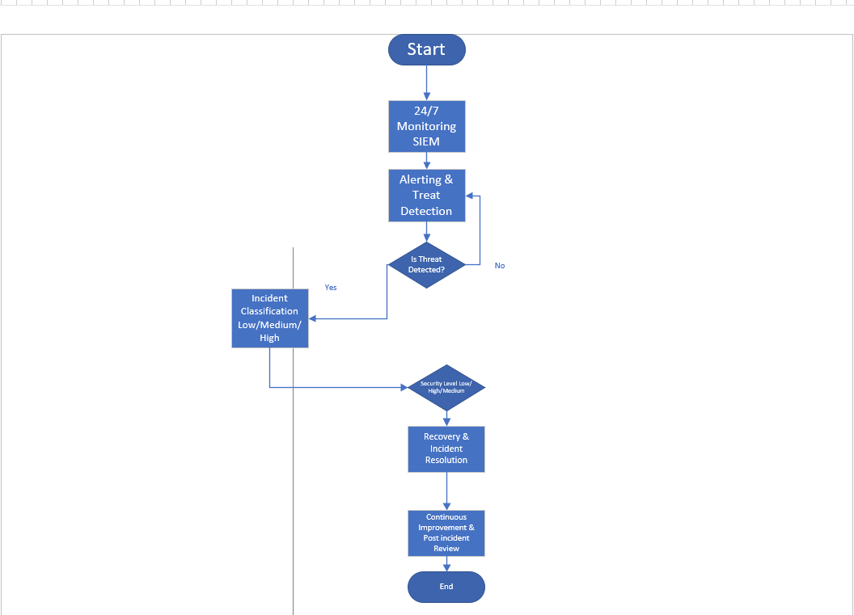

Continuous Training and Awareness
I think the continuous cybersecurity training programme must keep the training strong all the time. The continuous cybersecurity training programme should not rely on rule‑based sessions. The continuous cybersecurity training programme aims to put security choices into work. The continuous cybersecurity training programme also makes sure the users can recognise, report and respond to threats such, as phishing, vishing, AI‑generated lures and credential‑harvesting campaigns.

1. Programme Structure

a. Quarterly Threat-Driven Learning Modules
We push scenario-based eLearning modules that last fifteen to twenty minutes each quarter. Each scenario-based e-learning module aligns with the threat intelligence, including:

AI-generated phishing and deepfake-enabled vishing

Ransomware delivery techniques

Supply-chain impersonation schemes

Cloud-based credential theft and MFA fatigue attacks

Modules use branching stories and small quizzes.
Modules get the learner to make choices of just watching the content.
Modules want the learner to choose, not just watch.

b. Monthly Micro-Lessons
I have found that two-minute videos, infographics or interactive checklists help people remember the idea. We send two-minute videos, infographics or interactive checklists through the platforms to reinforce the concept of recognising MFA fatigue or validating sender identities. Two-minute videos, infographics or interactive checklists reduce the load. Keep frequent touchpoints.

2. Modern Attack Simulations

a. Phishing Simulations
I think the programme should have changing context phishing simulations that fit each user role. The sending patterns should copy the attacker behaviour. For example, the finance lures at the end of a quarter. The HR impersonation, during onboarding cycles. The difficulty should change based on the user performance:

Beginner: obvious red flags

Intermediate: AI-crafted messages with convincing tone and branding

Advanced: targeted spear-phishing and BEC impersonation scenarios

I notice that the automated feedback shows up in time. The feedback gives learning reinforcement. The feedback lets the learner feel the reinforcement away.

b. Vishing Simulations
We do vishing drills each quarter. The vishing drills use the trained operators or the synthetic voice systems to simulate:

MFA code harvesting

Executive impersonation attempts

Fraudulent payment authorisation requests

I notice that the employees receive feedback after the call. The feedback lists the indicators that the employees missed and the recommended verification steps.

3. Reinforcement Mechanisms

a. The "Report It Initiative
In my view we should implement a reporting system, with game elements. The reporting system rewards accurate reporting of suspected phishing or vishing attempts. The metrics such, as the first‑report time the false‑positive rate and the department performance will drive competition across the teams.

b. Inline Security Coaching
I think we should add real time guidance inside the collaboration tools and the email clients. For example, the real time guidance can give warnings when an external email copies the branding or when a hyperlink hides its address, with suspicious tricks.

4. Culture-Building Measures

a. Leadership Involvement
I see senior leaders send the messages from time to time. I see senior leaders stress the security expectations. I see senior leaders share the information from the threat intelligence. I see senior leaders take part and senior leaders view the security as a priority, for the organization. The security is not an IT concern.

b. Security Champions Network
I notice that each department picks a trained Security Champion. The Security Champion acts as the contact. The Security Champion encourages habits. The Security Champion helps staff. The Security Champion sends feedback to the cybersecurity team. The Security Champion joins a briefing. The monthly briefing keeps the Security Champion up, to date with threats.

c. Positive Reinforcement Culture
I find that avoiding the responses, to the training failures encourages reporting. I notice that the successes such, as recognition of calls are highlighted in the internal communications. I see that normalising the act of questioning requests helps combat the social‑engineering pressures.

5. Measurement and Maturity Tracking

Key metrics include:

Reduction in click-through rates and vishing-compliance events

Increase in phishing/vishing reporting rates

Time-to-report metrics

Awareness module completion and assessment scores

Department-level risk profiles derived from simulation performance

In my work a maturity model, such, as a NIST aligned model supports the evaluation. The maturity model also supports the programme refinement.

Conclusion
The assignment demonstrates that organizations need to maintain ongoing surveillance and use threat intelligence data and automate tasks to decrease human work while establishing specific operational protocols for achieving cybersecurity and operational excellence. The methods employed create a strong base for actual deployment and upcoming enhancements despite depending on high-quality system logs and system behavior predictions. The combination of research with problem-solving methods and technical design creates solutions that follow industry standards and scale effectively.
The research-based method used in this assignment proved successful for identifying current cybersecurity threats and developing suitable technical and organizational solutions. Organizations need to implement defensive systems which protect against Ransomware-as-a-Service and AI-based social engineering attacks and cloud security threats and supply chain vulnerabilities. The combination of MoSCoW prioritization model with systems thinking and cybersecurity standards from NIST and ISO 27035 enabled a systematic approach to problem breakdown and requirement definition and solution development.
The proposed designs show how technical automation and human expertise and structured processes can work together to improve operational resilience and reduce risk through the optimized delivery process workflow and 24/7 monitoring and incident response plan using SIEM and SOAR. The analysis demonstrated that evidence-based decision-making combined with problem decomposition and abstraction techniques enable designers to support their design choices.

References

[1] | R. Anderson C. Barton, R.Bohme et al, “Measuring the cost of cybercrime,” Journal of Cybersecurity , vol. 2, no. 2, pp. 121-135, 2016.
[2] | M. A. Ferrag L. Shu O. Friha X. Yang, “IEEE Communication Survays & Tutorials,” Cyber security intrusion detection for icloud computing and loT: A survey, vol. 24, no. 2, pp. 1254-1295, 2022.

Appendix A: Screenshot of the Board of Directors PowerPoint presentation:

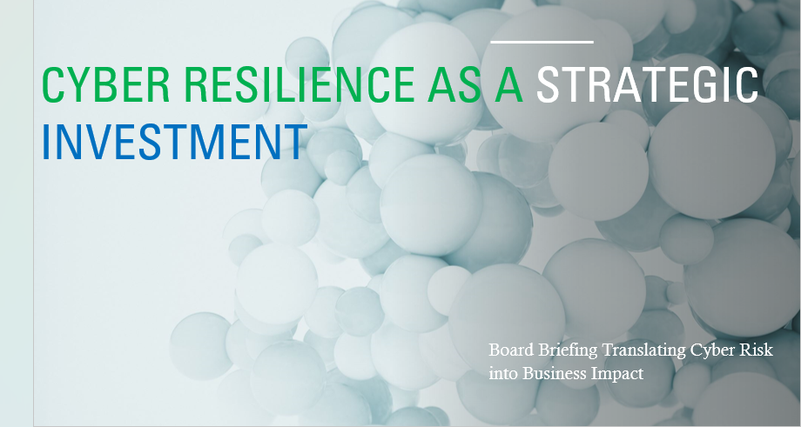

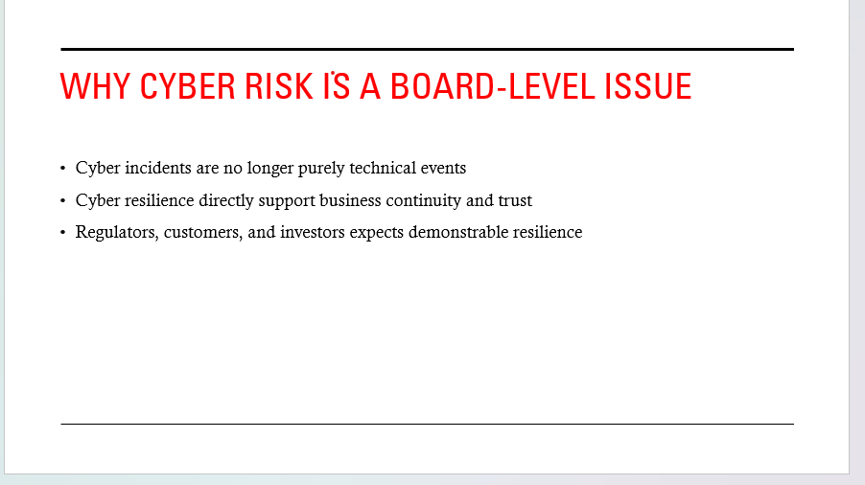

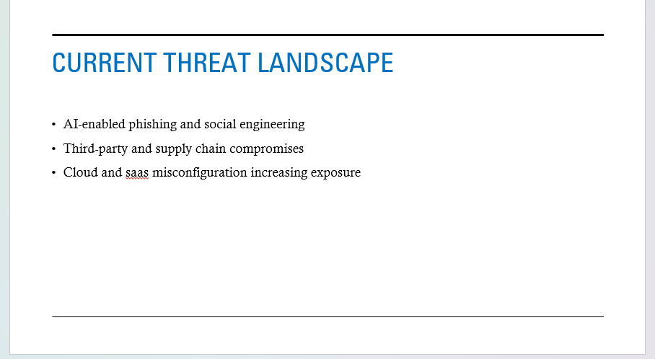
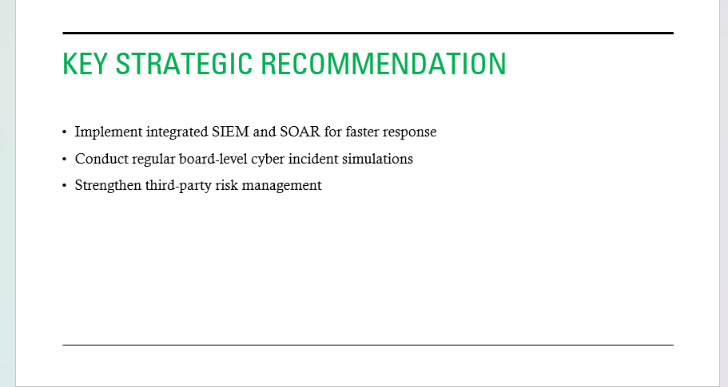
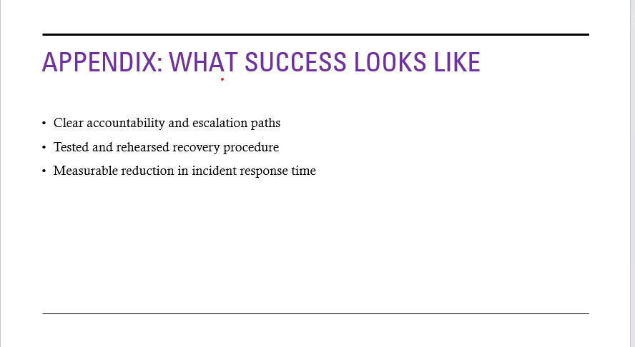

Appendix B: Screenshot of the Badge
This is My Cisco Certificate and badges


