University of Trinity St David

BA Inclusive Education

Name – Lyndsey Copp

Student number – 2118579

Classroom management (ECIE6003)

Resource Pack

Social Stories Resource Pack for Effective Classroom Management

Introduction
This resource pack presents a comprehensive Social Stories toolkit designed to support effective classroom management in inclusive educational settings. Social Stories are short, structured narratives that help pupils—particularly those with additional learning needs—understand social situations, behavioural expectations, and appropriate responses. Originally developed by Carol Gray in the early 1990s, Social Stories were intended to support children with autism by providing clear, respectful, and patient guidance through social scenarios (Gray & Garand, 1993). Over time, their use has expanded to mainstream primary and secondary classrooms, where they serve as a proactive strategy for promoting positive behaviour and emotional regulation. [psycnet.apa.org]
The toolkit is underpinned by key psychological theories, notably Bandura’s Social Learning Theory, which emphasises the role of observation, imitation, and modelling in learning (Bandura, 1977; McLeod, 2025). This theory supports the use of Social Stories by highlighting how pupils can internalise appropriate behaviours through narrative-based modelling. Additionally, cognitive behavioural principles and developmental psychology inform the structure and delivery of Social Stories, reinforcing their value in helping children process emotions and navigate complex social environments. [simplypsychology.org]
Furthermore, the toolkit aligns with current educational priorities such as inclusive pedagogy, trauma-informed practice, and social-emotional learning (SEL). It recognises the importance of creating psychologically safe spaces where all pupils feel seen, heard, and supported. By using Social Stories to explicitly teach social norms and emotional regulation strategies, educators can reduce behavioural incidents, increase pupil confidence, and foster a more empathetic classroom culture.
The inclusion of digital formats, such as editable PowerPoint templates and printable storyboards, ensures accessibility for diverse learners, including those with limited verbal communication or literacy skills. The toolkit also provides guidance for collaborating with families and support staff, promoting consistency across home and school settings.
Ultimately, this resource empowers educators to respond to behavioural challenges with empathy, structure, and clarity. It supports the development of pupils’ self-awareness, self-regulation, and social understanding—skills that are essential not only for classroom success but for lifelong learning and wellbeing.

Included in this pack are:
- A clear rationale for using Social Stories as a behaviour support tool.
- Links to psychological theories that explain their effectiveness.
- Step-by-step guidance for implementation, including how to personalise stories for individual pupils.
- A critical analysis of classroom management strategies, exploring both preventative and responsive approaches.
- Reflections on pupil behaviour, including the impact of neurodiversity, trauma, and socio-emotional challenges.
- Consideration of contemporary challenges, such as the integration of ICT to enhance accessibility and engagement.
The integration of digital technologies into classroom management is increasingly recognised as a key component of inclusive education. Tools such as interactive applications, screen readers, and augmented reality can personalise learning, remove barriers, and foster active participation (Samaniego López et al., 2025; Navas-Bonilla et al., 2025). However, successful implementation requires adequate teacher training, infrastructure, and ongoing support (Polat et al., 2023). [mdpi.com], [frontiersin.org] [files.eric.ed.gov]
By combining theory with practical application, this resource pack aims to empower educators to create inclusive, supportive learning environments where all pupils can thrive. It encourages reflective practice and offers adaptable tools to meet the diverse needs of learners, particularly those who benefit from structured, visual, and narrative-based interventions.
The Social Stories resource consists of a set of customisable story templates that address common classroom scenarios such as transitioning between activities, working in groups, managing frustration, and following routines. These stories can be printed or accessed digitally via tablets, laptops, or interactive whiteboards. Each story includes visual aids, simple language, and positive reinforcement strategies. The resource is designed for use with individual pupils or small groups, particularly those with SEND, anxiety, or behavioral challenges.

Rationale
Social Stories offer a powerful tool for promoting inclusive classroom management by fostering understanding, reducing anxiety, and encouraging positive behaviour among pupils with diverse needs. Their structured, narrative format helps children make sense of social situations, expectations, and consequences, thereby supporting emotional regulation and social competence.
This approach aligns closely with Carl Rogers’ humanistic theory, which emphasises empathy, authenticity, and unconditional positive regard (Rogers, 1967; DeCarvalho, 1991). By validating pupils’ experiences and providing clear, respectful guidance, Social Stories contribute to a psychologically safe environment where learners feel valued and understood. Such conditions are essential for fostering a sense of belonging and promoting intrinsic motivation (Teach HQ, 2025). [psycnet.apa.org] [teachhq.com]
Lev Vygotsky’s sociocultural theory further underpins the use of Social Stories, particularly through the concept of scaffolding and the Zone of Proximal Development (ZPD). Vygotsky posited that learning occurs through social interaction and guided support from more knowledgeable others (Vygotsky, 1978). Social Stories function as cognitive scaffolds, helping pupils navigate complex social situations and internalise appropriate behaviours through repeated exposure and modelling. [scirp.org]
Additionally, B.F. Skinner’s behaviourist principles are reflected in the use of reinforcement within Social Stories. Positive reinforcement—such as praise or rewards embedded in the narrative—can strengthen desired behaviours and reduce challenging ones (Skinner, 1975; Skinner, 1954). This aligns with operant conditioning, where behaviour is shaped by its consequences, making Social Stories a practical tool for behaviour modification in educational settings. [easybib.com], [psycnet.apa.org]
The resource also supports differentiation, allowing educators to tailor stories to individual pupils’ developmental levels, interests, and communication needs. This flexibility is particularly valuable in inclusive classrooms, where pupils may present with a wide range of neurodevelopmental profiles and social-emotional challenges. Stories can be adapted using symbols, simplified language, or visual supports to ensure accessibility for all learners.
Moreover, Social Stories align with trauma-informed practices, which emphasise predictability, safety, and emotional regulation. For pupils who have experienced adverse childhood experiences (ACEs), the clarity and consistency of Social Stories can reduce triggers and support self-regulation. This makes them a valuable component of a whole-school approach to wellbeing and behaviour.
Social Stories also support the development of executive functioning skills, such as impulse control, emotional regulation, and flexible thinking. By presenting scenarios in a step-by-step format, they help children anticipate outcomes and make informed decisions. This is particularly important for pupils with ADHD or other executive functioning challenges, who may benefit from structured guidance in navigating social expectations.
In response to contemporary educational demands, the integration of Information and Communication Technology (ICT) enhances the accessibility and engagement of Social Stories. Digital tools such as interactive story apps, visual supports, and multimedia formats can personalise learning and remove barriers for pupils with additional needs (Polat et al., 2023; Samaniego López et al., 2025). However, successful implementation requires adequate teacher training and infrastructure to ensure equitable access and meaningful use. [files.eric.ed.gov], [mdpi.com]
In today’s classrooms—characterised by increasing diversity, behavioural complexities, and the need for inclusive practices—Social Stories offer a proactive, empathetic, and evidence-informed approach to classroom management. They empower educators to respond to pupils’ needs with sensitivity and structure, promoting both academic success and emotional well-being.

Instructions for use
Implementing Social Stories effectively requires thoughtful planning, personalisation, and consistency. The following steps outline a structured approach for educators to maximise their impact in inclusive classroom settings:

1. Identify Target Pupils
Begin by identifying pupils who would benefit most from using Social Stories. These are often children who experience challenges with understanding social situations or managing their emotions. Pupils who may benefit include those with:
- Additional Learning Needs (ALN)
- Autism Spectrum Disorder (ASD)
- Anxiety or difficulties with emotional regulation
- Behavioural challenges or social communication needs
Use classroom observations, behaviour logs, and input from support staff, parents, and the pupils themselves to assess suitability and ensure targeted support.

2. Define the Social Situation
Select a relevant classroom scenario that the pupil finds challenging or confusing. Common examples include:
- Transitioning between activities
- Sharing resources
- Managing frustration or sensory overload
- Asking for help
- Participating in group work
Ensure the scenario is specific and meaningful to the pupil’s daily experience.

3. Customise the Story
Adapt or create a Social Story using the following principles:
- Use clear, concise, and positive language appropriate to the pupil’s comprehension level.
- Include visual supports such as symbols, photos, or illustrations to aid understanding.
- Maintain a first-person perspective (e.g., “I can…” or “Sometimes I feel…”).
- Ensure the story follows a logical structure: situation → feelings → appropriate response → outcome

4. Choose the Format
Present the story in a format that suits the pupil’s learning style:
- Printed booklets or laminated cards
- Digital formats (e.g., tablet, laptop, interactive whiteboard)
- Audio recordings for pupils with literacy difficulties
Create a calm, distraction-free environment for initial presentation.

5. Introduce and Discuss
Read the story with the pupil in a supportive, one-to-one or small group setting. Encourage discussion by:
- Asking open-ended questions (e.g., “How do you think that feels?”)
- Clarifying expectations and appropriate responses
- Relating the story to real-life experiences
This step builds emotional connection and comprehension.

6. Reinforce Through Practice
Use strategies to reinforce the story’s message:
- Role-play the scenario with peers or adults
- Repetition of the story before relevant situations
- Positive reinforcement (e.g., praise, stickers, tokens) when the pupil demonstrates the desired behaviour
Consistency is key to internalising the behaviour.

7. Monitor and Adapt
Observe the pupil’s response over time. Use behaviour tracking tools or anecdotal records to assess:
- Changes in behaviour
- Reduction in anxiety or outbursts
- Increased independence or social engagement
Adapt the story as needed to reflect progress or new challenges.

8. Collaborate Across Settings
Share the Social Story with:
- Support staff (e.g., teaching assistants, SENCOs)
- Parents/carers for use at home
- External professionals (e.g., speech and language therapists)
This ensures consistency and reinforces learning across environments.

9. Evaluate Impact
Regularly review the effectiveness of the Social Story by:
- Gathering feedback from the pupil, staff, and family
- Reflecting on behavioural data and learning outcomes
- Updating the story to remain relevant and engaging
Consider using pupil voice tools or visual feedback methods for younger children.

Here is a copy of the social story I created.

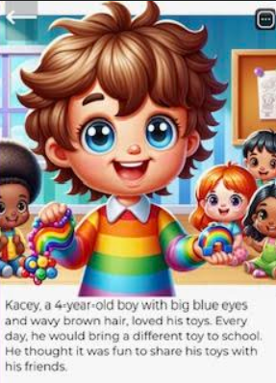
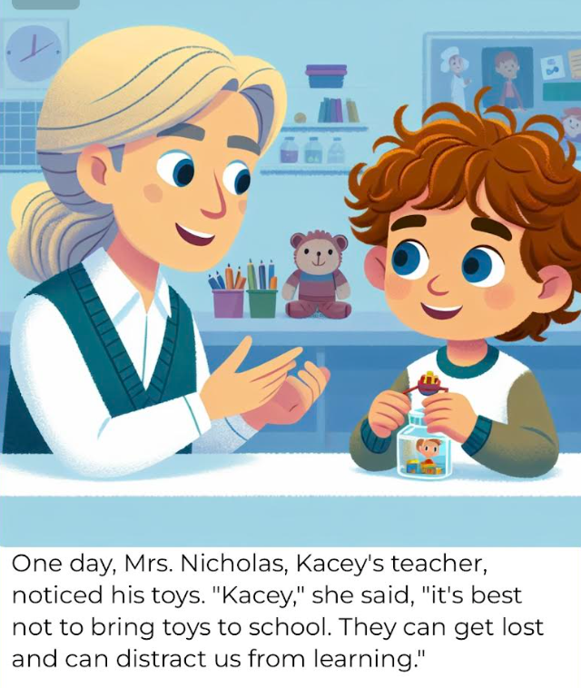



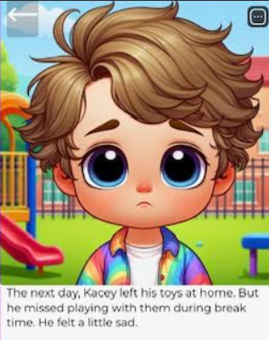

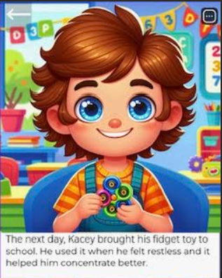

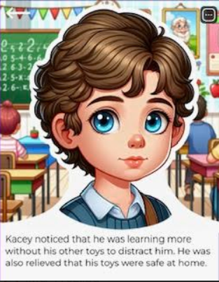

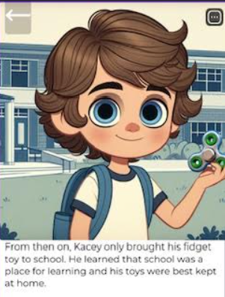

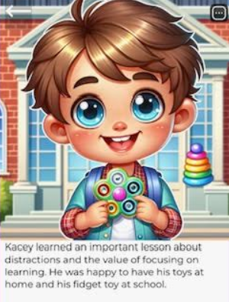

References
Action for Children (2024). Barriers to Learning. Available at: https://www.actionforchildren.org.uk
AERO (2021). Teaching Routines. Available at: https://www.aero.edu.au
Callahan, J. (2024). Educational Psychology and Inclusive Practice. London: Routledge.
Cambridge Assessment (2019). Differentiation in the Classroom. Available at: https://www.cambridgeassessment.org.uk
Drew, T. (2024). Behaviourism in Education. Oxford: Oxford University Press.
Education Hub (2021). Classroom Routines and Procedures. Available at: https://educationhub.blog.gov.uk
IQM (2025). Ofsted Framework and Inclusion. Available at: https://www.inclusionqualitymark.co.uk
NEU (2025). Behaviour and Inclusion. National Education Union. Available at: https://neu.org.uk
Praveen, S. & Alex, R. (2018). Choice Theory in Practice. Journal of Educational Psychology, 45(2), pp. 112-128.
Unionlearn (n.d.). Understanding Barriers to Learning. Available at: https://www.unionlearn.org.uk
Vygotsky, L. (1978). Mind in Society: The Development of Higher Psychological Processes. Cambridge, MA: Harvard University Press.

Bandura, A. (1977). Social Learning Theory. Englewood Cliffs, NJ: Prentice Hall.
Gray, C.A. & Garand, J.D. (1993). Social stories: Improving responses of students with autism with accurate social information. Focus on Autistic Behavior, 8(1), pp.1–10. [psycnet.apa.org]
McLeod, S. (2025). Albert Bandura's Social Learning Theory in Psychology. Simply Psychology. Available at: https://www.simplypsychology.org/bandura.html [simplypsychology.org]
Polat, E., Cepdibi Sıbıç, S., Cirit-Işıklıgil, N.C., Hopcan, S. & Baştuğ, Y.E. (2023). Educational technology in inclusive classrooms: Assessing teacher awareness and needs. Journal of Educational Technology & Online Learning, 7(1), pp.115–131. [files.eric.ed.gov]
Samaniego López, M.V., Orrego Riofrío, M.C., Barriga-Fray, S.F. & Paz Viteri, B.S. (2025). Technologies in Inclusive Education: Solution or Challenge? A Systematic Review. Education Sciences, 15(6), p.715. [mdpi.com]
Navas-Bonilla, C.R., Guerra-Arango, J.A., Oviedo-Guado, D.A. & Murillo-Noriega, D.E. (2025). Inclusive education through technology: A systematic review of types, tools and characteristics. Frontiers in Education, 10, Article 1527851.
DeCarvalho, R.J., 1991. The humanistic paradigm in education. The Humanistic Psychologist, 19(1), pp.88–104. https://doi.org/10.1080/08873267.1991.9986754 [psycnet.apa.org]
Polat, E., Cepdibi Sıbıç, S., Cirit-Işıklıgil, N.C., Hopcan, S. & Baştuğ, Y.E., 2023. Educational technology in inclusive classrooms: Assessing teacher awareness and needs. Journal of Educational Technology & Online Learning, 7(1), pp.115–131. [files.eric.ed.gov]
Rogers, C.R., 1967. Client-Centered Therapy: Its Current Practice, Implications and Theory. London: Constable.
Samaniego López, M.V., Orrego Riofrío, M.C., Barriga-Fray, S.F. & Paz Viteri, B.S., 2025. Technologies in Inclusive Education: Solution or Challenge? A Systematic Review. Education Sciences, 15(6), p.715. https://doi.org/10.3390/educsci15060715 [mdpi.com]
Skinner, B.F., 1954. The science of learning and the art of teaching. Harvard Educational Review, 24, pp.86–97. [psycnet.apa.org]
Skinner, B.F., 1975. About Behaviorism. New York: Random House. [easybib.com]
Vygotsky, L.S., 1978. Mind in Society: The Development of Higher Psychological Processes. Cambridge, MA: Harvard University Press. [scirp.org]

