

Student Name: Ghuzala Begum
Student ID: 2244713
Module Name: Independent Project
Module Code: BMHP 6020
Lecturer: Chloe Harries
Methods and Search Strategy Academic
Poster

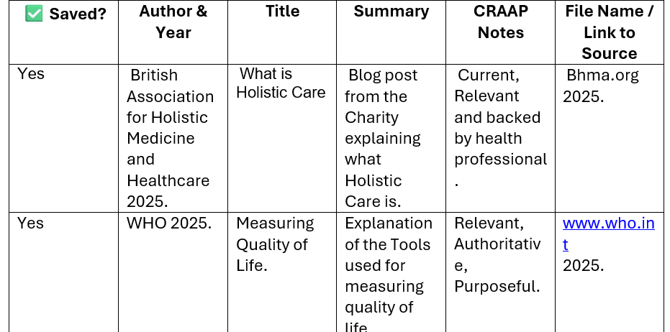
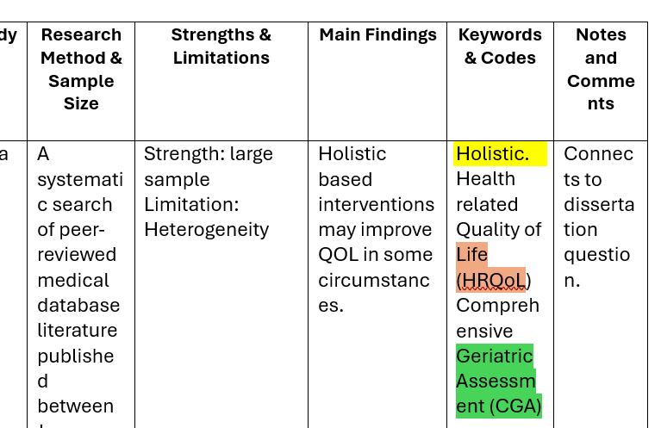
Results Summary table, identifying themes
Source tracking table
Holistic Care: An Evaluation of its’ Effectiveness in Improving Quality of Life for the Elderly Person.
The methods chapter provides the methodology processes carried out to gather information regarding the research aim. An in-depth look into the secondary data from academic journals or studies will be searched (Wickham, 2019).
The AIM of the research is to examine how effective ‘Holistic Care’ innovations are towards elderly care provisions. Does the research present valuable data on how the quality of life is affected by these innovations (Stafford et al, 2018).

01 Introduction and Research Aim
03 Searching for Information
- Internet access enabled online academic searching.
- Sources included Google Scholar and the UWTSD library.
- Search strategies used field codes and thesaurus-based synonyms (Bramer et al., 2018).
- Boolean operators (AND, OR, NOT) refined search results
- Findings were recorded in a source tracking table.

02 “A search strategy is an organised structure of key terms used to search a database. The search strategy combines the key concepts of your search question in order to retrieve accurate RESULTS”. (University of Leeds, 2026).
04 (NMC Standards,2024).
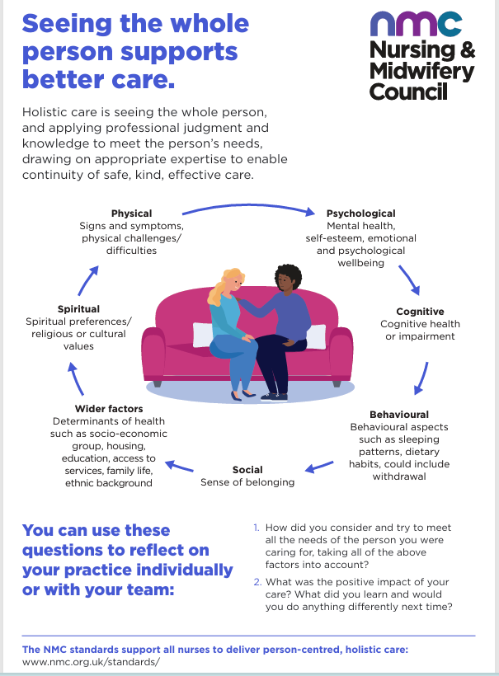

05 Research Validation and Analysis
Research validation refers to the process of ensuring that research methods, data, and findings are credible, accurate, and appropriate for addressing the research question. In secondary research, validation focuses on critically appraising existing studies to confirm their reliability, methodological rigour, and relevance (McGrew et al, 2018). Skimming techniques and applying the CRAAP test help to determine the relevance of an article. Thematic analysing involves generating codes. Codes help to identify recurrent patterns, which then become the ‘themes’ (Ahmed et al, 2025). Chapter 4 will focus on these themes.

07 Exclusion Criteria
- Non- English publications
- Sources which focus on young adults.
- Literature which is older than 10 years and not peer reviewed.
- Studies which do not meet the 3 most important criteria of the CRAAP test, Currency, Relevance and Authority (Patino and Ferreira, 2018).

06 Inclusion Criteria
- Literature written in English language.
- Academic peer reviewed literature not older than 10 years.
- Sources which link directly to research aim e.g. ‘holistic care’ and ‘quality of life for the elderly person.
- Official Governmental sites or NHS reports. (Patino and Ferreira, 2018).

08 Ethical Considerations
Ethical considerations are a critical component of secondary research, particularly in relation to academic integrity, transparency, and the credibility of findings. Academic integrity is maintained through accurate representation of original sources, proper citation, and acknowledgement of all secondary data. To avoid plagiarism paraphrase appropriately and reference all materials in accordance with academic conventions. Ethical responsibility centres on the appropriate and responsible use of data protecting the privacy and confidentiality of identifiable sensitive information. Data protection breeches can be avoided by complying with relevant laws and regulations governing data use and research (UK Statistics Authority, 2022).

References

Ahmed, S, K., Mohammed, R, A., Nashwan, A, J., Ibrahim, R, H., Abdalla, A, Q., Ameen, B, M, M. and Khadir, R, M. (2025) ‘Using Thematic Analysis in Qualitative Research’, Journal of Medical Surgery and Public Health. 6. Available at: https://doi.org/10.1016/j.glmedi-2025.100198 (Accessed: 7th February 2026).

Bramer, W, M., De-Jonge, G, B., Rethlefsen, M, L., Mast, F. and Kleljnen, J. (2018). ‘A Systematic Approach to Searching, An Efficient and Complete Method to Develop Literature Searches ‘, Journal of the Medical Library Association. 106, (4, October), pp531-541. Available at: https://jmla.pitt.edu/ojs/jmla/article/view/283 (Accessed: 5th February 2026).

McGrew, S., Breakstone, J., Ortega, T., Smith, M. and Wineburg, S. (2018). ‘Can Students Evaluate Online Sources? Learning from Assessments of Civic Online Reasoning’, Theory and Research in social Education. 46, (2, January), pp165-193. Available at: https://doi-org.uwtsd.idm.oclc.org/10.1080/00933104.2017.1416320 (Accessed: 6th February 2026).

Nursing and Midwifery Council. (2024) Seeing the Whole Person Supports Better Care (Standards). Available at: https://www.nmc.org.uk/globalassets/sitedocuments/standards/holistic/holistic-care-infographic-aw.pdf (Accessed: 5th February 2026).

Patino, C, M. and Ferreira, J, C. (2018) ‘Inclusion and Exclusion Criteria in Research Studies: Definitions and Why they Matter’, Journal Brasileiro de Pneumologia. Available at: https://doi.org/10.1590/S1806-3756201800000008 (Accessed: 6th February 2026).

Stafford, M., Steventon, A., Thorlby, R., Fisher, R., Turton, C. and Deeny, S. (2018) ‘Briefing: Understanding the Health Care Needs of People with Multiple Health Conditions’, The Health Foundation. Available at: https://www.health.org.uk/sites/default/files/upload/publications/2018/Understanding%20the%20health%20care%20needs%20of%20people%20with%20multiple%20health%20conditions.pdf (Accessed: 6th February 2026).

UK Statistics Authority. (2022) Ethical Considerations Associated with Qualitative Research Methods. Available at: https://uksa.statisticsauthority.gov.uk/publication/ethical-considerations-associated-with-qualitative-research-methods/pages/2/ (Accessed: 7th February 2026).

University of Leeds. (2026) Literature Searching Explained: Develop a Search Strategy. Available at: https://library.leeds.ac.uk/info/1404/literature_searching/14/literature_searching_explained/4 (Accessed: 5th February 2026).

Wickham, R, J. (2019) ‘Secondary Analysis Research’, Journal of Advanced Practitioner in Oncology. 10, (4, May/June), pp395-400. Available at: https://doi.org/10.6004/jadpro.2019.10.4.7 (Accessed: 5th February 2026).

