Academic Skills
Assignment 2
March 2018
Academic Skills
Nia James
1705762

Table of contents

- Executive summary
- Introduction
  - Report remit
  - Brief background on project
  - Models of reflection
  - Masterclass sessions
  - Influence of masterclass on the project
  - Influence of the masterclass on personal learning and development
  - Conclusion
- References

List of figures

Figure 2-1 – Driscoll’s three stage model of reflection
Driscoll’s three staged model image (2001) https://www.nationalcollege.org.uk/transfer/open/mentoring-and-coaching-core-skills/mccore-s06/mccore-s06-t01.html
Figure 2-2 – Nia James in Tesco doing the bag packing event
Figure 2-3 – Gibbs reflective cycle
Gibbs’ reflective cycle (2016) https://my.cumbria.ac.uk/media/MyCumbria/Documents/ReflectiveCycleGibbs.pdf.
Figure 2-4 – Facebook post
Figure 2-5 – Facebook group
Figure 2-6 – Go Fund Me page
Figure 2-7 – Poster for sponsored walk
Word press (2017), Poster – Nia James, Available at: https://wordpress.com/view/mattshousefund.wordpress.com. Accessed 19th February 2018.

- Executive summary

The purpose of this report is to produce a reflective and evaluative management report and also to use all skills learned from academic skills classes and theories. This project highlights how the masterclasses make an impact and inform the implementation of the project. It also reflects on and evaluates the masterclass sessions in relation to the project including literature. This report explains how the master classes made an impact on personal learning and development including recommendations on how to improve a similar project in the future and how to enhance personal skills and competences.
Masterclasses made a huge impact on personal learning as volunteers from different organisations came to explain and describe what their business is, what it is about, and how it can make an impact on lives and future careers. Many different organisations expressed their organisations in a positive light which influenced their audience to make an impact on their life goals. I have learned a lot as I got to speak to a marketing manager and ask questions that include a day in the life of a marketing manager. This helped me to build on my experience.
The masterclasses helped my project in many ways as to do many different tasks for the organisation it required different skills that I did not have. Although, after the masterclass sessions I was able to put these skills to good use which also made an impact on the work I did for Matthews House. It also helped me develop ideas which I could use to raise more money for my charity.
I used Driscoll and Gibbs models of reflection as these both fitted in with my personality and way of learning. They both helped me to reflect on my project work and personal learning and development.

- Introduction

The assignment brief was to produce a reflective and evaluative management report. It facilitates the use of all skills learned from academic skills sessions and theories. Reflection to Cottrell (2015), is critical, analytical thinking. He adds, reflection weighs up the strengths and weaknesses, costs and benefits, decisions and outcomes, which are skills required for academic work. Models of reflection from different theorists such as Driscoll (1994) and Gibbs (1988), will also be included as they will be discussed and compared. There will be evidence included with appropriate use of research-informed literature. Finally, masterclass sessions, taken within the academic skills module, will be explained using the primary themes that impacted on project performance as well as personal learning. These will all be linked to the project I worked on called Matthew’s House, which is an organisation that helps the vulnerable of Swansea.

  - Report remit

This report will provide an explanation of the different models of reflection, including a comparison of the theories of two different models of reflection including Driscoll and Gibbs. Furthermore, the impact the masterclass sessions had in regard to the context of these models, the project and on personal learning and development will be discussed. The models of reflection will demonstrate an in-depth explanation of how they relate to the experiences gained during the project as a whole including how each model of reflection links in with Matthews House.
2.2 Brief background on project

Matthews House is the project I have been working on. Matthew’s House was established in 2015, founded by a group of 30 friends who went to a similar organisation in Cardiff and decided that Swansea needed this type of support for the vulnerable as well. The group initially raised £5,000 in start-up capital, this small amount of investment had a limited impact, though did allow the organisation to begin operating in a limited capacity. They are located in Swansea in The Hill Church which went on auction for £80,000 but Matthew’s House put a £75,000 bid in and won. In May 2016, the church was bought by St Matthew’s Community Centre. It was previously owned by a charity called Cyrenians, but they went into administration. The Hill Centre has been renovated to a high standard (Matthew’s House website, 2017). My experience with Matthews House was all round positive as they helped me to help them which I think is important as I needed to know everything about the organisation so that I could inform others. My project was to raise money for Matthews House so that they could build a shower room for the vulnerable of Swansea to be able to come and have a shower free of charge.

2.3 Models of reflection

Driscoll (2007) created a three-stage model of reflection (Figure 2-1).
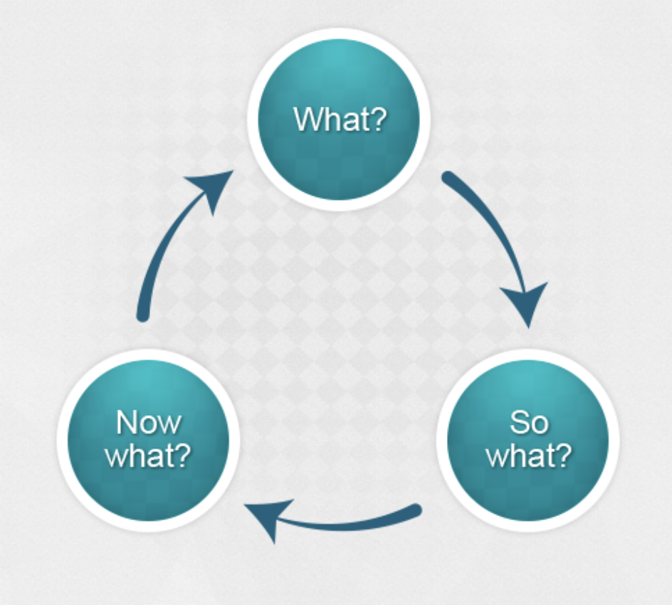
Figure 2-1 Driscoll’s three staged model image (2001) https://www.nationalcollege.org.uk/transfer/open/mentoring-and-coaching-core-skills/mccore-s06/mccore-s06-t01.html.

Driscoll (2007) describes his model of reflection as a three-stage process which starts with “what”, meaning what was done, then “so what”, meaning what was the consequence of the action, then finally “now what”, meaning what are you going to do next. Driscoll (2007) explained that he came up with this theory thanks to the influence of others such as Kolb (2014) as suggested he used “now what” as he needed advice on what to add. He added that “what” was simply a description of the event, for example, what happened, then “so what” is an analysis of the event, for example, how did you feel at the time of the event, and finally for “now what” is a proposed action following the event, for example, how can you modify your practice if a similar situation was to happen again.
In regard to my project, Matthew’s House, there are many different examples I can use to describe how this model of reflection worked for me. For example, I did some charity work for this organisation, which included bag packing in Tesco (Figure 2-2), to raise money to refurbish the showers at Matthews House so that the vulnerable of Swansea could go and have a wash. Using Driscoll’s (2007) model the “what” would refer to the problem that the showers need refurbishment and the “so what” relates to raising enough money so that the organisation could refurbish the showers, they are nearly completed now. Finally, the “now what”’ is the reflection that I really want to continue working with this organisation so that I can do everything I can in order to support and build on the organisation so that less homeless people are on the streets of Swansea.
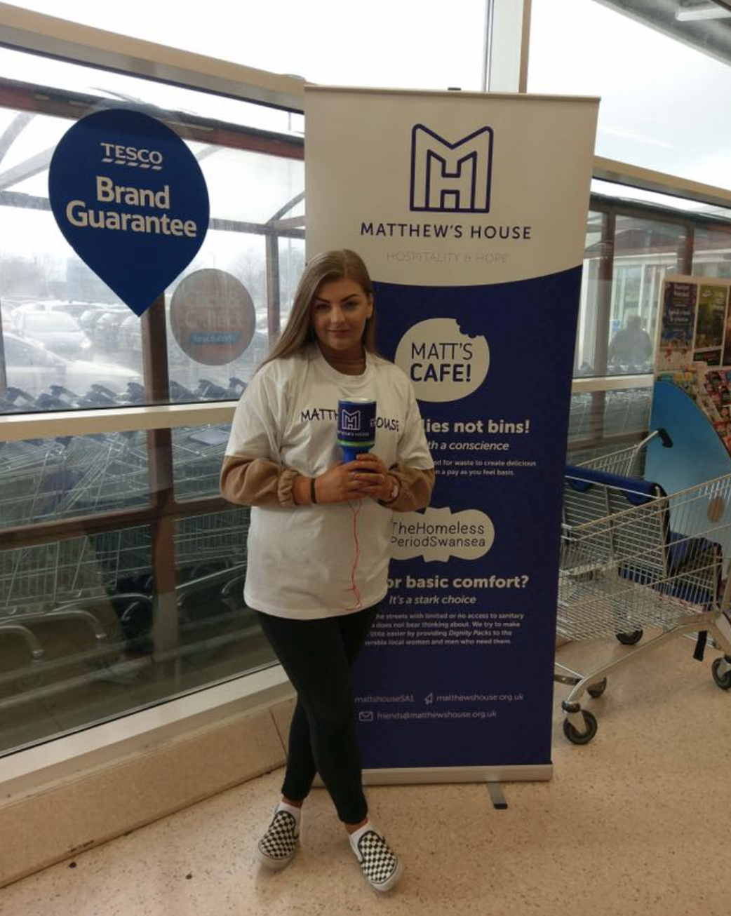

Figure 2-2: Nia James volunteering at Tesco to spread awareness and raise money for Matthews House.

The second model of reflection that I will use to discuss my experiences during my project was Gibbs’ (1988) reflective cycle (Figure 2-3).
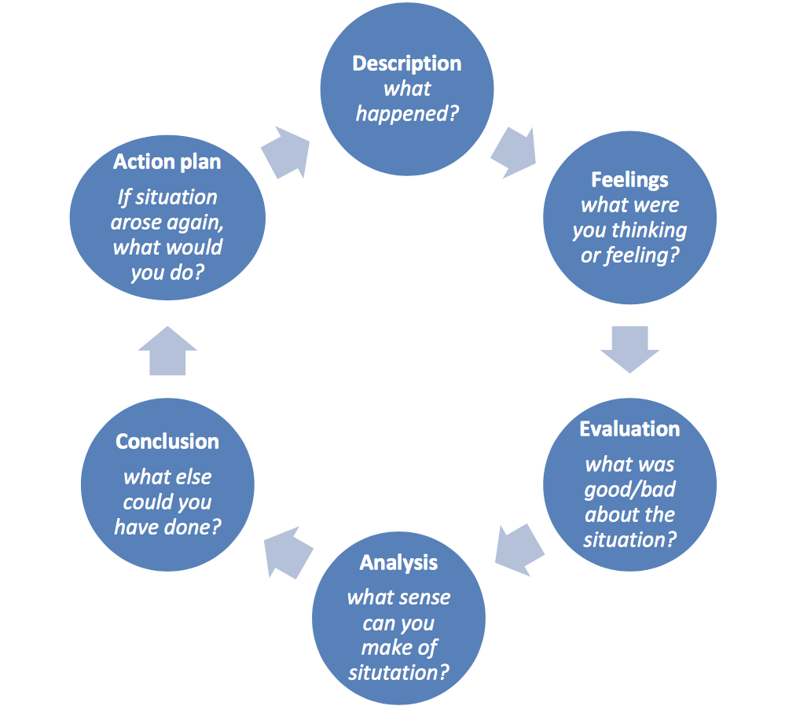
Figure 2-3 Gibbs’ reflective cycle (2016), Available at https://my.cumbria.ac.uk/media/MyCumbria/Documents/ReflectiveCycleGibbs.pdf. Accessed 16th February 2018.

Gibbs’ (1988) Reflective Cycle is a model of reflection which includes 6 different stages of reflection. It starts off with ‘description’ which is stating what has happened, its where you include background information such as what you’re reflecting on and who was involved. Then it goes onto ‘feelings’ which is what you were thinking of feeling after what happened, this is where you consider questions like what you were thinking about what happened afterwards? This is where you express emotions. Next, I moved onto ‘evaluation’ which is what was good and/or bad about the situation, it’s also about how you react to the situation and how did other people react. It’s a place to explain that if it went bad, then how can you resolve the situation. Analysis is the 4th stage which states what sense you can make of the situation, meaning whether or not it helped or hindered the event. Conclusion is the 5th stage as it comes to the end of the process, this is where you can identify what else you could’ve done. Finally, the 6th stage is the action plan which is if the situation were to come again what would you do differently, maybe to improve for example.
According to Pearce et al. (2003), critical reflection is essential for numerous reasons. Lyons (2010) described these reasons such as how it promotes thinking and understanding, it also refers to thought and going back to an event, it involves changing perspective and analysing one’s own role, it challenges commitment and feelings, it benefits mental discipline and time, and finally it approaches what the purpose was and the delivered outcome.
In relation to Matthews House, this model of reflection took place within experience as I made lots of different social media pages (Figure 2-4) which involved Facebook (Figure 2-5) and Go Fund Me (Figure 2-6) which is a charity website. I created these to spread awareness about the organisation which was their main aim, my feelings towards this were all positive, I wanted to support this organisation so was willing to extend my capabilities to create these pages and write loads of posts to spread awareness of what Matthews House is and what the money raised would go towards. In regard to evaluation, I believe everything was good about what I did as I got so much positive feedback from the general public and the organisation itself, another point to support this is the fact that £550 in total was raised for the showers to be refurbished which is such a big amount of money. I helped this event by continuing to do these posts online because every time I did more and more people got to see them. I think I could’ve gone broader and went on more social media sites such as Twitter, maybe this could’ve attracted a whole different audience which would’ve raised more money. If I was going to do this again I would do more physical charity work instead of basing it all online as this may have got more age groups involved as 65+ tend not to go online according to Mellor et al (2008).
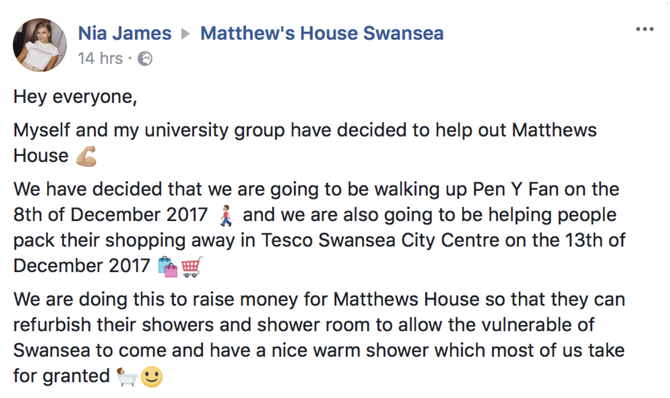

Figure 2-4: Blog post to raise awareness for Matthews house
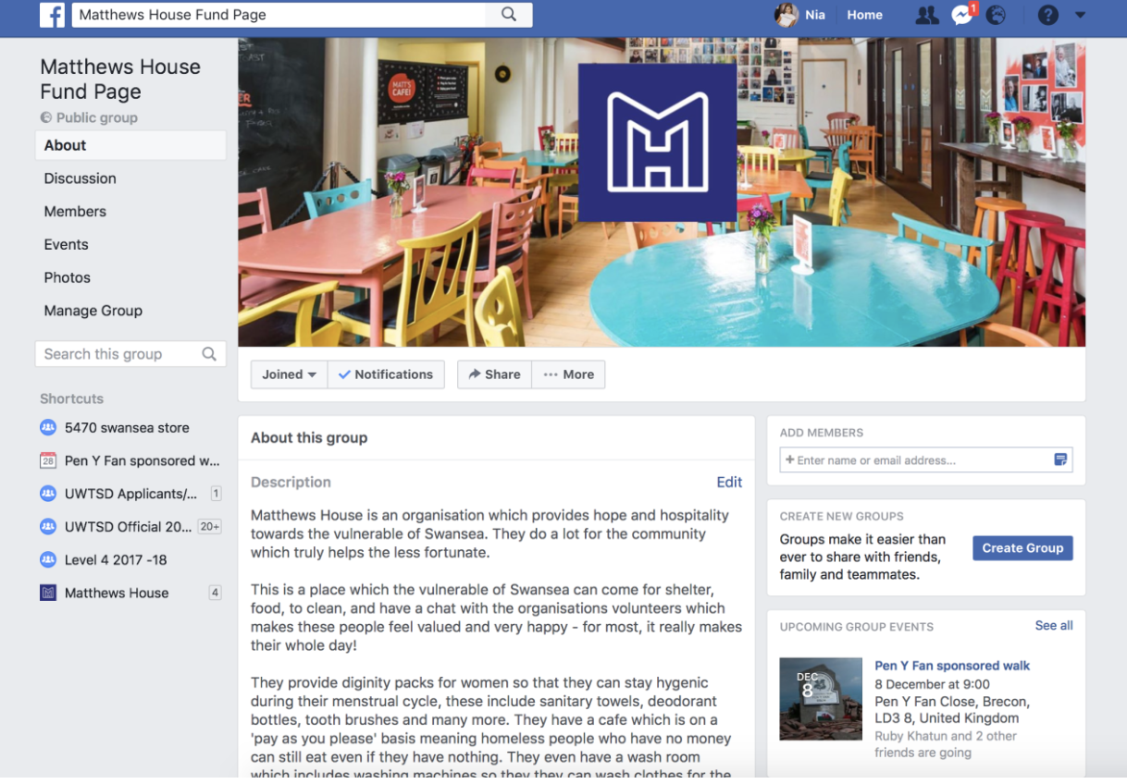

Figure 2-5: Facebook page to raise awareness for Matthews house

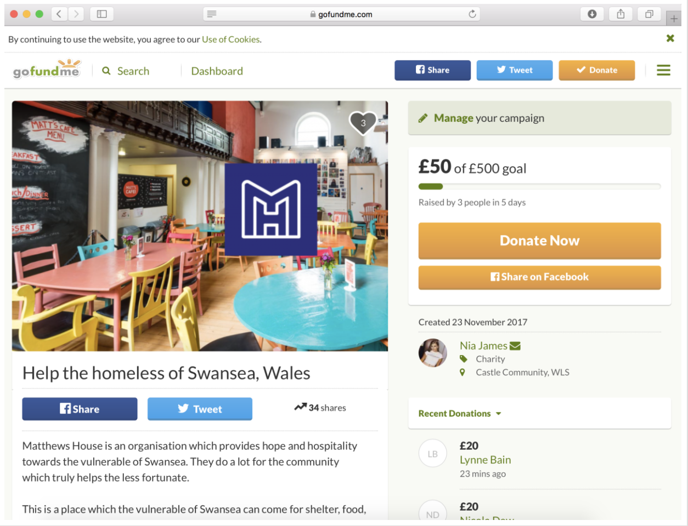

Figure 2-6 Go fund me web page to raise money for Matthews house

2.4 Masterclass sessions – the context

This part of the report will be discussing the masterclasses I took part in as a part of my academic skills module and how they impacted the project. According to Fabio (2015), a masterclass is taught by a master of a certain discipline and the classes are usually one-off events. We underwent ten different masterclass sessions that were all on different topics. I will be discussing the top five that benefited me.
The first masterclass session was The Entrepreneurial Spirit that was presented by Benedict Room. Firstly, Benedict started off the session by asking us what we all thought makes an entrepreneur. He stated that the four main skills to create a perfect entrepreneur included a positive attitude, creativity, building relationships and being organised (Figure 2-7). Benedict discoursed he is a company director for BRD Centre, Team BRD CLC, and Surfability UK CLC. These are all successful businesses which may be due to the fact he has nineteen years’ experience (BRD sport, 2008). This masterclass really influenced me as I got to know all about what it takes to be an entrepreneur and the benefits of it. He made me understand the struggles of competition with whatever area you decide to go in, but I also got to listen to his success which motivated me and made me learn that everyone starts from somewhere, so I should follow my future career goal and overcome the barriers when I get to them. Benedict also benefited me in regards to my project as he influenced me to direct my team with what our tasks were because this way we got goals accomplished on time. According to Ronis (2007), when you accomplish goals on time you seek better outcomes overall. Which is true as I was able to identify what went well and what went wrong in order to improve for the next task I did for Matthews House.
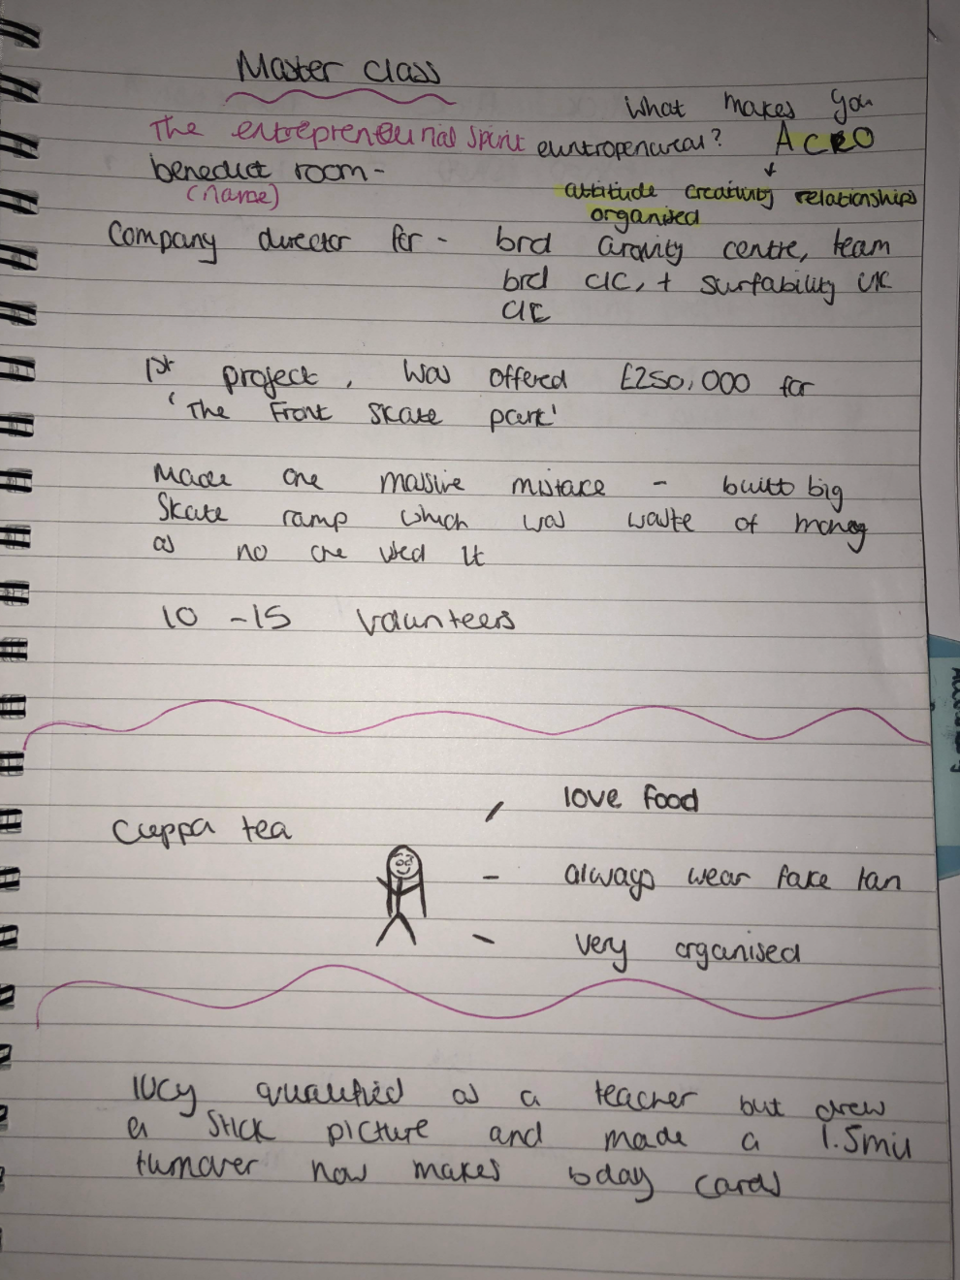
Figure 2-7: Notes taken at the “Entrepreneurial Spirit” masterclass session

The second masterclass session I attended that benefited me was The Networking Strategy for Introverts by Andy Rogers. Andy explained the ‘Zone’ process to us, this involved everyone having a comfort zone, panic zone, and risk zone. If you take risks in your career then you’re more likely to be in the panic zone as you won’t know the outcome. The more you do which you consider as things in your risk and panic zone, the more you grow and develop as an individual and you’ll have more positive effects on your job to enter the comfort zone.
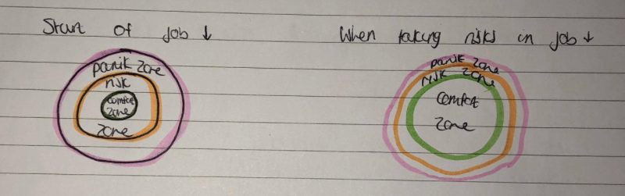
Figure 2-8: Notes taken at the “Networking Strategy for Introverts” masterclass session

Andy moved onto saying networking opens up opportunities for who you know. It connects you with other people who could potentially help you and your business. He said when it comes to building relationships you should always treat people how they want to be treated. This is because everyone is different and wants to be treated in different ways. This masterclass really made me realise that stepping outside of your comfort zone is a positive thing, even though barriers will come about through the way, it’s important to take risks to improve in anything you’re doing. I know that if I want to go far I need to work to the best of my ability and push myself to step out of my comfort zone as this is where ill gain more skills and abilities. Soon, these “panic zones” will become “comfort zones” and this is great for improvement. This helped me to step outside of my comfort zone with Matthew’s house by talking to people with confidence about the organisation. Even though Andy said the outcomes of stepping outside of your comfort zone, he didn’t explain what to do in order to do it, Dryden (2012), recommended that if you achieve goals and overcome inertia then this is how you step outside of your comfort zone.

The third masterclass that benefited me was Kate’s Gower Cottage Brownies which ventured in 2007. Within this masterclass session, she explained that she has been awarded “the best brownies ever tasted” by the BBC Good Food Magazine and she has been recognised for very good service by verygoodservice.com which both of these are such high achievements for a sole trader (Gower Cottage Brownies, 2016). Kate explained to us that she takes very good care of her products as she makes the brownies from scratch then uses unique gift wrap to stamp her mark on them for all occasions. Her passion and determination inspired me to never back down at opportunities that come my way. She even makes Gluten-free and nut free brownies which is so pleasing to hear as Gluten-free is becoming a popular trend in younger people due to celebrities opting for this option according to BBC News (2017). Kate is a perfect example of someone who decided to create their own business on something they truly love doing, and I think this is why she’s doing so well. She’s benefited me in so many ways as she has taught me to find something I love doing and take up a job surrounding this, as this will maintain my motivation to do well throughout my whole career. Hunt (2005) explains maintaining motivation is associated with balance which will affect your overall well-being and sense of self-worth. I do believe this statement is accurate because when I worked with Matthews House I was motivated throughout which led me to feel proud of myself.

The forth masterclass was Hilltop Honey which was presented by their marketing manager, Josh Owen. Josh explained that Hilltop Honey was expanded in 2017 into a 14,000 square foot production in Newtown. They supply eight of its honey products in a trial order to Saudi Arabia, Oman, Bahrain, Qatar and the UAE. Josh secured the order from two supermarket chains after joining a Welsh Government trade mission Gulfood at Dubai World Trade Centre which is such a high achievement. He explained that it’s a massive market with so much potential which inspires me as my future career goal is to become a marketing manager (Hilltop Honey, 2017). Josh is clearly motivated and determined to do well as he spoke with such passion. This was very encouraging for me as I got to hear his real-life experiences within Hilltop Honey and got to take some tips. He explained that if you put your all into something you will get ten times more back which got me thinking that I am more than capable to do well if I maintain focused and determined to work my way up. Biech (2008), explains that to maintain focused you need to do the following things, be cooperative, be competitive and help all other colleagues as this will improve your well-being and mentality as you’ll be helping others without noticing your refreshing your own memory.

The fifth masterclass session was a retail marketing consultant for BMW called Jonathan Robbins who describes himself as a passionate marketer with high integrity. He stated that he has made a huge impact through different projects when working with dealerships and Audi UK. he has also represented Sinclair Group with Audi National Digital Business Development Group as he helped develop and deliver strategies and initiatives in relation to modern, digital retailing across the Audi network (Robbins, 2017). My experience within this masterclass was pleasing as I got to understand the daily life of a retailer marketing consultant. I now understand the stresses of competitive marketing within the car industry as Jonathan described them all. I still want to go into retail marketing when I’m older as this is my dream job and I understand the daily processes that I would face. According to Blythman (2013), a typical daily process for a retail marketing manager includes directing, managing, controlling, and manager in advertising which I think both Matthews House and my personal learning and development have directed me into these directions.

2.5 Influence of masterclasses on the project

The Entrepreneurial Spirit influenced my project as I got to understand the life of an entrepreneur. Thom, the leader of Matthews House, is an entrepreneur as he created this organisation himself, he also runs it and is the only employee as the others are all volunteers. When working with this organisation I had to use entrepreneurial skills whilst raising money as I had to go out on my own and raise money. If I didn’t attend this session I wouldn’t have known the right things to say and do whilst raising money as I hadn’t done it before. I knew I had to maintain confident and stable so the people I was talking to were convinced I did know what I was talking about and that the information I gave was right.
Andy rogers made me understand that taking risks is key as it helps you to improve. I decided to do Tesco bag packing for Matthews House to raise money for the organisation but before the masterclass I was sceptical. I was unsure of whether it would be a success or not, but thankfully after this masterclass, I knew I had to take the risk as it was for an organisation that really needed the money. Also, according to Palethorpe (2011) the more work you do, the less anxious you become doing tasks, so I think this is exactly what happened to me.
Whilst working with Matthews House, I experienced working on my own for a big project for the first time. I made social media sites and blogs to spread awareness with no experience in this sector so I wasn’t sure whether they would be a success or not. Just like Gibbs (1988), Kate takes feelings into consideration as she said if you truly want to do something, go for it, which is what I did for Matthews House.
After listening to marketing manager Josh Owen I knew it would benefit me in regards to Matthews House as this organisation is all about marketing and how they represent themselves to the public. I had to make a poster to inform everyone in Swansea about the sponsored walk I was doing for Matthews House so that they knew how to sponsor money for the charity (Figure 2.9).
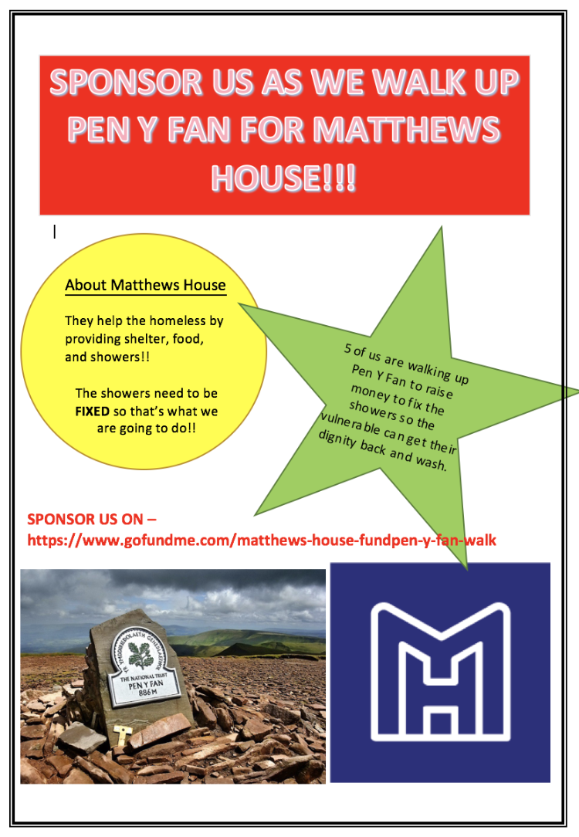
Figure 2.9 (https://wordpress.com/view/mattshousefund.wordpress.com)

If this project was to come around again I would take more models of reflection into consideration as I think the ones I did really benefited me in regard to my work with Matthews House. I would use Cottrell as he has a bigger process in his model of reflection, this may help me to identify more aspects of the work I was doing to help me improve and not make mistakes (Cottrell, 2010).

2.6 Influence of the masterclasses on personal development and learning

My personal development and learning have been massively impacted by all of the masterclass sessions I took part in many different ways. The first masterclass taught me entrepreneur skills which include being organised and creative. I have already mastered being organised as I have changed the way I work, I write down in sections what I need to do by what date so that I have time to do corrections before the deadline. The second masterclass made me realise that risk-taking is important for personal development, I have decided to come out of my comfort zone in university and answer questions in the class which I wouldn’t normally do, this is made an impact on my confidence positively and given me the determination to grow and develop. Allcorn (2002), explains that we grow and develop by new knowledge and learning from experience. This just proves that my personal development has improved from working with Matthews House as I did a lot of experience working with them.
I have never had creativity skills which is a negative as being creative can help you go a long way, after the third masterclass I understood the importance of this skill as it can make or break a business. According to Gallagher (2016), creativity skills can benefit you as will have the ability to transfer and apply methods of learning process and knowledge from one situation to another which is what happened with Matthews House as I had to remember a lot of facts and statistics within the organisation so that I could tell people when doing charity work and making social media posts. As I want to become a marketing manager this masterclass was vital for me to learn the creativity skill which I now have. The forth masterclass was perfect for me to attend as my future career goal is to become a marketing manager for an existing business, I learned that confidence is key in this job as you need to ensure your employees can trust what you’re telling them, I think I can do this as I have high confidence skills and now know key points after the masterclass that I can take on with me forever. I always thought retail would be a good job for me to go into as I can relate to the consumers wants and needs, so after the fifth masterclass I got to understand the demands of good marketing within the retail business. This helped me a huge amount as I know that competition is the biggest threat so as I go into a future job I know these key points to prevent myself from approaching barriers in the workplace.
Kolb (2015) states in his model of reflection that concrete experience is key. I do think that after I underwent these masterclasses I do have experience in preparation for my future job role and current personal development and learning. I have experienced what many others may not get the chance to experience as listening to others who have been in certain situations is key to success as they can influence you in what paths to take and how to overcome obstacles in everyday life.
I plan to build on my learning and development by undergoing more masterclass sessions as they really did influence me positively because I got to listen to real life experiences which is beneficial as it is easier to understand certain things rather than reading from a book for example.

2.7 Conclusion

This project has shown me the many different aspects of learning and how masterclass sessions can impact your personal learning and development. It has also shown me that I used the models of reflection whilst working with Matthews House without even knowing. If I was to do this again I would be benefited as I know now different models of reflection that can benefit me throughout.

- References
About US BRD Sport (2008), Available at: http://www.brdsports.co.uk/about-us. Accessed 16th February 2018.

Allcorn, S. (2002), Death of the Spirit in the American Workplace, Greenwood Publishing Group.

Biech, E. (2008), ASTD Handbook for workplace learning professionals, American Society for training and development.

Blythman, J. (2013), Retail Marketing, Routledge.

Cottrell, S. (2015), Skills for success: Personal Development and Employability, Macmillan International Higher Education.

Cottrell, S. (2010), The Study Skills Handbook, Macmillan international Higher Education.

Driscoll’s three staged model image (2001), Available at https://www.nationalcollege.org.uk/transfer/open/mentoring-and-coaching-core-skills/mccore-s06/mccore-s06-t01.html. Accessed 16th February 2018.

Dryden, W. (2012), How to come out of your comfort zone, SPCK Publishing.

Fabio, N. (2015), What’s the difference between a masterclass and a regular class? Available at: https://veraflow.com/blog/whats-the-difference-between-a-masterclass-and-a-regular-class/. Accessed 16th February 2018.

Fashion for gluten and dairy free continues to grow (2017), Available at: http://www.bbc.co.uk/news/business-39488047. Accessed 19th February 2018.

Gallagher, K. (2016), Essential Study and Employment Skills for Business and Management students, Oxford University Press.

Gibbs, G. (1988), Learning by Doing: A guide to teaching and learning methods, FEU Press.

Gibbs’ reflective cycle (2016), Available at https://my.cumbria.ac.uk/media/MyCumbria/Documents/ReflectiveCycleGibbs.pdf. Accessed 16th February 2018.

Gower Cottage Brownies (2016), Available at: http://www.gowercottagebrownies.co.uk. Accessed 19th February 2018.

Hilltop Honey (2017), Available at: https://www.hilltop-honey.com/news/hilltop-honey-lands-middle-east-deal/. Accessed 19th February 2018.

Hunt, A. (2005), Your research project: how to manage it, Psychology Press.

Kolb, D. (2014), Experiential Learning: Experience as the source of learning and development, FT Press.

Kolb, D. (2015), Experiential Learning: Experience as the source of learning and development, Pearson Education.

Lyons, N. (2010), Handbook of reflection and reflective inquiry: mapping a way of knowing for professional reflective inquiry, Springer Science and Business Media.

Mellor, D. Firth, L. Moore, K. (2008), Can the interned improve the well-being of the elderly? Available at: https://link.springer.com/article/10.1007/s12126-008-9006-3. Accessed 16th February 2018.

Pearce, R. Smojkis, M. (2003), Profiles and portfolios of evidence, Nelson Thornes.

Robbins, J. (2017), Available at: https://uk.linkedin.com/in/jonathanrobbins7. Accessed 19th February 2018.

Rob Palethorpe, John P. Wilson, (2011) "Learning in the panic zone: strategies for managing learner anxiety", Journal of European Industrial Training, Vol. 35 Issue: 5, pp. 420-438.

Ronis, D. (2007), Brain-Compatible Mathematics, Corwin Press.

The Hill Church (2017), Available at http://matthewshouse.org.uk/about/the-hill-church/. Accessed 16th February 2018.

Word press (2017), Poster – Nia James, Available at: https://wordpress.com/view/mattshousefund.wordpress.com. Accessed 19th February 2018.

Appendices

Appendix A –
Notes from master class sessions –


