16 December 2022
Zara John- Nicholls
Flow Telecommunication Company

Program: MBA Module: Strategic Management Module code: BMMB7013D Lecturer: Glenn Behenna Assignment Title: Developing a New Landscape for Customer Care



Table of Contents
Background 3
Executive Summary 4
Introduction 4
Internal External Analyses 7
FLOW Strategic Management Tools 7
1. Porters Five Force 8
Force 1: Rivalry among the Existing Competitors 9
How Flow Deal with Intense Rivalry among the Existing Competitors 9
Force 2: Threats of New Entrants 9
How FLOW Deals with Threats of New Entrants 9
Force 3: Bargaining Power of Suppliers 10
How FLOW Company Deal with Bargaining Power of the Suppliers 10
Force 4 Bargaining Power of Buyers 10
How FLOW Company deals with the Bargaining Power of Buyers 10
Force 5: Threats of Substitute Products or Services 11
How Flow deals withe the Treat of Substitute Products / Services 11
Implications of Porter Five Forces on Flow Company 11
2. Porter’s Generic Strategies 12
3. Bowman’s Strategy Clock 13
Bowman Strategy Clock eight different strategies: 13
4. Ansoff Matrix Strategy 14
5.SWOT 15
5. PEST 17
Innovated Customer Care 18
Challenges FLOW Company encounter to ssurvive 19
Customer Service Delivery 19
Service Quality and Satisfaction 20
Top benefits of improving your customer’s experience 20
Strategies Flow use to Enhance Customer Experience 21
Targeting using AI 23
Competitive advantages 23
competitive strategies 24
Findings 26
Conclusion 27
Recommendations 30
References 32

Background
The Flow Telecommunications firm is the primary service provider in St. Vincent and the Grenadines, with its headquarters in Kingstown, the capital city, and four branches throughout the country. Regarding FLOW St. Vincent and the Grenadines, the company wants to provide the most comprehensive range of telecommunications services in the region. Services comprise a total transformation of service delivery, including the introduction of its new concept retail shop designed to offer customers a novel and enhanced experience with all the bells and whistles.
Flow is the dominant provider of telecommunications services in the majority of our Caribbean markets. Customers are and will always be its primary emphasis. The company's success begins and ends with its personnel. The company's customers have made it stronger, faster, and smarter, and it will continue to innovate in order to provide a breakthrough customer experience. The mission of Flow Company is to empower communities and promote growth by making technical resources available to all residents, so enabling them to achieve their goals and fulfil their full potential. The management and personnel are dedicated to client service. Customers and employees are our primary concern.

Executive Summary
In 2020, the COVID-19 outbreak has significantly impacted numerous businesses, including the telecom industry. However, as stated in the introduction, this study focuses on the strategies of these three operators prior to the coronavirus outbreak. The pandemic will probably necessitate some modifications to the operator tactics and strategic management of Flow Company.Therefore, FLOW should be aware of the challenging market conditions and have a solid plan in place in which the offered products and services, internal operations, and external communication all align with its strategic objectives. The classification of Flow's strategy is based on a review of its consumer and business client offerings and the most recent investment papers. Global telecommunication markets have been altered by modern communication technology.

Introduction
Since the proclamation of the Covid 19 Pandemic two years ago, the business, customers, and workers of FLOW Telecommunication Company have been affected in some way by the eruption of La Soufriere Volcano and the subsequent floods. Given the aforementioned circumstances, Flow's senior management and board are justifiably concerned about the company's performance. They have determined that, in order to navigate the current and future turbulence, it is necessary to examine strategically new ways to deliver innovative customer care and to ensure future resilience and sustainable competitive advantage over its competitor Digicel. This reportdemonstrates that difficulties related to quickly changing technologies, frequent natural disasters, the Covid 19 Pandemic, etc. are not the primary or sole cause of a drop in customer Flow. Moreover, there was a consensus that these failures highlighted some of the intrinsic flaws in FLOW's operation. In addition, they revealed a lack of strategic management/thinking and action within the business, as well as an inability to adapt to a changing environment.
An internal and external strategy study and a strategic option for more individualised customer care would be conducted. A summary of the ramifications of my proposed technique on several Flow-related domains will be emphasised. Despite the fact that Flow has a strategic department, my evaluation revealed some deficiencies in Workforce Planning, Strategic Thinking, Embracing and Utilizing Technology for Customer Care, HR Analytics (people and data), training (re-skilling and up-skilling), Preparedness to Pivot, and customer care support software. Regarding Personalized Customer Care, in order for Flow to provide high-touch service to all customers, customer service can no longer be a separate department; rather, it must be integrated into every business unit that interacts with the customer, including sales, marketing, product design, and collections. There are multiple ways to increase client happiness. But it all boils down to optimising services and creating good experiences that will increase customer loyalty and ultimately, boost your revenue. Consequently, FLOW must focus the exceptional customer experience. In addition, an outline of a proposed plan of action for the future adoption of several strategic management tools in Flow will be presented to thieves.
Strategic Management
An effective system of strategic management is one of the key factors for the success of Flow companies, and to achieve its effectiveness. FLOW Management team see the need to form a competent innovation strategy that will take into account current technological innovations that are characteristic of the digital economy. According to Johnson and Scholes (2005), "strategy establishes an organization's long-term direction and scope, and they believe that it should establish how resources should be organized to satisfy markets and stakeholders. Chandler (1962) explains business strategy as a tailor-made comprehensive plan that connects an organization's strengths and weaknesses to environmental opportunities and threats and helps the organization achieve its main goals. In business management, strategy development is the plan to achieve future goals is one of the important duties of managers (Porter et al., 2001). It is the basis of management decision-making for the survival and improvement of the performance of the company, which is focused on creating unique advantages that differentiate the organization from its competitors (Rader et al., 2014). Strategic management FLOW. is the ongoing planning, monitoring, analysis, and assessment of all requirements that the business needs to meet in order to achieve its goals and objectives.

Internal External Analyses
Since business strategy requires understanding industry structure and competition principles, growing information technology, such as social media, changes industry structures and company competitiveness, introducing new business models and ways to business development. Social media has created a new strategic landscape, which requires managers and leaders to reconsider their roles in business strategy formulation (Bianchi & Andrews, 2015). The positioning strategy will assist FLOW assess its internal structure and external surroundings to build a sustainable competitive advantage. FLOW analyses its surroundings using Porter's Diamond, Generic Strategies, Five Forces, Swot, and PEST. FLOW strategy includes business strategies, customised customer care, processes, structure, hiring practices, and plans to help the organisation reach its goals. FLOW employs business-level approaches to get an edge over industry competitors by using core strengths in specific markets.
Business strategies need to monitor customer needs and competition.

FLOW Strategic Management Tools
Globalisation has resulted in significant political, social, cultural, technological, and economic advances. Since the middle of the 1990s, the world's economy has undergone a substantial technological shift. The FLOW communication sector is propelled by digitalization. Technological developments and the introduction of new markets have increased FLOW's competitive pressure.

The strategic management process defines the organization's strategies. It is the method by which FLOW management select a set of tactics to help the company achieve its performance and QoS goals. Strategic management is a continuous process comprised of three major phases: conceptualization, implementation, and assessment. FLOW utilizes strategic analysis techniques as part of their strategic management process.

Porters Five Force
Porter Five Forces Analysis is a strategic management tool used to analyze FLOW Telecommunication Company's five competing forces and build a strategy to improve FLOW's competitive advantage and long-term profitability in the telecom market.
Five forces influence industrial competition. Buyer and supplier power increases entry and substitution threats and industry competition.
Figure 1. Porter' Five Forces
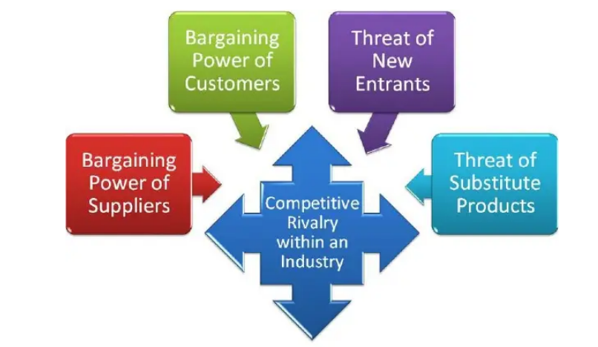

Force 1: Rivalry among the Existing Competitors
- High Exit Barriers
- High Fixed Cost
- Very less time to gain advantage by an innovation
- Price wars

How Flow Deal with Intense Rivalry among the Existing Competitors
• By creating a sustainable product and service distinction
• By increasing its size to enhance its competitiveness

Force 2: Threats of New Entrants

This can lead to innovation and pressure on FLOW through a lower pricing approach, cost reduction, and the introduction of new consumer value offerings.

How FLOW Deals with Threats of New Entrants
- By developing innovative products and services. New goods not only bring in new customers, but also provide existing customers a reason to continue purchasing and utilising FLOW's products and services.
- By creating economies of scale to reduce the fixed cost per unit.

Force 3: Bargaining Power of Suppliers
Manufacturers of telephone switching/switchboard equipment, fibre optic cables, network equipment, and billing software are the Suppliers in this business. Suppliers in a dominant position might reduce the profit margins FLOW can obtain on the market, hence decreasing the company's overall profitability.

How FLOW Company Deal with Bargaining Power of the Suppliers
By constructing an effective supply chain with diverse suppliers and cultivating loyal suppliers whose business depends on the organisation.

Force 4 Bargaining Power of Buyers
Typically, FLOW buyers are a demanding group. They wish to acquire the greatest available products for the least amount of money. This put pressure on FLOW's long-term profitability.
The smaller and more powerful FLOW's customer base, the greater the consumers' bargaining strength and capacity to request rising discounts and offers.

How FLOW Company deals with the Bargaining Power of Buyers
• By establishing a huge consumer base.
• By swiftly developing new products. Customers frequently seek discounts and promotions on known products; therefore, if FLOW continues to introduce new products, it can reduce the negotiating power of purchasers.
• New goods will also lower the number of FLOW customers that defect to a competitor (Digicel).

Force 5: Threats of Substitute Products or Services
When a new product or service satisfies a comparable client need in a different manner, FLOW's profitability is negatively impacted.

How Flow deals withe the Treat of Substitute Products / Services
- By placing a greater emphasis on service than on products.
- By recognising the underlying need of the consumer as opposed to what the customer is purchasing.
- By increasing the switching cost for the customer.

Implications of Porter Five Forces on Flow Company
• By investigating all five competitive forces Flow firm strategists can acquire a comprehensive understanding of the factors influencing the organization's profitability in the communications industry.They can recognise game-changing trends early on and act rapidly to capitalise on emerging opportunities. By gaining a thorough understanding of the Porter Five Forces, flow management can mould these forces in their favour.
• However, applying this method may necessitate a substantial initial investment in advanced equipment, aggressive pricing, and start-up losses.

Porter’s Generic Strategies
This strategy was devised by Michael Porter, who hypothesizes that there are three potentially viable strategic approaches a business can take to beat its competitors in a given industry (overall cost leadership, differentiation, and focus). Focus's strategy is Flow's main objective. The generic approach of concentration focuses on a certain customer group, product line section, or geographical market. The focus method is predicated on the notion that Flow can attain its limited strategic objective more effectively (differentiation) or efficiently (low cost). In its narrow aim, the approach of concentration can achieve distinctiveness, cost savings, or both. (Porter 1980.)
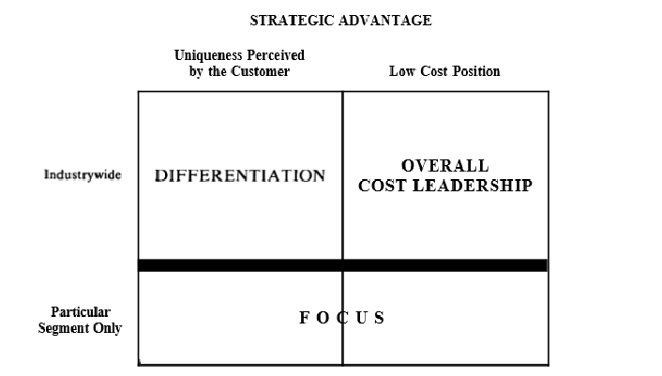
Figure 2 Porter's Generic Strategies

Bowman’s Strategy Clock
Figure 3. Bowman's Strategy Clock
.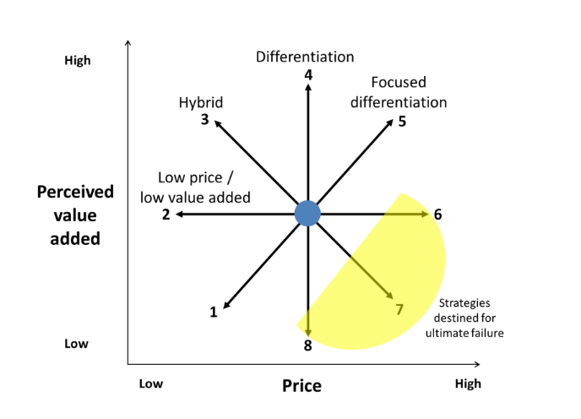
Bowman's Strategic Clock can be used to design Flow corporate product or service strategic positioning for market dominance. Price and value define the clock. In Bowman's Strategy Clock, cost and distinctiveness are competitive advantages like Porter's Three Generic Strategies. Flow management prioritizes personalized customer service.

Bowman Strategy Clock eight different strategies:
1.Low prices with little value added: low prices with little value and no differentiator
2. Low price: low pricing with minimal added value, sometimes known as "cost leaders"
3. Hybrid: low costs with some differentiation.
4. Distinction: the greatest level of perceived added value
5. Targeted differentiation: highest costs with strong perceived added value
6. High risky margins: high pricing with a low perceived added value
7. Monopolistic pricing: high prices with no perceived added value
8.Market share loss: mid-range or standard prices with limited perceived additional value

4. Ansoff Matrix Strategy
The Ansoff Matrix is a growth strategy tool based on four directions (Johnson 2014).
Figure 4. Ansoff Matrix 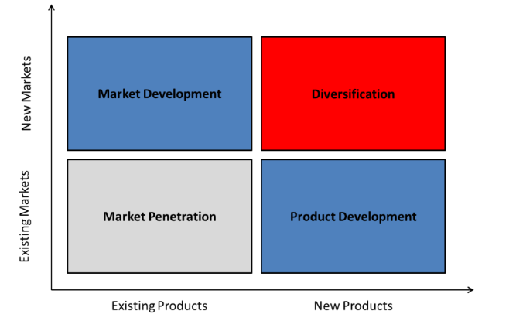

Four growth-focused approaches for the strategy include:
• Market Penetration: Flow can achieve growth by increasing its market share of existing products or services in the existing market.
• Market development: Flow can achieve growth by selling existing
products or services in new markets.
• Product Development: Flow can achieve growth by selling new
products or services in existing market.
• Diversification: Flow can achieve growth by selling new products or
services in existing markets. (Johnson 2014)

5.SWOT
SWOT analysis is used in strategic management to develop and implement strategies to meet objectives and QoS. SWOT analysis helps businesses evaluate their strengths, weaknesses, opportunities, and threats.
Figure 5. SWOT analysis can help the management team in a business to discover:

Figure 6 FLOW SWOT
Strengths | Weaknesses | Opportunities | Threats
- Customer Base  - Great Deals  - Automation of Activities  - High Level of Customer Satisfaction  - Skilled Workforce  - Network Coverage | - High Prices for Small Plans  - Competition with Brands Affecting the Market  - Reliance in UK Market for Major Revenue  - Customer Service  - Limited International Presence | - Internet Users  - New Environmental Policies  - Stable Free Cash Flow  - Customer Base | - New Entries  - Technical Advancement  - Challenging & Competitive Market Conditions

PEST
Telecommunication businesses' PEST analyses include political, economic, social, and technological factors (Barney, 1991). FLOW telecom's PEST analysis follows.
- Political Factors
The telecom sector's political forces are the ways in which the government interferes with industry operations and activities (Kavassalis, 1996). The Flow company must follow several laws set by the SVG government on the tariffs and products it offers. All new and current technology and goods must adhere to a tight set of restrictions established by the SVG government.
- Economic Factors
There is a need to provide superior amenities to customers at a lower price than competitors (Digicel). However, Flow had to boost pricing during the global recession.
- Social Factors
Safety and effectiveness societal influences have influenced FLOW. Mobile phones with basic capabilities like message alerts, cameras, internet, and 3g, conference calls, and instant messaging are becoming more popular. Flow must consider cell phone safety and accessibility. FLOW management ensures that all firm operations are environmentally friendly.
- Technological Factors
In the telecommunications industry, the rate of technical advancement is crucial. In a business environment that is constantly evolving, FLOW must ensure that its products and services are excellent and cutting-edge. FLOW must ensure that it develops new models of communication devices and mobile phones at an accelerated rate. There is a requirement for Flow to be current on the most recent techniques and ccustomer preferences.

Innovated Customer Care
Innovation has been crucial to economic development, attracting the attention of researchers and businesspeople. Payam et al. (2021) argue that innovation has become essential for the growth and success of any business due to the intensely competitive international corporate sector. Therefore, firms must be more efficient at rapidly producing and refining their products and delivering services that satisfy rapidly emerging client desires. There is no doubt that innovation and technology improvements are FLOW company's primary source of sustainable growth and rapid expansion. Notable is the fact that the company's performance and growth have been enhanced by the introduction of a variety of innovative technologies and products.
The introduction of advanced telecom technology, such as LTE and CDMA, has a greater data transmission rate and bandwidth, resulting in the development of new revenue streams, such as VAS (value-added services) (Alkhazaali et al., 2017). By the time of the COVID-19- outbreak, the telecommunications industry was attempting to deal with a variety of disruptions and a faltering economy. For instance, there have been customer-back disruptions in which digitally oriented companies like Netflix have established a unique norm for unified virtual experiences, prompting CEOs to reinvent their collaborative models (Clo et al., 2020). The influence of contemporary technical advancements on FLOW's customer service delivery. Thus, FLOW's Customer Satisfaction Management department determines the efficacy of its services and develops measures to boost customer satisfaction.

Challenges FLOW Company encounter to ssurvive
- The difficulty of differentiating their customer experience in order to keep a competitive advantage.
- The telecoms business has a high customer attrition rate.
- Customers have come to demand the same high-quality digital experience they receive in other industries.

Customer Service Delivery
Customer service delivery refers to the distribution of a company's service to a customer.
It includes all aspects of providing a service to a client, including initial collaboration, onboarding, setup, service ending, and follow-up provisions (Chi et al., 2020).CX is the sum of a customer's encounters with your brand that influence their future purchasing decisions and brand loyalty. Customers of FLOW anticipate that the company will provide the greatest quality of digital interaction across different channels. And on the other hand, the FLOW company has a significant opportunity to raise its revenue by enhancing the customer experience. Artificial intelligence and other technologies have become a part of our daily lives and influence our expectations.

Service Quality and Satisfaction
Companies must continually analyse client demands and expectations in order to meet this demand. Initiatives such as service quality and other factors influence customer happiness. The primary determinants of service quality are dependability, assurance, responsiveness, tangibles, and empathy, which define the level of client satisfaction at FLOW. When making a purchase, people usually examine the product's quality. On occasion, prior to making a purchase, the customer will compare the quality against the price. Even for the sake of their security and the durability of the products, flow consumers desire perfection. Generally, there is not a strong association between customer satisfaction and service quality. Aslam et al. (2018) found a substantial association between customer satisfaction and service quality in their research. Every firm values customer experience. Better experiences lead to recurring purchases, positive ratings, higher profitability, and fewer complaints and returns.

Top benefits of improving your customer’s experience
- More sales
- Increased customer satisfaction
- Increased customer loyalty
- Positive reviews and recommendations

Strategies Flow use to Enhance Customer Experience
New technologies facilitate a smooth consumer journey in the telecommunications industry by delivering a personalised experience and interactions across numerous channels.
1: The Omnichannel Customer Experience
Customers can engage via their preferred channel while receiving a consistent experience.
2. Understand Customer Expectations
Flow clients want 24/7 assistance, efficiency, fast problem response, and self-service.
3.Leverage AI-Powered Analytics and Data:

Employees can easily access consumer data across platforms. Chatbots will give Flow clients 24/7, rapid service. Based on user behaviour, a chatbot can anticipate challenges and provide proactive solutions to exceed expectations. Chatbots can also provide better bargains, issue payment reminders, review subscriptions, and securely personalise experiences.

4.Empower Customer Service Representatives: At Flow, AI and automation are crucial tools for employees, but many customers prefer live support from a polite, helpful, and knowledgeable team.
5: Personalize the Customer Service Experience: Understanding customer preferences and tailoring encounters enhances customer experience. Flow customers have dedicated customer service teams who stay on top of concerns.
Customers are the most valuable assets, thus enhancing and reinventing the customer journey is the focal point of the telecom agenda, which is essential for keeping competitive in an industry that is always evolving. Customer experience must be proactive, which entails demonstrating to customers that you are making substantial efforts and investing in exceeding their expectations. Increasing the value of digital customer service channels and enhancing interaction is crucial for FLOW client retention and loyalty over the long run. Ultimately, creating an amazing telecom customer journey satisfies the needs of customers and drives corporate expansion.

Targeting using AI
Artificial intelligence lets robots learn and act intelligently. It is a set of linked methodologies that can enhance traditional strategy, human intelligence, and analytics (Howard, 2019).
AI and technological data analytics apps enable data management (market, demographic, sales, customers, and trade data). Nair & Gupta (2021) found that AI customer service typically involves speech cooperation between customers and intelligent robots and real-time sentiment monitoring. FLOW's marketing team can now better analyse clients, repeat customers, and prospects using AI software (Data Analytic). Customer satisfaction can help Flow Company. Digital transformation and increased competition are forcing FLOW to rethink their customer experience or lose their "captive" customers to disruptive start-ups that offer seamless service using AI-enabled chatbots and are more customer-centric.

Competitive advantages
The telecom industry is expanding rapidly and getting increasingly competitive every day.
Customer service has always been vital to Flow's competitive advantage in the telecommunications market. Management team also introduces more creative ideas, products, and customer services in order to attract new customers and retain the trust of existing customers through more enticing market strategies. Today, long-term loyalty is contingent on service quality and customer happiness. Salih et al. (2020) contend that mobile technology has developed from 3G to 4G to 5G, with higher data transmission rates and bandwidths. The telecommunications industry has contemplated a significant transition from conventional voice and text messages to the incorporation of proficient media and web services.
These innovative advances helped telecom companies increase their sales volume by creating fresh revenue streams, such as B2B services and VAS (Martens et al., 2020). Flow employs business-level strategies to get a competitive advantage over industry rivals. Business-level strategies necessitate regular monitoring of client needs and prospective competition incursions. To balance the effects of competition and price pressure on traditional services, TLC operators (the Telco) have adopted a strategy based on developing innovative services and applications (e.g., Mobile Broadband, IPTV/Web TV, Technology, Online Advertising, Digital Home, etc.). It is now necessary for the Flow Management team to identify the competitive strategies for the market in order to compete with all players. Among the strategies that Flow is presently working and will develop in the future is one for the local market.

competitive strategies
- Unlike in the past, when the corporation had a monopoly in the market, the company is now giving the most affordable rates with all-inclusive packages.
• Promoting innovative items with complimentary supplementary services (such as smartphones with free internet for two months);
• Enhancing customer service
• Segmenting the quality to promote diverse products on the area in order to fulfil the diverse client needs
• Simplifying rates by deleting those with separate bands (peak and off-peak) based on hours and days of the week, as well as those based on the distinction between weekdays and holidays.
• Accomplishing improved billing transparency for the user.
• Introducing a new operational business model to maintain the value of the Internet connection while simultaneously enhancing cash flow through the construction of an all-IP network capable of supporting new services and ensuring the greatest performance on fixed and mobile networks at lower prices.
• Developing new market segments that will ensure growth over the medium term, such as mobile advertising, mobile content (such as social networking), mobile payment, location-based services, etc.
• Achieving continual service quality improvement with an eye toward customer happiness and customer loyalty.

• Developing new collaborations with the leading IT companies and operating selectively in expanding vertical sectors (e-health, e-government, finance, security/monitoring, and automotive).
- Developing new partnerships with Top IT players and operating selectively in emerging vertical markets (e-health, e-government, finance, security/monitoring, automotive).

Findings
FLOW customers are the most valuable assets, thus enhancing and reinventing the customer journey is the focal point of the telecom agenda, which is essential for keeping relevant and competitive in an industry that is always evolving. Customer experience must be proactive, which entails demonstrating to customers that you are making substantial efforts and investing in exceeding their expectations. Increasing the value of digital customer service channels and enhancing interaction is crucial for FLOW client retention and loyalty over the long run. Ultimately, creating an amazing telecom customer journey satisfies the needs of customers and drives corporate expansion.
FLOW must utilise IoT because this software assesses customer activity and predicts their behaviour patterns in a methodical manner. It is accomplished by discovering or building a model that evaluates data from the past, identifying innovative data sources, correlating those data with the past, and implementing relevant algorithms that may aid in capturing pertinent data and forecasting future events (Farrokhi et al., 2021).Tyagi et al. (2019) found that with the help of innovative IoT data sources, it could be simple for telecommunication companies to predict properly, enhance client satisfaction, and guarantee that they devise more targeted campaigns. Human agents will remain for the foreseeable future, but technology will enable Flow firm to deploy their employees more precisely and effectively in pursuit of customization. The 'care of one' will be backed by advanced analytics, AI, real-time natural language processing, and other sentiment and emotion detection techniques. In addition, robotic automation of back-office chores will enable agents to devote more time to high-value assignments.

Conclusion

As the business environment evolves, Flow corporation will have to continually evaluate its success tactics. The strategic management process supports Flow in assessing its existing state, formulating plans, implementing them, and evaluating their success. Because it is hard to forecast the future, I believe that Flow requires special techniques. Even without complete foresight, the corporation must be prepared to deal with the uncertain happenings that comprise the business environment. A strategic plan will also assist with long-term improvements as opposed to day-to-day operations, addressing the potential of future innovations or new products, new production techniques, or new markets. The design of a strategy plan takes customer and competitor behaviour into account. Employee management practices can predict employee behaviour. This report will examine the extent to which the FLOW Company's technical innovation advancements have improved customer service delivery by:
• Analyze the major technological innovations utilized by FLOW SVG customers.
• Determine the level of consumer satisfaction with the services offered by FLOW.
• Suggesting that FLOW SVG modify its business model to make use of innovative technologies to enhance customer service.
Flow management must understand how to achieve customer happiness, which will aid in retaining customers. In addition, FLOW's management must have an understanding of how technological advancements can improve customer service delivery, a crucial success factor in a competitive business environment. Therefore, the company can acquire superior technologies to enhance consumer interactions. It is essential that FLOW management as a whole prioritize innovation through the application of technology in order to increase customer satisfaction through the delivery of dependable and efficient services. Even during a severe global recession such as the present one, the telecoms sector is unquestionably among the most dynamic and chaotic. As a result, in the contemporary worldwide setting, the firm decision-making process is characterised by complexity, conciseness, probability, and regularity, which are required to produce customer value (Porter, 1993). Therefore, it is apparent that the actual sources of competitive advantage should be sought, now more than ever, in the management's ability to consolidate technology and productivity through the development of skills that enable each organisation to quickly adapt to the numerous market opportunities (Hamel and Prahalad, 1990).
To implement strategies and achieve the outlined strategic objectives, it is evident that, in a competitive environment that is far more dynamic and turbulent than in the past, FLOW management must develop a flexible and efficient organisational structure that, operating according to a logic based on processes, enables the quality of the product and service offered to be maintained with an eye toward customer satisfaction. Specifically, the home market operation. The company will serve three primary markets: the Customer Market, the Business Market, and the Top Client market, as well as providing a networked IT service. FLOW will be more consumer-centric than in the past in order to orient all corporate activities toward the customer. Diverse consumer segments will subsequently be provided with convergent products and services designed to defend Telecom Italia's market share, improve service quality, and foster brand loyalty.
The COVID-19 epidemic enhanced enterprises' and consumers' use of digital media.
During the pandemic, when more people were working from home and required help at all hours, the FLOW's high performance became an even more crucial element. FLOW business welcomes the increasing trends of intelligent automation, self-service, and other AI-powered products and will remain competitive in every client interaction. Customers want to know they will receive consistent service across all channels, including live chat, chatbot, virtual support, and others.

Recommendations
The loyalty of modern consumers is no longer based on brands, products, or costs.
Their loyalty is contingent upon the quality of service they receive, their impression of a company, and their level of contentment.
To thrive and compete in a highly competitive environment, Flow Company must make significant efforts to satisfy its consumers.
1. Recognize Customer Expectations
2. Increase Customer Engagement
3. Deliver Omni-Channel Engagement
4. Accelerate Digital Transformation
5.Enhanced asset usage
6.Embedded communications
7. artistic talent
8. Utilize the Potential of Big Data and Analytics Regularly, Flow must evaluate the effectiveness of its strategies and tactics by analysing data relating to customer service agent talks.
9. Individualize the Engagement, Based on previous contacts via email, social media, chat, text, or phone, Flow should combine human and artificial intelligence to create personalised experiences to each consumer.
10. Communicate with Dissatisfied Customers Proactivity is usually a good method for pleasing customers. Flow will be able to keep track of client issues and notify them in advance without waiting for them to contact customer care thanks to proactive customer service.
11.A lengthy history in the industry or a rare combination of competencies from different businesses.Flow must hire personnel who make the organisation smarter, like as analysts and AI specialists.
12. Continue to maintain a 'lean and efficient' Flow staff
13. Utilizing digital platforms for customer processes, network operation, and mobile network sharing partnerships to increase operational efficiency.
14. Being a convergent operator [offering both landline and mobile products and services].

References

- A.D. Chandler Strategy and structure: Chapters in the history of the industrial empire MIT Press, Cambridge, MA (1962) Google scholar.
- Alkhazaali, N., Aljiznawi, R., Jabbar, S. and Kadhim, D. (2017). Mobile Communication through 5G Technology (Challenges and Requirements). International Journal of Communications, Network and System Sciences, 10, 202-207. http://doi10.4236/ijcns.2017.105B020.
- Aslam, W., Arif, I., Farhat, K., & Khursheed, M. (2018). The role of customer trust, service quality and value dimensions in determining satisfaction and loyalty: an empirical study of mobile telecommunication industry in Pakistan., 30(2), 177–194. https://doi.org/10.22598/mt/2018.30.2.177.
- Armstrong, M. (1997) Competition in Telecommunications, Oxford Review of Economic Policy, Vol. 13, No. 1, pp. 64-82.
- Barney, J. (1991) Firm Resources and Sustained Competitive Advantage, Journal of Management, Vol. 17, No. 1, pp. 99–120.
- C. Bianchi, L. Andrews Investigating marketing managers' perspectives on social media in Chile Journal of Business Research, 68 (12) (2015), pp. 2552-2559.
- Chi, O. H., Denton, G., & Gursoy, D. (2020). Artificially intelligent device use in service delivery: a systematic review, synthesis, and research agenda. Journal of Hospitality Marketing & Management, 29(7), 757-786. https://doi.org/10.1080/19368623.2020.1721394

- Clò, S., Florio, M., & Rentocchini, F. (2020). Firm ownership, quality of government and innovation: Evidence from patenting in the telecommunication industry. Research Policy, 49(5), 103960. https://doi.org/10.1016/j.respol.2020.103960.
- Farrokhi, A., Farahbakhsh, R., Rezazadeh, J., & Minerva, R. (2021). Application of Internet of Things and artificial intelligence for smart fitness: A survey. Computer Networks, p. 189, 107859. https://doi.org/10.1016/j.comnet.2021.107859.
- Hajar, M. A., Ibrahim, D. N., Darun, M. R., & Al-Sharafi, M. A. (2020). Value innovation activities in the wireless telecommunications service sector: A case study of the Malaysian market. Journal of Global Business Insights, 5(1), 57-72. https://www.doi.org/10.5038/2640-6489.5.1.1125
- Hamel,G. and Prahalad, C.k. (1990). “The Core Competence of the Corporation”, Harvard business Review, no.3.
- Hitt, M. A., Ireland, R. D. &Hoskisson, R. E. (2009).Strategic management:
Competitiveness and globalization: Concepts and cases (8th Ed.). Boston,
Massachusetts: Cengage Learning, Inc.
- Howard, J. (2019). Artificial intelligence: Implications for the future of work. American Journal of Industrial Medicine, 62(11), 917–926. https://doi.org/10.1002/ajim.23037.
- Johnson G., Whittington R., Scholes K., Angwin D., Regner P. 2014. London: Pearson. Fundamentals of Strategy 2014.
- Johnson, G. and Scholes, K. (2005), Exploring Corporate Strategy (7th edition), Prentice Hall. Porter, Michael (1985), Competitive Advantage: Creating and Sustaining Superior Performance Barney, Jay (1991), Firm Resources and Sustained Competitive advantage, https://journals.sagepub.com/doi/abs/10.1177/014920639101700108.
- Karagiannopoulos, G. D., Georgopoulos, N., & Nikolopoulos,K. (2005). Fathoming Porter's five forces model in the internetera. info, 7(6), 66-76.
- Mihardjo, L., Sasmoko, S., Alamsjah, F., & Elidjen, E. (2019). Digital leadership role in developing business model innovation and customer experience orientation in industry 4.0. Management Science Letters, 9(11), 1749-1762. http://dx.doi.org/10.5267/j.msl.2019.6.015

- Miolo Vitali, P. (1993). “ The Corporate Decision- Marking System”, Giappichelli Editore Turin.
- Moghavvemi, S., Lee, S.T. & Lee., S.P. (2018), "Perceived overall service quality and customer satisfaction: A comparative analysis between local and foreign banks in Malaysia," International Journal of Bank Marketing, Vol. 36 No. 5, pp. 908-930. https://doi-org.library.open.uwi.edu/10.1108/IJBM-06-2017-0114.
- Martens, B., De Streel, A., Graef, I., Tombal, T., & Duch-Brown, N. (2020). Business-to-Business data sharing: An economic and legal analysis. EU Science Hub. https://ssrn.com/abstract=3658100

- Nair, K., & Gupta, R. (2021). Application of AI technology in a modern digital marketing environment. World Journal of Entrepreneurship, Management, and Sustainable Development. https://doi.org/10.1108/WJEMSD-08-2020-0099

- Panchiwala, S., & Shah, M. (2020). A comprehensive study on critical security issues and challenges of the IoT world. Journal of Data, Information, and Management, 2(4), 257-278. https://doi.org/10.1007/s42488-020-00030-2

- Payam, H., Parastou, H., Morteza, A., & Amir, A. (2021). Business model innovation is driven by the internet of things technology in internet service providers' business context. Information Systems and eBusiness Management, 19(4), 1175-1243. https://doi.org/10.1007/s10257-021-00537-0.
- Porter, M. (1993) “Competition in Global Industry” HBS Press, London
- Porter, M.E. (2008). The five competitive forces that shape strategy.
Harvard Business Review. 86-104
- Porter et al., 2001 M.E. Porter, Michael, i. Gibbs Strategy and the internet (2001)
- Rader et al., 2014 C.S. Rader, Z. Subhan, C.D. Lanier, R. Brooksbank, S. Yankah, K. Spears
CyberRx: Emerging social media marketing strategy for pharmaceuticals
International Journal of Pharmaceutical and Healthcare Marketing (2014).
- Salih, A. A., Zeebaree, S. R., Abdulraheem, A. S., Zebari, R. R., Sadeeq, M. A., & Ahmed, O. M. (2020). Evolution of mobile wireless communication to 5G revolution. Technology Reports of Kansai University, 62(5), 2139-2151. https://www.researchgate.net/profile/Mohammed-Msadeeq/publication/342549960_Evolution_of_Mobile_Wireless_Communication_to_5G_Revolution/links/5efb403c299bf18816f39184/Evolution-of-Mobile-Wireless-Communication-to-5G-Revolution.pdf.
- Scalera, F. (2011b). Managerial Strategies to Combat the Automotive Industry Crisis: the Context of Fiat
Automobiles Srbija , International Journal of Economics and Research, Vol. 2, No. 4, 153-161. On-
line ISSN: 2229-6158.

- Shim, J. P., Avital, M., Dennis, A. R., Rossi, M., Sørensen, C., & French, A. (2019). The transformative effect of the internet of things on business and society. Communications of the Association for Information Systems, 44(1), 5. https://doi.org/10.17705/1CAIS.04405

- Tyagi, A. K., Sharma, S., Anuradh, N., & Sreenath, N. (2019, March). How will a User Look at the Connections of Internet of Things Devices? A Smarter Look of Smarter Environment. In Proceedings of 2nd International Conference on Advanced Computing and Software Engineering (ICACSE). https://dx.doi.org/10.2139/ssrn.3350282

Artificial intelligence

