Assignment 1

Information Engineering

Joel Hunt – HUN11802466

Introduction
Within this report you will find 3 diagrams relating to the Bont Community Centre’s Event management. These diagrams detail the journey in which a Volunteer and Client must take to take part in an event; it also shows any other external or internal entities involved. There is also a brief diagram relaying the relationship between databases and information for Bont Community Centre.
- Context Level Data Flow Diagram
- System Level Data Flow Diagram
- Entity Relationship Diagram.

Context Level Diagram
Below is Figure 1 whish is the Context Level Diagram. This diagram aims to show how the main system works at its basic form. It demonstrates the interactions between the process system and external entities. The Context level shows the external entities that interact with the Bont community centre’s system. These entities include the Volunteer, Client, Secretary, Organiser, Ofsted and National careers service. You will note that the diagram has data flow connectors that indicate the exchange of information between the external entities and the system. Throughout each process on this context level diagram there is information passed between the external entities and the system. For instance the Volunteers database will be updated with the results of their DBS Check from Ofsted. This means that information will be passed to Ofsted and back with the answer.
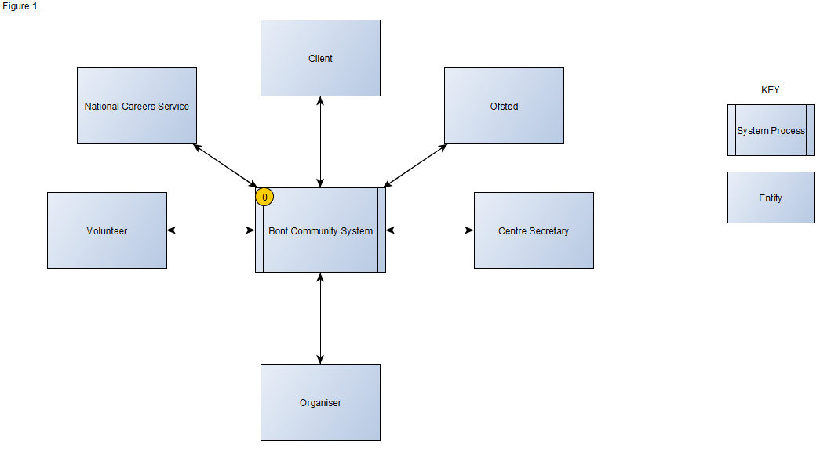

System Level Data Flow Diagram
Using the Context level diagram information it is then possible to create the System Level Data Flow Diagram. The Data Flow Diagram, also known as a DFD is shown below in Figure2 and it is a map of the flow of information for any of the processes or systems. The diagram uses different symbols to indicate various processes, databases and entities. You can view the Key on figure 2 for any assistance. Figure 2 shows the DFD for the Bont Community centre. Now that the external entities have been identified within the context level diagram, the DFD has been created. The process starts with the Volunteer/Applicant. The Volunteer starts their Application and then once it is submitted the Secretary sends of a request for a DBS check to be performed on the Volunteer. This can be seen in Process 2 within Figure 2. The secretary is responsible for ensuring the Volunteers DBS checks are performed and up to date, this is also the same for the Qualifications. The Volunteers Qualifications are also checked against another database, this one is held with the National Careers Service Desk. The Volunteers ULN is used to verify this. Both of these external checks are then collected and the results are stored in the Volunteers database.
There is also a form for proposed Clients to fill out; this process is also shown below. The Client enters the information required and then this information is stored in the Clients Database. Both the Client and the Volunteer Databases are accessed by the Organiser. The organiser’s role is to collate information regarding relevant Volunteers, Clients, Activities and the total cost of activities. The Organiser can view the Activity database to create the perfect event for the chosen Clients and respective Volunteers. Both the Volunteer and Client can then view the proposed Activity.
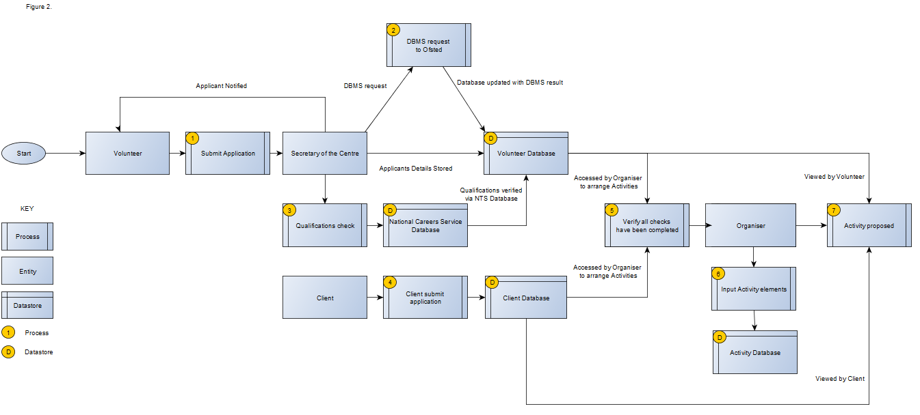

Entity Relationship Diagram
Figure 3 below is the Entity Relationship Diagram. This diagram, also known as ERD is the graphical representation of the information system that shows the relationship between the entities, people, data stores and activities within the community centres system. This is a data modelling technique designed to aid in the definition of the business processes. This ERD has not been normalised and a first suggestion would be to perform this to reduce data redundancy. The main tables identified in this ERD are the Volunteer, Activity proposed, Cost and Client tables. Each of these tables has a primary key which then links to the corresponding table and foreign key. The Volunteer is linked to the qualifications gained table which in turn is linked to the overall Qualifications table. Volunteer is only linked directly to the Qualifications gained so that there is no unnecessary data being stored. The Volunteer and Client are only linked via the Activity proposed table. There are smaller tables which are links between others. For instance the Activity for Client only has the Activity ID and Client ID within it. This is done so that the Client and Activity proposed tables do not have too much unrequired data shared between them.


