Mercedes Harding
1812519
What is your age group?
Based on the information gathered 52.5% of people will be 15-25 with a further 25% falling in to the 30+ category. This means that that are target market will be more drawn towards the ages 15-25.
How we can target that age group can be threw fun and more vibrant décor as well as younger generation music. We could also include, wider selection of refreshments to suit youngers needs, like soft drinks as well as the tea and coffee we already have in place.
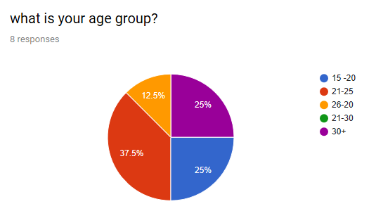

Kindly select your gender.
We gave the public the option to select the gender in our questionnaire, based on the statistics we found that 50% of our clients were males so as a business we will have to cater for males needs, which could be using make up products specifically designed for men. My partner and I have come across a brand that specifically supplies male make up products. Her brand has been featured on the front page of Forbes magazine, this is a massive achievement or the artist and it means her brand is a trust well known certified brand. (Knowles, 2018) this will be a fantastic opportunity to have a unique selling point for our business.
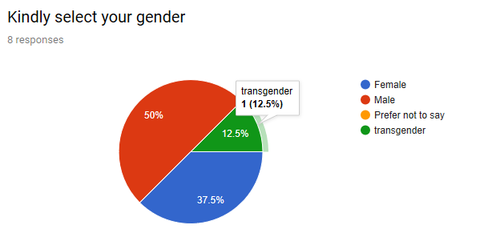
Would you like the selection of afternoon of afternoon tea with your make up?
With our recent feedback 50% of people would like the option to have afternoon tea with the make up and services, this is a great result for our business as my partner and I have put In a lot of time and effort to make the afternoon tea affective. Afternoon tea is only available with mass bookings but seeing as there is such a high interest, perhaps my partner and I could make it available with smaller bookings. We could even open a few days in the week for the afternoon tea as now it Is only available on weekends.

thth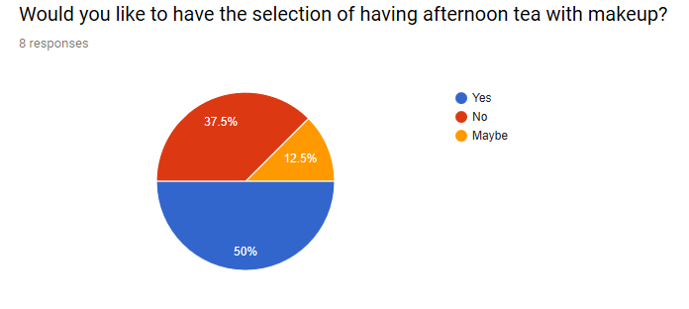Why I designed my websit in the way I did
The reason I chose to do the website the way I did was because, I wanted to keep the web page clean and straight to the point. I included plenty of images, as research has found that using images can be much more affective words on their own. The most used social media out there other than Facebook is Instagram and Instagram solely uses images to communicate and millions of people use Instagram worldwide. People want things to be more visual then a load of words on a screen the same for billboards and so on. Do you ever see a plain billboard will loads of writing on it without images? The answer my question is no, because people will be easily board and it will trend to not catch people’s eyes and attention. Therefore, I created my website to be visual, creative straight to the point with the appropriate amount of information needed to keep potential clients, informed and engaged whilst scrolling through my website. The reason why I chose make-up was to do something I have always loved and always had a passion for. Make-up is what I am good at there for my visual images on my website will sell. I am also taking on a new brand in my makeup kit and this brand will be Jecca, Jecca is a well-known brand and she specializes in suppling transgender make-up or as she calls it ‘Genderless’ make-up. This will be a perfect oppitunity to bring in a wide range of clients of all different sexes. Jecca also made front cover on Forbes magazine (Knowles, 2018). I also chose to do afternoon tea alongside of my make-up and the reason behind this is because it is a unique selling point for my business and it will be the perfect opportunity to bring in group bookings, as in bridal, proms and all kind of occasions. What does SEO stand for? Search engine optimization.
SEO is very important for businesses as the higher your website appears the more people are going to trust it and click on it. Research has found that most web searchers tend to go for the first five appeared websites. SEO is not always about the search engine it’s also about the usability and how appealing your website looks. SEO can also rank you higher than other websites that are selling the same product as you if they are sitting underneath, this means for sales for you. (Chris, 2019).

References;

References
Chris, A., 2019. Reliablesoft.net. [Online]
Available at: https://www.reliablesoft.net/what-is-search-engine-optimization-and-why-is-it-important/
[Accessed 12 12 2019].
Knowles, K., 2018. Genderless Makeup Brand Jecca is L'oreal's Latest Startup Squeeze. [Online]
Available at: www.forbes.com
[Accessed 27 11 2019].



