1/25/2019
Critical Discussion of Sustainability
Management Ethics Assignment 2
Lucy Crocker
1701540
Management Ethics
M5X00803
Table of Contents
Executive Summary: 2
Introduction: 2
What Is Sustainability? 2
Kellogg’s: 2
Triple Bottom Line: 3
Kellogg’s Commitment to Environmental Sustainability: 3
Global Sustainability Commitments 2020: 4
Economical Sustainability Commitment: 5
Social Sustainability Commitment: 5
Kellogg’s CSR Policy: 6
Conclusion: 6
Bibliography 7

Figure 1 Kellogg's Corporate Responsibility Poster (Kellogg's, 2017) 4
Figure 2 Global Sustainability Chart For Kellogg's (Kellogg's, 2017) 4

Executive Summary:

Introduction:
The aim of this report is to critically analyse sustainability within an organisation and review the challenges faced by the organisation and their policies. The author has chosen to research Kellogg’s and their sustainability for this report.

What Is Sustainability?
Sustainability has been defined by (Crane & Matten, 2016) as “the long-term maintenance of systems according to environmental, economic and social considerations”. Sustainability has also been defined as “meeting the needs of the present generation without compromising the ability of future generations to meet their own needs” (Brundtland Commission, 1987). The author believes that the definitions that were provided by the Brundtland Commission (1987) and Crane & Matten (2016) provide an academically acceptabel definition of sustainability as required for this report however Crane and Matten’s definition provides a more specific definition that is more relatbale to the example of Kellogg’s, that is the focus of this report.
Sustainability is a powerful resource for organisations as it creates a profit for the shareholders whilst protecting the environment (Sustainable Business Strategies , 2013). Kellogg’s have set guidelines for sourcing activities which include, agricultural ingredients and setting measurable goals for reducing emissions, energy, waste and water use (Kellogg's, 2018A).

Kellogg’s:

The Kellogg’s Company was founded in 1906 by W.K. Kellogg, who firstly developed the recipe for Corn Flakes. W.K. Kellogg’s passion and commitment to nutrition and his dedication to well-being is what has made Kellogg’s the industry it is today (Kellogg's, 2018). By 1914, Kellogg’s had expanded the company into its first foreign cereal facility in Canada. After its success in the U.S market Kellogg’s decided to expand even further by locating facilities in Australia and England (Kellogg's , 2016) . Kellogg’s have a wide variety of products ranging from breakfast cereals to snacks, and brands ranging from Crunchy Nut and Rice Krispies to Nutri-grain and Special K and provide breakfast to 180 countries in the world.
In 2018, Kellogg’s was recognised for an ECPI Sense in Sustainability and the organisation has been honoured as one of Ethisphere Institute’s World’s Most Ethical Companies from 2015 until 2018 (Kellogg's, 2018). Kellogg’s are also current members of The Dow Jones Sustainability Indices, which are known as benchmarks for investors who have recognized that a sustainable business practice is crucial for generating a long-term shareholder value (Robecosam, 2018) .

Triple Bottom Line:

The triple bottom line theory consists of 3P’s which are known as People, Planet and Profit. The first element of this theory is People, where companies think about the impact their actions will have on the people involved with the organisation, for example, customers, farmers and CEO’s. The second element of this theory is Planet, companies who follow the triple bottom line theory would research the cycle of their actions and determine the cost of their actions in regard to the environment. The third and final element of this theory is profit, which is an organisations main objective. In relation to the triple bottom line theory profit would benefit and sustain the community not just the shareholders and CEO (MindTools, 2018).
In relation to Kellogg’s, the organisation ensures that all ingredients that are bought are sustainably sourced from an environmentally friendly environment, and ensures that its suppliers and employees are treated with respect and receive a good wage for the skills they have provided.

Kellogg’s Commitment to Environmental Sustainability:
According to (Environmental Science, 2019), environmental sustainability is the “primary concern of the future of humanity”, and in order to achieve sustainability for the environment organisations should aim to base their commitments to environmental sustainability in order to protect air quality, ecosystems and integrity , but to also focus on the elements which place stress upon the environment.
The Kellogg’s Company’s stated purpose is to “nourish families so they can flourish and thrive” and their commitment to be a sustainable organisation is fuelled by this purpose. Kellogg’s have a variety of sustainable strategies already in place within its production line, an example of this is since they were founded in 1906, cereal boxes were made entirely from recycled material and today all boxes are made from “100% recycled carton board”. This strategy reduces the amount of cardboard that will end up in landfill, where 41% of cardboard is considered to be solid waste within landfills in the US (Annenberg Learner, 2016). The introduction of the 100% recycled carton board also illustrates Kellogg’s commitment to environmental sustainability through the use of recycling, which can reduce the amount of greenhouse gases that are produced within their production line.
Another strategy that illustrates Kellogg’s commitment to environmental sustainability is through its efforts to reduce greenhouse gas emissions and energy use, by researching various ways to transport their ingredients and by reducing their energy consumption within the organisation’s facilities, which shows that Kellogg’s is committed to reducing their carbon footprint a little more every year. This strategy has been proven to have been successful within Kellogg’s European facilities where the amount of greenhouse gas emissions has decreased by 13%, but also within their UK facilities, where the greenhouse gas emission had decreased to 26% (Kellogg's, 2018A).
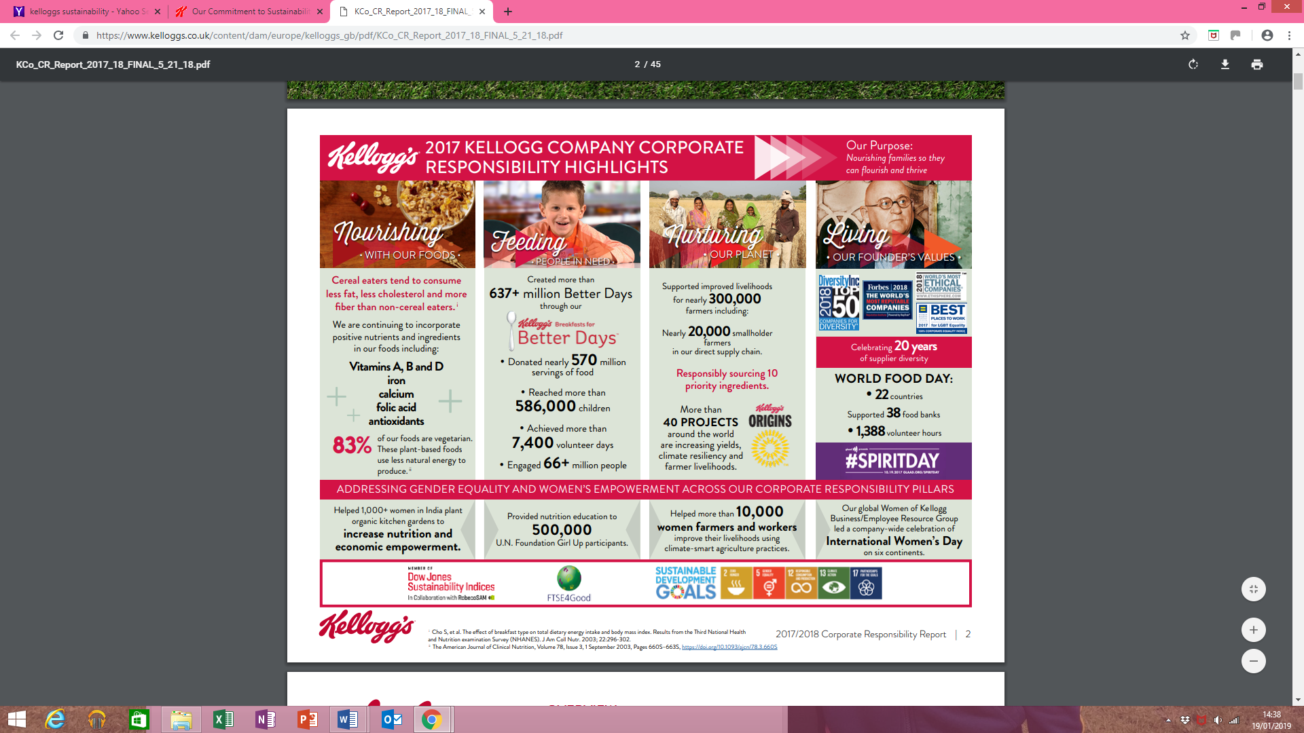
Figure 1 Kellogg's Corporate Responsibility Poster (Kellogg's, 2017)

Global Sustainability Commitments 2020:

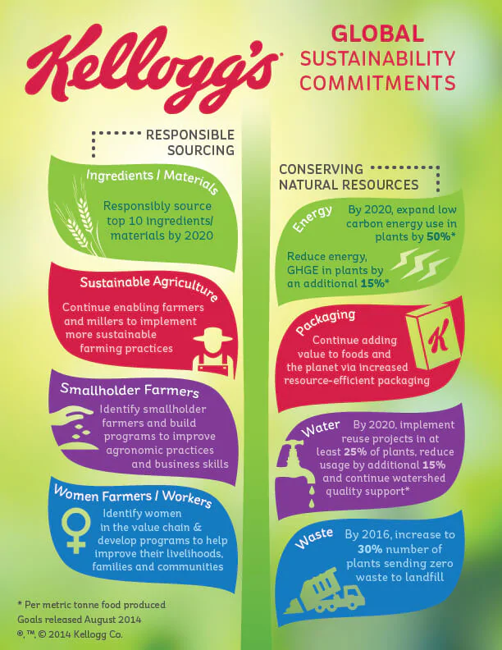
Kellogg’s sustainability commitments reach further than their facilities, they also have global sustainability commitments in place which Kellogg’s hope to achieve by 2020, for example one of their global sustainability commitments is that Kellogg’s are aiming to identify smallholder farmers and develop a variety of programmes to improve business skills and agronomic practices, through this strategy Kellogg’s aims to support the livelihoods of 15,000 farmers and their families by 2020 (Kellogg's, 2017).
Figure 2 Global Sustainability Chart For Kellogg's (Kellogg's, 2017)
Another strategy that will illustrate Kellogg’s commitment to global sustainability is through reducing the amount of water that is used unnecessarily. Across Kellogg’s manufacturing facilities in Europe, employees have achieved a 30% decrease in water usage in comparison with 2005. Another facility has also managed to decrease the amount of water that is used within its production facility, this facility is based in Manchester where they have reduced their water usage by 50%, they have achieved this by investing in technology that recycles water efficiently (Kellogg's, 2018A).
As of October 2018, Kellogg’s have announced that they are expanding their global sustainability commitments to include an objective of working towards a “100% reusable, recyclable or compostable packaging” by 2025 (Kellogg's , 2018B).

Economical Sustainability Commitment:

Economic sustainability is known to refer to practices and activities which support long term economic growth without effecting the environmental, cultural and social aspects of a community (University Of Mary Washington , 2019).
One element of Kellogg’s commitment to economical sustainability is through the numerous projects and donations that are organised to support local communities, for example, Fare Share, which is the UK’s largest charity fighting hunger and food waste that redistribute food to charities and charitable organisation who in turn develop meals with the food donated. Every year in the UK, 18 million tonnes of food and drink are wasted (Food Aware, 2018), and Kellogg’s are one of the many corporations that collaborate with organisations, such as, Fare Share to avoid food waste and have been providing snacks and cereals to Fare Share in Greater Manchester since 2010. Kellogg’s have provided Fare Share with over 1,300 tonne of food which equated to over 3 million meals, which have been used to support 2,700 organisations, 312 breakfast clubs and 153 after school clubs within the UK (FareShare, 2019).
Another example of how Kellogg’s have had an impact upon the UK’s economy, is through the amount of corporation tax that is paid by Kellogg’s. An organisation must pay corporate tax for any profits made as a limited company, a foreign company with a UK based branch or as a club or any other unincorporated association (GOV, 2019). It was reported that at the end of 2016, Kellogg’s hadn’t paid corporation tax in Britain for that year, where the organisation had made a £40 million profit on £944million worth of sales, it appears that Kellogg’s were able to use losses from a variety of UK based investment offshoots to offset profits achieved by other divisions of the company and therefor reduce the amount of corporation tax that was to be paid for that year (Daily Mirror, 2017). Whilst this example provides an illustration of a negative economic impact, it must be noted that Kellogg’s have a positive impact in terms of the tax paid by its 1,600 employees who are employed within its UK facilities. The tax and national insurance contributions of these employees of course, are used to fund public services such as The NHS and transport infrastructure in the UK (Manchester Evening News, 2013).

Social Sustainability Commitment:
According to (United Nations Global Compact, 2019) social sustainability has been defined as “identifying and managing business impacts, both positive and negative on people”.
A major element of social sustainability can be illustrated by examining the response of global food corporations such as Kellogg’s to a topic such as obesity. Many professionals believe that countries such as America and the UK are suffering an “obesity crisis” (The Guardian, 2017), and Kellogg’s have adopted their corporate social responsibility policies to address this by reducing the amount of sugar that is used within its children’s cereals, such as , a 20% sugar cut within its Rice Krispies and a 40% sugar reduction in Coco Pops (BBC News, 2017).
Another major element of social sustainability that is illustrated is Kellogg’s commitment to improving sustainable agriculture. Kellogg’s commitment to improving sustainable agriculture comes through Kellogg’s own Origins Program, where suppliers, farmers, scientists and non-government organisations are encouraged to increase their productivity and to improve environmental outcomes that can positively impact farmers livelihoods, this program has transformed the livelihoods of more than 300,000 farmers worldwide. The Kellogg’s Origins Program focus on certain objectives in various countries around the world, for example, the main objective in Louisianna, U.S is to improve the water and habitat quality on local rice farms, where this will be a benefit to more than 200 farmers in the U.S. Another example of how Kellogg’s Origins program illustrates Kellogg’s commitment to social sustainability is the objective to improve labor conditions within El Salvador’s sugar cane supply chain. Kellogg’s have a partnership with Solidaridad which had assisted fundraising for the development of training materials for 25,000 workers (Kellogg's Origins, 2015).

Kellogg’s CSR Policy:
Kellogg’s developed its Code Of Ethics in 2013, which is focused on how Kellogg’s live up to their values as an organisation. The topics which are mentioned within the code are organized under five major headings which represent Kellogg’s main stakeholders and investors, whom of which have are affected with how the business is being run, the five main stakeholders for Kellogg’s are People, Consumers, the Marketplace, Investors and Communities, where this report specifies the values Kellogg’s have for their stakeholders, for example, how they contributing to local communities and how to promote fair competition. (Kellogg's, 2013)
Kellogg’s have a Global Supplier Code Of Conduct, which provides an outline of the business standards and practices that Kellogg’s direct and extended suppliers must adhere to, for example, suppliers must adhere to the United Nations Convention against Corruption and The UK Bribery Act whilst supplying ingredients to Kellogg’s (Kellogg's, 2018 C). The Code Of Conduct supplies detailed information on a variety of sub headings which include, the quality, health and safety standards for suppliers and their products and what steps must be taken in order to comply with standards set by the Hazard Assessment and Critical Control Points (HACCP) (Kellogg's, 2018 C).

Conclusion:
To conclude this report, there are a variety of strategies that Kellogg’s have developed to maintain their sustainable reputation. Sustainability is vital for an organisation such as Kellogg’s, as it is an important resource which develops a profit for both the organisation and its shareholders but it also protects the local environment of the facilities. Kellogg’s have utilised social, economic and environmental as well as developing a global sustainability commitment, whilst working in collaboration with local communities and organisations such as Fare Share, but also to develop projects such as The Kellogg’s Origins Program, that would benefit farmers and their families on a global scale.

Bibliography
Annenberg Learner, 2016. Paper and Cardboard. [Online]
Available at: http://www.learner.org/interactives/garbage/landfill/paper.phtml
[Accessed 20 01 2019].
BBC News, 2017. Kellogg's to cut sugar in kid's cereals by up to 40%. [Online]
Available at: https://www.bbc.co.uk/news/business-42174618
[Accessed 22 01 2019].
Brundtland Commission, 1987. Our Common Future, Oxford: Oxford University Press.
Crane, A. & Matten, D., 2016. Business Ethics. 4th ed. Oxford: Oxford University Press.
Daily Mirror, 2017. Cereal giant Kellogg's paid no corporation tax in 2016 despite £900MILLION sales. [Online]
Available at: https://www.mirror.co.uk/news/uk-news/cereal-giant-kelloggs-paid-no-11295564
[Accessed 24 01 2019].
Environmental Science, 2019. What Is Sustainability and Why Is It Important?. [Online]
Available at: https://www.environmentalscience.org/sustainability
[Accessed 23 01 2019].
FareShare, 2019. What We Do. [Online]
Available at: https://fareshare.org.uk/what-we-do/
[Accessed 23 01 2019].
Food Aware, 2018. Food Waste. [Online]
Available at: https://foodawarecic.org.uk/stats-2/
[Accessed 23 01 2019].
GOV, 2019. Corporation Tax. [Online]
Available at: https://www.gov.uk/corporation-tax
[Accessed 24 01 2019].
Kellogg's , 2016. A Historical Overview. [Online]
Available at: http://www.kellogghistory.com/history.html
[Accessed 18 01 2019].
Kellogg's , 2018B. KELLOGG ANNOUNCES NEW GLOBAL SUSTAINABLE PACKAGING GOAL. [Online]
Available at: https://www.kelloggs.co.uk/content/dam/europe/kelloggs_gb/pdf/Global_Sustainable_PackagingCommitmentUKFINAL.pdf
[Accessed 24 01 2019].
Kellogg's Origins, 2015. THE KELLOGG’S ORIGINS™ PROGRAM HELPS FARMERS WORLDWIDE. [Online]
Available at: http://www.openforbreakfast.com/en_US/content/sustainability/working-with-farmers.html
[Accessed 23 01 2019].
Kellogg's, 2013. Living Our Values: Kellogg Company's Global Code Of Ethics, Michigan: Kellogg's.
Kellogg's, 2017. Nourishing Families So They Can Flourish And Thrive, Michigan: s.n.
Kellogg's, 2018 C. Global Supplier Code Of Conduct, Michigan: s.n.
Kellogg's, 2018. A Foundation for the Future. [Online]
Available at: https://www.kelloggcompany.com/en_US/our-heritage.html
[Accessed 18 01 2019].
Kellogg's, 2018A. Sustainability. [Online]
Available at: https://www.kelloggs.co.uk/en_GB/what-we-believe/sustainability.html
[Accessed 19 01 2019].
Manchester Evening News, 2013. Windfall for Kellogg’s staff. [Online]
Available at: https://www.manchestereveningnews.co.uk/business/business-news/windfall-for-kelloggs-staff-937096
[Accessed 21 01 2019].
MindTools, 2018. The Triple Bottom Line. [Online]
Available at: https://www.mindtools.com/pages/article/newSTR_79.htm
[Accessed 24 01 2019].
Robecosam, 2018. DJSI index family. [Online]
Available at: https://www.sustainability-indices.com/index-family-overview/djsi-index-family.html
[Accessed 20 01 2019].
Sustainable Business Strategies , 2013. Sustainable Business Strategies. [Online]
Available at: http://www.getsustainable.net/
[Accessed 24 01 2019].
The Guardian, 2017. UK is most obese country in western Europe, OECD finds. [Online]
Available at: https://www.theguardian.com/society/2017/nov/10/uk-most-obese-country-in-western-europe-oecd-report-finds
[Accessed 23 01 2019].
United Nations Global Compact, 2019. Social Sustainability. [Online]
Available at: https://www.unglobalcompact.org/what-is-gc/our-work/social
[Accessed 22 01 2019].
University Of Mary Washington , 2019. Economic Sustainability. [Online]
Available at: https://sustainability.umw.edu/areas-of-sustainability/economic-sustainability/
[Accessed 23 01 2019].

