Harry Woollands
2214706
Abstract
This report contains the solutions to four different coding tasks, which were completed through the use of the Embedded C coding language. The report details the solutions to these tasks, outlining the steps taken to complete them.
Generating a program for a specified embedded requirement in c
ACDA4013 - Embedded C
1527 Words
Contents
Table of figures 1
Introduction 2
Code structure 3
Task 1 5
Task 2 7
Task 3 8
Task 4 9
Conclusion 10

Table of figures
Figure 1 - Proteus circuit provided 2
Figure 2 – Code declaring routines and variables 3
Figure 3 - While true loop 3
Figure 4 - switch_position and clear_outputs routines 4
Figure 5 - Routine for Task 1 5
Figure 6 – “read_pot” and “analog” routines 6
Figure 7 – Routine for Task 2 7
Figure 8 - Routine for Task 3 8
Figure 9 – Routine for Task 4 9

Introduction
This report will outline a number of tasks completed using the Embedded C coding language. To complete these tasks, a Proteus 8 Professional simulation circuit was provided. This circuit can be seen below in Figure 1. In order for the circuit to simulate, a PIC-C Complier was also used.
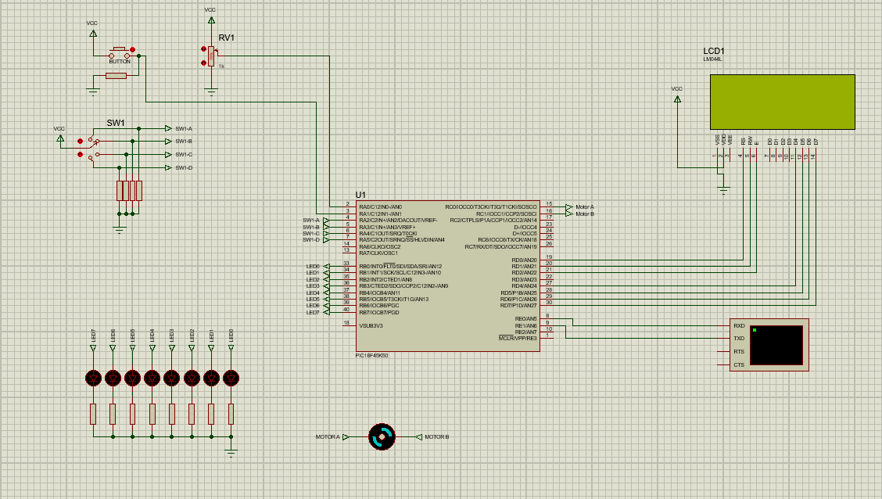
Figure 1 - Proteus circuit provided
The circuit was ran using a PIC Microcontroller, specifically a PIC18F45K50. Connected to the PIC is a variety of input and output components, on 5 different ports. A potentiometer, a push button and a switch with 4 positions are connected on Port A. On Port B, 8 LED’s are connected. A motor is connected on Port C, an LCD screen is connected on Port D, and finally a virtual terminal is connected on Port E.

Code structure
Before beginning any of the tasks, the basic structure layout of the code needed to be set out. This included defining variables and routines that would be used later during the tasks, as well as creating the while true loop which is used to allow the code to run when the switch position is changed. Figure 2 below shows the declared variables and routines that will be used throughout the code. Those that are declared using unsigned int are done so as they return integers, and the others that declared using void are done so as they are generic functions. Also, the array “km” is declared. This array contains 15 hexadecimal values which are used to turn the 8 LED’s on and off in a sequence from left to right.
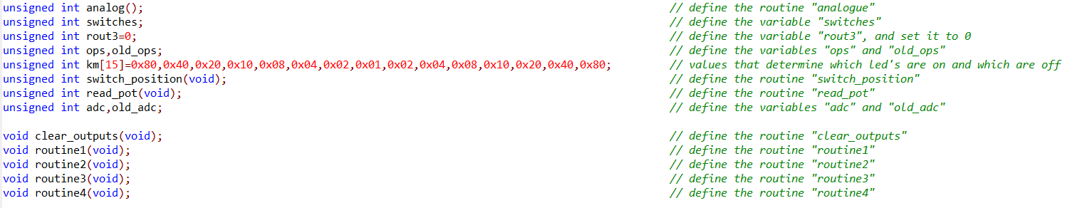
Figure 2 – Code declaring routines and variables
The next step was to create a While True loop to allow the code to run when the switch position was changed. Figure 3 below shows this section of code. Firstly, the variable ops was defined as the routine switch_position. An important part of this routine was masking off the first 2 pins of Port A, as they are not switch pins. By masking off these pins, the correct section of code will be executed on each switch position. This routine can be seen in Figure 4. Next, an if statement was used to clear all output pins, if the switch position had changed. The clear_outputs routine can also be seen in Figure 4. Next, a switch case was used, with the 4 different task routines within it, allowing the routine switch_position to be tested against the different tasks. Finally, the routine executed is set to the variable old_ops.
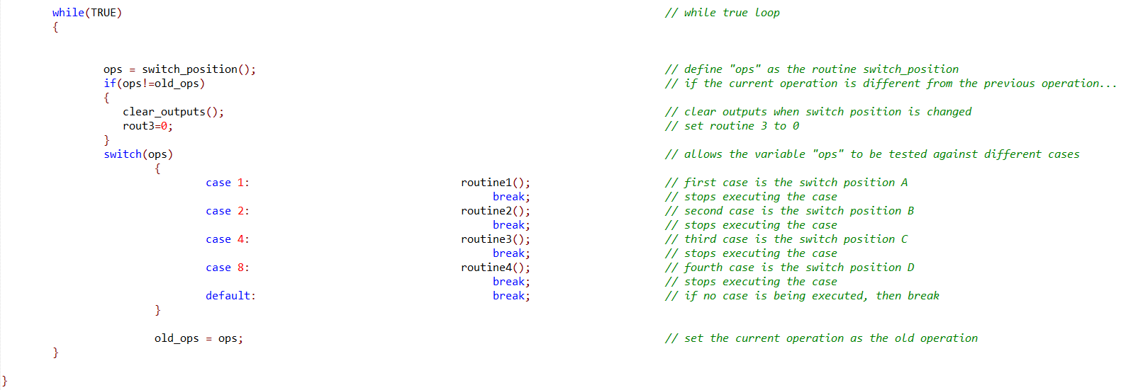
Figure 3 - While true loop
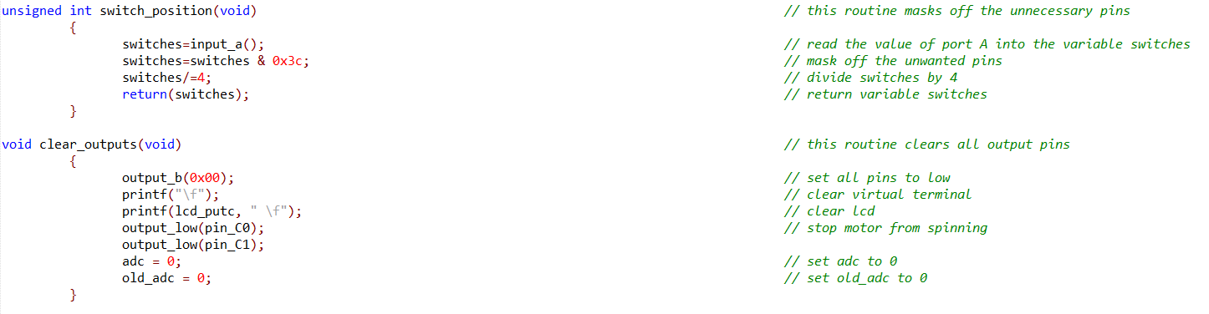
Figure 4 - switch_position and clear_outputs routines
One final change that was needed before beginning the tasks was changing the virtual terminal pins on the main.h file to the correct E0 and E1 pins. Without this, the virtual terminal would not be able to display anything.

Task 1
Task 1 was to make the motor spin in a certain direction, depending on the value of the potentiometer. If the value of the potentiometer is below 75, then the motor had to spin clockwise, if the value was above 175, the motor had to spin anticlockwise, and if the value was between 76 and 174 then the motor stops spinning. The potentiometer value and motor direction had to be displayed on line 2 of the LCD, and this had to function on switch position B. The solution to this task can be seen below in Figure 5.
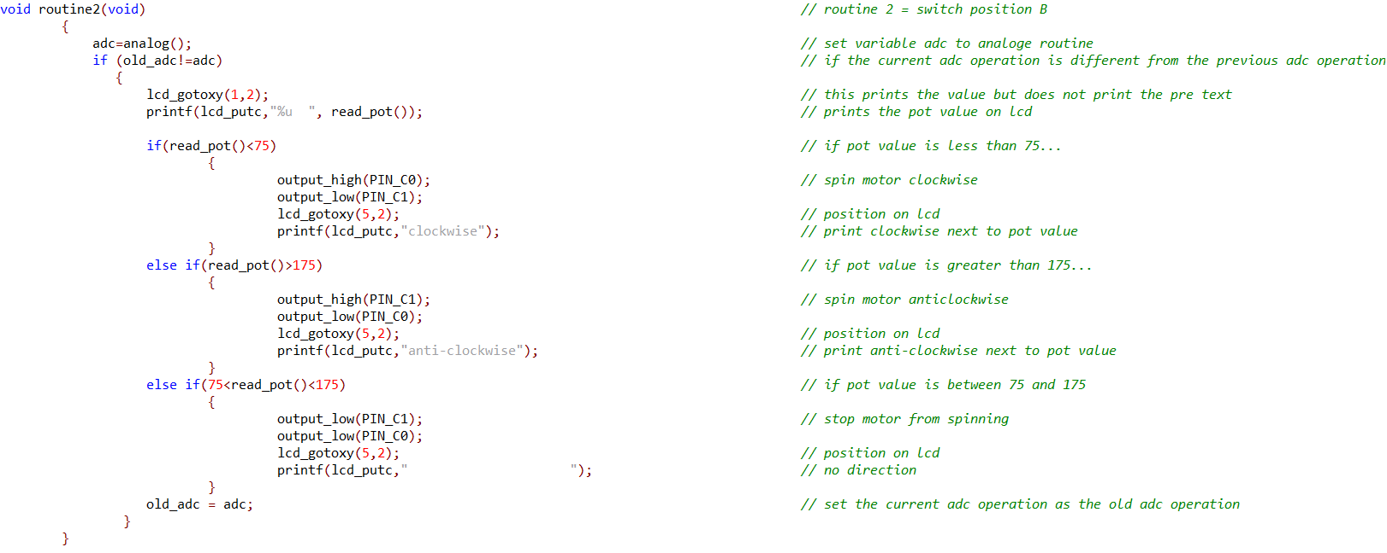
Figure 5 - Routine for Task 1
Firstly, the position 1,2 was specified on the LCD, which is on its second line. Next, the read_pot value calculated is printed on line 2 of the LCD. In order to output the correct message and motor direction, if and else if statements were used for the three possible outcomes. The first if statement is executed if the potentiometer value is below 75. If that is the case, Pin C0 is set to high, and the motor spins clockwise, along with the message “clockwise” displayed on the LCD alongside the potentiometers value. Next, the first else if statement is executed if the potentiometer value is above 175. If that is the case, Pin C1 is set to high, and the motor spins anti-clockwise, along with the message “anti-clockwise” displayed on the LCD alongside the potentiometers value. Finally, the second else if statement is executed if the potentiometer value is between 76 and 174. If that is the case, both Pin C0 and Pin C1 are set to low, so the motor does not spin, along with no message displayed on the LCD alongside the potentiometers value, as there is no motor direction. All of the messages displaying the motor’s direction are at location 5,2 on the LCD, three characters to the right of the potentiometer value. The potentiometers maximum value, 255, is three characters long, therefore the motor’s direction is displayed immediately next to the potentiometer value.
To successfully complete this task, it was necessary to read and output the value of the potentiometer. To do this, the routines analog and read_pot were used, which can be seen below in Figure 6. Within those routines the read_adc command was used to read the analogue value of the potentiometer, before it is returned to a variable. These routines are executed every time the potentiometer is manually changed during the simulation.

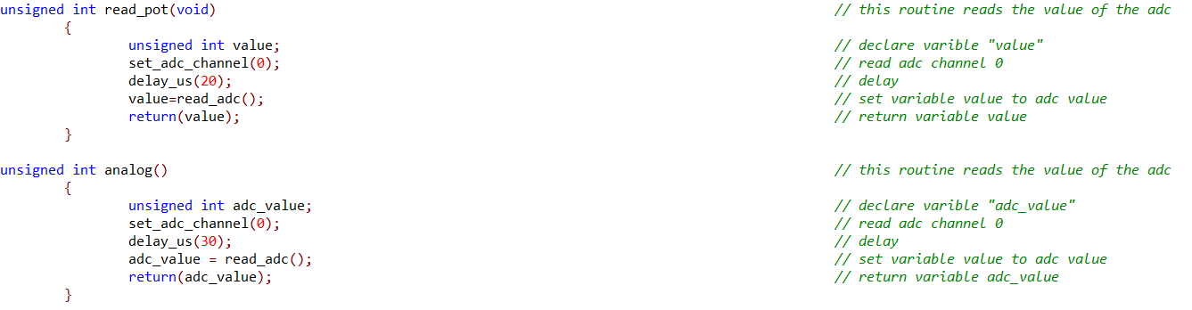
Figure 6 – “read_pot” and “analog” routines

Task 2
Task 2 was to make the LED’s flash in order from left to right and back again, in 150ms intervals, whilst displaying the message “Kitt mode” on line 4 of the LCD, as well as on the virtual terminal. This had to function on switch position C. The solution to this task can be seen below in Figure 7.
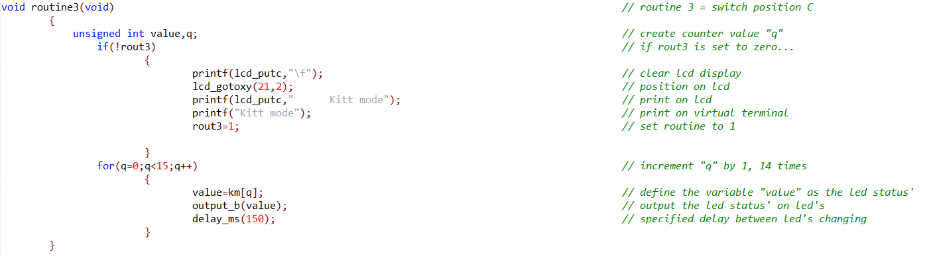
Figure 7 – Routine for Task 2

To complete this task, first, the position 21,2 on the LCD is specified, which is line 4, as specified. Next, the message “Kitt mode” is displayed at that position on the LCD, with white space included before the message, making “Kitt mode” appear centred on the LCD, as well as on the virtual terminal. Next, a for loop is introduced, using the letter “q”. “q” is a temporary variable used to store the position within the for loop. “q” is specified to start in position 0, and end at position 14, incrementing by 1 each time the section within the loop is run. Within the loop, the variable “value” is set as the array km (Kitt mode). The contents of the array was previously seen in Figure 2. Finally, the variable “value” is outputted on to Port B, the port containing the LED’s, with the specified 150ms delay between the LED’s flash sequence.

Task 3
Task 3 was to output the binary digital output of the potentiometer onto the LED’s, with the numerical value displayed centred on the first line of the LCD as well as on the virtual terminal. This had to function on switch position A. The solution to this task can be seen below in Figure 8.
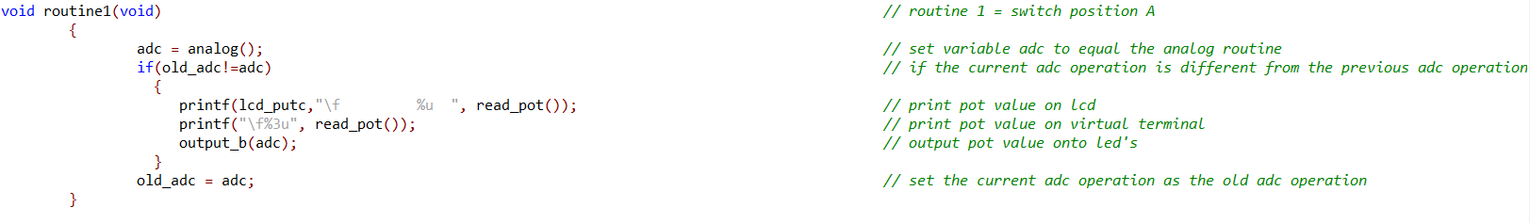
Figure 8 - Routine for Task 3
To complete this task, the routines analog and read_pot were used, which were previously seen in Figure 6, and previously used in Task 1. Firstly, the variable adc was set to the routine analog, reading the potentiometer value. Next, the potentiometer was outputted onto the LCD and virtual terminal. For this task, as the value was required to be on line 1 of the LCD, it was not necessary to specify the LCD location as done so before, instead the \f command was used, clearing the display before outputting the value. After the \f, white space is added, so that the potentiometer value appears centred on the LCD. Finally, the variable “adc” is outputted on to Port B, the port containing the LED’s.

Task 4
The final task was the make the motor spin clockwise when the push-button was pressed, and stop rotating when the button was released. The LCD had to display the status of the button on line 3, as well as on the virtual terminal. This had to function when the switch was in position D. The solution to this task can be seen below in Figure 9.
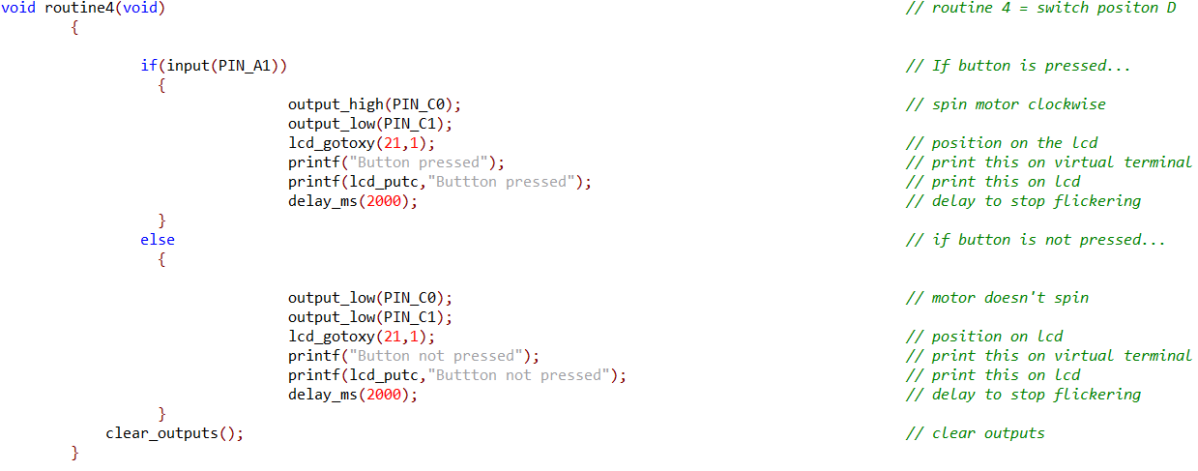
Figure 9 – Routine for Task 4
To complete this task, an If/Else statement was used. The If statement checks if there is an input on Pin A1, the pin the button is connected to. If so, Pin C0, one of the pins the motor is connected to is set to high, so the motor can spin clockwise. Then, the statement “Button pressed” is outputted at position 21,1 on the LCD, which is on the 3rd line, and also outputted on the virtual terminal. These commands are then repeated within the else command, however both motor pins are set to low so the motor does not spin, and the message “Button not pressed” is outputted. Finally, the clear_outputs routine was called, ensuring that the motor was not spinning when the switch position was changed to another task.

Conclusion
In conclusion, this report, shows that Embedded C is an adequate coding language that can produce structured code which can be interpreted and understood by anyone with basic knowledge of Embedded C. This is highlighted by the demonstration of successful completion of all tasks, all of which are functioning as specified.
If these tasks were to be done again, the aim would be to use fewer lines of code whilst retaining complete functionality, as that would make it more efficient and increase the code’s readability.

