Prepared by:
Ivan Yordanov Ivanov - 2434440
The program : CERTHE Computing Skills for the Workplace
Module name : Analysing and Solving Problems
Module code : ACCA4019
Lecturer’s name : Dr Abida Perveen

Table of Contents

List of figures / tables -------------------------------------------------------------------- Add Page No.

1. Introduction
2. Problem Deconstruction
3. Proposed Solution
4. Flowchart of the Solution
5. Explanation of the Flowchart
6. Reflection and Justification
7. Conclusion
8. References

- Introduction
This report focuses on the issue of classroom allocation within a local college, where space is not being used effectively. At the moment, some rooms are overcrowded while others are not fully utilised, which creates an imbalance in how resources are used. As a result, timetable clashes can occur and both staff and students may have to move unnecessarily between rooms, leading to delays and disruption during the day. These challenges show that the current system is not efficient and requires improvement.
To address this, the problem will be examined by breaking it down into smaller parts and identifying the key requirements, constraints, and variables involved. The MoSCoW method will be applied to prioritise these requirements. A structured solution will then be designed using a flowchart, followed by an explanation of how the process works in practice. The report will also reflect on the problem-solving methods used and explain why this approach is suitable, supported by relevant academic sources [1].

- Problem Deconstruction
The main problem in this scenario is that the college is not allocating classrooms efficiently. At the moment, some rooms are too full while others are not being used properly, which shows that the available space is not managed well. This can also lead to timetable clashes, where more than one class is planned at the same time in the same room. On top of that, students and staff may have to move between rooms that are far apart, which wastes time and can cause delays to lessons. Overall, this suggests that the current system for allocating rooms is not organised effectively.
To understand the problem more clearly, it can be broken down into smaller parts. One part of the issue is matching class sizes with the correct room capacities, as larger classes need bigger rooms. Another part is the scheduling of lessons, where classes must be placed into time slots without overlapping. There is also the issue of movement, since having lessons in distant locations increases travel time between classes. Finally, there is the general problem of how resources are being used, as some rooms are left empty while others are overused. Breaking the problem into these sections makes it easier to analyse and work towards a solution.
There are also several variables that need to be considered. These include the number of classrooms available, the size and capacity of each room, the number of students in each class, lesson times, and teacher availability. In some cases, certain classes may require specialist rooms, such as labs or IT rooms. The location of each room is also important, as it affects how long it takes to move between lessons. Along with these variables, there are also constraints that limit how the system can work. For example, rooms cannot be double-booked, class sizes must not exceed room capacity, and teachers cannot be in two places at the same time. These types of constraints are common in timetabling problems and must be taken into account when planning a solution [2].
To organise the requirements, the MoSCoW technique can be used. The “Must Have” requirements include making sure every class has a suitable room, avoiding timetable clashes, and ensuring that rooms have enough capacity. The “Should Have” requirements focus on improving things such as reducing movement between rooms and using space more evenly. The “Could Have” requirements may include keeping classes in nearby locations or making the timetable more convenient. Finally, the “Won’t Have” category includes features that are not necessary at this stage, such as advanced automated systems or real-time changes. Using MoSCoW helps to clearly separate what is essential from what is less important, which makes the problem easier to manage [1].

- Proposed Solution
To deal with the classroom allocation problem, a more organised and step-by-step approach is needed so that rooms can be used properly and timetable clashes can be avoided. The main aim of this solution is to match classes with suitable rooms based on their size and any specific requirements, while also reducing unnecessary movement between lessons. Instead of assigning rooms randomly, the process follows a clear order to make the timetable more structured.
The first step in the process is to collect all the necessary information. This includes class sizes, room capacities, lesson times, teacher availability, and any specialist requirements such as computer rooms or laboratories. Having accurate data at the beginning is important because it supports better decision-making later on.
After this, the classes are prioritised. Larger classes and those that require specialist rooms are allocated first, as they have fewer options available. This makes the process easier to manage because smaller or more flexible classes can be fitted in afterwards without causing major issues. This type of approach is commonly used in timetabling, where more complex constraints are handled first to reduce conflicts [2].
The next step is to identify suitable rooms for each class. This is done by checking whether the room has enough capacity, whether it is available at the required time, and whether it meets any specific requirements. Rooms that do not meet these conditions are removed from the available options, which helps narrow down the choices.
If more than one suitable room is available, the best option is chosen based on practicality. For example, rooms that are closer to the previous or next lesson can be selected to reduce movement time for staff and students. In addition, rooms that closely match the class size can be chosen so that space is not unnecessarily wasted. This helps improve how resources are used overall [3].
Before confirming the allocation, checks are carried out to make sure there are no conflicts. This includes confirming that the room is not already booked, that the teacher is available, and that the class does not overlap with another lesson. These checks act as decision points in the process, ensuring that conflicts are identified and resolved before a room is assigned.
If no suitable room can be found, alternative options are considered. This may involve selecting another room, adjusting the time slot where possible, or marking the issue for manual review. This makes the solution more realistic, as not every situation can be solved automatically.
Finally, once all classes have been allocated, the timetable is reviewed to identify any remaining issues. This includes checking for overcrowded rooms, unused spaces, and unnecessary movement between lessons. This final review helps to improve the timetable and ensures that available space is used more appropriately.
The proposed solution is based on a number of assumptions. It is assumed that all data, such as class sizes, room capacities, and timetables, is accurate and available in advance. It is also assumed that rooms and staff availability remain consistent during the allocation process. In addition, it is assumed that all special requirements for classes are clearly identified beforehand. These assumptions are necessary to ensure that the solution can operate effectively.

- Flowchart
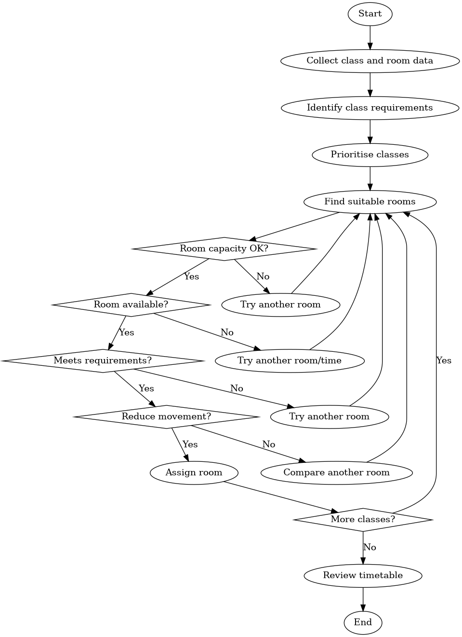

- Explanation of the Flowchart

The flowchart represents a step-by-step process for improving how classrooms are allocated in the college. It begins with collecting all the necessary information, such as the number of students in each class, room sizes, lesson times, and any special requirements. This stage is important because without accurate information, it would be difficult to make correct decisions later in the process.
After gathering the data, the classes are organised based on priority. Larger classes and those that need specific rooms, such as computer labs, are dealt with first because they have fewer suitable options. This makes the overall process easier to manage, as smaller classes can be fitted in afterwards with less difficulty.
The next part of the flowchart focuses on selecting suitable rooms. This is done by checking a number of conditions, such as whether the room is big enough, whether it is available at the required time, and whether it meets any specific needs. If a room does not meet these conditions, the process goes back and another option is considered.
Another step included in the flowchart is checking movement between classes. Rooms that are closer together are preferred, as this helps reduce unnecessary travel time for both students and staff. This makes the timetable more practical to follow during the day.
Once a suitable room has been found, it is assigned to the class. This process continues until all classes have been allocated. At the end, the timetable is checked again to identify any remaining problems, such as rooms being overused or not used enough. This final step helps to make sure the allocation is as efficient as possible. This structured approach helps ensure consistency in decision-making and reduces the likelihood of scheduling conflicts and inefficient room usage.

- Reflection and Justification
In this assignment, different problem-solving techniques were used to develop a solution for the classroom allocation issue. One of the main approaches used was breaking the problem into smaller parts. Instead of trying to solve everything at once, the problem was divided into areas such as room capacity, scheduling, and movement between classes. This made it easier to understand the situation and focus on each part individually.
Another important technique used was abstract thinking [4]. The solution was designed as a general process rather than something specific to one timetable. This means it could be used in different situations or adapted if changes are needed. Logical thinking was also applied to create a clear step-by-step process, where each stage follows on from the previous one in a structured way.
The MoSCoW method was used to prioritise requirements, which helped to separate what is essential from what is less important. For example, avoiding timetable clashes and making sure rooms are suitable were treated as the most important factors. This made the problem easier to understand and allowed each part to be considered separately [1].
The approach used in this report is suitable because classroom allocation is a complex problem with many connected factors [5]. Decisions about room size, timing, and location all affect each other, so using a structured method helps to keep the process organised. Similar structured approaches are often used in timetabling problems, where different constraints need to be considered at the same time [2].
However, there are some limitations to this solution. For example, it assumes that all information is available and accurate, which may not always be the case in real situations. Unexpected changes, such as last-minute timetable adjustments or room issues, could affect how well the solution works. In addition, the model does not fully consider personal preferences of staff or students, which may also have an impact. Despite these limitations, the solution still provides a clear and practical way to improve classroom allocation.

7. Conclusion
In conclusion, this report looked at the problem of classroom allocation in a college and identified the main issues affecting how space is used. Problems such as overcrowded rooms, unused spaces, and timetable clashes were highlighted. A structured solution was then developed to improve how classrooms are assigned, with the aim of making better use of available space and reducing unnecessary movement between lessons.
The use of problem-solving techniques, such as breaking the problem into smaller parts and prioritising requirements, helped to create a clear and logical approach. Although there are some limitations, such as relying on accurate data and not fully considering personal preferences, the solution still provides a practical way to improve the overall organisation of the timetable.

8. References

[1] | A. B. Consortium, “MoSCoW Prioritisation,” Agile Business Consortium, 2020. [Online]. Available: https://www.agilebusiness.org/dsdm-project-framework/moscow-prioritisation.html. [Accessed 26 March 2026].
[2] | S. Abdipoor, R. Yaakob, S. L. Goh and S. Abdullah, “Meta-heuristic approaches for the University Course Timetabling Problem,” Results in Control and Optimization, 2023.
[3] | C. B. Mallari and e. al., “The university coursework timetabling problem: An optimization approach to synchronizing course calendars,” Computers & Industrial Engineering, 2023.
[4] | M. Reynolds and S. Holwell, “Systems thinking in practice: mapping complexity,” Cambridge University Press, 2010.
[5] | J. da Costa Junior and e. al., “A framework for a systems design approach to complex societal problems,” Design Science, 2019.

