REHAN JOSEPH
Independent Project
ACCA6020
Project Proposal
21 October 2026

Table of Contents
Introduction / Background to the Proposed Research 2
Problem Statement 2
Project Aim 3
Project Objectives 3
Research Methodology 3
Research Design 3
Flow Diagram 4
Research Materials 5
Project Timeline 6
GANTT CHART 6

Table of Figures
Figure 1: Flow Diagram 5
Figure 2: Table of materials 6
Figure 3: Project timeline 7
Figure 4: Gantt Chart 7

Predictive Cyber Defence Through Adaptive Deception: An Explainable AI-Driven Approach to Corporate Financial Networks

Introduction / Background to the Proposed Research
Cyberattacks rarely begin at the moment an intruder breaks in. They often develop gradually, with unusual login attempts, suspicious network activity and unexpected access patterns appearing before serious damage occurs [1]. In the UK alone, nearly half of businesses experienced a cyber breach in the past year, with phishing continuing to dominate attack methods. Within the financial sector, the threat is even more pronounced: 82% of respondents in the Bank of England’s 2026 H1 Systemic Risk Survey identified cyber-attack as one of the top risks to the UK financial system[2]. This is particularly concerning for the financial sector, where organisations depend on secure networks to protect customer data, process transactions and maintain essential services[3]. Hence, a successful attack could affect not only an organisation’s operations but also the people and businesses that rely on them.
Predictive cyber defence is one of the crucial preventive mechanisms to protect networks [4]. Traditional security approaches often focus on identifying suspicious activity once an attack has happened, making them less effective against evolving cyber-attacks [5]. In contrast to traditional approach, Artificial Intelligence (AI) models such as Deep Learning [5][6] and Machine Learning [7] work on analysing historical cybersecurity data and ongoing network activity to identify patterns that may indicate an upcoming attack. It is important in cyber-attack defensive mechanisms, to provide early warnings about the type of attack that may occur and which systems could be targeted [6]. Although many studies [3] [5] have explored AI models for cybersecurity detection and prediction, their predictions are not always transparent. A useful defence must therefore consider what happens when the model is wrong, as well as when it correctly identifies a potential threat [8].
An important challenge is ensuring that AI predictions can be understood and trusted. Explainable AI can help by showing which network activities or warning signs influenced a prediction, allowing security teams to understand why a potential attack has been identified [8]. These predictions can help guide adaptive defensive mechanism such as honeypots to attract suspicious activity and reveal attacker behaviour without deliberately exposing genuine systems[9].

Problem Statement
Corporate financial networks must protect sensitive information, support secure transactions and maintain essential services while facing the ongoing risk of cyber-attacks [3]. Although AI can predict cyber threats and defensive mechanisms can reveal attacker behaviour, limited research appears to explore how explainable AI predictions can guide the adaptive deception in financial networks. Furthermore, predicting threats alone does not directly protect systems[3]. This creates a need for an approach that uses explainable predictions to guide defensive actions, helping organisations prepare for potential attacks while keeping genuine systems protected.

Hence, this project will explore how predictive cyber defence can be combined with adaptive deception within a continuously running simulated financial network. The proposed system will use AI based predictions to help guide defensive mechanisms. This will be achieved by the following Aim and Objectives.

Project Aim
To investigate how an explainable deep learning model can predict emerging cyber threats and support adaptive defensive responses within a continuously running simulated financial network.

Project Objectives
Objective 1: Design and develop a simulated corporate financial network.
To create a continuously running simulated corporate financial network that generates realistic user, network and security activities.
Objective 2: Implement an adaptive cyber defence system.
To create an adaptive defence system such as honeypot for the simulated financial network
Objective 3: Develop and evaluate an explainable Deep learning model
To train, test and evaluate an explainable deep learning model that identifies early warning patterns, predicts potential cyberattacks and estimates their likely targets within the simulated network
Objective 4: Deployment of the defensive system with the visualisation of predicted threats and the network and cyber activities
To deploy the developed defensive mechanism based on the predictive analysis, and visualise predicted threats, network activity and defensive responses through a real-time monitoring dashboard.

Research Methodology

Research Design
The project will follow a system development and experimental evaluation approach. An initial literature review will be conducted using peer-reviewed journal articles, conference papers and cybersecurity industry reports to identify suitable methods, technologies and datasets for developing the proposed system.
A continuously running simulated financial network will be designed based on findings from the existing literature. Python and suitable simulation tools will be used to represent departments, users, systems and normal and suspicious network activities [10]. The literature review will also help determine the most suitable honeypot approach for the simulated network. Existing tools, such as Cowrie[11], and the possibility of developing a custom Python-based decoy will be considered. The selected honeypot will be configured to attract suspicious activity and record attacker interactions without exposing genuine systems[4].
Suitable deep learning approaches, including the Deep Sequential Prediction Model (DSPM)[6] and Bayesian deep learning[5], will be reviewed to identify an appropriate model for predicting potential cyberattacks and their likely targets. Relevant cybersecurity datasets such as UNSW-NB15 containing examples of normal and malicious activity will also be investigated to support the training and testing of the predictive model[12]. Model performance will be assessed using appropriate evaluation metrics, including precision, recall, F1-score[5] and, where suitable, Mean Absolute Error (MAE) [6].
An explainable AI technique, such as SHAP or LIME, will then be investigated to identify the factors influencing the model's predictions[8]. This will help assess whether the predictions can be clearly explained and understood by security analysts. Predictions from the deep learning model will help guide where and when the honeypot should be deployed[6]. Conventional security monitoring will also be maintained to support detection when predictions are incorrect or uncertain. The completed system will be evaluated through controlled attack simulations in an isolated environment using authorised datasets and simulated systems. The evaluation will examine the model's predictive performance, false alarms, the honeypot's ability to detect suspicious activity and the availability of essential services. The results will be used to assess the effectiveness and limitations of the proposed predictive defence approach.
Finally, the predictive model, honeypot and simulated network will be integrated into a single system. Python based code will be used to develop the system and connect its components, while Streamlit will be used to create a monitoring dashboard[13]. The dashboard will display network activity, predicted threats, explanations, honeypot status and suspicious interactions.

Flow Diagram
The following flowchart illustrates the proposed research model, showing how the simulated financial network, cybersecurity datasets, explainable deep learning model and adaptive defence mechanisms will work together to achieve the project aim.
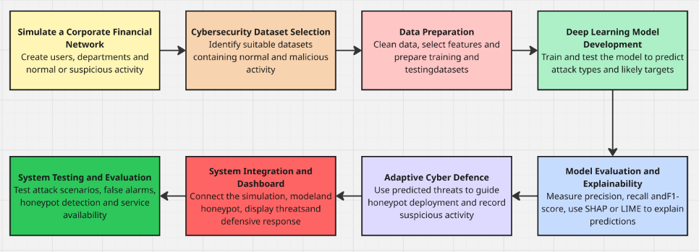
Figure 1: Flow Diagram

Research Materials

Resources | Why? | References
Python | To develop the simulated financial network, predictive model and defensive system.
Streamlit | To create an interactive dashboard for visualising network activity, predicted threats and defensive responses. | [13]
Python libraries: tensorflow / keras, pandas and numpy,shap/lime, matplotlib.pyplot | To develop and train the deep learning model, process datasets, explainability and analyse network activity. | [14][15]
Cybersecurity datasets (eg. UNSW-NB15, NSL-KDD) | To provide examples of normal and malicious network traffic for training and evaluating the predictive model. | [12]
Cowrie or a custom Python honeypot | To detect and record suspicious interactions within the simulated environment. | [11]
Virtualisation software (e.g. Oracle VirtualBox) | To create isolated virtual machines for running and testing the simulated network and honeypot. | [16]
Git / GitHub-  Version Control | To manage source code, track changes and maintain working versions of the system. | [17]
Event logging and storage  (eg. SQLite) | To record simulated network activity, predictions and honeypot interactions over time. | [18]
Hardware –  SOAC Lab Computer Windows Laptop ( Intel core i7-1355u 1700 mhz, 10 core , 16GB RAM) | Computer hardware  To develop the system, train the model, run virtual machines and evaluate the completed project.
Figure 2: Table of materials

Project Timeline
Phase | Timeline
1. Initial Literature Review | 15 Sep 2026 – 20 Oct 2026
2.Proposal Submission | 21 October 2026
3.Comprehensive Literature Review | 15 Oct - 27 Apr 2027
4. System Requirements and Design | 22 Oct – 15 Nov 2026
5. Simulated Network Development | 9 Nov – 13 Dec 2026
6. Honeypot Development | 30 Nov 2026 – 10 Jan 2027
7. Deep Learning Model Development | 4 Jan – 21 Feb 2027
8. System Integration | 8 Feb – 7 Mar 2027
9. Dashboard Development | 15 Feb – 14 Mar 2027
10. Testing and Evaluation | 1 – 28 Mar 2027
11. Final Report Preparation | 31 Oct 2026 – 18 Apr 2027
12. Final Checks and Submission | 19 – 27 Apr 2027
Figure 3: Project timeline

GANTT CHART

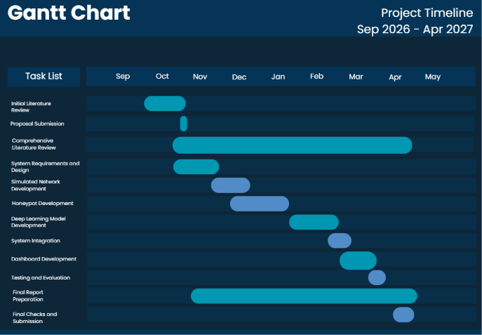
Figure 4: Gantt Chart

References

[1] A. Mtair, "Predictions of Cybersecurity Experts on Future Cyber-Attacks and Related Cybersecurity Measures,"
[2] "Systemic Risk Survey Results - 2026 H1." Accessed: Oct 20 2026. [Online]. Available: https://www.bankofengland.co.uk/systemic-risk-survey/2026/2026-h1
[3] M. Qasaimeh, R. A. Hammour, M. B. Yassein, R. S. Al‐qassas, J. A. L. Torralbo and D. Lizcano, "Advanced security testing using a cyber‐attack forecasting model: A case study of financial institutions," J Software Evolu Process, vol. 34, no. 11, -08-08 2022, doi: 10.1002/smr.2489.
[4] R. B. Pittala et al., , "A Lightweight SSH Honeypot for Intrusion Logging," 2025 4th International Conference on Automation, Computing and Renewable Systems (ICACRS), -12-10 2025, doi: 10.1109/icacrs67045.2025.11324212.
[5] Y. Wu, Y. Chen, Z. Liu and W. Lin, "Enhancing financial decision-making under cyber threats: a dual-branch framework integrating bayesian deep learning and explainable AI," Ann Oper Res, -12-03 2025, doi: 10.1007/s10479-025-06973-2.
[6] A. A. A. Ali, A. T. Zahary and T. A. Ali, "A Novel Deep Learning Technique to Model and Predict the Spread of Cybersecurity Threats," IEEE Access, vol. 14, 2026, doi: 10.1109/access.2026.3670355.
[7] H. Dong and I. Kotenko, "Cybersecurity in the AI era: analyzing the impact of machine learning on intrusion detection," Knowl Inf Syst, vol. 67, no. 5, -02-19 2025, doi: 10.1007/s10115-025-02366-w.
[8] S. Papastergiou, N. Basheer, K. Lampropoulos, P. Verrios and S. Islam, "Explainable AI based dynamic cybersecurity risk management for cyber insurability," Int. J. Inf. Secur., vol. 25, no. 1, -01-22 2026, doi: 10.1007/s10207-025-01189-8.
[9] Unknown. "What Is a Honeypot? Meaning, Types, Benefits, and More." Accessed: Oct 20 2026. [Online]. Available: https://www.fortinet.com/resources/cyberglossary/what-is-honeypot
[10] D. Kim, G. Sin, K. Kim, J. Kang, S. Im and M. Han, "Network Traffic Synthesis and Simulation Framework for Cybersecurity Exercise Systems," CMC, vol. 80, no. 3, -09-12 2024, doi: 10.32604/cmc.2024.054108.
[11] W. Z. Cabral, C. Valli, L. F. Sikos and S. G. Wakeling, "Review and Analysis of Cowrie Artefacts and Their Potential to be Used Deceptively," 2019 International Conference on Computational Science and Computational Intelligence (CSCI), -12 2019, doi: 10.1109/csci49370.2019.00035.
[12] Unknown. "UNSW-NB15 Augmented Dataset | Datasets | Research | Canadian Institute for Cybersecurity | UNB." Accessed: Oct 20 2026. [Online]. Available: https://www.unb.ca/cic/datasets/cic-unsw-nb15.html
[13] "A Beginners Guide To Streamlit." Accessed: Oct 20 2026. [Online]. Available: https://www.geeksforgeeks.org/python/a-beginners-guide-to-streamlit/
[14] M. Abadi et al., , "TensorFlow: A system for large-scale machine learning,"
[15] M. Levy. "Guide to NumPy, pandas, and Data Visualization." Accessed: Oct 20 2026. [Online]. Available: https://www.dataquest.io/guide/numpy-pandas-and-data-visualization-tutorial/
[16] E. Apps. "VirtualBox - System Emulators Emulator." Accessed: Oct 21 2026. [Online]. Available: https://virtualbox.emuapps.com/
[17] K. Y. Chen, M. Toro-Moreno and A. R. Subramaniam, "GitHub enables collaborative and reproducible laboratory research," vol. 23, no. 2, pp.e3003029, 2025, doi: 10.1371/journal.pbio.3003029.
[18] Ravikiran A S. "What is SQLite? And When to Use It?" Accessed: Oct 20 2026. [Online]. Available: https://www.simplilearn.com/tutorials/sql-tutorial/what-is-sqlite

