Reflective Journal

Part one: Science Education
On October 27, 2019, I walked into the National Waterfront Museum by coincidence and found that Swansea Science Festival was held there. At the event, I saw all kinds of interesting science projects, such as heat sensors, robots with visual glasses and operating handle, virtual reality glasses, normal distribution of balls and so on. These science projects not only broaden my horizons, but also attract the attentions of children in these activities, some of them gathered around the booth to listen to the explanation, some wait for the experience project in line. However, what impressed me most was the staff who patiently explained to the children beside each science project. As the festival is organised by Swansea University, these explainers are students from various schools at Swansea University. By demonstrating popular science projects, they arouse children's interest and patiently explain the project to help children understand what these scientific phenomena are and how the principle is. Besides, a seed of science is planted in the hearts of children.

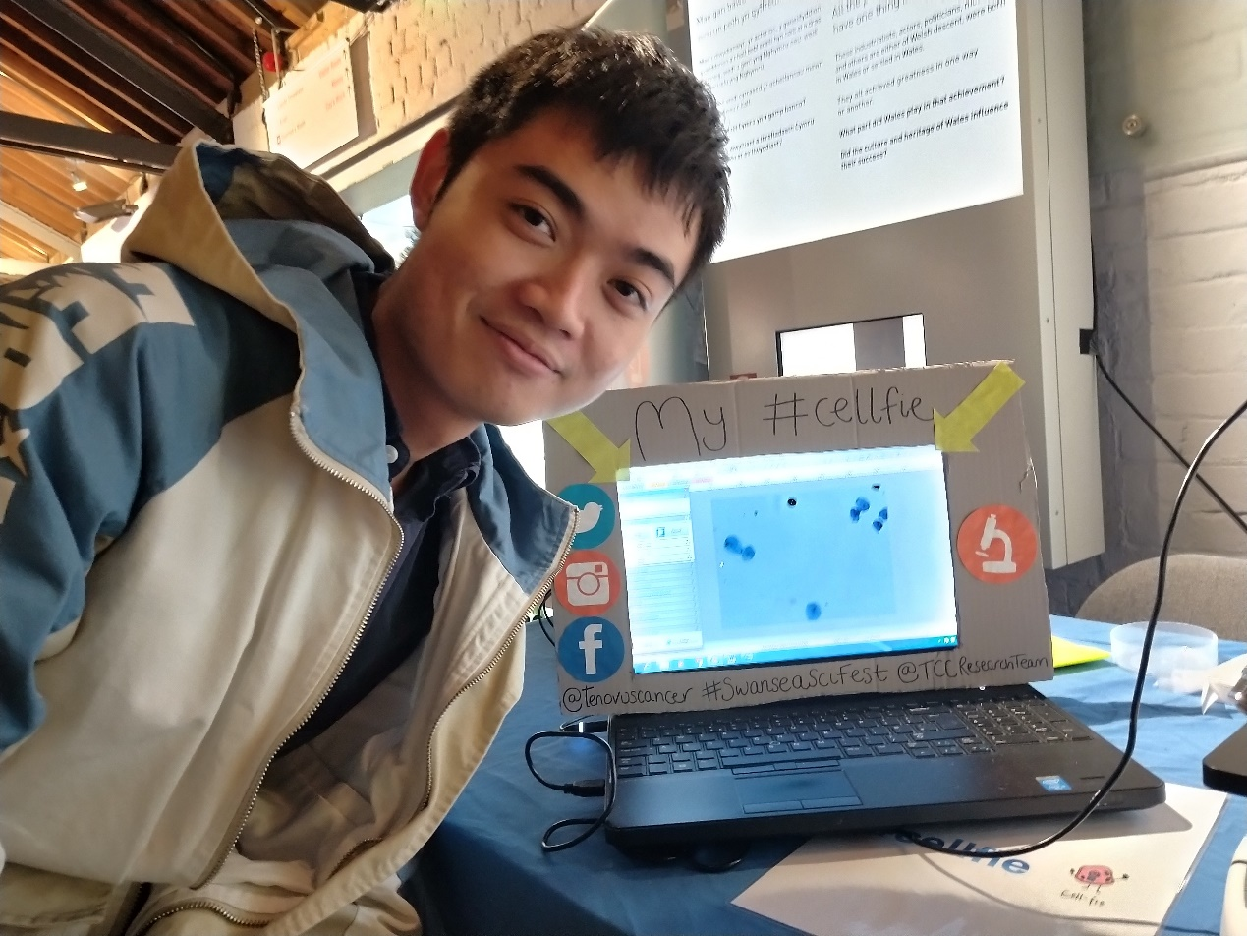

I was inspired by this science festival and attracted by what the nation or university had done for the science education. In this reflective journal, therefore, I will explore more about the science education in the UK by tracing back to the history of science education in the UK and looking up its current situation. Compared with the situation in China, I can find some problems in my nation and put forward corresponding solutions to contribute to the development of science education in China even some developing countries.

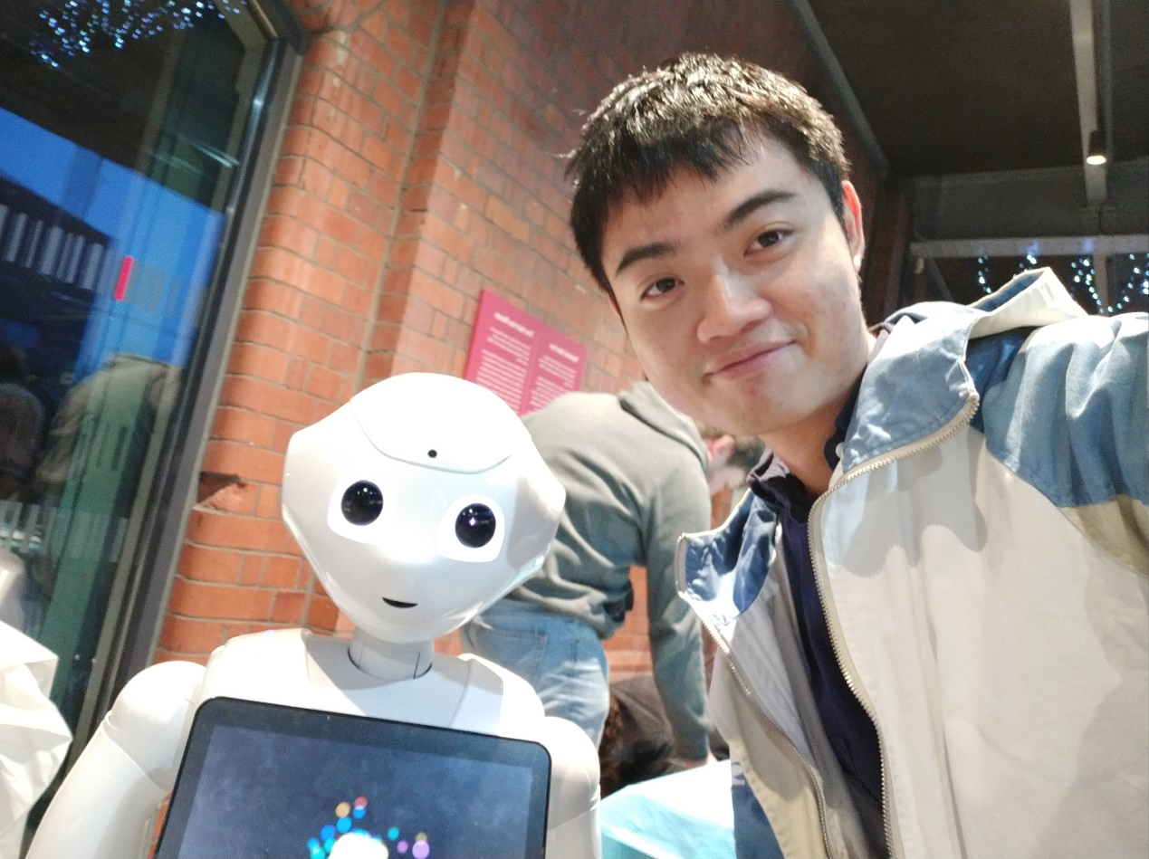

Tracing the history, the UK is the birthplace of science education. Sharp, William was a physician and homoeopathist. In 1847, Sharp convinced Dr Tait, the headmaster of Rugby school, of the value of the teaching of natural science. He thus became the first teacher of science in a public school, setting the example which other schools followed. (Oxford Dictionary of National Biography, 2005) After the industrial revolution, people in the UK realized the importance of science education and began to offer science courses at first in independent schools, which can be seen that the British have a forward-looking vision for science education.

However, no more progress is made in the development of UK science education after Sharp had science courses. Until the middle of the 19th century, the attitude for science and science education in the society of the UK was still on. Most of the people with higher education was ignorant of science, the legislature of the members was like primary school students who did not understand science. What’s worse, it was illegal for researcher to study natural science in the historical university, those who in low status were not able to secure their degrees by the study of natural sciences. As for the application of science, which matters to the country's great wealth and economic prosperity, the UK even lagged far behind France and even further behind Germany.

To push the development of science education in UK, two key measures related to Thomas Henry Huxley had been taken. One key development was the founding of the first London School Board in 1870, which discussed the school curriculum; the other was the initiation of courses to supply the country with trained science teachers. These two actions to a certain extent, promoted the development of the science education, but still failed to make the UK in a leading position of science education all over the world.

After the Second World War, the science and technology developed rapidly. The emergence of new scientific research achievements and a series of scientific disciplines such as space science, life science and information science brought profound changes to people's social life. Under this background, science education in the UK is also undergoing a great change because of the following two aspects:

First, science education should be strengthened throughout the compulsory education period. Science 5-16: A statement of policy (1985) from the Department for Education and Science and Welsh Office, stated that secondary school for the all students under the age of 16 should provide broaden science education. This broad science education should be of quality, adaptable to the needs of less able students and provide equal learning opportunities for boys and girls. The document puts forward specific requirements that science curriculum should be allocated about 10 per cent of total curriculum time to science in the first two years, and about 15 per cent in the third year. In addition to physics, chemistry and biology, science education in the first three years of high school may also include earth science, environmental science, astronomy and an introductory course in modern technology. Teaching should emphasize the connection with real life. The government document as an outline document played an important role in the progress of science education.

Secondly, in view of the weakness of the general science courses that are independent and separated from social problems, cross-subject courses that are closely related to social problems should be offered. In the early 1970s, science, technology and social education in the UK started from the sixth school level, and then extended up and down to secondary education and higher education under the age of 16. Science in Society is a form of Science, technology and social education.

In recent years, although science courses are set into the school curriculum, the school still do not attach much importance on it. On September 2017，Wellcome Trust, which is a research charity based in UK, publish a report with the title of 'state of the nation' report of UK primary science education. As the data showed in the report, science is taught weekly for an average of 1 hour and 24 minutes on average. The younger the children are, the fewer time they will receive. Less than two hours of weekly science course on average for total year groups. Nearly half said they were "very interested" in science, but that was lower than PE, arts and maths. 51% science leaders get specific release time to lead science in addition to planning their own lessons. One-third take 10 hours (or less) a year, one-third take 11-20 hours and one-third take more than 21 hours. As far as I’m concern, the time allocated to the science education is away from basic requirement which can educate students.

The science leader who undertake CPD and the range of science equipment have a positive relationship with students’ attitude toward science. From another report (Wellcome Trust, 2019a), 90 per cent of students 我、were reported to study science at school this academic year in the UK. 48 per cent of students were "very interested in science" and their school had a science guru who had attended CPD in the past year, compared with 37 per cent of students who had not. Schools where 46 per cent of students "like science very much" said they had all the science equipment, while 40 per cent said they had science equipment "to some extent. As a result, professional science teachers and abundant equipment are the essential guarantee of science education.

Besides, Students’ enjoyment of the science modules is related to their perceived difficulties. Pupils in younger year groups are more likely to report that science lessons are ‘too easy’ but also that they like science lessons ‘a lot’. Those pupils who report that science is ‘too difficult’ are more likely to not like the subject (56%) compared with those who state it is ‘too easy’ (8%).

For promoting the development of science education, Explorify, which is a programme of fun and simple science activities to inspire teachers and spark their pupils’ curiosity, prevail among the primary schools. As it is stated in the report (Wellcome Trust, 2019b), 98% of respondents using Explorify plan to continue using it because of its unique characters. First of all, the content of each event in Explorify links into the curriculum. In addition, the visual nature of the content which appeals to pupils. Besides, it is easy to use website for instruction and learning. Last but not least, the great impact it has had on them and their pupils.

Explorify is often used by teachers in science lessons with 88% of respondents but is also used at other times in the school day: 42% use it at the start of the day, 38% use it during other lessons and 36% use it at other times during the school day (excluding breaks or lunch).

All respondents reported increased student participation in discussions when using Explorify. While this was true for students of all abilities, the majority of respondents emphasized that it was students who were previously anxious or uninterested in science who showed the most significant increase in participation. So do students with special educational needs or English as an extra language.

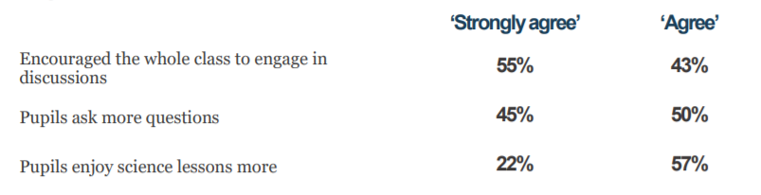
(Wellcome Trust, 2019b)

Although there are still some shortcomings in science education in UK, there are still many things to learn from compared with my country, China. By comparing the progress and current situation of science education in UK, I find that there are also many problems in science education in China. I will state them from the perspectives of country, school and supporting equipment.

From the perspective of the state, the government does not pay enough attention to and invest enough in science education. First of all, funds are the foundation for the development of science education. The Chinese government does invest a lot of funds in natural science research, but only a little in the cultivation of students' scientific education literacy. Secondly, science and technology museum utilization are insufficient. The Chinese government has built science and technology museums in various provinces or regions, but most science and technology museums only present scientific phenomena and lack explanations for scientific phenomena. And there is less collaboration between science museums and schools. Finally, I rarely see the launch of science and technology festivals in China. After looking up relevant materials, it is found that although science and technology festivals are indeed held in some provinces and cities with good development of science education, they are not widely attended, and the commercial nature of science and technology festivals is too high and the public welfare nature is weak.

From the perspective of schools, China's primary and secondary schools do not attach much importance to science education. First of all, China's examination system determines the importance of the discipline. Often the subjects that determine which students go on to higher education are taken seriously by schools, teachers, and students, while the subjects that are not tested are often taken up by these major subjects, and there is very little time a student can really spend on science each week. Secondly, teachers lack scientific professional quality and teaching methods are single. The teachers who teach science courses are often the head teachers of a class. They may be Chinese teachers or math teachers. These teachers are not professionally trained, and the course is often taught in a way that introduces experiments in the textbook, failing to arouse students' interest in science.

In terms of supporting facilities, China's science education facilities have little impact on students. Science education needs a wide variety of equipment, and more demand, for many schools can not afford this equipment. Therefore, when teaching science courses, the school lacks the equipment needed to give students direct demonstrations. Second, school equipment is underutilized. Some schools spend a lot of money to buy some equipment, they cherish this expensive equipment, so they take great care of them. Some schools are afraid that students will damage the equipment in the experiment, and they tend to keep these devices as treasures instead of letting students use them. The equipment is equipped but the utilization rate of the equipment is low, which is unable to play a role in assisting teaching.

Therefore, to link the problem of science education in China, we must start from these three aspects to improve. First of all, the government should attach importance to science education and increase the support of policies and funds for science education. Science museums and science festivals are important platforms for carrying out science education for public benefit. Secondly, schools should attach importance to science education. It’s necessary to recruit professional science teachers and give 1.5 hours of science education per week. Finally, schools can combine government and business sponsorship to buy science education equipment and make full use of it for science education.

In the 21st century, the competition of comprehensive national strength among countries is increasingly fierce, the importance of science and technology is increasingly prominent, and the development of national scientific literacy has become the focus of countries. Throughout the world, there are many countries even worse than China, this is now a common problem in education. Therefore, it is urgent to attach importance to the national science education, only in this way can a country develop better.

Finally, I recorded some episodes in Swansea Science Festival and make the video posted in Youtube. The website is https://youtu.be/yfddfZ7-3f4. Welcome to click for watching it.

Reference list

Oxford Dictionary of National Biography, (2005) Sharp, William, Available at: https://www.oxforddnb.com/view/10.1093/ref:odnb/9780198614128.001.0001/odnb-9780198614128-e-25223?rskey=n4s16K&result=1 (Accessed: 14 January 2020).

Department for Education and Science and Welsh Office, (1985) Science 5-16: A statement of policy, Available at: http://www.educationengland.org.uk/documents/des/science5-16.html (Accessed: 14 January 2020).

Wellcome Trust, (2017) 'state of the nation' report of UK primary science education, Available at: https://wellcome.ac.uk/sites/default/files/state-of-the-nation-report-of-uk-science-education.pdf (Accessed: 15 January 2020).

Wellcome Trust, (2019) what pupils think of science in primary schools, Available at: https://wellcome.ac.uk/sites/default/files/what-pupils-think-of-science-in-primary-schools.pdf (Accessed: 15 January 2020).

Wellcome Trust, (2019) does explorify support better primary science, Available at: https://wellcome.ac.uk/sites/default/files/does-explorify-support-better-primary-science.pdf (Accessed: 15 January 2020).

Ofsted, (2013) Maintaining curiosity: a survey into science education in schools, Available at: https://www.gov.uk/government/uploads/system/uploads/attachment_data/file/379164/Maintaining_20curiosity_20a_20survey_20into_20science_20education_20in_20schools.pdf (Accessed: 15 January 2020).

J, Zhang, (2018) investigation and research on the implementation status of science curriculum in primary schools in China, Yangzhou University: Dissertation.

Part two: Mental health education
This is not something I have encountered in the placement experience, but it is something that has happened in my life. When I came to the University of Wales Trinity Saint David to start my exchane study, I was in a freshman class. The students in the class are very shy, everyone seems to be reluctant to take the initiative to speak, probably because of the lack of familiarity. However, they were very kind to accept me as a student from China. What impressed me most was that the first time I got lost in the IQ building and couldn't find the toilet on the ground floor, I met a girl in my class. She seemed to see what I was looking for, so she kindly asked me if I needed help. With her help, I found the toilet. This makes me think she is a positive girl. Later, I found that she also took the initiative to answer questions put forward by teacherq in class, which confirmed me that she was truly a positive girl. However, one day I came across her account on Instagram. Her posts are full of negative elements. After reading several of her posts carefully, I guess she may have some mental health problems. It shocked me that a girl who was so positive in her daily life poured out her negative emotions in the virtual world of the Internet.



This isn't the first time I've met someone with a mental health problem. Before I was in China, before I came to the UK, I had some friends with mental illness. They have been unable to adjust their emotions through self-control, so they must take medicine to control their unbearable sadness. I really want to do something to help them, so every time I talk to them, I will be with a positive attitude, I hope they can be happy in chatting with me. In addition to the people I know, there are also many people I didn't know before, who become the topic of talking in school by suicide because of mental health problems. Mental health problem does not divide the country, whether in my motherland China, or in the country I study in the United Kingdom, there are bound to be people with mental health problems.

In 2018, there were 6,507 suicides registered in the UK, an age-standardised rate of 11.2 deaths per 100,000 population. Rates among the under 25s have generally increased in recent years, particularly 10 to 24-year-old females where the rate has increased significantly since 2012 to its highest level with 3.3 deaths per 100,000 females in 2018. (Office for national statistics, 2019) As we can learn from the data, the suicide resulted from mental health problem is sevetr. Besides, Sooner or later, we all go through tough times. We might seem to be OK, but inside we can be feeling worried or low, or struggling to cope with life events such as bereavement, relationship problems or debt. The pain of mental health problems affects not only us, but the people around us too. (Big White Wall, 2020) All in all, mental health education is an urgent task.

To control or alleviate mental health problems, we must understand the causes of mental health problems. Mental health problems are by no means caused by a single factor. The causes are diverse and complex. Generally speaking, his reasons can be divided into internal reasons and external reasons. The internal reasons are mainly generated by the original family and personal experience, this part of the reasons is often different from person to person, not good for extensive discussion. So, I'm going to focus on external causes for some analysis.

First of all, in the traditional concept, people's cognition of mental health is odd and insufficient. Especially in the traditional Chinese concept, mental illness is not correct. When a Chinese person has a physical illness, such as a cold or a fever, he will be advised commonly to go to the hospital to see a doctor, but when a Chinese person is psychologically unhealthy, the public even the patient will think it is a shameful thing and hide it. It is for this reason that although there will be psychological counseling rooms in schools, there will be few people to make psychological counseling.

In addition, schools do not adequately educate students about mental health. In the past, mental health education was not included in the curriculum of primary and secondary schools. Later, under the requirements of national policies, primaryq and secondary schools began to offer relevant mental health courses, but they did not play a practical role. These courses are either occupied by other subjects or become self-study classes for students. Moreover, some teachers who instruct mental health courses have not received professional training. They lead students to play some mental games in class, but do not give necessary explanations and guidance, which cannot have an effective support in education.

There are other external reasons, but at the root of it is mental health education. Therefore, reflecting on the current situation of mental health education, we should integrate various resources within education and expand channels of psychological education. Mental health education should not be an isolated educational task, but should be integrated and supplemented with information educational technolog
, aesthetic education and intellectual education in the education system.

At first, mental health education should be strengthen in schools. The government and schools should pay attention to the important impact of mental health in school education, not only to ensure the professionalism of mental health teachers, but also to ensure the effective teaching of mental health courses. On the basis of completing the basic mental health courses, schools should also cooperate with some mental health institutions, such as Big White Wall, to give mental health lectures to eliminate students' misunderstanding of mental illness and help students under mental problems.

In addition, educational technology can be used to promote traditional mental health education. The current large class teaching model is not suitable for the requirements of mental health education courses. The teaching time is short and students' psychological experience is low, which is not conducive to cultivating students' healthy psychology. Flipped classroom adheres to the student-centred teaching philosophy, integrates the teaching resources of network, classroom and extracurricular, and constructs the teaching methods of independent learning and exploration, intensive teaching and improvement, and discussion and answer questions. (Cai & Chen, 2019) Flipped classroom, because of its unique characteristics, conforms to the requirement of mental health education courses, strengthens the interaction between teachers and students and deepens students' psychological experience.

Besides, art education is integrated with psychological education. (Ma, 2019) As a form of education to improve the overall quality of college students, art education plays a unique role in promoting the comprehensive and coordinated development of students' body and mind. Art education, with its various art forms, helps college students to vent their emotions, cultivate and shape their healthy personalities, and can effectively prevent the occurrence of psychological diseases. Art education can be better integrated into students' mental health education by scientifically setting up art education courses, creating excellent art education environment, and carrying out rich art education practice activities, so as to improve students' mental health level.

Last but not least, mental health education can be permeated in individual subject education. Mental health education should not only be the work of mental health teachers, teachers of various subjects should actively cooperate with mental health teachers, pay attention to students' mental health status in daily discipline teaching, and give positive and positive guidance to help students develop healthy mental state.

There is no doubt that mental health education can be of great help to not only the countries but also individuals. To begin with, mental health education can quickly help teenagers to establish a correct attitude on life. The adolescence is the period that young students gradually take shape of their attitude toward life and value. However, they are also sensitive in psychology and easily disturbed by the outside terrible factors in this period. If they suffer a huge blow, the attitude they establish newly will collapse and have a bad influence on them. Therefore, mental health education is much important. It can not only improve the psychological quality of young students, but also enhance their psychological self-regulation ability and bearing capacity, so that young people can face difficulties bravely and face life and study with a healthy attitude.

Additionally, mental health education can reduce juvenile delinquency. In recent years, more and more juvenile delinquency phenomenon, has caused a certain impact on the social stability. Any crime is dominated by criminal psychology, and criminal psychology is an extreme behaviour caused by psychological imbalance. The mental health education for young students can make students have good psychological quality, resist the erosion of bad factors in the society and reduce the occurrence of juvenile delinquency.

Apart from above benefits, mental health education is also a reliable way to develop students' potential. It can contribute student to build good psychological quality, which is the prerequisite condition for the development of potential. The students who have a strong heart can be much more confident and adopt the real environment easily. They can also face the complicate situations in a calm and view himself at different perspectives to make their potential developed.

Now, more and more schools have realized the importance of mental health education and they try their efforts to create an environment where mental health issues are recognized and supports are offered. For example, schools set up mental health curriculum and give mental health support.

In July 2018, New York became the first state in the U.S. to require mental health education for all students. The School Mental Health program will promote the healthy emotional, social, and behavioural development of all the students. (Joe McLean, 2019)

More and more measures have been taken into practice because of the importance of mental health. It would be also greatly improved with the efforts of schools, parents and the whole society.

Reference list

Office for national statistics, (2019) Suicides in the UK: 2018 registrations. Available at: https://www.ons.gov.uk/peoplepopulationandcommunity/birthsdeathsandmarriages/deaths/bulletins/suicidesintheunitedkingdom/2018registrations (Accessed: 18 Jan. 2020).

Joe McLean, (2019) Why Mental Health Education in Schools is So Important. Available at: https://thedoctorweighsin.com/why-is-mental-health-education-so-important/ (Accessed: 18 Jan. 2020).

Big White Wall, (2020) Everybody hurts. Available at: https://www.bigwhitewall.co.uk/ (Accessed: 18 Jan. 2020).

L. Cai & M. Chen, (2019) Research on flipped classroom teaching model of mental health education ,The Party Building and Ideological Education in Schools, (18), pp.53-54.

A. Ma, (2019) Research on the integration of art education into college students' mental health education, Journal of Henan Radio & TV University, (04), pp.109-112.

Reflection

To be honest, it’s my first time that I complete reflective journal. I find it’s a little difficult for me and I don’t know if I understand totally the standard of it. Therefore, I do my efforts to read both English literature and Chinese literature to help me to make it.

