KNOWLEGDE AND INFORMATION MANAGEMENT SKILLS FOR THE WORKPLACE

Student name – Antonia Nikolova
Student ID – 1921644
Lecturer name – Md Kalam
Module name – Knowledge and Information Management Skills for the Workplace

Executive Summary
Leadership and management skills are essential to lead organisations and organisational knowledge management has helped business such as Amazon to manage its business efficiently during Covid -19. Despite a lot of challenges, Amazon was able to remain fully functional and profitable during pandemic and hired new employee during this period. It became default retail company for essential supply during lockdown for many consumers and continue to have same level of success after Covid-19 numbers went down due to efficient leadership and management practices observed in this company.

Table of Contents
Task 1- Individual Report 3
Introduction 3
Overview of organisation 3
Key knowledge management theory 3
Effective creation, storing, sharing, application and integration of information is an essential prerequisite for good knowledge management development practices 4
Effectiveness of knowledge and information management culture within the given organisation 7
Creating knowledge assets 8
Maintaining effective customer relationship management 8
Amazon’s potential knowledge management challenges 9
Recommendations to strengthen their knowledge management practices 10
Conclusion 11
Task 2. Evaluation of Proposed Knowledge Management Framework 13
Introduction and purpose 13
Amazon’s potential knowledge management challenges 13
Recommendations to strengthen their knowledge management practices 13
Summary 14
References 15

Task 1- Individual Report

Introduction
Leadership is the most significant part of management as it assists businesses to remain efficient and at the same time helps them to reach their goals and visions. During Covid-19 businesses faced a difficult situation as there was unemployment and economic turmoil due to unprecedented health crisis. But Amazon has shown growth during this period, they handled this crisis situation by applying knowledge management systems principles. Amazon navigated user experience efficiently as it delivered essential supplies to a wide range of customers and even hired new employees during this period. In this study leadership and management principles and practices which helped amazon to overcome this crisis and its continuous growth is discussed.

Overview of organisation
Amazon’s vision is to become a customer centric company and provide every product a customer wants to buy. It has mission is to sell products to customers in lowest possible price. At the same time, it wants to offer best selection and convenience to its customers. Amazon has revenue of $ 113.08 billion in 2020 as its revenue has seen 27% growth per annum (Cnbc.com, 2021). During Covid-19 Amazon successfully conducted its operations and fulfilled customer orders in the height of pandemic whereas other businesses struggled to remain operational. It has a positive growth forecast due to prime days in October and holiday season at the end of the year. Globally Amazon employs 1.3 million individuals and in terms of employment opportunities it is only second to Walmart which employs 1.6 million workers in US (Nbcnews.com, 2021). Amazon used an advanced knowledge management system to evaluate gigabytes of information to serve its customers which resulted in an increased profit margin during pandemic.

Key knowledge management theory
Organizational knowledge management (KM) theory
Organisation knowledge management (KM) theory is mainly focussed on organisational structures and the ways businesses are designed to manage knowledge and knowledge process. It includes theories of knowledge management which is derived from knowledge-based view of the company. As emphasized by Zaim et al. (2019) Knowledge management processes are used for creating, sharing, using and maintaining companies’ information and knowledge. Knowledge management process is multidisciplinary in nature. Key process of Knowledge management is Knowledge acquisition, knowledge storage, distribution of knowledge and use of knowledge. It needs to be incorporated in the entire organisation as leaders of the organisation build management strategies to promote transparency and facilitate communication between employees. Amazon has taken knowledge management practices such as singular interface and portal, modular content and crowdsourcing to add value to its service to customers. Organisational knowledge management process helps to improve business decision making ability by making sure workforce of the business has vital information able to make quick and informed decisions which will eventually benefit the company.
Ecological KM theory
Ecological knowledge management model is based on another perspective that requires knowledge distribution, interaction of knowledge as well as competition and evolution of knowledge. As opinionated by Bowman and Hendy (2019), Organisation needs to manage healthy knowledge of ecology by managing these four elements of these theories which interact with one another. This approach enables organizations to have a healthy knowledge management process. It helps to increase organisational agility, enables quick problem solving, increases chances of innovation and supports employee growth and helps to share expertise with organisations.

Effective creation, storing, sharing, application and integration of information is an essential prerequisite for good knowledge management development practices
Knowledge management development practices are useful for generating, sharing, managing and storing information. This is the age of big data and vast amounts of information is overwhelming. It provides various opportunities which are used in knowledge management processes to benefit business. It is useful for business to create, store, share, apply and integrate information in organisation’s database.
Creation of information in knowledge management
The role of knowledge management development practices in creating information is that it relentlessly combines, transfers and transforms all kinds of knowledge. It occurs while users interact, practice and learn and in simple terms it refers to creation of ideas which provides companies with competitive advantage (Grimsdottir and Edvardsson, 2018) Amazon has control of what users are seeing and Amazon standard designs, practices and policies ensures that information provided by them is more useful for customers.
Storing of information in knowledge management
Knowledge management process helps to store information in the form of knowledge repository, documents, reports and databases are part of this process. Specialized software tools assist to organize information which is then used in an effective manner. As opinionated by Abbas (2020), knowledge storage requires recording of information, retention of information and this information needs to be easily retrieved for use. Therefore, it is useful for saving time and improves organisational performance. Amazon uses same portal to do business from foods, books, electronics and clothing. It is a one stop shop for everything. Therefore, customers find it useful and familiar, it also becomes easier for customers to explore its website more which and this same system is useful for their employees as it provides an easy-to-use gateway to work and with different knowledge available in same portal.
Sharing of information
Knowledge management process, knowledge sharing refers to sharing tactical knowledge to other individuals, it also involves exchanging information, it is aimed to improve understanding among individuals (Merlo,2017). Amazon production specifications are represented in the same order which is the result of efficient management of content and data. This information management system also assists tracking each information easily and it is archived in ways that finding any information is possible without much effort.
Application of knowledge management development practices
Knowledge management practices have a lot of applications, it helps to identify organisation’s expertise, it helps to remove obsolete information. Information generated and shared by organisations has practical application. In views of Al Mansoori et al. (2021), knowledge management includes information management, innovation and human activities, it involves business intelligence analytics and approaches. Information management refers to the infrastructure which is used to collect, manage, store and deliver information to the right person at the right time.it is significant because it helps organisations to form strategies. Business growth is dependent on a well-organized information management system therefore business such as Amazon spends time and resources to build them.
Integration of knowledge management development practice
Knowledge management development practices need to be an integrated part of business as it is essential to reach objectives set by this process. Companies such as Amazon uses Management information system (MIS) to transform data into information which helps them to make decisions aptly (Alkatheeri et al. 2020). Amazon operating system is integrated successfully and it has two main parts: storage service which is connected to its database and Amazon Web Service which is connected to e-commerce platform. Amazon Web Service is made up of several parts which have specific functions. It is highly useful for customers, employees and sellers who are interacting with one another through this system.
Identified scenario within the given organisation
Amazon is counted to be one of the largest e-commerce giants in the global market who have taken the shape of most profound retailer in Coronavirus pandemic situation. In 2020, because of COVID-19 pandemic, it was evident that retail sector was one of most affected sectors after tourism where production and customer demand have dropped greatly (Batista et al. 2019). Many retail chains have suffered immense losses because of COVID-19 situation. Belonging from same sector, Amazon has proven to be an all-time favourite e-commerce site for customers in pandemic situations for ordering products and services at home. When most companies were facing losses because of fluctuating demand and improper production lines, Amazon used several strategies of boosting their services and understanding customer requirements. From very beginning of lockdown, Amazon has started delivering all types of products to their customers at lower prices and giving those essential services at their doorsteps. This was exactly what customers in 2020 were looking for because of social distancing and prolonged lockdown in pandemic situations. The number of online orders in Amazon started increasing with diversification of products and new product lines like health kits, internal testing devices and grocery items.
Giving discounts to offers was a secondary attraction whereas Instant delivery to customers in their doorsteps were mostly given emphasis. In 2020, Amazon had an annual revenue of $386,064 million which was much higher as compared to the previous five years (macrotrends.net, 2021). 2020 has given Amazon an opportunity of expanding their business greatly to many countries with their main products and essential services that were the main attraction for customers in Coronavirus pandemic situation. Not only in terms of earning profit, Amazon‘s expansion in global market was also evident with huge hiring they incurred. Amazon in global market has hired more than 175000 new employees in their warehouse and delivery services between March 2020 and mid- April 2020. The increasing customer demands for online delivery have compelled Amazon to not only increase their production but at same time incur new employees to give on-time services of products. With an increase of 34% in overall employment, Amazon added 36,400 people in three months by end of June 30 making total employee count to 876800. Amazon‘s Project ultraviolet which is an internal testing initiative and introduction of safety gears for workers have also been famous in terms of employee management.
Amazon invested about $11.5 billion in 2020 to keep their employees safe and help customer’s gate safe products (aboutamazon.com, 2021). These investments mainly included Covid-19 safety measures like personal protection equipment, sanitisers and personal cleaning, masks, on Covid-19 testing capabilities and higher wages for hourly teams. With more than hundred million face masks and additional 34 million gloves, Amazon has also added more than 2200 hand wash stations with 48 million sanitisers and 93 million sanitising spray is and wipers. Investments for keeping employees safe had helped them to give a constant flow of delivery to their customers with minimum turnover in employee strength (Abusweilem and Abualoush, 2019). When there was a high rate of employee turnover in most of the countries in Coronavirus situation, Amazon, which had such initiatives to keep their employees protected, added heads to their employee strength in order to give customers demand. With more employees, Amazon has come out with more opportunities and availability of services for customers thereby increasing the demand and quality.

Effectiveness of knowledge and information management culture within the given organisation
Effective knowledge and information management has a significant effect on an organisation's culture. It helps to make workplaces more efficient and enable faster decisions and increases collaboration by building knowledge assets such as reputation and it has a positive effect on company’s workforce retention by adding value to knowledge, training and innovation (Martín et al. 2021). Amazon uses knowledge and information systems to streamline its activities, as it is one of the organisations which benefited from pandemic, mainly due to surging online sales. It became default retailer form many during pandemic as stores closed because of lockdown and increasing demand fuelled its sales. Amazon supply chain was also disrupted during pandemic and it is still recovering from inventory crisis. Amazon invested to provide support to staffs, consumers and communities during Covid-19. Amazon has taken possible safety issues to ensure health and wellbeing of its stakeholders. It provided $ 2.5 billion worldwide as bonus and incentive to its team members in 2020. It created $ 25 million relief fund for delivery drivers, other associates (Aboutamazon.com, 2021). It helps to support them from financial hardship during pandemic and ensures fair pricing for its customers during pandemic. Effective information management systems have four major components: people, process, content and strategy. Any business regardless of size requires leaders who have capabilities to guide and support sharing of knowledge. On an individual level knowledge management (KM) is key to innovation and it enables cultural transformation needed in organisations. This helps businesses to adapt to changing business needs and it is purpose of KM networks to accumulate employee’s knowledge and expertise and use it for development of organisations.

Creating knowledge assets
Knowledge assets refer to organisations' collective intellectual resources. Three are different types of knowledge assets such as information, ideas, learning, technical expertise, business insights. It is the process library, which is used by individuals to share knowledge among one another. Businesses find managing knowledge assets challenging, but these are useful for creating value. As opinionated by Natalicchio et al. (2017) these assets are specific to organisations and it helps businesses to fulfil objectives at the same time. Knowledge assets are mainly of four types such core, dynamic, supportive, low value. Businesses need to create core knowledge assets which are substantial and profitable such as reputation, culture of companies which in the long term provides competitive advantage. Outdated knowledge and skills on the other hand are considered as low value assets which have low durability for business. As opinionated by Wu et al. (2017), knowledge assets need to be classified for proper management. Stakeholder relationship, intellectual property, culture, practices and human resources are factors which help to classify knowledge assets. Business leaders need to have proper data security policies to safeguard knowledge assets. They need to promote sharing of valuable knowledge in secure systems by incorporating right technology. Efficient management of knowledge assets is helpful to prevent data loss, it also helps to inspire a cognitive system in business to be more consistent and standardized. Knowledge also improves an organisation's capacity to innovate. Strategic knowledge assets for organisation’s long-term sustainability.

Maintaining effective customer relationship management
Customer relationship management (CRM) refers to strategies, techniques and tools used by businesses to manage relationships with customers. As emphasized by Adiyanto (2021), businesses use software systems to increase organisation's efficiency, time management. It also helps businesses to generate brand awareness, acquire leads and assists to provide high quality customer service. Amazon use salesforce which is CRM tools which enables them to collect data and payment details of customers which helped them to provide personalized customer services. Amazon’s CRM is useful for providing offers and promotions to customer ‘s which are customized according to their past purchases. As opinionated by Dibyo et al. (2021), CRM tools help businesses to identify sales opportunities and conduct marketing campaigns. It aggregates all information in one location and every interaction with customers is made available to employees by using CRM tools. Therefore, CRM has operational, analytical and collaborative applications. Businesses are able to manage customer information data accurately by using these tools and build better relationships with their customers. Walmart uses Ready Cloud which is a CRM tool to remember every customer interaction. Technology plays an important role in CRM and helps businesses to cater to customers and it is essential for CRM’s survival. Databases are main source used by CRM and technology is key to make CRM tools cost less in future and providing long term benefits to business. Amazon provides customers with an easy-to-use interface with reasonable prices and quality products. It wants customers to have consistent and transparent experience while shopping from its web platform. It has accurate product suggestions that are key to building long term relationships with customers as it comes access as a reliable advisor.

Amazon’s potential knowledge management challenges
Security
Security is one of the key risk factors that Amazon has been facing in terms of managing its knowledge and information. With a large amount of customer data, Amazon had always been subjected to data breach and risk of personal information leakage. Moderating Amazon‘s content is very much challenging as information given by customers cannot be used without their permission. Many customers refused to give personal preferences to the company because of security issues and therefore it became difficult for organisation to manage data (Grimsdottir and Edvardsson, 2018). Any breach in Amazon’s database cannot only bring out confidential information of company but at the same time can also bring identity threats to its customers whose personal information including name, address, bank details and personal photos are saved in Amazon’s database.
Increasing cost of technological updation
Increasing cost of technology updation has also been an issue for knowledge management in Amazon. With everyday modification or upgradation in technologies, information saving and data devices have also undergone modifications. For companies like Amazon, constantly upgrading the technologies for better services is difficult as they have a fixed budget for technological advancement and need lump sum investments in other aspects like supply chain, production and marketing (Väyrynen et al. 2017). In such a scenario, regularly updating technologies with increasing cost is a big challenge for Amazon to manage their information and knowledge. In 2020, more intensify digitalisation in every aspect of operations had make it difficult for Amazon to manage their operations and shift to a complete online platform which has incurred lump sum investments.
Updation of information
Amazon always has the tendency of analysing time spent by customers in surfing a particular site and their preferences so that upcoming list of products and services are sorted according to their wishes. Based on this scenario, a major challenge that Amazon faces is the updation of information. With every new customer changing their searching pattern every moment, it becomes difficult for Amazon to keep a track of information and constantly update them with time. As influenced by Durst and Evangelista (2018), with millions of customers changing taste and preference, it becomes difficult for Amazon to keep a record of all the information and help employees get customer preferences. Therefore a constant updation of such information has been a major threat for Amazon to understand and analyse customer preference and market trends.

Recommendations to strengthen their knowledge management practices
It is important for Amazon to improve their knowledge management practises so that they have a proper and secure database of saving customer information. Employees that are handling the knowledge management practises in Amazon need to 1st understand the organisational culture. It is important for employees to know Amazon’s organisational culture so that they can put effort into meeting objectives. In recent times, it has been evident that giving employees benefits can help companies to increase staff efficiency and endure them in undergoing technological developmental activities (Bashir and Farooq, 2019). This would increase their computer skills and handling of technologies making it easier for Amazon to give customers more product centric services.
In addition to this, it is also important for Amazon to motivate employees with implications of online training practises, appreciations, incentives and on job promotions can help employees to get motivated and come up with better ideas and ideologies. It is also important for employees to undergo research based approaches where they can improve their information and give Amazon creative ideas of knowledge management. These gestures of appreciation and acknowledgement can help companies like Amazon to build up a good employee relationship for long term.
In order to resolve issues that are specific to knowledge management, it is important for Amazon to hire a knowledge management executive. A knowledge management executive needs to have good ideas about data saving and security services along with IT knowledge who can easily use customer information according to business needs (Frasquet et al. 2018). Knowledge management executive needs to have experience in understanding organisational aims and objectivists and at the same time Seek for information that helps in product and service modification along with giving customers a better service approach.
Moreover, it is also important for Amazon to frame formal knowledge exchange policies where employees irrespective of their hierarchy need to follow a policy in order to bring uniformity in information usage. Employees and customers' information can be used by any authorities for any misleading purposes and therefore this policy can safeguard Amazon from getting any legal suits because of data breach. A formal knowledge exchange policy can also help Amazon to have a good control of information that employees hold of their customers so that any employee while leaving their job does not leak any of the confidential data which further helps in quick recovery of information (Usai et al. 2018). Any negative impact and unethical usage of knowledge management can be prevented by a formal policy formulation for knowledge and information in Amazon

Conclusion
From the study, it can be concluded that knowledge management has been an integral part of Amazon in recent times especially in Covid-19 situation. Being one of the most profound business operations, Amazon makes sure use different strategies of managing information for better customer analysis. The major knowledge management challenge is Amazon's weak security system in protecting information and knowledge along with multiple access of users to information. With every day updating technologies, it becomes difficult for Amazon to have a well constantly updating system for technologies. Constant updating the security technologies is very much costly and time-consuming thereby increasing the overall budget for Amazon. Amazon has been using big data and cloud computing storage systems for saving their employee and customer data which can be beneficial in strengthening knowledge management practices.

References
Abbas, J., (2020). Impact of total quality management on corporate sustainability through the mediating effect of knowledge management. Journal of Cleaner Production, 244, p.118806.
aboutamazon.com, (2021). About Amazon investment in covid-19 employee relief. Available at: https://www.aboutamazon.com/news/operations/amazon-will-invest-4-billion-to-keep-employees-safe-and-get-people-what-they-need [Accessed on 05 November 2021].
Aboutamazon.com,(2021) About Amazon’s Covid-19 Update Available at:https://www.aboutamazon.com/news/company-news/amazons-covid-19-blog-updates-on-how-were-responding-to-the-crisis [Accessed on 26th October 2021]
Abusweilem, M. and Abualoush, S., (2019). The impact of knowledge management process and business intelligence on organizational performance. Management Science Letters, 9(12), pp.2143-2156.
Adiyanto, N., (2021). Customer Relationship Management (CRM) Based On Web To Improve The Performance Of The Company. IAIC Transactions on Sustainable Digital Innovation (ITSDI) The 1st Edition Vol. 1 No. 1 October 2019, p.32.
Al Mansoori, S., Salloum, S.A. and Shaalan, K., (2021). The impact of artificial intelligence and information technologies on the efficiency of knowledge management at modern organizations: a systematic review. Recent Advances in Intelligent Systems and Smart Applications, pp.163-182.
Alkatheeri, Y., Ameen, A., Isaac, O., Al-Shibami, A. and Nusari, M., (2020). The Mediation Effect of Management Information Systems on the Relationship between Big Data Quality and Decision making Quality. Test Engineering and Management, 82, pp.12065-12074.
Bashir, M. and Farooq, R., (2019). The synergetic effect of knowledge management and business model innovation on firm competence: A systematic review. International Journal of Innovation Science.
Batista, L., Dora, M., Toth, J., Molnár, A., Malekpoor, H. and Kumari, S., (2019). Knowledge management for food supply chain synergies–a maturity level analysis of SME companies. Production Planning & Control, 30(10-12), pp.995-1004.
Bowman, S. and Hendy, J., (2019). A liquid profession: An ecological approach to the theory and knowledge that underpin the practice of public relations. Public Relations Inquiry, 8(3), pp.333-351.
Chierici, R., Mazzucchelli, A., Garcia-Perez, A. and Vrontis, D., (2019). Transforming big data into knowledge: the role of knowledge management practice. Management Decision.
Cnbc.com,(2021) About Amazon Earnings Available at:https://www.cnbc.com/2021/07/29/amazon-amzn-earnings-q2-2021.html [Accessed on 25th October 2021]
del Rosario Pérez-Salazar, M., Aguilar Lasserre, A.A., Cedillo-Campos, M.G. and Hernández González, J.C., (2017). The role of knowledge management in supply chain management: A literature review. Journal of industrial Engineering and Management (JIEM), 10(4), pp.711-788.
Dib, B., Mangifera, L., Putri, P.A.K. and Wardani, S.F.A., (2021). Effectiveness of Customer Relationship Management (CRM) and Customer Satisfaction on Shopee Customer Loyalty. Issues on Inclusive Growth in Developing Countries, 2(1), pp.31-40.
Durst, S. and Evangelista, P., (2018). Logistics knowledge management: state of the art and future perspectives. Knowledge Management Research & Practice, 16(4), pp.427-434.
Frasquet, M., Dawson, J., Calderón, H. and Fayos, T., (2018). Integrating embeddedness with dynamic capabilities in the internationalisation of fashion retailers. International Business Review, 27(4), pp.904-914.
Grimsdottir, E. and Edvardsson, I.R., (2018). Knowledge management, knowledge creation, and open innovation in Icelandic SMEs. Sage Open, 8(4), p.2158244018807320.
Grimsdottir, E. and Edvardsson, I.R., (2018). Knowledge management, knowledge creation, and open innovation in Icelandic SMEs. Sage Open, 8(4), p.2158244018807320.
macrotrends.net, (2021). About Amazon Revenue. Available at: https://www.macrotrends.net/stocks/charts/AMZN/amazon/revenue [Accessed on 05 November 2021].
Mardani, A., Nikoosokhan, S., Moradi, M. and Doustar, M., (2018). The relationship between knowledge management and innovation performance. The Journal of High Technology Management Research, 29(1), pp.12-26.
Martín, C., Moreno Segarra, I., Ibáñez, M.A., Mira, S., Fajardo, C. and González-Benito, M.E., (2021). Effectiveness of a Hybrid Project-Based Learning (H-PBL) Approach for Students’ Knowledge Gain and Satisfaction in a Plant Tissue Culture Course. Education Sciences, 11(7), p.335.
Merlo, T.R., (2017). Knowledge management technology: human-computer interaction & cultural perspective on pattern of retrieval, organization, use, and sharing of information and knowledge. Knowledge and Performance Management, 1(1), pp.46-54.
Natalicchio, A., Ardito, L., Savino, T. and Albino, V., (2017). Managing knowledge assets for open innovation: a systematic literature review. Journal of Knowledge Management.
Nbcnews.com,(2021) About Amazon Employment Available at:https://www.nbcnews.com/business/business-news/amazon-now-employs-almost-1-million-people-u-s-or-n1275539 [Accessed on 24th October 2021]
Pellegrini, M.M., Ciampi, F., Marzi, G. and Orlando, B., (2020). The relationship between knowledge management and leadership: Mapping the field and providing future research avenues. Journal of Knowledge Management.
Usai, A., Scuotto, V., Murray, A., Fiano, F. and Dezi, L., (2018). Do entrepreneurial knowledge and innovative attitude overcome “imperfections” in the innovation process? Insights from SMEs in the UK and Italy. Journal of Knowledge Management.
Väyrynen, H., Helander, N. and Vasell, T., (2017). Knowledge management for open innovation: comparing research results between SMEs and large companies. International Journal of Innovation Management, 21(05), p.1740004.
Wu, W., Liu, Y., Zhang, Q. and Yu, B., (2019). How innovative knowledge assets and firm transparency affect sustainability-friendly practices. Journal of cleaner production, 229, pp.32-43.
Zaim, H., Muhammed, S. and Tarim, M., (2019). Relationship between knowledge management processes and performance: Critical role of knowledge utilization in organizations. Knowledge Management Research & Practice, 17(1), pp.24-38.

Task 2. Evaluation of Proposed Knowledge Management Framework

Introduction and purpose
Knowledge management refers to the process of collecting information relating to sharing, creating and managing knowledge and information organisation. It is a multidisciplinary approach that helps organisational objectives to be fulfilled by proper and ethical utilisation of knowledge by employees. The main purpose of this study is to understand Amazon‘s knowledge management strategies along with challenges they face in knowledge management practises. The study also comes up with recommendations that can be adopted for Amazon to improve their knowledge management practises

Amazon’s potential knowledge management challenges
There have been many incidents where Amazon has been accused of data insecurity and data breach. Amazon, with millions of customers, needs to have a proper security channel for keeping the information and personal data of employees and customers safe from any third-party intrusion (Chierici et al. 2019). Amazon always prefers to analyse the searching techniques and user activity of customers on their official sites in order to know their taste and preferences.
In such a scenario Amazon gets access to customer information like their name, address, phone number along with bank details which can be very much harmful for Amazon as well as customers leading to financial losses. At the same time with more than 800000 employees working for Amazon, the company gives access to all its employees the customer details for proper analysis of market trends. With so many users getting access to customer data can do harm to security systems leading to unethical practices (Pellegrini et al. 2020). Employees dealing with confidential information of Amazon and its customers might engage into unethical practises leading to legal implications under GDPR.

Recommendations to strengthen their knowledge management practices
In order to strengthen the knowledge management practises, Amazon can come up with specific policies related to information and knowledge (Mardani et al. 2018). These policies need to be strictly implemented among employees so that any staff working with customer details and company information for a long-term cannot miss use data after leaving the company. These policies would also help Amazon to maintain a uniformity in knowledge and information usage for market analysis along with proper dissemination of information.
While operating in different countries, Amazon needs to follow countries' data protection laws and policies in order to keep the customer information safe (del Rosario Pérez-Salazar et al. 2017). They also need to make sure that customers are well aware of such data protection rules and regulations and get assurance of security Amazon provides. This would help Amazon to build a better customer relation with proper transfer of information from customers and to company. This transfer of information from one end to another under proper legal framework can be beneficial for Amazon to maintain customer values.

Summary
With multiple users getting connected to data sources through multiple devices can also weaken security systems being constantly accessed from different sources. This weakens security code and firewall that lead to higher chances of intruders getting inside the organisation's information system. These are the major challenges of Amazon’s knowledge management. In similar context, framing specific policies for knowledge management can be helpful for Amazon to allow smooth, transparent and safe exchange of information for market analysis.

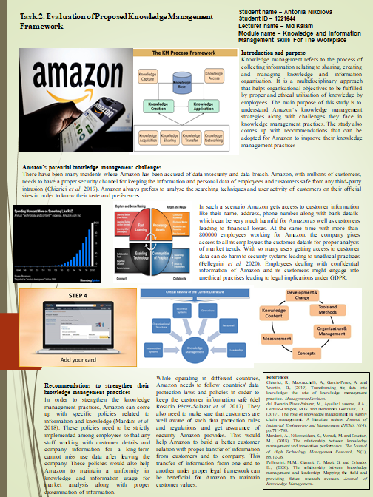

Practical evaluation of the proposed knowledge management framework for amazon

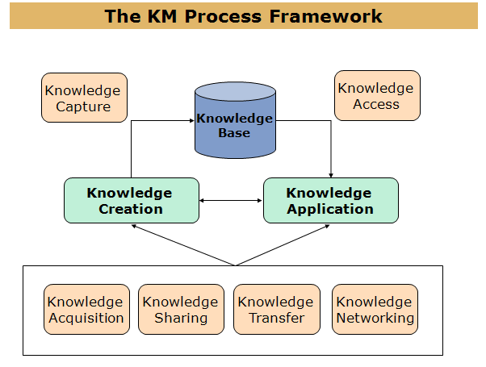

Task 2 Individual poster
Introduction and purpose
Knowledge management refers to the process of collecting information relating to sharing, creating and managing knowledge and information organisation. It is a multidisciplinary approach that helps organisational objectives to be fulfilled by proper and ethical utilisation of knowledge by employees. The main purpose of this study is to understand Amazon‘s knowledge management strategies along with challenges they face in knowledge management practises. The study also comes up with recommendations that can be adopted for Amazon to improve their knowledge management practises
Student name – Antonia Nikolova
Student ID – 1921644
Lecturer name – Md Kalam
Module name – Knowledge and Information Management Skills For The Workplace

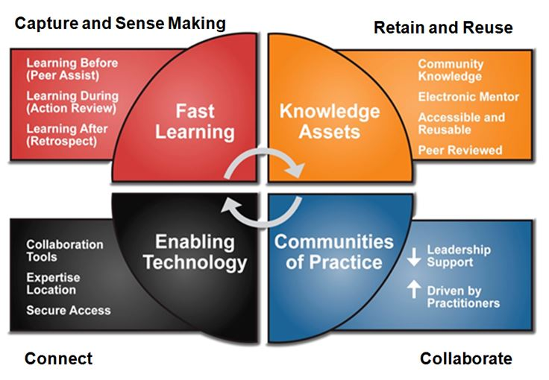
In such a scenario Amazon gets access to customer information like their name, address, phone number along with bank details which can be very much harmful for Amazon as well as customers leading to financial losses. At the same time with more than 800000 employees working for Amazon, the company gives access to all its employees the customer details for proper analysis of market trends. With so many users getting access to customer data can do harm to security systems leading to unethical practices (Pellegrini et al. 2020). Employees dealing with confidential information of Amazon and its customers might engage into unethical practises leading to legal implications under GDPR.
Amazon’s potential knowledge management challenges
There have been many incidents where Amazon has been accused of data insecurity and data breach. Amazon, with millions of customers, needs to have a proper security channel for keeping the information and personal data of employees and customers safe from any third-party intrusion (Chierici et al. 2019). Amazon always prefers to analyse the searching techniques and user activity of customers on their official sites in order to know their taste and preferences.

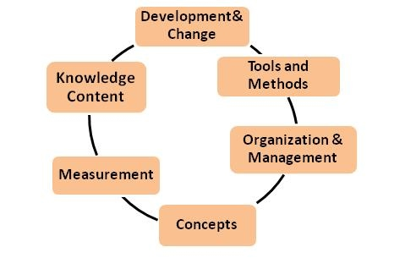
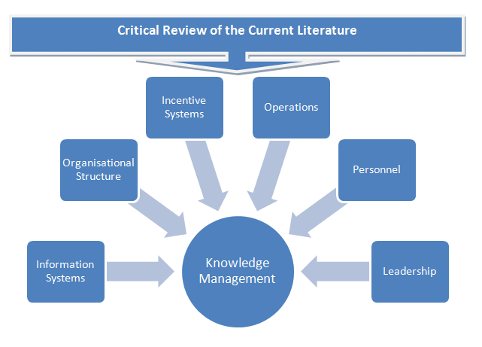
References
Chierici, R., Mazzucchelli, A., Garcia-Perez, A. and Vrontis, D., (2019). Transforming big data into knowledge: the role of knowledge management practice. Management Decision.
del Rosario Pérez-Salazar, M., Aguilar Lasserre, A.A., Cedillo-Campos, M.G. and Hernández González, J.C., (2017). The role of knowledge management in supply chain management: A literature review. Journal of industrial Engineering and Management (JIEM), 10(4), pp.711-788.
Mardani, A., Nikoosokhan, S., Moradi, M. and Doustar, M., (2018). The relationship between knowledge management and innovation performance. The Journal of High Technology Management Research, 29(1), pp.12-26.
Pellegrini, M.M., Ciampi, F., Marzi, G. and Orlando, B., (2020). The relationship between knowledge management and leadership: Mapping the field and providing future research avenues. Journal of Knowledge Management.
While operating in different countries, Amazon needs to follow countries' data protection laws and policies in order to keep the customer information safe (del Rosario Pérez-Salazar et al. 2017). They also need to make sure that customers are well aware of such data protection rules and regulations and get assurance of security Amazon provides. This would help Amazon to build a better customer relation with proper transfer of information from customers and to company. This transfer of information from one end to another under proper legal framework can be beneficial for Amazon to maintain customer values.
Recommendations to strengthen their knowledge management practices
In order to strengthen the knowledge management practises, Amazon can come up with specific policies related to information and knowledge (Mardani et al. 2018). These policies need to be strictly implemented among employees so that any staff working with customer details and company information for a long-term cannot miss use data after leaving the company. These policies would also help Amazon to maintain uniformity in knowledge and information usage for market analysis along with proper dissemination of information.

