Software Engineering
ACCA4017
Matthew James
1809299

06/05/2019

Abstract
This report will go in depth on how to design and create an information system for Dylan’s Bookstore. the main topics that will be discussed are:
Design – Entity relationship diagrams, relationships, membership classes, attributes and entities.
Implementation – Tables, forms, queries, reports, macros

Design

Entity Relationship Diagram (ERD)
An entity relationship diagram is graphical representation of an information system that depicts relationships between people, places, objects as well as many other entities and attributes. An ERD is a data modelling technique which can assist a creator when developing an information system by defining processes and relationships which is used as a foundation.
The author has created one which will form the foundation of the information system that they are creating for Dylan’s Bookstore.
The initial ERD is as shown within figure 1 was a simple concept on which the database was build on, progressing forward the design changed.

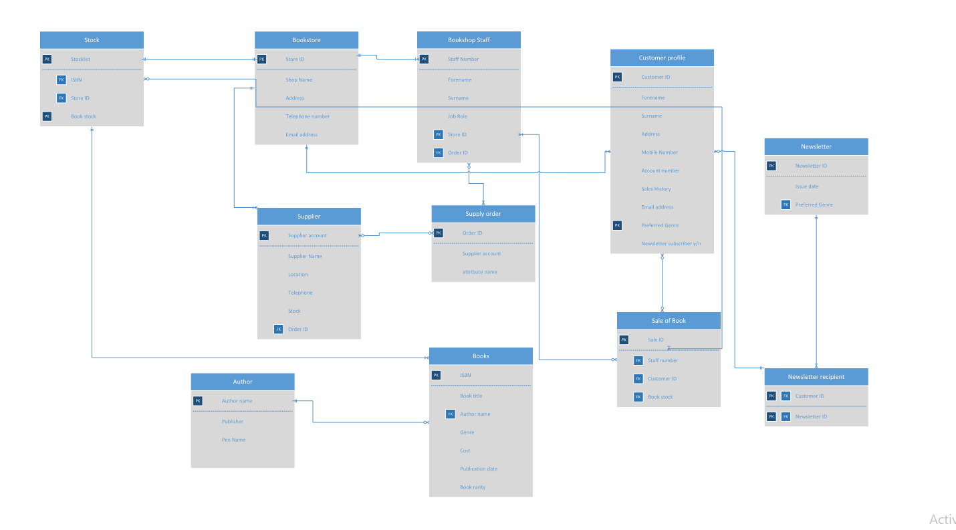
Figure 1 - initial ERD
After implementing the ERD into the database the author soon realised that the ERD simply could not suffice what the owner had envision the information system would be. Additional tables and forms will need to be created as shown in figure 2. (no Visio available)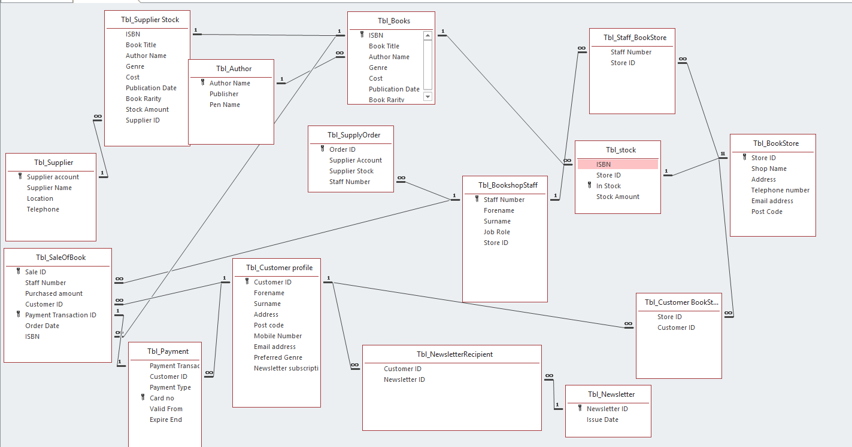
Figure 2 - ERD after implementation

Relevant tables were created from the design of this new ERD as shown within figure 3.

Tables were only able to be created when 3rd normal form was achieved as no duplicate data can be entered within the system
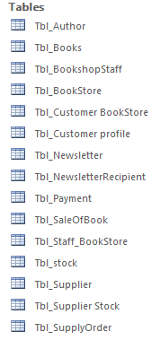
Figure 3 – Tables of Information System
Information will be filled in to the tables created via the forms which are using the tables fields.
The process is shown through figure 4-6
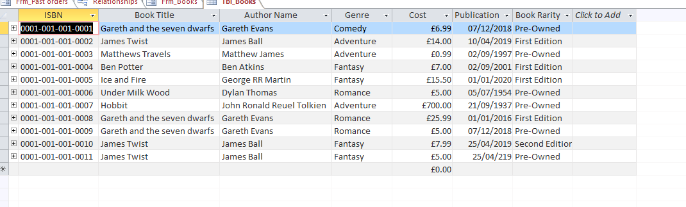
Figure 4 - table with data
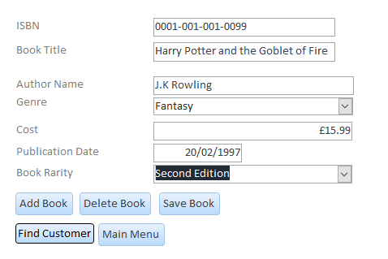
Figure 5 - Using Form To Input Data
Figure 6 - Data in Table

Other forms which the author created to control the information system for Dylan’s Bookstore as shown in figure 7.
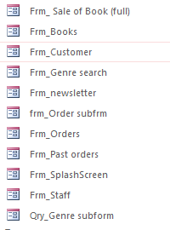
Figure 7 - Forms in Information system

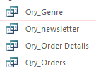
Figure 8 - Queries in Information System

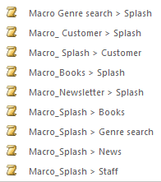
Figure 9 - Macros used to navigate

3 Guide to Dylan’s Bookstore information system
This guide will show and teach the user on how to interact with the Dylan Bookstore system.

- Once the program launches you will be greeted with the splash screen A.K.A the main menu
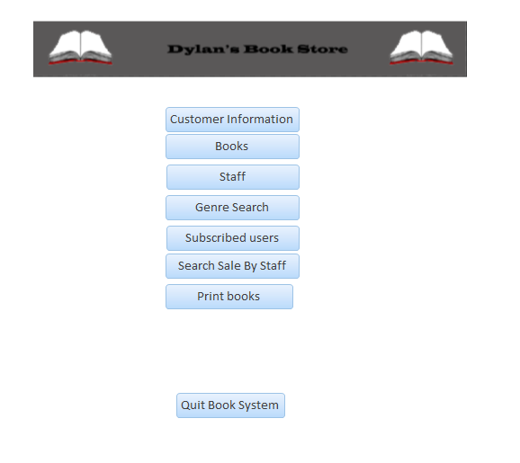
Figure 10 - Main Menu

- Each button on the main menu will take you to an area of the program. By selecting “customer information” you will be taken to the customers information screen which will display all customers that Dylan’s Bookstore have in the database. Through this you can navigate all the users.
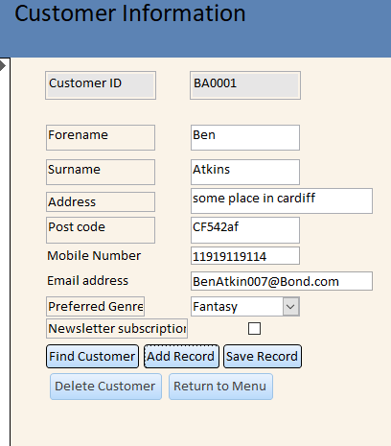
Figure 11 - Customer interface
- Looking towards the lower half of the Screen, you will see buttons which will perform a function once clicked, e.g the “find customer” button once clicked will display a search function which can be used to search for any information displayed on screen, simply clicked the box you wish you query and select “find customer” and you enter the information you are searching for. If any information is within the database, then it will be displayed on screen.
Figure 12 - Search function
Add record – This will create a blank form and the user will input data that they want to save to the database, this works along with the “save record” button which will save the data within the database, this can also be used to update data that is present on the screen.
Delete record – this will delete the information throughout the entire database system.

SQL
The author did not need to use SQL but wanted to highlight that it can be used to create, update, amend and query the system and its content
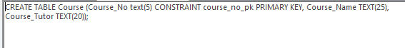
Figure 13 - SQL to create course table
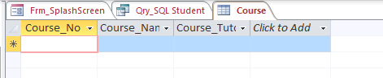
Figure 14 - Table created with SQL

