


RESEARCH PROPOSAL
The Association Between Primary Care Access and Emergency Department Utilisation in Deprived Populations in England:
A Systematic Review

Student: Nevyana Nikolova
Email: 2111481@student.uwtsd.ac.uk
Program: Public Health and Social Care in Practice
Supervisor: Dr. Oluwadamilola Tayo
Lecturer: Mr. Muhammed Khan

Tables Content

1. Prevalence of the Problem 5
2. Introduction 5
3. Literature Review 5
4. Health Inequalities and HealthcareAccess………………………………………..6
5. Critical Synthesis and Research Gaps………….…………………………………6
6. Rationale and Research Questions 7
7. Research Methodology: A Systematic Review 8
8. Ethical Considerations 14
9. Implications of Research 15
10. Plan of Work and Time Schedule 17
11. References 18

1. Prevalence of the Problem

Emergency department (ED) utilisation in England has reached critical levels, with 26.5 million attendances recorded in 2024/25, representing a 25% increase from pre-pandemic levels (NHS England, 2025). This burden disproportionately affects deprived communities, with ED attendance rates 65% higher in the most deprived quintile compared to the least deprived (Baker et al., 2024). Simultaneously, primary care access has deteriorated significantly, with average GP appointment waiting times increasing from 9.6 days in 2019 to 15.8 days in 2024 (Healthwatch England, 2024). In deprived areas, 47% of patients wait over three weeks for appointments (Royal College of General Practitioners, 2024).

Approximately 41% of ED attendances are potentially manageable in primary care settings (Royal College of Emergency Medicine, 2024), contributing to an estimated £5.2 billion in avoidable costs annually. Beyond financial implications, prolonged ED overcrowding has been associated with increased mortality and reduced patient safety (The King's Fund, 2024). This confluence of deteriorating primary care access and escalating ED utilisation in deprived communities represents a critical public health challenge demanding urgent investigation.

2. Introduction

The National Health Service (NHS) in England faces unprecedented pressures across both primary and emergency care services. Emergency department (ED) attendance has reached crisis levels, with 26.5 million attendances recorded in 2024/25, a 25% increase from pre-pandemic levels (NHS England, 2025). This surge occurs with ED departments operating at over 95% capacity year-round, contributing to increased mortality and compromised patient safety (The King's Fund, 2024).
Average waiting times increased from 9.6 days in 2019 to 15.8 days in 2024, with 2.5 million patients waiting over two weeks (Healthwatch England, 2024). These pressures disproportionately affect deprived communities, which face both the greatest disease burden and the most substantial barriers to timely primary care access (Marmot et al., 2024). Deprived communities experience ED rates 65% higher than least deprived areas (Baker et al., 2024), whilst 47% of patients in the most deprived decile wait over three weeks for GP appointments (Royal College of General Practitioners, 2024).

3. Literature Review

This literature review examines the existing evidence on the relationship between access to primary care services and emergency department (ED) utilisation, with a particular focus on socioeconomically deprived communities in England. It critically explores how structural health inequalities shape patterns of healthcare access and influence patient decision-making, often leading to increased reliance on emergency services. The review considers key dimensions of primary care access, including availability, accessibility, continuity, and timeliness, and evaluates how recent primary care transformation initiatives, such as digital consultations and extended access, impact these populations.
In addition, the review analyses patterns of ED utilisation, highlighting the extent to which attendances may be driven by unmet primary care needs, perceived urgency, or barriers to timely GP access. It examines broader system-level factors, including workforce pressures and service capacity, that contribute to these trends. Methodologically, the review evaluates the strengths and limitations of existing studies, with particular attention to the use of secondary qualitative data in capturing patient experiences and lived realities. This approach enables a deeper understanding of how individuals navigate healthcare systems, while also acknowledging potential limitations related to data context and interpretation.

4. Health Inequalities and Healthcare Access

Health inequalities in England are persistent and well-documented, with socioeconomic deprivation serving as a fundamental determinant of both health outcomes and healthcare utilisation patterns (Marmot et al., 2024). The "inverse care law" describes how those with the greatest healthcare needs face the most substantial access barriers (Hart, 1971). Recent evidence suggests primary care access barriers have intensified following COVID-19, with particularly severe impacts on deprived communities (Healthwatch England, 2024).

5. Critical Synthesis and Research Gaps
This review shows strong evidence that poor primary care access increases ED utilisation, with deprived communities experiencing both worse access and higher ED use, inequalities further intensified by COVID-19.
However, key gaps remain. First, the GP–ED relationship has not been sufficiently examined within deprived communities, despite evidence that intervention effects and decision-making vary by social context. Second, the mechanisms linking GP delays to ED attendance are poorly understood, as quantitative studies identify correlations but not underlying decision processes. Third, patient voices from deprived populations remain underrepresented, limiting understanding of those most affected.

6. Rationale and Research Questions
6.1 Rationale for the Study
This qualitative secondary data analysis is essential for four key reasons. First, understanding patient perspectives embedded in existing data sources provides authentic insights into whether and how GP waiting times influence ED utilisation decisions, without additional research burden on vulnerable populations. Second, secondary analysis enables examination of naturally occurring narratives from multiple contexts and timepoints, potentially revealing patterns and mechanisms linking GP access barriers to ED use that quantitative studies cannot capture. Third, this approach is time- and cost-efficient, enabling more rapid evidence generation to inform urgent policy needs regarding the relationship between primary care access and emergency services. Fourth, analysing existing healthcare professional perspectives from reports, case studies, and published research provides complementary insights on system-level challenges and observed patterns of ED utilisation when GP access is limited.

6.2 Research Question
What is the association between access to primary care services and emergency department utilisation among socioeconomically deprived populations in England?

6.3 Research Aim and Objectives
Aim
What is the association between access to primary care services and emergency department utilisation among socioeconomically deprived populations in England?

Objectives

1. To identify and synthesise evidence on access to primary care services among socioeconomically deprived populations in England.

2. To examine patterns of emergency department utilisation within these populations.

3. To analyse the relationship between primary care access and emergency department utilisation, including how access barriers influence attendance.

7. Research Methodology: A Systematic Review

7.1 Research Design: A case study
This research adopts a qualitative secondary data analysis within a case study design to explore the relationship between primary care access and emergency department (ED) utilisation in socioeconomically deprived populations in England. A case study design is particularly suited to investigating complex healthcare phenomena within their real-world context, where the boundaries between the issue being studied and its wider system influences are not clearly defined. In this study, the “case” is defined as GP access and its influence on ED utilisation within deprived communities, allowing for an in-depth, context-sensitive analysis of how structural, organisational, and service-level factors interact.
The methodology involves the systematic analysis of existing qualitative data to address the research question (Heaton, 2008). This interpretive approach enables the re-examination of data through a new analytical lens, generating insights into how access barriers operate across different healthcare settings (Ruggiano and Perry, 2019). The case study design strengthens this approach by situating findings within the broader healthcare system, including workforce pressures, service capacity, and organisational practices that shape access to care.
An integrative, multi-source strategy will be used, drawing on published qualitative research, Healthwatch reports, healthcare professional case studies, organisational reports, and policy documents. These sources provide detailed, context-rich accounts of service delivery, access challenges, and system performance. By focusing on formally collected and documented data, the study maintains methodological rigour and ensures that all evidence is derived from ethically governed sources.

The case study approach facilitates analytical triangulation, enabling comparison across multiple datasets to identify consistent patterns, variations, and underlying mechanisms linking primary care access to ED utilisation. It also supports the examination of key processes such as referral pathways, service availability, and escalation patterns, as well as variation across different organisational and geographical contexts. This allows the research to move beyond simple associations and develop a more nuanced understanding of how access barriers contribute to ED demand within deprived populations.

7.2 Data Sources
Secondary Data Sources
1. Patient Feedback and Complaints Data
NHS Patient Advice and Liaison Service (PALS) reports and Patient Experience data containing qualitative feedback about GP access difficulties and ED experiences. These will be accessed from NHS Trusts serving high-deprivation areas through formal data access requests, ensuring full anonymisation. Care Quality Commission (CQC) inspection reports often contain patient feedback quotes that will be systematically extracted.
2. Healthwatch Reports
Healthwatch produces numerous reports containing patient testimonials and qualitative feedback about healthcare access. Reports focused on GP access, ED experiences, and health inequalities from Healthwatch organizations in high-deprivation areas (2020-2024) will be systematically reviewed and qualitative data extracted.
3. Journal Data
This study will utilise published qualitative research and patient experience studies as a source of secondary data to explore barriers to GP access and decision-making related to emergency department (ED) attendance. Peer-reviewed journal articles will be systematically identified and sampled, with a particular focus on studies involving populations residing in socioeconomically deprived areas or those experiencing difficulties accessing primary care services.
4. Existing Qualitative Research Datasets
The UK Data Service archives qualitative datasets from completed research studies. Relevant datasets containing interviews or focus groups with patients about healthcare access, GP experiences, or ED utilisation will be identified and accessed following appropriate procedures. Particular attention will be given to studies conducted in deprived areas.
5. Healthcare Professional Perspectives
Published case studies, reflective pieces in professional journals (e.g., British Journal of General Practice, Emergency Medicine Journal), Royal College reports containing clinician testimonials, and academic research papers presenting qualitative findings from healthcare professionals about managing access pressures and ED demand.
Inclusion Criteria for Data Sources
Data generated between 2020-2024 (capturing the post-pandemic period), relates to GP appointment access and/or ED utilisation in England, contains qualitative data (narratives, testimonials, quotes, open-ended survey responses), involves patients from or healthcare professionals serving IMD quintiles 4-5 (most deprived) where identifiable, publicly available or accessible through formal data access procedures, and of sufficient data quality and detail for meaningful analysis.
Exclusion Criteria

Data from private healthcare settings, data where geographic or socioeconomic context cannot be determined, quantitative data without qualitative components, data requiring payment or unavailable within the research timeframe, and low-quality data lacking sufficient detail or context.

7.3 Data Collection Methods and Procedures

Data Collection Procedure
1. Systematic search and identification of relevant data sources using predefined criteria.
2. Formal data access requests submitted where required (NHS PALS data, UK Data Service datasets), with appropriate ethical approval and data sharing agreements.
3. Systematic review of identified sources (Healthwatch reports, professional publications, CQC reports) with extraction of all relevant qualitative data.
4. Creation of comprehensive data extraction template documenting: source, date, context, geographic area, participant characteristics, and full text of qualitative data.
5. All extracted data compiled into NVivo qualitative analysis software for systematic coding and analysis.
6. Detailed audit trail maintained documenting all sources consulted, inclusion/exclusion decisions, and data extraction processes.
Data Management

All data will be stored on secure, encrypted university research servers. Where data contains any potentially identifying information, additional anonymisation will be applied. A master document will record all data sources with full citations. Extracted data will be organised in NVivo with clear documentation of source, context, and any modifications made for anonymisation.

7.4 Data Analysis Technique

Reflexive thematic analysis will be employed, following Braun and Clarke's (2006; 2019) framework adapted for secondary data analysis. This analytical approach enables identification of patterns across diverse data sources whilst maintaining sensitivity to context and recognizing the researcher's interpretive role (Braun and Clarke, 2019).

Analysis Phases
- Familiarisation
Reading and re-reading extracted data from all sources, noting initial observations and patterns, maintaining a reflexive journal documenting researcher responses and emerging ideas.
- Systematic coding
Generating initial codes across the entire dataset using NVivo software. Codes will capture both semantic content and latent themes. Attention will be paid to how the source context may influence meaning.
- Theme development
Collating codes into candidate themes, organising data extracts around potential themes. Themes will be developed both within and across data sources, identifying convergence and divergence.
- Theme review and refinement
Checking themes against coded extracts and the full dataset, ensuring coherence and distinction between themes. Refining theme boundaries and considering how themes relate to different data sources and contexts.
- Theme definition and naming
Developing a detailed analysis of each theme with clear definitions. Considering how themes address research questions and relate to existing literature.
- Report production
Selecting compelling data extracts illustrating each theme, integrating analysis with research questions and literature. Reflexively considering how data source characteristics may have influenced findings.

Ensuring Rigor in Secondary Analysis

Credibility will be enhanced through triangulation across multiple data sources, systematic documentation of analytical decisions, peer debriefing with supervisors, and thick description in reporting. Dependability will be ensured through maintaining detailed audit trails of source selection, data extraction, and coding processes. Confirmability will be addressed through reflexive practice - maintaining a reflexive journal documenting the researcher's assumptions, interpretations, and how personal perspectives may influence analysis. Transferability will be supported through providing rich contextual descriptions of data sources and settings (Ruggiano and Perry, 2019).

8. Ethical Considerations

Ethics Approval
Approval will be obtained from the University Research Ethics Committee. Additional approvals will be sought as required for accessing specific datasets (UK Data Service protocols).
Informed Consent and Secondary Data Ethics
Secondary analysis of publicly available data (published reports) does not require individual consent, but researchers have ethical obligations to use data respectfully and appropriately. For publicly available online content, ethical guidelines for internet research will be followed (British Psychological Society, 2021), including assessing whether users had reasonable expectations of privacy and avoiding direct quotation of content that could enable identification. For accessed datasets (NHS data, archived research data), existing consent provisions will be verified to ensure compatibility with this study's purposes. Where original consent was for specific purposes not covering this research, data will be excluded.

Confidentiality and Anonymisation
All data will be thoroughly anonymised, removing or altering any potentially identifying information. Direct quotes used in reporting will be checked to ensure they cannot enable identification through internet searching. Where data is already anonymised in source materials, this will be preserved. Where online forum data is used, usernames will be replaced with participant codes, and quotes will be slightly modified to prevent searchability whilst preserving meaning (British Psychological Society, 2021).

Respect for Vulnerable Populations

This study focuses on patients in deprived communities who may be experiencing health inequalities and access barriers. Data will be analysed and reported with sensitivity to vulnerabilities, avoiding stigmatising language or interpretations. The research aims to amplify patient voices to inform service improvements, maintaining focus on systemic issues rather than individual blame.

Data Protection

GDPR compliance will be ensured. For publicly available data, the legal basis for processing is Article 6(1)(e) (public interest/scientific research). For accessed NHS or archived data, the legal basis will be Article 6(1)(e) and Article 9(2)(j) (scientific research with appropriate safeguards).

Transparency and Attribution

All data sources will be appropriately acknowledged and cited. Where data comes from published research, the original researchers will be credited. The secondary nature of the analysis will be clearly stated in all outputs.

9. Implications of Research
This study will adopt a secondary qualitative case study design to generate robust insights with direct implications for healthcare policy, service design, and clinical practice. By synthesising patient voices from multiple authentic and relevant sources, it will provide a comprehensive understanding of how barriers to GP access drive emergency department utilisation in deprived communities.
This multi-source approach goes beyond single-source studies by identifying consistent patterns across contexts and timepoints, producing stronger evidence of systemic issues requiring policy action. The findings will directly inform primary care redesign by grounding interventions in real patient experiences and decision-making, rather than assumptions.
The study will identify population groups and circumstances requiring targeted support, guiding resource allocation and service prioritisation. Incorporating healthcare professionals’ perspectives will further highlight system-level constraints, including workforce capacity, infrastructure limitations, and the need for integrated care pathways.
Methodologically, it demonstrates the value of secondary qualitative case study analysis as an efficient, ethical, and rigorous approach to addressing urgent health service challenges, particularly for vulnerable populations.
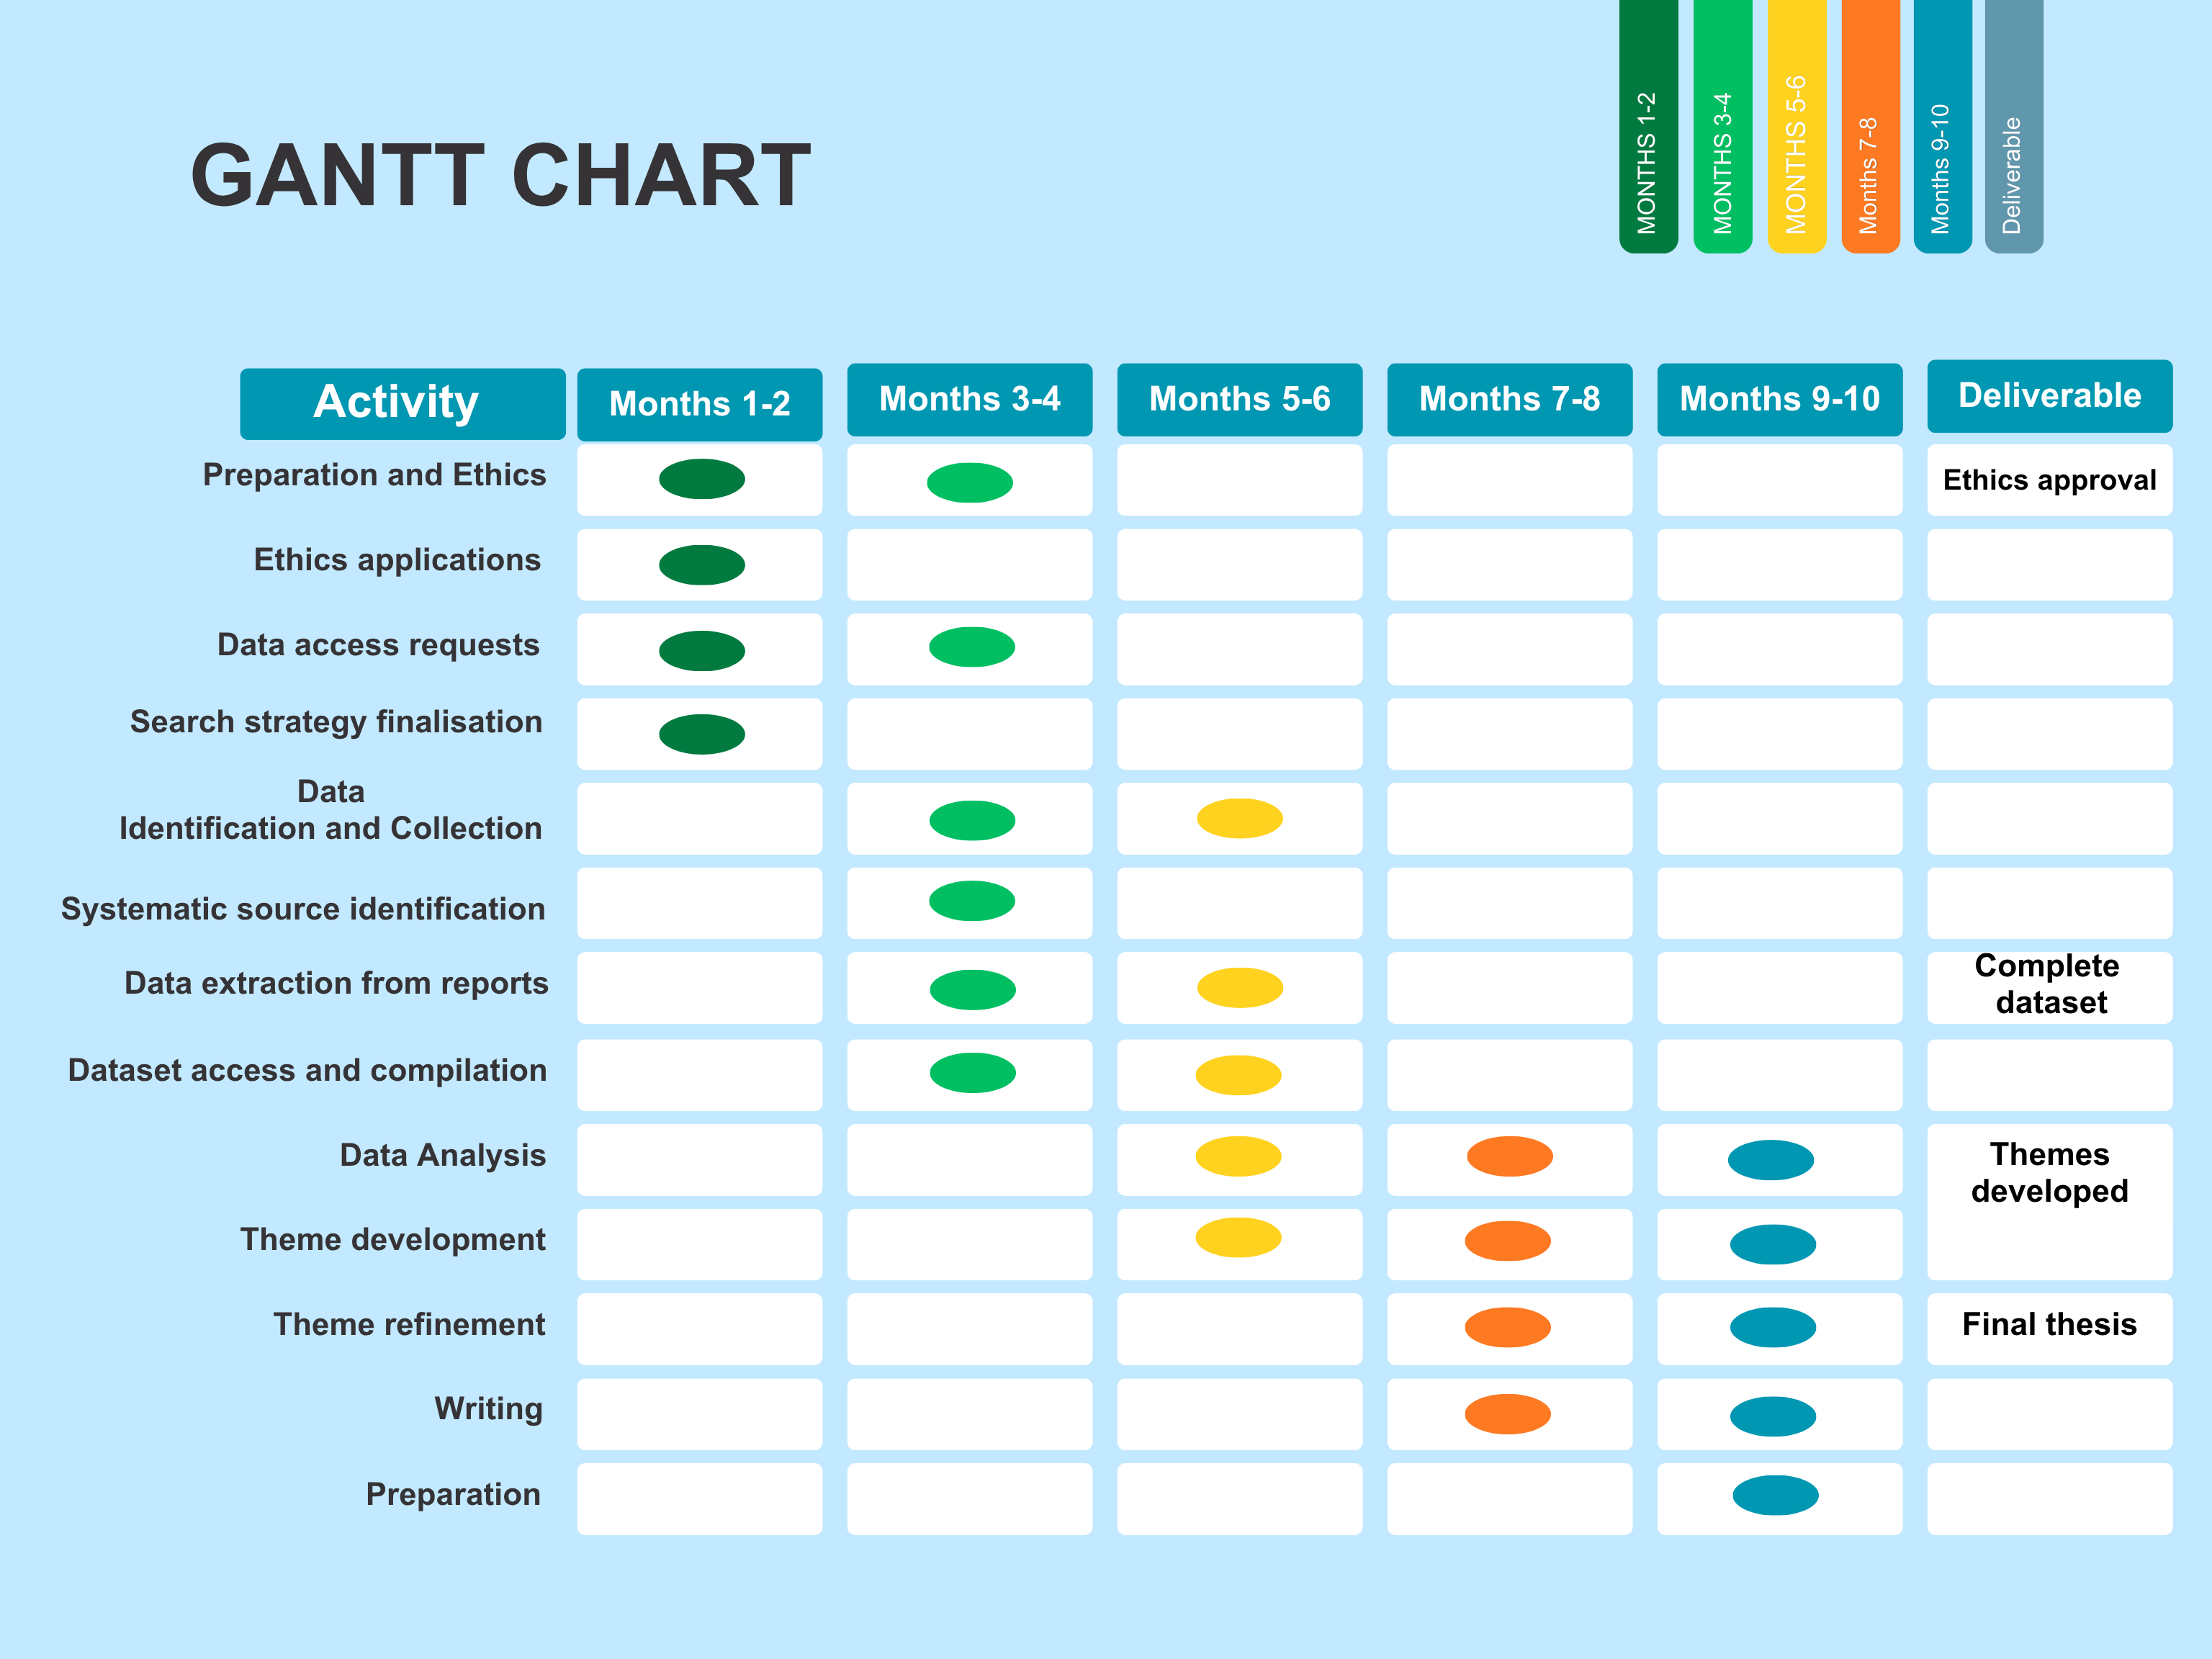
10. Plan of Work and Time Schedule

11. References
Baird, B. and Beech, J. (2022) 'Understanding pressures in general practice', London: The King's Fund.
Baker, M., Hann, M. and Howells, K. (2024) 'Socioeconomic inequalities in general practice: a cross-sectional analysis of the English GP Patient Survey', British Journal of General Practice, 74(738), pp. e105-e112.
Boyle, A.A., Higginson, I. and Benger, J.R. (2022) 'What is the impact of primary care transformation on emergency department workload? A time series analysis', Emergency Medicine Journal, 39(12), pp. 897-903.
Braun, V. and Clarke, V. (2021) 'One size fits all? What counts as quality practice in (reflexive) thematic analysis?', Qualitative Research in Psychology, 18(3), pp. 328-352.
British Medical Association (2024) Pressures in general practice: Data analysis 2024. London: British Medical Association.
Campbell, J. and Baird, B. (2021) 'Improving access to general practice in England', BMJ Open, 11(5), e045123.
Castle-Clarke, S. and Hutchings, R. (2021) 'Digital health: A route to improved health and care services?', Journal of the Royal Society of Medicine, 114(4), pp. 165-169.
Croxson, C.H.D., Ashdown, H.F. and Hobbs, F.D.R. (2020) 'GPs' perceptions of workload in England: a qualitative interview study', British Journal of General Practice, 70(696), pp. e507-e515.
Department of Health and Social Care (2023) Primary Care Recovery Plan. London: DHSC.
Fisher, R.F., Croxson, C.H.D., Ashdown, H.F. and Hobbs, F.D.R. (2022) 'GP views on strategies to cope with increasing workload: a qualitative interview study', British Journal of General Practice, 72(714), pp. e89-e98.
Gershlick, B. and Fisher, R. (2021) A worrying cycle of pressure: Understanding the growing problem in urgent and emergency care. London: The Health Foundation.
Greenhalgh, T., Rosen, R., Shaw, S.E., Byng, R., Faulkner, S., Finlay, T., Husain, L., Hughes, G., Kwan, I., Moore, L., Papoutsi, C., Rybczynska-Bunt, S., Rushforth, A., Wherton, J. and May, C. (2022) 'Planning and evaluating remote consultation services: a new conceptual framework incorporating complexity and practical ethics', Frontiers in Digital Health, 4, 726095.
Healthwatch England (2024) Access to GP appointments: What do patients think? London: Healthwatch England.
Heaton, J. (2022) 'Secondary analysis of qualitative data: Methodological considerations and future directions', International Journal of Social Research Methodology, 25(6), pp. 773-786.
Kontopantelis, E., Mamas, M.A. and van Marwijk, H. (2021) 'Socioeconomic disparities in GP consultation rates in England', BMJ Open, 11(9), e052345.
Marmot, M., Allen, J., Boyce, T., Goldblatt, P. and Morrison, J. (2020) Health equity in England: The Marmot Review 10 years on. London: Institute of Health Equity.
McLean, S. and Sheikh, A. (2023) 'Digital triage in primary care: benefits and risks', BMJ Health & Care Informatics, 30(2), e100456.
NHS Confederation (2024) NHS at 76: Challenges and opportunities. London: NHS Confederation.
NHS Digital (2022) Health Survey for England 2021: Primary care utilisation report. London: NHS Digital.
NHS England (2023) Delivery plan for recovering access to primary care. London: NHS England.
NHS England (2025) A&E Attendances and Emergency Admissions 2024-25. London: NHS England.
Nuffield Trust (2023) Emergency hospital admissions in England: which may be avoidable and how? London: Nuffield Trust.
Office for National Statistics (2024) Healthcare access and outcomes in England: 2024 update. London: ONS.
O'Cathain, A. and Knowles, E. (2020) 'Understanding urgent care system navigation: a mixed-methods study', Health Services and Delivery Research, 8(12), pp. 1-120.
Pitchforth, E., Nolte, E., Corbett, J., Miani, C., Winpenny, E., van Teijlingen, E., Hove, J., King, S. and Elissen, A. (2020) 'Community hospitals and their services in the NHS: identifying transferable learning from international developments', Health Services and Delivery Research, 8(19), pp. 1-178.
Royal College of Emergency Medicine (2024) Emergency care crisis: Winter 2023/24 review. London: Royal College of Emergency Medicine.
Royal College of General Practitioners (2024) General practice workforce crisis: State of general practice 2024. London: Royal College of General Practitioners.
Roland, M. (2021) 'Primary care transformation: where next?', The Lancet, 397(10285), pp. 1520-1522.
Ruggiano, N. and Perry, T.E. (2020) 'Secondary analysis of qualitative data: Considerations and strategies', Qualitative Social Work, 19(1), pp. 81-97.
Salisbury, C., Murphy, M. and Duncan, P. (2022) 'The impact of digital-first consultations on workload in general practice: modeling study', Journal of Medical Internet Research, 24(8), e39163.
Taylor, M. (2023) NHS workforce pressures and general practice sustainability. London: Nuffield Trust.
The Health Foundation (2023) Public satisfaction with the NHS and social care in 2022: Results from the British Social Attitudes survey. London: The Health Foundation.
The King's Fund (2024) Emergency departments under unprecedented pressure: What can be done? London: The King's Fund.
Watt, G. (2022) 'Primary care and health inequalities in the UK', BMJ, 376, o123.
World Health Organization (2021) Operational framework for primary health care: transforming vision into action. Geneva: WHO.
Zhou, R.A., Baicker, K. and Taubman, S. (2020) 'The effect of primary care access on emergency department utilization: Evidence from a randomized trial', Journal of Health Economics, 73, 102358.

