Student Name: [enter]  Student ID: [enter]  Module Title: Foreign Languages & Cultural Awareness  Module Code: BMIH5003  Lecturer: [enter]  Date: [enter] | 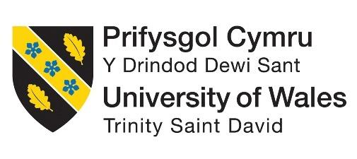
ASSIGNMENT 1: PORTFOLIO
(4 Components)

Component 1: Professional Reflection

Weighting: 25%
I had my level 4 placement at The Savoy in London as a customer relationship manager. This is a 5-star hotel which provides different services like guest information, beauty and fitness, butler service, concierge service and others (Thesavoylondon.com, 2024). Similarly, it also consists of restaurants and bars as well as in-house F&B options (Thesavoylondon.com, 2024). In accordance with this, I have observed a cultural misunderstanding between a server and an international guest during breakfast service in the hotel's restaurant during my level 4 placement. The guest who spoke limited English has requested a traditional English breakfast. However, they later appeared surprised and dissatisfied with the contents of the meal as they were expecting a different selection of items. The server assumed they knew what tradition meant and did not clarify the specifics with the guest which led to the misunderstanding. This indicates that cultural misunderstanding in hospitality can occur easily, especially when language barriers, cultural expectations or novel cues play a role. For example, the idea of tradition varies from culture to culture as what is considered traditional in an English breakfast might be entirely different from what a guest from Asia or the Middle East and vision. According to Christiansen et al. (2020), cultures vary significantly in their approach to uncertainty and ambiguity. Based on Hofstede cultural dimensions theory high-context cultures place a greater emphasis on nonverbal cues and assumptions contrarily low-context cultures like the UK value explicit verbal clarity (Hofstede et al. 2014). Hence, if I had been the server in the situation, I would have clarified with the guest by asking open-ended questions about their breakfast preferences and ensuring they understood what was included in a traditional English breakfast.
In addition, reflecting on the scenario I have realised that I need to develop specific skills to prevent similar misunderstandings in the future. I need to enhance my cultural intelligence as it is essential. The study by Maheshkar and Sharma (2018), highlighted that cultural intelligence involves recognising and adapting to cultural differences which can reduce misunderstandings and improve communication in diverse environments. Therefore, I can increase my cultural intelligence by studying common dining expectations and the adequateness of different cultures, specifically, those frequently visiting The Savoy. This kind of practice really assists me in a way to have a better understanding of the guests’ needs while containing guest satisfaction. Consequently, there are several other activities that I must address like active listening. According to the article by Elche et al. (2020), both empathy and attentiveness are two of the key elements of emotional intelligence as a concept in the sphere of services. Therefore, practising active listening means that I can give my best to ensure higher guests satisfaction and can be less of an issue in terms of the cues I miss. This also strengthens guest satisfaction and reduces the likelihood of misunderstandings. I can similarly, filter guest’s requests and modify their expectations to note they were understood and help them in the process. This also goes a long way in assisting me with some of my future professional career goals and guaranteeing guest’s satisfaction.

References:
Christiansen, B., Branch, J.D. and Karmowska, J. eds., 2020. Cultural Factors and Performance in 21st Century Businesses. IGI Global.
Elche, D., Ruiz-Palomino, P. and Linuesa-Langreo, J., 2020. Servant leadership and organizational citizenship behavior: The mediating effect of empathy and service climate. International Journal of Contemporary Hospitality Management, 32(6), pp.2035-2053.
Hofstede, G., Hofstede, G.J. and Minkov, M., 2014. Cultures and organizations: Software of the mind.
Maheshkar, C. and Sharma, V. eds., 2018. Handbook of research on cross-cultural business education. IGI Global.
Thesavoylondon.com, 2024. “About Us” Available at: https://www.thesavoylondon.com/about-us/ [Accessed on: 29-10-2024]
Thesavoylondon.com, 2024. “Restaurants & Bars” Available at: https://www.thesavoylondon.com/restaurants-bars/ [Accessed on: 29-10-2024]

Component 2: Training Plan

Identified cultural misunderstanding.
This cultural misinterpretation took place during the breakfast service in the Savoy, London. An international guest who had little understanding of English asked for an English breakfast. However, they were not happy with the amount of food provided as they expected to see different dishes. The server expected the guest to know more about the tradition applicable to the UK, but he never bothered to explain the details and that is why the guest was caught off guard. This misunderstanding arose from the conflict in cultural norms or language disparities and pointed to the necessity of improving the precise and cultural experience in service transactions (Helkkula et al. 2023). It also showed that there is a need for adequate staff training plans to guarantee that other employees are prepared for similar situations in the future.

Training plan
The Savoy London needs to conduct proper training with different aspects to fulfil satisfactoriness and reduce cultural issues. Therefore, the training plan proposed here is going to follow the four major training needs that cover cultural intelligence training, active listening and communication training and guest expectation management training (Livermore et al. 2022). In compliance, CQ is a much-needed aspect. It allows staff to realise cultural differences and be prepared for the slightest deviation within one’s cultural norms. According to Lam et al. (2022), the CQ module should contain a basic understanding of cultures, standard practices, and international eating etiquette, preferably of the most visiting countries. The training also facilitates practical activities and skit performances to help the employees work better. This module is mandatory for everyone working in F&B and all the personnel who have direct contact with guests. Hence, the training sessions are scheduled to take place at The Savoy training room because of the accessibility and confidentiality to employees monthly with the option of refresher courses on a quarterly basis.
On the other hand, listening carefully while speaking is another aspect which constitutes the training plan. The study by Wingate et al. (2021), supports the notion that attentive listening helps diminish misinterpretations and confusion. These skills focus on making employees able to ask questions, restate the requests made by guests and ensure they understand the request before acting on it. This training is to be conducted for all F&B staff and guest service teams. This is going to be conducted on-site as this enables them to practice in the real environment of the service. In addition to this, managing the expectations of guests is also important (Nunkoo et al. 2020). The training seeks to equip staff with knowledge on how to manage guests’ expectations through prior communication especially on product descriptions by using simple language especially when serving products that have a cultural significance through images where possible. The training is for all employees who work in the food and beverage or front desk areas that may interrupt guests. This training is going to be provided in the training room supplementary by shadowing experienced staff and monthly sessions with follow-ups are going to be implemented for positive outcomes.

References:
Helkkula, A., Arnould, E. and Chen, A., 2023. Glocalization in service cultures: tensions in customers’ service expectations and experiences. Journal of Service Research, 26(2), pp.233-250.
Lam, R., Cheung, C. and Lugosi, P., 2022. The impacts of cultural intelligence and emotional labor on the job satisfaction of luxury hotel employees. International Journal of Hospitality Management, 100, p.103084.
Livermore, D., Van Dyne, L. and Ang, S., 2022. Organizational CQ: Cultural intelligence for 21st-century organizations. Business Horizons, 65(5), pp.671-680.
Nunkoo, R., Teeroovengadum, V., Ringle, C.M. and Sunnassee, V., 2020. Service quality and customer satisfaction: The moderating effects of hotel star rating. International Journal of Hospitality Management, 91, p.102414.
Wingate, T.G., Jones, S.K., Khakhar, M.K. and Bourdage, J.S., 2021. Speaking of allergies: Communication challenges for restaurant staff and customers. International Journal of Hospitality Management, 96, p.102959.
Component 3: Student Self-Reflection

I have also been through the learning procedure of operating with cultural awareness within the industry and learning its importance through my experiences in The Savoy in London. To gain a comprehensive understanding of my learning procedure, Gibb’s Reflective Cycle came to an aid successfully. Gibb's Reflective Cycle consists of 6 stages, which are description, feelings, evaluation, analysis, and conclusion (Adeani et al. 2020). A structured reflection of my learning and understanding of cultural awareness within this sector can be described through this model and help to present how my perspective has evolved.
Description
I had started my learning procedure regarding cultural awareness when I only thought that it was essential at the surface level as it is required to make international guests feel more homely from my operation point. I can set an example of myself to such students and employees from other countries so that they do not make similar mistakes.
Feelings
Initially, I thought learning cultural awareness could be easy since it was not on my top priority list. However, after a while, my perspective completely changed after recognising the complexity of cultural awareness due to the mentioned learning procedures. My experience with guests from other cultures was also a learning experience for me, which reflected how my existing skills were not enough, so to increase my confidence level, I must focus on my cultural importance.
Evaluation
The learning procedure and experience helped me to recognise my strengths and weaknesses, which gave me a better understanding of which areas of improvement I need for my betterment in this industry. Evaluation from the experience suggests that cultural difference management is required to eliminate the risk of cultural mission understanding (Abramson and Moran, 2018). It is one of the most important things that I learned from my experience at The Savoy.
Analysis
The experience played an essential role in my self-development and pointed out the necessity of cultural awareness in the hospitality industry. According to the Global Shapers Annual Survey in 2017, founded by the World Economic Forum, demonstrated that from over 180 countries, 81% of respondents of 18-35-year-old group are willing to work abroad (Bbc.com, 2018). Cross-border culture learning can give an upper hand to people operating in the hospitality field (Deresky, 2017). My experience also indicated that, like me, others in this industry should learn about cultural understanding as well.
Conclusion
It can be concluded that from my experience and the learnings I had regarding hospitality management, cultural awareness is a crucial factor. Proper learning gives one a better understanding of cultural sentiments and cultural assumptions and how these are involved while travelling the world or providing service.
Action plan
Certain hospitality practices, such as cultural awareness training, cultural intelligence, guest expectation management, active listening, and communication skill development, are on my list to improve myself and prevent the risks of cultural misunderstanding from happening further. It is also my responsibility to pass on what I have learned to my subordinates so that they can learn from my experience as well. I can set an example of myself to others.
References
Abramson, N.R. and Moran, R., 2018. Managing Cultural Differences: Global Leadership for the 21st Century. 10th Ed. Abingdon: Routledge.
Adeani, I.S., Febriani, R.B. and Syafryadin, S., 2020. Using GIBBS’reflective cycle in making reflections of literary analysis. Indonesian EFL Journal, 6(2), pp.139-148.
Bbc.com, 2018. “Is cultural knowledge more important than language skills?” Available at: <https://www.bbc.com/worklife/article/20180518-is-cultural-knowledge-more-important-than-language-skills> [Accessed on: 29.10.2024]
Deresky, H., 2017 International Management: Managing Across Borders and Cultures: Text and Cases. 9th Ed. Harlow: Pearson Education Ltd.
Component 4: Training Presentation (6 Slides)

Title slide


[Content Slide 1]
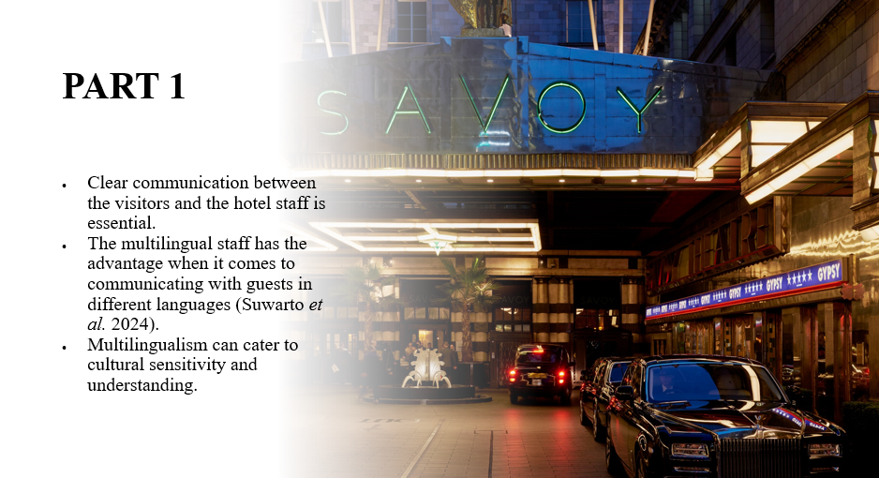
The establishment of effective communication between hotel staff and guests has the potential to enhance the experience of visiting the Savoy. The multilingual staff have the advantage of clear communication with guests from different regions of the country or the world (Suwarto et al. 2024). This type of communication helps to foster a sense of hospitality and warmth for visitors. Multilingual staff can also comprehend the requests and requirements of their guests easily and fulfil those properly. Furthermore, they can assist other staff who are not multilingual or do not know a specific language. Multilingualism can help hotel staff to gain a perspective of cultural sensitivity.

[Content Slide 2]
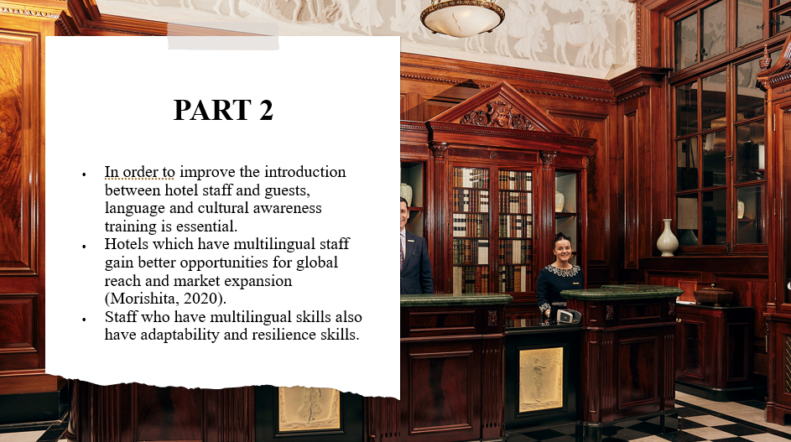
Language cognition and aptitudes are relevant because they can enhance the relationship between the guests and the staff and make the guests comfortable. It can also increase the number of customers in the hotel because people make them more comfortable whenever they speak their native language. The multilingual hotel staff have a brighter chance of expanding its global market since it provides services in different languages (Morishita, 2020). The hotel maintains a staff that can meet the needs of international guests, thus boosting the hotel's competitiveness. Furthermore, the multilingual approaches have adaptability and resiliency, so there are higher chances of competitive advantages for the hotel itself.

[Content Slide 3]
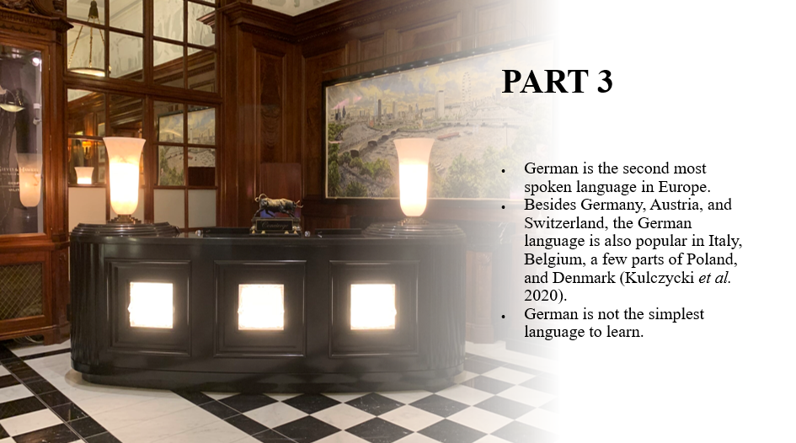
German is the second most spoken language, next to Russian in Europe. Numerous people take the prospect of learning this language since it is spoken in many regions, Germany, Austria, and Switzerland. The German language is also very widespread in Belgium, Italy, Denmark, and Poland (Kulczycki et al. 2020). There are also German-speaking communities in Canada, the United States, Argentina, and Brazil due to migration. German might not be the most straightforward language to learn or to speak. However, despite the complexity, it can be advantageous for people to learn and adapt to a specific European culture that comes with this language.

[Content Slide 4]
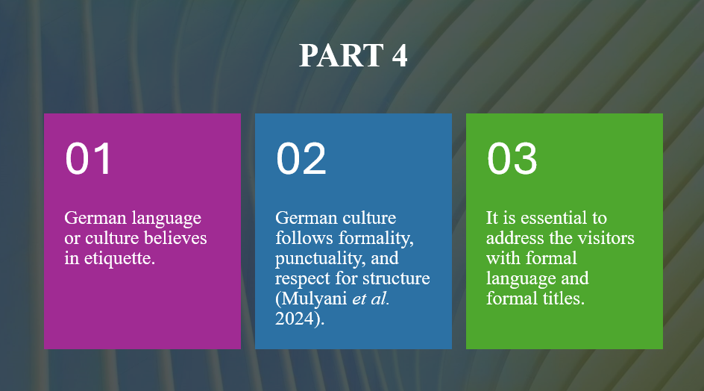
Etiquette is a crucial factor in the business context for the German language, especially in hospitality management. If the hotel staff want to be polite to the visitors who speak the German language or come from German culture, punctuality, formality, and respect for structure are essential factors (Mulyani et al. 2024). It is necessary for the staff to address guests with formal titles and use formal language. Greetings and handshakes with firm eye contact are also considered to be polite. However, small talk is not preferable most of the time in business practice. It is best to avoid interrupting conversations while talking with guests from a German background. Also, over-promising, such an exaggerated soft language without proper commitment, is not trustworthy in this language.

[Content Slide 5]
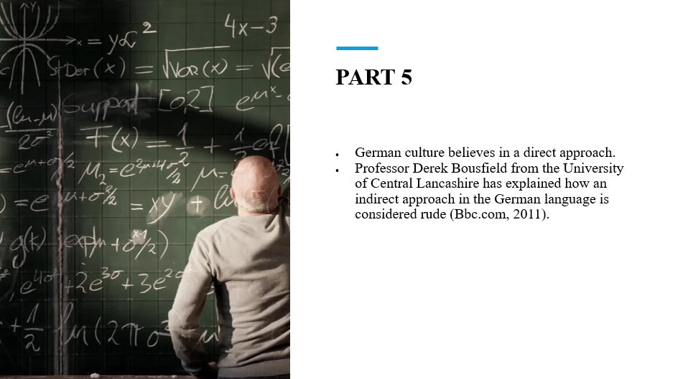
German culture fosters a practical and direct approach, which is only considered polite. An example of the directness of German people is explained by Professor Derek Bousfield, who is the head of linguistics of the University of Central and an editor of the Journal of Politeness Research (Bbc.com, 2011). According to his example, terms such as “Would you mind…?” a rude and abrupt command. Hence, directness should be practised for language in hospitality industry for ensuring guest satisfaction and improving the operational effectiveness within the workplace through developing two-way channel of communication.

References
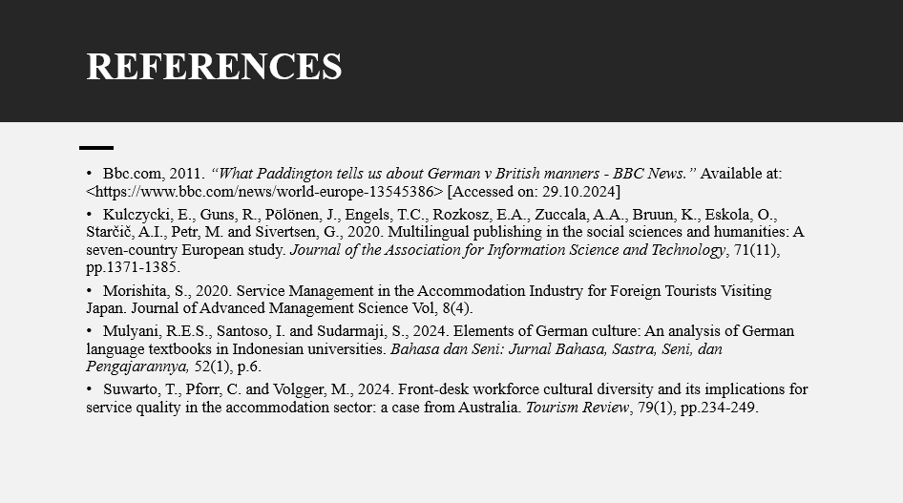
Bbc.com, 2011. “What Paddington tells us about German v British manners - BBC News.” Available at: <https://www.bbc.com/news/world-europe-13545386> [Accessed on: 29.10.2024]
Kulczycki, E., Guns, R., Pölönen, J., Engels, T.C., Rozkosz, E.A., Zuccala, A.A., Bruun, K., Eskola, O., Starčič, A.I., Petr, M. and Sivertsen, G., 2020. Multilingual publishing in the social sciences and humanities: A seven‐country European study. Journal of the Association for Information Science and Technology, 71(11), pp.1371-1385.
Morishita, S., 2020. Service Management in the Accommodation Industry for Foreign Tourists Visiting Japan. Journal of Advanced Management Science Vol, 8(4).
Mulyani, R.E.S., Santoso, I. and Sudarmaji, S., 2024. Elements of German culture: An analysis of German language textbooks in Indonesian universities. Bahasa dan Seni: Jurnal Bahasa, Sastra, Seni, dan Pengajarannya, 52(1), p.6.
Suwarto, T., Pforr, C. and Volgger, M., 2024. Front-desk workforce cultural diversity and its implications for service quality in the accommodation sector: a case from Australia. Tourism Review, 79(1), pp.234-249.

