
Understanding and Engaging in the Customer Experience (BMSK5003)



Name: Mohammed Kamal Hussain
Student ID: 1711129

LECTURER: Olu Adegbite

Executive Summary

This report aims to identify ethics and sustainability within the organisation by observing the operational practices of ASDA. It will look at ASDA and some of its competitors such as TESCO and MORRISON and attempt to identify the elements of ethics and sustainability and areas of improvement. Comparisons will be made between the different supermarkets on various issues ranging from managing quality control of products they are selling, understanding how effectively they are looking after their customers and the value they are providing. Models and theories will be used and illustrated in this report to understand and establish the full nature of ethical behaviour, sustainability, quality control, customer experience, sellers rights and customers rights.
The report will conclude with recommendations of how ASDA should operate in the in the day to day operations from an ethical and sustainable point of view whilst still making a profit..

Table of Contents
0
Executive Summary 1
Introduction 3
Customer Experience 4
Ethical Marketing 5
Sustainability 8
Mckinsey 7s 10
Figure: 2 Mckinsey 7S Framework 10
Figure 3 : Deming Theory 14
Figure 4 : 7 Deadly Diseases 15
Figure 5 : Juran Trilogy 16
Recommendation 18
Conclusion 19
References 20-21-22

Introduction

This report it will look at ASDA’s ethical stance on its dealing with customers and its suppliers. Business to Business dealings (B2B) cannot be seen from customers as this is done behind the scene. (B2B) can have a re-buy system in process, where they simply just order the product or services they ordered previously without modification being done. Modified re-buy is where a product is modified, the price and the suppliers. New task is were organisation like ASDA buying a product for the first time (Robinson et al,.1979)
For example when cornflakes are made in factories and supplied to ASDA, if ASDA were to package them as ‘Budget Cornflakes’ ‘Quality Cornflakes’ and ‘Premium Cornflake’ and price them differently, the consumer would not know that the quality of all the cornflakes were the same. In these circumstances the company would be charging higher price for the same quality products. Sometimes companies charge the same price but reduce the quality of the product for different consumer markets. With laws regarding quality being more stringent in the western world’s corporations have no choice but to follow them, however when they are dealing with countries where the rules are not followed as strictly, the give inferior products and charge the same price.
Are they doing ethical behaviour that is expected of a big superstore and are they incorporating sustainability within them self. This report will scrutinizes ASDA for its ethical behaviour and its competitor’s for example MORRISON and TESCO and do comparison between them and analyse why is ASDA not the number one store in the England.
Models and theories have been brought forward in order to enhance the quality process and understand what ASDA is doing well and what are they doing wrong. The models and theories that has been used in this report are the most profound in business fields. Many businesses use models and theories around the world and have been very successful.
Recommendation has been given based on the assessment done of ASDA. The customer-based marketing strategy, customer approach and more government involvement to eradicate any uncertainty the customer might feel or have toward ASDA for ethical behaviour and sustainability.

Customer Experience

Customer experience is perceived in two major categories, first an organisation prospective (Berry et al., 2002 Stuart and Tax 2004). It is the organisations role to define the job role of its employees, this also includes the growth of the company and what will be needed to accomplish all the tasks they do. Second the customers prospective (Schmitt, 2011). The customer looks at the performance of the organisation, so that the organisation keeps a focus on their needs and satisfaction (Departmental Management, 2020). Customer Relationship Management (CRM) it is a bottom to up practice which targets intelligent mining of data from customers to have an advantage for their tactical purposes. (CRM) could also be known to be top down view where the aim is to have a business strategy and their aim is to keep customers giving the organisation profit (Ellis, 2011). To gain an understanding of customers value, behaviour and emotions, (CRM) must observe and understand what customers want from the whole experience they encounter. It is the organisations responsibility to design and decoratively give customers a value in a form of experience. To carry any kind of strategy the organisation must gain an understanding of the customers journey, to the expectation they have before the experience occurs. The customer has internal and external contact with the organisation. The direct contact the customer has can be of many purposes, and the use of the services. The indirect contact may be unplanned, for example using their products and services or recommendation, and other social media platform (Meyer and Schwager, 2007).
Customer experience is the resulting feeling of satisfaction (or non-satisfaction) a person gets from interactions with sellers or service providers. Are the products they are buying working as they should? are they getting value for money? Are they happy about their purchase? Emotions plays a big part of customer experience, are they being spoken to in a soft and gentle manner or being helpful? If a company is disorganised, or if there are long queues, the customer might not be very patient and walk away without purchasing any goods. Is the business trying to understand the customer’s needs in order to give them a better service. Some firms have strategy on how to retain customers or have first time buys to come back again. Some strategies may have low prices, buy one get one free or buy now pay later, this strategy might not always work as customer will want a customer satisfaction, and have a satisfactory experience (Berry, Carbone and Haeckel 2002). The customer is always influenced by the contact it has with a company (UK Act, 2020).
Many organisations such as ASDA, MORRISON and TESCO have (CRM), they are responsible for creating and mostly managing the experience the customer has (Lemon, and Verhoef, 2016). Schmitt, (1999) was one of many scholars that identified this and said how important customer experience was. A good customer experience could be enhanced through effective practice of ethical marketing and sustainability.

Ethical Marketing

Ethics is an approach of understanding, or distinguishing right and wrong, the good and bad. Ethics is a belief that controls ones attitude, this also includes of ones virtues, loyalty to someone, honesty and compassion (University, 2020).
ASDA is one of the biggest supermarkets in UK (United Kingdom) they are rivalling superstores like MORRISON and TESCO. The supermarket is quite vulnerable after low sales and share, whilst rivals supermarket is growing. ASDA tried to have a competitive edge over its rivals by launching a price guarantee scheme (Thomas, 2010). After complaints made of ASDA of not doing ethical marketing dealing with (B2B) abroad, and employees doing more than 50 hours of work with low pay. ASDA has made an ethical stance of paying a living wage to its employees for example, (BANGLADESH) and also pledged that they do not do more than 48 hours of work a week (Creevy, 2007). Everyone needs to make a living, the superstore affects the lives of many people directly and indirectly, who provide everything from the cloths that are sold in ASDA stores to the everyday food on sale. Most of us will certainly struggle to make home grown food, our own clothing or the many other products that are needed on a daily basis. Hence supermarkets are a one stop base for our daily needs.

ASDA’s stance on ethics, social and environmental do have credentials, but critics continue to criticise their schemes and accuse them of using unethical means within their business model such as substantial fine words to hike their price (Prickett, 2010). ASDA’s ethical stance also been put down by a survey called Watchdog in which they claim Asda is the worst supermarket in the UK. The treatment it has with its suppliers, they dropped below MORRISON which was below ASDA previously. ASDA rarely looked into the conduct of its suppliers or how they were treating the workforce. It would be better for ASDA to have a greater degree of control over the distribution and supply chain. They should practice a more ethical stance on all aspect of the business such as :

- Ethics in distribution
- Ethics in promotion
- Ethics in marketing
- Ethics in pricing.
ASDA should consider the consumers rights as well as the sellers rights, when creating their (CRM)

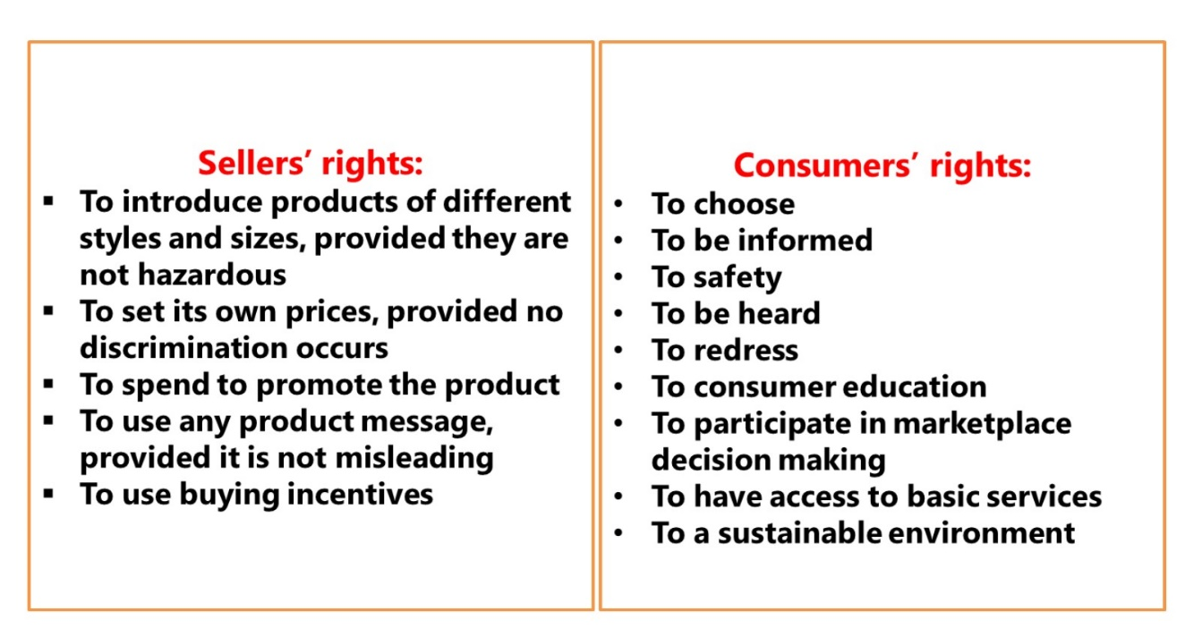
figure: 1 Sellers rights, Customers rights

According to the American Marketing Association (AMA), which has established a systemised ethical guideline for business to address Ethical Conduct
“Marketers shall uphold and advance the integrity, honour and dignity of the marketing profession, by being honest in serving consumers, clients, employees, suppliers, distributors, and the public.” AMA (2020).

ASDA have directly taken deductions from invoices without prior notice. ASDA requested a large sum of money so they can make up substantial amount of profit margin. After numerous complaints ASDA eradicated this problem with its suppliers and ensured they do a job ethically. The small businesses got paid within 14 days of transaction. More ever, they also made a help desk where suppliers can contact them when there is a concern (The Guardian, 2020).
ASDA should practice Transparency and create openness with all trading partners and customers and contribute to the overall sustainability of trade and products..
ASDA’s marketing ethics where they address principle and high standards which is accepted in the marketplace, however sustaining a marketing goal is deep rooted with customer and organisational welfare, this can be achieved and accomplished through ethical marketing conduct (Kotler, et al.,). TESCO has a high marketing ethics where they advertise plant-based food and have plastic free bottle, they are doing exactly as advertised (Ethical Marketing News, 2020).
According to the Guardian Newspaper (2020), ASDA’s CRM has made sure that the suppliers keep the prices down, so the customer can have a low price buying from ASDA, they are being very ethical and assertive. ASDA is very committed to treating is suppliers fairly and ethically (The Guardian, 2020). But it is only when someone brings these matters to light. However, they should be very mindful of the four areas of pricing which are considered illegal and unethical:
Deceptive Pricing – Advertising Low prices, selling at Higher Prices
Where stores advertise that they are selling some particular item at a lower price to lure potential customer into their stores, and after that they try to influence the customer to purchase a product that is priced higher by claiming certain things were not part of the offer.
Unfair Pricing – eradicating competitors with low prices, then increasing prices to high levels
Comparison will be made to check what smaller shops and stores are selling the same product, then the prices of their items will be reduced to attract the customers from the smaller stores into their own stores. After the small store has suffered and gone out of business, big stores increase prices of the goods to a higher level than it was before. This achieves two objectives, (A) Decreases competition (B) Higher profit margin and may even have a third advantage in the Product Exclusivity are.
Price Discrimination – charging people different prices for the same product
Prices are charged differently depending on the customer, for example if a person is seen to have lots of money, or well-dressed the company charges them at a higher price than of a person casually dressed who might not be very wealthy.
Price Fixing – Agreeing beforehand with other Sellers to set prices at a certain level
When firms co-ordinate with each other and fix the prices on certain products. For example if the cost of milk is normally 75p in TESCO and MORRISON, and if ASDA sells Milk for £1 and manage to convince TESCO and MORRISON to do the same, customers will be forced to buy at this price and think that is the standard price.
In the workplace ethical behaviour has received attention from practitioners and who do research on major firms. Ethics starts from corporate to managers in organisation this reflects to bottom line workers. Employees interact with customers in a daily basis who faces many ethical decisions with customers every day. ASDA employees do have self-perception about their own ethical value, this manifests through the behaviour that they portray. As an organisation knowing how employees treat the customers has a fundamental implementation in the market concept. Moreover, a great degree of understanding of how employees perceive their day to day intercommunication with customers and organisation is an internal issue, that could be from employees perception of satisfactory and high ethical performance (Amyx, et al., 2008). TESCO is always above ASDA in profit margins, ASDA do compete with MORRISON and TESCO and other competitive stores, for example ASDA put their prices low on item to have a competitive edge, but many other products prices go up (Beddall, 2000). ASDA must be very ethical and not take advantages of any given situation or attempt to deceive customers for example They must have a creative programme and teach employees about ethics, and sustainability.
To better understand ethical values and to better understand ethical decision-making scholars have made variety of frameworks and models to help with ethics (Barnett and, Vaicys 2000).

Sustainability
Over the years people have become more aware of the surroundings around them. We are in a constant change in our global environment, weather changes and natural disasters. This has raised customers to take importance on sustainable marketing and also value how the product they purchase impacts the world (Crane and, Matten (2010) ). Sustainability is the development of products that fulfils customers without compromising the ability of future generation to meet their own needs (Worlds commissions of Environment and Development, 1987). Meeting the customers’ needs is based on marketing however with ethics and critical decision making supermarkets now have taken the effects of the global world around them into consideration. ASDA has taken charge and changed their stance on business as they state at ASDA, the approach to sustainability is that their belief is that protecting the environment and saving people money for customers (Pink, 2011).
ASDA has recognised that consumers are more aware and concerned on ethical consumption and sustainable consuming. ASDA have concentrated on waste, transport and energy. Just as their competitors have also taken on a stance on sustainable marketing (Asda supplier, 2020). Both MORRISON and TESCO have changed their way of product development and deliverance. All major supermarkets have taken initiative in the removal of plastic bags which decrease the carbon footprint. However, ASDA have opened a project called “Better Planet” which shows plans and transparency on how they can work with customers to a better sustainable stance.
Service failure most of the time has a detrimental effect on customers and organisation, when this happens organisation usually adapt to service recovery where they process and investigate the in attempt to rectify the situation (Kelly and Davis, 1994). If a complaint accrues ASDA has a complaint department and will rectify any problem. They have a feedback system where you can put your thought of the experience you had when visiting ASDA (Asda, 2020).

Mckinsey 7s

Mckinsey 7s framework (thereafter known as the Framework) is used for analysing organisations and how effectiveness it can bring to their success. It has 7 elements when applied can create an understanding of how you should apply these to an organisation for it to be successful (Singh, 2013). If ASDA applied this framework it can improve their performance and implement a strategy to improve (CRM). Asda can bring changes to its organisation by analysing the Framework.

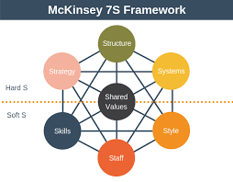
Figure: 2 Mckinsey 7S Framework - (Expert Program Management, 2019).

Strategy
Strategy is used for planning and building an advantage for competitiveness of your competitors. Moreover, without implementing a strategy no business cannot be successful (Hrebiniak, 2006). ASDA (CRM) has a strategy of running the business, but if they keep to the Framework they can have advantages over their competitors for example TESCO and, MORRISON. The Framework has interconnection between them, following them will lead ASDA’s greater success.

Structure
The structure is that it defines who is accountable for what particular job and what responsibility they have. Who is taking orders from who, and who should be accountable for if anything goes wrong. In today’s organisation work is done in team, and specialist which is more common. Structural idea is to make organisation more flexible by empowering the employees to eradicate the middleman (Boyle, 2007). ASDA has cut middle management in few stores, they are always looking to bring in new structure in their organisation (Lawson, 2020). ASDA does have a structure in their organisation, following the Framework will give them a better understanding.

System
System refers to information that goes around the organisation, for example contacting suppliers for the best price they can offer. System can also be refers to customer and distributers. The information can be collected to gain an advantage by contacting individual suppliers to cut additional costs. If purchases are made in large scale the product will be at a cheaper rate (Higgins, 2005). ASDA do purchase in a large scale, but the price is not always cheap compared to smaller supermarket such as ALDI, ASDA is cheaper than TESCO and MORRISON (Finns, 2020).

Style
Style is when a company’s management or (CRM) approaches the outside world in search of potential customers and investors. Style can refer to behaviour of senior management to (CRM), how they acknowledge this and communicate with employees and uphold the priorities and value of the company (Waterman, Peters and Phillips 1980). ASDA has 14,000 employees serving 19 million customers every week, the style is serving customers from food to clothes, café, pharmacy, and optician. Their stores are tailored for specific location and for specific customers. Click and collect is also available for example, you can reserve an item at the store and collect it later on (Corporateasda, 2020).

Skills
Skills is what the organisation does best, what management skills does employees have such as personal skills, are they communicating well with others or do they have team building skills (Alshaher, 2013). ASDA does have skills in their organisation, they are always competing with MORRISON and TESCO. ASDA has overtaken MORRISON, but they are behind TESCO. This Framework illustrates much skills is needed in order to accomplish being the number one store in UK (Griggs, 20060).

Staff
Staff in organisation is the background of workers who is employed in the company. Organisation hire employees who match their goals, belief, values, and ethics. Hiring these types of people, the organisation believe that they can be more effective in the workplace. The employees have similar belief to them in the way of thinking (May, 2005). ASDA staff pay more to farmers for buying dairy product more than TESCO and MORRISON. ASDA publish what they pay to farmers each month, unlike TESCO and MORRISON who do not publish any payment detail at all (Asda Defends Role, 2006).

Shared value
Shared values are characteristic, behaviours, mission and vision an organisation believe in. this influences the behaviour of employees and management. This might be a guideline of an organisation which may be presented to all employees before start of their job. Shared value are behaviours accepted in organisation. If employees do not align with the mission and vision of the company there might be conflict with college and management (Martins and Terblanche, 2003) cited in (Singh, 2013). ASDA shared values might be good, but TESCO has higher profit margin, they talk to customers and do a lot of research on customer retention. TESCO thinks big that is why they are very successful in their organisation. They do not under value their employees, no matter how young they are they will give them a high post in their organisation (Barnes, 2011).

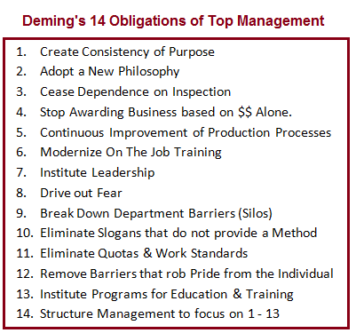
Figure 3 : Deming Theory - CQE Academy, (2020).

Deming’s is acknowledged for management thinker in quality. He is a statistician, more ever a business consultant, his methods of 14 points has helped japans recovery from second world war and beyond that also. He helped organisation and individuals to plan their structure and improve themselves more ever, improve customer service. Deming’s philosophy and techniques Total Quality Management (TQM) which focuses on continues improvement (The British Library, 2020). If ASDA was to gain an advantage in this approach with their employees involved in improving quality and sustainability of product and services, the market share would dramatically improve
If ASDA was to follow this principle they will have a greater Market share and can open many more stores around (UK) and create more jobs. Deming also emphasized that 10- 20 % of employees are responsible for managing control and about 80-90% of this is the management control. ASDA made changes to the management board which saw commercial director and Marketing director resign (Bernady,1997). TESCO market share is greater than MORRISON and ASDA, if Deming’s philosophy was implemented ASDA could be in a very high position in the market share. ASDA has many complaints on delivering products to their customers for example the delivery did not come on time and other times the products they received were defected product and the products sometimes were out of date. More ever, the drivers were rude to the customers and did not acknowledge them fully and drove away. There are many websites where customers write a review of their experience and difficulties they have faced when visiting ASDA (Trustpilot, 2020). (CRM) of ASDA could develop a better culture, ethics and sustainability and understanding of customers concerns if they followed these models for example Deming said it is better to get it right first time and will cost less rather than fixing the problem later on. Deming also illustrates that, when an idea is thought of first it must be done on a small scale to validate it full reward and employees then have time to accept it and support it.
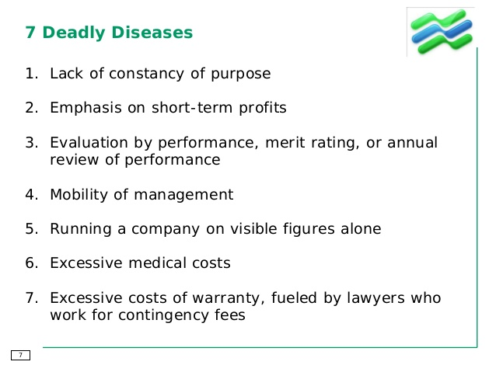
Figure 4 : 7 Deadly Diseases - (Cahoon, 2013)

This is Deming’s 7 diseases if these were eradicated from ASDA’s day to day operations then this could enhance the quality of ASDA overtaking superstores for example TESCO and MORRISON on all front. Having a long-term vison, and not focusing on short term profit, having a long-term strategy. Managers need to stay long term in order to implement any changes, for example If Steve Jobs was in APPLE PLC, for few months and then left, APPLE IPHONE would have not been invented (Joshi and Ivanov, 2017). ASDA has changed invoices in order to show large profit margin without acting ethically, and not thinking about customer retention. Eradicating the 7 deadly problem would live ASDA in high regard with customers and be one of the best Superstores in the World.

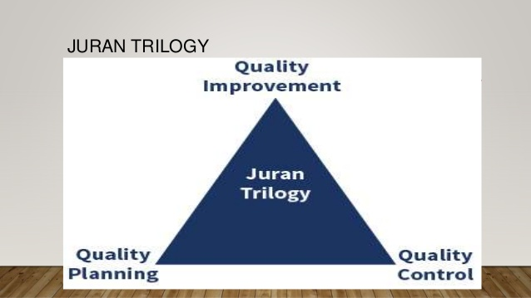
Figure 5 : Juran Trilogy- (Zargiya, 2019)

Dr Juran is recognised for one of the most influential experts in quality management. Juran’s concept therefor can be used and establish for quality system. He has been called the Father of quality, more ever as the most influential quality giant in the 20th century. He stated that humans relations difficulties or problem was important to isolate and resolve. He thinks reluctant to change was a cultural issue, then of quality problem. Juran developed this quality control and this became the most influential quality course. His quality control is thought to many people around the world (Smith, 2011). This focuses on these three-quality control.

Juran’s quality trilogy shows roles of,
- Quality Planning- This purpose is to provide goods and services to customer’s needs.
- Quality Control- In this process the organisation must know who the customers are and what they require.
- Quality improvement- This is the third in it trilogy, which is to improve fitness of use of products and eradicate mistakes. It is to enhance performance from previous work done.
This trilogy has helped many businesses by improving manufacturing and marketing, saving millions of pounds when conducting business (Romano,1994). Quality planning is what ASDA should be doing in order to not have defect product coming back, they should always have a quality control in place in order for that not to happen. The improvement they should do is improve the quality of product ready for customers to use. TESCO and MORRISON do have similar problem of their own. TESCO do have a return policy where you can return item within 30 days, and other item have different return times (Tesco, 2020). ASDA must apply all these quality control for customer retention and have a prosperous future.

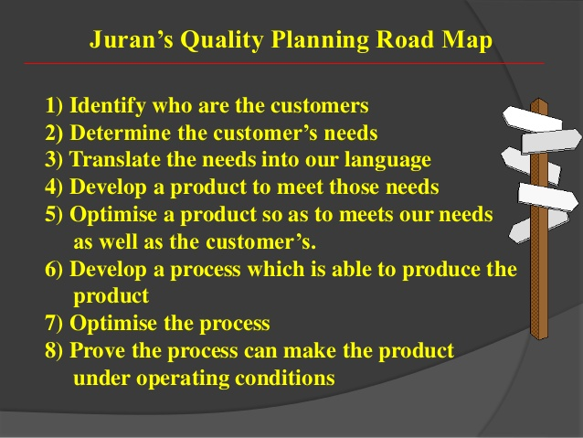
Figure 6: Juran’s Quality Planning Road Map- ( Slideshare, 2020)
The road map covers numerous aspects of improvements, if ASDA can follow Juran’s road map, it can be hoped they can be very successful. ASDA must lead the effort in quality and infrastructure, through this can be very ethical in dealing with customers and maximising profit. Cosby, (1979) also stated that businesses should have a clear vision for customer requirement and should prevent any defect products.

Recommendation

There are numerous actions needed to be taken by ASDA, for complete intangible services and its ethical and sustainability issues image for its customers. As it was already found that marketing for pure profit would not be enough to secure long term stability in the UK retail market. ASDA needs to put an enlarged focus on the principles of sustainable marketing approaches. Consumer-oriented and customer value-based marketing would be ideal strategies for the company to adopt. ASDA must look for solution to ongoing problem for example ASDA needs to approach community with more engagement procedures by starting first with its own employees talking about ethical behaviour and sustainability and continue to do so every month. Give employees and (CRM) training on ethics and sustainability. The value that this approach generates will inevitably play a huge part in evoking customer satisfaction and enhanced loyalty towards ASDA. They must follow the quality management process, theory’s and models that have been illustrated which has been proven to work in many organisations. They must not have a perishable relationship with suppliers, they must be very honest and be ethical in dealings. Making friends with all suppliers will ensure the suppliers look after them and always give then better products and services.
In summary, ASDA should adhere to the five following recommendations:

- Put an enlarged focus on the principles of sustainable marketing
- Engage in Consumer-oriented and customer value-based marketing
- Engage with local community
- Build ethical supplier base
- Practice openness with customers and suppliers

Conclusion

To conclude this report, ASDA has been found to be unethically dealing with customers and suppliers in many ways for example not paying suppliers on time, using fine words to hike the prices of the products, only doing something about a problem when the matter has been raised. Recommendation have been given to enhance their brand image and customer retention. Comparison have been made from TESCO and MORRIOSON in order to find out what ASDA is doing well and what they are not. Theories and models have been incorporated to evaluate their dealings with customers and suppliers. Some things ASDA is doing exceptionally well for example taking out plastic bags from production line.
Ethics and sustainability play a big factor in ASDA (CRM) for customer retention to sustaining quality control products. Understanding what customer needs in order to give a profound tangible service, without compromising the full experience of the consumer. It is hoped that ASDA follow these recommendations as well as act ethically for not just a profit margin, but socially and environmentally be clear to exactly what they advertise.

References

- AMA (2020). Codes of Conduct | AMA Statement of Ethics,available@:https://www.ama.org/codes-of-conduct/, (01/02/2020)
- Amyx, D. et al. (2008) ‘Salesperson Corporate Ethical Values (Scev) Scale: Development and Assessment among Salespeople’, Journal of Personal Selling & Sales Management, 28(4), pp. 387–401. doi: 10.2753/PSS0885-3134280404.
- Asda Defends Role as Wiseman Plans 'inevitable' price cut. 2006. Farmers Guardian, , pp. 107.
- Asda.com. (2020). Asda.com - Online Food Shopping, George, & more. [online] Available https://www.asda.com/ [Accessed 16 Feb. 2020].
- Asdasupplier.com. (2020). Welcome to Asda Supplier | Asda Supplier. [online] Available at:https://www.asdasupplier.com/ [Accessed 14 Feb. 2020].
- Barnes, R., 2011. 'You have to break the straitjacket'. Marketing, , pp. 14-15,17.
- Benady, D., (1997). Asda brings in sweeping management changes. Marketing
- BERRY, L.L., CARBONE, L.P. and HAECKEL, S.H., 2002. Managing the total customer experience. MIT Sloan Management Review, 43(3), pp. 85-89.
- Boyle, S. (2007). Impact of Changes in Organizational Structure on Selected Key Performance Indicators for Cultural Organizations. International Journal of Cultural Policy, Vol. 13 (3), pp.319-334
- Cahoon, a. (2013). SlideShare.net. [online] www.slideshare.net. Available at:https://www.slideshare.net/[Accessed 4 Mar. 2020].
- Corporate.asda.com. (2020). Asda Corporate - ASDA Corporate. [online] Available at: https://corporate.asda.com/ [Accessed 25 Feb. 2020].
- CQE Academy.com. (2020). CQE Academy, Certified Quality Engineer Training. [online] Available at: http://www.cqeacademy.com/ [Accessed 26 Feb. 2020].
- Crane A, Matten D (2010) Business ethics: managing corporate citizenship and sustainability in the age of globalization, 3rd edn. Oxford University Press GRA, New York
- Creevy, J., 2007. ETHICS IN VOGUE. Promotions & Incentives, , pp. 27-28.
- Crosby, P.B. (1979). Quality Is Free, McGraw-Hill, New York, NY.
- Customer Journey. Journal of Marketing, 80(6), 69–96. https://doi.org/10.1509/jm.15.0420
- Dm.usda.gov. (2020). USDA | Departmental Management (DM) | Home. [online] Available at: <https://www.dm.usda.gov/> [Accessed 12 March 2020].
- Ethicalmarketingnews.com. 2020. Ethical Marketing News. [online] Available at: <http://ethicalmarketingnews.com/> [Accessed 12 March 2020].
- Expert Program Management. (2019). Expert Program Management. [online] Available at: https://expertprogrammanagement.com/ [Accessed 29 Feb. 2019].
- Finns, A. (2020). inews.co.uk: news, politics, opinion and sport from the i newspaper. [online] Inews.co.uk. Available at: https://inews.co.uk/ [Accessed 25 Feb. 2020].
- GRIGGS, T., 2006. FT.com site : Sales rise for fourth straight quarter at Sainsbury: [3]. FT.com, , pp. 1.
- Hrebiniak, L.G. (2006), Obstacles to effective strategy implementation. Organizational Dynamics, 35(1), p 12-31..
- Joshi, U. and Ivanov, S., PHD., 2017. EVALUATION OF A BOUTIQUE CONSULTING FIRM: DEADLY DISEASES REPORTING TO MANAGEMENT. International Journal of organizational innovation (online), 9(4), pp. 83-89.
- Kelly, S.W. and Davis, M.A (1994), Antecedents to customer expectations for service recovery Journal of the Academy of Marketing Science, 22 (1) (1994), pp. 52-61
- Kotler, P. Armstrong, G. Harris, L. C. and Piercy, N. (2017). Principles of Marketing, 7thEuropean Edition, Pearson.
- Lawson, A. (2020). Retail Week | News, insight, video and data. [online] Retail Week. Available at: https://www.retail-week.com/ [Accessed 23 Feb. 2020].
- Lemon, K. N., & Verhoef, P. C. (2016). Understanding Customer Experience Throughout the
- Meyer, C. and Schwager, A. (2007), “Understanding Customer Experience,” Harvard Business Review, February 1,17–26 Organizational Innovation (Online), 9(4), pp. 83-89.
- Pink, H., 2011. Asda beats CO2 target. Motor Transport, , pp. 8.
- Prickett, R., 2010. THE BOTTOM LIME. Financial Management, , pp. 18-20.
- Robinson, P. J. Faris, C. W. and Wind, Y. (1979). Industrial Buying and Creative Marketing, Boston, MA: Allyn and Bacon and the Marketing Science Institute.
- Romano, C., (1994). Report card on TQM. Management review, 83(1), pp. 22.
- Schmitt, Bernd H. (1999), Experiential Marketing. New York: The Free Press.
- Singh, A., (2013). A Study of Role of McKinsey's 7S Framework in Achieving Organizational Excellence. Organization Development Journal, 31(3), pp. 39-50.
- Slideshare.net. (2020). Slideshare.Net. [online] Available at: <https://www.slideshare.net/> [Accessed 10 March 2020].
- Smith, J.L., (2011). A Tribute to Dr. Joseph M. Juran. Quality, 50(3), pp. 20.
- Tesco.com. (2020). Tesco - Supermarkets | Online Groceries, Clubcard & Recipes. [online] Available at: https://www.tesco.com/ [Accessed 5 Mar. 2020].
- The British Library. (2020). The British Library. [online] Available at: Beddall, C., 2000. Asda, Tesco are media darlings. Grocer, 223(7443), pp. 6. https://www.bl.uk/[Accessed 1 Mar.2020].
- The Guardian. (2020). News, sport and opinion from the Guardian's UK edition | TheGuardian.[online] Available at: https://www.theguardian.com/ [Accessed 6 Feb. 2020].
- Thomas, J., 2010. Asda. Marketing, , pp. 17.Asda.com. (2020). Asda.com - Online Food Shopping, George, & more. [online] Available at: https://www.asda.com/ [Accessed 31 Jan. 2020].
- Trustpilot. (2020). Trustpilot Reviews: Experience the power of customer reviews. [online] Available at: https://uk.trustpilot.com/ [Accessed 3 Mar. 2020].
- UK Act.com. (2020). What is customer experience | Learn the essentials with Act!. [online] Available at: https://www.act.com/en-uk/what-is-customer-experience [Accessed 15 Jan. 2020].
- University, S. (2020). Home - Santa Clara University. [online] Scu.edu. Available at:https://www.scu.edu/ [Accessed 14 Feb. 2020].
- Waterman Jr., R. H., Peters, T. J. and Phillips, J. R. (1980) ‘Structure Is Not Organization’, Business Horizons, 23(3), p. 14. doi: 10.1016/0007-6813(80)90027-0.Week, 19(42), pp. 7.
- Wilkinson, d. (2020). Act! - CRM & Marketing Automation in One. [online] act_com.
- Wunsch, N. (2020). Statista - The Statistics Portal for Market Data, Market Research and Market Studies. [online] Statista.com. Available at: https://www.statista.com/ [Accessed 25 Feb. 2020].
- www.slideshare.net. (2020). SlideShare.net. [online] Available at: https://www.slideshare.net/ [Accessed 5 Mar. 2020].
- Zargiya, (2019). SlideShare.net. [online] www.slideshare.net. Available at: https://www.slideshare.net [Accessed 4 Mar. 2020].

