
Master of Business Administration

LCMB7024

Marketing Management

Assessment Component 1: Essay

Student Name: Aayush Rajeshbhai Gurjar
Student ID: 2419900
Lecturer Name: DR. Laila maazouz
Date of Submission:28/03/25
Word Count: 2,493

Table of Contents
Advantages of Being Pioneer and Follower Company 3
Product Lifecycle Strategies Applied by Pioneer and Follower Companies for Growth and Competitive Advantage 7
References 11

Advantages of Being a Pioneer and a Follower Company
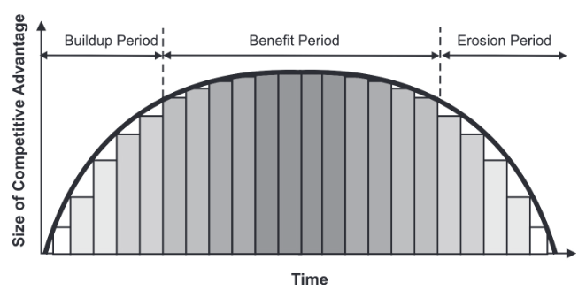
A company is considered a pioneer or first mover when it is the first one to enter a new product market, while followers are all those firms that enter the market in the footsteps of the pioneer. There are different schools of thought regarding which one is better since advantages and disadvantages exist for both cases. Pioneers can create barriers to entry for others to enter the market through proprietary technology or patents, thus ensuring dominance in the market (Srinivas, Zagone and Therattil, 2014). Studies have also noted that pioneers are subjected to greater customer loyalty, especially in the consumer goods industries and financial services industries. On the other hand, pioneers spend much higher than followers due to higher development costs and addressing shifts in customer preferences, while followers learn from pioneers and apply the learnings to gain an advantage (Srinivas, Zagone and Therattil, 2014). Kaličanin (2008) noted that the only prominent advantage that pioneers enjoy is the larger market share, albeit even that is not sustainable for a long time. This advantageous market share slowly declines as followers enter the market, and pioneers have to be actively working on defending or increasing their market share. The benefits of being a follower company have only been studied lately with historical data glorifying pioneers to the point that the risks associated with it were often ignored. The performance of a pioneer company often depends on the resources available to the pioneer and how well they utilise them (Kaličanin, 2008).
Figure 1: Curved buildup and erosion of the Pioneer competitive advantage (adapted from Thompson and Strickland, 2003, p. 186)
For a pioneer to enjoy the advantages of a new market, it is necessary to innovate in technology, marketing, or product, and the focused differentiation strategy suits pioneers the most. According to Thompson and Strickland (2003), first movers enjoy the advantage of owning the positive reputation and image associated with being a pioneer. They also get the first opportunity to create a loyal customer base and reduce total costs by controlling the innovative technology and its supply channel, as well as the distribution channels. High switching costs for customers and the learning curve for followers also ensure a significant advantage for the pioneer, as noted in Figure 1, which has resulted in the pioneer almost always holding on to its dominant market share (Kaličanin, 2008). The erosion of the competitive advantage starts with the increasing saturation of the market by followers. The disadvantages of being the pioneer include the unavoidable benefit that it provides to the free-riding followers, the unforeseen changes that may occur technologically or in the demands of customers, and the uncertainties associated with technology or market. High research and development (R&D) costs have often caused pioneers to never be able to recover in revenues. It is also noted that pioneers have to face the major challenge of creating the primary demand for a novel product by spreading awareness amongst customers, which can be particularly costly (Kaličanin, 2008). The study of Min, Kalwani, and Robinson (2006) also found that pioneer companies that created a completely new product or service were less likely to sustain themselves compared to those pioneer companies that undertook incremental innovation to start a market. Only 23 per cent of pioneers that created a new product market survived for twelve years, while 61 per cent of pioneers that undertook incremental innovation were sustained. This signifies that although market pioneers have the advantage of having a monopoly over the market, depending on the product innovation and its nature, their risk can be high or low. The graph in Figure 2 exhibits how the pioneer advantage starts to reduce with time while the late entrant or follower advantage grows as they start capitalising on the low cost of development and market research needed.
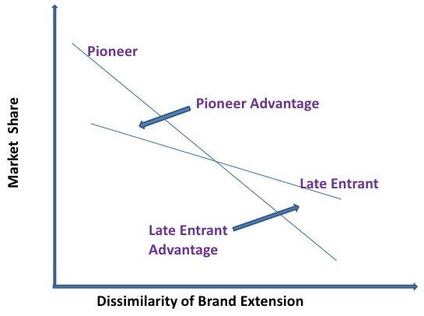
Figure 2: Comparison of the advantages of pioneers and followers in a new market (adapted from Singh, 2011)
A prominent example of expanding on an existing idea to pioneer is Henry Ford, the man who is credited with the invention of the assembly line. While the underlying technology had existed for a century at the time, it was Ford who expanded on the idea and reduced the manufacturing costs and time for cars significantly, leading to increased output and productivity. The assembly line revolutionised industries worldwide with widespread adoption across industries. The stronger-than-ever distribution and communication networks of the present time can essentially be attributed to Ford (Hollinger, 2015). Another pioneer from the automobile industry is Taiichi Ohno, who is deemed the founder of lean manufacturing, also known as the Toyota Production System. While Toyota itself is not a pioneer company as per the technical definition, the lean model was, and its widespread application and adoption to this day signifies the impact it has had. In recent times, SpaceX can be considered a pioneering organisation since it made commercially viable reusable space launch vehicles a feasible option through breakthroughs in rocket technology. Space travel and rockets were once only exclusive to government-funded space associations like NASA, but since SpaceX, private organisations have entered the sector. (Hollinger, 2015). Other prominent pioneer companies that have experienced unprecedented success include Apple, which revolutionised personal computing and further changed music listening through its iPods and iTunes. Google pioneered and became a global leader in online searching, while streaming as we know it today was pioneered by Netflix. Amazon Prime and Hulu, amongst others, were followers of Netflix in the sector with the hope of replicating its success (Morris, 2014). However, Netflix is heads and shoulders above the competition due to risk-taking pioneering decisions like producing original content. Another example of a pioneering development was the precursor to smartphones in BlackBerry. BlackBerry was a necessity for the business world due to its ability to combine instant messaging and mail delivery on the same device, ensuring more efficient communication, making it the most popular mobile company at the time (Morris, 2014).
Innovative designs often drive the pioneer to establish or enter a new market, but it does not mean that followers do not innovate, particularly the successful followers. A great example of this is the American direct banking segment. Direct banking as a concept was introduced in 1995 with the first internet-only bank, but it struggled to compete with traditional banks and build trust amongst customers. It was only in 2000 that ING Direct was launched as an Internet bank and decided to take a different approach. ING Direct focused on differentiating from its competitors by offering ease-of-use to customers through its easy-to-use interface and higher interest rates by cutting activities with high overhead costs. The high financial benefits and simplicity boosted ING Direct’s position in the market, and by 2009, the bank became the leading Internet bank in the United States (Srinivas, Zagone, and Therattil, 2014). ING continued to refine its products to deliver value to customers that they did not receive from its competitors. Another example of a follower innovating to become successful in the market was the BankAmericard in the credit card sector. Offering customers revolving credit to expand their spending capacity and expanding card distribution through alliances allowed BankAmericard to engage with customers and create a brand image that pushed it to a leading position in the market (Srinivas, Zagone, and Therattil, 2014). Uber is another prominent follower company that has surpassed the pioneers and was able to establish its strong base globally, courtesy of its capital base and strong leadership. Airbnb is another major example of a smart follower strategy that entered the accommodation sector and disrupted it completely (Rao, 2024). Facebook became the leading social media platform, but it was a fast follower of early platforms like Friendster and MySpace, while Microsoft purchased and adapted MS-DOS as a follower. Microsoft also allegedly developed the highly successful Office in the footsteps of Lotus 1-2-3, and it has almost become the industry standard in the present context (Lemkin, n.d.). It can thus be noted that being a pioneer does not guarantee success or market dominance, and even a follower company can well become the most successful firm, leaving behind the pioneers by a significant margin.

Product Life Cycle Strategies Applied by Pioneer and Follower Companies for Growth and Competitive Advantage
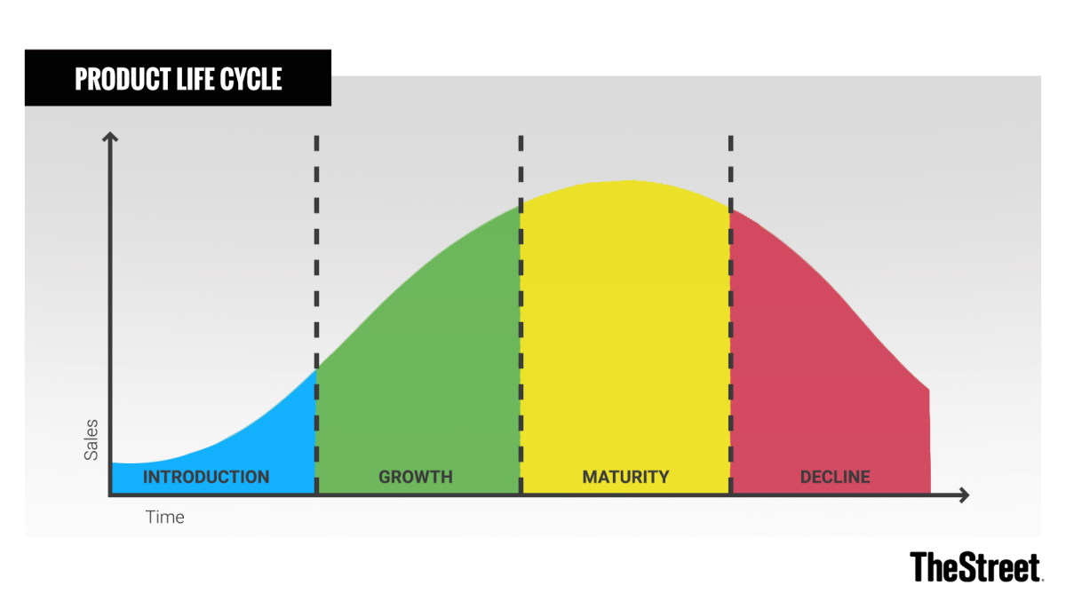
The product life cycle (PLC) concept is used as a decision-making tool to support the product development process. PLC describes the performance of products as they move from one phase of their life to another, from the initial development to retirement and enables full exploitation of the utility and profitability of the product at each of the four life cycle stages. These stages are introduction, growth, maturity, and decline, as noted in Figure 3 (Udokporo, 2021). The curve displays the sales corresponding to each PLC stage.
Figure 3: The stages of the PLC (adapted from Sraders, 2021)

Now, it is obvious that the PLC curve of a pioneer will start ahead in the timeline and reach maturity ahead of followers. For a follower to get close to market leadership, they need to create a competitive advantage that reduces the time required in growth and achieve maturity far more efficiently than the pioneer. Two of the most common strategies that followers implement for this is differentiation and cost leadership. On the one hand, followers can capitalise on their low cost of R&D to attract customers and boost profitability; on the other hand, followers can build on the innovation of the pioneer and differentiate their product from the existing one (Gómez, Perez-Aradros, and Salazar, 2022). The examples of the most successful follower companies exhibit mostly the second case, from ING Direct to Ford to Toyota. Differentiation is also suggested for pioneers, too, as differentiating early in the PLC, in the introductory or growth stage, can function as an appropriate path to gain market share, improve profitability, and hinder the entry of a prospective follower rival (Ruiz-Ortega and García-Villaverde, 2008). Google, for example, did it by dividing its product into segments such as YouTube and YouTube Kids. Facebook did it in 2014 by dividing its messaging features into the Facebook Messenger app (Pichler, 2024).
Several studies, on the other hand, have found that followers can use a wide range of strategies to differentiate themselves from pioneers, including focused advertising, greater quality, or even imitating the pioneers. These strategies are suitable for application in the growth stage of the PLC. However, in the case that the follower is a late entrant in the industry, during the late maturity or decline stage, a standardised product with low pricing is sufficient to meet the expectations of the customers. This is mainly because adopters of the product at this stage do it out of societal obligation or economic necessity (Gómez, Perez-Aradros, and Salazar, 2022). A great example of a late follower trumping pioneers has been Huawei in the smartphone market. In the second quarter of 2020, the company recorded the highest smartphones shipped, the first time in nine years a company other than Apple or Samsung had achieved this. To achieve this despite the sanctions and restrictions of the US was a significant achievement (Canalys, 2020). The main selling factor and major strength of Huawei has been its overall low costs and pricing (Xi, 2021).
As per Pichler (2024), a follower should be focused on the needs of the market segment they aim to target. This is essentially what Steve Jobs did with the original iPhone, focusing on a niche segment: existing customers of Apple products who could afford to spend a premium price on a new phone. This allowed iPhone to reach the growth stage in a comparatively less time compared to the pioneers like Blackberry and Nokia. Today, both Nokia and Blackberry are technically non-existent, while Apple is one of the biggest companies globally. Followers should also be flexible in their approach and adjust their business model and offering to optimize according to the PLC stage they are in. Pichler (2024) even noted that if a product does not perform well, companies should be willing to put an end to it rather than invest money in its growth because it may never reach maturity. All products reach their maximum maturity and enter into the decline stage, which is undesirable. To avoid this, businesses have to either extend the lifecycle of the product by reworking the product and addressing a new need of the market or use the product as a cash cow. The second strategy is preferred when new products are in the pipeline to replace the existing ones (Pichler, 2024).
It can be noted from the discussion that followers have to undertake different strategies compared to pioneers in different stages of the PLC, with fiercer low-cost market penetration strategies suiting followers while identifying market needs and hindering followers from entry through early stage diversification is suited for pioneers. Focusing on R&D and patenting to copyright innovative developments are some of the prominent strategies pioneers can use. However, there are certain methods that are not specific to pioneers or followers and rather suit whichever company capitalizes on it more effectively. This includes innovating, recruiting and training staff, and strengthening distribution channels (Karpenko et al., 2021). Whichever company is able to capitalise on these aspects better will be able to extend the growth and maturity stages of PLC to a longer period. As the PLC enters the growth stage, changes in consumer demands from the product category are noted, and pioneers can respond to these changes by diversifying their products, which, as noted previously, leaves little scope for followers to enter and compete with the pioneer. On the other hand, companies can forecast possible changes in customer behaviour and create appropriate value beforehand. While riskier and cost-intensive, this approach solidifies the position of the pioneer as a market leader (Karpenko et al., 2021). On the other hand, in the maturity stage, companies need to stabilise their approach by reducing costs, optimizing value chains, and maintaining active marketing activities. Unnecessary costs must be avoided in this stage. This reduction of costs has to be made even stricter during the decline of the PLC stage. Essentially, these strategies are not specific for followers or pioneers but rather standardized across the different stages of the PLC. Whichever type of organisation effectively undertakes this will be able to sustain its position longer and extend the PLC (Karpenko et al., 2021). Pioneering definitely provides higher opportunities and benefits for a firm, but it does not necessarily guarantee sustained success. The smartphone market is a testimony to this. Pioneers like Blackberry and Nokia are part of the history now, while a late follower like Huawei is making its mark. The benefits of the late-mover advantage or first-mover advantage are less on the PLC itself and more on how the particular company has designed its overall strategy while entering and maintaining the product market (Xie, Donthu, N. and Johnston, 2021). Thus, it is important to refine the strategy of the firm depending on which stage of the PLC they are entering the market. This applies to the pricing strategy, degree of innovation, targeting of particular segments, R&D capacity, and access to distribution networks that the pioneer or follower company can potentially capitalise on.

References
Canalys (2020) ‘Huawei trumps Samsung for first time in worldwide smartphone market in Q2 2020’, 30 July. Available at: https://www.canalys.com/newsroom/Canalys-huawei-samsung-worldwide-smartphone-market-q2-2020 (Accessed: 10 March 2025).
Gómez, J., Perez-Aradros, B. and Salazar, I. (2022) ‘How to beat early movers: The role of competitive strategy and industry dynamism on followers’ performance in the telecommunications industry.’ Long Range Planning, 55(5), p.102244. Available at: https://doi.org/10.1016/j.lrp.2022.102244
Hollinger, P. (2015) ‘Business pioneers in industry’ Financial Times, 31 March. Available at: https://www.ft.com/content/c18fd2c6-cc99-11e4-b5a5-00144feab7de (Accessed: 8 March 2025).
Kaličanin, Đ. (2008) ‘A question of strategy: To be a pioneer or a follower?’ Economic Annals, 53(177), pp.89-102. Available at: http://dx.doi.org/10.2298/EKA0877089K
Karpenko, Y., Kuznetsova, I., Chykurkova, A., Matveyeva, M., Hridin, O. and Nakonechna, K. (2021) ‘Formation of the enterprise strategy based on the industry life cycle.’ Independent Journal of Management & Production, 12(3), pp.s262-s280. Available at: https://doi.org/10.14807/ijmp.v12i3.1537
Lemkin, J. (n.d.) ‘Dear SaaStr: What Are Great Examples of Fast Follower Companies That Become Market Leaders?’ SaaStr. Available at: https://www.saastr.com/great-examples-fast-follower-companies-become-market-leaders/ (Accessed: 9 March 2025).
Min, S., Kalwani, M.U. and Robinson, W.T. (2006) ‘Market pioneer and early follower survival risks: A contingency analysis of really new versus incrementally new product-markets.’ Journal of Marketing, 70(1), pp.15-33. Available at: https://doi.org/10.1509/jmkg.70.1.015.qxd
Morris, C. (2014) ‘13 pioneers that forever changed consumers’ lives’ CNBC, 21 June. Available at: https://www.cnbc.com/2014/06/18/13-pioneers-that-forever-changed-consumers-lives.html (Accessed: 9 March 2025)
Pichler, R. (2024) ‘The Product Strategy and the Product Life Cycle’ Medium, 12 November. Available at: https://romanpichler.medium.com/the-product-strategy-and-the-product-life-cycle-79fb1fd8ef67 (Accessed: 11 March 2025)
Rao, D. (2024) ‘First Mover. Fast Follower. Smart Follower: What’s Best For You?’ Forbes, 13 March. Available at: https://www.forbes.com/sites/dileeprao/2024/03/13/first-mover-fast-follower-smart-follower-whats-best-for-you/ (Accessed: 8 March 2025).
Ruiz-Ortega, M.J. and García-Villaverde, P.M. (2008) ‘Capabilities and competitive tactics influences on performance: Implications of the moment of entry.’ Journal of Business Research, 61(4), pp.332-345. Available at: https://doi.org/10.1016/j.jbusres.2007.07.029
Sraders, A. (2021) ‘What is the Product Life Cycle? Stages and examples’ The Street, 29 October.Available at: https://www.thestreet.com/markets/commodities/product-life-cycle-14882534 (Accessed: 10 March 2025)
Srinivas, V., Zagone, R. and Therattil, L. (2014) From follower to leader: Innovation strategies in retail financial services. Deloitte. Available at: https://www2.deloitte.com/content/dam/insights/us/articles/financial-services-innovation-strategies/DUP-694_From-follower-to-leader_vFINAL.pdf (Accessed: 7 March 2025).
Thompson, J. and A. Strickland, (2003), Strategic Management: Concepts and Cases, McGraw-
Hill/Irwin
Thompson, J. and A. Strickland, (2003), Strategic Management: Concepts and Cases, McGraw-
Hill/Irwin
Thompson, A. and Strictland, A. (2003) Strategic management: Concepts and cases. Chicago: McGraw-Hill/Irwin.
Udokporo, C.K. (2021) ‘Understanding the stages of the product life cycle.’, in Petrillo, A. and De Felice, F. (eds) Product Life Cycle-Opportunities for Digital and Sustainable Transformation. IntechOpen. Available at: http://dx.doi.org/10.5772/intechopen.99036.
Xi, W. (2021) ‘Analysis of Huawei's International Marketing Strategy Based on the SWOT Analysis.’ 2021 2nd International Conference on E-Commerce and Internet Technology (ECIT), Hangzhou, China, 2021, IEEE. pp. 151-154. Available at: https://doi.org/10.1109/ECIT52743.2021.00041 (Accessed: 10 March 2025).
Xie, F.T., Donthu, N. and Johnston, W.J. (2021) ‘Beyond first or late mover advantages: timed mover advantage.’ Journal of Business & Industrial Marketing, 36(7), pp.1163-1175. Available at: https://doi.org/10.1108/JBIM-11-2018-0334

