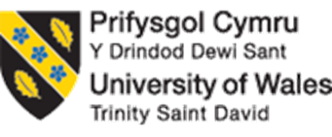

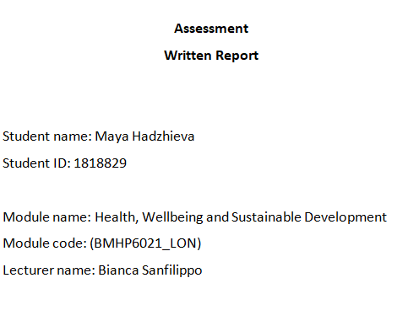
Word Count: 4400

Table of Contents
Introduction 3
17 Sustainable Development Goals of 2030 Agenda 4
London targets to become a sustainable world city 12
Critical examination of London’s benefits from SDG 15
Recommendations 16
Conclusion 17
References and bibliography 18
Appendix 20

Introduction
The environment and the balance of changes are required from all countries in the world to accomplish sustainable human development (Sandbrook, 2019). The processes of identification of some criteria are vital for a systems approach to sustainability. Discussions and decision-making from institutions are the main headway for the establishment of diverse social and political traditions. This approaches donors and global agencies with a movement in the right direction (Sandbrook, 2019).
According to UNESCO (2021), technology, engineering, and science are at the heart of sustainable development. The achievement of 17 sustainable development goals is the global blueprint for future prosperity and peace on a healthy planet. This international acknowledgement is vital for development that meets the requirements and presents the unique opportunities to that highlight the engineers’ role and to advance to solutions for future generation to meet their requirements. These are the core characteristics of world transformation (UNESCO, 2021).
17 goals based on the 2030 agenda were supported by 193 UN members in 2015 including the UK (Hareem, 2020). The main focus is on sustainable development. The current global Covid-19 pandemic requires new innovative approaches to fill the funding gap and a new shared framework to tackle the international challenges. Collective activities are required for real progress to achieve all sustainable development goals (Hareem, 2020).

Suitable development promotes own development without compromising future development and the development of the future generations (Tracey, 2019). It is an extremely significant problematic issue after more than 8 million tons of plastic are thrown into the world ocean every year. The leading ecological danger to public health in the UK is poor air quality. The UN decides to tackle all these problems with Agenda 2030 (Tracey, 2019).
17 Sustainable Development Goals are grouped into three categories (Zhang, 2019). The application of these goals within the compound worldwide system is an optimisation of the process driven by necessary requirements and realisation of the anticipated purposes. The synergies among these goals are considered holistically. Monitoring of these crucial requirements to their lowermost possible level is the core groundwork of awareness of their supportable expansion (Zhang, 2019).
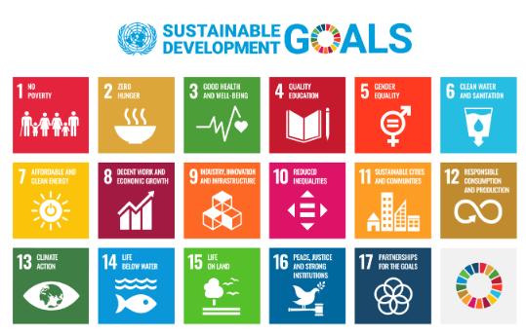
Figure 1: Sustainable Development Goals
Source: (UN, 2020)

1 ‘No poverty’: The principal goal is to finish it. The UK government wants poverty to be eliminated in all forms (GOV.UK, 2021). The opportunities are for career progression and job posts. The Homelessness Act 2017 is a vital step to fight poverty in the UK with new responsibilities for the local authorities such as suitable accommodation for homeless people and ex-prisoners. This strategy is to close the gap between advantages and disadvantages between adults and children.
2 ‘Zero Hunger’: The second target is to end hunger with a strategy to achieve food security, promotion of sustainable agriculture, and improve nutrition. Implementation of sustainable food production is included (GOV.UK, 2021). Other vital points are intervention to support developing states, human right respects, and implementation of humanitarian strategies.
3 ‘Good Health and Wellbeing’: This goal confirms healthy exists and the promotion of good health. This includes a strategy to tackle climate changes, improve the quality of the air, and decarbonise transport (GOV.UK, 2021). Other important steps are to minimise waste, to improve the water and air quality, and the general level of equality. It includes issues to reduce crime, equality access to ethnic minorities, and recovering from Covid-19.
4 ‘Quality Education’: The next goal is to guarantee inclusive and equitable quality learning. It includes promotion for lifetime knowledge prospects for everyone, reducing reoffending, training and employment opportunities, supporting disadvantaged and vulnerable in local communities, and ensuring high standards in education (Kuhn, 2020).
5 ‘Gender Equality’: The fifth goal is to empower all girls and women and to achieve gender equality. It includes opportunities for under-represented groups to have access to work and education (Zimmermann, 2021).
6 ‘Clean Water and sanitation’: This confirms accessibility and ecological water control and cleanliness for everybody. It includes improvement of the environment through cleaner water and air, to minimise waste, and terrestrial and marine wildlife (GOV.UK, 2021).
7 ‘Clean and affordable energy’: This guarantees entrance to consistent, reasonable, and recent energy for everyone. The UK wants to decrease the gas emissions to net-zero by 2045.
8 ‘Decent work and economic growth’: This stimulates continuous, sustainable, and inclusive financial progress, dynamic occupation, and decent work for everyone (GOV.UK, 2021). It includes supporting the people to start and grow a business, to increase economic growth and output through digital connectivity.
9 ‘Infrastructure, Innovation and Industry’: This shapes resistant infrastructure, encourages sustainability and development, and fosters innovative thinking. This includes greener, safer, quality, and affordable homes (Brandil, 2021).
10 ‘Reduce inequalities’: This reduces inequality inside and between the states. This includes reducing illegal immigration, developing the cohesiveness of our communities and countries including main events and ceremonial events. It reduces inequalities of participation in communities, especially between individuals (GOV.UK, 2021).
11 ‘Communities and sustainable cities’: This marks towns and human settlements inclusive, sustainable, and safe. It includes tackling climate change. They develop communities to ensure everybody is included and not marginalised (GOV.UK, 2021).
12 ‘Production and responsible consumption’: This safeguards sustainable feeding. It includes controlling the manufacture and minimising waste (Brandil, 2021).
13 ‘Climate Action’: This precedes crucial activities to contest climate change and its consequences. It includes reducing gas emissions and decarbonising transports (GOV.UK, 2021).
14 ‘The life below water’: This conserves and usages the sea treasures and World Ocean (Snoep, 2021).
15 ‘The life on land’: This reinstates, defends, and promotes native ecosystems’ sustainable usage, contest desertification, and halt biodiversity harm (GOV.UK, 2021).
16 ‘Justice, peace and strong institutions’: This encourages peaceable sustainable development for societies, equal access to justice to all, and building efficient, and inclusive instructions. It includes reducing crime, the safety of prisons, and tackling terrorism (Brandil, 2021).
17 ‘Partnerships for the goals’: The last target is to reinforce the application and regenerate the international partnership with a strong focus on sustainable development. This includes working in partnership with other agencies at the worldwide and national stages to implement these goals (GOV.UK, 2021).

Policies implemented by the UK government to meet SDGs 3, 4, and 17.
Strategies are vital to meet Goal 3 for wellbeing and good health, Goal 4 for quality education, and Goal 17 for the partnership to complete the goals.
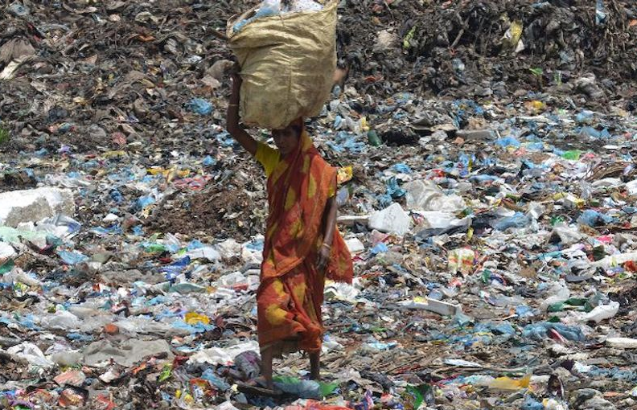
Figure 2: Global Pollution
Source: (UN, 2020)

Goal 3 is related to aims to achieve good health and wellbeing for all. It contains 13 related targets, such as:
3.1 ‘Maternal Mortality’ aims to reduce maternal mortality across the globe (PHE, 2021).
3.2. ‘Neonatal and child Mortality’ aims to reduce deaths of children under the age of five across the globe.
3.3. ‘Infectious diseases’ aims to reduce diseases, such as AIDS and malaria.
3.4 ‘Noncommunicable disease’ aims to reduce mental health disorders that cause premature deaths.
3.5 ‘Substance misuse’ wants to reduce the level of substance misuse such as alcohol or tobacco.
3.6. ‘Road Traffic’ aims to reduce deaths caused by road accidents.
3.7 ‘Sexual and reproductive health’ aims to provide access to sexual and fertility health.
3.8. ‘Universal health coverage’ which aims to ensure equality of access to essential healthcare services
3.9 ‘Environmental health’ aims to decrease the level of toxic air and reduce deaths caused by air pollution.
Goal 3 at a national level is with the implementation of a strategy for public health for 2020-25 (PHE, 2021). This is the UK government’s strategy to challenge poor health, close the gaps, support the economy, and keep individuals safe. “Public Health England Strategy 2020-25” includes making an economic case for prevention, optimising behavioural science, realising the new technologies potential, supporting the system partners, and creating healthy communities. This vital strategy has successful results in a significant decrease in smoking rates (PHE, 2021).
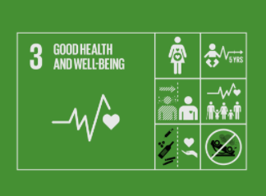
Figure 3: Goal 3, Good Health and Wellbeing
Source: (UN, 2020)
NHS supports positive mental health and wellbeing with vital information such as looking after a child’s mental health with the best chances and further changes for the parents and carers (PHE, 2021). Self-care for young people includes techniques, tips, and videos. Many young are feeling uncertain or anxious for the future. Self-care is extremely important during the Covid-19 pandemic. Many people are feeling isolated with a severe impact on their daily life. There is practical support for individuals with mental or physical symptoms (PHE, 2021). NHS recommends mindfulness and relaxation. These activities support relaxation exercises with a strong focus on shifting negative thoughts. There are many interesting videos such as progressive muscle relaxation for learning to relax body and mind. Bad experiences can be overwhelming with techniques for positive experiences. This programme supports the government to accomplish the target in goal 3 to non-communicable diseases which include the promotion of positive mental health (PHE, 2021).
Vital NSH Programme is “Change for Life” for supporting healthy eating and nutrition (Chertow, 2020). It promotes exercise and prevents obesity. This programme offers steps for cooking healthier meals, promotes healthy lifestyles, offers mental wellbeing tips for parents, promotes dancing, and has a strong focus on family fruit and veg boost. With this programme, NHS wants to accomplish the target linked to goal 3 such as reducing the mortality rate of children under 5 (Chertow, 2020).
Goal 3 includes the worldwide maternal mortality ratio, to reduce child mortality, to end infectious diseases as AIDS, malaria, hepatitis, and water-related diseases (WHO, 2021). The maternal mortality current ratio is 70 per 100, 000 live birth. Current child and neonatal mortality for new-born and children under 5 years old is 12 per 1000 live birth. This wellbeing promotion wants to reduce non-communicable diseases, reduce death numbers from road traffic, environmental health, and universal health coverage. From the other side means for implementation for the targets include universal health coverage, emergency preparedness, tobacco control, and health financing and workforce (WHO, 2021).
Very important for goal 3 is the NHS programme “Best Start in Life” to reduce the mortality rate of children under five and maternal mortality rate (NHS England, 2021). The essential share of enlightening health and reducing health variations is the improved way for children. This programme provides invaluable opportunities for the identification of families with poor outcomes of supporting children (NHS England, 2021). The main features are to reduce childhood obesity, a strong focus on children’s needs, to keep the children to reach their full potential, protection of the children from a serious illness through immunisation and screening, etc. This improves the overall health and wellbeing of young families with children and contributes to the reduction of hospital attendances admissions from preventative illness (NHS England, 2021). This programme promotes the benefits of the children in the improvement of health and wellbeing approaches, drives the high educational accomplishment of all children, and promotes physical and dental good health. Another programme from NHS is “Help Us, Help You” from October 2021. This is to encourage people to seek medical advice early and not to wait until things are worse (NHS England, 2021).
The new government campaign encourages millions to lose weight and to reduce the risk of the Covid-19 (PHE, 2021). It introduces changes to support healthier changes. This includes apps and free tools for promoting healthier eating, drinking less alcohol, and getting more active. Vital is the information from Public Health England for the risks for the health from the extra weight. Losing weight has lasting impacts on health. There is a mass nationwide promotion with a special focus on the special target groups that are the most affected by obesity (PHE, 2021).
The outcome delivery plan for local government and communities is vital during the Covid-19 pandemic (MHCLG, 2021). This outlines the national priorities for supporting better and greener top domestic priorities. This mission means to rebuild and recover with significant changes the support for local economic growth. It includes regenerating the UK towns and cities, improving the local transport links, investing in local culture, establishing free ports, and giving a stronger voice over cherished local assets. This is critical for creating jobs and proving measurements to demand and supply from the coherent housing agenda. The government introduces landmark reforms for modernisation of the development housing policy system with digitised systems for the benefit of everybody including small builders and consumers (MHCLG, 2021). The mission and vision are for creating more opportunities for better occupations. This introduces the major building safety changes in a generation with more cheap houses. The results of the top priority include empowering the places where everyone can benefit, raising productivity, ending rough sleeping with effective prevention, and a resilient and sustainable local government sector (MHCLG, 2021).
Universal health coverage is an extremely important issue from target 3. This protects from financial hardship, and obstacles related to the weak health system and inadequate financing mechanisms (Lin, 2018). High medical costs for long-term treatment create risks for poverty. This universal coverage contributes to the achievement of the goals by producing sustainable and equitable health outcomes. A better understanding of the factors of the health services contribution shapes the accomplishment of the other goals of the UN 2030 agenda (Lin, 2018). This includes reducing the poverty, attaining gender equality, and improving education. This agenda has a strong focus on the emphasis on the environmental determinants of health. Many deaths are linked to environmental issues such as poor sanitation, air pollution, exposure to radiation, and other environmental-linked issues (Lin, 2018).
Vital support for people to lose weight and to cut the risk of coronavirus is the government’s better health campaign (Kuhn, 2020). The main points are to provide a range of tools and apps to support people to have healthy food selections and to avoid weight gain. The other health issues are to drink less alcohol, quit smoking, and get active. This campaign is with online membership packages from the slimming world (Kuhn, 2020).
The extremely important is the government strategy for clean air from 2019 (Dube, 2021). It is related to accomplishing the target in goal 3 linked to “Environmental health” to reduce the level of pollution and toxic air. This includes protecting the environment, reducing emissions from industry, transport, and homes, and protecting the nation’s health. This strategy provides monitoring of the progress (Dube, 2021).
Goal 4 aims to accomplish the quality education targets and includes ten linked targets (Burgess, 2021). They are universal prime and secondary education, universal pre-primary education, equal access to higher education, universal youth literacy, gender equality and inclusion, relevant skills for decent work, education for sustainable development, and global citizenship (Burgess, 2021). The three means of implementation are scholarships, an effective learning environment, and substantially increasing the supply of qualified teachers (Burgess, 2021).
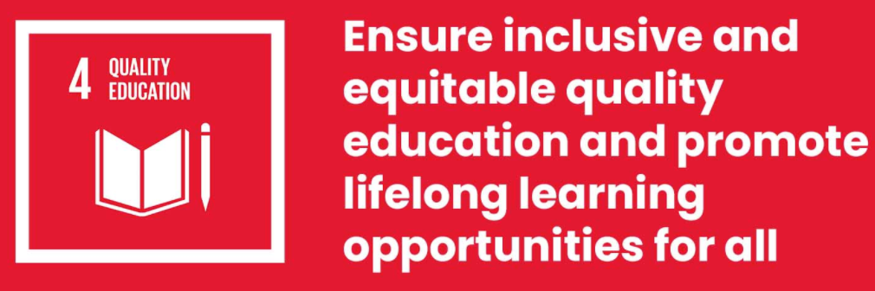
Figure 4: Goal 4 - Quality Education
Source (UN, 2020)

The introduction of tax-free childcare and 30 hours of child care for eligible families aims to accomplish the target of ‘Early childhood development and universal pre-primary education’ (GOV.UK, 2021).
Another beneficial government programme is free 15 hours of childcare for two years old (GOV.UK, 2021). This advantage is vital for future achievement and school readiness. It provides opportunities for children to be with other children and to play with them, and learn from them. This programme is for all 3 and 4-year-olds in England to receive 580 free hours per annum. There are various programmes in Wales, Northern Ireland, and Scotland (GOV.UK, 2021).
Goal 4 is vital for improving the connection links to enhance the UK transport network and to support the economy to grow (Department for Transport, 2021). It builds confidence in the transport links as the post lockdown recovery intensifies. This improves the transport users’ experience and ensures a safety network. After Brexit, there are opportunities in front of the UK. This reinvigorates worldwide transport cooperation. All this has a strong impact on the country’s transport priorities (Department for Transport, 2021).
The government supports universal pre-primary education and introduces the Early Years Foundation Stage (EYFS). This is a set of principles for development, care, and learning for children up to five years old (GOV.UK, 2021). The Ofsted registered providers for early years and all schools must follow the rules counting child-minders, kindergartens, preschools, and school programmes. The core areas of learning are physical development, language, communication, maths, knowledge for the world, expressive arts, and social, emotional, and personal development. The signs of progress of the children are reviewed between two and three early years by a health visitor. The early learning goals are a vital part of the framework for early years such as to ensure the children are kept safe and healthy and to ensure they have the knowledge to start school. The framework is for childcare providers, child-minders, out-of-school providers, school staff, and school leaders (GOV.UK, 2021).
The implementation of the UK government of the Lifetime Skills Guarantees programme provides opportunities for adults if they don’t have an A-level qualification (Azul, 2021). This strategy supports the nation to accomplish the target linked to “Relevant skills for decent work. “This scheme provides chances for adults to take free valuable courses. This boosts productivity and supports the country for building better from the Covid-19 pandemic (Azul, 2021). The programme transforms the foundations of the skills system by funding apprenticeships and providing training for construction industries. This plays a core character in developing skills for the economy for existing and future generations. It contributes to tackling the nation’s skills challenges for rebuilding the economy after the coronavirus pandemic (Azul, 2021).
The UK Government through the implementations of strategies and policy to achieve Goals 3 and 4 shows the ability to work in partnership with different agencies, such as NHS, Public Health England, Department of Education, meeting the targets of SDG 17 – ‘Partnerships for the Goals’.
London targets to be a sustainable world city
The capital introduces the London Sustainable Development Commission to support the capital to achieve these goals. It has implemented various strategies to accomplish goals 3, 4, and 17. The main benefits for the capital are promoting inclusiveness, emphasising partnership, supporting decision-making, and providing international recognition and lawfulness between local and national governments, local community groups, and businesses (London Development Commission, 2021).
Goal 3 – Strategies to accomplish this goal include the London mayor’s zone for ultra-low emission from October 2021. This programmes targets to accomplish goal 3 connected to ‘Environmental health’ reducing pollution level and toxic air. From October 2021 the ultra-low emission zone (ULEZ) is expended and includes North and South Circular roads. This zone covers 3.8 million people who live in London (Mayor of London, 2021). This aims to improve the Londoners’ health, clean to city’s toxic air, and reduce the number of early deaths by thousands of individuals each year. Other measurements from the same strategy include a 9,000 strong bus fleet with the cleanest Euro VI emissions standards, air quality audits from 50 schools in the capital, expansion of the electric vehicle charging infrastructure, and creation of new imaginative approaches to emission reduction from all sources (Mayor of London, 2021).
London’s ULEZ zone is the first ultra-low emission zone that saves billions of pounds for NHS by 2050 (London Chamber of Commerce, 2021). This zone with other strategies by the mayor of London could save NHS more than £5 billion for the next 30 years. This global principal achievement means that 310, 000 fewer Londoners are suffering from air pollution such as cancer, and dementia. Without this activity from the government, the bill for social healthcare and NHS will be more than £10 billion higher by 2050. The immediate advantages are that fewer polluting cars are on the road with a 38% reduction of roadside nitrogen dioxide. It reduces the air pollution linked to hospital admissions by more than one million (London Chamber of Commerce, 2021).
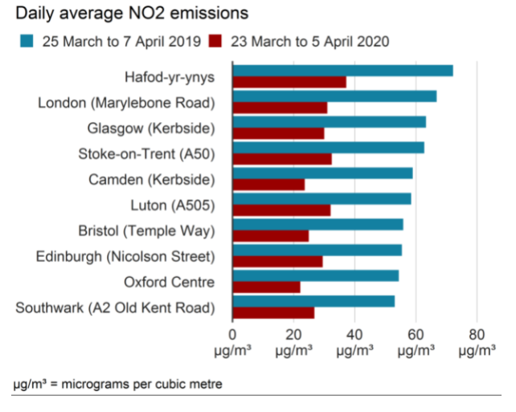
Figure 5: UK Polluted Cities by NO2
Source: (Defra, 2020)
Another vital programme is the Child Death Review Programme with Partnership of Healthy London (Healthy London Partnership, 2021). This important strategy is linked to the accomplishment of goal 3 to reduce the mortality rates for children under five. This programme is connected to the accomplishment of goal 17 because it is a working partnership between agencies. If follows the Children and Social Work Act 2017 for outlining the bodies responsible for the process of safeguarding children and to review the child deaths (Healthy London Partnership, 2021).
Vital for the health of Londoners is the NHS programme to stop smoking. This is part of the aim to accomplish the target in goal 3 in reducing substance abuse. According to the government figures, the number of smoking rates has declined from 14.6% in 2017 to 13.9% in 2018 (Lewis, 2021). This is an important success for this programme. It provides important information for the damages to the body from smoking tobacco. This includes the airways, lungs, and the whole immune system. Other risks are getting acute respiratory infections and developing serious health problems with the Covid-19 (Lewis, 2021).
The key findings are that 29 % of Londoners live in poverty in 2020, with earnings 60% below the national average (London Development Commission, 2021). The main reason for that is housing costs for those on a lower income in private renting accommodation and continuously rose of the rough sleeping from 2015 to 2021. The Covid-19 pandemic expands the inequality and ethnic minorities are hardest hit. The other difficulties are a rise in food costs, housing rents, and contests with a severe impact on low-income households. The children from low-income households are particularly hit by school disruption, lack of IT access, and increased risk of food insecurity. The policies of London authorities include providing more integrated support for adults who suffer from financial difficulties, support to reduce childhood insecurities and enhancing educational outcomes (London Development Commission, 2021). Other vital policies are reducing homelessness, improving public health, and to reducing inequalities.
Critical examination of London’s benefits from SDG’s such as goal 4 for quality education
The goals from the UN have an ambiguous aim to generate economic, environmental, and social developments by 2030 (London Development Commission, 2021). The main advantage for London is receiving a comprehensive image of the capital performance for identifications of any gaps. It unlocks other benefits such as broader areas of informed decisions by using the systems-thinking approach to the complex interconnected challenges. It reduces the inequalities, involves many types of stakeholders at all levels with emphasising partnership, and promotes inclusive and participatory approaches. This is achieved by the policy of funding and local actors (London Development Commission, 2021). It is a strong platform for policy-makers, civil society groups, businesses, and other stakeholders for building a new partnership for building partnerships for local activities in London to accomplish the UN’s goals.
The main objectives for London are to conduct an integrated assessment of target performance with a strong focus on inequalities (London Development Commission, 2021). This includes exploring the contributions of the regional and local government, business, public sector, and civil society groups. The analyses are required for the identification of assess data and policy coverage especially those analyses supporting the inequalities. This supports encourages embedding the principles for decision-making for London’s fair and green recovery. Other vital policies are supporting partnership-building and community participation. The help is received from local London authors. Vital for achieving the goals from the 2030 agenda are proving a platform for policy-makers and stakeholders. The general public builds new partnerships for accelerating local actions on SDGs in London. This strong participatory approach promotes co-development with London’s diverse communities (London Development Commission, 2021).
The measurements of London’s performance of all 169 SDG targets include 110 metrics that are believed for the most comprehensive SDG indicator set (Filho, 2020). Please see Appendices from 7 to 14. London established 28 indicators in 2017 to accomplish the goals by 2030. The new systems-thinking approach unlocks multiple advantages such as investing in housing, cutting carbon, creating jobs, tackling fuel poverty, reducing inequalities, and improving the residents’ wellbeing and health (Filho, 2020).
Recommendations for London’s boroughs are to embed the principles of the UN’s goals and to support the integration of decision-making and policy on investments for green and fair recovery of the capital (Robinson, 2021). The public sector organisations, civil society groups, and businesses support integrated sustainability plans. This facilitates networking, shares best practices, and accelerates collaborative activities in London. All levels of public bodies, businesses, and other government bodies must participate in decisions on local policy, investments, main development, and public services. There are opportunities for larger development such as deeper reflection of people’s experiences. The amazing practice creates London Recovery Board for lessons for learning from the recovering experiences. This leads to more inclusive and participatory governance (Robinson, 2021).
- Ensure appropriate housing for everyone in London. The housing crisis in London impacts Londoners’ mental and physical health. Many people live in poor housing conditions across London (Wall, 2021). Providing affordable housing as well as properties in London is very expensive and this can limit the financial availability for other things, such as food.
- Make public transport more affordable. This can have a positive impact as this will ensure more people will use public transport instead of their own car (Brandil, 2021).
- Make roads in London safer. For example, this can allow more Londoners to use bikes instead of cars (Hoyo, 2021). This will have a positive impact on physical health, such as reducing obesity and will reduce the level of toxic air.
- Open more libraries instead of closing them. Data show that 800 libraries have closed since 2010. Opening more libraries can support the achievement of goals 3 and 4 (Jeronen, 2021). This is because libraries are places where people can have access to books, the internet, computer, services, such as CV writing which can enhance employability skills.

Conclusion
This academic work studies the UN agenda 2030 for sustainable development. The main goals are to decrease child mortality, to confirm environmental sustainability, to improve worldwide partnerships for development, to combat diseases such as malaria and AIDS, to promote gender equality, to empower women, and eradicate poverty, and hunger.
The 17 sustainable goals are vital for global success especially for the elimination of harmful practices such as violence, and discrimination in all forms. This academic report includes the desired human perspectives for security and capability. It shapes the dangers and limitations in the links with the goals at national and local levels. This academic report highlights the understanding of the development of a meaningful life for people.

References and Bibliography
Azul, A., Brandil, L., Ozuyar, P., Filho, L., and Salvia, A., (2021). No Poverty. Sydney: Springer International Publishing.
Brandil, L., Filho, W., and Azul, A., (2021). Peace, Justice and Strong Institutions. Melbourne: Adventure Works Press.
Burgess, J., and Barbier, E., (2021). Economics of the SDGs. Putting the Sustainable Development Goals into Practice. London: Palgrave.
Chertow, M., Adenle, A., Moors, E., and Pannel, D., (2020). Science, technology, and innovation for sustainable development goals. Oxford: University Press.
Defra. (2020). Air pollution has fallen compared with last year. [Online]. Accessed at: https://www.bbc.co.uk/news/uk-england-52202974/ [Accessed: 11.11.2021].
Department for Transport. (2021). Plan for 2021-22. [Online]. Available at: https://www.gov.uk/government/publications/department-for-transport-outcome-delivery-plan/dft-outcome-delivery-plan-2021-to-2022/ [Accessed: 17.11.2021].
Dube, K., Nhamo, G., and Togo, M., (2021). Sustainable development goals for society. London: Springer.
Filho, W., Salvia, A., Azul, A., Brandil, L., and Wall, T., (2020). Life on land. New York: Springer International Publishing.
GOV.UK. (2021). Children free healthcare. [Online]. Available at: https://www.gov.uk/help-with-childcare-costs/free-childcare-and-education-for-2-to-4-year-olds/ [Accessed: 18.11.2021].
GOV.UK. (2021). Foundation stage. [Online]. Available at: https://www.gov.uk/early-years-foundation-stage/ [Accessed: 11.12.2021]
GOV.UK. (2021). Realising the SDG. [Online]. Available at: https://www.gov.uk/government/publications/implementing-the-sustainable-development-goals/implementing-the-sustainable-development-goals--2/ [Accessed: 11.12.2021].
Hareem, A, and Metzger, C., and Runde, F., (2020). Covid-19 demands innovative ideas for financiang the SDGs. New York: Centre for Strategic and International Studies.
Healthy London Partnership. (2021). Child Death Review Programme. [Online]. Available at: https://www.healthylondon.org/our-work/children-young-people/child-death-review-programme/ [Accessed: 11.11.2021].
Hoyo, R., and Visvizi, A., (2021). Smart Cities and the UN SDGs. Amsterdam: ELSEVIER.
Jeronen, E. (2021). Transitioning to Quality Education. Melbourne: MDPI.
Kuhn, H., Krajewski, M., and Kaltenborm, M., (2020). Sustainable development goals and human rights. London: Springer Nature.
Lewis, K., Belo, S., and Elif, D., (2021). Supporting Tobacco Cessation. Oxford: ERS.
Lin, V., Acharya, S., and Dingra, N., (2018). "The role of health in achieving the sustainable development goal". Bulletin of the World Health Organisation, 97(9), p. 592.
London Chamber of Commerce. (2021). World's Principal ULEZ for saving billions. [Online]. Available at: https://www.selondonchamber.org/news/worlds-first-ultra-low-emission-zone-to-save-nhs-billions-by-2050/ [Accessed: 10.11.2021].
London Development Commission. (2021). Development To Meet the UN's SDG. [Online]. Available at: https://www.london.gov.uk/sites/default/files/londons_progress_towards_the_un_sdgs_-_lsdc_0.pdf/ [Accessed: 13.11.2021].
Mayor of London. (2021). ULEZ. [Online]. Available at: https://www.london.gov.uk/what-we-do/environment/pollution-and-air-quality/mayors-ultra-low-emission-zone-london/ [Accessed: 11.11.2021].
MHCLG. (2021). Ministry of Housing, Local Government and Communities . [Online]. Available at: https://www.gov.uk/government/publications/ministry-of-housing-communities-and-local-government-outcome-delivery-plan/mhclg-outcome-delivery-plan-2021-to-2022/ [Accessed: 15.12.2021].
NHS England. (2021). Better start. [Online]. Available at: https://www.england.nhs.uk/ltphimenu/children-and-young-people/best-start-in-life/ [Accessed: 12.12.2021].
PHE . (2021). Better Health. [Online]. Available at: https://www.gov.uk/government/news/major-new-campaign-encourages-millions-to-lose-weight-and-cut-covid-19-risk/ [Accessed: 10.12.2021].
PHE. (2021). Strategy of PHE 2020-25. [Online]. Available at: https://www.gov.uk/government/publications/phe-strategy-2020-to-2025/ [Accessed: 10.12.2021].
Robinson, N., Popovski, V., and Kakar, N., (2021). Fulfillling the Sustainable Development Goals. New York: Routledge.
Sandbrook, R., and Homberg, J., (2019). Policies for a small planet. Melbourne: Routledge.
Snoep, M., Middlelschulte, D., and Holmes, S., (2021). Competition Law, Climate Change and Environmental Sustainability. Amsterdam: Adventure Works Press.
Tracey, J., Derbyshire, E., Chatterji, T., and Franco, I., (2019). Actioning the global goals for local impact. Berlin: Springer.
UN. (2020). SDG. (online). Available at: http://www.un.org/sustainabledevelopment/ [Accessed: 16.11.2021].
UNESCO. (2021). Engineering for Sustainable development. Paris: ICEE.
Wall, T., Brandil, L., and Salvia, A., (2021). Partnerships for the Goals. Chicago: Springer International Publishing.
WHO. (2021). WHO. [Online]. Available at: https://www.euro.who.int/en/health-topics/health-policy/sustainable-development-goals/sustainable-development-goals-sdgs/targets-of-sustainable-development-goal-3/ [Accessed at: 24.11.2021]
Zhang, J., Fu, B., Li, J., and Hou, Z., (2019). "Unravelling the complexity in achieving the 17 sustainable-development goals". National Science Review, 1(6), pp. 386-388.
Zimmermann, A., and Binswanger, C., (2021). Transitioning to Gender Equality. London: MDPI.

Graph 1
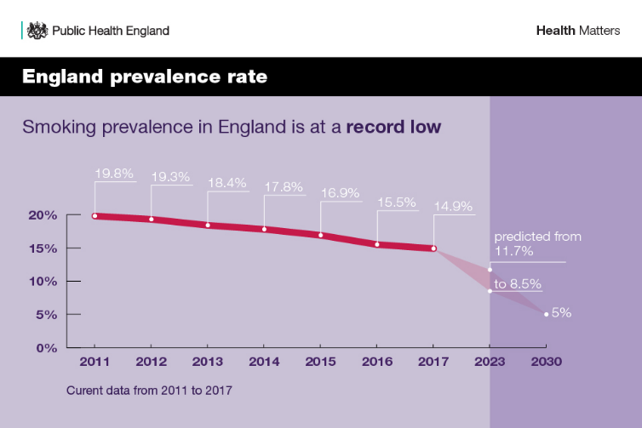
Source: (PHE, 2021)

Graph 2

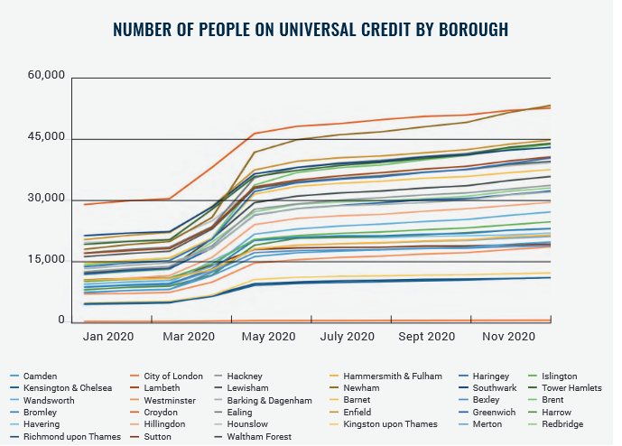

Source: (London Development Commission, 2021)

Graph 3

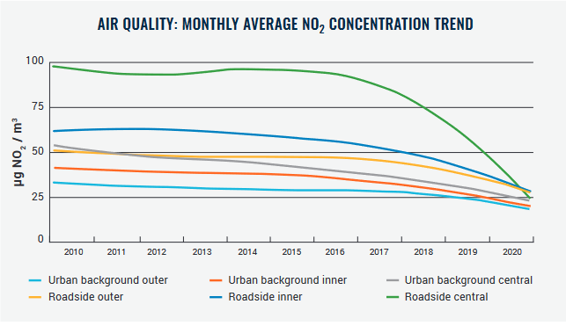
Source: (London Development Commission, 2021)

Figure 1

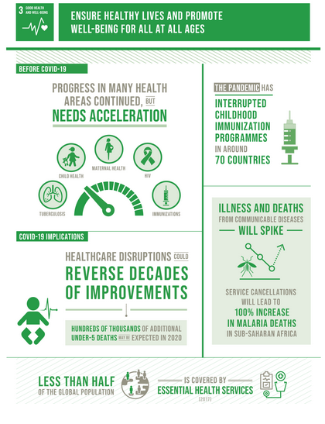
Source: (UN, 2020)

Figure 2

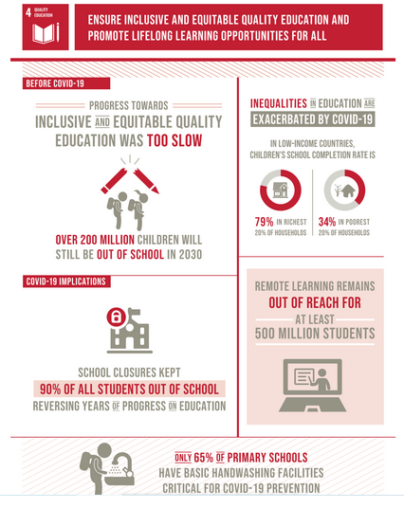
Source: (UN, 2020)

Appendix 6
Figure 3

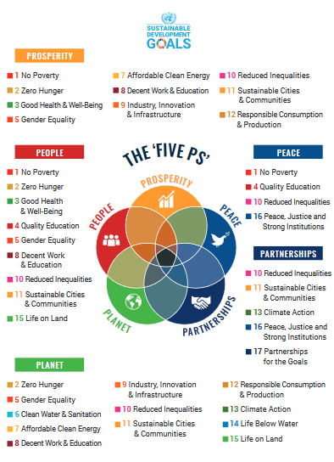
Source: (London Development Commission, 2021)

Appendix 7
Table 1

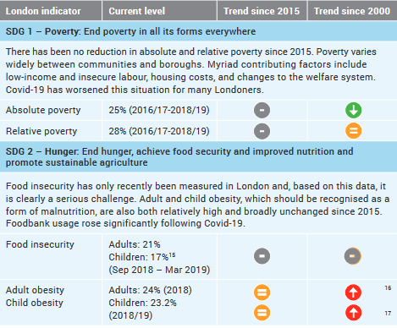
Source: (London Development Commission, 2021)

Appendix 8
Table 2

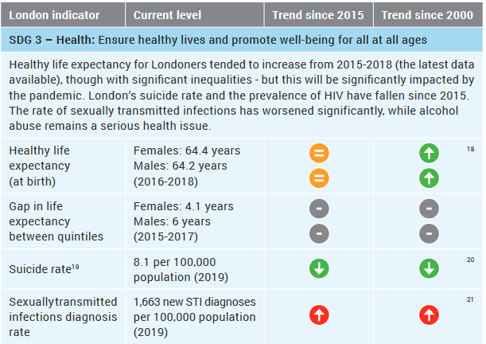
Source: (London Development Commission, 2021)

Appendix 9
Table 3

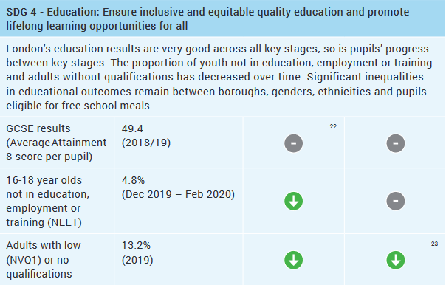
Source: (London Development Commission, 2021)

Appendix 10
Table 4

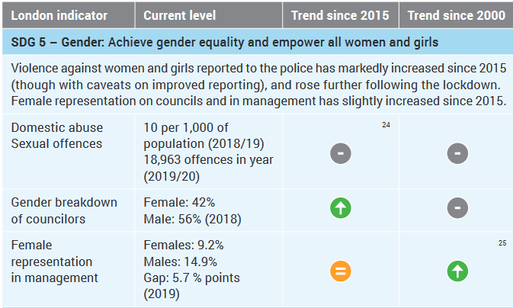
Source: (London Development Commission, 2021)

Appendix 11
Table 5

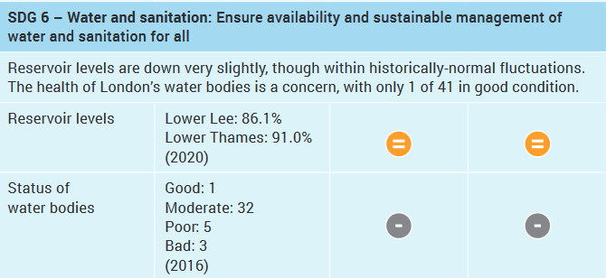

Source: (London Development Commission, 2021)

Appendix 12
Table 6

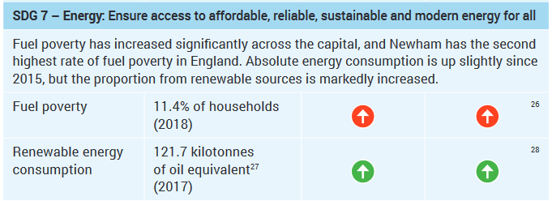
Source: (London Development Commission, 2021)

Appendix 13
Table 7

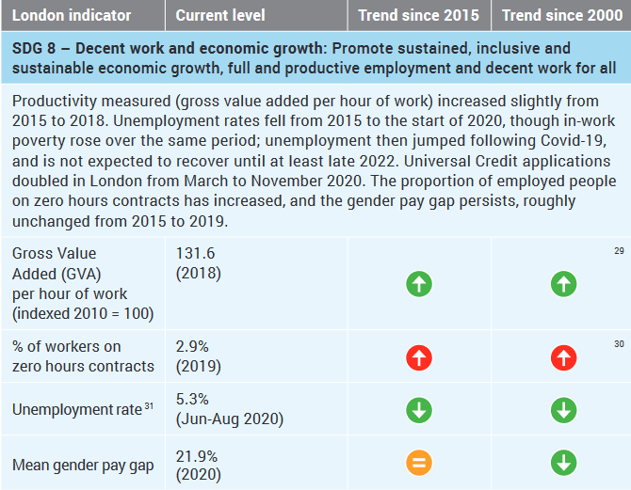
Source: (London Development Commission, 2021)

Appendix 14
Table 8

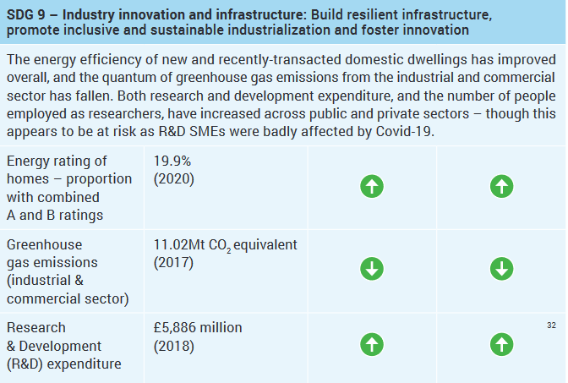
Source: (London Development Commission, 2021)

Appendix 15
Table 9

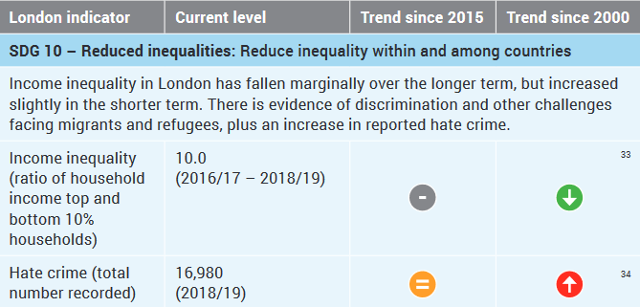
Source: (London Development Commission, 2021)

Appendix 16
Table 10

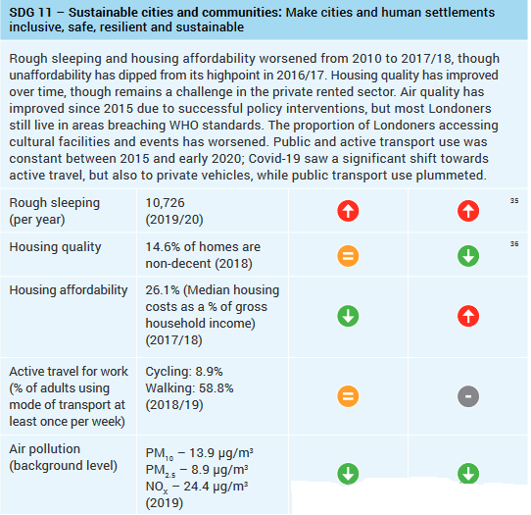
Source: (London Development Commission, 2021)

Appendix 17
Figure 11

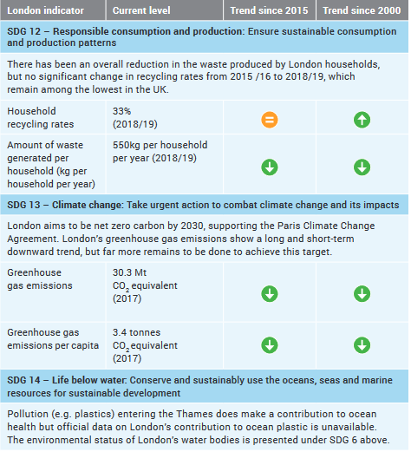
Source: (London Development Commission, 2021)

Appendix 18
Figure 12

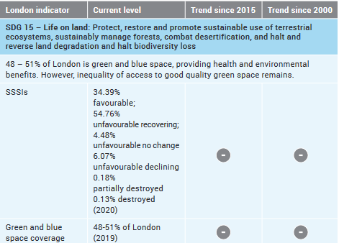
Source: (London Development Commission, 2021)

Appendix 19
Figure 13

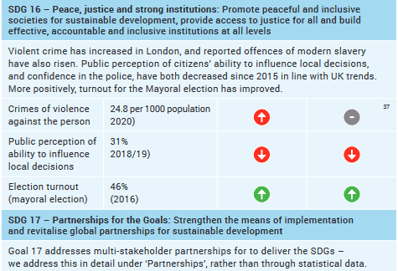
Source: (London Development Commission, 2021)

