International Meetings Management
BMIH6007
International Meetings Management for the Hotel Industry

Name: Rezaul Rabbani
Student Number: 1813391
Lecturer’s Name: Kathryn Flynn

Individual Presentation Title
Planning and Delivering an International Event: Sustainable Winter Tech Expo at the Radisson Blu Plaza Hotel in Oslo, Norway

Table of Contents
Introduction 3
Event Content and Context s4
Market Factors 5
Operational Factors 7
Resources and Logistics 8
Financial Factors 10
SWOT Analysis 11
The Marketing Plan Framework 13
Event Feasibility and Pre-planning 16
Conclusion 17
References 18

Introduction
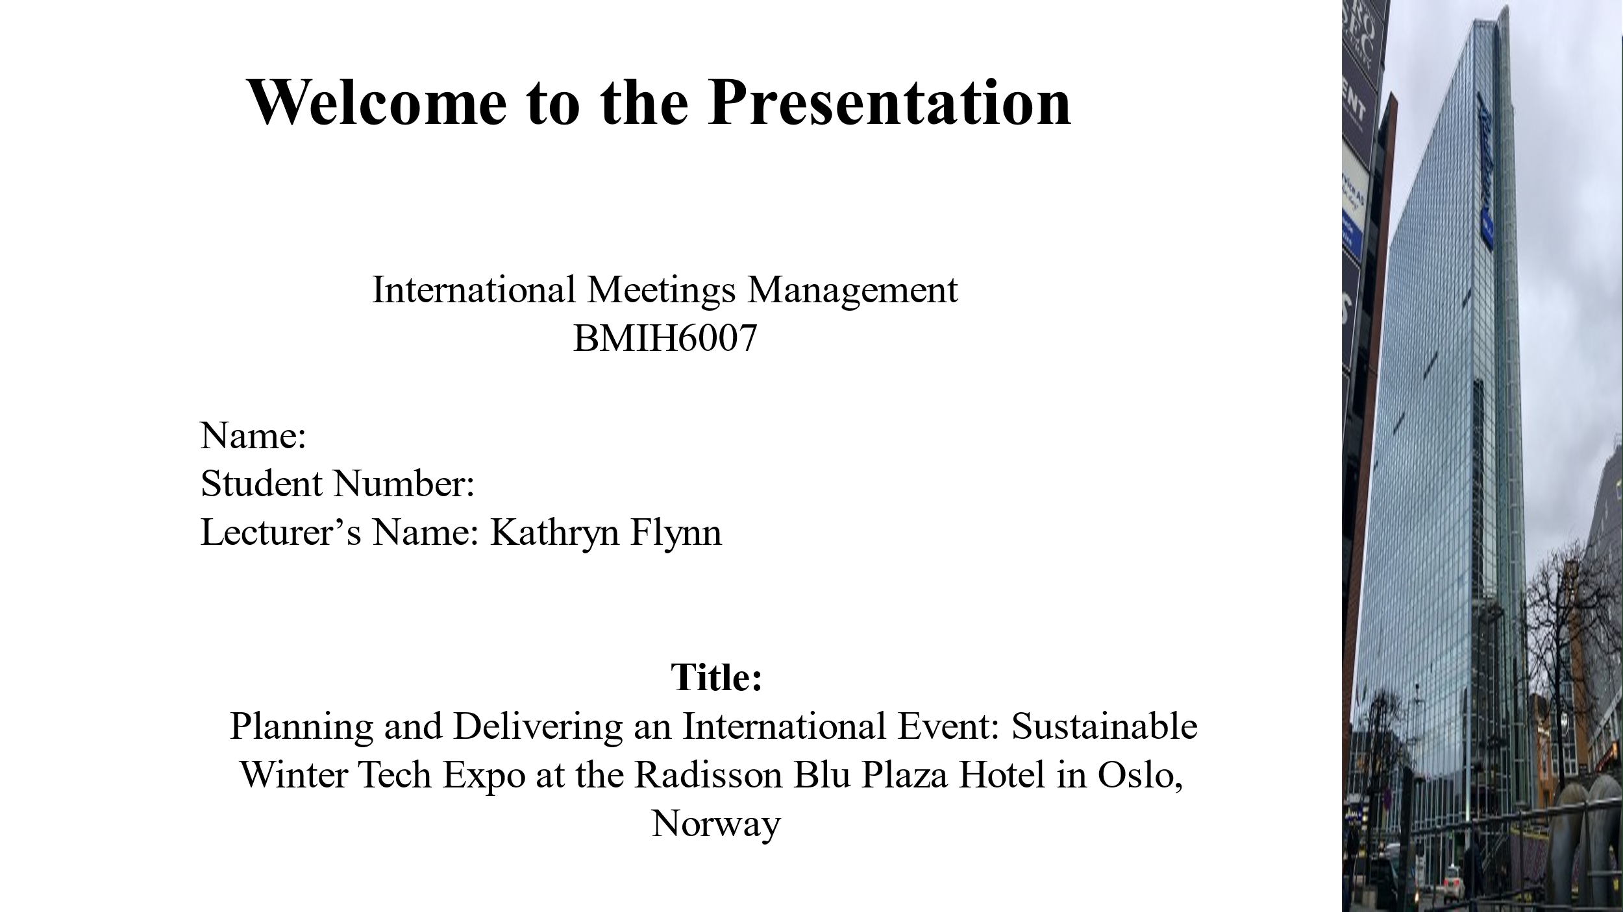
As a growing awareness of environmental responsibility has shifted the focus of industries globally to sustainability, the concept of the Sustainable Winter Tech Expo seeks to bring together new technologies best suitable for winter conditions. This international event will focus on the green energy, electricity vehicles, and environmental friendly products that deal with winter challenges.
Venue: The event will be held at the Radisson Blu Plaza Hotel in Oslo, Norway – an eco certified hotel that fulfils special standard for environmental responsibility and has high technology equipment. Oslo being a global hub of green technology is the perfect venue for such an event, the setting of the event is perfect to discuss future innovations in sustainability.

Event Content and Context
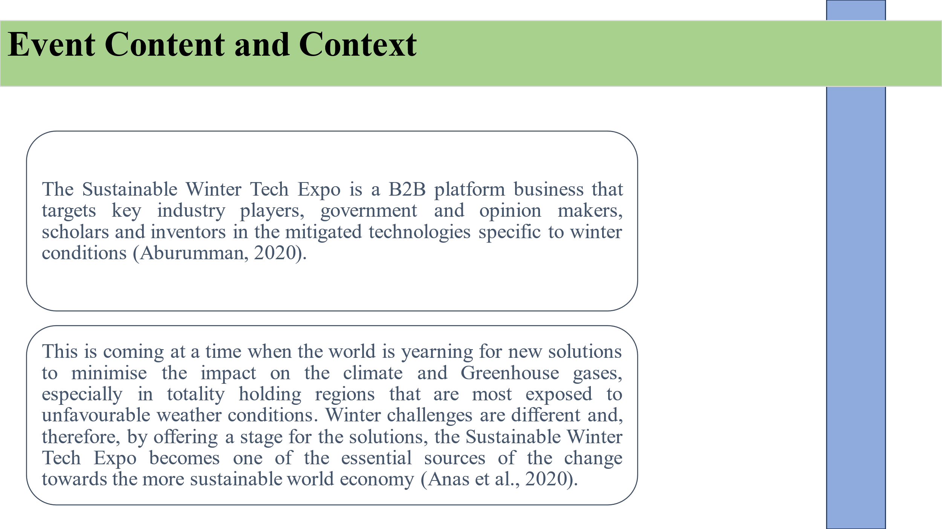
The Sustainable Winter Tech Expo is a B2B platform business that targets key industry players, government and opinion makers, scholars and inventors in the mitigated technologies specific to winter conditions (Aburumman, 2020). The expo will feature various solutions in the form of renewable energy sources and electric vehicles, which can function well in extreme cold.
This is coming at a time when the world is yearning for new solutions to minimise the impact on the climate and Greenhouse gases, especially in totality holding regions that are most exposed to unfavourable weather conditions. Winter challenges are different and, therefore, by offering a stage for the solutions, the Sustainable Winter Tech Expo becomes one of the essential sources of the change towards the more sustainable world economy (Anas et al., 2020). There will also be workshops, panel discussions and live displays, thus, guests will get a feeling of how these technologies work.

Market Factors
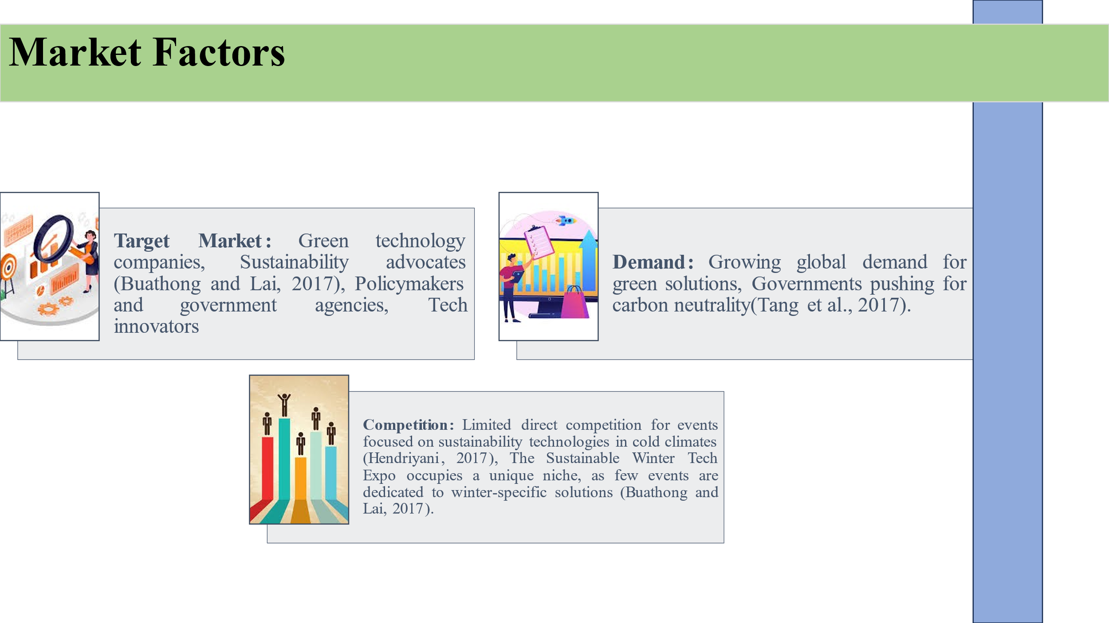
Target Market
The target market for the Sustainable Winter Tech Expo includes several key sectors:
- Green technology companies: Socially innovative individuals particularly those pursuing solutions to sustainable issues such as inventors of technology that can support winter conditions.
- Sustainability advocates: Specifically the programme targeted Non governmental organisations, policymakers and relevant environmental specialists in the promotion of environmentally friendly activities (Buathong and Lai, 2017).
- Policymakers and government agencies: Major stakeholders in policies of incentives in green energy and sustainable solutions.
- Tech innovators: New and growing companies, as well as already-settled technology organisations looking to design new products, or enhance already existing ones for cold climate purposes.

Demand
This type of event is needed due to enhance demand for green solutions in all areas, especially in parts of the world with cold climate. These spur governments globally to encourage green energy and aspiring for carbon neutrality, there has been emphasis on technologies that can minimise the overall effect of energy consumption on the environment, especially in places with severely cold winter (Tang et al., 2017). It serves a vital gap in the market: every society needs to build, and showing off one that is technologically viable while being energy efficient, durable, and able to function in a cold climate is highly useful.
Competition
There are other events dedicated to sustainability and green technologies in the Nordic countries; however, little of them is dedicated to winter solutions as much as the Sustainable Winter Tech Expo (Buathong and Lai, 2017). This is an advantage of the event as it positions it in a niche, market that is not flooded with similar events. In addition to this, Norway has taken the leadership role in renewable energy making the expo for such an event to be ideal.
Small though it is, there is not too much direct competition for an event that is devoted to the sustainability technologies within cold climate, this will ensure that the expo targets a niche market in look for such specific solutions (Hendriyani, 2017).

Operational Factors
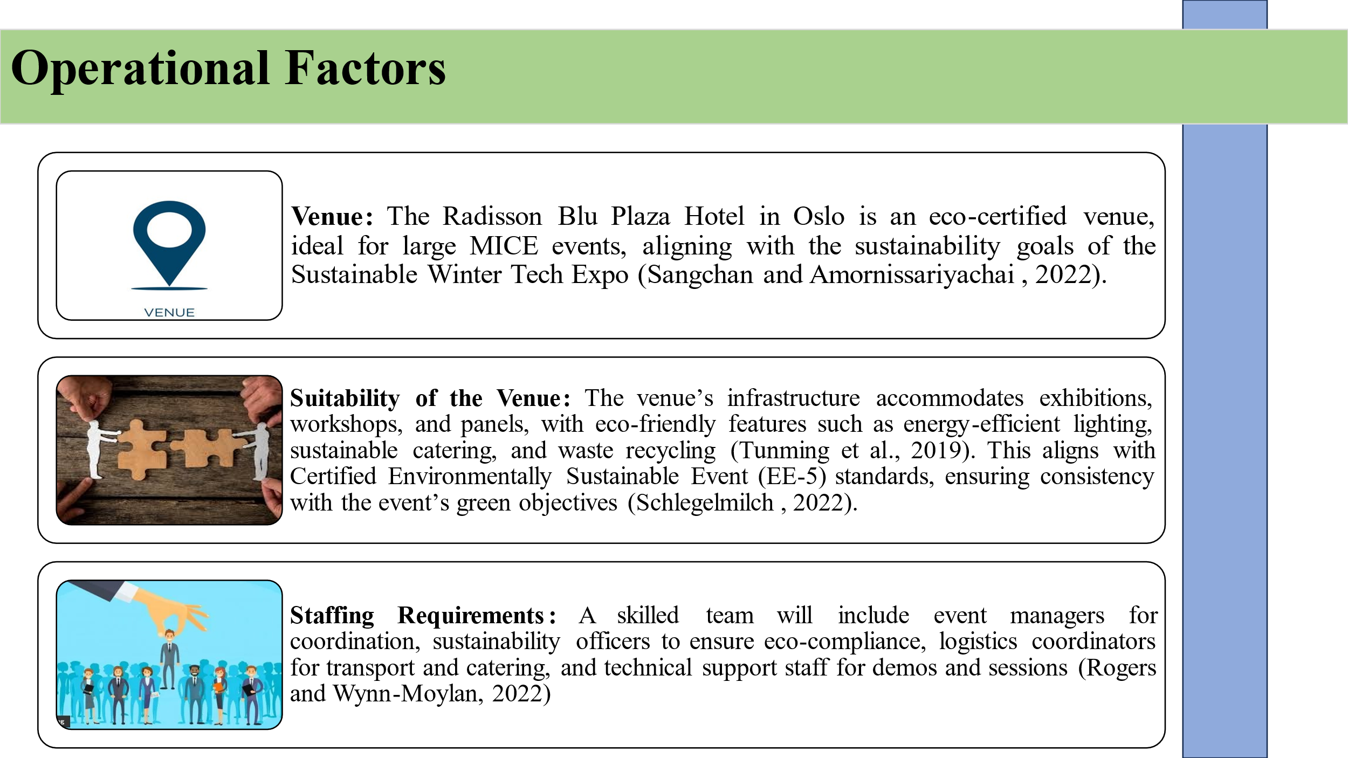
Venue
The specific location for the event, Radisson Blu Plaza Hotel, provides success on both the goals of sustainability and effectiveness. This is an accredited environmentally friendly facility well equipped to host mega MICE business events including meetings, incentives, conferences and exhibitions (Sangchan and Amornissariyachai, 2022). Located in Oslo the hotel will be central for the attendees from all over the world thus making it convenient for a global meeting. It remains consistent with the objectives of the expo in the sense that the event seeks to respect the natural environment.
Suitability of the Venue
The infrastructural setting of the venue can also be used to serve the purpose of the event through setting up different forms of display, workshops and panels etc (Schlegelmilch, 2022). It will be seen that with respect to Certified Environmentally Sustainable Event (EE-5), all aspects of the hotel operation conform to the event policy on sustainable events utilisation of appropriate lightings, sustainable food and beverages aid serve sizes, and waste recycling (Tunming et al., 2019).

Staffing Requirements
To ensure the smooth execution of the event, a skilled team will be assembled, comprising:
- Event Managers: Supervising the overall coordination of the expo and managing time lines as well as monitoring whether the event complies with the goals of sustainability (Rogers and Wynn-Moylan, 2022).
- Sustainability Officers: Compliance of all the running processes and procedures with environmental standards.
- Logistics Coordinators: Including transport arrangements, the provision of food and drink and arranging tables and chairs for the event.
- Technical Support Staff: The technical support for the demonstrations and other interactive sessions that were held.

Resources and Logistics
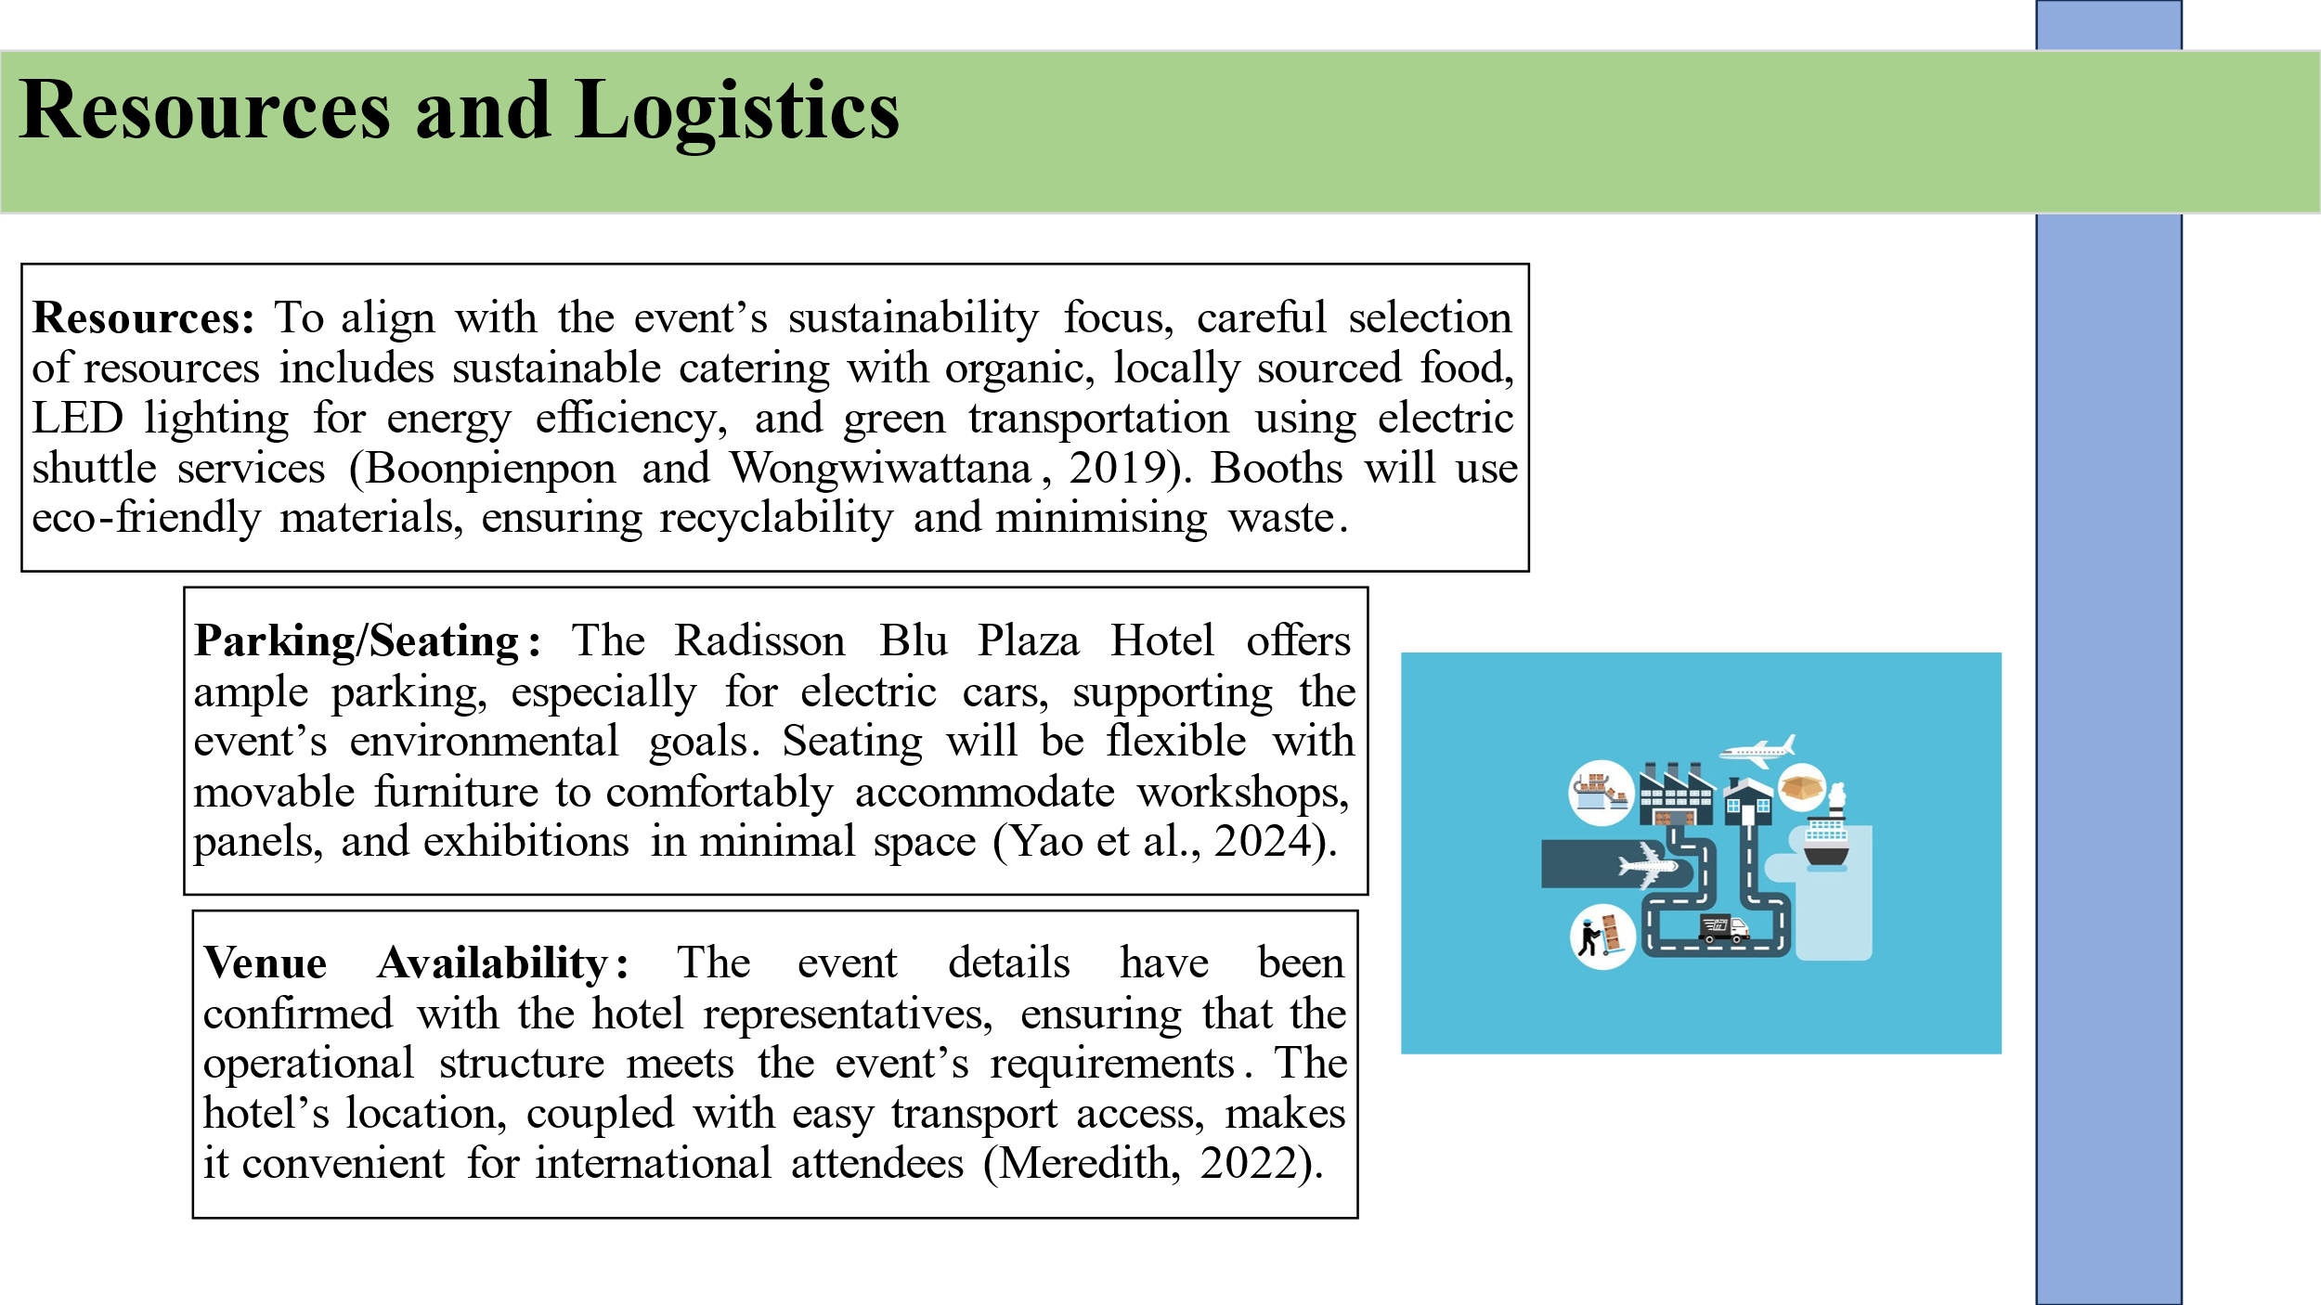

Resources
To ensure the event's sustainability focus, resources will be selected with great care:
- Sustainable catering services: Providing locally grown, organic food products with the least food packaging.
- LED lighting: The correct and efficient types of luminaries that will be employed includes energy saving types.
- Green transportation options: Transportation for participants in electric cars with shuttle services provided within the event (Boonpienpon and Wongwiwattana, 2019).
- Eco-friendly booth materials: Every stand at the fair shall be designed by non-recyclable or recycled material, so that the wastes generated can be easily recycled.
Parking/Seating
There is a good parking space at the Radisson Blu Plaza Hotel especially for electric cars hence proving support for the environmental conservation course of the event. Space segmentation will also involve the arrangement of movable furniture to accommodate workshops, panels, and exhibitions within the least space and with comfort to users (Yao et al., 2024).
Venue Availability
The event specifications have been corroborated with the representatives of the Radisson Blu Plaza Hotel proposed for the event, in terms of the operational structure on the event days. The location of the hotel and the good access to transport means makes it convenient for the international participants (Meredith, 2022).

Financial Factors
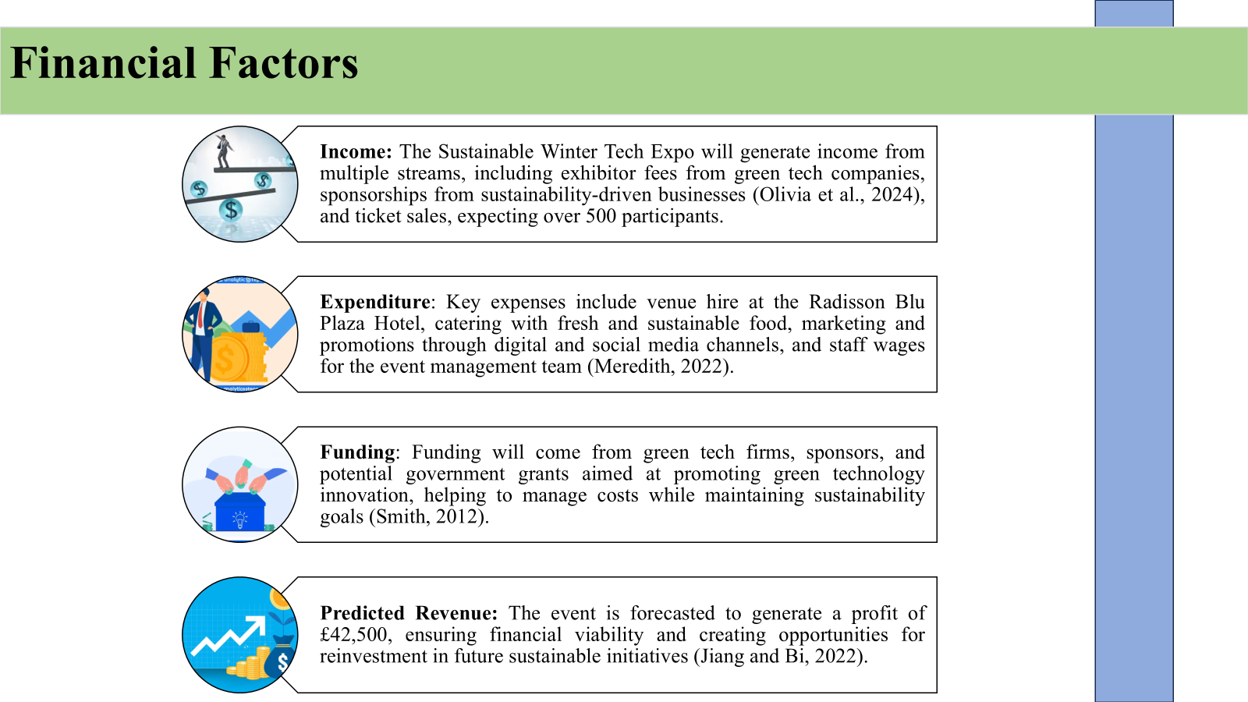
Income
The Sustainable Winter Tech Expo will generate income from several sources:
- Exhibitor Fees: Payments for services from companies in the green technology industry who offer and demonstrate their technology at the expo.
- Sponsorships: Business collaborations involve working with other institutions that are very much into sustainability and companies that have products that need to be marketed (Olivia et al., 2024).
- Ticket Sales: Ticket fee for the participants in expectation of having in excess of five hundred participants in the event.
Expenditure
The main costs for the event include:
- Venue Hire: Holding of the venue space at the Radisson Blu Plaza Hotel.
- Catering and Event Services: Fresh and healthy food and beverages to be served to attendees.
- Marketing and Promotions: Marketing communication strategies include the digital marketing campaigns, social media promotions, and Media partnerships.
- Staff Wages: Remuneration for the team responsible for executing event operations, event managers, technological support, and environmental coordinators (Meredith, 2022).
Funding
The event will be supported through funding received from green tech firms, sponsors, potential governmental funding being directed towards innovative green technology (Smith, 2012). They will help keep the event fiscally manageable while including some kinds of sustainability goals.
Predicted Revenue
Based on the revenue forecast for the event, this is expected generate a profit of £42,500 which make the event financially viable without having to make loss. This surplus will help to invest in future events and create a focus on sustainable solutions specifically for cold environment areas (Jiang and Bi, 2022).

SWOT Analysis
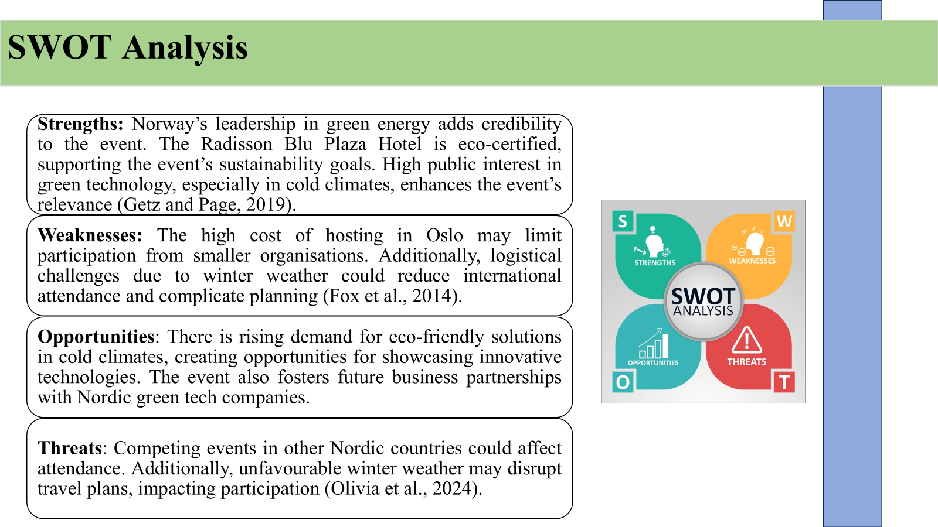

Strengths
- Norway as the leader of green energy solutions and technologies will add credibility to the initiative.
- The Radisson Blu Plaza Hotel is an eco-certified hotel which will help in the achievement of the event’s sustainability objectives.
- The public has a high concern with green technology especially in countries with cold climates (Getz and Page, 2019).
Weaknesses
- Due to the high cost of hosting the event in Oslo, there may be few people attending from these organisations especially those from small organisations.
- Inherent organisational complications arising from winter season may reduce the likelihood of international participation (Fox et al., 2014).
Opportunities
- Increasing need for environmentally friendly products in the cold climate is additional opportunity.
- It provides chances for future business cooperation with green tech companies in the Nordic countries.
Threats
- Having rivals in other Nordic states holding comparable events might pose a problem to participation.
- Winter weather could be unfavourable for travel and accommodation arrangements of participants (Olivia et al., 2024).

The Marketing Plan Framework
Event Mission, Goal, Factors
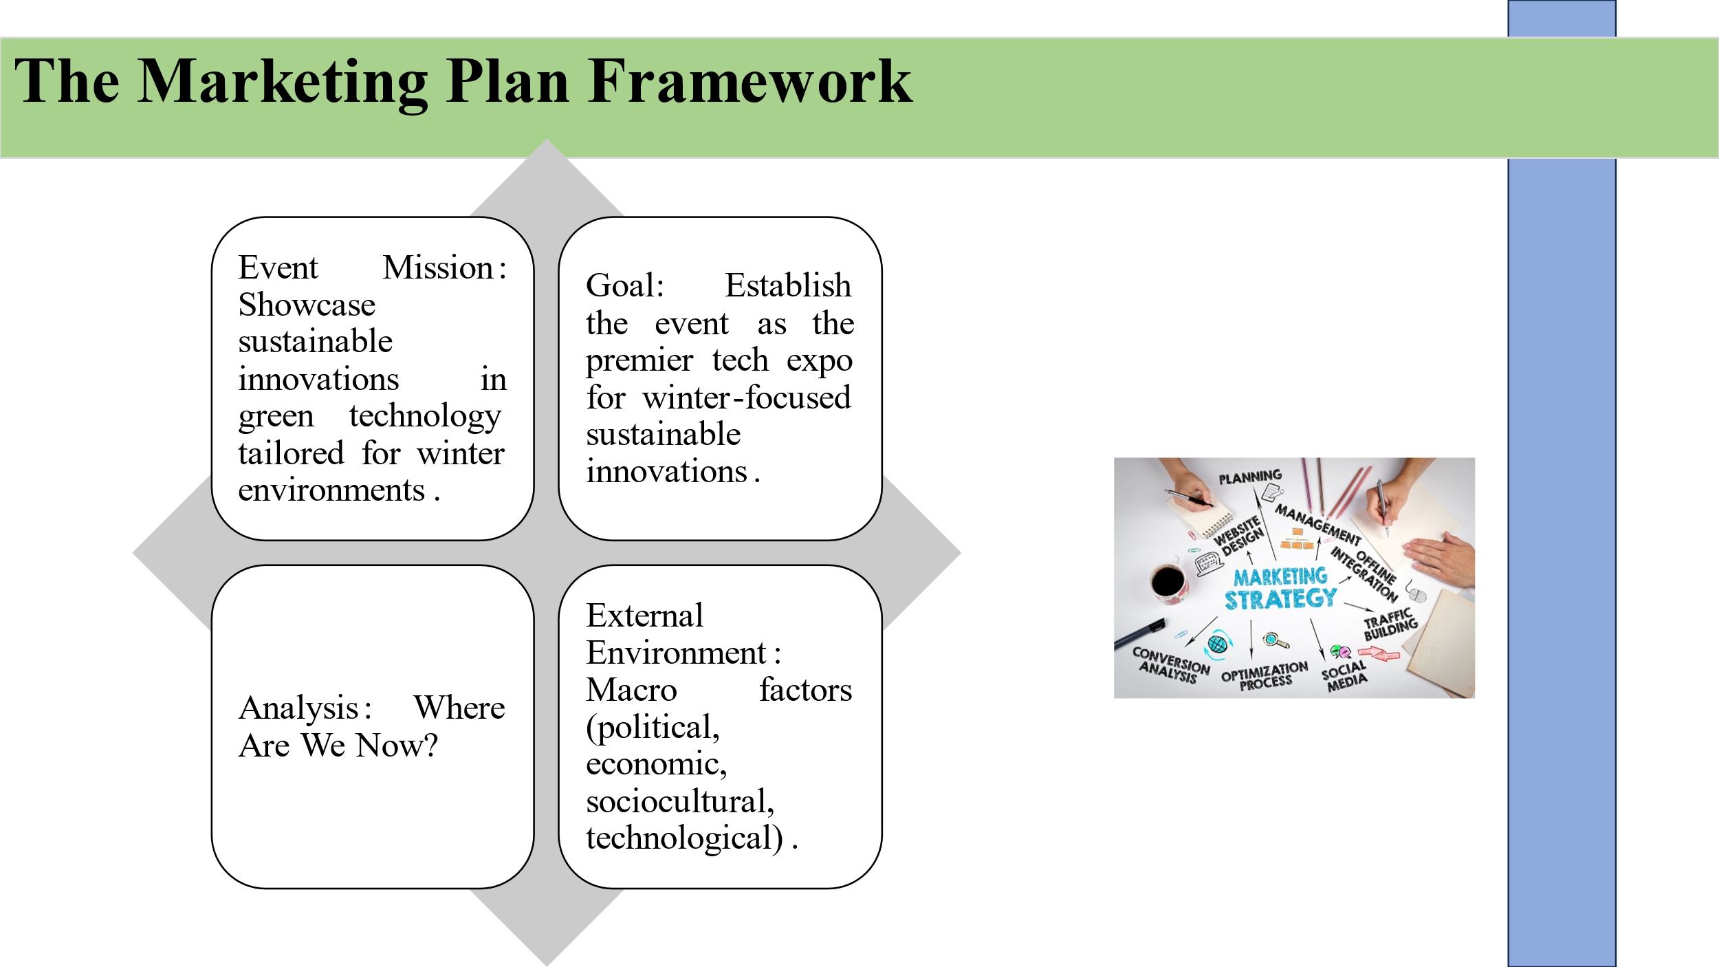
The strategic Event Mission of the Sustainable Winter Tech Expo is to become the premier event for presenting sustainable technologies that can operate effectively in cold climates (Meredith, 2022). Again, the emphasis personnel on inventions within renewable power, electric cars, and sustainable systems. The Analysis features the review of the entire environment to determine the situation (External Environment: political, economic, sociocultural and Technological factors) and internal environment (resources available, capacities within an organisation and event arrangements) to help in the planning process (Olivia et al., 2024).

Planning and Implementation Strategies
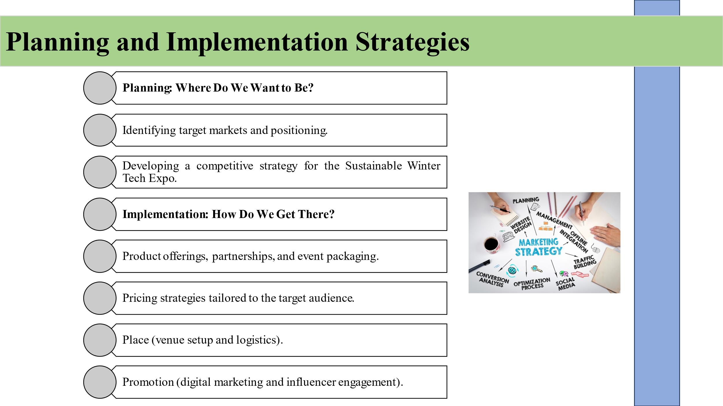
In the Planning phase, the target market is determined with regard to green tech firms, sustainability promoters and new thinkers. The ideas are to enhance interaction with the event programme through specific showcases and the positioning of the event (Hendriyani, 2017). The Implementation phase focuses on just four elements of the promotional mix, known as the 4Ps- Product, Price, Place and Promotion to provide an effective all round strategy that works to capture the audience’s attention and improve the overall effectiveness of the event (Kumar and Samtani, 2021).

Control and Monitoring for Event Success
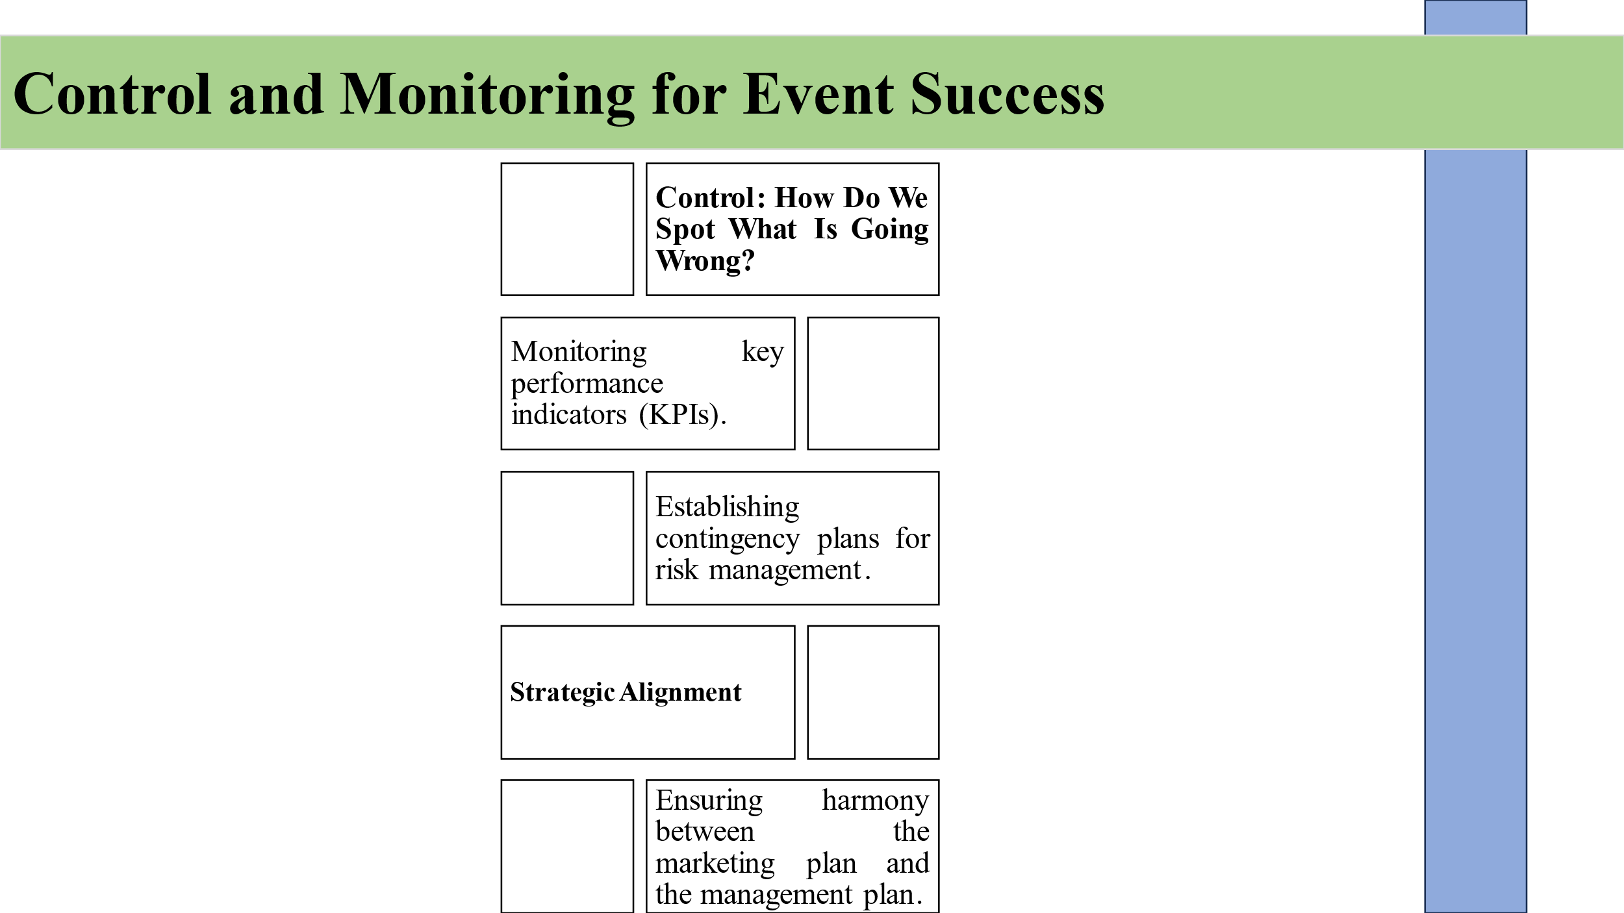
The evaluation of the event’s success will be in the form of Key Performance Indicators (KPI) such as engagement and Social Media impressions (Jiang and Bi, 2022). Emergency Plans which help organizaitons manage any interuptions that may occur are called Contingency Plans. It is important to synchronise the marketing plan in relation to the company’s managerial objectives for efficient event running and event analysis for the subsequent refinements (Getz and Page, 2019).

Event Feasibility and Pre-planning
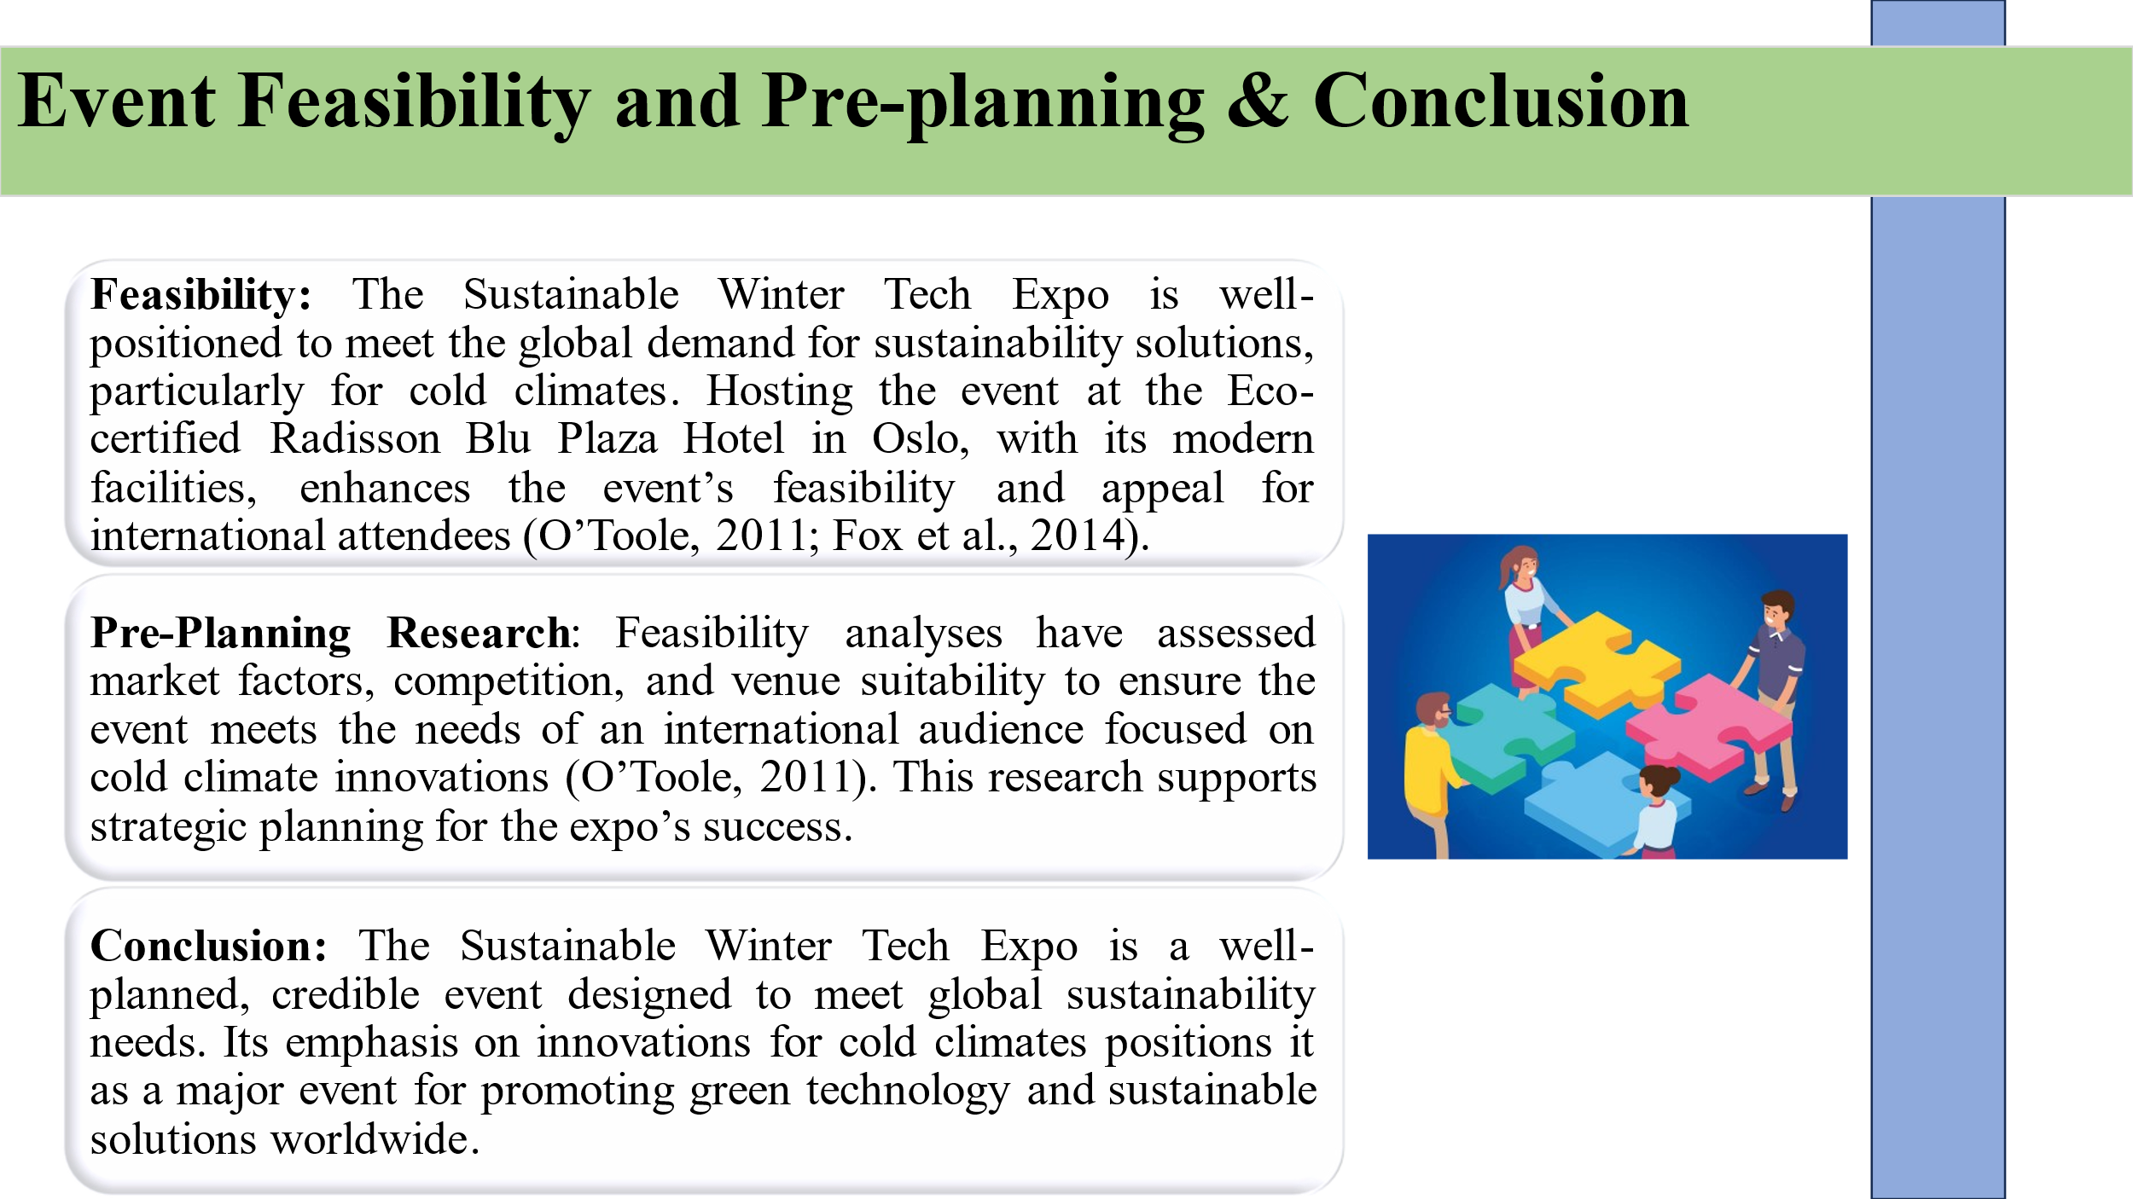

Feasibility
The Sustainable Winter Tech Expo is positioned perfectly to cater for the increasing need for sustainability solutions across the globe, but most especially the areas that experience winter (O’Toole, 2011). Even arranging the event at the superb Eco-certified Radisson Blu Plaza Hotel in Oslo that has up to date facilities conducive to an event of this nature improves the chances of the event (Fox et al., 2014). The hotel is sustainable and the location is central thus the event is easily feasible in as much as it tries to maximise the attendance of international persons.
Pre-Planning Research
A series of feasibility analyses has been prepared in the preliminary process to assess the market factors, competitive environment, and the site environment (O’Toole, 2011). In undertaking this analysis, it will guarantee that the event addresses the needs of an international audience with a view of giving a twist to cold climate innovations.
Strategic Considerations
Yielding to the fact that Oslo is one of the high-cost areas of the world, the operational expenditures will be offset by sponsoring and collaborating with green tech organisations which will in turn help to share costs and get extra funding (Kumar and Samtani, 2021). High emphasis on sustainability and targeting cold climate technologies proposes a strict audience of participants and key stakeholders to the event making it both financially and strategically feasible.

Conclusion
The Sustainable Winter Tech Expo outlines a carefully designed, credible event with identified market demand and implementation capacity. Due to its emphasis on such hostile climates the expo creates a context for presenting the newest solutions in the sphere of environmental protection. The overall outcome of the event is expected to create a major revolution of green technology especially in aspects that seek to support sustainable solutions in the entire world.

References
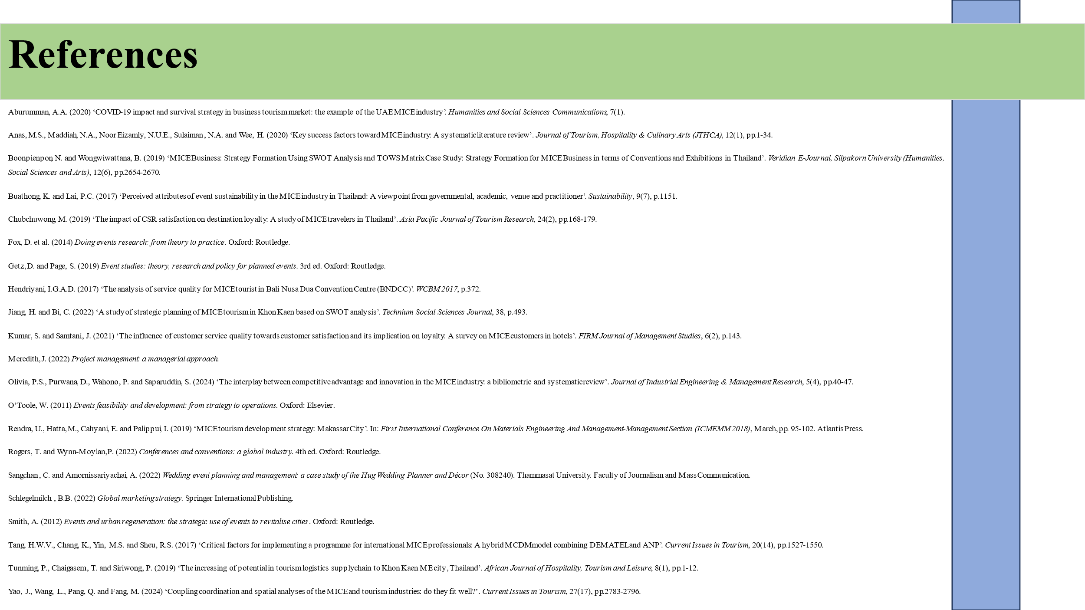
Aburumman, A.A. (2020) ‘COVID-19 impact and survival strategy in business tourism market: the example of the UAE MICE industry’. Humanities and Social Sciences Communications, 7(1).
Anas, M.S., Maddiah, N.A., Noor Eizamly, N.U.E., Sulaiman, N.A. and Wee, H. (2020) ‘Key success factors toward MICE industry: A systematic literature review’. Journal of Tourism, Hospitality & Culinary Arts (JTHCA), 12(1), pp.1-34.
Boonpienpon, N. and Wongwiwattana, B. (2019) ‘MICE Business: Strategy Formation Using SWOT Analysis and TOWS Matrix Case Study: Strategy Formation for MICE Business in terms of Conventions and Exhibitions in Thailand’. Veridian E-Journal, Silpakorn University (Humanities, Social Sciences and Arts), 12(6), pp.2654-2670.
Buathong, K. and Lai, P.C. (2017) ‘Perceived attributes of event sustainability in the MICE industry in Thailand: A viewpoint from governmental, academic, venue and practitioner’. Sustainability, 9(7), p.1151.
Chubchuwong, M. (2019) ‘The impact of CSR satisfaction on destination loyalty: A study of MICE travelers in Thailand’. Asia Pacific Journal of Tourism Research, 24(2), pp.168-179.
Fox, D. et al. (2014) Doing events research: from theory to practice. Oxford: Routledge.
Getz, D. and Page, S. (2019) Event studies: theory, research and policy for planned events. 3rd ed. Oxford: Routledge.
Hendriyani, I.G.A.D. (2017) ‘The analysis of service quality for MICE tourist in Bali Nusa Dua Convention Centre (BNDCC)’. WCBM 2017, p.372.
Jiang, H. and Bi, C. (2022) ‘A study of strategic planning of MICE tourism in Khon Kaen based on SWOT analysis’. Technium Social Sciences Journal, 38, p.493.
Kumar, S. and Samtani, J. (2021) ‘The influence of customer service quality towards customer satisfaction and its implication on loyalty: A survey on MICE customers in hotels’. FIRM Journal of Management Studies, 6(2), p.143.
Meredith, J. (2022) Project management: a managerial approach.
Olivia, P.S., Purwana, D., Wahono, P. and Saparuddin, S. (2024) ‘The interplay between competitive advantage and innovation in the MICE industry: a bibliometric and systematic review’. Journal of Industrial Engineering & Management Research, 5(4), pp.40-47.
O’Toole, W. (2011) Events feasibility and development: from strategy to operations. Oxford: Elsevier.
Rendra, U., Hatta, M., Cahyani, E. and Palippui, I. (2019) ‘MICE tourism development strategy: Makassar City’. In: First International Conference On Materials Engineering And Management-Management Section (ICMEMM 2018), March, pp. 95-102. Atlantis Press.
Rogers, T. and Wynn-Moylan, P. (2022) Conferences and conventions: a global industry. 4th ed. Oxford: Routledge.
Sangchan, C. and Amornissariyachai, A. (2022) Wedding event planning and management: a case study of the Hug Wedding Planner and Décor (No. 308240). Thammasat University. Faculty of Journalism and Mass Communication.
Schlegelmilch, B.B. (2022) Global marketing strategy. Springer International Publishing.
Smith, A. (2012) Events and urban regeneration: the strategic use of events to revitalise cities. Oxford: Routledge.
Tang, H.W.V., Chang, K., Yin, M.S. and Sheu, R.S. (2017) ‘Critical factors for implementing a programme for international MICE professionals: A hybrid MCDM model combining DEMATEL and ANP’. Current Issues in Tourism, 20(14), pp.1527-1550.
Tunming, P., Chaigasem, T. and Siriwong, P. (2019) ‘The increasing of potential in tourism logistics supply chain to Khon Kaen ME city, Thailand’. African Journal of Hospitality, Tourism and Leisure, 8(1), pp.1-12.
Yao, J., Wang, L., Pang, Q. and Fang, M. (2024) ‘Coupling coordination and spatial analyses of the MICE and tourism industries: do they fit well?’. Current Issues in Tourism, 27(17), pp.2783-2796.

