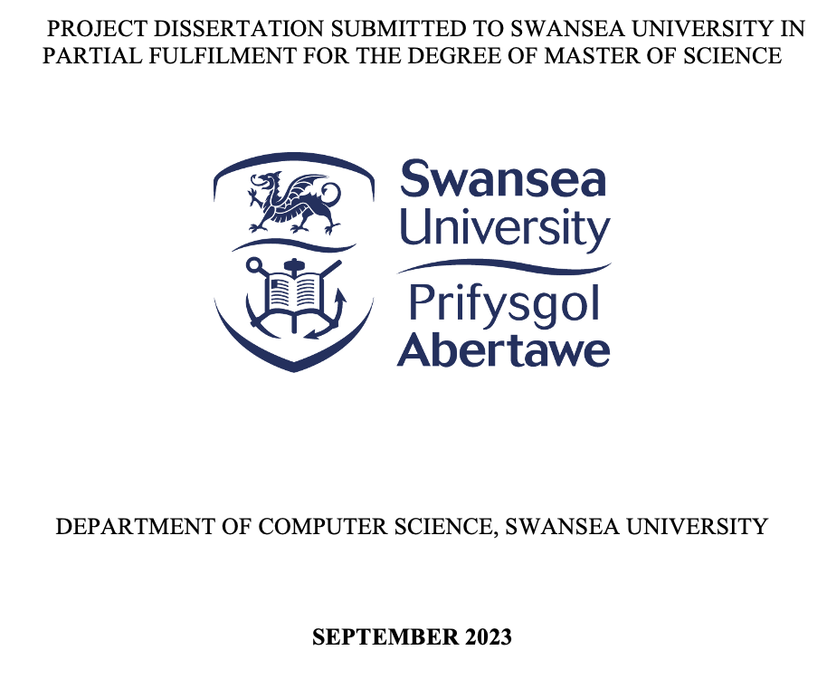


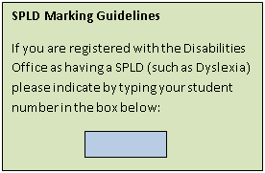


WORD LIMIT POLICY

STUDENT NUMBER: 2235802
WORD COUNT:
MODULE CODE: MN-D017

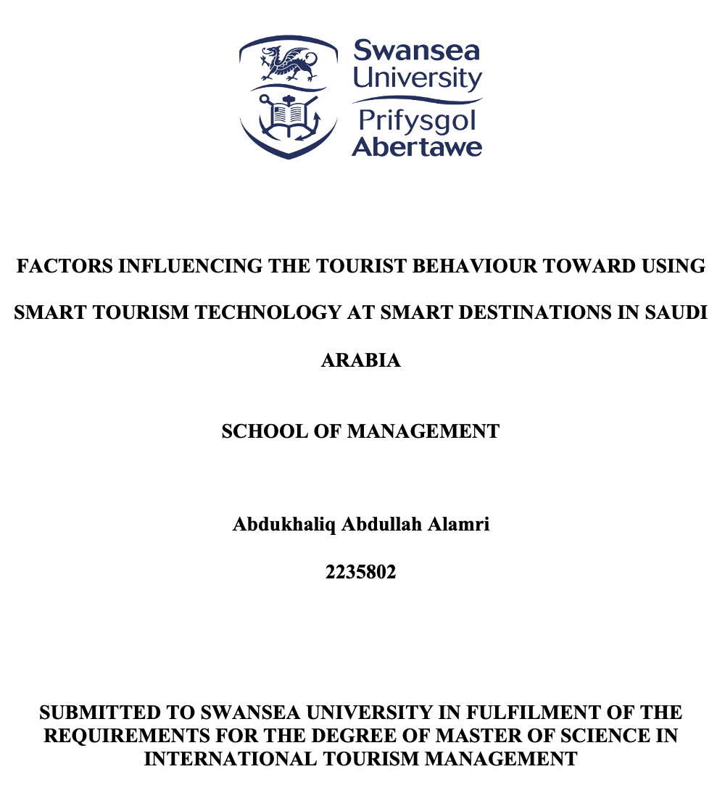

ABSTRACT
Smart tourism, driven by advancements in technology, has become integral to modern travel experiences. This research investigates the intricate dynamics of tourist behaviour towards the utilisation of Smart Tourism Technologies (STTs) at smart destinations in Saudi Arabia. The study focuses on key determinants such as Informativeness, Accessibility, Interactivity, Personalisation, Privacy and Security, aiming to understand their impact on tourist satisfaction and subsequent revisit intentions. Quantitative research method was employed, utilising non-probability sampling to gather responses from a diverse pool of 385 participants. The study used SPSS and Smart PLS for data analysis, employing Structural Equation Modelling (SEM) to scrutinize the relationships amongst the identified factors. Remarkably, all formulated hypotheses were accepted, revealing that Informativeness, Accessibility, Interactivity, Personalisation, Privacy and Security significantly influence tourists' satisfaction. This satisfaction, in turn, plays a pivotal role in determining their intention to revisit smart destinations in Saudi Arabia. The findings of this research contribute nuanced insights into the complex interplay between tourists and STTs, offering valuable implications for the development and enhancement of smart tourism initiatives in the region. The study underscores the importance of tailoring STTs to align with tourists' preferences, providing policymakers, destination managers, and technology developers with actionable insights to craft strategies that accommodate to the precise needs of tourists.
Keywords: Smart Tourism, Smart Tourism Technologies, Smart Destinations, Saudi Arabia, Tourist Behaviour, Quantitative research.

DECLARATIONS AND STATEMENTS
Signature:
Abdul
Name: Abdukhaliq Abdullah Alamri
Date: 20/02/2024
Student ID Number: 2235802
ETHICAL APPROVAL FORM

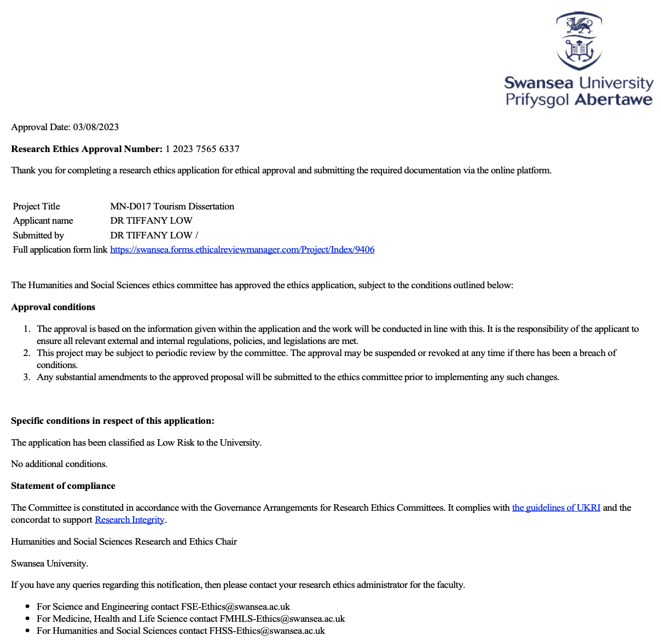
SCHOOL OF MANAGEMENT ETHICAL REVIEW CHECKLIST
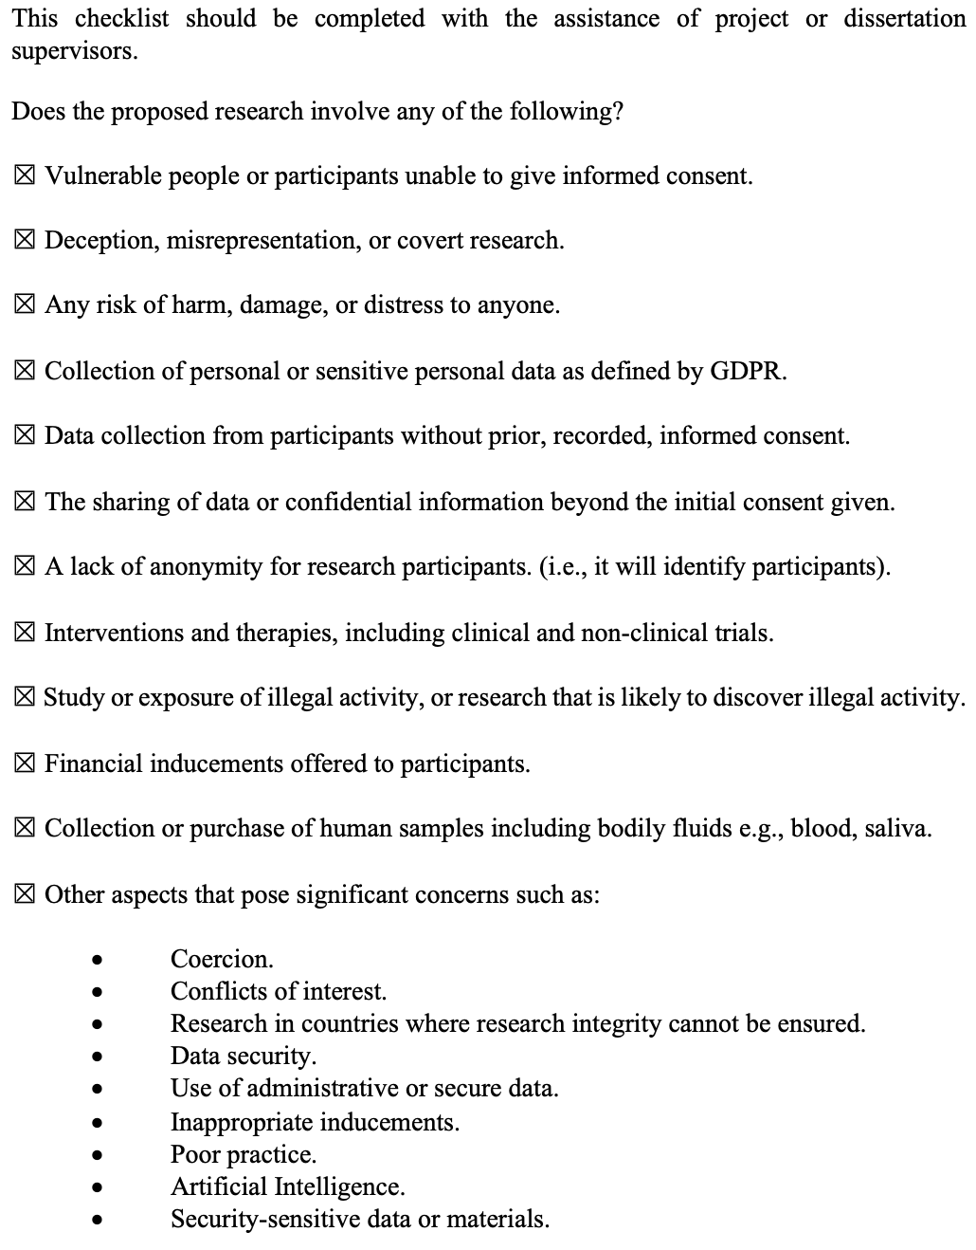

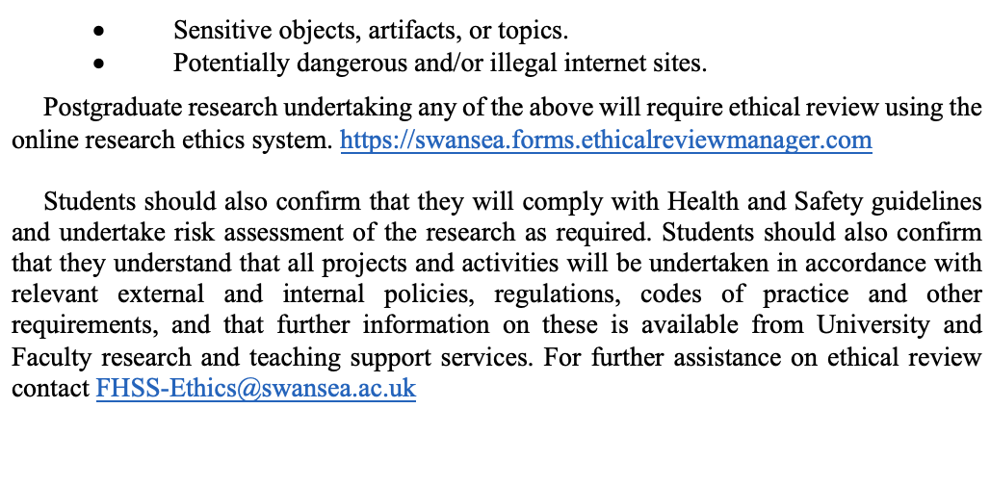

ACKNOWLEDGEMENTS

I would like to thank my parents, whom I am truthfully blessed to have had, and I am grateful to them for their profound influence on my personal and academic development.
To my dear friends, you have been more than companions; you have been pillars of strength, cheering me on through the highs and standing by me during the lows. Your belief in my abilities and your constant encouragement have fuelled my determination to strive for excellence.

Contents PAGE
ABSTRACT II
ACKNOWLEDGEMENTS 5
CONTENTS PAGE 6
FIGURES 10
TABLES 11
ABBREVIATIONS 12
CHAPTER 1: Introduction 13
1.1 Research Background 13
1.2 Research Motivation 14
1.3 Research Problem 14
1.4 Research Objectives 15
1.5 Research Questions 16
1.6 Research Scope 16
1.7 Research Significance 16
1.7.1 Academic Significance 17
1.7.2 Practical Significance 17
1.8 Thesis Outline 17
CHAPTER 2: Literature Review 20
2.1 Introduction 20
2.2 Smart Tourism 20
2.3 Smart Tourism Technologies (STTs) 21
2.4 Related Research 23
2.4.1 Informativeness 24
2.4.2 Accessibility 25
2.4.3 Interactivity 25
2.4.4 Personalisation 27
2.4.5 Security And Privacy 27
2.5 Related Research Summary 28
2.6 Theoretical Models 30
2.6.1 Smart Tourism Technologies (STTs) 30
2.6.2 Theoretical Model Selection 31
2.6.3 Theoretical Model Development 32
2.7 Research Hypothesis Development 34
2.7.1 Informativeness 34
2.7.2 Accessibility 35
2.7.3 Interactivity 35
2.7.4 Personalisation 36
2.7.5 Security and Privacy 36
2.7.6 Satisfaction 37
2.8 Summary 37
CHAPTER 3: Methodology 39
3.1 Introduction 39
3.2 Research Design 39
3.3 Instrument Development Process 42
3.3.1 Questionnaire Construction 42
3.3.2 Items Measurement Scale 43
3.3.3 Content Validity 43
3.3.4 Pilot Study 43
3.4 Data Collection Instrument 44
3.5 Sampling Design 44
3.5.1 Population 44
3.5.2 Sample Frame 44
3.5.3 Sample Size 45
3.5.4 Sampling Techniques 45
3.6 Statistical Tools and Data Analysis Approaches 46
3.7 Summary 46
CHAPTER 4: Data Analysis and discussion 48
4.1 Introduction 48
4.2 Data Screening 48
4.2.1 Missing Data 48
4.2.2 Outliers 49
4.3 Descriptive Analysis 49
4.3.1 Demographic Profile of the Respondents 49
4.4 Measurement Model Assessment 51
4.4.1 Measurement Model Results 51
4.4.2 Construct Reliability and Validity 52
4.4.3 Convergent Validity 53
4.4.4 Discriminant Validity 53
4.5 Structural Model Assessment 55
4.5.1 Research Hypotheses Testing Results 56
4.5.2 Coefficient of Determination: R² Value 57
4.5.3 Hypothesis Discussion 58
4.6 Summary 60
CHAPTER 5: Conclusion 61
5.1 Introduction 61
5.2 Research Summary 61
5.3 Research Recommendation 64
5.4 Research Contribution 65
5.5 Research Limitation 66
5.6 Future Research 66
5.7 Conclusion 67
REFERENCES 69
APPENDICES 81
Appendix A: Questionnaire Construction 81
Appendix B: Questionnaire Sample 84

Figures
Figure ‎3-1 Research Design 38
Figure ‎4-1 Gender of Respondents 48
Figure ‎4-2 Age of Respondents 48
Figure ‎4-3 Education of Respondents 49
Figure ‎4-6 Measurement Model Results 53
Figure ‎4-7 Structural Model Testing 54

Tables
Table ‎2-1 Related Research Summary 28
Table ‎2-1 The Developed Theoretical Model Selection Criteria 33
Table ‎4-1 Demographics of Respondents 49
Table ‎4-2 Outer Loadings 52
Table ‎4-3 Measurement Model Results 53
Table ‎4-4 Correlation Matrix and Square Root of the AVE 54
Table ‎4-5 Heterotrait-Monotrait Ratio 54
Table ‎4-6 Research Hypotheses Test Results 57
Table ‎4-7 Dependent Variables R2 Values 57
Table ‎4-8 Research Hypothesis Decision 58

Abbreviations
STTs | : | Smart Tourism Technologies
IoT | : | ﻿Internet of Things
ICT | : | ﻿Information and Communication Technology
DMOs | : | ﻿Destination Marketing Organisations
VR | : | Virtual Reality
AR | : | Augmented Reality
HMRC | : | Heterotrait-Monotrait Ratio of Correlations
SPSS | : | Statistical Package for Social Sciences
SEM | : | Structural Equation Modelling

Introduction

Research Background
The fast advancement of information and communication technology (ICT) has ushered the traditional tourism industry into a transformative era known as smart tourism (Naramski, 2020). Smart technologies, encompassing a spectrum of innovative tools and applications, have become integral components of the tourism landscape (Morales-Urrutia et al., 2020). These technologies not only redefine the way tourists interact with destinations but also extend the boundaries of co-creation, aiming to craft unforgettable and tailored experiences for travellers (Corrêa & Gosling, 2021).
Based on tourists’ perception, the role of smart technology in travel has evolved significantly (Gao & Pan, 2022). In the initial stages, ICT primarily served as a means for travel information searching and decision-making (Kuoksa, 2022). However, as the trend towards smart tourism gained momentum, tourists started embracing a broader array of technologies, marking a paradigm shift in how they engage with their travel experiences (Rodrigues et al., 2022). This evolution prompted many tourism-related businesses to adopt various smart technologies as part of their strategies for promoting and marketing destinations (Križaj et al., 2021).
Existing research have delved in the use of smart tourism technology (STT) services when assessing overall satisfaction (Jeong & Shin, 2020). Yet, there is still a significant research gap regarding how smart tourism experiences contribute to tourist satisfaction and revisiting intentions (Mehraliyev et al., 2020). No comprehensive research have been performed to build a holistic conceptualisation of perceived smart tourism technologies and its impact on satisfaction and revisiting intention, particularly within the Saudi Arabian population (Alotaibi et al., 2022).
To address this gap, this research aims to propose and examine a theoretical model that explores the attributes of smart tourism technology, their influence on travel satisfaction, and subsequent effects on tourists' revisiting intentions This research endeavours to fill the existing gap in the literature, providing valuable insights into the evolving dynamics of smart tourism destinations in the context of Saudi Arabia.

Research Motivation
This research is motivated by the profound recognition of the transformative role that smart tourism technologies play in shaping the landscape of the burgeoning tourism sector in Saudi Arabia (Al-Omari & Al-Marghirani, 2017). The research aims to examine six crucial dimensions namely, information, accessibility, interactivity, personalisation, privacy, and security, to gain a holistic understanding of their collective influence on tourists' overall satisfaction (Jeong & Shin, 2020). Acknowledging the distinctive socio-cultural context of Saudi Arabia adds a layer of complexity to the investigation, making it imperative for both academic and practical reasons (Madkhali et al., 2023). Ultimately, the research seeks to explore the effect of smart tourism technologies on the tourists’ satisfaction and the revisiting intention within the dynamic landscape of smart destinations in Saudi Arabia.

Research Problem
The rapid integration of smart tourism technologies in Saudi Arabia, exemplified smart tourism destinations, underscores the need for a thorough exploration into the influence of these technologies on tourists' overall satisfaction (Balakrishnan et al., 2023). As Saudi Arabia positions itself at the forefront of technological advancements in the tourism sector, it becomes imperative to assess the holistic impact of these innovations on the visitor experience (Al-Shammari & El-Sawy, 2020).
Despite the increasing prevalence of smart tourism technologies in the country, a notable research gap exists in comprehensively understanding tourists' overall satisfaction with these technologies and discerning whether this satisfaction significantly influences their intention to revisit (Almathami & Mair, 2023). This research aims to address this gap by embarking on a nuanced investigation, delving into the intricate dimensions of Information, Accessibility, Interactivity, Personalisation, Privacy, and Security within the unique context of smart tourism destinations and examine how smart tourism technologies impact tourists' satisfaction, providing crucial insights for shaping the future of Saudi Arabia's tourism industry.

Research Objectives
This research aims to examine factors influencing the tourist behaviour toward using smart tourism technologies at smart destinations in Saudi Arabia. To accomplish this, the subsequent research objectives are articulated:
- To examine the effect of informativeness on tourists’ satisfaction at smart tourism destinations in Saudi Arabia
- To examine the effect of accessibility on tourists’ satisfaction at smart tourism destinations in Saudi Arabia
- To examine the effect of interactivity on tourists’ satisfaction at smart tourism destinations in Saudi Arabia
- To examine the effect of personalisation on tourists’ satisfaction at smart tourism destinations in Saudi Arabia
- To examine the effect of privacy and security on tourists’ satisfaction at smart tourism destinations in Saudi Arabia
- To examine the effect of satisfaction on tourists’ revisit intention to smart tourism destinations in Saudi Arabia

Research Questions
To accomplish the objectives mentioned above, this research will be answering the subsequent research questions:
- What is the effect of informativeness on tourists’ satisfaction at smart tourism destinations in Saudi Arabia?
- What is the effect of accessibility on tourists’ satisfaction at smart tourism destinations in Saudi Arabia?
- What is the effect of interactivity on tourists’ satisfaction at smart tourism destinations in Saudi Arabia?
- What is the effect of personalisation on tourists’ satisfaction at smart tourism destinations in Saudi Arabia?
- What is the effect of privacy and security on tourists’ satisfaction at smart tourism destinations in Saudi Arabia?
- What is the effect of satisfaction on tourists’ revisit intention to smart tourism destinations in Saudi Arabia?

Research Scope
This research focuses on quantitatively studying tourists' satisfaction with smart tourism technologies in Saudi Arabian destinations and its impact on revisit intention. It analyses Information, Accessibility, Interactivity, Personalisation, and Privacy and Security effect on tourists’ Satisfaction using surveys to collect structured data. The sampling strategy aims for demographic representation, employing statistical methods to reveal correlations between Satisfaction and Revisit Intention. This approach provides empirical insights into smart tourism's impact on satisfaction, benefiting academic discourse and practical applications in the Saudi Arabian tourism industry.

Research Significance
The significance of this research extends across multiple dimensions, contributing valuable insights to academia, industry stakeholders, and policymakers.

Academic
This research addresses a crucial gap in existing literature by examining the influence of smart tourism technologies on tourists' satisfaction and revisit intention, particularly in the distinctive context of Saudi Arabia. It advances smart tourism theory by intricately exploring dimensions such as Informativeness, Accessibility, Interactivity, Personalisation, Privacy, and Security, providing nuanced insights into their collective impact on satisfaction. Moreover, it contributes to the growing knowledge of smart tourism destinations, offering insights applicable to similar initiatives worldwide.

Practical
The research findings have direct relevance for industry stakeholders in Saudi Arabia, such as destination marketers, technology developers, and tourism businesses. Destination marketers can use insights to improve the design and promotion of smart tourism technologies, enhancing the overall satisfaction of tourists in smart destinations. Technology developers can identify key areas influencing satisfaction and revisit intention, guiding the enhancement of existing technologies or the development of innovative solutions.

Thesis Outline
Chapter 1 offers a brief overview of the research background, offering preliminary insights into factors influencing tourists' behaviour in visiting smart tourism destinations, with a focus on Saudi Arabia. It explores the motivations driving the research, detailing components such as the research problem, research objectives and research questions, research scope, and finally the research significance. The subsequent chapters are structured as follows:
- Chapter 2 provides a comprehensive exploration of smart tourism. It begins with an overview of the chapter and then delves into smart tourism technologies in Sections 2.2 and 2.3. Section 2.4 examines existing related research, while Section 2.5 explores theoretical models influencing tourist behaviour smart tourism technology. This leads to the development of theoretical models in Section 2.6 and research hypothesis development in Section 2.7, concluding with a summary in Section 2.8.
- Chapter 3 explores the research methods used to achieve the outlined objectives, detailed in Section 3.2. This section provides a thorough overview of the methodology. Section 3.3 discusses the development of research instruments, covering aspects such as the questionnaire, item measurements, content validity, and the finally the pilot study. Following this, Section 3.4 explains the data collection techniques, while Section 3.5 details the sampling design, including information on the population of interest, the sampling frame, the sampling size, and lastly the sampling technique. The chapter concludes in Section 3.7 with a comprehensive summary of the research methodology.
- Chapter 4 delves into critical aspects of data analysis and discussion. It begins in Section 4.2 by explaining the crucial process of data screening to ensure dataset integrity. Following this, Section 4.3 provides a meticulous descriptive analysis, unveiling essential patterns and insights within the data. Section 4.4 explores the measurement model's validity and reliability, while Section 4.5 assesses the structural model, including hypothesis testing and discussion. Finally, Section 4.6 consolidates main results and discussions driven from the data analysis phase, offering a cohesive overview of research outcomes and their implications. This chapter provides valuable insights and interpretations derived from the research findings.
- Chapter 5 summarises the research journey, highlighting the successful accomplishment of research objectives in Section 5.2. The chapter then provides research recommendations based on the analysis in Section 5.3. Section 5.4 discusses the research contributions, unveiling novel insights and emphasising the research’s impact on existing knowledge. Recognising limitations in Section 5.5, the chapter explores constraints in-depth. Looking to the future, Section 5.6 recommends further research. The chapter concludes in Section 5.7 with a comprehensive summary, reflecting on the study's significance within the broader context of the topic.

Literature Review

Chapter Overview
This chapter will comprehensively explore the intersection of smart tourism technology attributes, tourist satisfaction, and revisit intention in smart destinations in Saudi Arabia. Starting with a smart tourism overview, it emphasizes its importance in the digitally connected world, addressing unique challenges and considerations in Smart Tourism Technologies. The chapter reviews related research, highlighting the lack of studies in this area and emphasising the importance of the investigation. It discusses theoretical models relevant to understanding smart tourism dynamics and then focuses on developing a theoretical model with five independent variables (informativeness, accessibility, interactivity, personalisation, security, and privacy) and two dependent variables (satisfaction and revisit intention), integral to the research hypotheses.

Smart Tourism
The concept of "smart" has evolved as a transformative force in economic and social development, encapsulating practical devices such as smartphones, smart TVs, and smart cars (Um & Chung, 2021). In the context of smart tourism, the term extends beyond mere technological advancements; it signifies intelligence, eco-friendliness, sustainability, integration, and ubiquity (J. Liu et al., 2023). This novel approach to tourism integrates technologies, akin to the complexity of a city, resulting in significant achievements (Gelter et al., 2021). The practical applications of smart tourism have outpaced academic endeavours, emerging primarily as marketing strategies and government projects (Mehraliyev et al., 2019). However, the lack of consensus in the literature regarding the definition of smart tourism has led to varied interpretations, encompassing aspects of management, trends, and information services (Ye et al., 2020).
Smart tourism is defined as a systematic and intensive management transformation (J. Liu et al., 2023). This emphasise that smart tourism holds the potential for resource optimization and value co-creation between tourists and service providers. To articulate the principles of smart tourism, (Ye et al., 2020), developed a comprehensive attributes applications framework. This framework extends to the application background of smart tourism, offering market strategies for Destination Marketing Organisations (DMOs) and private companies, aligning public welfare with profitability.
Crucially, research elucidates that smart tourism transcends a mere application of Information and Communication Technologies (ICT); it manifests as an ecosystem facilitating interactions among tourists, DMOs, and other stakeholders (Leung, 2022). This ecosystem generates added value, particularly in the form of co-creation value instigated by tourists. In essence, smart tourism is conceptualised as a mobile information system seamlessly intertwining information and physical infrastructure, thereby crafting an entirely new and enriched experience for tourists (Bhuiyan et al., 2022). Other research defined smart tourism by emphasising its multifaceted nature and the transformative potential it holds for the tourism industry by not just providing services but fostering interactive ecosystems that enhance the overall value for all involved stakeholders (Gretzel, 2021).

Smart Tourism Technologies (STTs)
Smart destinations represent a paradigm shift in the tourism industry, where the integration of cutting-edge technologies becomes a fundamental strategy in enhancing tourism resources and serves as a dynamic marketing platform (Jeong & Shin, 2020). The term "Smart Tourism Technologies" (STTs) encompasses a wide array of both general and specific applications designed to not only augment tourists' experiences but also generate added value across various dimensions (Azis et al., 2020). These technologies collectively redefine the landscape of destination management and visitor engagement (Gajdosik & Orelova, 2020).
Examples of STTs extent a diverse spectrum, incorporating ubiquitous computing and the Internet of Things (IoT), where interconnected devices seamlessly communicate to create an intelligent environment (Novera et al., 2022). Cloud computing plays a pivotal role, providing scalable and efficient data storage and processing capabilities (Lv & others, 2022). Ubiquitous connectivity is ensured through Wi-Fi, fostering continuous and seamless access to information(Alias & Hashim, 2023).
Smartphones and mobile connected devices serve as ubiquitous companions throughout the tourist journey, offering personalised information, navigation, and contextual insights (Dorcic et al., 2019). Beacons strategically positioned within the destination facilitate location-based interactions, while virtual reality (VR) and augmented reality (AR) technologies provide immersive and engaging experiences, transcending traditional modes of sightseeing (Idris et al., 2021).
STTs represent a convergence of diverse technologies, creating an interconnected ecosystem that not only enhances the efficiency of destination management but also revolutionises tourists' interactions with the locale (Pasquinelli & Trunfio, 2023). The integration of these technologies into the fabric of smart destinations is aimed not just at meeting the immediate needs of tourists but also at creating a dynamic and immersive environment that adds significant value to their overall experience (Jeong & Shin, 2020). As destinations increasingly embrace these innovations, the landscape of tourism undergoes a transformative shift towards a more connected, intelligent, and engaging future (Dorcic et al., 2019).

Related Research
Smart Tourism Technologies (STTs) constitute a comprehensive array of cutting-edge technologies and services that collectively redefine the landscape of tourism engagement and destination management (Gajdosik & Orelova, 2020). To assess the effectiveness of STTs in destinations, researchers have categorised these technologies based on four key attributes: information, providing comprehensive and relevant information; accessibility, ensuring seamless and user-friendly interactions; interactivity, fostering engagement and participation; and personalisation, tailoring experiences to individual preferences (Torabi et al., 2023). These attributes collectively contribute to the overall effectiveness and success of STTs in shaping a destination's smart tourism ecosystem (Ng et al., 2023).
Building on existing research, this study takes a step further by delving into the critical dimension of security and privacy in technology-mediated tourism destinations (Gong & Schroeder, 2022). The utilisation of STTs in smart tourism is intricately tied to the safeguarding of tourists' privacy and their perceptions of security when engaging in transactions that require the sharing of digital information (Tiwari et al., 2023). Understanding and addressing security and privacy concerns become paramount in ensuring the sustainable and ethical implementation of smart tourism technologies (Gong & Schroeder, 2022). By examining this aspect, the research aims to provide nuanced insights into the delicate balance between technological innovation and the protection of tourists' privacy and security, ultimately contributing to the responsible and secure advancement of smart tourism destinations.

Informativeness
Research on Informativeness within the context of Smart Tourism Technologies (STTs) has been a vibrant and evolving field (Sustacha et al., 2023). Scholars and researchers have explored various facets of how information is delivered, processed, and utilised in smart tourism environments (Nafrees & Shibly, 2021). In their study, (Gajdosik & Orelova, 2020), have investigated the role of diverse technological platforms and applications, including mobile apps, augmented reality, virtual reality, and interactive displays, in delivering informative content to tourists. They have also explored the effectiveness of these platforms in enhancing tourists' understanding of destinations and attractions (Gajdosik & Orelova, 2020).
Similarly, another research have investigated the role of diverse technological platforms and applications, including mobile apps, augmented reality, virtual reality, and interactive displays, in delivering informative (Kumar et al., 2022). In addition, the research highlighted the impact of user-generated content on social media platforms, such as reviews, recommendations, and real-time updates, has been studied extensively (Kumar et al., 2022). The research then offered an understanding how tourists engage with and rely on peer-generated content for information about destinations has become crucial in shaping the informativeness of STTs, which is also aligned with other research such as (Nafrees & Shibly, 2021).
Furthermore, the virtual reality has also been explored for its potential in offering richer and more engaging informational experiences (Idris et al., 2021). This research has investigated how these technologies contribute to tourists' understanding of historical sites, cultural events, and other attractions (Idris et al., 2021). However, as STTs involve the collection and processing of personal data, research has delved into tourists' concerns regarding data privacy and security (Jeong & Shin, 2020). Understanding the balance between providing informative content and ensuring user privacy has been a key consideration in recent studies (Nafrees & Shibly, 2021).

Accessibility
Research on Accessibility within the context of Smart Tourism Technologies (STTs) has focused on ensuring seamless and inclusive access to information and services for all tourists (Azis et al., 2020). One of the primary focuses has been on adopting universal design principles to ensure that STTs are accessible to a diverse range of users, including those with disabilities (Atanga, 2020). In this research, the authors have explored how technologies can be designed to accommodate various needs, such as visual or auditory impairments, to create an inclusive tourism experience. In addition, the authors also have investigated the role of mobile applications with responsive design features to enhance accessibility (Atanga, 2020). This includes features like adjustable text size, voice-guided navigation, and other functionalities that cater to different user preferences and requirements (Atanga, 2020).
Furthermore, the use of geospatial technologies, such as GPS and location-based services, has been explored to improve accessibility in smart tourism (Mitala et al., 2022). This enables tourists to navigate and explore destinations more efficiently, providing real-time information about nearby points of interest and accessible routes (Diaz-Parra et al., 2023). To cater to a global audience, this research, have explored the implementation of multilingual interfaces within STTs. Additionally, voice recognition technologies have been studied to facilitate hands-free interaction, particularly beneficial for users with mobility challenges (Diaz-Parra et al., 2023).

Interactivity
Studies on Interactivity within the context of Smart Tourism Technologies (STTs) has explored how technology facilitates dynamic and engaging interactions between tourists and their surroundings (Jeong & Shin, 2020). Studies have investigated the role of mobile applications in fostering real-time interaction between tourists and destinations (Akdu, 2020). Mobile apps equipped with geolocation services enable users to access relevant information, receive notifications, and actively engage with their surroundings during their visit (Mitala et al., 2022). Moreover, the integration of AR and VR technologies has been a central focus of research on interactivity. These immersive technologies offer tourists interactive experiences, allowing them to overlay digital information on the physical environment (AR) or virtually explore destinations (VR), enhancing engagement and understanding (Gajdosik & Orelova, 2020).
Furthermore, research has explored the effectiveness of interactive displays and smart signage in enhancing tourists' interactions with destinations (Sood & Bhandari, 2023). These technologies provide interactive maps, historical information, and multimedia content, encouraging tourists to actively participate in their exploration (Kadir et al., 2023). Similarly, the integration of social media platforms within STTs has been studied to understand how tourists engage with and share their experiences (Gajdosik & Orelova, 2020). Social media functionalities embedded in apps or destination platforms encourage real-time sharing, fostering a sense of community and interactivity among tourists (Balakrishnan et al., 2023).
In addition, Chatbots and virtual assistants have been investigated for their role in providing interactive support to tourists (Orden-Mejia & Huertas, 2022). These AI-powered tools offer instant responses to queries, guide users through destinations, and enhance the overall interactivity by creating a conversational interface. Platforms that facilitate user-generated content, such as reviews, recommendations, and photos, have been a subject of research (Yang et al., 2023). These platforms contribute to interactivity by allowing tourists to share their experiences, influencing others, and creating a dynamic exchange of information.

Personalisation
Research on Personalisation within the context of Smart Tourism Technologies (STTs) has focused on tailoring the tourist experience to individual preferences, creating a more engaging and relevant interaction (Marin Diaz et al., 2023). Personalisation in STTs often involves the use of machine learning algorithms to analyse user behaviour, preferences, and past interactions (Gajdosik & Orelova, 2020). Research has explored how data-driven personalisation can enhance the accuracy and effectiveness of tailored content delivery (Yang et al., 2023). Similarly, Studies have investigated the role of personalised recommendations in guiding tourists through their journey (Marin Diaz et al., 2023). Personalised suggestions for attractions, activities, dining options, and other relevant services contribute to a more customised and pleasant travel experience (Yang et al., 2023).
Furthermore, research has delved into the creation of user profiles to capture individual preferences and interests (Diaz et al., 2023). Understanding tourists' preferences allows STTs to offer content and services that align with their specific needs, contributing to a more personalised and user-centric approach (Marin Diaz et al., 2023). Additionally, the development of mobile applications has been a focal point in providing personalised experiences. These apps often feature functionalities like itinerary planning, location-based suggestions, and real-time updates, catering to the unique preferences of each tourist (Xu et al., 2024).

Security And Privacy
Research on Security and Privacy within the context of Smart Tourism Technologies (STTs) has been a critical area of investigation, focusing on ensuring the protection of user data and maintaining a secure technological environment (Tiwari et al., 2023). Studies have explored the impact of data protection regulations and similar frameworks, on the development and implementation of STTs (Tassikas, 2021). Research has emphasised the importance of compliance with these regulations to safeguard user privacy (O’Connor, 2020). Understanding tourists' awareness and perceptions of security and privacy in STTs has been a central theme. Research has investigated how user trust and confidence are influenced by the transparency of data collection practices, user consent mechanisms, and overall communication regarding security measures (Gong & Schroeder, 2022).
Moreover, the use of encryption technologies to secure communication channels within STTs has been a focus of research (Nafrees & Shibly, 2021). Ensuring that data transmitted between users and the smart tourism platform is encrypted helps prevent unauthorised access and protects sensitive information (Meiyanti et al., 2022). Likewise, research has investigated the role of cybersecurity measures in protecting STTs from cyber threats and attacks (Vinodan et al., 2024). In addition, ethical considerations related to data use in STTs have been a research focus (Femenia-Serra et al., 2019).

Related Research Summary
Table 2.1 summarises the main findings of the research articles on Informativeness, Accessibility, Interactivity, Personalisation, and Security & Privacy within the context of Smart Tourism Technologies (STTs):
Table ‎2-1 Related Research Summary
Author(s) | Main Findings
Sustacha et al., 2023 | - Explored various facets of information delivery, processing, and utilisation in smart tourism environments.
Nafrees & Shibly, 2021 | - Explored diverse technological platforms in delivering informative content.
Gajdosik & Orelova, 2020 | - Investigated diverse technological platforms in delivering informative content.  - Explored the effectiveness of these platforms in enhancing tourists' understanding.
Kumar et al., 2022 | - Investigated diverse technological platforms in delivering informative content.
Idris et al., 2021 | - Investigated how VR technologies contribute to tourists' understanding.
Jeong & Shin, 2020 | - Explored tourists' concerns regarding data privacy and security.  - Investigated the direct impact of informativeness on tourists' decision-making processes.
Torabi et al., 2023 | -Examined the importance of informativeness for destination management organisations and stakeholders.
Atanga, 2020 | - Explored how technologies can accommodate various needs to create an inclusive tourism experience.  - Investigated the role of mobile applications with responsive design features to enhance accessibility.
Mitala et al., 2022 | - Explored the use of geospatial technologies to improve accessibility in smart tourism.  - Investigated the implementation of multilingual interfaces within STTs.
Diaz-Parra et al., 2023 | - Explored the use of geospatial technologies to improve accessibility.  - Studied voice recognition technologies for hands-free interaction.
Akdu, 2020 | - Investigated the role of mobile applications in fostering real-time interaction.
Sood & Bhandari, 2023 | - Explored the effectiveness of interactive displays and smart signage.  - Provided interactive maps and historical information.
Yang et al., 2023 | - Explored platforms facilitating user-generated content for interactivity.
Gajdosik & Orelova, 2020 | - Explored gamification elements to enhance interactivity.
Wise & Heidari, 2019 | - Explored the integration of IoT into STTs for creating interactive environments.
Marin Diaz et al., 2023 | - Focused on tailoring tourist experiences to individual preferences.  - Explored data-driven personalisation and personalised recommendations.
Diaz et al., 2023 | - Explored the creation of user profiles for capturing individual preferences.
Xu et al., 2024 | - Investigated mobile applications for providing personalised experiences.
Gajdosik & Orelova, 2020 | - Explored the integration of AR and VR technologies for personalised experiences.
Tiwari et al., 2023 | - Focused on ensuring the protection of user data and maintaining a secure technological environment.
Nafrees & Shibly, 2021 | - Explored the use of encryption technologies for securing communication channels.
Vinodan et al., 2024 | - Examined cybersecurity measures to protect STTs from cyber threats and attacks.
Femenia-Serra et al., 2019 | - Discussed ethical considerations related to data use in STTs.

Theoretical Models
Various theoretical models are employed to analyse tourist behaviour in destination selection, each offering unique perspectives on the decision-making process (McKercher & Prideaux, 2020). Traditional models, such as the Theory of Planned Behaviour (Abd Hamid & Mohd Isa, 2015) and the Push-Pull Theory, focus on psychological and socio-economic factors influencing destination choices (Soldatenko et al., 2023). Yet, the theory of Smart Tourism Technologies (STTs) provides a contemporary lens, emphasising the impact of advanced technologies, information accessibility, and personalised experiences on tourists' decisions, offering a holistic framework for understanding the evolving landscape of destination selection in the digital era (Pai et al., 2020).

Smart Tourism Technologies (STTs)
The theory of Smart Tourism Technologies (STTs) constitutes a comprehensive framework that navigates the integration of advanced technologies into the tourism sector (Jeong & Shin, 2020). At its core, STTs theory encompasses the synergistic fusion of information and communication technologies, data analytics, and innovative applications within the tourism domain (Zhang et al., 2022). This theoretical framework seeks to explore how these technologies collectively enhance the entire tourism ecosystem, from destination management and marketing to the personalised experiences of individual travellers (Pai et al., 2020). By delving into the multifaceted dimensions of STTs, researchers aim to elucidate the mechanisms through which smart technologies contribute to more efficient, interactive, and personalised tourism experiences (Jeong & Shin, 2020).
The theoretical underpinnings of STTs also address considerations such as accessibility, interactivity, personalisation, security, and privacy, reflecting a holistic approach to understanding and optimising the evolving landscape of smart tourism (Zhang et al., 2022). As an emerging field, STTs theory continues to evolve in tandem with technological advancements, providing a dynamic foundation for scholarly inquiry and practical applications within the rapidly transforming tourism industry (Pai et al., 2020).

Theoretical Model Selection
The theory of Smart Tourism Technologies (STTs) serves as an optimal theoretical model for conducting research on using smart tourism technology in smart destinations (Pai et al., 2020). STTs theory inherently aligns with the core objectives of this research by providing a comprehensive framework that explores the integration and impact of advanced technologies in the tourism sector (Zhang et al., 2022). Given the evolving landscape of smart destinations in Saudi Arabia, STTs theory offers a nuanced lens to dissect the intricate factors shaping tourist behaviour.
This theoretical model not only encompasses the technological aspects but also considers broader dimensions such as accessibility, interactivity, and personalisation (Jeong & Shin, 2020). As tourists engage with smart technologies in these destinations, STTs theory allows for a holistic examination of the multifaceted influences on their behaviour (Pai et al., 2020). Its adaptability to the dynamic nature of technological advancements and its emphasis on the entire tourism ecosystem make STTs theory the most suitable choice to unravel the complexities of tourist behaviour in the context of smart tourism technologies in Saudi Arabia.

Theoretical Model Development
The theory of Smart Tourism Technologies (STTs) has been adapted in this research study to examine factors influencing the tourist behaviour toward using smart tourism technology when visiting smart destinations in Saudi Arabia. The developed theoretical model variables have been adapted from the original theory to examine the tourist behaviour toward using smart tourism technology when visiting smart destinations in Saudi Arabia. An additional variable is added to the original variables named privacy and security. The developed theoretical model has set five independent variables namely: Informativeness, Accessibility, Interactivity, Personalisation, and Privacy and Security. And two dependent variables namely: Satisfaction and Revisit Intention as illustrated in Figure 2.3.
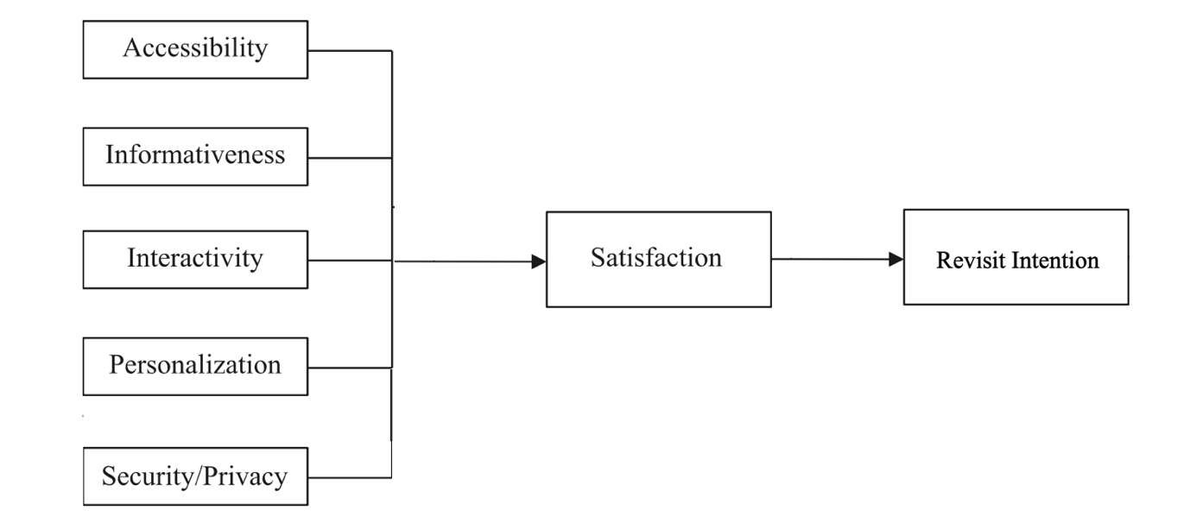
Figure ‎2-1 Developed SSTs Theoretical Model
Table 2.2 serves as a visual representation detailing the chosen criteria for variable selection in the formulation of the theoretical model. This table meticulously delineates each variable incorporated into the theoretical model, accompanied by a comprehensive explanation for their inclusion. The variables presented within the table have been carefully selected based on specific selection criteria to provide a clear rationale for their relevance in the developed theoretical framework.
Table ‎2-1 The Developed Theoretical Model Selection Criteria
Author | Model | Dimension | Inclusion | Reasons
(Zhang et al., 2022) | Smart Tourism Technologies (STTs) | Informativeness | √ | Informativeness refers to the degree and quality of information provided by STTs, offering tourists comprehensive and reliable data to enhance their understanding and engagement with a destination.
(Zhang et al., 2022) | Smart Tourism Technologies (STTs) | Accessibility | √ | Accessibility refers to the ease with which tourists, including those with diverse needs, can interact with and benefit from technology-driven tourism services and information.
(Zhang et al., 2022) | Smart Tourism Technologies (STTs) | Interactivity | √ | Interactivity refers to the dynamic and engaging exchange of information and experiences between tourists and technological platforms, enhancing their active participation and connection with destinations.
(Zhang et al., 2022) | Smart Tourism Technologies (STTs) | Personalisation | √ | Personalisation refers to the tailoring of tourist experiences through the use of advanced technologies to meet individual preferences, creating a more customised and enjoyable travel journey.
(Zhang et al., 2022) | Smart Tourism Technologies (STTs) | Privacy and Security | √ | Privacy and security involve safeguarding user data, ensuring compliance with regulations, and fostering user trust through transparent practices to create a secure and privacy-respecting environment for tourists engaging with smart tourism technologies.
(Zhang et al., 2022) | Smart Tourism Technologies (STTs) | Satisfaction | √ | Satisfaction refers to the overall contentment and fulfilment experienced by tourists as a result of their interaction with technology-driven services, contributing positively to their travel experiences.
(Zhang et al., 2022) | Smart Tourism Technologies (STTs) | Revisit Intention | √ | Revisit intention denotes to the tourist's willingness to revisit a particular destination based on their positive experiences and satisfaction with technology-enhanced services during a previous visit.

Research Hypothesis Development
This research is structured around the formulation of six research hypotheses, each serving as guiding principles and theoretical foundations for the investigations and analyses conducted. These hypotheses are integral to delineating the scope and direction of the research’s objectives. The hypotheses are outlined as follows:

Informativeness
Informativeness in Smart Tourism Technologies (STTs) refers to the quality and extent of information provided to enhance tourists' understanding and engagement with a destination. The hypothesis suggests a positive correlation between STTs' informativeness and tourists' overall satisfaction, as follows:
Hypothesis 1: STTs’ informativeness positively affect the tourists’ satisfaction at smart tourism destinations in Saudi Arabia.
Exploring this hypothesis aims to reveal the direct impact of informativeness on tourists' satisfaction at smart tourism destinations in Saudi Arabia, providing valuable insights for stakeholders and policymakers in the tourism industry to enhance satisfaction and revisit intention.

Accessibility
Accessibility in Smart Tourism Technologies (STTs) refers to the ease with which tourists, including those with diverse needs, can interact with and benefit from technology-driven tourism services and information. This hypothesis suggests that improved accessibility facilitated by smart tourism technologies results in higher levels of tourist satisfaction. Stated as follows:
Hypothesis 2: STTs’ accessibility positively affect the tourists’ satisfaction at smart tourism destinations in Saudi Arabia.
By investigating this hypothesis, this research aims at revealing the direct impact of accessibility on tourist satisfaction at smart tourism destinations in Saudi Arabia, providing insights for stakeholders and policymakers in the tourism sector to enhance satisfaction and revisit intention.

Interactivity
Interactivity within Smart Tourism Technologies (STTs) refers to the dynamic exchange of information and experiences between tourists and technological platforms, enhancing their active participation and connection with destinations. This hypothesis suggests that increased interactivity facilitated by smart tourism technologies correlates with higher levels of tourist satisfaction. Stated as follows:
Hypothesis 3: STTs’ interactivity positively affect the tourists’ satisfaction at smart tourism destinations in Saudi Arabia.
Exploring this hypothesis aims to uncover the direct impact of interactivity on tourist satisfaction at smart tourism destinations in Saudi Arabia, offering insights for stakeholders and policymakers in the tourism sector to enhance satisfaction and revisit intention.

Personalisation
Personalisation within Smart Tourism Technologies (STTs) involves tailoring tourist experiences using advanced technologies to meet individual preferences, creating a more customized and enjoyable travel journey. This hypothesis suggests that personalised experiences facilitated by smart tourism technologies contribute positively to tourists' overall satisfaction. Stated as follows:
Hypothesis 4: STTs’ personalisation positively affect the tourists’ satisfaction at smart tourism destinations in Saudi Arabia.
By investigating this hypothesis, the study aims to reveal the direct impact of personalisation on tourist satisfaction at smart tourism destinations in Saudi Arabia, providing valuable insights for stakeholders and policymakers in the tourism sector to enhance satisfaction and encourage revisit intention.

Security and Privacy
Privacy and security in Smart Tourism Technologies (STTs) involve safeguarding user data and ensuring compliance with regulations to create a secure and privacy-respecting environment. This hypothesis suggests that tourists' perception of security and privacy in the use of smart tourism technologies influences their overall satisfaction. Stated as follows:
Hypothesis 5: STTs’ Privacy and Security positively affect the tourists’ satisfaction at smart tourism destinations in Saudi Arabia.
By investigating this hypothesis, the study aims to reveal the direct impact of Security and Privacy on tourist satisfaction, providing valuable insights for stakeholders and policymakers in the tourism sector to enhance satisfaction and foster revisit intention.

Satisfaction
Satisfaction in the context of Smart Tourism Technologies (STTs) refers to the overall contentment and fulfilment experienced by tourists as a result of their interaction with technology-driven services, contributing positively to their travel experiences. his hypothesis suggests that higher levels of satisfaction derived from smart tourism technologies positively impact tourists' intentions to revisit smart destinations. As such, the following hypothesis is created:
Hypothesis 6: Satisfaction positively affect the tourists’ revisit intention to smart destinations in Saudi Arabia.
By investigating this hypothesis, the study aspires to unveil the direct influence of tourist satisfaction on their revisit intention to smart tourism destinations in Saudi Arabia. This exploration seeks to offer valuable insights to stakeholders and policymakers in the tourism sector in Saudi Arabia.

Chapter Summary
This chapter thoroughly explores the intricate corelation between the smart tourism technology attributes, tourist satisfaction, and revisit intention in smart destinations in Saudi Arabia. Starting with a smart tourism overview, it emphasizes its crucial significance in today's digitally connected world, addressing unique challenges and considerations associated with Smart Tourism Technologies. The chapter reviews existing research, identifying a significant gap in this niche, and underscoring the importance of the current investigation. It discusses theoretical models relevant to understanding smart tourism dynamics and delves into the development of a theoretical model with five IVs (informativeness, accessibility, interactivity, personalisation, security, and privacy) and two DVs (satisfaction and revisit intention), integral to research hypotheses.

Methodology

Chapter Overview
This chapter explores the selected methodology for the current study. It begins by emphasising the selected research design and then explores the systematic process of instrument development. The construction of the questionnaire is meticulously detailed, covering the data collection instrument. The chapter further discusses the systematic sampling design for representativeness and introduces the statistical tools together with the data analysis techniques to be applied. Through this comprehensive examination, the chapter goals to facilitate a clear and all-encompassing understanding of the method designed to effectively address the research objectives.

Research Methodology Design
The research design serves as a foundational blueprint, guiding both data collection and analysis efforts, as emphasized by (Lowhorn, 2007). This section will thoroughly explore the research design, discussing carefully considered options aligned with the research’s objectives. Focusing on crucial aspects like sampling design, data collection methodologies, variable measurement approaches, and hypothesis testing strategies. The research design for this research is outlined as follows:
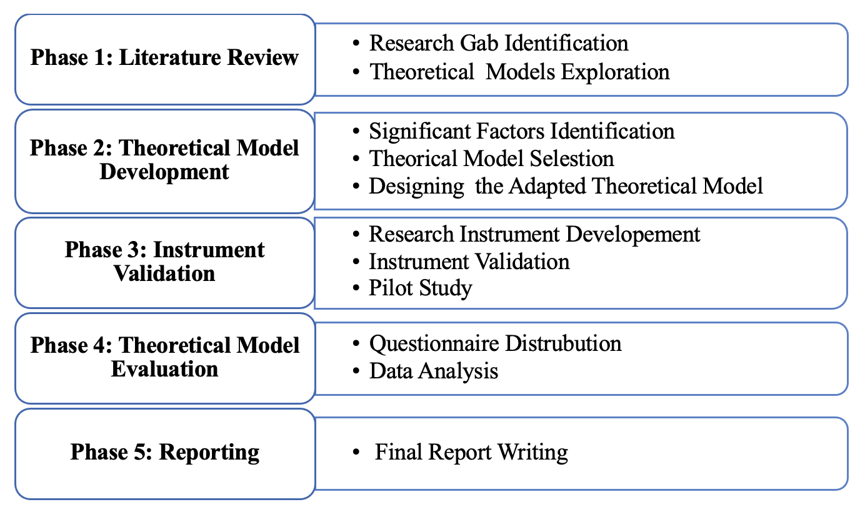
Figure ‎3-1 Research Methodology Design
- Phase 1: Literature Review
The literature review in this study is crucial for identifying research gaps and exploring theoretical models influencing tourist behaviour in adopting smart tourism technology at smart destinations in Saudi Arabia. This phase involves a systematic global review of tourist behaviour related to smart tourism technology, with a focus on studies in Saudi Arabia. Scrutinizing theoretical models used to assess tourist behaviour, the review aims to yield valuable insights. The synthesis of findings from this extensive review will enable drawing conclusive remarks on existing research gaps and theoretical frameworks applied to understand tourist behaviour regarding the use of smart tourism technology at smart destinations in Saudi Arabia.
- Phase 2: Theoretical Model Development
From the extensive literature review, the study is positioned to gain conclusive insights into the key factors shaping tourist behaviour in adopting smart tourism technology within smart destinations in Saudi Arabia. The subsequent theoretical framework will be carefully developed, drawing inspiration from the Theory of Smart Tourism Technologies (STTs), extensively discussed in Chapter 2, Section 2.6. This adapted theoretical model will establish a strong foundation for examining the nuanced dynamics of tourist behaviour in smart destinations. It ensures a comprehensive exploration of perceived threats and facilitates a clear understanding of the factors influencing smart tourism technology adoption among tourists in Saudi Arabia.
- Phase 3: Instrument Validation
The instrument validation will undergo a comprehensive development process, encompassing various crucial stages. This includes the meticulous design of the questionnaire, the refinement of questionnaire scales, the execution of a pilot study to assess the instrument's effectiveness, and a thorough validation of the questionnaire content. Each step in this development process is essential to ensure the reliability and validity of the research instrument, providing a robust foundation for collecting accurate and meaningful data in the subsequent phases of the study.
- Phase 4: Theoretical Model Evaluation
The research will employ a quantitative approach, using an online survey to collect data from tourists in Saudi Arabia. This dataset is vital for examining relationships between independent variables (IVs) like Informativeness, Accessibility, Interactivity, Personalization, Security, and Privacy, and dependent variables (DVs) such as Satisfaction and Revisit Intention. The data analysis process includes identifying and rectifying errors, addressing missing values, outliers, normality, linearity, reliability, validity, and descriptive data, along with tests for response bias. SPSS and SmartPLS software will be utilised for statistical analyses, including Structural Equation Modelling (SEM) and hypothesis testing, aiming to uncover meaningful insights into the intricate dynamics shaping tourist behaviour in response to smart tourism technologies in Saudi Arabia.
- Phase 5: Report Writing
The research final stage of this research is writing a report summarising findings and offering recommendations for future research. It aims to contribute to existing knowledge in smart tourism technologies, serving as a resource for scholars, practitioners, and policymakers. The report seeks to stimulate ongoing scholarly discourse and practical advancements in the dynamic landscape of smart tourism research.

Instrument Development Process
The instrument development process is characterised by a methodical and detail-oriented approach aimed at crafting tools that precisely gauge the variables under scrutiny (Kalkbrenner, 2021). This comprehensive process involves crucial stages, beginning with questionnaire construction and careful selection of measurement items and scales aligned with research objectives. Content validation ensures comprehensive coverage, and pilot studies identify and rectify any issues.

Questionnaire Construction
The following sections elaborate on the integral constructs of the adapted theoretical model and detail their operationalization. The questionnaire, inspired by previous research employing the same theoretical model, ensures consistency and validation. A validated item pool is created from established scales, tailored to measure identified constructs within the Smart Tourism Technologies (STTs) framework. The constructed questionnaire is presented in detail in Appendix A.

Items Measurement Scale
The selection of measurement scale aligns with the recognised quantitative observational research, ensuring a robust foundation for empirical investigation. Modifications have been applied to the phrasing of these instruments, tailoring them to specifically reflect the nuances of tourist behaviour regarding the utilisation of smart tourism technology within smart destinations in Saudi Arabia. To maintain consistency with prevailing practices in the literature, the study opts for Likert 5-point scale (Sangthong, 2020). This widely acknowledged scale allows participants to express their agreement or disagreement, ranging from (1) "Strongly Agree" to (5) "Strongly Disagree”.

Content Validity
Before initiating the data collection phase, it is imperative to conduct a thorough content validity assessment of the questionnaire, considering both the clarity of item presentation and obtaining ethical approval for the questionnaire (Silva et al., 2020). In line with ethical research standards, this study will conduct a thorough content validity assessment of the questionnaire. Feedback from ten expert academics in Saudi Arabian tourism will be sought to refine the instrument, ensuring relevance, clarity, and ethical alignment.

Pilot Study
A pilot study, employing a convenient sampling method, will be undertaken with a sample size of 20 tourists to scrutinise their behaviour concerning the utilisation of smart tourism technology at smart destinations in Saudi Arabia. The primary objective of the pilot study is to assess the validity and reliability of the questionnaire (Andrade, 2020). The outcomes of the pilot study will play a pivotal role in refining the questionnaire, affirming its validity, and fortifying its reliability before implementing it on a larger scale.

Data Collection Instrument
Online surveys stand out as the predominant approach for gathering primary data, particularly in quantitative studies where it serves as the most prevalent method (Biffignandi & Bethlehem, 2021). Among the recommended data collection methods, questionnaires emerge as a key instrument. The primary method chosen for data collection and measurement for this research is the online survey (Iglesias et al., 2024).

Sampling Design
This section explores the research's population intricacies, covering the sample frame, optimal size for objectives, and the employed sampling technique. It ensures the selected sample is reflective and strategically chosen for meaningful insights.

Population
The term "population" encompasses the entire collective or grouping of individuals, items, or entities sharing a common characteristic of interest that forms the subject of research (Bhatt, 2020). Within the scope of this research, the primary population of interest comprises domestic tourists in Saudi Arabia. As given on available data from the published in the Ministry of Tourism website, the year 2023 recorded a remarkable number of domestic tourist of 39.0 million (Tourism, 2023). This statistic underscores the significance of focusing on the domestic tourist population within the context of Saudi Arabia for this research efforts.

Sample Frame
The sample frame holds pivotal importance within the study design, serving as a foundational component in the research process. It constitutes an exhaustive compilation or database detailing all the units or elements within the specified population, forming the basis from which a sample will be selected for the research (Bhatt, 2020). This list serves as the sampling frame, providing a defined source of potential participants or items for the study. Clarity and accuracy in defining the sample frame enhance the integrity and validity of the research methodology. In this research, the sample frame is established as follows:
- Residence of Riyadh city.
- Has the experience of visiting smart destinations.
Ensuring the precision and appropriateness of the sample frame is vital for the research, as any oversights can impact credibility, validity, and reliability (Lowhorn, 2007).

Sample Size
Selecting an appropriate sample size is a pivotal consideration in quantitative research endeavours (Fowler & Lapp, 2019). It significantly influences research reliability and validity, impacting statistical power and the ability to discern meaningful effects. Inadequate sample sizes may hinder detecting significant patterns, limiting the study's generalisability.
As suggested by (Krejcie & Morgan, 1970), the sample size for this research has been determined to be 384 domestic tourists within Riyadh city, Saudi Arabia. This sample size is deemed sufficient to adequately represent the entire population of interest, ensuring robust and comprehensive data collection for subsequent analysis.

Sampling Techniques
Sampling, as elucidated by (Sekaran & Bougie, 2016), is a methodological approach entailing the selection of specific members from a population. In instances where the population size is considerably large, it becomes impractical and resource-intensive to consider every single member for inclusion in the study. Two predominant categories of sampling techniques exist: probability and non-probability sampling (Malhotra et al., 1996) (Churchill & Iacobucci, 2006).
In this research, a non-probability sampling method known as convenience sampling was employed. This technique facilitates the selection of participants based on their accessibility and willingness to participate, making it particularly suitable when the population is not well-defined, as is the case in this research focusing on tourists within Riyadh city. The utilisation of convenience sampling offers flexibility in data collection, allowing the researcher to efficiently gather insights from individuals who have experience visiting smart destinations in Riyadh.

Statistical Tools and Data Analysis Approaches
The data management and analysis process involve key steps, with SPSS software used for data entry. SPSS is utilised for tasks such as data screening, descriptive analysis, correlation assessments, and factor analysis, contributing to the initial exploration of patterns and relationships. For advanced analyses, including examination of the measurement model, structural model, and hypothesis testing, the study employs Structural Equation Modelling (SEM) techniques using SmartPLS. SEM allows simultaneous analysis of multiple relationships, providing a comprehensive understanding of the proposed theoretical model. The combination of SPSS and SmartPLS ensures a robust and multifaceted approach, allowing for a thorough examination of research hypotheses and enhancing the overall validity and reliability of the study.

Chapter Summary
This chapter outlined the research methodology employed, providing a detailed overview of key components. It started by elucidating the research design, emphasising strategic decisions aligned with the study's objectives. The instrument development process is comprehensively explained, covering the design of questionnaires and scales. The sampling design is then explored, highlighting choices ensuring representative participant selection. Additionally, the chapter discussed the diverse statistical tools and data analysis approaches used to derive meaningful insights.

Data Analysis and discussion

Chapter Overview
This chapter outlines the data analysis process, starting with meticulous data screening techniques to ensure dataset integrity. It then covers descriptive analysis, revealing characteristics and patterns within variables. The chapter proceeds to the measurement model, rigorously examining the validity and reliability of instruments. It extends to the assessment of the structural model, including hypothesis testing, coefficient of determination, and comprehensive discussions on formulated hypotheses. The chapter concludes with a summarizing section encapsulating key findings and insights.

Data Screening
In the initial phases of data analysis, the crucial task of data screening plays a significant role. This entails a thorough scrutiny of the dataset to detect and rectify potential issues or outliers that might affect the dependability and accuracy of subsequent analyses. Within the scope of this study, the process of data screening involves pinpointing missing values and outliers.

Missing Data
Dealing with missing data a major part of the data analysis, due to its vital effect on the reliability and accuracy of results. This process provides the flexibility to choose from various strategies for handling missing data. Notably, the examination revealed the absence of any missing values in the collected dataset.

Outliers
Identifying outliers is crucial in statistical analysis, as they represent unusual or extreme data points that significantly deviate from the norm (Sarstedt et al., 2020). These infrequent and unexpected values can distort regression coefficient estimates (Sarstedt et al., 2020). Therefore, detecting and addressing outliers before conducting regression analysis is imperative. In the collected data, specific responses (2, 10, 28, 35, 74, 95, 104, and 204) were intentionally excluded to ensure the accuracy and reliability of the research findings. This deliberate exclusion of certain data points aims to mitigate potential confounding factors or outliers that could impact the results.

Descriptive Analysis
The descriptive data analysis section plays a crucial role in comprehending numerical values and their contextual significance in this research. It delves deeply into the demographic profile of respondents, covering aspects like gender, age, education, and level of education. Through this examination, the research seeks valuable insights to illuminate the nuanced dynamics within our research context.

Demographic Profile of the Respondents
Regarding the distribution of genders among participants, it is important to highlight that around 69% of the survey participants self-identified as male, while the remaining 31% identified themselves as female. This distribution of gender is visually represented in the data displayed in Figure 4.1 and Table 4.1.
Table ‎4-1 Participants Demographics
Participants Profile | Frequency | Percentage
Gender
Male | 265 | 69%
Female | 119 | 31%
Age Group
18-29 | 77 | 20%
30-39 | 154 | 40%
40-49 | 107 | 28%
50 and above | 46 | 12%
Level of Education
Secondary School | 85 | 22.3%
BSc. | 146 | 38.1%
MSc. | 100 | 26.2%
Ph.D | 51 | 13.4%
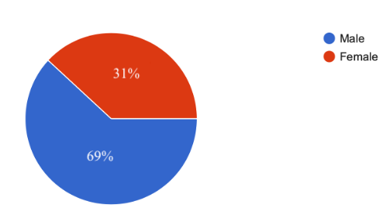
Figure ‎4-1 Gender of Respondents
Regarding age distribution, around 44.1% of participants are in the 30-39 years age bracket, with the 18-29 age group comprising 24.3% and the 40-49 age group making up about 23.8%. Participants aged over 50 represent 7.9% of the total, while those below 20 are a smaller subset. These detailed age statistics are visually presented in Figure 4.2.
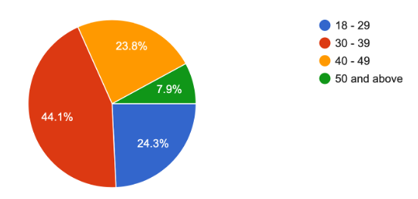
Figure ‎4-2 Age of Respondents
In Figure 4.3, the educational profiles of the 385 respondents are illustrated. Notably, around 38.1% have a bachelor’s degree, with 26.2% holding master's degrees, indicating a strong presence of postgraduate education. Additionally, 22.3% have achieved secondary school status, and 13.4% hold a PhD degree. This diverse educational spectrum emphasizes the richness of our respondent pool's backgrounds.

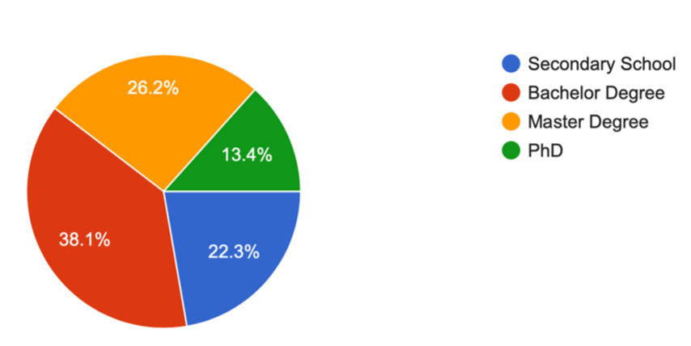
Figure ‎4-3 Education of Respondents

Measurement Model Assessment
Evaluating the measurement model is crucial to assess the reliability and authenticity of instruments or models in quantifying latent constructs. This research utilises statistical techniques, including assessing multicollinearity, measuring construct reliability and validity, checking convergent and discriminant validity, and employing structural equation modelling (SEM).

Measurement Model Results
Evaluating the measurement model holds significant importance in assessing internal consistency reliability, item reliability, as well as convergent and discriminant validity. The examination of individual item reliability involved calculating standardized loadings or simple correlations. As shown in Table 4.3, the computed item loading values varied between 0.727 and 0.921. All 21 items successfully met the criteria recommended by (Chin, 1998), demonstrating statistical significance and justifying their retention for subsequent phases of analysis. This meticulous evaluation ensures the measurement model's reliability and validity, establishing a sturdy foundation for the assessment of the broader construct and its implications within the study's context.
Table ‎4-2 Outer Loadings
Outer loadings
INFO1 | 0.865
INFO2 | 0.748
INFO3 | 0.870
ACCE1 | 0.765
ACCE2 | 0.743
ACCE3 | 0.870
INTER1 | 0.848
INTER2 | 0.869
INTER3 | 0.823
PERS1 | 0.799
PERS2 | 0.870
PERS3 | 0.727
SEC&PRI1 | 0.899
SEC&PRI2 | 0.870
SEC&PRI3 | 0.728
SATI1 | 0.844
SATI2 | 0.803
SATI3 | 0.859
REVI_INT1 | 0.912
REVI_INT2 | 0.891
REVI_INT3 | 0.882

Construct Reliability and Validity
The assessment of variable reliability, utilizing both Cronbach's Alpha and Composite Reliability, demonstrated a high level of reliability. All Cronbach's Alpha values exceeded the benchmark of 0.7, supported by consistent surpassing of the 0.7 criterion in Composite Reliability values (Table 4.4). Notably, Composite Reliability values ranged from 0.742 to 0.978, indicating an exceptionally high degree of internal consistency within the investigated constructs. These findings align with the research standards set forth by (Hair Jr et al., 2021), affirming the reliability of the variables under investigation.
Table ‎4-3 Measurement Model Results
 | Cronbach’s alpha | Composite reliability (rho_c) | Average variance extracted (AVE)
INFO | 0.886 | 0.924 | 0.801
ACCE | 0.717 | 0.742 | 0.641
INTER | 0.884 | 0.894 | 0.799
PERS | 0.814 | 0.875 | 0.638
SEC&PRI | 0.848 | 0.897 | 0.687
SATI | 0.858 | 0.898 | 0.697
REVI_INT | 0.954 | 0.978 | 0.891

Convergent Validity
Following to the stringent criteria outlined by (Hair Jr et al., 2021), the validation of convergent validity is contingent upon item factor loadings surpassing the 0.70 threshold. Therefore, the assessment includes examining the Average Variance Extracted (AVE) for each construct, necessitating that it exceeds the prescribed benchmark of 0.50 (>0.50). Our meticulously conducted research, detailed in Table 4.4, consistently reveals AVE values ranging from 0.641 to 0.891 across the investigated constructs. This meticulous validation process instils confidence in the reliability and coherence of the measurement model, ensuring its suitability for robust analyses in the subsequent phases of the study (Hair Jr et al., 2021).

Discriminant Validity
To ensure the rigorous validation of discriminant validity, this study used both the Fornell & Larcker criterion and the Heterotrait-Monotrait Ratio of Correlations (HTMT). As revealed in Table 4.5, to the correlations between the focal construct and others in the model. Our discriminant validity assessment, detailed in Table 4.5, relies on the Fornell & Larcker criterion, robustly substantiating discriminant validity for each construct. This confirms the distinctiveness of each construct, adhering to our research framework stipulations.
Table ‎4-4 Correlation Matrix and Square Root of the AVE
 | INFO | ACCE | INTER | PERS | SEC&PR | SATI | REVI_INT
INFO | 0.895
ACCE | 0.090 | 0.801
INTER | 0.138 | 0.593 | 0.836
PERS | 0.054 | 0.231 | 0.612 | 0.798
SEC&PRI | 0.015 | 0.310 | 0.702 | 0.815 | 0.829
SATI | 0.055 | 0.493 | 0.662 | 0.655 | 0.493 | 0.811
REVI_INT | 0.074 | 0.531 | 0.442 | 0.675 | 0.573 | 0.703 | 0.820

In examining discriminant validity, this study employed the Heterotrait-Monotrait Ratio of Correlations (HTMT) method, thoroughly exploring inter-item correlations within constructs. SmartPLS findings, presented in Table 4.6, show that HTMT values mostly remained below the 0.9 threshold, with one exception. Crucially, most of values were considerably lower than the widely accepted cut-off of 0.895 (Henseler et al., 2015).
Table ‎4-5 Heterotrait-Monotrait Ratio
 | INFO | ACCE | INTER | PERS | SEC&PR | SATI | REVI_INT
INFO | 0.122
ACCE | 0.108 | 0.895
INTER | 0.147 | 0.791 | 0.664
PERS | 0.086 | 0.420 | 0.732 | 0.812
SEC&PRI | 0.033 | 0.379 | 0.838 | 0.881 | 0.784
SATI | 0.234 | 0.434 | 0.736 | 0.837 | 0.633 | 0.673
REVI_INT | 0.567 | 0.564 | 0.864 | 0.564 | 0.564 | 0.634 | 0.876
In Figure 4.6, depicted outcomes show outer loadings of items and Cronbach's alpha values for each construct. Upon analysis, these results confirm item reliability, construct internal consistency, and overall model validity. Outer loading assessment provides insights into the strength of the relationship between items and constructs, ensuring meaningful contributions. Additionally, Cronbach's alpha values measure internal consistency, indicating reliability and item homogeneity within constructs. These findings collectively contribute to robustly validating the measurement model, reinforcing confidence in the reliability and validity of the proposed theoretical framework.
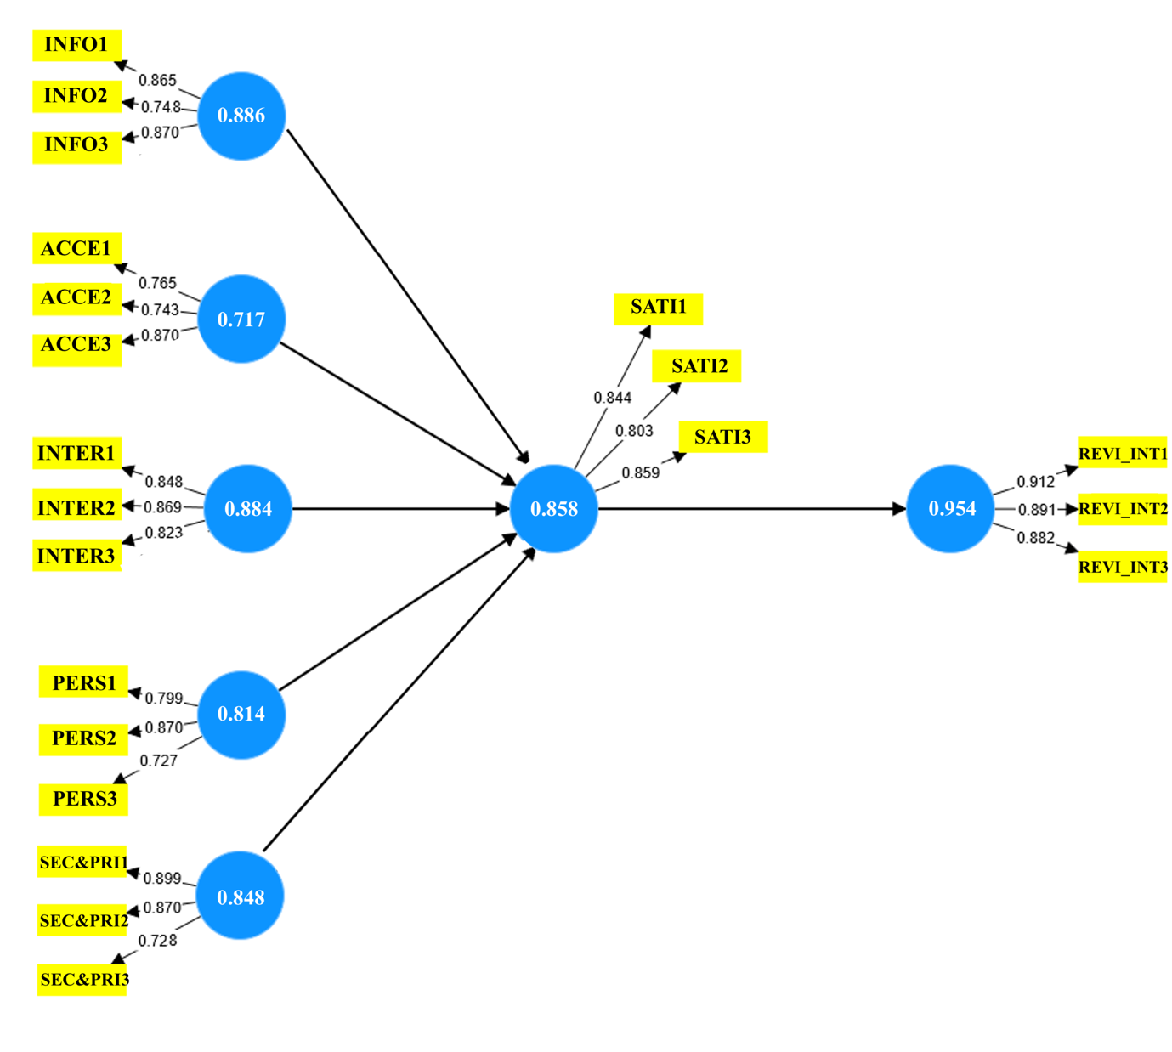
Figure ‎4-6 Measurement Model Results

Structural Model Assessment
In subsequent analysis stages, we rigorously evaluate the structural model using bootstrapping with 5000 samples—a robust statistical method endorsed by (Hair Jr et al., 2021; Sarstedt et al., 2020). This assesses the significance of paths, providing estimations of standard errors and 95% confidence intervals. The path coefficient (β) gauges the strength of relationships, indicating effect size and variance explained (R²). Following criteria by (Chin, 1998), a path coefficient approaching or surpassing 0.5 indicates a large-sized effect, 0.3 suggests a medium-sized effect, and values near or below 0.1 indicate a small-sized effect. A path coefficient exceeding 0.2 indicates a partially significant effect size relationship (Chin, 1998). Detailed results in Figure 4.7 offer insights into p-values and the coefficient of determination (R²), providing a concise overview of our research findings.
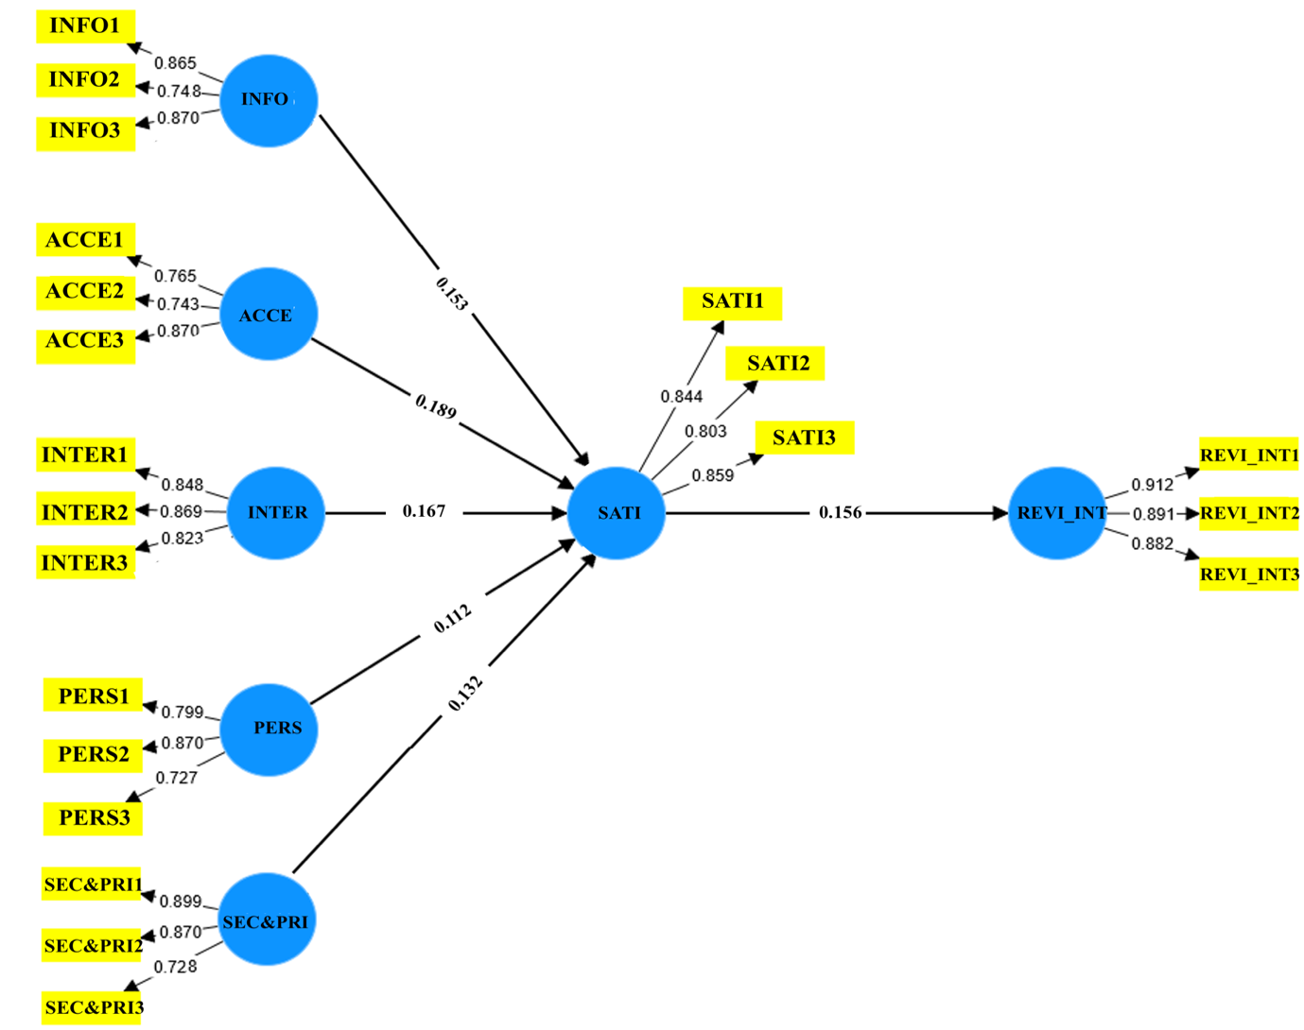
Figure ‎4-7 Structural Model Testing

Research Hypotheses Testing Results
Table 4.7 displays the results of hypotheses tested in this study. H1, examining the impact of Informativeness (INFO) on tourists' Satisfaction (SATI), was supported (β= 0.487, t=3.069, p>0.00). H2, investigating the positive influence of Accessibility (ACCE) on tourists' Satisfaction (SATI), also found supporting evidence (β= 0.464, t=2.982, p<.001). Similarly, H3, exploring the influence of Interactivity (INTER) on tourists' Satisfaction (SATI), was supported (β= 0.428, t=5.077, p<.001). H4, assessing the effect of Personalization (PERS) on tourists' Satisfaction (SATI), received statistical support (β= 0.498, t=4.143, p>0.00). H5, examining the impact of Security and Privacy (SEC&PRI) on tourists' Satisfaction (SATI), showed a strong effect (β= 0.512, t=4.443, p>0.00). Lastly, H6, investigating the effect of Satisfaction (SATI) on tourist Revisit Intention (REVI_INT), indicated a strong effect (β= 0.454, t=4.445, p>0.01). In summary, all the hypotheses proposed in this research were accepted, affirming the positive relationships between the investigated variables.
Table ‎4-6 Research Hypotheses Test Results
Hypothesis | Original sample (O) | T statistics (O/STDEV) | P values
INFO > SATI | 0.487 | 3.069 | 0.000
ACCE > SATI | 0.464 | 2.982 | 0.001
INTER > SATI | 0.428 | 5.077 | 0.001
PERS > SATI | 0.498 | 4.143 | 0.000
SEC&PRI > SATI | 0.512 | 4.443 | 0.000
SATI > REVI_INT | 0.454 | 4.445 | 0.001

Coefficient of Determination: R² Value
Analysing the data in Table 4.8, the research model explains about 69% of the variance in smart tourism technologies' attributes. The model summary indicates a strong positive correlation between independent variables and the dependent variable, tourist satisfaction as per the recommended thresholds for R² values exceeding 0.67. Similarly, the overall results confirm a positive relationship between tourist satisfaction and tourist revisit intention.
Table ‎4-7 Dependent Variables R2 Values
 | R² | Adjusted R ²
SATI | 0.56 | 0.007
REVI_INT | 0.66 | 0.642

Results from the analysis of hypothesised relationships, as described in Table 4.9, confirm the validity of all six research hypotheses. These findings align with our research framework, emphasising the intricate and dynamic nature of the research.
Table ‎4-8 Research Hypothesis Decision
Hypothesis Relationship | Result
INFO > SATI | Supported
ACCE > SATI | Supported
INTER > SATI | Supported
PERS > SATI | Supported
SEC&PRI > SATI | Supported
SATI > REVI_INT | Supported

Hypothesis Discussion
Hypothesis 1 posits that STTs’ informativeness positively correlates with tourists’ satisfaction at smart tourism destinations in Saudi Arabia. This hypothesis underscores the pivotal role of informative features in enhancing tourists' experiences, aligning with prior research emphasising the importance of information provision in tourism settings (Jeong & Shin, 2020; Torabi et al., 2023). The acceptance of this hypothesis suggests that well-informed tourists are more likely to be satisfied with their smart destination experiences, contributing to the broader discourse on the significance of information dissemination in enhancing tourist satisfaction (Sustacha et al., 2023).
Hypothesis 2 suggests that STTs’ accessibility positively influences tourists’ satisfaction at smart tourism destinations in Saudi Arabia. This hypothesis emphasises the role of accessibility features in facilitating tourists' interactions with smart tourism technologies, aligning with previous studies highlighting the importance of accessibility in shaping tourist perceptions and experiences settings (Jeong & Shin, 2020; Torabi et al., 2023). Its acceptance underscores the critical role of easy access to technological resources in enhancing tourist satisfaction and fostering positive destination experiences (Sustacha et al., 2023).
Hypothesis 3 proposes that STTs’ interactivity positively relates to tourists’ satisfaction at smart tourism destinations in Saudi Arabia. This hypothesis underscores the significance of interactive features in engaging tourists and enriching their experiences, echoing findings from existing research stressing on the role of interactivity in enhancing tourist satisfaction settings (Jeong & Shin, 2020; Torabi et al., 2023). Its validation highlights the importance of interactive elements in smart tourism destinations, contributing to a deeper understanding of the dynamics between technology and tourist satisfaction.
Hypothesis 4 suggests that STTs’ personalisation positively impacts tourists’ satisfaction at smart tourism destinations in Saudi Arabia. This hypothesis underscores the value of personalised experiences in meeting tourists' diverse needs and preferences, aligning with previous research emphasising the role of personalization in enhancing tourist satisfaction and loyalty. Its acceptance emphasises the importance of tailoring smart tourism technologies to individual preferences, contributing to the evolving discourse on personalised tourism experiences (Sustacha et al., 2023).
Hypothesis 5 suggests that the Privacy and Security features of Smart Tourism Technologies positively impact tourists' satisfaction in smart tourism destinations in Saudi Arabia. Emphasising the importance of these features in building trust, it aligns with prior research indicating their influence on tourist perceptions and behaviours (Gong & Schroeder, 2022). Acceptance of this hypothesis underscores the crucial role of robust privacy and security measures in enhancing tourist satisfaction and promoting positive destination experiences (Nafrees & Shibly, 2021).
Hypothesis 6 proposes a positive correlation between satisfaction and tourists' revisit intention to smart destinations in Saudi Arabia. Supported by established theories and prior research (Azis et al., 2020; Torabi et al., 2022), it emphasises satisfaction as a predictor of revisit behaviour. Acceptance of this hypothesis highlights the need for high satisfaction levels to foster repeat visits to smart tourism destinations, enhancing the overall understanding of tourist behaviour and destination loyalty (Jeong & Shin, 2020; Torabi et al., 2023).

Chapter Summary
This chapter conducted a thorough exploration of the research methodology and findings. Beginning with meticulous data screening, it established a solid foundation for dataset integrity. Descriptive analysis uncovered latent patterns and insights within variables. The measurement model evaluated the validity and reliability of instruments, enhancing data robustness. The chapter then investigated the structural model through hypothesis testing, revealing intricate relationships crucial to the research. A detailed discussion of hypotheses provided critical insights into the findings' implications, connecting methodological underpinnings to substantive results. This holistic view clarified the study's journey, rendering implications clear within the broader research landscape.

Conclusion

Chapter Overview
This chapter concludes the research, establishing connections between the initial research objectives outlined in Chapter One and the subsequent findings in Chapter Two. It provides research recommendations based on the outcomes, clarifying practical implications. Additionally, it highlights the distinctive contributions to the existing knowledge in the field. The chapter discusses research limitations and explores future opportunities for further exploration. In conclusion, it summarises the significant content, encapsulating the core elements of the chapter.

Research Summary
This research extensively explores tourist behaviour, specifically focusing on the utilization of smart tourism technology in smart destinations in Saudi Arabia. It delves into dimensions like informativeness, accessibility, interactivity, personalisation, and security and privacy features within smart tourism technologies, unravelling the complexities of tourist interactions with these technological advancements. This was accomplished by achieving the research objectives initially stated in chapter one, which are:
- To examine the effect of informativeness on tourists’ satisfaction at smart tourism destinations in Saudi Arabia
The first objective was to assess the impact of informativeness on tourists' satisfaction at smart tourism destinations in Saudi Arabia. Through detailed data analysis, the study investigated various aspects of informativeness in smart tourism technologies. The findings indicated a strong positive relationship between the informativeness provided by these technologies and tourists' overall satisfaction, highlighting the role of well-informed tourists in enhancing satisfaction.
- To examine the effect of accessibility on tourists’ satisfaction at smart tourism destinations in Saudi Arabia
The second objective investigated the impact of accessibility on tourists' satisfaction at smart tourism destinations in Saudi Arabia. The study meticulously evaluated the accessibility features of smart tourism technologies, revealing how these aspects contribute to tourists' satisfaction. The analysis demonstrated a significant positive relationship between the accessibility of smart tourism technologies and tourists' satisfaction, emphasizing the crucial role of easy access in shaping a positive visitor experience.
- To examine the effect of interactivity on tourists’ satisfaction at smart tourism destinations in Saudi Arabia
The third objective delved into examining the effect of interactivity on tourists' satisfaction at smart tourism destinations in Saudi Arabia. Through an in-depth exploration of interactivity features within smart tourism technologies, the research revealed the intricate dynamics of tourist interactions. The results conclusively supported the notion that heightened interactivity positively correlates with tourists' satisfaction, highlighting the importance of engaging and interactive technological experiences in the context of smart tourism destinations.
- To examine the effect of personalisation on tourists’ satisfaction at smart tourism destinations in Saudi Arabia
The fourth objective aimed to understand the impact of personalisation on tourists' satisfaction at smart tourism destinations in Saudi Arabia. By dissecting the personalisation features inherent in smart tourism technologies, the research uncovered valuable insights into how tailored experiences contribute to overall tourist satisfaction. The study's outcomes demonstrated a significant positive relationship between personalisation and tourists' satisfaction, accentuating the role of customised services in elevating the visitor experience.
- To examine the effect of privacy and security on tourists’ satisfaction at smart tourism destinations in Saudi Arabia
The fifth objective focused on examining the effect of privacy and security on tourists' satisfaction at smart tourism destinations in Saudi Arabia. The research conducted a thorough analysis of the privacy and security features integrated into smart tourism technologies. The findings unequivocally supported the idea that robust privacy and security measures positively impact tourists' satisfaction, emphasising the critical role of trust and safety in shaping a positive visitor experience.
- To examine the effect of satisfaction on tourists’ revisit intention to smart tourism destinations in Saudi Arabia
The sixth and final objective centred on exploring the effect of satisfaction on tourists' revisit intention to smart tourism destinations in Saudi Arabia. Through a comprehensive analysis of the data, the research established a clear link between tourists' satisfaction levels and their intention to revisit smart tourism destinations. The results underscored the significance of ensuring a positive and satisfying experience to foster repeat visits, providing valuable insights for destination managers and policymakers in Saudi Arabia.
Employing the theoretical framework of Smart Tourism Technologies (STTs) and quantitative research methods, this study investigated factors influencing tourist behaviour regarding the use of smart tourism technology in Saudi Arabian smart destinations. The research, designed for a comprehensive understanding, generated valuable insights and implications. A structured questionnaire, administered to 385 participants through convenient sampling, served as the primary data collection method. The study focused on six key factors: Informativeness, Accessibility, Interactivity, Personalisation, Security and Privacy, and their collective impact on tourists' overall satisfaction. Additionally, it explored the reciprocal relationship, examining the effect of tourists' satisfaction on their revisit intention. The rich dataset contributes to a nuanced understanding of the intricate dynamics between tourists and smart tourism technologies in the context of Saudi Arabian destinations.
The research significantly contributes to our understanding of the complex relationship between tourists and Smart Tourism Technologies (STTs), offering nuanced insights with implications for smart tourism initiatives in Saudi Arabia. By examining factors like Informativeness, Accessibility, Interactivity, Personalisation, Security, and Privacy influencing tourists' behaviour, the study highlights the intricate interplay of these elements in smart destinations. The findings emphasize the importance of tailoring smart tourism technologies to meet tourists' preferences, enhancing overall satisfaction. These understanding guides policymaker, destination managers, and technology developers in crafting strategies for a more immersive and satisfying smart tourism experience in Saudi Arabia.

Research Recommendation
Building upon the insightful findings of this research, several key recommendations emerge to guide the future development and implementation of Smart Tourism Technologies (STTs) in Saudi Arabia's smart tourism destinations:
Firstly, destination authorities and developers must prioritise and boost the informativeness of these solutions. This involves delivering real-time, comprehensive, and contextually relevant information to tourists. STTs should serve as dynamic repositories, providing instant updates on attractions, services, and amenities. Beyond data provision, incorporating engaging multimedia content, vivid descriptions, and interactive elements enriches the user experience. By adopting a holistic strategy, STTs can evolve into invaluable tools that captivate and guide users throughout their entire tourist journey.
Secondly, it is also crucial to focus on improving accessibility. This involves creating user-friendly interfaces with intuitive design elements, straightforward navigation, and clear visual cues. Incorporating robust multilingual support ensures inclusivity for a diverse global audience. A commitment to seamless navigation within STTs allows users to explore features effortlessly. Prioritising accessibility leads to a more inclusive and user-centric smart tourism experience, ultimately enhancing overall satisfaction among tourists.
Overall, the recommendations stress the need for a user-centric and holistic approach in Smart Tourism Technologies (STTs) in Saudi Arabia. Integrating user feedback at every stage ensures tourists' evolving preferences are actively incorporated into STTs' design. A holistic perspective emphasizes interconnected factors like informativeness, accessibility, interactivity, personalization, and security and privacy. Collaborative efforts should create an integrated ecosystem addressing these facets cohesively for an enhanced user experience. This strategy is fundamental to meeting current needs and staying ahead of evolving trends in smart tourism.

Research Contribution
This research significantly contributes to the field by examining the nuanced dynamics between tourists and Smart Tourism Technologies (STTs) in Saudi Arabia's smart destinations. Beyond technological functionality, the study delves into factors like informativeness, accessibility, interactivity, personalisation, and security and privacy. The findings offer a holistic understanding of how these factors collectively influence tourists' behaviour, satisfaction, and revisit intentions. These insights are invaluable for destination authorities, policymakers, and technology developers, guiding the improvement of STT design, implementation, and ongoing refinement.
Additionally, the research contributes practical recommendations rooted in theoretical insights and tailored to Saudi Arabia's smart tourism context. Emphasizing a user-centric and holistic approach, these recommendations serve as a roadmap for policymakers and developers in STT development. Addressing key aspects like informativeness, accessibility, interactivity, personalisation, and security and privacy, the research provides actionable strategies for creating an advanced and satisfying tourism experience in Saudi Arabia. Overall, this research significantly contributes to theoretical knowledge and practical applications in smart tourism, offering valuable insights for scholars, practitioners, and policymakers.

Research Limitation
Despite While making valuable contributions, this research has limitations. The use of convenient sampling may introduce bias, limiting generalizability. A more diverse sample would enhance external validity. Additionally, focusing on smart tourism technologies may overlook cultural influences on tourist behaviour. Exploring cultural nuances could provide a more comprehensive understanding. The cross-sectional design offers a snapshot, limiting the capture of temporal changes. A longitudinal study could track the evolution of tourist behaviour and technology usage over time. Addressing these limitations guides future research to build on this study's strengths for a nuanced understanding of tourist behaviour in smart tourism contexts.

Research Future Work
Future work can explore the dynamic interplay between emerging technologies and tourist behaviour in smart destinations. Investigating the impact of advancements such as augmented reality, artificial intelligence, or blockchain on tourists' interactions and satisfaction could offer insights into the evolving smart tourism landscape. This research could delve into adoption rates, challenges, and benefits associated with integrating these cutting-edge technologies, providing guidance to destination managers and policymakers aligning their strategies with technological advancements.
Furthermore, future research can explore the socio-cultural dimensions of smart tourism technology adoption. Examining how cultural factors influence tourists' preferences, trust in technology, and privacy concerns is crucial for tailoring smart tourism technologies to diverse cultural contexts. Qualitative methodologies, like in-depth interviews or ethnographic studies, can provide a nuanced exploration of these cultural influences. Investigating the role of cultural competence in designing and implementing smart tourism technologies may contribute to more culturally sensitive and inclusive approaches. By integrating technological advancements with cultural considerations, future research can play a pivotal role in shaping the next phase of smart tourism development in Saudi Arabia and beyond.

Conclusion
In conclusion, the research on factors influencing tourist behaviour toward using smart tourism technology at smart destinations in Saudi Arabia provides valuable insights into the complex dynamics between tourists and Smart Tourism Technologies (STTs). Through a thorough examination of dimensions such as informativeness, accessibility, interactivity, personalisation, security, and privacy, the study achieves its objectives and significantly contributes to the field. The findings underscore the importance of tailoring STTs to align with tourists' preferences, enhancing overall satisfaction, and influencing revisit intentions. Research recommendations advocate for a user-centric approach, urging destination authorities and technology developers to prioritize enhancing STTs in informativeness, accessibility, interactivity, personalization, and security. Looking ahead, the research suggests promising avenues for future studies, including exploring the impact of emerging technologies and delving deeper into the socio-cultural dimensions of smart tourism technology adoption. Overall, this research lays a foundation for a more immersive and satisfying smart tourism experience in Saudi Arabia, with implications extending beyond its borders.

REFERENCES
Abd Hamid, M., & Mohd Isa, S. (2015). The theory of planned behaviour on sustainable tourism. Journal of Biological and Environmental Sciences, 6(5), 84–88.
Akdu, U. (2020). Smart tourism: issues, challenges and opportunities. The Emerald Handbook of ICT in Tourism and Hospitality, 291–308.
Al-Omari, A. H., & Al-Marghirani, A. (2017). Smart tourism architectural model (Kingdom of Saudi Arabia: a case study). International Journal of Advanced Computer Science and Applications, 8(10).
Al-Shammari, H. H., & El-Sawy, N. A.-M. (2020). The Reality Of Using Digital Technology On The Development Of E-Tourism In The Kingdom Of Saudi Arabia. Multicultural Education, 6(5).
Alias, Z. Z. M., & Hashim, H. A. (2023). Smart Technologies for the Development of Smart Tourism. International Journal of Business and Technology Management, 5(2), 329–334.
Almathami, R., & Mair, J. (2023). Socio-cultural barriers to Saudi women’s participation in the tourism industry: a systematic literature review. A Research Agenda for Gender and Tourism, 91.
Alotaibi, A., Alsubaie, D., Alaskar, H., Alhumaid, L., Thuwayni, R. Bin, Alkhalifah, R., & Alhumoud, S. (2022). Kingdom of Saudi Arabia: Era of Smart Cities. 2022 2nd International Conference on Computing and Information Technology (ICCIT), 285–292.
Andrade, C. (2020). Sample size and its importance in research. Indian Journal of Psychological Medicine, 42(1), 102–103.
Atanga, B. A. (2020). Assessing the impact of smart tourism on the accessibility of people living with mobility disabilities. Kent State University.
Azis, N., Amin, M., Chan, S., & Aprilia, C. (2020). How smart tourism technologies affect tourist destination loyalty. Journal of Hospitality and Tourism Technology, 11(4), 603–625.
Balakrishnan, J., Dwivedi, Y. K., Malik, F. T., & Baabdullah, A. M. (2023). Role of smart tourism technology in heritage tourism development. Journal of Sustainable Tourism, 31(11), 2506–2525.
Bhatt, K. P. (2020). A Synopsis on Population and Sample: Quantitative Research. Research Design and Sampling Strategy, 1–7.
Bhuiyan, K. H., Jahan, I., Zayed, N. M., Islam, K. M. A., Suyaiya, S., Tkachenko, O., & Nitsenko, V. (2022). Smart Tourism Ecosystem: A New Dimension toward Sustainable Value Co-Creation. Sustainability, 14(22), 15043.
Biffignandi, S., & Bethlehem, J. (2021). Handbook of web surveys. John Wiley \& Sons.
Burmeister, E., & Aitken, L. M. (2012). Sample size: How many is enough? Australian Critical Care, 25(4), 271–274.
Chin, W. W. (1998). The partial least squares approach to structural equation modeling. In G. A. Marcoulides (Ed.), Modern methods for business research (pp. 295-358). New Jersey: Lawrence Erlbaum Associates. Mahwah, NJ: Lawrence Erlbaum.
Churchill, G. A., & Iacobucci, D. (2006). Marketing research: methodological foundations. Dryden Press New York.
Collado-Agudo, J., Herrero-Crespo, A., & San Martin-Gutierrez, H. (2023). The adoption of a smart destination model by tourism companies: An ecosystem approach. Journal of Destination Marketing \& Management, 28, 100783.
Corrêa, S. C. H., & Gosling, M. de S. (2021). Travelers’ perception of smart tourism experiences in smart tourism destinations. Tourism Planning \& Development, 18(4), 415–434.
Dias, S., & Afonso, V. A. (2021). Impact of mobile applications in changing the tourist experience. European Journal of Tourism, Hospitality and Recreation, 11(1), 113–120.
Diaz-Parra, O., Fuentes-Penna, A., Marroquin-Gutiérrez, F., Rodriguez-Lara, B. M., Ramirez, J. C. S., Trejo-Macotela, F. R., & Aguilar-Ortiz, J. (2023). Smart Tourism: Technologies to Improve Tourism. In Management, Technology, and Economic Growth in Smart and Sustainable Cities (pp. 83–96). IGI Global.
Diaz, G. M., Salvador, J. L. G., & Hernández, J. J. G. (2023). Are Smart Cities Successfully Accepted by all Citizens? A New Recommender System Applied to Tourist Mobile Technologies.
Dorcic, J., Komsic, J., & Markovic, S. (2019). Mobile technologies and applications towards smart tourism- state of the art. Tourism Review, 74(1), 82–103.
Femenia-Serra, F., & Ivars-Baidal, J. A. (2021). Do smart tourism destinations really work? The case of Benidorm. Asia Pacific Journal of Tourism Research, 26(4), 365–384.
Femenia-Serra, F., Neuhofer, B., & Ivars-Baidal, J. A. (2019). Towards a conceptualisation of smart tourists and their role within the smart destination scenario. The Service Industries Journal, 39(2), 109–133.
Fowler, S. B., & Lapp, V. (2019). Sample size in quantitative research: Sample size will affect the significance of your research. American Nurse Today, 14(5), 61–63.
Gajdosik, T., & Orelova, A. (2020). Smart technologies for smart tourism development. Artificial Intelligence and Bioinspired Computational Methods: Proceedings of the 9th Computer Science On-Line Conference 2020, Vol. 2 9, 333–343.
Gao, J., & Pan, Y. (2022). Evaluating Influencing Factors of Tourists’ Experiences with Smart Tour Guide System: A Mixed Method Research. Sustainability, 14(23), 16320.
Gelter, J., Lexhagen, M., & Fuchs, M. (2021). A meta-narrative analysis of smart tourism destinations: implications for tourism destination management. Current Issues in Tourism, 24(20), 2860–2874.
Gong, Y., & Schroeder, A. (2022). A systematic literature review of data privacy and security research on smart tourism. Tourism Management Perspectives, 44, 101019.
Gretzel, U. (2021). Conceptualizing the smart tourism mindset: Fostering utopian thinking in smart tourism development. Journal of Smart Tourism, 1(1), 3–8.
Gretzel, U., Fesenmaier, D. R., Formica, S., & O’leary, J. T. (2006). Searching for the future: Challenges faced by destination marketing organizations. Journal of Travel Research, 45(2), 116–126.
Hair Jr, J. F., Hult, G. T. M., Ringle, C. M., Sarstedt, M., Danks, N. P., & Ray, S. (2021). Partial least squares structural equation modeling (PLS-SEM) using R: A workbook. Springer Nature.
Halim, H. S. (2022). Technology in Smart Tourism: Concepts and Applications. Handbook of Technology Application in Tourism in Asia, 451–470.
Hamzah, M. L., Purwati, A. A., Sutoyo, S., Marsal, A., Sarbani, S., & Nazaruddin, N. (2022). Implementation of the internet of things on smart posters using near field communication technology in the tourism sector. Computer Science and Information Technologies, 3(3), 194–202.
Henseler, J., Ringle, C. M., & Sarstedt, M. (2015). A new criterion for assessing discriminant validity in variance-based structural equation modeling. Journal of the Academy of Marketing Science, 43, 115–135.
Hidayah, N., Suherlan, H., & Putra, F. K. K. (2022). Stakeholders’ Synergies in Developing Smart Tourism Destination. A Phenomenographic Study. Journal of Environmental Management \& Tourism, 13(2), 313–323.
Hujran, O., Al-Debei, M. M., Al-Adwan, A. S., Alarabiat, A., & Altarawneh, N. (2023). Examining the antecedents and outcomes of smart government usage: An integrated model. Government Information Quarterly, 40(1), 101783.
Idris, I., Adi, K. R., Firmansyah, R., Nadhianty, A., Mobaroq, M. H., Putri, P. G., Pratama, A. S., & Wahono, E. R. (2021). Developing smart tourism using virtual reality as a tourism promotion strategy in Indonesia. Geo Journal of Tourism and Geosites, 35(2), 332–337.
Iglesias, P. A., Ochoa, C., & Revilla, M. (2024). A practical guide to (successfully) collect and process images through online surveys. Social Sciences \& Humanities Open, 9, 100792.
Jeong, M., & Shin, H. H. (2020). Tourists’ experiences with smart tourism technology at smart destinations and their behavior intentions. Journal of Travel Research, 59(8), 1464–1477.
Jung, J.-H., Ha, J.-Y., & Shin, J.-I. (2022). The relationship between attractiveness, convenience, experiential quality, tourism satisfaction, and revisit intention in a local tourism destination: After the easing of the COVID-19 quarantine guideline. 관광연구저널, 36(10), 37–52.
Kadir, B. N., Sahid, M. H., Noviana, M., & others. (2023). Effectiveness of Virtual Reality (VR) in Improving Social Skills in Autism Spectrum Disorder Cases: A Literature. Proceedings of the International Conference on Vocational Education Applied Science and Technology (ICVEAST 2023), 783, 45.
Kalkbrenner, M. T. (2021). A practical guide to instrument development and score validation in the social sciences: The MEASURE Approach. Practical Assessment, Research, and Evaluation, 26(1), 1.
Kock, N. (2017). Common method bias: a full collinearity assessment method for PLS-SEM. Partial Least Squares Path Modeling: Basic Concepts, Methodological Issues and Applications, 245–257.
Kovačić, N. (2022). The acceptance of smart technologies in tourist regions with respect to mobility preferences of their visitors. Transportation Research Procedia, 64, 257–269.
Krejcie, R. V, & Morgan, D. W. (1970). Determining sample size for research activities. Educational and Psychological Measurement, 30(3), 607–610.
Križaj, D., Bratec, M., Kopić, P., & Rogelja, T. (2021). A technology-based innovation adoption and implementation analysis of European smart tourism projects: towards a smart actionable classification model (SACM). Sustainability, 13(18), 10279.
Kumar, P., Dubey, S., & Sahu, A. K. (2022). A Review on Smart and Intelligent Techniques for Digital Tourism. International Journal of Scientific Research in Computer Science, Engineering and Information Technology (IJSRCSEIT), 8(6), 617–624.
Kuoksa, A. (2022). Utopian thinking in smart tourism development: rethinking the Helsinki Tourist Information service concept. A case study. Itä-Suomen yliopisto.
Kusumawati, Y. A., Yasmin, Q. N. D., Lasmy, L., Gunawan, E. P., & Renanda, D. G. (2023). Developing Mobile Apps to Support Smart Tourism in Indonesia. E3S Web of Conferences, 426, 2059.
Leung, R. (2022). Development of information and communication technology: from e-tourism to smart tourism. Handbook of E-Tourism, 1–33.
Liu, J., Hall, C. M., Zhu, C., & Ting Pong Cheng, V. (2023). Redefining the concept of smart tourism in tourism and hospitality. Anatolia, 1–13.
Liu, L., Pollock, N. J., Contreras, G., Tonmyr, L., & Thompson, W. (2023). Original quantitative research-Pandemic-related impacts and suicidal ideation among adults in Canada: a population-based cross-sectional study. Health Promotion and Chronic Disease Prevention in Canada: Research, Policy and Practice, 43(3), 105.
Lowhorn, G. L. (2007). Qualitative and quantitative research: How to choose the best design. Academic Business World International Conference. Nashville, Tennessee.
Lv, H., & others. (2022). Construction of a Virtual Reality Model of Smart Tourism Scenic Spot Based on Cloud Computing. Mathematical Problems in Engineering, 2022.
Madkhali, H., Lugosi, P., & Hawkins, R. (2023). Socio-cultural drivers of Saudi tourists’ outbound destination decisions. Journal of Vacation Marketing, 13567667231152936.
Madyatmadja, E. D., Pristinella, D., Rahardja, N., & Ginting, R. B. (2021). Smart tourism services: a systematic literature review. 2021 1st International Conference on Computer Science and Artificial Intelligence (ICCSAI), 1, 329–333.
Malhotra, N. K., Agarwal, J., & Peterson, M. (1996). Methodological issues in cross-cultural marketing research: A state-of-the-art review. International Marketing Review, 13(5), 7–43. https://doi.org/10.1108/02651339610131379
Marin Diaz, G., Galdón Salvador, J. L., & Galán Hernández, J. J. (2023). Smart Cities and Citizen Adoption: Exploring Tourist Digital Maturity for Personalizing Recommendations. Electronics, 12(16), 3395.
McKercher, B., & Prideaux, B. (2020). Tourism theories, concepts and models. Goodfellow Publishers Ltd.
Mehraliyev, F., Chan, I. C. C., Choi, Y., Koseoglu, M. A., & Law, R. (2020). A state-of-the-art review of smart tourism research. Journal of Travel \& Tourism Marketing, 37(1), 78–91.
Mehraliyev, F., Choi, Y., & Köseoglu, M. A. (2019). Progress on smart tourism research. Journal of Hospitality and Tourism Technology, 10(4), 522–538.
Mei, X. Y. (2023). 12 Smart Tourism in Developing Smart Destinations. Tourism and the Experience Economy in the Digital Era: Behaviours and Platforms.
Meiyanti, R., Rasyiidin, M. Y. B., Murad, F. A., & Fajriah, R. (2022). Smart Wifi Design for Integrated Tourist Destinations in Smart Tourism. Tech-E, 5(2), 103–114.
Mitala, A., Konstantoglou, A., Folinas, D., & Fotiadis, T. (2022). Smart Tourism Technologies: How Effective Are They for Millennial Tourists? Transcending Borders in Tourism Through Innovation and Cultural Heritage: 8th International Conference, IACuDiT, Hydra, Greece, 2021, 339–351.
Morales-Urrutia, X., Morales-Urrutia, D., Simabaña-Taipe, L., & Ram\’\irez, C. A. B. (2020). Smart tourism and the application of ICT: The contribution of digital tools. Revista Ibérica de Sistemas e Tecnologias de Informação, E32, 64–76.
Nafrees, A. C. M., & Shibly, F. H. A. (2021). Smart technologies in tourism: a study using systematic review and grounded theory. 2021 International Research Conference on Smart Computing and Systems Engineering (SCSE), 4, 8–13.
Naramski, M. (2020). The application of ICT and smart technologies in polish museums—towards smart tourism. Sustainability, 12(21), 9287.
Ng, K. S. P., Wong, J. W. C., Xie, D., & Zhu, J. (2023). From the attributes of smart tourism technologies to loyalty and WOM via user satisfaction: The moderating role of switching costs. Kybernetes, 52(8), 2868–2885.
Novera, C. N., Ahmed, Z., Kushol, R., Wanke, P., & Azad, M. A. K. (2022). Internet of Things (IoT) in smart tourism: a literature review. Spanish Journal of Marketing-ESIC, 26(3), 325–344.
O’Connor, P. (2020). Data privacy and the travel sector. Handbook of E-Tourism, 1–14.
Orden-Mejia, M., & Huertas, A. (2022). Analysis of the attributes of smart tourism technologies in destination chatbots that influence tourist satisfaction. Current Issues in Tourism, 25(17), 2854–2869.
Pai, C.-K., Liu, Y., Kang, S., & Dai, A. (2020). The role of perceived smart tourism technology experience for tourist satisfaction, happiness and revisit intention. Sustainability, 12(16), 6592.
Pasquinelli, C., & Trunfio, M. (2023). Smart Technologies for Sustainable Tourism Development: Exploring Practices in European Destinations. In Sustainability-oriented Innovation in Smart Tourism: Challenges and Pitfalls of Technology Deployment for Sustainable Destinations (pp. 111–143). Springer.
Podzharaya, N., & Sochenkova, A. (2020). The Concept of Smart Tourism Based on Museum Digitalization in Montenegro. 2020 9th Mediterranean Conference on Embedded Computing (MECO), 1–4.
Rane, N., Choudhary, S., & Rane, J. (2023). Sustainable tourism development using leading-edge Artificial Intelligence (AI), Blockchain, Internet of Things (IoT), Augmented Reality (AR) and Virtual Reality (VR) technologies. Blockchain, Internet of Things (IoT), Augmented Reality (AR) and Virtual Reality (VR) Technologies (October 31, 2023).
Rodrigues, V., Stevic, I., & Breda, Z. (2022). Smart and 4.0 paradigms fostering innovation dynamics within tourism destinations. Revista Turismo \& Desenvolvimento (RT\&D)/Journal of Tourism \& Development, 39.
Ryan, C., & Gu, H. (2009). Destination branding and marketing: The role of marketing organizations. In Handbook of hospitality marketing management (pp. 383–411). Routledge.
Sangthong, M. (2020). The effect of the likert point scale and sample size on the efficiency of parametric and nonparametric tests. Thailand Statistician, 18(1), 55–64.
Sarstedt, M., Ringle, C. M., Cheah, J.-H., Ting, H., Moisescu, O. I., & Radomir, L. (2020). Structural model robustness checks in PLS-SEM. Tourism Economics, 26(4), 531–554.
Sekaran, U., & Bougie, R. (2016). Research methods for business: A skill building approach. John Wiley & Sons.
Shen, S., Sotiriadis, M., & Zhang, Y. (2020). The influence of smart technologies on customer journey in tourist attractions within the smart tourism management framework. Sustainability, 12(10), 4157.
Shmueli, G., Sarstedt, M., Hair, J. F., Cheah, J.-H., Ting, H., Vaithilingam, S., & Ringle, C. M. (2019). Predictive model assessment in PLS-SEM: guidelines for using PLSpredict. European Journal of Marketing, 53(11), 2322–2347.
Sia, P. Y.-H., Saidin, S. S., & Iskandar, Y. H. P. (2023). Systematic review of mobile travel apps and their smart features and challenges. Journal of Hospitality and Tourism Insights, 6(5), 2115–2138.
Silva, D. F. O., Souza, A. L. de S., Pimentel, J. B., Souza, T. O., Araújo, E. P. dos S., Sena-Evangelista, K. C. M., Arrais, R. F., & Lima, S. C. V. C. (2020). Development and content validity of an instrument for assessing the motivation for weight loss in adolescents with overweight and obesity. Plos One, 15(11), e0242680.
Slavec, A., Sajinčič, N., & Starman, V. (2021). Use of smartphone cameras and other applications while traveling to sustain outdoor cultural heritage. Sustainability, 13(13), 7312.
Soldatenko, D., Zentveld, E., & Morgan, D. (2023). An examination of tourists’ pre-trip motivational model using push--pull theory: Melbourne as a case study. International Journal of Tourism Cities, 9(3), 572–597.
Sood, M., & Bhandari, H. (2023). Integrating Smart Technologies in Heritage Interpretation of Historic Gardens for Enhancing Visitor Experiences. 2023 3rd International Conference on Technological Advancements in Computational Sciences (ICTACS), 1249–1255.
Sustacha, I., Banos-Pino, J. F., & Del Valle, E. (2023). The role of technology in enhancing the tourism experience in smart destinations: A meta-analysis. Journal of Destination Marketing \& Management, 30, 100817.
Tassikas, A. D. (2021). Data Processing and Legal Protection in Contracts in the Technologically Innovative Tourism Sector. European Journal of Tourism, Hospitality and Recreation, 11(1), 77–90.
Tiwari, V., Mishra, A., & Tiwari, S. (2023). Role of data safety and perceived privacy for acceptance of IoT-enabled technologies at smart tourism destinations. Current Issues in Tourism, 1–16.
Torabi, Z.-A., Pourtaheri, M., Hall, C. M., Sharifi, A., & Javidi, F. (2023). Smart tourism technologies, revisit intention, and word-of-mouth in emerging and smart rural destinations. Sustainability, 15(14), 10911.
Torabi, Z.-A., Shalbafian, A. A., Allam, Z., Ghaderi, Z., Murgante, B., & Khavarian-Garmsir, A. R. (2022). Enhancing memorable experiences, tourist satisfaction, and revisit intention through smart tourism technologies. Sustainability, 14(5), 2721.
Torres, B. L., & Ogbeide, G.-C. (2015). Destination marketing organizations’ stakeholders and best practices. Discovery, The Student Journal of Dale Bumpers College o f Agricultural, Food and Life Science S, 54.
Tourism, M. of. (2023). Domestic Tourism Indicators - 1st Half of 2023. 03(4), 845.
Tseng, C.-H., & Sim, D. (2021). Sample size planning for pilot studies. ArXiv Preprint ArXiv:2105.05483.
Um, T., & Chung, N. (2021). Does smart tourism technology matter? Lessons from three smart tourism cities in South Korea. Asia Pacific Journal of Tourism Research, 26(4), 396–414.
Vinodan, A., Meera, S., & Shreeansh, M. (2024). Incentivized adoption of smart tourism services: Host community perspective. Smart Tourism, 4(2), 2454.
Wang, W., Kumar, N., Chen, J., Gong, Z., Kong, X., Wei, W., & Gao, H. (2020). Realizing the potential of the internet of things for smart tourism with 5G and AI. IEEE Network, 34(6), 295–301.
Wang, X., Zhen, F., Tang, J., Shen, L., & Liu, D. (2022). Applications, experiences, and challenges of smart tourism development in China. Journal of Urban Technology, 29(4), 101–126.
Wise, N., & Heidari, H. (2019). Developing smart tourism destinations with the internet of things. Big Data and Innovation in Tourism, Travel, and Hospitality: Managerial Approaches, Techniques, and Applications, 21–29.
Xia, L., Lee, T. J., & Kim, D.-K. (2024). Relationships between motivation, service quality, tourist satisfaction, quality of life, and spa and wellness tourism. International Journal of Tourism Research, 26(1), e2624.
Xu, J., Shi, P. H., & Chen, X. (2024). Exploring digital innovation in smart tourism destinations: insights from 31 premier tourist cities in digital China. Tourism Review.
Yang, X., Zhang, L., & Feng, Z. (2023). Personalized tourism recommendations and the E-tourism user experience. Journal of Travel Research, 00472875231187332.
Ye, B. H., Ye, H., & Law, R. (2020). Systematic review of smart tourism research. Sustainability, 12(8), 3401.
Zhang, Y., Sotiriadis, M., & Shen, S. (2022). Investigating the impact of smart tourism technologies on tourists’ experiences. Sustainability, 14(5), 3048.
Zikmund, W. G., Babin, B. J., Carr, J. C., & Griffin, M. (2013). Business research methods. Cengage Learning.

APPENDICES

Appendix A: Questionnaire Construction

FACTORS INFLUENCING THE TOURIST BEHAVIOUR TOWARD USING SMART TOURISM TECHNOLOGY AT SMART DESTINATIONS IN SAUDI ARABIA
Instructions for Sections A to D

Please assign a number to reflect your opinion for each statement, ranging from strongly agree (1) to strongly disagree (5). Respond to all questions; if uncertain, provide your best response.
Scale:
1= Strongly agree | 4= Disagree
2= agree | 5= Strongly Disagree
3= Unsure


SECTION A: Informativeness

 |  | Strongly Agree |  |  |  | Strongly Disagree
1. | Smart technology applications provided useful information in smart destinations in Saudi Arabia | 1 | 2 | 3 | 4 | 5
2. | Smart technology applications assisted me in smart destinations in Saudi Arabia | 1 | 2 | 3 | 4 | 5
3. | The use of smart technology applications in smart destinations in Saudi Arabia completed my trip successfully. | 1 | 2 | 3 | 4 | 5
INSTRUCTION: (Please rate your score between 1 (Strongly agree) to 5 (Strongly Disagree).


SECTION B: Accessibility

INSTRUCTION: (Please rate your score between 1 (Strongly Agree) to 5 (Strongly Disagree).
 |  | Strongly Agree |  |  |  | Strongly Disagree
1. | I used smart technology applications anytime and anywhere in smart destinations in Saudi Arabia. | 1 | 2 | 3 | 4 | 5
2. | Smart technology applications were easily available to use in smart destinations in Saudi Arabia. | 1 | 2 | 3 | 4 | 5
3. | In smart destinations in Saudi Arabia, smart technology applications were easily accessible. | 1 | 2 | 3 | 4 | 5

SECTION C: Interactivity

INSTRUCTION: (Please rate your score between 1 (Strongly Agree) to 5 (Strongly Disagree).
 |  | Strongly Agree |  |  |  | Strongly Disagree
1. | Many other users’ questions, answers, and reviews were available on smart technology applications | 1 | 2 | 3 | 4 | 5
2. | Smart technology applications were highly responsive to users. | 1 | 2 | 3 | 4 | 5
3. | It was easy to share local information through smart technology applications. | 1 | 2 | 3 | 4 | 5



SECTION D: Personalisation

INSTRUCTION: (Please rate your score between 1 (Strongly Disagree) to 5 (Strongly Agree).
1. | Smart technology applications allowed me to receive tailored information. | 1 | 2 | 3 | 4 | 5
2. | I could interact with smart technology applications to get personalised information. | 1 | 2 | 3 | 4 | 5
3. | The personalised information provided by smart technology applications met my needs. | 1 | 2 | 3 | 4 | 5

SECTION E: Privacy and Security

INSTRUCTION: (Please rate your score between 1 (Strongly Agree) to 5 (Strongly Disagree).
1. | Smart tourism technologies protected my personal and sensitive information. | 1 | 2 | 3 | 4 | 5
2. | Smart tourism technologies respected my privacy and the safety of my transactions. | 1 | 2 | 3 | 4 | 5
3. | Smart tourism technologies are trustworthy and reliable. | 1 | 2 | 3 | 4 | 5
SECTION F: Satisfaction

INSTRUCTION: (Please rate your score between 1 (Strongly Agree) to 5 (Strongly Disagree).
 |  | Strongly Agree |  |  |  | Strongly Disagree
1. | Overall, I was satisfied with the smart technology available in smart destinations in Saudi Arabia. | 1 | 2 | 3 | 4 | 5
2. | The smart technology available in smart destinations in Saudi Arabia exceeded my expectations. | 1 | 2 | 3 | 4 | 5
3. | The smart technology available in smart destinations in Saudi Arabia was close to my ideal technology. | 1 | 2 | 3 | 4 | 5

SECTION G: Revisit Intention

INSTRUCTION: (Please rate your score between 1 (Strongly Agree) to 5 (Strongly Disagree).
 |  | Strongly Agree |  |  |  | Strongly Disagree
1. | I want to revisit smart destinations in Saudi Arabia again. | 1 | 2 | 3 | 4 | 5
2. | I would recommend smart destinations in Saudi Arabia to family and friends. | 1 | 2 | 3 | 4 | 5
3. | I would say positive things about smart destinations in Saudi Arabia to other people. | 1 | 2 | 3 | 4 | 5


SECTION F: Demographic Profile

INSTRUCTION: Please tick () the answer that is most relevant to you
1- Gender:
□ Male | □ Female
2- Age:
□ 18- 29 |  | □ 30- 39 |  |  | □ 40- 49 |  | □ 50 Years & Above
3 – Education Level:
□ Secondary School |  |  | □ Bachelor’s degree |  |  | □ Master’s degree |  | □ PhD

- Do you have any comments on the subject?
-
-

Appendix B: Questionnaire Sample


