An investigation into the role of art and its engagement
within robotics

Submitted in partial fulfilment for the degree of BA (Hons) Illustration
L6 DISSERTATION
(M6X01791)

Shannon Louise Flay
P142595
December 2017

Word Count: 5999
Dissertation Supervisor: Julia Lockheart

Content
Page
Content …………………………………………………………………………………………………………………….[2]
List of Illustrations …………………………………………………………………………………………………….[3]
Summary …………………………………………………………………………………………………………………..[4]
Introduction ………………………………………………………………………………………………………………[5]
Chapter 1: Leonardo da Vinci and his transition between art and science
Leonardo da Vinci ………………………………………………………………………………………………[7]
Robotics: The knight …………………………………………………………………………………………[12]
Chapter 2: Early to modern robotics
Karakuri: Historical …………………………………………………………………………………………[15]
Pepper: Modern ……………………………………………………………………………………………..[16]
Chapter 3: Robotic advancement and art forms
Stelarc …………………………………………………………………………………………………………….[18]
Donna Haraway ………………………………………………………………………………………………[24]
Science & art …………………………………………………………………………………………………..[26]
Conclusion ………………………………………………………………………………………………………………[27]
Bibliography ……………………………………………………………………………………………………………[29]

List of Illustrations

Figure | Page
Figure 1: Vascular Tree, 1508 ………………………………………………………………………….…………[8]
Figure 2: Ornithopter, 1485 ………………………………………………………………………………….……[9]
Figure 3: Superficial anatomy of the shoulder and neck, 1510 ………………….……….….…[12]
Figure 4: Knight interior, 1495 ………………………………………………………………….………………[12]
Figure 5: Robotic knight recreation, 2002 ……………………………………………….…………………[14]
Figure 6 & 7: Tamaya Shobei, 1796 ………………………………………………………………………..…[15]
Figure 8: Pepper software robotics, n.d. ……………………………………………………………………[16]
Figure 9: Drawing diagram, 1980 ………………………………………………………………………………[19]
Figure 10: Installing the third hand, 1980 ………………………………………………………………….[19]
Figure 11: Ear on arm photo, 2007 ……………………………………………………………………………[19]

Summary
This dissertation will research into robotics and the function art plays that allows it to become a vital component. By looking at past and present scientists that use methods of combining art and science and how it may have enhanced or hindered their research. By taking three main individuals who were and are an inspiration to their field of science, they being Leonardo da Vinci, Stelarc and Donna Haraway.

Introduction
This dissertation will focus on researching into how science communicates with art through the notion of robotics and how the collaboration impacts the results, solidifying a relationship between art and science. The reasoning behind this chosen topic is that art and science are barely observed in the same category to the public eye especially to those not familiar with the individual fields of work. Yet their collaboration has existed for centuries despite the differences in results; science seeking truth and adaptation whilst art prioritises appearance and perception. Robotics is a category within the science field that relies heavily on the appearance as well as the function, as the invention can be received to the public or others within the scientific community, whether through plans or final mock ups. The idea is to review the result before the final is created.
The main sources of research will involve looking at historical and present examples of science and art collaboration, concentrating on three influential people that have a background in robotic based work. Through looking at the comparisons of robotic categories and methods of presentation by the three individuals, a greater understanding can be gained on how the collaboration of art and science is important. The three individuals follow three forms of art within presentation and research such as drawing and diagrams, performance and writing. The main influence from history is Leonardo da Vinci, with his inventions demonstrating a prime example of robotic science and art that show clear benefits through collaboration. A more modern example is Stelarc, an inventor who uses performance arts to display his robotics. The last being Donna Haraway who uses essays as her form of spreading information on robotics and society. By looking at these three individuals I hope to gain a better understanding on the collaboration benefits and disadvantages of their robotic understanding and presentation methods. By using Harraway and Stelarc I will compare their work to da Vinci’s, to discover why the art component was so important to his success. By comparing them I hope to find if their own methods for displaying their work has given them any advantages or disadvantages within the understanding of robotics. The three people I have chosen as a focus of comparison have been influential in their own ways towards robotics as well as engaging in vastly different methods of projecting their ideas.

Chapter 1: Leonardo da Vinci and his transition between art and science
Robotics is a field of science that relies a great deal on visual representation, as robotic based experimentation is based on movement and function; this relies on inspiration from animals and humans, studying areas of joint movement and organ functions. The research aspect falls into the scientific study section, as would the diagrams or any sketches into the art category; art and science become intertwined within the depiction of robotics when considered in this way. The creation of robotics relies heavily on scientific measurements and function whilst utilising visual formation and movement also. This use of mixed studies is especially prevalent with Leonardo da Vinci’s work; known primarily as an artist and well-renowned for his painting of the Mona Lisa, less known are his anatomical structures and drawings linking science and art together in the creation of robotics.
Leonardo da Vinci is represented throughout history as a ‘Renaissance man’, one who excels in many fields of study; he is famously known for his paintings rather than for the many scientific studies and anatomical sketches, see figure 1 as an example. It is not regularly questioned how he obtained his research within this area; information is ordinarily gained from books, but our ancestors would use the opportunity to dissect human bodies or animals, gaining information from primary research instead. Da Vinci was no exception, as his many journals show sketches and detailed diagrams of his experimental dissections of corpses. This allowed him to indulge into the scientific section of the human body rather than just the artistic side. He compiled all his research into notebooks; two of his main ones were called the ‘Anatomical Manuscript A and B’ (Kemp, 2005) which showed his interest in areas such as how the body was constructed and worked, alongside animals and nature studies. He had used this time to observe the mechanics of the human body; a popular example of this is a detailed drawing of ‘a system of body vessels’ with notes explaining his findings.
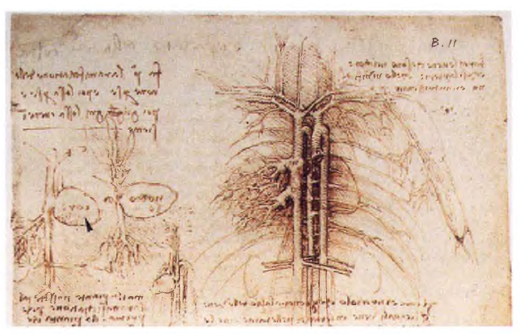
Figure 1: Vascular Tree, 1508
He used his research of the human body and how it moves, then applied it to life in mechanics. The sketch of the ‘Vascular Tree’ by da Vinci is an example of how he constructed his findings, sketching quickly and writing notes which allowed him to show a clear understanding of his thoughts. He then applied his findings into either his art or inventions. Versed in a range of different areas, da Vinci was also interested in nature demonstrated through the Vascular Tree sketch (Figure 1) whereby the heart is portrayed as if it were a seed, with the blood vessels being the roots; he made a lot of comparisons like this throughout his work which allowed the crossing of fields, an important component of his process.
An example of his research through corpse studies would be the first accurate depiction in drawing, of the human spine. He used ships mast to compare the ropes and mast to components of a body like the muscles of a neck. (‘’Recto the muscles of the upper spine’’, 2017, www.royalcollection.org.uk) Studying of bones and how they fit together influences most of his understanding of what is realistic for posing figures. These facts helped his paintings appear more real, rather than appearing exaggerated in areas. Being able to find these comparisons through observing and drawing, he was also able to apply them to his science. Drawing parallels from nature inspired many of his inventions, as areas closely resemble how bones would interlock and interact with each other. Seeing that joins and muscle of the human body mirrored gears and pulleys, he used the human form because he considered it ‘’the greatest instrument in nature’’ (‘’Leonardo da Vinci: The Engineer’’, 2005, www.illumini.usc.edu)
His interest in drawing gave him an advantage within his research as it included observation as a main practice, leading him to apply his robotic based inventions to resemble present humans and animals. An area of this would be his observation of bird flight, which inspired his sketches of a flying machine (Figure 2).
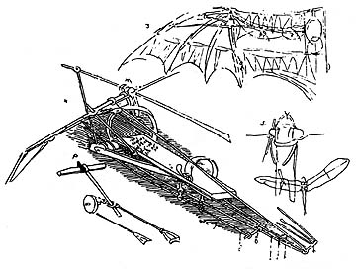
Figure 2: Ornithopter, 1485
Many studies on birds, muscles and joint movement allowed him to work out the basics of what his Ornithopter was aiming to do, allow gliding or flight. Da Vinci has also completed many studies in geology (Keele, p201, 1983), particularly in viewing land structure and air currents. The Ornithopter would have to take into mind these factors in order to fly/ glide; small experiments on candle flame and smoke were taken into consideration to extend da Vinci’s knowledge on aerodynamics. Da Vinci’s understanding of scientific laws came from observation of life, shown through the notes he left behind. With nature as his resource of research, he was able to test scientific laws; he believed observation and obtaining information was vital to how he lived his life. As he stated by this following quote. “There are three classes of people: those who see. Those who see when they are shown. Those who do not see.” (Nicholl, p20-23, 2005). He categorises himself as ‘those who see’, as he discovers through his own eyes and research, not relying on others as his main source. This is shown prominently throughout his work, using his tools and skills to find what he wants to know. ‘Those who… are shown’ are the consumers of life, they look at what is already found and presented to them. Then the last ‘Those who do not see’, the ones who do not care to see, blind to increased knowledge and understanding. His quote places ‘those who see’ in a higher light compared to the others, as he values observation and experimentation.
Da Vinci’s drawings were both iconic in science and the arts; the research was scientific in nature as well as observation, then the art was applied to the findings and life experience. Areas overlapped often, and information found from one area may be of use in the other, in a sense heightening his understanding of both areas of study. He was one of the few scientists who saw art and science as complimentary; even today this is not quite accepted, and they are kept to their own distinct disciplines, as one area can inform the other on what may be missing or improved upon. Of course, there has been disadvantages of the collaboration, as he is mainly praised for his paintings while a lot of his scientific studies and inventions go unnoticed by the public eye.
His inventions started to merge into becoming what was an early form of robotics; they relied on his gift of laying down plans through drawing and note. Despite experiencing many complications and failures within his experiments, this ultimately increased his learning. The idea of continuous motion started to have an increased presence within his experiments; the concept that once something starts motion how will it continue on its own without any help. Figure 2 is an example of this; it was created with no form of engine. Another example seen is the ‘Machine gun’ (“Machine gun”, 2011, leonardodavinci.net) which despite working, had to be retriggered after each bullet, leaving it to not be an automatic as he hoped but a close attempt. His inventions were greatly advanced for the day and rapidly improved his work and research with each new invention. A lot of his inventions and illustrations got left unfinished and this is a fault of a ‘Renaissance man’, as being so adapt in many areas there was never enough time to do everything. This is interesting as there are many articles and statements that explain how Leonardo da Vinci was very advanced for his time within his area (Rosheim, p.11, 2006).

The Knight
Among his ideas of automatic movement, based on replicating life he moved onto more literal humanoid based inventions. Using years of research on animal and human movement da Vinci began creating ‘The da Vinci’s Knight’, a commission given to him, reflecting his knowledge on human movement.
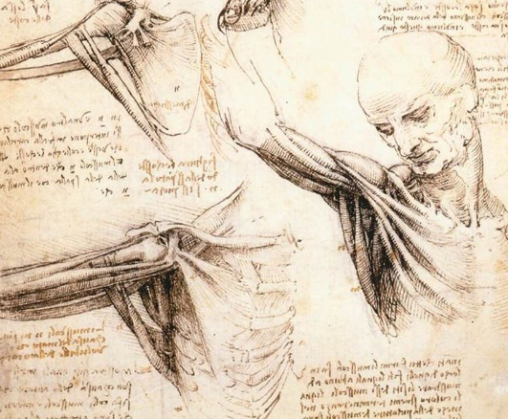
Figure 3: Superficial anatomy of the shoulder and neck, 1510
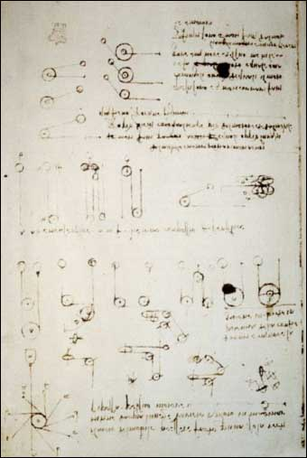
Figure 4: Knight interior, 1495
Many sketches have been found of da Vinci’s robot knight however its actual location is unknown. Da Vinci left behind detailed notebooks and sketches of what the Knight looked like and how it was operated; without these there would be no evidence it had ever existed. Thanks to these detailed pieces many scientists have tried to recreate the knight; the notes had shown that the invention had a couple of functions such as lifting its visor, moving the arms and legs, in addition to standing and sitting.
Mark Rosheim was able to recreate the knight with more modern mechanics using the evidence left behind; he is a mechanical engineer with knowledge on historical tools. Using the plans of da Vinci’s sketches of pulleys and muscle studies he was able to recreate it. He wrote a book called the ‘Robot Evolution: The Development of Anthrobotics’, whereby he coined the term ’anthrorobotics’ relating to the development of robots as humanlike; this depicts a clear curiosity towards past robotic based inventions, and the study of improvements.
As Rosheim was one of the few that attempted to recreate the knight from the evidence he quickly became known for bringing to life da Vinci’s invention. Beforehand his scientific studies and book were not recognised, but as soon as he became involved with research into and recreating da Vinci’s vision his work became more widely recognised to the public. It can be speculated that da Vinci’s knight gave Rosheim the push to become known in the media rather than just within his scientific circle.
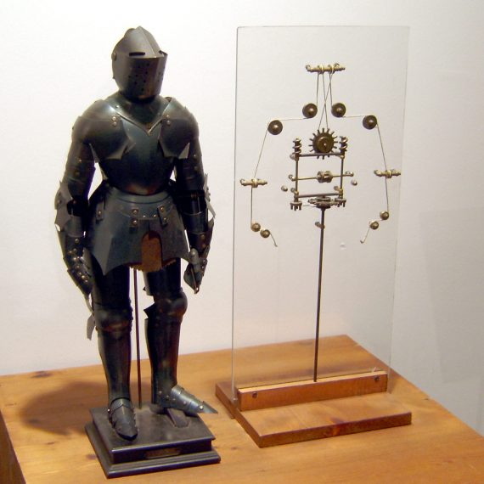
Figure 5: Robotic Knight Recreation, 2002
The recreation of da Vinci’s plans had functions beyond what Leonardo had already planned, such as the ability to walk and wave along with anything that the original plans could already do. Also, the gears and mechanics were more up to date as the original ones from his time would be antique in terms of modern technological developments.
Da Vinci’s work wasn’t scientifically coded because they were drawings and simply stated the intent behind his projects; his work was readable to all therefore not contained within the art or science field. With him having an outlet and a background in art he was able to display what he was thinking; arguably if he had not combined his scientific knowledge with his art he may have been lesser known to the public. Pictures and drawings are a universal language and if he had just used notes the public may have taken less interest as it caters to the scientific community rather than the average person; his art pieces are more well known in the public eye rather than his sketches or scientific based notes.

Chapter 2: Early to modern robotics
The impact of art on Leonardo da Vinci’s inventions arguably enabled people to understand what they were trying to convey. The idea behind human movement in inventions has been used within other cultures also, although on a smaller scale compared to da Vinci. Small scale robotics have evolved into toys or novelty items such as the ‘Karakuri Puppet’.
The ‘Karakuri Puppet’ was made for entertainment purposes later in the 17th century and could perform basic movement. There are three types of these robots but the one pictured below in figure 6 is the Zashiki Karakuri known as the tea serving robot; it would be wound up and travel across the table, making little movements giving the allusion of the feet moving, then it would bow. Used in tea ceremonies and was displayed as a piece of art, a cute porcelain doll, used to put on a show of riches for the guests. Their aim was to create a robot with human appearance and movement; the viewer would be deceived by the mechanics, believing the feet to be moving when they weren’t and by the pretty dressing of the features.
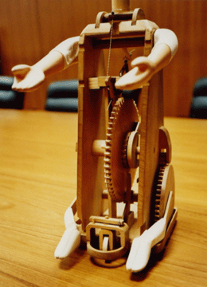
Figure 6 & Figure 7: Tamaya Shobei, 1796
The aim behind the tea serving robot was to make them appear as dainty and elegant as possible, intended for entertainment and to bring happiness due to their beauty. Their appearance made them seem far removed from robotics and the scientific community, placing them instead into the real world. As their main purpose is to appear pretty but also impressive with the technology it possesses, a harmony can be argued for between robotics and art.
Japan has not stopped inventing and improving on their robotics, as they are one of the lead countries in technological advancements in the world. As a more modern version within robotics ‘Pepper’ is a recent development, a human shaped robot, programmed with speech and movement, intended for a butler role. This demonstrates improvement in robotics; starting with basic actions moving onward to humanoid robots, possibly developing into android status. The design is sleek and appealing, to look humanoid making it personable and approachable despite its man-made, artificial nature.

Figure 8: Pepper Softbank robotics, n.d.
From the company the ‘Software Bank Robotics’ they state alongside this image that
“Pepper is much more than a robot, he is a genuine humanoid companion created to communicate with you in the most natural and intuitive way” (Softbank robotics). 2016 Robots in this sense have developed beyond simply taking on a role like delivering tea, transforming now into replicating humans. The construction of Pepper demonstrates how advanced robotics have become since da Vinci’s ‘Knight’ and the reasoning behind them has progressed also. Alongside this the appearance aspect has changed to a more modern outlook, a sleeker and cleaner appearance.

Chapter 3: Robotics advancements and art forms
The Karakuri and Pepper robot both take robotics to a new level of advancement, progressing from automated beings to items of enjoyment and approachability. Their semi-automatic movement yet delicate likeable appearance makes one question any negative feelings towards robotics and in many ways demonstrate the progression from science into art; the robots are beautiful and can be appreciated for their aesthetic beauty in addition to their robotics. Whereas da Vinci concentrated on the scientific aspect, making detailed diagrams, robotics has progressed into a new era of development as conveyed by performance artists Stelarc, who works primarily with robotics.
Mainly researching into the human body and extending its capabilities, Stelarc uses his own body to experiment and expand on the body’s natural boundaries. Almost all his experiments are shown to the public through stage performances or videos. His views on the matter are that we need to enhance the human body and mind, we have reached our absolute in this form and need to move forward; this is the main focus of most of his performances. His interests lie in enhancing humans to a new level of living, combining robotics with his body and performance. His curiosity leads him to wonder about human limitations of the body and mind, saying things like ‘the body is biologically inadequate’
(‘’Interview Stelarc’’, https://web.stanford.edu/dept/HPS/stelarc/a29-extended_body.html)
Stelarc’s ‘third hand’ shown in Figure 9, probably his second most well-known piece after the ‘ear on his arm’ (Figure 11). It is a robotic arm attached to his right arm created using the arm’s dimensions. In order to make it work Stelarc transmitted signals from his leg into the ‘third hand’ as using the arm’s own signals would put too much pressure on it and make the real arm weak.

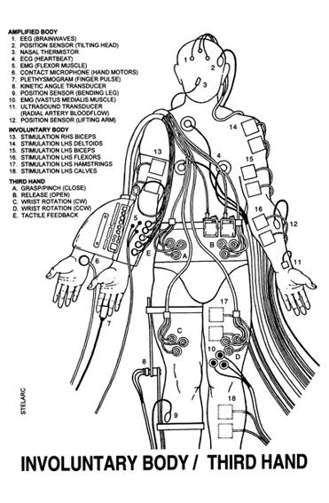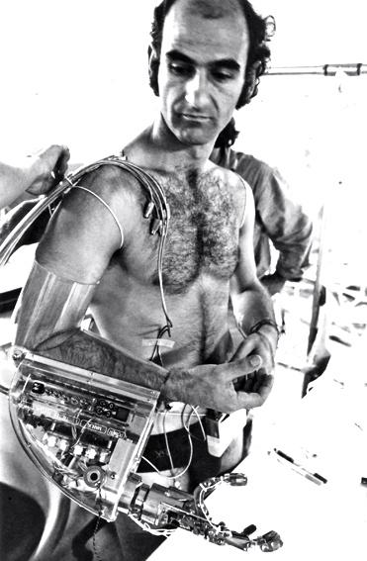
Figure 9: Drawing diagram. 1980. Figure 10: Installing the third hand. 1980.
Figure 9 and 10 show a diagram of the mechanics and a photo of Stelarc using his system to perform. It was said that it was made to be an addition to enhance what was already there, not a replacement in this case. (‘Third Hand’’, 2017, http://stelarc.org/?catID=20265). This arguably demonstrates the progression from robotics into borderline cyborg; in a sense this is what he is subtly describing throughout his work as the definition of cyborg is to enhance through mechanical body parts.
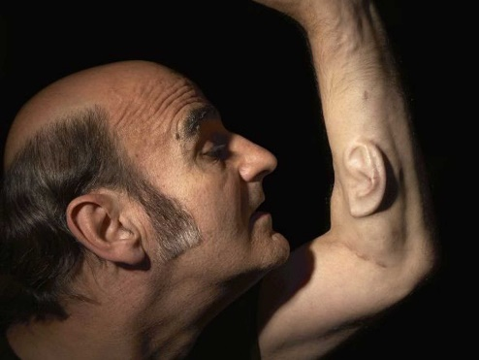
Another major invention of Stelarc is the ‘ear on arm’ (Figure 11) which he made through combining engineering, his art and biology. The ear was originally grown from stem cells, shaped into an ear then biologically attached to his arm; engineered to connect to the internet it allowed Stelarc to communicate with the public but this was one way as he couldn’t hear through the ear.
Figure 11: Ear on arm photo, 2007
This is way for his ideal of enhancing the human body to be realised; using his knowledge of biology and robotics he found a form an in-grown phone, a direction of body enhancement he engaged in purely for a performance art piece. The performance would include linking the ear to the internet so people across the world could hear his surroundings, anyone could tune into his website and see the experiment in action. Aiming to get people to interact with his experiment in comparison to da Vinci, Stelarc looked further into the future considering what more can be shown to the public through his performances as to get the public engaged in what he was doing. While da Vinci’s work was for explaining his process, Stelarc’s art form was to show the final experiment and show what more can be done from them. Robotics in this case have progressed further with Stelarc bringing robotics in a new direction and into a new time even though they both arguably create to benefit the future; they just chose a different path in showing people.
Stelarc uses performance as a main source of getting his inventions known, in a fine art or drama based way incorporating acting in addition to his scientific work. It may be questioned whether it is through his performances that his work has become more well-known and this can be argued both ways as he uses the shock factor whilst also showing the bare result of his experiments and intent; he uses his performances to demonstrate to his audience the abilities and functions that are now possible. People find his performances unconventional and this can make them uncomfortable, but it is through these that he is able to explain his process and reasoning, encouraging understanding as a result. Without the performances he would have likely just been labelled as a crazy scientist rather than a crazy performer.
In comparison with da Vinci, who was universally known more for his art, Stelarc’s art form of performance is obscure yet intriguing, causing interest allowing his robotic inventions to become known. Stelarc’s performances are as well-known as his inventions which is not seen in da Vinci’s case as his art is more of a known focus. However, compared to da Vinci, Stelarc is not widely known through an average person’s knowledge.
The idea of enhancing the body is a modern set of goals within this area of inventing, and demonstrates a greater acceptability within contemporary society of robotics being combined with humans, which can be seen today within the Para-Olympic athletes. Both da Vinci and Stelarc find the human body to be their main source of research and utilise this knowledge, knowing what they have and how can they use it to their advantage. As image and capture of his work through recordings is important to Stelarc, he allows the public to see most of his work and thorough process on his own website.
Stelarc concept of turning himself into a cyborg type form leaves a gap between the idea of the basic robotics da Vinci made and other early inventions through history. The link would be considered opposite to what Stelarc had mentioned with enhancing what is already there but instead to give what is missing like prosthetic limbs. Prosthetics were made to help people who lost something like, a leg or arm then to apply these things without needing would ultimately enhance what is already there. The question behind this would be why enhance? Stelarc’s argument behind this is his belief that the human race has stopped evolving and for one to carry on living they must evolve to suit the environment. Stelarc mentions that with humans not evolving further, we have reached the peak of our evolution; to move the process along we must continue to evolve. He thinks we must evolve onwards but to evolve humans would have to wait around one million years, so in Stelarc’s viewpoint he may be just observing digression with humanity. This here is where Stelarc arguably begins to lose the aim of performance arts, focusing more on the idea of enhancing rather than how he wishes to display his work to the public.
Within Stelarc’s website he keeps a record of his art and mechanics, in addition to a number of quotes he agrees with about his own work from interviews. The following is an example of this.
Stelarc's art starts from and continually returns to a point at which idea and body have not yet split or at which they have re-joined. His medium is the body as a sensible concept. Problem: In what way is the body an idea and the idea bodily? In what way can probing one extend the other?
(Massumi, B. 2002)
This quote explains the art behind Stelarc’s study of the body and clarifies upon Stelarc’s intentions to enhance and evolve the body further; Massumi questions this challenging whether the body and idea are yet split in which case how can this concept be developed further. This quote could really bring forward some more ideas on how his art may enhance what he has achieved already and advance further forward.
Stelarc has a strange way of showing his discoveries in the non-traditional sense, through theatre from countless hours of experiments and research; this is similar to Leonardo da Vinci, as da Vinci shows his workings out through drawing and notes. Their motives are similar and very different at the same time. The motives of Stelarc are to show how humans can evolve as we have in his opinion achieved the evolutional high for our own bodies. He argues that we need to use our own minds to evolve further and last longer on this earth, a combination of his curiosity and forward thinking to think what comes next? In that area da Vinci is very similar, with the thinking of what more is there through curiosity; Stelarc would also be categorised as ‘those who see’. As well as exploring and showing their curiosity to the public, how things can change or be improved for the future with the idea of ‘dream big’ as an aspiration.

Haraway
Donna Haraway displays her work in a more philosophical sense on robotics and cyborgs, through written work, mainly essays. She’s a professor in the history of consciousness and feminist studies with her main area concentrating on the history of science. Haraway wrote a piece called ‘A Cyborg Manifesto’ which utilises her background of socialism and feminism to begin to question the line between man and machine. It details the concept of human relationships in terms of how different we are from each other; how cyborgs could bring them together, since the fear of the half-human and half-robotic being would not be considered human in people’s eyes so would cause a scare factor. Argues that sexuality, gender and race are being pushed aside in the creation of robotics but that they must work in unison to combat the out of hand technology that was once controlled. The ideology of the manifesto focuses on identity in an era of the future, where social standing, race and gender is not of importance when defining’s human beings. The underlying topic is postmodern feminism concentrating on the concepts of feminism and community. In the world she is imagining the things that define us as human are not important on a physical and conscious level, as a new factor has been introduced called a ‘Cyborg’. The cyborg has its own category as it does not have the conscience we possess; it is not organic and has no sense of community. Human are naturally sociable creatures Harraway argues that the introduction of a foreign body such as the cyborg would unite people.
The fear of the cyborg that Haraway is implying within her manifesto is supported by the teachings of Aristotle, originating years before the concept of the robot existed. He states that,

Man is by nature a social animal; an individual who is unsocial naturally and not accidentally is either beneath our notice or more than human. Society is something that precedes the individual. Anyone who either cannot lead the common life or is so self-sufficient as not to need to, and therefore does not partake of society, is either a beast or a god. (‘Aristotle’, p.94)
This explores how humans are social and how anyone or anything that doesn’t live by or require basic instincts would be considered a beast or god. For Harraway the cyborg would be considered the same as the beast or god that Aristotle refers to; humans would collectively remove themselves and unite against a force that was considered to not have human characteristics, unsocial and self-efficient. Haraway and Aristotle Fears collectively refer to be of the unknown or a higher being; conceptually humans are unable to recognise as it appears so alien to their own being.
The cyborg does not dream of community on the model of the organic family, this time without the oedipal project. The cyborg would not recognize the Garden of Eden; it is not made of mud and cannot dream of returning to dust
(Haraway, p.151)
As Haraway states the cyborg is unable to understand or work on the same basic logic as a human being and therefore becomes a non-understandable element; unable to work on the same belief systems or social laws that as humans we survive on and live by. Grasping onto the idea of how technology ‘the cyborg’ will be received by society, the idea of it going too far so we end up a weaker link compared to the cyborgs who now appear god like. Compared to Stelarc wanting to enhance humanity into a higher form, it can be interpreted that Stelarc is aiming for humans to become cyborg based beings; the definition of cyborg is an enhanced human being with mechanical elements built in. Stelarc wants to evolve further, with Harraway warning about the enhanced beings. With Leonardo the aim was to create a basic human looking mechanical object, Stelarc changes the idea of robotics to an object but applying to the body. It is like a progression over the ages, the reasoning behind the creation of robotics.
Based on how Haraway presents her essay, she has a very particular way of writing and therefore expressing her findings to the others. Through her work there are inconsistencies, she wishes the public to be aware of cyborg threats yet she writes in a form that most of the common public would have trouble understanding. In comparison to Leonardo da Vinci and Stelarc, they have an open and universal way to express their ideas through acting or drawing. Harraway seems to cater to a higher educational category of people, however in her manifesto she tries to touch on a more public appeal by using many metaphors like the ‘garden of Eden’. If she wishes to aim for a larger audience she would have to bring in some changes in her writing style, as she shows how she wants the public to know of threats.
Combining science and art
Through the three influential people discussed they have shown their methods of allowing the public to see their work and for some this has worked more than others. Stelarc and da Vinci have been shown to share common methods by using universal ways of communication through acting and drawing; of course some problems can emerge with being represented in more of an artistic light rather than the inventions they have created. Harraway has been shown to want to be in the public sphere but the level of her writing has shown to be a road block when sharing information with other cultures and across less scientific communities; she needs to evolve her writing style to enable all audiences to be catered for.
Conclusion
With this dissertation exploring the robotics side of science’s that collaborates with the arts, many interesting points have been held on the importance of art being used to communicate ideas. From the idea of recording research and moving forward to the design, with da Vinci he used his art primarily to record what he has found then plans what can be created; sketches are not meant to be a part of the final invention. The same can’t be said about other robotic inventions such as the ‘Karakuri puppet’ which primarily thrives on the artistic aspect even though it was made as a form of robotics as its main purpose showing that art and science can be in a balance. But even the art area of the invention and design has changed as the idea behind ‘Pepper’ the Japanese robot, can be seen with its sleeker appeal which is also shown in the later Stelarc’s work. Stelarc is a prime example alongside Leonardo da Vinci on demonstrating how art can be an advantage and even a main source to contribute to their robotic inventions. Da Vinci has shown that recording his work in the method he chose allows people throughout time to understand through simple strokes; the best example of this is his ‘knight’ designs which even got recreated by Mark Rosheim. Stelarc used his stage performances to demonstrate and keeps a large library of work on his website for the public to see, best example he has shown is the ‘third hand’ with separate photos and pages explaining aspects of work. Lastly moving onto Donna Haraway who wrote a thesis on cyborgs in realisation of the modern robotics; many points and upstanding decisions were shown throughout but she needs to reconsider her method of writing if she wishes to be seen within the public sphere as it is a more academic form of writing which is shown to not be so universal, a very select audience.
The art forms demonstrate a sense of involving the community in the past and present through a universal language within the arts. The succession of how the science research had been displayed within an art form leaves availability for those within the future to gain and understanding; da Vinci’s work as an example shows how his art has left an impact on the world allowing it to be understood further. Even if it was mainly for his drawings, he gains interest from the public first by viewing his art form and that can gain access to educate the public in other areas; which is what his robotics or inventions do. Stelarc gets straight to the point and balances both his inventions and his performance, less information is shown to the public by putting forward both but he allows interest in his work to spread. Harraway shows to have very little advantage over how her work is seen as it is a very particular way of English it is written in so it is arguable it may not reach as diverse a range of people as Stelarc and da Vinci may accomplish.
Using these three main influential people has shown how the art aspect has had a large impact upon the scientific community and body of knowledge, impacting across the fields of writing, design and performance. Drawing and acting has been the best shown method of linking art and science whilst writing can be limiting and segregating if completed at too high an academic level. Harraway could benefit from either using a more common language of writing rather than scientific if her aim was to appeal to more types of people. The art forms have shown in this dissertation that it can come as an advantage to exposure as well as make the science field appear more welcoming and understanding.

Bibliography

Figures
- Figure 1: Leonardo da Vinci, 1508, Vascular Tree, Royal Collection [online] Available at: https://www.royalcollection.org.uk/collection/919028/recto-the-heart-compared-to-a-seed-verso-the-vessels-of-liver-spleen-and-kidneys
[accessed 11/05/2017]
- Figure 2: Leonardo da Vinci, 1485, Ornithopter, Flight Machines [online] Available at: http://www.flyingmachines.org/davi.html
[accessed 13/05/2017]
- Figure 3: Leonardo da Vinci, 1510, Superficial anatomy of the shoulder and neck, Royal Collective [online] Available at: https://www.royalcollection.org.uk/collection/919003/recto-the-superficial-anatomy-of-the-shoulder-and-neck-verso-the-muscles-of-the
[accessed 25/05/2017]
- Figure 4: Leonardo da Vinci, 1495, Knight interior, [online] Available at: https://www.anthrobot.com/press/article_leo_programmable.php
[accessed 25/05/2017]
- Figure 5: Mark Rosheim, 2002, da Vinci’s robotic knight recreation, Nasa [online] Available at: https://blog.salvius.org/2014/01/a-history-of-robotics-da-vincis.html [accessed 11/06/2017]
- Figure 6 & Figure 7: Tamaya Shobei, 1796, Chahakobi Ningyo (Tea Serving Doll), [online] Available at: http://www.karakuri.info/zashiki/
[accessed 14/06/2017]

- Figure 8: Softbank robotics, n.d. Pepper [online] Available at: https://www.ald.softbankrobotics.com/en/robots/pepper
[accessed 10/06/2017]
- Figure 9: Stelarc, 1980, Drawing third hand [online] Available at: http://stelarc.org/?catID=20265
[accessed 05/05/2017]
- Figure 10: Stelarc, 1980, Installing the third hand [online] Available at: http://stelarc.org/?catID=20265
[05/05/2017]
- Figure 11: Nina Seller, 2007, Ear on arm photo, Stelarc [online] Available at: http://stelarc.org/?catID=20242
[accessed 05/05/2017]
Books
- Clark, K. and Kemp, M. (2005). Leonardo Da Vinci. 1st ed. London: Folio Society.
- Edgerton, S. (1991). The heritage of Giotto's geometry. 1st ed. Ithaca: Cornell University Press.
- Keele, K. (1977). Leonardo da Vinci and the art of science. Hove, Sussex: Wayland.
- Keele, K. (1983). Leonardo da Vinci elements of the science of man. New York: Academic.
- Nicholl, C. (2005). Leonardo da Vinci: the flight of the mind. 1st ed. Penguin.
- Rosheim, M. (1994). Robot evolution. New York: Wiley.
- Rosheim, M. (2006). Leonardo’s Lost Robot. Berlin: Heidelberg.
- Sonnenwald, D. (2016). Theory development in the information sciences. University of Texas Press.
- Thompson, S. (1956) Androids, Cyborgs, and Robits in Contemporary Culture and Society.US: IGI Global.
Journals
- Ackerman, S.J. (1998) Leonardo da Vinci: Art in Science. Art Education, p.207-224.
- Haraway, D. (1984). A Cyborg Manifesto. Technology & feminism.
- Jovanovich, H, B. N.D. Human Nature, Anthropology, p.94.
- Squeri, R. (1961). Leonardo da Vinci: innovator. Art Education, 14(9), p.6.
Videos
- Ajvanughan3 Documentary Films. (2016) Leonardo da Vinci: Full Documentary, YouTube, [online] Available at: https://www.youtube.com/watch?v=FYBO0YyJ6RU
[accessed: 12/05/2017]
- Christie’s. (2017) The Last Leonardo da Vinci: Salvator Mundi, YouTube, [online] Available at: https://www.youtube.com/watch?v=hCHD-6s2tes
[accessed: 14/05/2017]
- National Geographic. (2011) Leonardo’s Universe: National Geographic, YouTube, [online] Available at: https://www.youtube.com/watch?v=DSsGRfCqN2s
[accessed: 23/06/2017]
- SPIETV. (2010) Robots from Leonardo to the present: interview Mark Rosheim, YouTube, [online] Available at: https://www.youtube.com/watch?v=BcQy2ld6hrE
[accessed: 22/06/2017]
Websites
- Atzoni, P. 1997. Extended body: Interview with Stelarc. [online] Available at: https://web.stanford.edu/dept/HPS/stelarc/a29-extended_body.html [accessed: 02/07/2017]
- Gray, C. 2003, Flying Machines: Leonardo da Vinci. [online] Available at: http://www.flyingmachines.org/davi.html [accessed: 05/05/2017]
- Harper, D. 2010. Dictionary: cyborg. [online] Available at: http://www.dictionary.com/browse/cyborg [06/07/2017]
- Harper, D. 2010. Dictionary: robotics. [online] Available at: http://www.dictionary.com/browse/robotics [06/07/2017]
- Lusheck, C,H. 2014. Perfecting nature: Empiricism, geometry and the rhetoric of liveliness in Leonardo’s Studies of Brambles. [online] Available at: http://faculty.virginia.edu/Fiorani/NEH-Institute/essays/lusheck [accessed: 05/05/2017]
- Lustig, A. 2017. Stelarc projects. [online] Available at: http://stelarc.org/projects.php [accessed: 24/06/2017]
- Massumi, B. 2002. Selected Quotes: Stelarc. [online] Available at: http://stelarc.org/?catID=20314 [accessed: 22/06/2017]
- Scharping, N. 2017. How humans are evolving right now. [online] Available at: http://blogs.discovermagazine.com/d-brief/2017/09/07/genetic-study-evolving-still/#.WgTL1Wh-rIU [22/06/2017]
- Smith, M. 2014. Robot pepper: Home. [online] Available at: https://www.engadget.com/2014/06/12/home-robot-pepper/ [accessed: 10/06/2017]
- N.N. 2017. What does it mean to be human? Human evolution, Human Origins Initiative. [online] Available at: www. humanorigins.si.edu/education/introduction-human-evolution [accessed: 22/06/2017]
- N.N. 2016. Who is pepper, Softbank robotics. [online] Available at:
https://www.ald.softbankrobotics.com/en/robots/pepper [accessed: 22/06/2017]

