

LEVEL 4

MODULE CODE: BMSA4001

DEVELOPING AND SUPPORTING EARLY CHILDHOOD PHYSICAL DEVELOPMENT

aSSESSMENT TYPE: Reflective journal

Assessment/Component: 1

COMPONENT WEIGHTING: 50 %

WORD COUNT: 2000 WORDS (approx. 1000 per cycle)

MODULE TUTOR: Dr Nalda Wainwright/ Dr Amanda John

SUBMISSION DETAILS:

You need to complete two reflective journal cycles. Each cycle should demonstrate specific learning about the practical implementation of the SKIP-Cymru programme in your setting.

Your reflections should link your experiences with relevant literature and key theories relating to early childhood physical development. Each cycle should clearly demonstrate progressive developments in your knowledge, understanding and skills in relation to the implementation of SKIP-Cymru.

Submit via Turnitin

School of Sport, Health & Outdoor Education

Assessment Feedback Sheet

Student No./Name: Hayley Lewis-Howell

Personal Evaluation – to support your academic progress please complete the section below BEFORE submitting your work.
What do you consider to be the best aspects of this work? |  |  | I enjoy the practical delivery however whilst attending the course, I know have more knowledge about the reasons on why development is so crucial during young age, especially during the first three years.
Which aspects do you consider could have been improved in this piece of work? |  |  | N/A
What have you found most satisfying whilst undertaking this submission? |  |  | Lots of support and guidance from tutors and others on the course. Has been an enjoyable course.
ASSESSMENT CRITERIA | Learning  Outcomes |  | GRADE
ASSESSMENT CRITERIA |  |  | Poor  < 20% | Weak  20-29% | Unsatisfactory  30-39% |  | Satisfactory  40 – 49% | Good  50 – 59% | Very Good  60 – 69% | Excellent  70 – 84% |  | Exceptional  85– 100% | %
Overview of setting and evaluation of practical activities | 3 |  |  |  |  |  |  |  |  |  |  |  | 30%
Reflection and analysis of practical delivery. Linking reflections to child development, motor development theory and implications for future practice | 2,3 |  |  |  |  |  |  |  |  |  |  |  | 40%
Analysis of pupils’ physical skills and implications for their development, Physical activity and self-perceptions | 1, 2 |  |  |  |  |  |  |  |  |  |  |  | 30%
It is expected that students will present work that is proof read, correctly referenced and adheres to the Assessment Checklist. Therefore a range of 0 – 10 marks will be deducted for non-completion of any of the points on the checklist below.
TUTOR COMMENTS:

Submission date:  via Turnitin |  | Return date:  (at least within 4 weeks) |  |  |  | Tutor: Nalda Wainwright/ Amanda John |  |  |  |  | Mark:

MODULE CODE: BMSA4001

DEVELOPING AND SUPPORTING EARLY CHILDHOOD PHYSICAL DEVELOPMENT

Below is a reflective journal that I experienced when delivering physical development sessions within school settings. I am an Active Young People Officer, Explore and Learn stage, focussing on developing children’s physical literacy within foundation phase within Carmarthenshire. I worked within two schools: Gwynfryn and Saron and worked with children aged five and six in the year one classes.

Saron is Free School Meal (FSM) 1 and medium of Welsh school, good indoor space and huge outdoor space. The second school Gwynfryn is FSM 2 in a rural deprived area, smaller school with a small hall and decent outdoor space. I tried to run the sessions outside as there was more space but sometimes had to run sessions in the hall due to weather. Both schools identified children to be part of an intervention group due to low fundamental motor skills, low concentration skills and or low attendance. In Saron, a couple of children also had learning and behavioural difficulties within the group. Each child would take part in two sessions a week for twelve weeks. To make the sessions sustainable for the duration, I delivered the first four weeks and members of staff observed and took notes to deliver the remaining sessions.

A lot of the children have had less opportunities to take part in physical activity because of Covid 19 and this is something that reflected in the sessions. The majority of children when asked stated they do not attend a sports or physical activity session out in the community. For lots of children, they would have spent a lot of time indoors and at such a crucial age of their development. I believe this has had an effect on the children’s physical development along with their fundamental motor skills as they have spent more time indoors and not playing or socialising due to Covid 19 restrictions. As Ayres states “Most of the activity in the first seven years of life is part of one process: the process of organising the sensations on the nervous system” (Ayres, 2005,p.13). I believe interventions like this are vital now and focussing on helping to develop children’s fundamental movement, locomotor skills and their manipulative skills. These skills are fundamental to children’s sensory integration skills which are identified by Gallaehue, Ozmuin and Goodway (2012) as being the building blocks to children becoming efficient movers.

Whilst spending time at both schools observing and assessing the children, I noticed that the lack of fundamental motor skill and sensory integration is having an effect on their general development and childhood experiences. “When a child moves and improves their movement skills, their brain develops more connections (dense neutral networks) and when a child moves they learn to process information more quickly and efficiently and have a better attention” (SKIP Cymru, 2016).

Figure 1: Developmental Mechanisms Influencing Physical Activity Trajectories of Children (Stodden et al, 2008: 294).
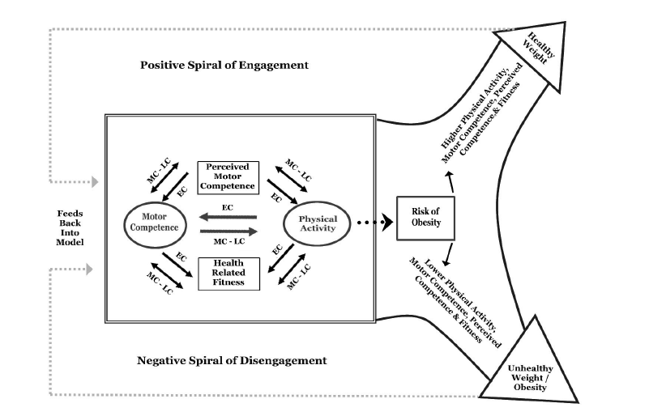

I was intrigued to see what impact these physical development sessions would have on the children physically and socially but also other areas such as their behaviour and concentration levels.
I chose activities that would develop movement skills, as well as the manipulative skills catching and throwing through fun imaginatory games. These are called fundamental motor skills and there are three types: object control, locomotor and stability skills (Gallachue et al, 2012).
A lot of people think that children can develop and improve their fundamental motor skills naturally through free play however evidence suggests that many children do not become proficient in all their skills just by playing and they need to be taught correctly suited to their ability (Goodway & Branta, 2003).

The mountain of motor development suggest that “FMS represent the base camp from which children will climb up the mountain of motor development to achieve context-specific motor skills” Clark & Metcalfe (2002, p.176). Children will develop at different stages based on individual constraints and environmental opportunities. Young children under the age of seven years old often may have low levels of motor competence but perceive themselves to be highly skilful (Harter & Pike, 1984). Children at a young age will continue to practice because of their perceived more competence so it is vital that children of a young age have as many opportunities as they can to physically active and to develop FMS. It suggests that due to children having low levels of cognitive development the relationships between actual and perceived motor competence is weak (Stodden, 2008).

During warm up games in both schools, I used activities such as spot to spot, spots in space, tails and traffic lights to see what their spatial awareness, body awareness, relationships and dynamics were like. It was clear to see when observing, that the children liked to move in one direction (forward) and in a circular movement. There was a wide variety of stages and abilities within the children’s fundamental movement skills and sometimes we take it for granted that children can perform these skills but actually they need to practice and improve to become proficient. “If children cannot proficiently run, jump, catch, throw etc. then they will have limited opportunities for engagement in physical activity later in their lives as because they will not have the prerequisite skills to be active” Stodden, Goodway, Langendorfer, Robertson, Rudisill, Garcai & Garcia, (2012, p.291).

To improve the children’s creative ways of moving, I demonstrated how to change direction, gave verbal cues to enhance their creativity and reiterated the fact they had to move to different colour spots each time. With constant encouragement and commands, the children started to move sideways, forwards and backwards however found it much harder to move backwards. All children after the sessions were showing emerging signs of running with either middle guard or heel-toe arms extended. One or two children were very close to becoming proficient in running but to become proficient they need to pump their arms. With jumping, again the majority of children were at the emerging stages, all with winging arms and some working their arms to swing to their head. I observed contralateral patterns of movement when the children were hopping as well as jumping but all were at the emerging stages not the proficient stage.

As well as movement skills, in Gwynfryn school I focussed on catching which has five stages which is supported by (Gallahue et al, 2012). I tried to incorporate the skill catching into fun games like me to you to me, crazy capers and know it is really important to demonstrate correctly and not give too much information at one time. If a child was performing correctly, I would get them to demonstrate as well as sometimes when children see another child do something, it gives them confidence to copy and have a go. The two cues I gave were eyes on the ball and hands up ready to catch. The majority of children were huggers and scoopers with only a couple being hand catchers. Focus in future sessions need to be catching with hands only. Again, a lot of people think if you can throw an object, you can catch it but catching is something that needs to be taught. This supports “Fundamental motor skills do not simply develop as a result of age; they must be instructed and practiced” (Haywood & Getchell, 2002; Payne & Isaacs, 2002).

As the sessions progressed, I became more aware of the significance of the constraints highlighted in Newell’s model in terms of understanding that “The individual is always undergoing age related change. This constantly changes the interaction with the environment and task and subsequently changes the way individuals move.” (Haywood and Gethell, 2014 :6)

Figure 2: Newell’s Model of Constraints (Haywood and Gethell, 2014 :6)

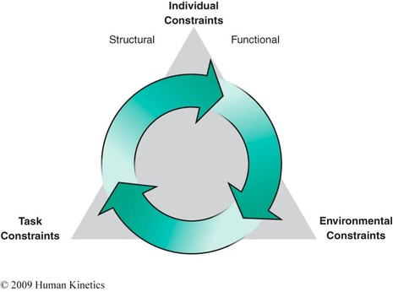

From the model above, the individual cannot be changed but the task and environment can be changed. In the game crazy capers, I changed the task slightly, by changing ball location and flight trajectory, distance and height and ball speed. To change the environment, I changed the size of the ball so used a variety of balls such as beach balls, foam balls, hedgehog balls all different colours as well as changing the instruction. I used the bigger lighter balls to start to assess children’s levels. Once children started to catch the ball with their hands as opposed to hugging or scooping I changed the size of the ball to a smaller size and also changed the distance to be less from the thrower.

In Saron school, as well as movement skills, I focussed on their throwing skills. I started children off at a similar distance from the target and with the same equipment to throw. By observing, I could see that some children needed to be challenged as it was too easy. Those that needed to be challenged had smaller targets, further away and different equipment to throw (in progression, not all at once). A couple of children struggled with the starting distance so decreased the distance to throw and made the target bigger. By constantly adapting the game, children were being challenged but also having success. All children played the same game but with slightly different constraints. The majority of children were at stage three throwing, with two at stage two and two at stage four. I manipulated the environment by adding a fence to throw the objects over to encourage opposite leg to arm and to step. The challenge was to get the object over the bench and in to a target of their choice. For those that needed it, I used a scarf to identify the opposite foot to arm and demonstrated stepping in with the foot with the scarf on. This helped to enable children to get their opposition right when throwing. My two cues were eye on the target and opposite foot and hand but when reflecting, I focussed to much on opposition and didn’t give enough praise when children were successful even if they weren’t in opposition, they were still progressing with their stepping forward and throwing action. This is something I want to get right next time.

As a couple of weeks went by, it was lovely to hear how excited the children were to take part in the sessions and see them participate with a smile on their face. As well as stages of skill levels improving, confidence was also growing. Children asked to help set up gardens which was great and at times, I gave children the choice on what equipment to use to make them feel involved in decisions. Staff had also seen a difference in concentration levels in the classroom which is great to hear. When children were taking part in the activities, I would constantly observe and what I did notice is that some children found it harder when they had to cross the midline. Blythe states that “Between six and a half and eight years of age a major period of myelination takes place, in which connections to the vestibular system, the cerebellum, and the corpus callosum are strengthened” (Goddard Blythe, 2005: 101). Blythe also states “Both sides of the brain are involved in a period of entertainment, and that the partner succeeds supremacy to the other side continues to provide a supporting, if secondary role” (Goddard Blythe, 2005: 101). To practice crossing the midline, during a warm up, I used benches, where children sat on the bench and had to pick up items from one side and transfer to the other side and reiterate about crossing the mid line.

Both schools are continuing running the sessions twice a week and I am hoping that the teachers will continue to see children improve their fundamental motor skills as well as keep gaining confidence. I did suggest setting a practical homework task and encouraging family participation at home. I have thoroughly enjoyed the course, I had prior knowledge and experience in the practical delivery however I did not know a lot of the theory behind which has been very interesting to learn and look forward to using this in the future. The idea now is to keep these children engaged in physical activity, nuture them, keep providing opportunities within school but also in the community to encourage lifelong participation in physical activity.

Word count: 2038.

Reference list:
- Gallahue, David L., and John C. Ozmun. (2012) Understanding Motor Development : Infants, Children, Adolescents, Adults. 7th ed. New York: McGraw-Hill Higher Education.
- Goodway J. 2016 SKIP Cymru Ohio State University.
- Stodden, D., Goodway, J., Langendorfer, S., Roberton, M., Rudisill, M., Garcia, C., and Garcia, L. (2008) ‘A Developmental Perspective on the Role of Motor Skill Competence in Physical Activity: An Emergent Relationship’, Quest, 60(2), pp. 290-306.
- Goodway, J.D. & Branta, C.F. (2003). ‘Influence of a motor skill intervention on fundamental motor skill development of disadvantaged preschool children’, Research Quarterly for Exercise and Sport, 74 (1), 36-46.
- Gethell, N., and Hayward, K., (2014) Lifespan Motor Development (6th edition) Human Kinetics.
- Clark, J.E., & Metcalfe, J.S. (2002). The mountain of motor development: A metaphor. Motor development: Research and reviews, 2 (163-190), 183-202.
- Harter, S., & Pike, R. (1984). The pictorial scale for perceived competence and social
acceptance for young children. Child Development, 55, 1969–1982.
- Goddard Blythe, S., (2005) The Well Balanced Child (2nd edition) Gloucester, Hawthorn Press.
- Ayres, A. J., & Robbins, J. (2005). Sensory integration and the child: Understanding hidden sensory challenges. Western Psychological Services.

Assignment Checklist

- Please complete the Personal Evaluation section of the Assessment Feedback sheet, add your name and details, and paste the whole of this assignment document into the front of your assignment

- Submission is a single word file, clearly labelled with your name and module code
- Font style - Times New Roman, size -12 for text and 14 for headings
- Ink colour – black only
- Line spacing – 1.5 line spacing and 2cm- 2.5cm page margins
- Quotations more than three lines to be indented 1 line spacing
- One line space between paragraphs, paragraphs must be left aligned
- Pagination (your assignment should have page numbers)
- All tables and figures are internally referenced and have a title
- Word count checked and written at end of text (before references and any appendix)
- Assignment is within 10% of the word limit (excluding references and any appendices)
- All references in the text are included in the reference list
- Correct referencing following the Harvard style, as described in the Palgrave study skills book ‘Cite them Right’.
- Correct spelling using UK English
- Correct use of punctuation
- Grammar and syntax correct- double check anything that has a green line under it
- I have read my assignment out loud to myself and it makes sense and is easy to read
- Somebody else has read my work and it makes sense to him or her!
- I have checked and I have not plagiarised
Failure to follow these guidelines will cost you marks!

