
APPENDIX GA36a

LEVEL 4 ASSESSMENT SPECIFICATION

Student name: |  | Student ID number:
Programme: | BSc/HND Computing Portfolio
Module: | Software Development
Module code: | ACCB4017 | Contribution to Overall Module Assessment (%): | 70%
Lecturer: | Geoff Dawkins | Internal Verifier: | Paul John
Assignment Title: |  | Word count (or equivalent): | N/A
Submission deadline: | 6/2/22 | Return date of provisional marks & written feedback: | 27/2/2
Submission method: | All written assessments, where practical and possible, must be submitted via Turnitin unless otherwise instructed by the Lecturer. (Please DO NOT put this assessment specification into Turnitin or it will match many similarities with other students’ submissions.)  Alternative submission method (if applicable):  Late submission of the assessment will result in a late penalty mark. Penalties for late submission: Up to one week late, maximum mark of 40%. Over one week late, 0%. Only the Extenuating Circumstances Panel may approve a change to submission dates.
Academic honesty / referencing: | Academic honesty is required. In the main body of your submission you must give credit to authors on whose research and ideas your work is based. Append to your submission a reference list that indicates the books, articles, etc. that you have used, cited or quoted in order to complete this assessment.

Module Learning Outcomes
(from module syllabus)
- Understand the syntax and semantics of a high-level programming language and develop programs using good programming practices.
- Select and deploy basic software constructs using simple algorithms in the development of solutions to programming problems

TASK DESCRIPTION

Note: Please use the programming language that you have studied during your module to complete the following (eg C, Python).

PART A (UNDERSTANDING)

A1. What is a variable and why are they important in writing programs? Discuss the way variables are handled in the programming language you have studied (eg static vs dynamic typing)

A2. Explain what an if/else statement is, how and why they are used, and give a code example of when you would use one. Include in your answer a discussion of the use of multiple conditions.

A3. Explain why loops are needed in a program and when you might use a for and a while loop. Give suitable examples of each in the programming language you have studied

PART B (IMPLEMENTATION)
The following exercises become increasingly more challenging. You don't need to complete all the exercises to pass this assignment. Marks will be awarded for attempting the exercises – a partial solution will still gain marks (particularly on Exercise 4, which is more challenging).

For each exercise below:

- Write a clear analysis of the solutions (the thought process behind them) – what logical stages are required. Identify specific problems in completing the exercise (eg any formulae required).
- Show a code listing with annotations (comments) IMPORTANT – copy and paste your code, do not use a screenshot! (This is so that I can run your code if required while marking!)
- Use validation in your code where appropriate to prevent the user from entering inappropriate values.
- Show testing (screenshots), clearly labelled, that demonstrate that the software solution you have developed works under all circumstances (not just the "happy path")

Exercise 1:
Show how variables can contain different types of values by declaring three variables that will contain a name, a measure of height (e.g. 1.84m) and a person's age (e.g. 26). Prompt the user to input these values and display them on the screen. The variables should be appropriately typed for the data required.

Outputs from the program might look something like these:

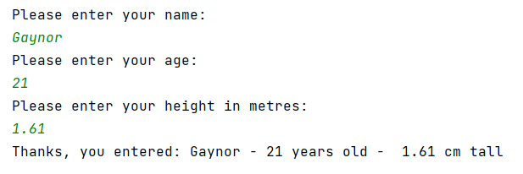

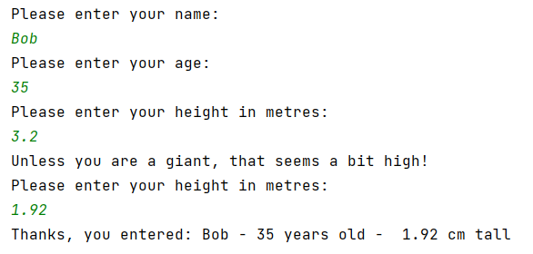

Exercise 2:
Allow the user to enter the dimensions of shapes shown below (in cm), then calculate the area of the blue shaded part. Note: The square and rectangular areas are empty.

rl
rw
sw
radius

Note:
Area of circle is given by $A=πr^{2}$
Area of square and rectangle is given by $A=l*w$

Outputs from the program might look something like these:

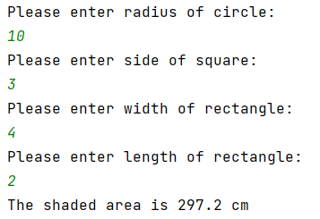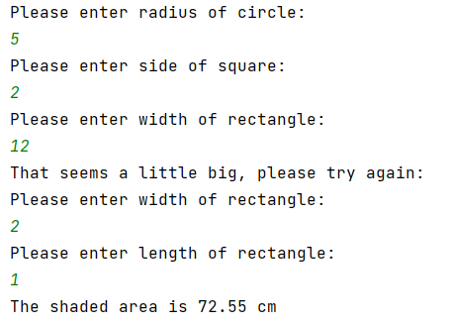

Exercise 3:
Write a program that allows the user to car mileage (per day) for a week. When the mileage has been entered, calculate the total mileage. Finally, calculate the total cost of petrol for the week, at the rate of £1.35/litre and 11.2 miles to the litre. Use a list/array and loop(s) where appropriate.

Outputs from the program might look something like these:

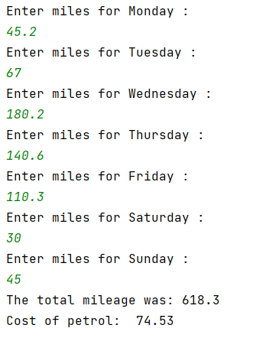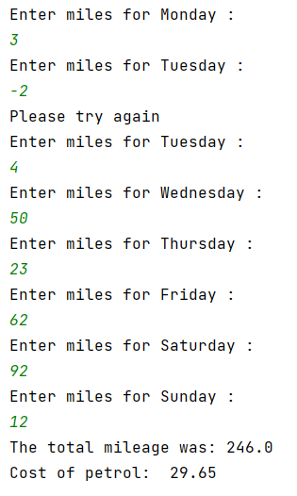

Exercise 4:
Pairs

You may implement the rules simply or in a more complex way. For example, you could have the same board each time, or you could set it up so that the values are placed randomly. Use a list to store the content of the game board.

You should use at least one function in your program. Extra credit will be given for more complex implementations.

Note: Remember, there are many marks available for design etc. It is better to have a version of the game that is partially functional, even if it does not incorporate the more involved requirements (eg counting/limiting number of turns or updating the board).

Outputs from the program might look something like these (note, the below implementation has many rules implemented)

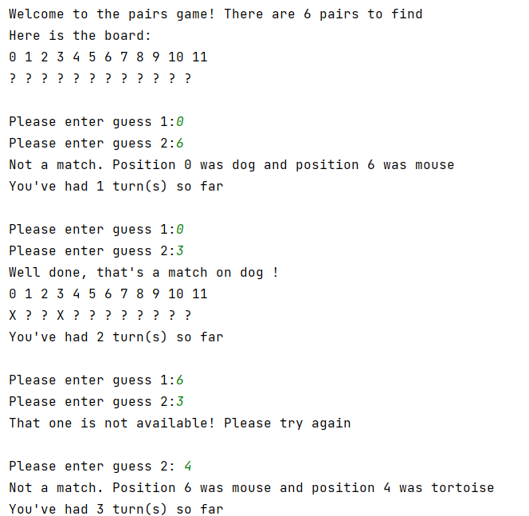

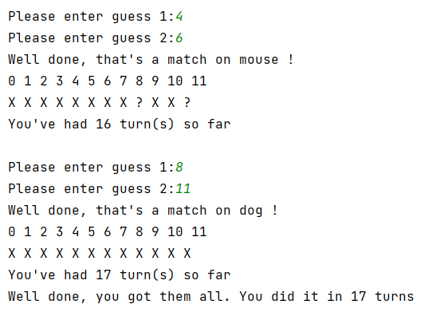

GUIDANCE FOR Students IN THE COMPLETION OF TASKS

NOTE: The guidance offered below is linked to the five generic assessment criteria overleaf.

- Engagement with Literature Skills
Your work must be informed and supported by scholarly material that is relevant to and focused on the task(s) set. You should provide evidence that you have accessed an appropriate range of sources, which may be academic, governmental and industrial; these sources may include academic journal articles, textbooks, current news articles, organisational documents, and websites. You should consider the credibility of your sources; academic journals are normally highly credible sources while websites require careful consideration/selection and should be used sparingly. Any sources you use should be current and up-to-date, mostly published within the last five years or so, though seminal/important works in the field may be older. You must provide evidence of your research/own reading throughout your work, using a suitable referencing system, including in-text citations in the main body of your work and a reference list at the end of your work.

Guidance specific to this assessment: N/A

- Knowledge and Understanding Skills
At level 4, you should be able to demonstrate knowledge of the underlying concepts and principles associated with your area(s) of study. Knowledge relates to the facts, information and skills you have acquired through your learning. You demonstrate your understanding by interpreting the meaning of the facts and information (knowledge). This means that you need to select and include in your work the concepts, techniques, models, theories, etc. appropriate to the task(s) set. You should be able to explain the theories, concepts, etc. to show your understanding. Your mark/grade will also depend upon the extent to which you demonstrate your knowledge and understanding.

Guidance specific to this assessment: See below

- Cognitive and Intellectual Skills
You should be able to present, evaluate and interpret qualitative and quantitative data, in order to develop lines of argument and make sound judgements in accordance with basic theories and concepts of your subject(s) of study. You should be able to evaluate the appropriateness of different approaches to solving problems related to your area(s) of study and/or work. Your work must contain evidence of logical, analytical thinking. For example, to examine and break information down into parts, make inferences, compile, compare and contrast information. This means not just describing what! But also justifying: Why? How? When? Who? Where? At what cost? You should provide justification for your arguments and judgements using evidence that you have reflected upon the ideas of others within the subject area and that you are able to make sound judgements and arguments using data and concepts. Where relevant, alternative solutions and recommendations may be proposed.

Guidance specific to this assessment: See below

- Practical Skills
At level 4, you should be able to apply the basic underlying concepts and principles to evaluate and interpret these within the context of your area of study. You should be able to demonstrate how the subject-related concepts and ideas relate to real world situations and/or a particular context. How do they work in practice? You will deploy models, methods, techniques, and/or theories, in that context, to assess current situations, perhaps to formulate plans or solutions to solve problems, or to create artefacts. This is likely to involve, for instance, the use of real world artefacts, examples and cases, the application of a model within an organisation and/or benchmarking one theory or organisation against others based on stated criteria.

Guidance specific to this assessment: See below

- Transferable Skills for Life and Professional Practice
Your work must provide evidence of the qualities and transferable skills necessary for employment requiring the exercise of some personal responsibility. This includes demonstrating: that you can communicate the results of your study/work accurately and reliably, and with structured and coherent arguments; that you can initiate and complete tasks and procedures, whether individually and/or collaboratively; fluency of expression; clarity and effectiveness in presentation and organisation. Work should be coherent and well-structured in presentation and organisation.

Guidance specific to this assessment: N/A

Knowledge and Understanding Skills

PART A | Max | Marks
Knowledge of variables | 5
Knowledge of decisions | 5
Knowledge of counting loops | 5

Cognitive and Intellectual Skills (Logical Stages/Testing)

PART B | Max | Marks
Exercise 1 | 5
Exercise 2 | 5
Exercise 3 | 10
Exercise 4 | 10

Practical Skills (Coding/Annotation)

PART B | Max | Marks
Exercise 1 | 10
Exercise 2 | 10
Exercise 3 | 10
Exercise 4 | 25

Student FEEDBACK FORM

This section details the extent to which the assessment criteria are demonstrated by you, which in turn determines your mark. The marks available for each category of skill are shown. Lecturers will use the space provided to comment on the achievement of the task(s), including those areas in which you have performed well and areas that would benefit from development/improvement.

Generic Assessment Criteria | Marks available | Marks  awarded
1. Engagement with Literature Skills
.
2. Knowledge and Understanding Skills

3. Cognitive and Intellectual Skills

4. Practical Application Skills

5. Transferable Skills for Life and Professional Practice

Assessment Mark (Assessment marks are subject to ratification at the Exam Board. These comments and marks are to give feedback on module work and are for guidance only until they are confirmed. ) | Late Submission Penalties (tick if appropriate) |  | %
 | Up to 1 week late (40% Max) |  | %
 | Over 1 week late (0%) |  | %

GENERIC ASSESSMENT CRITERIA

Level 4
In accordance with the Framework for Higher Education Qualifications, at the end of Level 4 students will be expected to have demonstrated knowledge of the basic underlying concepts and principles of a subject, and an ability to evaluate and interpret these within the context of that area of study. They should be able to present, evaluate and interpret qualitative and quantitative data in order to develop lines of argument and make sound judgements in accordance with basic theories and concepts of their subject(s) of study. They will have learned how to evaluate different approaches to solving problems, and will be able to communicate the results of their study/work accurately and reliably, and with structured and coherent arguments. They will be able to undertake further training and develop new skills within a structured and managed environment and will have the qualities and transferable skills necessary for employment requiring the exercise of some personal responsibility.

Level 4 | FAIL | MARGINAL FAIL | SATISFACTORY  (3rd / Pass) | GOOD  (2.2 / Pass) | VERY GOOD  (2.1 / Merit) | EXCELLENT  (1st / Distinction) | EXCEPTIONAL  (1st / Distinction)
Category | 0-29% | 30-39% | 40-49% | 50-59% | 60-69% | 70-84% | 85-100%
Engagement with literature (including reading, referencing,  academic conventions and  academic honesty) | Little or no evidence of reading and/or reliance on inappropriate sources.  Views and findings mostly unsupported and non-authoritative.  Referencing conventions used incoherently or largely absent. | Poor engagement with essential reading. No evidence of wider reading. Reliance on inappropriate sources, and/or indiscriminate use of sources. Heavily reliant on information gained through class contact. Inconsistent and weak use of referencing. | Engagement with a limited range of mostly relevant and credible sources but with some reliance on information gained through class contact. Some omissions and minor errors.  Referencing conventions evident though not always applied accurately or consistently. | Engagement with an appropriate range of literature, including sources retrieved independently. Some over-reliance on texts rather than other sources. Referencing may show minor inaccuracies or inconsistencies. | Engagement with a wide range of literature, including sources retrieved independently.  Selection of relevant and credible sources. Generally sound referencing, with no/very few inaccuracies or inconsistencies. | Engagement with an extensive range of relevant and credible literature. Consistently accurate application of referencing. | Exceptional engagement with an extensive range of relevant and credible literature. High-level referencing skills consistently applied.
Knowledge and understanding (Knowledge of the basic underlying concepts and principles of a subject.) | Major gaps in knowledge and understanding of the basic underlying concepts and principles of the subject matter. Inclusion of irrelevant material. Substantial inaccuracies. | Gaps in knowledge of the basic underlying concepts and principles, with flawed or superficial understanding. Some significant inaccuracies and/or irrelevant material. | Limited knowledge and understanding of the basic underlying concepts and principles within the subject area. Some elements may be missing. | Knowledge of the basic underlying concepts and principles is accurate with a good understanding of the field of study but lacks depth and/or breadth. | Competent knowledge of the basic underlying concepts and principles. Exhibits very good understanding. | Excellent knowledge and understanding of the basic underlying concepts and principles of the subject. | Exceptional, detailed knowledge and understanding of the basic underlying concepts and principles
Cognitive and intellectual skills  (Evaluate underlying concepts and principles of a subject and interpret qualitative and quantitative data in order to develop lines of argument and make sound judgements.) | Wholly or almost wholly descriptive work. Little or no evaluation of the underlying concepts and principles.  Failure to develop arguments, leading to illogical or invalid judgements. Minimal or no use of  evidence to back up views. | Largely descriptive work, with superficial evaluation of the underlying concepts and principles. Weak interpretation of data, flawed development of arguments and judgements. Information accepted uncritically, uses generalised statements made with scant evidence and unsubstantiated opinions. Ideas sometimes illogical and contradictory. | Limited attempt at evaluation of the underlying concepts and principles, tending towards description.  Can interpret qualitative and quantitative data but with some errors. Some evidence to support emerging arguments and judgements but these may be underdeveloped or with a little inconsistency / mis-interpretation. | Good evaluation of the underlying concepts and principles. Can interpret qualitative and quantitative data, with minor errors.  An emerging ability to use evidence to support the argument.  Mostly valid arguments and logical judgements. | Sound evaluation of the underlying concepts and principles. Can interpret qualitative and quantitative data accurately. Ability to devise arguments using evidence to make mostly appropriate and valid judgements. | Excellent evaluation of the underlying concepts and principles. Can interpret qualitative and quantitative data accurately and with some insight. Excellent ability to devise arguments using evidence and make appropriate and valid judgements. | Exceptional evaluation of the underlying concepts and principles based evidence. Outstanding interpretation of qualitative and quantitative data.  Exceptional ability to devise arguments using evidence and make wholly appropriate and valid judgements.
Practical skills  (Different approaches to solving problems in particular contexts.) | Limited or no use of taught, basic methods, materials, tools and/or techniques.  Little or no appreciation of the context of the application.  Very weak evidence of different approaches to problem-solving in particular contexts. | Rudimentary application of taught, basic methods, materials, tools and/or techniques but without consideration and competence. Flawed appreciation of the context of the application.  Weak evidence of different approaches to problem-solving in particular contexts. | An adequate awareness and mostly appropriate application of basic methods, materials, tools and/or techniques.  Basic appreciation of the context of the application.  Can identify problems in particular contexts and propose basic alternative approaches or solutions though there may be errors. | A good and appropriate application of basic methods, materials, tools and/or techniques.  Clear appreciation of the context of the application.  Good evidence of different approaches to problem-solving in particular contexts and proposes mostly appropriate solutions. | A very good application of a range of basic methods, materials, tools and/or techniques.  Very good consideration of the context of the application. Very good evidence of different approaches to problem-solving in particular contexts and proposes appropriate solutions. | An advanced application of a range of taught, basic methods, materials, tools and/or techniques.  The context of the application is well considered, and insightful.  Excellent evidence of different approaches to problem-solving in particular contexts and proposes appropriate solutions. | Exceptional levels of application and deployment skills in particular practical contexts. Outstanding identification of problems in particular contexts and formulation of wholly appropriate, thoughtful solutions / different approaches.
Transferable skills for life and professional practice  (Communicate the results of their study/work accurately and reliably, and with structured and coherent arguments; the qualities needed for employment requiring the exercise of some personal responsibility within a structured and managed environment.) | Work is poorly structured, disorganised, inaccurate and/or confusingly expressed. Very weak use of language and/or very inappropriate style. Failure to work effectively individual or as part of a group. Little or no evidence of the skills for employment requiring the exercise of some personal responsibility. | Work is poorly presented in a disjointed manner. It is loosely, and at times incoherently, structured, with information and ideas often poorly expressed. Weak use of language and/or inappropriate style. Flawed approach to individual or group work, meeting only partial obligations to others. Limited evidence of the skills for employment requiring the exercise of some personal responsibility. | Mostly ordered presentation and structure in which relevant ideas / concepts are reasonably expressed. Work may lack coherence and/or accuracy in places. Can work as part of a group, meeting most obligations to others but perhaps with limited involvement in group activities.  Demonstrates the basic skills for employment requiring the exercise of some personal responsibility, with some areas of minor weakness. | Mostly coherent, organised and accurate work, in a suitable structure and is for the most part clearly expressed. Can work effectively independently and/or as part of a team, with clear contribution to group activities.  Demonstrates the skills for employment requiring the exercise of some personal responsibility, with some areas of strength and some of minor weakness. | Work is accurate, coherent, fluent, well-structured and organised.  Can work effectively independently and/or as part of a team, with very good contribution to group activities. Demonstrates very good skills for employment requiring the exercise of some personal responsibility, with just occasional minor weakness. | Work is coherent, very fluent and is presented professionally. Can work effectively independently and/or as part of a team, with an excellent contribution to group activities. Demonstrates excellent skills for employment requiring the exercise of some personal responsibility with an appetite for further development. | Work is accurate, exceptionally coherent, very fluent and presented well. Can work effectively independently and/or as part of a team, with an exceptional contribution to group activities. Demonstrates exceptional skills for employment requiring the exercise of some personal responsibility with an appetite for further development.

THIS DOCUMENT IS ALSO AVAILABLE IN WELSH

