

RSEULT

ASSIGNMENT DETAILS AND FEEDBACK
SOUTH WEST WALES CENTRE FOR TEACHER EDUCATION
Sections marked with * should be completed by module lead
Student name: | Georgia Roach | Student P number: | P136878
Programme: * | Secondary Post Graduate Certificate in Education
Module: * | Curriculum Development and Enhancement | Module Level (6 or 7): | Level 7
Module code: * | ECSP7002 | Contribution to Overall  Module Assessment (%): * | 100
Module Lead:* | Jan Barnes
Assignment Title:* | Reflections on Teaching and Learning | Assignment No (x of x): | 1
Start date:* | 16/04/18 | Submission deadline:* | 14th May 2018 –full submission
Return date of provisional marks & written feedback:* | 11th June 2018

Referencing: | In the main body of your submission you must give credit to authors on whose research your work is based. Append to your submission a reference list that indicates the books, articles, etc. that you have read or quoted in order to complete this assignment (e.g. for books: surname of author and initials, year of publication, title of book, edition, publisher: place of publication).
Submission: | All assignments must be submitted to Turnitin unless otherwise instructed by the Lecturer.  Note: the Turnitin version is the primary submission and acts as a receipt for the student. Late submission of the electronic version of the assignment will result in a late penalty. Penalties for late submission: Up to one week late, maximum grade D. Over one week late, Refer. Only the Extenuating Circumstances Panel may grant an extension. | Date: | 13/05/18

Module lead to tick to indicate if a hard copy version of the assignment must be submitted.* | YES
 | NO | √

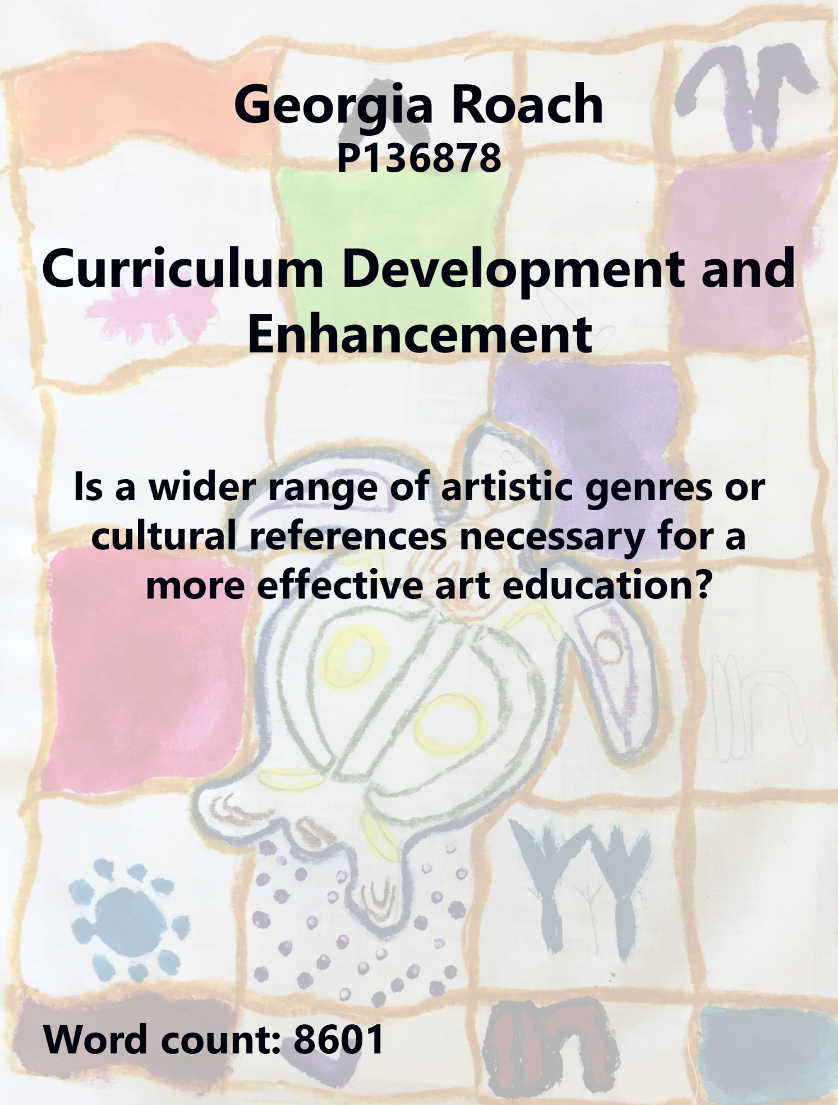

Contents | Page
1.Introduction | 4
2.1. Literature Review | 5
2.2. School policy and practice | 10
2.3. Ethics and methodology | 11
3.1. Evaluation | 13
3.2. Limitations and future developments | 22
4.2. Conclusions | 24
5.0. Bibliography | 26

- Introduction

This study can be seen in the national context of the re-organising of the school curriculum in Wales, which is occurring in response to Donaldson’s (2015) Successful Futures. His outlining of the four purposes of education raises questions about the characteristics of a global citizen who has awareness of national identity and the wider world. His emphasis on the importance of skills and the inter-related nature of subject knowledge allow teachers to reflect on how a subject such as Art can contribute to a pupil’s overall development. A wider range of artistic genres and cultural references may need to be explored in order to consider whether they are necessary for a more effective art education, post-Donaldson. The specific context for the study is a particular school in the Afan Valley. Another of Donaldson’s (2015) recommendations is based on the need for Welsh children to have access to their own culture and an awareness of Welsh identity. A school in the heart of the Welsh Valleys can provide an interesting starting point to explore these concepts in action. In the twenty-first century, awareness of global literacy is crucial for pupils to understand how cultures are created, eroded and re-formed. These contexts, national, local and global, drive the research question and underscore the interrogation of the subject.

2:1 Reading Review:

Addison and Burgess (2000, p.5) usefully outline different approaches to the teaching of art. Amongst those methodologies they list an approach which they describe as an investigation of art as a way of developing thinking skills through ‘social and cultural production’. Allied to this method is their description of art teaching as an issue-based fusion of the personal with social, political and moral responses. Both of these latter approaches link with the concept of culture which is a complex and polysemic site of meaning.

Firstly, culture can refer to the arts themselves and the refined understanding of their importance. Western traditions of art, exemplified by Kenneth Clarke’s Civilization (1969), have tended to equate the words culture and genre with so-called civilized and refined manners of living, connected to Western ways of thinking. In his seminal book and television series, Clarke largely ignored the art of other cultures, and of women in particular. He makes, a now controversial distinction, between art and craft. Conservative critics have connected culture with concepts such as, being educated to a high level, enlightenment and appreciation of finer things. Often people or events are described as cultured when referring to so-called ‘high art’. Although some of these elitist attitudes linger, the word culture has come to indicate a community’s shared set of values or conventions as in concepts such as pop culture or youth culture. However, The National Association of Multicultural Education (NAME) claims that teachers still feel more comfortable in teaching about fine art of the nineteenth and twentieth centuries, and that this may reflect old perceptions of what art is, and what art should be valued. NAME maintains that there are still significant gaps in provision when it comes to women artists and non-Western traditions. This leads to areas in art which are overlooked and not included in programmes of study. To complicate things further, Donaldson (2015) has argued that the emphasis on subject knowledge, as in the study of key movements or artists, has been assumed by subject specialists to have stood the test of time and the best path to a sound education. His recommendations for change, in Wales, are based on the development of key skills or competences that will be developed in pupils across the curriculum. These thoughts come at time when others such as, Freedman (2003), are suggesting extending the perimeters of art teaching to include wider references to genre and culture. Such vision looks at the growth of visual literacy in the global age and how pupils need to develop critical thinking to make sense of their identities and cultures.

In outlining different approaches to Art teaching, Addison and Burgess (2000) also list genre-based approaches as a common methodology. One application of the word genre, refers to different styles of art, such as Realism or Expressionism. An artefact can be classified by looking for its typical characteristics such as typical subject, style or motif. Erikson (2015) develops genre-based teaching further by recognising the wide use of modelling, provided by teacher example, pupil exemplar or the practices of established artists. Haston (2007, p.26) refers to modelling ‘as the mother tongue’ of teaching; using pupil work and other exemplar can be observed in most art classrooms.

Erikson’s (2015) enthusiastic endorsement of experiential learning in Art, is shared by Donaldson (2015) who lists that approach as a successful methodology in Successful Futures. This approach is based on Kolb’s (2014) premise that pupils learn best when engaged in first-hand experiences. Barrett et al (2005, p.1) describe enquiry-based learning as ‘a broad umbrella term’ which involves the teacher establishing the task, offering support while students pose questions and pursue enquiry by drawing on their fore-knowledge, logical thinking and research. Erikson (2015) sees modelling and experiential learning as slightly opposed to each other, but in practice surely both approaches are legitimate methodologies in introducing a genre-based approach. In practice, they are both part of the Art teacher’s repertoire and would be used according to purpose and context.

In both England and Wales, governments have acknowledged the importance of both cultural heritage and connection with a wider world. Such heritage would include knowledge and understanding of a range of genres. Gove (2013) has written that schools should integrate cultural education into lessons and that it is important for children to grow up with a sense of pride in their local area with an understanding of cultural heritage. This resonates in Wales where Successful Futures (2015) looks at the holistic education of children and their place in a modern society. Schools are expected to develop creative contributors and informed citizens, with a clear sense of their position in Wales and the world. In order to develop creative contributors and informed citizens, it is important that pupils develop a strong sense of their own culture, and it is especially important in a small nation that pupils connect with their local area and with other cultures. All our Futures (1999, p.50) quotes Imison who describes understanding only one culture as seeing with one eye. Being exposed to a range of genres in Art, including those from other cultures, would allow pupils to have eyes wide open.

However, Garber (2015) criticises teachers who introduce cultural artefacts without giving any context or cultural referencing. He accuses them of looking at non-Western art from the perspective of their own value system and through the filter of Western attitudes. Garber does not believe that simply introducing art from across the world is effective in widening a student’s perspective or sense of genre without some references to history, stories or experiences of the specific culture studied. Garber is right in his accusations, as without context or cultural reference a work of art from a culture outside the student’s experience can seem exotic and runs the risk of underlining ‘otherness’ rather than bringing a new perspective to the learner. American artist Kara Walker teaches traditional eighteenth century methods of cutting silhouettes, to allow pupils to engage with the issue of inter-relations between African-Americans and white slave owners during the last years of slavery. By so doing the artist allows pupils to connect with and understand aspects of American culture. Through questioning and research, pupils reflect on the cultural context of nineteenth century America. By putting them into that society, greater understanding is created and the art works they produce have moral purpose.

Teachers under the duress of classroom stresses sometimes use stimulus from other cultures without context or explanation. Davenport (2015) examines how teachers can be confused about how to deal with questions of culture within the classroom setting. She analyses four approaches which may prove useful to this study. The first approach concentrates on the pupils’ own community. This method uses the materials and attitudes of the local area. This connects with Donaldson (2015) who claims that knowing the heritage of your home is important in an individual’s development. In terms of art in Wales this could include looking at the work of local artists, using local resources, and exploring local themes. Ford and Harris (1999) have linked the lack of educational relevance of resources with decreased student motivation and interest in school, a link which art teachers need to take into account when planning.
Similarly, Donaldson (2015) makes it clear that learning should be relevant to the individual. With this in mind, he has urged teachers to ensure that pupils are knowledgeable about their own culture and community so that they understand their own society and world. Clearly, for many art teachers starting with the known and, as Morley (2012) suggests, defamiliarising the norm, is a useful practice. Getting pupils to look again with new eyes at things which have become familiar is a useful technique for creating art. However, as Imison (1999) suggested pupils will not become binocular if the only culture they encounter is their own. In fact, without contact with other cultures it is debatable whether one can ever truly understand one’s own world.

Davenport’s (2015) second area of discussion, for spotlighting cultural references, is comparative approaches to culture. This approach could be seen as akin to Hyerle’s (2008) use of thinking maps, whereby pupils would be encouraged to find connections between works of art, before looking at differences through using a visual organizer, such as a double bubble map. They might be encouraged to explore what is the same and what is different about two art works from differing cultures or to compare their own with that of one from another place. This could be useful in an art lesson and would contribute to the development of critical thinking. For example, in looking at patterns used in the Mexican Day of the Dead, pupils could use a Venn diagram or double bubble map to compare and contrast with the Welsh artist Swci Delic. A drawback might be that pupils may, as Chalmers (1999, p.1) points out, feel more comfortable with the local artist, in which case, the ethnic art could become part of what she calls ‘a smorgasbord of exotic places’. The key would be to find ways in which Western art is not privileged and pupils are encouraged to look with open minds.

Davenport (2015) cites multiculturalism as a third aspect of culture although she recognizes that multiculturalism has become a loaded word. Donaldson (2015) has pointed out that pupils should learn respect for the needs and rights of others and their specific cultures. That is seen as an essential part of Wales’ educational vision. We live in a pluralistic society, a fact which is usefully discussed by Gollnick (2009) who sees the term multiculturalism as a catch-all idea that brings together issues of ethnicity, language and class. In education this concept is about recognising the uniqueness of each student and finding ways to help them on that journey. How to help pupils to access education no matter what their background is the challenge for all teachers. Johnson et al (2004) helpfully outline ways of encouraging such diversity and equality. Fundamentally the teacher’s relationship and respect for the class is crucial. In the art classroom this could mean offering supplementary material from varied cultures and educating pupils to have respect for cultures they do not initially understand. Added knowledge about purpose and context can give a class new respect for another culture. Other factors outlined by Johnson et al (2004) include specific and integrated studies of ethnic and other cultural groups as well as the development of critical thinking skills. In Art, teachers must guard against journeys into ethnic studies as just an interval from the main course of studying white Western men.

Johnson et al (2004) are supported by Slavin (2006) in placing the development of thinking skills at the heart of challenging stereotypes. In art this might mean choosing materials that demonstrate positive qualities among a variety of ethnic groups. However, simply choosing the greatest art works produced from different cultures will not change attitudes on its own. Pupils need to engage with the processes of art in order to understand the choices and creativity of different artists. Through making artefacts, pupils can reach a greater appreciation of the artists’ methods and thinking but critical analyses, questioning, debate and research deepen understanding further.

The last aspect of culture which Davenport (2015) discusses is global culture. We live in a world which is linked by internet, media and industrial giants. Sometimes this is described as the global village. In such a world, it is important to have cultural competence where the pupils develop a sense of their own cultural identity without losing the ability to understand and appreciate both sub-cultures within Welsh society, and cultures from around the globe. In Art, access to the digital world allows pupils to research artists, to take virtual tours of sites such as Monet’s Garden or American galleries and even to talk to and interview living artists. This gives opportunities to pupils who otherwise would have a very narrow experience of Art. This underlines the importance of references to wider genre and cultural references in order to support those whose lives would otherwise be narrow and impoverished.

Some teachers do not see the importance of teaching Welsh culture because ‘they know that already’. That is to underestimate the richness of Welsh heritage in terms of history, art and language. Donaldson (2015) is attempting to redress that complacency. Attitudes to both gender and ethnicity in Art can be patronising. Addressing cultural issues is complex and best addressed through encouraging critical attitudes. Who made this, under what circumstances, with what purpose and for whom? Questioning what we see and encouraging pupils to interrogate their own practices is a good starting point. As Art teachers we need to reflect on our resource choices and when considering culture, ask ourselves, whose culture are we representing. Especially important is the fact that some Welsh Valley teachers have suggested that it is unnecessary to teach other cultures in a predominantly white area. What my reading has shown is that in such an environment, access to a different culture, and a variety of genres is even more important for those pupils so that they feel part of the global world.

Davenport’s (2015) research supports Donaldon’s (2015) recommendation that pupils need to establish secure values and ethical beliefs. By connecting pupils with the rest of the world, a sense that all people have more in common than they are different could be developed. Respect for others and the creative artefacts they produce are steps in embedding humane values. The Art teacher can open the eyes of pupils by providing them with a larger perspective on the world through providing varied experiences, contact with great art and teaching critical and creative practices.

Freedman (2003) make a case that the growth of virtual culture demands curriculum changes in Art. She points out that study of fine art is not the only cultural capital in the modern era, as artefacts such as advertising posters, film paraphernalia and installations can now be found in art museums. Although still seeing the value of studying fine art, she argues that the exploration of visual culture and its global meanings are important in the contemporary world. Freedman (2003) challenges art teachers to widen the content of art courses and to address cultural references through both involvements with cultural heritage, and by connecting with the wider world. These are challenging suggestions for art teachers, that underline the complexities of cultural referencing in a global age.

These considerations are significant in Wales as the Successful Futures document is fleshed out as part of a debate as to how best serve the interests of pupils, making sure that they are knowledgeable about their culture and the wider world. In order to provide that education pupils may need to have wider references to genre and culture and this research will consider how those issues are addressed in a specific Valley school. Through this reading it is clear that some key points will colour the investigation. Clearly, most art educationists writing on this area:
- acknowledge modelling and experiential learning with reference to a range of genres as central to art education;
- see the importance of cultural references to a pupil’s own culture and environment and to the context of works of art;
- acknowledge the multicultural society we live in, and the sensitivity which is needed in bringing references to non-Western and neglected areas of art so as not to use artefacts in a patronising way, but as a reflection of human creativity;
- promote art as a vehicle for widening pupil experience and cultural capital to allow all pupils access to the cornucopia of global art.

These concerns will shape the research question and influence the reflections to follow.

2:2. School policy and practice:

Cymer Afan Comprehensive School (11-16) serves the Afan Valley, which is a deprived area of South Wales. It once was a coal mining area and that heritage is preserved by the Afan Valley Mining Museum. There are plans to close the school in the near future because of falling rolls. The area is becoming depopulated and can no longer sustain a secondary school. The effect of the closure has led to the school being starved of resources as it is intended that the children will be bussed to Port Talbot, a move which is very unpopular with parents, teachers and pupils. Art is not part of most children’s lives outside of school. The Art Department recognises this lack of opportunity and tries to address it through exhibiting pupils’ work, and encouraging entry to competitions. Despite being an area of deprivation, (35% eFsm) the school’s website acknowledges that some pupils have received ‘awards and national recognition’. Examination results in Art and Photography are good as smaller classes allows the teacher to give pupils individual support

The area is predominantly English-speaking and there are few pupils from an ethnic background. In some ways, as the Reading Review suggests, pupils who have little contact with those from other cultures have an even more urgent need to engage with art from across the globe so as to combat prejudice. The Art Department includes modules on non-Western art in its SoW, which partly addresses the inclusion of a more global approach to culture. As the school is situated in the centre of the village of Cymmer, there are advantages in that resources such as the spectacular landscape, the stimulus of a Welsh community, and some awareness of local history are available.

The Art Department has only one teacher because of the small size of the intake. The department is allocated two rooms, an art room and one for photography. However, the photography room is rarely used because of lack of staff and resources. It could be dispiriting to work in a school marked for closure, but the Head of Art has made her room into a pleasant and stimulating work-shop. Because there is only one member of staff the need for written policy on every aspect of work is diminished. However, there is a Department Book and SoW which help remind the Head of Art of the department’s direction and this can be shared with staff or visitors.

Cymer Afan School’s aims acknowledge the role of teachers in tackling racist and sexist attitudes so as to promote multiculturalism through a range of cultural references. The school’s skills programme attempts to equip pupils to question and reflect so as to combat closed attitudes through critical thinking. The Art Department Handbook lists how factors of ethnicity, gender and social circumstances may affect learning. Crucially, one of the aims of the Art Department is to teach an understanding of visual language which can play a unique role in addressing cultural diversity.

2.3. Methodology and Ethics
Ethical concerns are paramount in all research, and we need to remind ourselves of upholding certain principles. The first is that of transparency and with that in mind, the department will need to be informed that its work will be scrutinised. Especially important is the ethical and transparent use of data, references to demographic and any pupil work. The school will be informed of the research and will have access to the findings. Secondly, research is concerned with honest scrutiny of practices. The findings and approaches will be undertaken in a straightforward manner whereby the truth of impact or lack of impact will be acknowledged. Lastly, as a researcher scrutinising practices, the approaches chosen to answer the research question will be based on data, qualitative evidence and professional judgement. The reasons for the project and how information will be used, will be shared with the head of the department. Any references to pupil work will be anonymous and photographs will only be used where the school has permission to use such artefacts as part of school life. Names will not be attributed to such material.

The question as to whether a wider range of cultural references is needed for an effective art education has arisen from the reading review. According to educationists, the area is a problematic one which art teachers needs to try to get right. Although there are practitioners who do not make any cultural references, and believe in the-artefact-can-speak-for-itself school of teaching, the majority of educationists believe that some cultural reference should go hand in hand with critical analyses.

From the reading review it is clear that the insights of the Head of Art should be taken into account as she has access to practices that the researcher could overlook. Wisker (2001) suggests that a good reason for interviewing could be to gather insider experience, privileged insights and accounts. Such knowledge and understanding could be valuable in trying to find out how and why cultural referencing is important and how a wide repertoire of genres can aid understanding in Art. She will be interviewed to give insight into how she approaches this question. Clearly her answers will not be definitive but will present a snapshot of professional opinion. The best fit interview technique would be the semi-structured interview whereby the interviewee will have some set questions but will be allowed to elaborate as she thinks fit. The drawback of interviews is that what is being said can be misconstrued by the interviewer or words can be taken out of context. To mitigate against this, the purpose of the interview- to gauge the attitude of the practitioner and test the extent of cultural referencing she would consider effective – will be made transparent, and the results will be shared with the interviewee to make sure that her views are represented correctly. Kvale (1996) has outlined different types of questions which can be used in an interview. Some are purely factual but others concern values and opinions. This will not produce major evidence but the answers will be used to cross-reference findings and to make sure that key areas are not overlooked.

The practices of Cymer Afan Comprehensive will be analysed in the light of Davenport’s (2015) categorisation of cultural referencing, which was noted in the reading review. The insights of other writers examined in the reading review will also inform the analyses. This will take the form of scrutinising display work, sketchbooks, department handbook and creative outcomes. Allied to this a case-study approach will focus on a typical scheme of work which uses cultural referencing. Adelman (1980) calls the case-study the study of an instance in action; he argues that case-studies are significant and legitimate research methods. The drawback, according to Nisbet &Watts (1984) is that they can be personal and subjective, but their strength is that they offer rich detail of classroom practice. Zuber-Skerrit, (1996) has referenced the importance of teachers describing classroom practice and planning, so as to contribute to knowledge about educational matters. Cohen, et al (2004) have pointed out that significance rather than frequency is the strength of case-studies and that they offer the researcher insights into real situations and real people. By examining the practices within a particular school, we may gain insights into how the issues explored affect classrooms elsewhere. Clearly, it is important not to be subjective in interpreting data but as Groundwater-Smith (2004) has pointed out, it is impossible to be theoretically innocent, as everyone has a bias and all the researcher can do is act in good faith and be aware of prejudices.

During the research period two SoW relevant to the research question will be taking place in Cymer Afan School. The first is based on Aboriginal Art, a SoW which is covered over two terms. The work produced, and the processes of learning adopted, will provide rich examples of learning through referencing other cultures. A SoW based on Mexico’s day of the Dead will be discussed where relevant but the focus of the analysis will be the Year 7 SoW based on Aboriginal art and the artefacts produced.

One of the interesting by-products of this work is the means by which it will be evaluated. While using the usual methods of self-assessment and teacher assessment, an added element of interest will be the use of an attitudinal questionnaire. Osgood et al (1957) were the pioneers of this technique and despite its limitations, for example, pupils may lie, it can still give a litmus test of how a class feels. Osgood et al (1957) suggested that statements should be in the present tense so as to be an accurate guide to present attitudes and experiences. This could be an interesting evaluative approach to see pupil attitudes to cultural referencing and variety of genre.

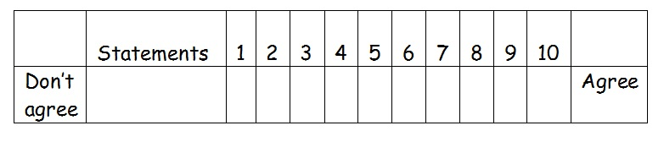
An example of an attitudinal test framework

Overall, the research will use the paradigms presented by Davenport (2015) on culture, and the genre-based approaches suggested by Erikson (2015) to study art at Cymer Afan School. The approach to the research will be to:
- gauge teacher opinion on genre and cultural references;
- analyse the material used for modelling in the classroom including displays, exemplar, artists’ work;
- examine SoW for evidence of variety of genre and cultural references;
- evaluate SoW in action by looking at pupil outcomes.

3:1. Evaluation

3.1a. Exploration of local culture in a range of genres

The art room at Cymer Afan School is a vibrant and colourfully stimulating place which is rich with exemplar material. First of all, it is clear that this is a Welsh classroom, as artefacts show relevant links with the catchment area. Ford and Harris (1999) have suggested, educational relevance increases student motivation. Using Davenport’s (2015) exploration of culture as a means of strengthening identity and investigating nationality it is clear that pupils have had opportunities to consider their places in the Afan Valley through a variety of genres. The classroom has displays of Welsh artists and the Head of Department in her interview, named an impressive array of Welsh artists whose work had been referenced in her classroom. The wall of artists serves several purposes, as it provides role models for pupils who have little knowledge of how people from their own vicinity have achieved creative success. Another purpose of the display is to provide stimulus and teaching opportunities as cultural references can be made seamlessly.

Several of the Welsh artists are used in SoW as stimulus or for the modelling approach outlined by Erikson (2015). For example, the work of Welsh artist Swci Delic is used in the SoW on Day of the Dead as a contrast in pattern-based art work. Care is taken not to use the Western artist as a means to suggest that Mexican art is in some way more primitive, for as Garber (2015) has pointed out that would be to perpetuate a condescending value-laden attitude to art. Instead it is more a case of putting Swci Delic’s work on the same footing as the sugar skulls of Mexico in order to facilitate debate on how different artists can work in different genres on similar themes. This approach is akin to Erikson’s (2015) description of enquiry-based learning through comparison of Welsh art with that of Mexico. A comparative approach to culture is another way, according to Davenport (2015), of presenting a wider range of cultural and generic references without over-privileging Western art over ethnic.
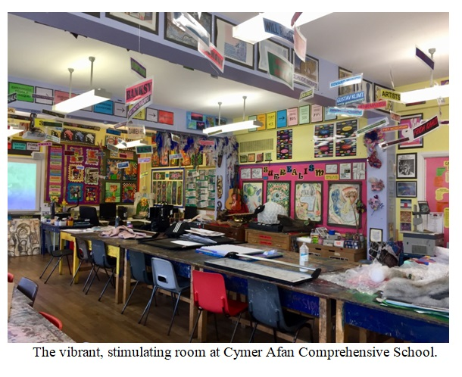

The art classroom uses past pupil work as exemplar, a staple of genre-based teaching. However, Cymer Afan’s classroom has a variety of artefacts relating to the Afan Valley and to Welsh experiences. In her interview the HoD commented that pupils explore a variety of traditional and contemporary Welsh artists to inform their own ideas and 2D and 3D work whether, the traditional palette knife paintings of Sir Kyffin Williams or the modern, pop, abstract works of Swci Delic. Classes have clearly played with stereotypical symbols of Welsh life, working in 3D to create sculptures of dragons and decorate love spoons. Both of these symbols are important to Welsh culture, the dragon appearing on the Welsh flag and the love spoon traditionally carved by lover. In creating versions of these traditional symbols, pupils necessarily needed to find out about the context and meanings of Welsh icons. They are encouraged to think beyond the obvious clichés. This is further underlined by the display of a dress using the colours of Wales, but made completely from recycled plastic bags. The pupil is using readily available materials to create a work of art which could be a comment on the need to reclaim materials which would otherwise become landfill.

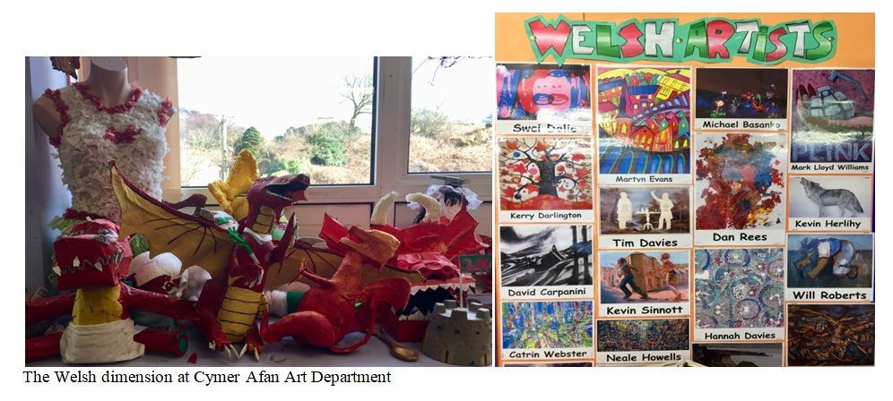

Another genre explored involves using local culture in the creation of concertina booklets which act as triptychs when displayed on the wall. These are explorations of the Afan Valley. Pupils have been out in their local community drawing landmarks which act as indexical signs of the area. Furthermore, pupils were encouraged to use earth and other found materials from the valley in the project. This encourages pupils to look again (Morley, 2014) and to find a pride in local culture and heritage (Gove, 2013). The display is a constant reminder of the Valley’s history and its worthiness as a subject for art. Through such work, pupils look again at their own environment and develop a stronger sense of their own culture and local area.

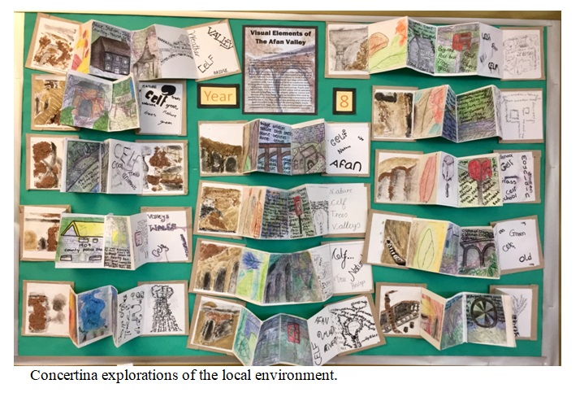

3:1b. Schemes of Work: A case-study of Aboriginal art

The SoW used by the Art Department often make reference to work from other cultures, the Day of the Dead is a good example. However, Year Seven’s study of Aboriginal Art offers interesting insight through a combination of experiential learning and modelling. Johnson, et al (2004) discuss how integrated studies of ethnic and other cultural groups contribute to pupil understanding of our pluralistic society. The Aboriginal Art syllabus contributes to Donaldson’s (2015) suggestion that as well as developing creative contributors, it is important to encourage pupils to be informed citizens who have a sense of the wider world.

The SoW begins by introducing Aboriginal Art to the year 7 classes through the use of a PowerPoint presentation which outlines key facts of Aboriginal culture and displays the artefacts produced. The information is important so as to avoid pupils looking at Aboriginal art only through their own value-system and with Western attitudes. By feeding in information on history and the experiences of the Aboriginal people, pupils should have a greater understanding of the purpose and tradition of such art. This is in keeping with Garber’s (2015) plea that teachers do not introduce cultural artefacts without context or cultural reference. Pupils are expected to listen to the information, take notes and be able to apply the information to their work. This is a version of genre-based teaching, as outlined by Addison & Burgess (2015). The PowerPoint not only gives cultural references but provides models of Aboriginal patterning which will act as exemplar; pupils can adapt them for their own purposes. The first task for pupils is a research page; they are to compose a two-page spread within their sketch-books which will be filled with designs based on the art work and information they have seen so far. This includes looking independently at additional Aboriginal art work on postcards, as well as incorporating the information from the notes taken from the PowerPoint presentation. This research page uses aspects of experiential learning as pupils need to use their research in an investigation of the characteristics, purpose and context of Aboriginal Art.

Pupils responded to the initial PowerPoint with curiosity and interest. Apart from past pupil work on the walls, they had not encountered Australian art before. In fact, a significant percentage (40%) had no knowledge of Aborigines. The methodology for deepening knowledge and understanding of the culture was to use a drip-drip effect whereby after the initial introduction, more information was fed to the class about Aborigine Art. The extra information took the form of video, postcards and recapping of facts already introduced. This reiteration is suggested by some educationists (Brigley, 2015) as a tool for retaining knowledge. The pupils were eager to provide information and to engage with dreamtime stories. Evidence of assimilation of the information can be seen in sketchbooks. What the sketchbooks show is that pupils have grasped some of the key features of Aboriginal culture. Pupil A’s notes are typical of class efforts for, as well as listing key points in written form, the pupil has incorporated the typical pointillism, symbolism and patterning common in Aboriginal Art. She has conveyed information, not only in words but in the graphic organization of the pages. Pupil B has been inspired to do independent study and includes symbols such as hands, lizards, the sun and the tree, none of which were referenced in class.

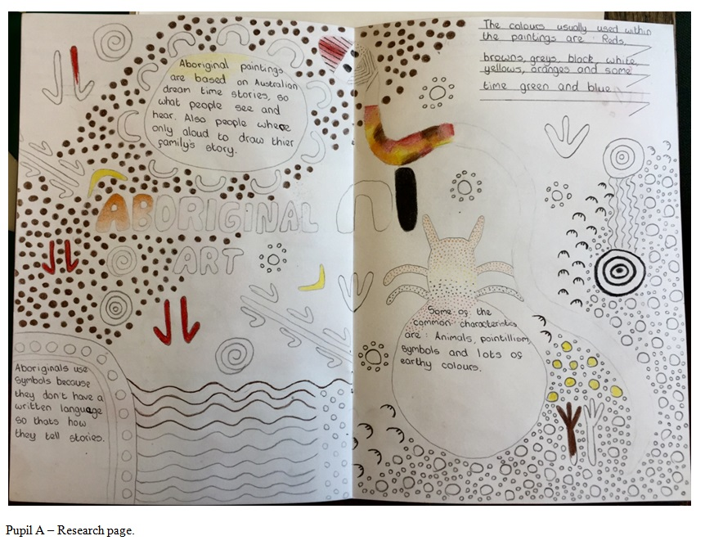
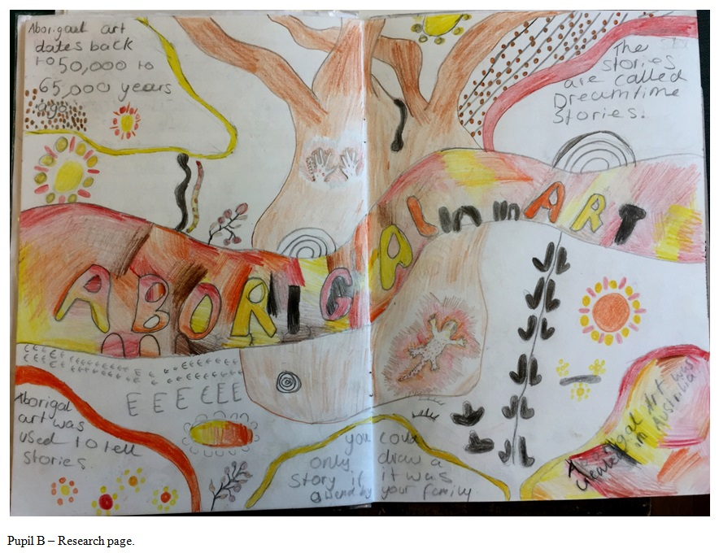

This SoW incorporates useful recapping tasks to ensure pupils understand the information they are receiving. This is checked through the use of a variety of tasks, designed to build on past information. One such task which pupils will undertake is to look at the importance of symbols within Aboriginal Art. Through the SoW pupils learn some of the tools of critical thinking which Johnson, et al (2004) consider most important in investigating art. Symbolism is explored as a key element in Aboriginal Art but it is also key in studying all representation. In this context, the reasons behind why symbols are used is explored so that pupils begin to develop knowledge on what such signs represent. Once pupils have practiced drawing these traditional symbols, they are asked to develop more contemporary symbols based on aspects of their own lives. Without such probing of the Aboriginal patterns, the pupils might be inclined to fall back on stereotypes.

Pupils are encouraged to develop subject specific skills used in Aboriginal art such as pointillism through the use of acrylic paint. Using an animal stencil in the centre of their paper pupils create multiple pathways, a common characteristic in Aboriginal Art, using tools such as cocktail sticks, straws and cotton buds to create pointillism effects. The development process is made clear in the next step of drawing versions of the same animal in sketchbooks and to create designs. Animals are filled with the patterns studied within this particular culture. Colours used are of earth, black and white. Pupils are expected to critique each design and choose the most interesting to add to their paintings. This process would be mere instruction and would fall into the trap that Garber (2015) has suggested of simply imitating without thought, if the context and purpose of the art had not been already outlined. Slavin (2006) has pointed to the fact that pupils need to engage with these processes in order to better understand the creativity of the artists. Just as, the artist Kara Walker has used silhouettes for pupils to explore slavery and thus gain greater understanding of American society, so transposing the symbolism and genre forms of Aboriginal art to a Welsh context creates deep resonances on both societies.

One of the learning opportunities offered by the SoW is the study of symbols and the creation of personal iconography. Although the classes soon understood the symbols used in Aboriginal paintings, making their own symbols proved problematic for many. A significant number found it difficult to choose objects/emotions which were important to them. For teachers this was hard work as they questioned on hobbies, places of interest and pets, yet some pupils struggled to name any interests. This may be a sign of deprivation and lack of opportunity in the vicinity.

The final outcome of the SoW involves pupils either using the templates to include an animal or drawing one by freehand. They take elements from their previous designs and simplify them before adding them into the new animal. The outcomes of the SoW allow pupils to work in a variety of ways. Some produce rain sticks or boomerangs which are in keeping with Aboriginal culture. Another outcome is the production of class bunting showing their designs. This is a way of taking the designs and using them in a familiar context to enhance a Western classroom. Through making art, pupils have a hands-on experience of exploring symbolic language, a greater insight into another culture and what can be learnt from it.

By examining typical end-products, it can be seen how the work on Aboriginal culture has influenced the work produced. A boomerang was produced by Pupil C. The main colours chosen are reminiscent of earth, and the use of pointillism has been skillfully applied. A pleasing aspect is the bursts of star/flowers which give life to the painting and acknowledges Aborigine symbolism. Similarly, the rain-stick designs show awareness of the generic characteristics of Aborigine Art. Pupil D uses typical shades, symbolism and style of representation. The designs are striking with their vivid colours and authentic depiction of creatures and natural objects, such as insects and leaves. Those working on bunting have not yet completed their work, but even in draft, it is possible to see how pupils are experimenting with generic characteristics through the use of colour, patterning and in the incomplete examples of Pupils E and F, the process of laying out grids for patterning to be administered.

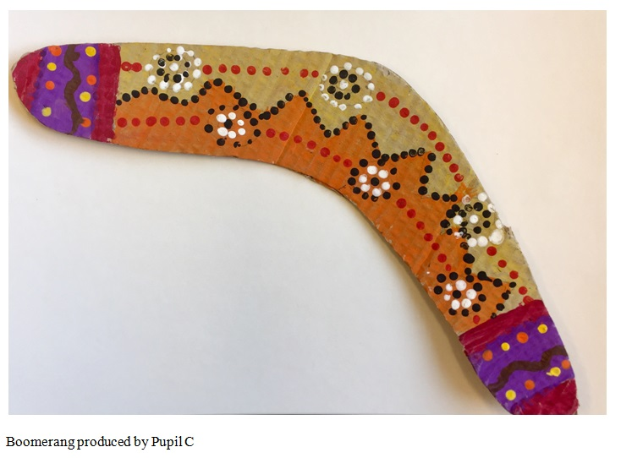
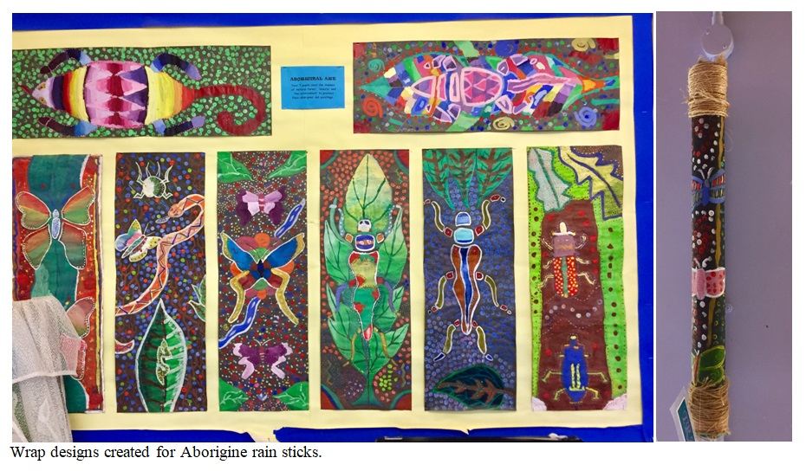

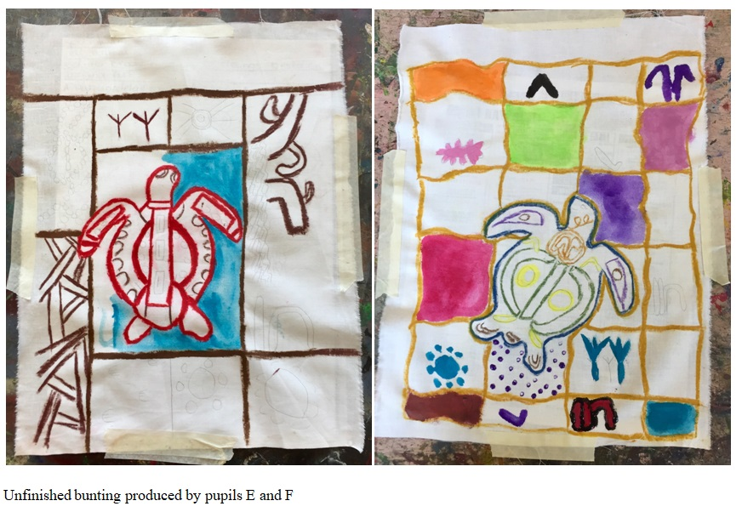

How successful the information about context and culture is in enhancing learning is difficult to measure in terms of final outcomes. However, an attitudinal test formed part of final evaluation and at least indicates how pupils see the impact of background information.

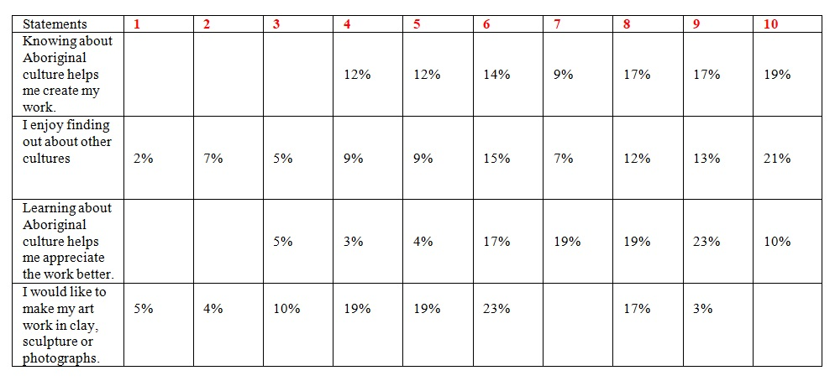

Interestingly, the majority of pupils found knowledge of Aboriginal culture useful in creating their own work and no pupil found it of no help at all. Similarly, a majority thought that their study had given them a greater appreciation of Aboriginal Art. Where pupils were more divided was in measuring their enjoyment of studying other cultures at all. This may be because the pupils lead very sheltered lives where they rarely venture out of the Valley and so other cultures may seem alien to them which according to Harland, et al (2000) is an even more important reason for them to be exposed to art from the rest of the world. There are no pupils in the year seven who have any link with another culture so it is critical that they encounter art from another culture. Pupils were more confused about working in another genre or medium with 38% below the mean. This could be because of the school’s situation, they lacked the imagination or confidence to consider working in areas of which they had no experience, but it does point to a lack of opportunity to experiment with different forms of art.

4.0 Limitations

Clearly, the school uses its own environment and resources to explore Valley culture. The school’s status as one marked for closure, makes it difficult for it to take on new projects. But in an ideal world this work could be further developed through visiting artists, using funding from such initiatives as the Creative School’s programme. This would further enhance pupils’ awareness of artists working in Wales. Although trips to museums and art galleries are difficult in the present climate of finance, one idea put forward by Harland, et al (2000) is to create a gallery in the school itself or its surrounding village in order to accustom pupils to gallery etiquette and to promote the work of pupils and ex-pupils. This has been successfully done in schools such as Porthcawl Comprehensive but is needed even more in Valley schools where gallery visits, outside of school trips, are almost non-existent. For example, Harland et al (2000) cites an occasion when children visiting the Tate were told off by the guide for not answering questions, but he was mortified when it was explained to him that this was the pupil’s first visit out of his village. Again, it is clear that simply providing cultural experiences is too passive and that children need to be properly prepared for such events. Opening its own gallery would help children have a sense of how to behave and knowledge of a gallery’s function.

One area which is not covered by the SoW but which is outlined by Davenport (2015) is that of global technologies in creating cultures and the tools for learning such technologies represent. The Head of Department was well aware of apps and various software with which pupils can now create artwork in digital forms, thus preparing them for the world of work. The lack of access to technology at Cymer Afan hinders the possibility of such work. In a different setting, pupils could undertake their own research on Aboriginal Art and could even have contact with an Australian school, making the experience more real for them. However, that is something which could be developed in the future. The Head of Department talked about how in the past the school had made links with a school in Dubai through Connecting Classrooms. Some of the limitations to the schemes of work stem from the situation of a school marked for closure. Because of this, there are no opportunities for pupils to work in clay, graphics or textiles. The importance of opportunities to experiment with different art forms holds back some pupils from doing their best work. Whereas, in other, better equipped schools, pupils can produce digital art and kiln work, the key stage three pupils of Cymer Afan are restricted to pencil and paint. This does not stop them from producing interesting work, but they may not be working in their best medium.

Freedman and Stuhr (1998) have pointed to the fact that global, visual culture is created through ‘commodification’ and then sold on an international level. One way of dealing with a lack of technology would be to look at how Aboriginal Art has been used in fashion or advertising. Designers Laura and Kate Mulleavy came under fire in 2012 when they used prints based on Aboriginal art for their fashion show. They defended themselves saying that they had been inspired by the art and held a license from the Aboriginal Council to use the images. Nonetheless, the fashion caused controversy and would be an interesting addition to the SoW. Such a study would allow pupils to see how ethnic art has been appropriated and to consider the implications of that, and whether that is exploitation or exposure. According to The NAME these are important issues in advancing social justice for all pupils. They argue that it is necessary to learn about and engage in global art without misrepresenting and devaluing social groups. This is good counsel for teachers as we need to continue reflecting about the ways in which art from non-Western cultures are introduced ways in which a class can debate whether the fashion has negative effects because it disenfranchises the original culture or positive effects because the art is given a new global significance. Such thinking illustrates to pupils the complexity of cultural referencing.

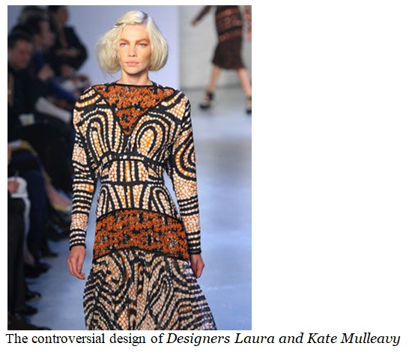

One limiting factor in the Aborigine project was the over-excitement of pupils in practical tasks which meant that sometimes their first efforts lacked precision. Their keenness has sometimes hindered their progress as they sometimes worked too quickly when a more careful, meticulous approach would have resulted in more accurate painting. Although called upon at the start of each lesson to take time and care over work, they have found it difficult to control enthusiasm. One way of minimising this disruption could be the use of silence and mindfulness. A voiced meditation (Brigley, 2016) based on a ‘Dreamtime’ story could be useful in creating the right atmosphere.

Applying symbolism to their own lives proved difficult for a significant minority. Even when objects were chosen to represent them such as an X box, pupils struggled to think of the object symbolically. Understanding symbolism in Aboriginal Art did not transfer to some pupils’ own creations. How things are represented goes to heart of understanding culture. It is a complex and conceptual idea. This might be best addressed by constructing a game, part Taboo and part Articulate. The idea would be to give pupils cards with names of objects that others must guess from drawn clues. The drawings could not be of the object, thus forcing the pupils to make associations with key symbols. This is important because representation is not only a key concept in art but an important concept for understanding how cultures are constructed. Furthermore, such understanding helps with an appreciation of a range of genres such as Expressionism, Surrealism and Abstract art.

5.0 Conclusion:

If art is to contribute to Donaldson’s (2015) purposes of education, then it needs to make reference to a wide range of artistic genres and cultures. The present climate privileges ‘learning to’ over ‘learning about’. Art teachers (and all subject teachers) will need to be less concerned about subject knowledge and more centred on the skills, application and development of the subject, and how those skills transfer to other areas of education. Art clearly contributes to the development of creative contributors but through a variety of generic and cultural references, art can contribute to the development of pupils who are informed citizens of Wales and the world. Because Wales is a nation with its own educational system, art can aid pupils in developing knowledge about their culture and community. The Head of Art at Cymer Afan commented that pupils at the school are able to draw inspiration from Welsh artists and transfer their ideas between a variety of genres and that this is important for their sense of themselves.

The programme of work on Aboriginal Art is typical of how a SoW based on another culture has enabled pupils to gain a greater understanding of non-Western art. Clearly, the pupils themselves believe that the project has enhanced their understanding of the skills needed to create such art. Their comments in evaluation show that learning about the history and culture of Australia has given them a greater insight into that specific society but has made them aware of a wider world. Their starting point was very low as some of them could not even locate Australia on a world map. MAT pupils were able to talk about the stories of how the snake lost its legs or how the kangaroo got its pouch and enjoyed how the story tellers solved those questions with imagination and creative thinking. A few pupils found it hard to connect to the stories because they lacked a creative imagination and were un-used to thinking in such a way. A future possibility to help this difficulty might be to work with the English department on creating imaginative answers to set questions. This could link the Aboriginal stories with Kipling’s Just So Stories. This suggests further avenues for fruitful collaboration between departments.

Within the Aboriginal project there are many opportunities for pupils to work in different genres. During the SoW pupils produce graphic organisers, sketches, pointillism, pattern design and the production of boomerangs, rain sticks and bunting. Through linking cultural references with generic ones the department offers both choice and a range of opportunities for developing skills. Apart from this project, just a cursory glance around the classroom shows evidence of a range of genres studied by pupils in the school including specific exemplar which Addison & Burgess (2000) define as a characteristic of the genre based approach. There are also examples which fulfil the wider definition of referring to the study of movements in art such as Abstract art and Surrealism. Access to a range of genre and cultural referencing has enabled pupils to realise that art does not need to be realistic and that the subject offers many opportunities for creative thinking, expression and experimentation. Such an approach offers a more effective art education as a range of traits can be developed including, curiosity, persistence, imagination, discipline and collaboration, all of which are cited by the Arts Council of Wales as qualities needed across the curriculum. Collaboration is particularly important as Hattie (2012) has pointed out its dynamic effect on motivation and achievement. Slavin (2006) sees such co-operation as important in creating the empathy needed to respect work from a range of people and cultures. This is a strong element in the Art Department and helps develop a climate of critical thinking and debate which are seen by Sleeter and Grant (2007) as helping pupils become more open-minded.

A wider range of artistic genres and cultural references are necessary for a more effective art education in the 21st century. Having a sense of context and the cultural determinants which give life to a work of art deepens understanding of the artefact, but also gives insight into the role of art within a culture. It is a truism of art teaching that if pupils think that they are poor at art, it is probably because they have not found the right form or genre to help express ideas and feelings. This is why it is so important that pupils have access to a range of genres and cultural references. The challenges of living in a global culture need to be addressed in art lessons so that pupils have a better understanding of the purposes, audiences and forms of art throughout the world. Art has made increasing links with photography, video and digital content as well as crossing disciplinary boundaries, as Buffington (2013) has pointed out.

Such studies can bring deeper understanding of what art is and how it helps define and critically question cultures. Most importantly, it is only through encountering a range of genres and cultural references that pupils can be informed citizens of the world with a clear sense of identity. Donaldson (2015) believes that this is crucial for the health of individuals and the health of the nation.

In conclusion, offering a wider range of opportunities could include:
- exploration of Welsh culture and heritage, and pupils’ own identities;
- chances to work with other areas of learning and experience including humanities and language, literacy and communication;
- better understanding of art’s methods, purposes and audiences;
- opportunities to experiment with different methods to find their own style;
- creation of global citizens with open minds and critical thinking who can understand non-Western as well as Western art;
- greater appreciation of our multicultural society;
- moving away from an emphasis on traditional fine arts towards a broader range of visual arts.

These opportunities are very much in-keeping with Donaldson’s (2015) suggestions for a broader, more skills-based curriculum. A more effective art education in the twenty-first century demands a wider range of genre and cultural references.

Bibliography
Addison, N. & Burgess. L. (2006) Learning to Teach Art in the Secondary School, Oxford: Routledge Falmer
Addison, N. (2010) ‘Art and Design in Education: ruptures and continuities’, in N. Addison, L. Burgess, J. Steers and J. Trowell (eds), Understanding Art Education: Engaging Reflexively with Practice, London: Routledge.
Adelman, C. (1980) in Simons, H. (eds) Towards a Science of the Singular, East Anglia: University of East Anglia.
Atkinson, D. and Dash, P. (2005) Social and Critical Practices in Art Education, Staffordshire: Trentham Books.
Barrett, T., Mac Labhrainn, I., Fallon, H. (eds) (2005) Handbook of Enquiry and Problem-based Learning, Galway: CELT.
Beard, M. (2016) Available at:https://www.theguardian.com/books/2016/oct/01/kenneth-clark-life-art-civilisation-james-stourton-review/ accessed: 15 April 2018.

Bishop, C. (2012) Artificial Hells, London: Verso.
Brigley, J. (2016) ‘Silence, flow and engagement, available at: http://www.judebrigley.co.uk/silence-flow-and-engagement-in-the-writing-process/ Accessed: 23 April 2018.
Brigley, J. (2016) ‘Learning journeys and why children do not learn’, available at: http://www.judebrigley.co.uk/learnings-journey-students-not-learn/ accessed: 23 May 2018.
Buffington, S. (2013) ‘Art Teaching for a New Age’, in The Chronicle of Higher education, available at:https://www.chronicle.com/article/Art-Teaching-for-a-New-Age/140117/ accessed: 30 April 2018
Burgess, L. (2003) ‘Monsters in the playground’, in N. Addison and L. Burgess (eds) Issues in Art and Design Teaching, London: Routledge Falmer.
___ (2010) ‘Learning as a social practice in art and design’, in N. Addison et al. Understanding Art Education: Engaging Reflexively with Practice, London: Routledge.
Chamers, G. (1999) ‘Cultural colonialism and art education,’ in Boughton, D. & Mason, R.(Eds), Beyond Multicultural Education: International Perspectives, New York: Waxman.
Clarke, K. (1969) Civilisation, London: Murray.
Cohen, L. & Manion, L and Morrison, K. (2000) Research Methods in Education, London: Routledge.
Davenport, M. (2015) ‘Culture and Education: Polishing the Lenses’, Studies in Art Education, 41:4, 361-375

Duncum, P. (2015) ‘What Elementary Generalist Teachers Need to Know to: Teach Art Well’, Art Education. 52:6, 33-37

Dyson, A. (1989) ‘Art History in Schools: a comprehensive strategy’, in D. Thistlewood (ed.) Critical and Contextual Studies in Art and Design Education, Harlow, Essex: Longman.
Erickson, M. (2015) Teaching Art History as an Inquiry Process, Art Education, 36:5, 28-31

Erstad, O. and Sefton-Green, J. (eds) (2013) Identity, Community, and Learning Lives in the Digital Age, Cambridge: Cambridge University Press.

Eraut, M. (1994) Developing Professional Knowledge and Competence, London: Routledge.

Field, R. (1970) Change in Art Education, New York: Routledge and Kegan Paul.
Freedman, K. (2003) Teaching Visual Culture: Curriculum: Aesthetics and the social life of art. New York: Teachers College Press

Freedman, K. Stuhr, P. (1998) ‘Curriculum change in the 21st century’ in Freedman, K. (ed) Curriculum, Culture and Art Education: Comparative Perspective, New York: University of New York.

Ford, D. & Harris, J. (1999) Multicultural Gifted Education, New York: Teacher’s College Press.

Garber, E. (2015) Teaching Art in the Context of Culture: A Study in the Borderlands, Studies in Art Education, 36:4, 218–232

Gardner, H. and Davis, K. (2014) The App Generation: How Today’s Youth Navigate Identity, Intimacy, and Imagination in the Digital World, New Haven, and London: Yale University Press.

Gollnick, D.& Chinn, P. (2009) Multicultural Education in a Pluralistic Society, New York: Pearson.

Gove, M. Vaizey, E. (2013) Cultural Education: A Summary of programmes and opportunities, available: https://assets.publishing.service.gov.uk/government/uploads/system/uploads/attachment_data/file/226569/Cultural-Education.pdf
Accessed: 23 April 2018

Groundwater-Smith, S. (2004) ‘Serving Different Masters? Relating evidence to policy and practice in the provision of services’ Educational Action Research invited seminar 2004 City University, London.

Hyerle, D. (2008) Visual Tools for Transforming Information into Knowledge, New York: Corwin.

Haston, W. ‘Teacher Modeling as an Effective Teaching Strategy.’ Music Educators Journal, vol. 93, no. 4, 2007, pp. 26–30.

Johnson, J. Musial, D. Hall, G. Gollnick, D. & Dupuis, V. Foundations of American Education: Perspectives on Education in a Changing World, New York: Pearson.

Kipling, R (1993). Just So Stories, London: Wordsworth.

Kohut, H. (1987) The Kohut Seminars: On Self Psychology and Psychotherapy with Adolescents and Young Adults, Chicago: Norton.

Kolb, D.A. (2014) Experiential Learning: Experience as a source of Learning and Development, New York: Pearson.

Kvale, S. (1996) Interviews, London: Sage Publications.

Matthew, N. (2013) A Teacher’s Guide to Kara Walker, available: https://www.camdenartscentre.org/assets/whats-on/Walker_Teachers_Guide.pdf
accessed: 23 April 2018.

Morley, D. (2012) The Cambridge Companion to Creative Writing, Cambridge: Cambridge.

NAME (2018) ‘What is the potential of multiculturalism in art?’ available: https://www.nameorg.org/learn/what_is_the_potential_of_multi.php
accessed: 3 May 2018.

Osgood, C.E., Suci, G.S., Tannenbaum, P.H. (1957) The Measurement of Meaning, Urbana: Illinois.

Pringle, E. (2008) The Artist as Educator: An Examination of the Relationship between Artistic Practice and Pedagogy within Contemporary Gallery Education, Ph.D. dissertation, Institute of Education, University of London.

Pringle, E. (2009) ‘The Artist as Educator; Examining Relationships between Art Practice and Pedagogy in the Gallery Context’, Tate Papers, no. 11, available at: http://www.tate.org.uk/research/publications/tate-papers/11/artist-as-educator-examining-relationships-between-art-practice-and-pedagogy-in-gallery-context Accessed: April 6th 2018

Rogoff, B. (2003) The Cultural Nature of Human Development, Oxford: OUP.

Schon, D. (1982) The Reflective Practitioner: How Professionals Think in Action, London: Routledge.

Slavin, R. (2006) Educational Research in an Age of Accountability, New York: Pearson.

Taylor, B. (1989) ‘Art History in the Classroom: a plea for caution’, in D. Thistlewood (ed.) Critical Studies in Art and Design Education, Harlow, Essex: Longman.

Trowell, J. (2010) ‘Collaborative Liberatory Practices for Global Citizenship’, in N. Addison et al., Understanding Art Education: Engaging Reflexively with Practice, London: Routledge.

Wisker, G. (2001) The Postgraduate Research Handbook, Basingstoke: Palgrave.

Zuber-Skerrit, O. (1996) New Directions in Action Research, London: Falmer.

