Topic Name: A challenge to the leadership construct
Name of the student: Mohd Mohasin Mohd Nishar Shaikh
Student ID: 2207962
Name of the University: University Of Wales Trinity Saint David

Table of Contents
Introduction 3
Discussion 3
Conclusion 6
References 7
Appendix 8

Introduction
International human resource management is the process of recruiting, educating, and rewarding staff members in multinational and worldwide enterprises. An international corporation has branches outside of its home country that rely on the manufacturing or commercial know-how of the parent company. A multinational corporation (MNC) is typically thought of as having several enterprises located in different countries that are all managed from the same country's headquarters. International HRM encompasses the standard HRM duties including recruiting, choosing, training and development, performance reviews, etc. up to a global level. A corporation gains a competitive advantage by having a productive personnel base. Furthermore, we are aware that a sizable proportion of firms are global in scope (Murthy and Nethravathi 2021). Consequently, the need for global employee management is increasing. The effective management of multinational staff is a crucial aspect in determining if an international business endeavor succeeds or fails. It is now challenging for international organizations to attract, hire, and retain people. IHRM is crucial when it comes to managing personnel from different nations and areas.

Discussion
By demonstrating dynamic leadership, managers may increase the motivation and morale of their workforce. A successful leader influences others' behavior so that they actively help the organization reach its objectives (Boyd et al. 2017). The function of leadership is to encourage group efforts. It improves the group's performance via constant efforts as well as effect on interpersonal relationships. Individuals with similar interests may work together beyond the purview of formal partnerships because no organizational structure could accommodate all relationship kinds. The behavior of the subordinates is better regulated and controlled by these informal links (Cooper and Sommer 2016). Effective leadership uses these unofficial relationships to accomplish company goals.
The pandemic having paved the way for hybrid working arrangements and highlighted the importance of the employee experience. This raises the question of whether employees believe their companies are developing the proper competencies, qualities, and procedures for the workplace of the future. For most recent Capgemini Research Institute research, Re-learning leadership: Creating the hybrid-workplace leader, Capgemini surveyed 1,380 respondents from 548 businesses and conducted in-depth interviews with business executives, educators, including leadership-development experts. It discovered a widening disconnect. Compared to 69% of executives, just 49% of employees believe that their organizations successfully made the switch to a remote/hybrid working paradigm (Capgemini 2022). Organizations need to develop leaders with the skills (such as authenticity, emotional acuity, as well as ability to adapt to change) required to address the requirements of employees in a hybrid world in order to accomplish this (Capgemini 2022). As a consequence, organizations should indeed implement policies and practices that acknowledge and reward such qualities. A systems-thinking mindset and a C-suite that prioritizes people may help implement change, and limiting burnout would improve employee wellbeing.
The foundation of the Capgemini Automotive TechnoVision Playbook for 2022. Consequently, as a consequence of ESG standards, OEMs confront a particularly severe leadership task. Sustainable thinking should be as crucial to overcoming it as the traditional concerns of cost and quality. The hybrid workplace is posing new problems for organizations, necessitating a renewed emphasis on traits like honesty, emotional intelligence (EI), willingness to change, and the ability to create culture of trust where personnel feel empowered. Nevertheless, businesses aren’t doing enough to prepare leaders for effective leadership in a hybrid workplace. Thus, Capgemini’s leaders should try to adopt transformation leadership style in order to efficiently manage their workforce.
Leaders are required to inspire and mentor their team while exhibiting traits like emotional intelligence (EI) as well as sincerity. They are also expected to give employees the freedom they require. Only 37% of employees in non-supervisory roles say that the pandemic helps them uncomfortable heard and included by their employer, and therefore only 47% of employees in these roles indicate that their companies actively encourage teams in making choices on their own (Capgemini 2022). In reality, the pandemic has made it even more crucial to respect the physical and mental health of employees. The leadership as well as the workforce had different perceptions of how successfully health and wellness were managed all through the crisis, however (Capgemini 2022). Contrary to 72% of executives, only 49% of workers believed that their firms were capable of protecting the physically and psychologically wellness of their employees. Only 34% of workers said their firms are actively exploring steps to reduce employee burnout, according to the survey (Capgemini 2022).
Most of the push to go back to work comes from top management. Nevertheless, the majority of workers demand flexible choices, particularly in light of COVID-19. Because several employees are "anger leaving" their jobs, there is a lot at stake for standard when it comes to introducing a mixed work paradigm. One of the primary challenges of hybrid work is figuring out how to lead as well as interact with other people who have quite diverse inclinations for sharing their opinions and thoughts within such a company. Speaking up in meetings or in front of others is not natural to everyone. According to the findings of research poll, feeling overloaded with additional meetings and messages was a significant difficulty with hybrid work (Dahik et al. 2020). The hybrid model focuses on innovative teamwork strategies that promote harmony between chances for deliberate work and group debate of concepts and points of view. Teaching new skills to leaders is essential, but this is only part of what is required to have them ready to lead in a hybrid context.
Capgemini leadership must also make absolutely sure that the right enabling conditions are present for leaders to function effectively. Redesigning hiring as well as performance evaluation frameworks are only two examples of how to make sure the talents and traits necessary for hybrid employment are taken into account and rewarded appropriately. Fundamental modifications to these procedures are needed in addition to leadership training. However, the research revealed that businesses are not focusing enough on making these key adjustments.

Conclusion
Businesses that aggressively grow their leadership development initiatives may see larger benefits for their staff, but first organizations must establish a strong cultural basis for change. This will involve fundamentally altering procedures and practices in strategy to garner and compensate leaders who display the traits necessary to guide enterprises toward a hybrid future. It may become more difficult for leaders to start serving as noticeable examples to follow to their teammates when they work remotely since home and family cultures may start to take center stage, despite the fact that a flexible strategy might very well show up to become more inclusive, staying at home also increases the likelihood that individuals will have become lonely as well as associate with the "out crowd." Customers' expectations and experiences were among the other important topics brought up.

References
Boyd, B., Henning, N., Reyna, E., Wang, D.E., Welch, M.D. and Hoffman, A., 2017. Hybrid organizations: New business models for environmental leadership. Routledge.
Cooper, R.G. and Sommer, A.F., 2016. The agile–stage‐gate hybrid model: a promising new approach and a new research opportunity. Journal of Product Innovation Management, 33(5), pp.513-526.
Cooper, R.G. and Sommer, A.F., 2018. Agile–Stage-Gate for Manufacturers: Changing the Way New Products Are Developed Integrating Agile project management methods into a Stage-Gate system offers both opportunities and challenges. Research-Technology Management, 61(2), pp.17-26.
Dahik, A., Lovich, D., Kreafle, C., Bailey, A., Kilmann, J., Kennedy, D., Roongta, P., Schuler, F., Tomlin, L. and Wenstrup, J., 2020. What 12,000 employees have to say about the future of remote work. Boston Consulting Group.
Employees call for new leadership styles to meet the changing needs of the future workplace (2022) Capgemini UK. Available at: https://www.capgemini.com/uk-en/news/employees-call-for-new-leadership-styles-to-meet-the-changing-needs-of-the-future-workplace/# (Accessed: December 9, 2022).
Li, W., Liu, K., Belitski, M., Ghobadian, A. and O'Regan, N., 2016. e-Leadership through strategic alignment: An empirical study of small-and medium-sized enterprises in the digital age. Journal of Information Technology, 31(2), pp.185-206.
Murthy, A. and Nethravathi, P.S., 2021. The Future with New Brand Identity–Success Story of Capgemini: A Case Study. International Journal of Case Studies in Business, IT and Education (IJCSBE), 5(1), pp.244-255.

Appendix
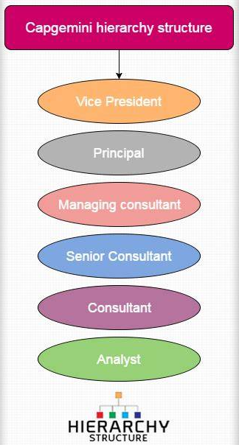
(Source: Capgemini Hierarchy Structure | Org Chart Capgemini)

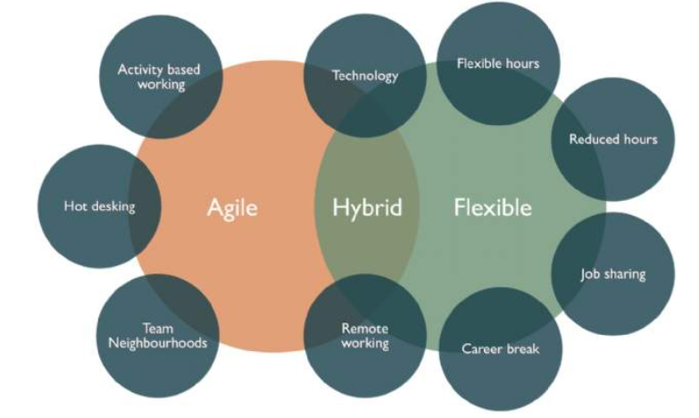
(Source: Savills Blog | How do you successfully implement a hybrid working model?)

