

Module Title: Foreign Languages and Cultural Awareness
Module Code: BMIH5003
Assignment Title: INTERCULTURAL COMPETENCE REPORT
Student Name: Luminita Malanciuc
Student ID:2211340
Module lead:Lisa Bassler
Word count:1000

Executive Summary
The report provides the key findings and recommendations. This report will go through the cultural changes, which includes an overview of culture and a detailed analysis of the country using the GLOBE Project. This also shows in-depth cultural insights and discusses different cultural perspectives. The findings show the importance of sensitivity that comes from different cultures for effective leadership. This report will end by offering recommendations to improve intercultural competence. This report helps the General Manager of Diversity Hotel & Spa to prepare international operations.
Table of Contents
Introduction 4
Exploring Cultural Dynamics 5
Culture Overview 5
GLOBE Project and Country Analysis 5
In-Depth Cultural Insights 7
Recommendations 9
Conclusion 10
References 11

Introduction
This study highlights the important concept of cultural awareness when applied to the industry of hospitality. The goal of this report is to provide a proper understanding of cultural factors, with a focus on the value of cultural sensitivity and awareness for effective leadership in an international business environment. It gives in-depth cultural insights, goes into the country’s study of the GLOBE Project, and examines a variety of cultural topics. As it highlights the important function that has the ability to adapt plays in making successful relationships and activities in a culturally dependent world.

Exploring Cultural Dynamics
Understanding the importance of social factors is important to the success of global efforts. This part will help us navigate the many facets of culture. It includes an informative nation analysis from the GLOBE Project as well as a complete cultural overview (Huang and Crotts, 2019).

Culture Overview
Japan's Culture plays an important role in making its values, beliefs, behaviour, and communication styles. It is the foundation on which Japanese society is built. This understanding of Japanese culture is most important as the General Manager of Diversity Hotel & Spa, which needs to expand operations to this new global site.
Cultural Dimensions: Japan’s culture highlights different things, like language, traditions, conventions, religion, social standards and so on. These people go though the world and interact with one another. Effective leadership needs the ability to identify the unique characteristics that show Japan's culture. (Canestrino et al., 2020).
Communication Styles: Language is one of the most apparent aspects of Japanese culture. Understanding the Japanese language and its nuances is vital for effective communication. Additionally, recognising variations in non-verbal communication, such as gestures and body language, is equally important in Japan, where non-verbal cues usually carry unspoken messages.
Value Systems: Japanese culture places a strong impact on the value system, as it makes many differences from the western cultures. While the country has the aspect of collectivism, it also values elements of individualism. Going through these nuanced value systems is important for making decisions, which is based on customer service, hiring and firing, and corporate movements (Francesco and Roberta, 2019). The knowledge is important for the General Manager as they need to see the intricacies of the culture and business practices.

GLOBE Project and Country Analysis
In order to obtain a deeper knowledge of the Japanese cultural dynamics of Japan, this can refer to the GLOBE Project, a wide-ranging study project that investigates the connections between leadership, organisational culture, and society culture in several nations.
GLOBE Project Overview: As Japan is in the GLOBE project which is a short form of Global Leadership and Organisational Behaviour Effectiveness Project, it highlights a wide range of cultural elements and behaviours which is related to leadership in different countries (Nazarian et al., 2021).
Country Analysis: Going by the wealth of information from the GLOBE project, it can show a thorough analysis of the unique cultural features that show what Japan is. Japan is a nation known for its rich cultural heritage and economic prowess, which represents unique cultural dynamics and opportunities for the General Manager of Diversity Hotel & Spa. Japanese society highlights values of group loyalty and agreement, which shows a high level of collectivism. The Hofstede culture shows a higher score for power, which highlights respect for authority and hierarchy. This shows the need for respectful and structured leadership within a company. On the other hand, Japan’s language and communication needs to have a focus on mastering their culture language in order to interact with them for business or other purposes. As for the Economic indicators, they demand a deep understanding of customer likings and behaviour.
Leadership Styles: When it comes to the way of leadership, based on the GLOBE Project, highlights consensus-building and group-oriented decision-making. The culture values leaders who go for proper and established relationships, management, and a focus on long-term strategic vision. The understanding of these cultural leadership styles is important for the manager in order to achieve success in Japan (Lim and Ok, 2021).

In-Depth Cultural Insights
Understanding the cultural context of the regions where the hospitality sector works is important for securing the success of international efforts. Ten cultural groups have been discovered by the Global Leadership and Organisational Effectiveness (GLOBE) study, and each is defined by particular cultural aspects. Anglo, Latin America, the Middle East, Southern Asia, Germanic Europe, the Nordic region, Eastern Europe, Latin America, Sub-Saharan Africa, and Confucian Asia are some of these clusters (OpenStax, 2019).
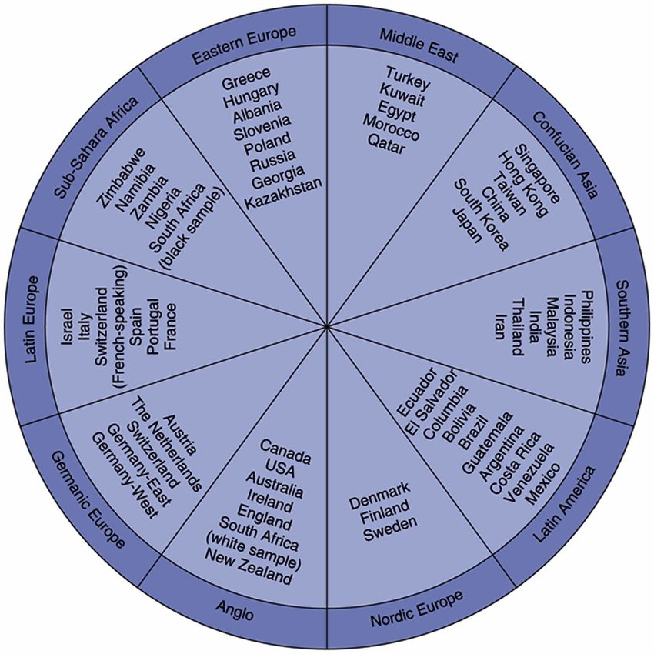
Figure: GLOBE Societal Clusters
Source: (OpenStax, 2019)
According to GLOBE's research, nations in the same cluster usually depend on one another regardless of having more cultural similarities than differences. This requires the hospitality industry to acknowledge and honour these cultural differences. Guest satisfaction and operational efficiency can be improved by implementing a customised approach to service, communication, and business practices.
A primary factor that affects the success of the hospitality sector is its capacity to meet a wide range of cultural tastes. The unusual growth of the worldwide hospitality market can be seen in this below graph. With a 7.0% Compound Annual Growth Rate (CAGR), it increased greatly from $4,390.59 billion in 2022 to $4,699.57 billion in 2023 (EHL Insights, 2023). Part of this growth can be credited to the reduction of limitations on international travel. The information highlights the industry's strength and bright future.
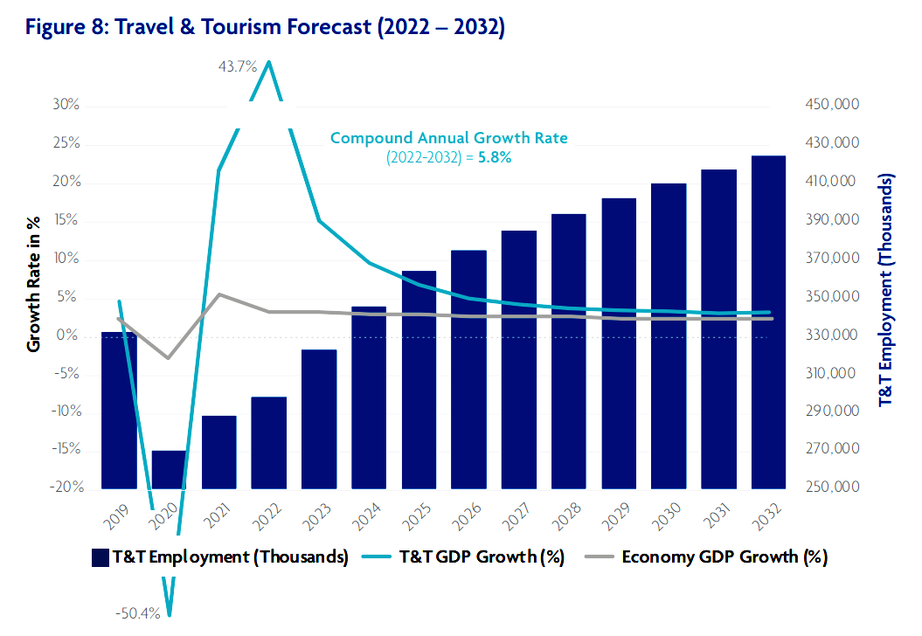
Figure: Travel and Tourism Forecast from 2022-2032
Source: (EHL Insights, 2023)
Since cultural sensitivity and adaptability are important to the long-term growth and success of the international hospitality sector, this graph highlights the importance of these qualities in the context of Diversity Hotel & Spa’s expansion into Japan.

Recommendations
Cross-Cultural Training: Providing complete cross-cultural training courses to all employees of Diversity Hotel & Spa, specifically focused on the nuances of Japanese culture. These programs can cover up the cultural clusters that are defined by the GLOBE Project and point out the minor cultural differences unique to japan, helping the staff with in-depth cultural knowledge will help them to engage in more seamless interactions with japanese visitors and improve guest satisfaction.
Continuous Cultural Assessment: In order to measure the effectiveness of cultural awareness efforts, make a system for ongoing cultural projects. Daily feedback from both visitors and staffs with a proper focus on their experiences in the Japanese context. Use this feedback to make proper adjustments to the strategies and operations of the company.

Conclusion
In terms of DIversity Hotel & Spa’s expansion into japan, Understanding cultural differences in the increasingly globalised hospitality industry/ Going through the insights from the GLOBE Project analysis, the general manager can maintain the management approaches to go along with japan’s unique cultural nuances, helps to get an inclusive environment for both staff and guests. The journey to global growth hinges on showing different perspectives and going for cultural awareness, making it imperative for the General Manger to help these aspects for seamless operation and make prosperity of the new hotel in the rich environment of Japan in terms of culture.

References
Canestrino, R., Ćwiklicki, M., Magliocca, P. and Pawełek, B., (2020). Understanding social entrepreneurship: A cultural perspective in business research. Journal of Business Research.
EHL Insights, (2023). What is the Hospitality Industry? All your questions answered. [Online] Available at: https://hospitalityinsights.ehl.edu/hospitality-industry [Accessed 18 October 2023].
Francesco, G. and Roberta, G., (2019). Cross-country analysis of perception and emphasis of hotel attributes. Tourism Management, 74.
Huang, S.S. and Crotts, J., (2019). Relationships between Hofstede's cultural dimensions and tourist satisfaction: A cross-country cross-sample examination. Tourism management, 72.
Lim, S.E. and Ok, C.M., (2021). A meta-analytic review of antecedents of hospitality and tourism firms’ performance: A cross-cultural comparison. Tourism Management, 86.
Nazarian, A., Velayati, R., Foroudi, P., Edirisinghe, D. and Atkinson, P., (2021). Organizational justice in the hotel industry: revisiting GLOBE from a national culture perspective. International Journal of Contemporary Hospitality Management, 33(12).
OpenStax, (2019). 6.3 The GLOBE Framework - Principles of Management. [Online] Available at: https://openstax.org/books/principles-management/pages/6-3-the-globe-framework [Accessed 18 October 2023].

