  Component One: Student Journal (learning log) 750 words +/- 10%  Contribution to Overall Module Assessment: 25% | Student No: | 2245646
 | Module Title: | Operating Hotel Facilities
 | Module Code: | BMIH4006
 | Lecturer: | Natalie Brailsford, Dan Payne, Lisa Bassler Giulia Chifari, Ben Chong Scott James

Title: Reflective Journal Entry - Housekeeping Placement at Maldron Hotel using Gibbs' Reflective Model
Introduction:
Gibbs’ Reflective Model developed by Graham Gibbs in 1988 is an extensive system of self-reflection; an individual can now explore deeper into his or her experience to capture wonderful insights (Adeani, Febriani et al. 2020). In this reflective entry, I will use Gibbs’s model to reflect on the housekeeping placement at Maldron Hotel, sharing not only the highlights but also the challenges and emotions I experienced in this transitional period. (Adeani, Febriani et al. 2020)
Description
My experience at my housekeeping placement in Maldron Hotel exposed me to the day-to-day running of housekeeping in maintaining and preparing guest rooms (Tawanwongsri and Phenwan 2019). Housekeeping that impeccably cleaned rooms, restocked trimmings, and ensured that every guest was comfortable and satisﬁed. The importance of detail-orienteers and unwavering dedication to the upkeep of the hotel’s excellent reputation became clear to me within a short time. (Aneeis Hashim, Yaacob et al. 2023)
Feelings:
I felt both excitement and apprehension at the beginning of my placement. People had increased enthusiasm for participating in customer service; however, this expectancy was immediately drowned by sheer awesomeness as the hotel had high standards. The feelings evolved as I acclimatized into the responsibility, incorporating instances of achievement, pressures, and an aura of accomplishment with it. (Aneeis Hashim, Yaacob et al. 2023)
Evaluation:
My housekeeping placement evaluation showed both, positive and problematic sides. This source of personal satisfaction stemmed from the fact that I knew that my pains helped the guests feel comfortable and that made me happy.(Oviawe 2020)
But during rush hours, the situation was greatly influential. Achieving efficiency without sacrificing the quality of standards that the hotel had demanded for the cleanliness of its premises was challenging. It demanded painstaking preparation, efficient time management, and quick response to unforeseen changes.
Analysis:
Because of the place of people’s assessment, the role of the housekeeping department in the guests’ satisfaction can be highlighted further. They are key components of what we call a positive guest experience; we simply cannot have a positive experience, for instance, if guest rooms are dirty or if housekeeping has failed to adequately prepare them. (Tanaka, Okamoto et al. 2018)
I also gathered enlightenment on the importance of teamwork and communication in the department. Effective internal communication among team members supported the appropriate execution of tasks, provided rooms were prepared for guests and this process was quick. (Oviawe 2020)
Conclusion:
There were opportunities for improvement as I reflected on my placement. However, during the high peak, I was also able to see what improvements were needed in my time management and the ability to multitask quickly. Making provisions to find ways of minimizing duties to ensure efficiency would have enabled better performance. (Wain 2017)
In addition to this, a lot of help and mentorship is invaluable and the veteran housekeeping professionals could have assisted with things (Adeani, Febriani et al. 2020). Learning from their expertise and adopting advanced practices and problem-solving techniques would have accelerated my growth.(Ardian, Hariyati et al. 2019)
Action Plan
Housekeeping and similar alternative roles in the future will be deemed successful according to my action plan which is formulated to prepare me for these events:
1. Pay attention to improving effectiveness in time management and multitasking during rush hours. (Hashim, Yaacob et al. 2023)
2. Basic housekeeping being your only source of knowledge, go for further training in housekeeping-specific cleaning practices and standardizations.
3. Enhance your skills of working with more experienced colleagues, who will share knowledge about innovative practices conducted to solve different issues. (Tawanwongsri and Phenwan 2019)
I have been able to attain great insight from Gibbs’ Reflective Model on my housekeeping placement at the Maldron Hotel. It has the proper lighting to some promising areas of development and individual progress, drawing my focus on the best commitment, and outstanding service delivery within the realm of the hospitality industry (Adeani, Febriani et al. 2020). Each of us has times when we find ourselves in the lunchroom with a bag of deals as we hang out. In my case, my team-mate and I increasingly found ourselves in said situation and soon after lunch, we got to our patient’s destination. This experience has only further strengthened my passion for supporting guest experience and my commitment always to improve in my role. (Tawanwongsri and Phenwan 2019)
I vow to use them during my pursuing career with this placement and in the hospitality sector. The goal I want to achieve is not only to be a competent housekeeping practitioner but also to be a valuable team player who fulfills guest needs impeccably. One of the most significant areas in which I intend to develop is in proficiency, effectiveness, and cooperation and it is in this area that I believe I will grow and succeed in this dynamic and lucrative industry. My life in the hospitality industry just started; I am looking forward to the new challenges I will be meeting ahead of me (He, Parkinson et al. 2018).

Component Two: Health and Safety Guide

Contribution to Overall Module Assessment: 25%

"Health and Safety Guide for Room Cleaning"
Ensuring the safety and well-being of our housekeeping staff is paramount. This guide outlines key precautions and procedures designed to maintain a safe working environment during room cleaning operations.(Guide 2016)
Room Cleaning Procedures:
- Preparation: Gather all necessary equipment and PPE before entering the room.
- Cleaning Sequence: Start cleaning from the furthest corner of the room and move towards the door. Clean from top to bottom. (Clifton 2022)
- Ventilation: Ensure the room is well-ventilated while cleaning, especially when using chemicals.(Dhaliwal, Singh et al. 2018)

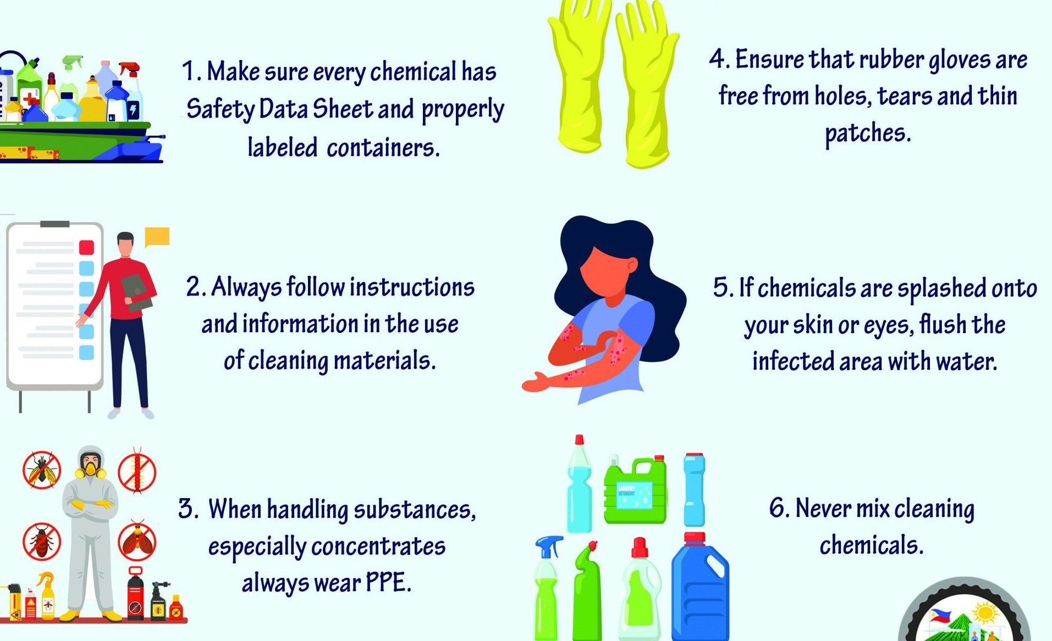

Safety Precautions:
- Personal Protective Equipment (PPE): Always wear gloves and non-slip shoes. Use masks when handling cleaning chemicals. (Tian, Stedman et al. 2020)
- Proper Lifting Techniques: To avoid injury, bend your knees and keep your back straight when lifting heavy items (Mahmood, Crimbly et al. 2020).
- Chemical Safety: Familiarize yourself with the Material Safety Data Sheets (MSDS) for all cleaning chemicals. Wear appropriate protective gear when using these substances (Organization 2020).
- Emergency Procedures: report any accidents or health emergencies quickly.
Essential Equipment:
- Cleaning Carts: Organize supplies and equipment for efficiency.
- Vacuums: Use vacuums with HEPA filters to reduce airborne dust.(Larsson and Törnered 2021)
- Mops: Microfiber mops for efficient cleaning and reduced chemical usage.
- Cleaning Agents: Use approved chemicals and store them securely (Rock, Cosgrove et al. 2016).
Hazard Mitigation:
- Slip, Trip, and Fall Hazards: Keep walkways and corridors clear. Immediately clean spills and mark wet areas with warning signs (Piton and Recking 2016).
- Chemical Hazards: Store chemicals in a secure area. Do not mix chemicals unless directed by the manufacturer. Always label containers clearly (Fernandes, Javaroni et al. 2023).
- Biological Hazards: Handle linens and waste with care. Use gloves and dispose of waste in designated bins (Sun, You et al. 2018).
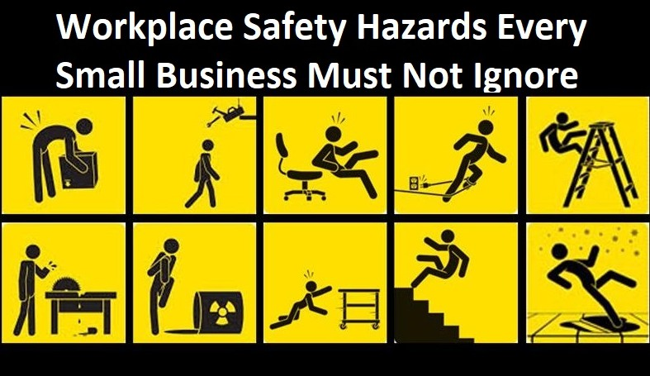
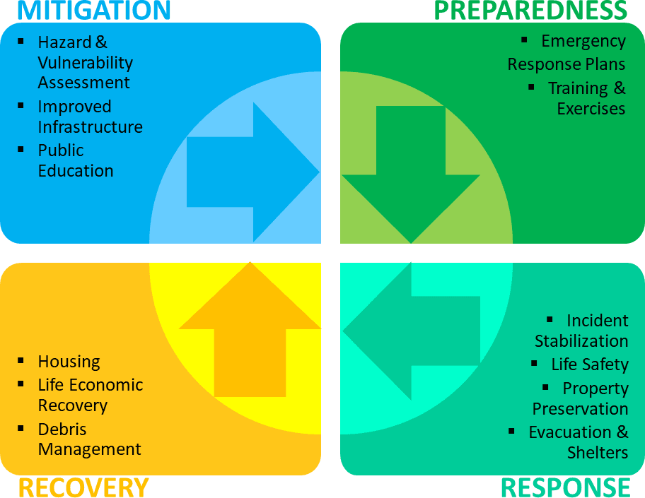

Maldron Hotel Newcastle in City centre, UK BT2 7GE
+44 (0)28 9600
1680res.belfastcity@maldronhotels.com

Reference List

Adeani, I. S., et al. (2020). "Using GIBBS’reflective cycle in making reflections of literary analysis." Indonesian EFL Journal 6(2): 139-148.

Aneeis Hashim, S. N., et al. (2023). "Exploring the Use of Gibbs’ Reflective Model in Enhancing In-Service ESL Teachers’ Reflective Writing." Arab World English Journal (AWEJ) Volume 14.

Ardian, P., et al. (2019). "Correlation between implementation case reflection discussion based on the Graham Gibbs Cycle and nurses’ critical thinking skills." Enfermeria Clinica 29: 588-593.

Clifton, D. (2022). Hospitality Security: Managing Security in Today’s Hotel, Nightlife, Entertainment, and Tourism Environment, CRC Press.

Dhaliwal, U., et al. (2018). "Reflective student narratives: honing professionalism and empathy." Indian J Med Ethics 3(1): 9-15.

Fernandes, L. d. M., et al. (2023). "Advanced ceramic grinding process combined to hazard mitigation to the employees’ health by using an alternative lubri-refrigeration technique." The International Journal of Advanced Manufacturing Technology: 1-14.

Guide, B. (2016). Health & Safety, Retrieved in February.

Hashim, S. N. A., et al. (2023). "Exploring the Use of Gibbs' Reflective Model in Enhancing In-Service ESL Teachers' Reflective Writing." Arab World English Journal 14(2).

He, K. N., et al. (2018). "Gibbs’ Reflective Cycle."

Larsson, A. and K. Törnered (2021). "Patientens upplevelse av delaktighet i vårdavdelningens hygienarbete."

Mahmood, S. U., et al. (2020). "Strategies for rational use of personal protective equipment (PPE) among healthcare providers during the COVID-19 crisis." Cureus 12(5).

Organization, W. H. (2020). "Personal protective equipment."

Oviawe, J. (2020). "Application of Graham Gibbs Model of Reflection to Improve Teaching Understanding among Technical Education Students in Ambrose Alli University Ekpoma Edo State." Sumerianz Journal of Education, Linguistics and Literature 3(2): 1201-2617.

Piton, G. and A. Recking (2016). "Design of sediment traps with open check dams. I: hydraulic and deposition processes." Journal of Hydraulic Engineering 142(2): 04015045.

Rock, C., et al. (2016). "Using a human factors engineering approach to improve patient room cleaning and disinfection." infection control & hospital epidemiology 37(12): 1502-1506.

Sun, H., et al. (2018). "Experimental study on blocking and self-cleaning behaviors of beam dam in debris flow hazard mitigation." International Journal of Sediment Research 33(4): 395-405.

Tanaka, M., et al. (2018). "Relationship between reflective practice skills and volume of writing in a reflective journal." Health 10(3): 283-288.

Tawanwongsri, W. and T. Phenwan (2019). "Reflective and feedback performances on Thai medical students’ patient history-taking skills." BMC medical education 19: 1-8.

Tian, Z., et al. (2020). "Personal protective equipment (PPE) and infection among healthcare workers–What is the evidence?" International journal of clinical practice 74(11): e13617.

Wain, A. (2017). "Learning through reflection." British Journal of Midwifery 25(10): 662-666.

