Paul Griffiths (2410226)
Introduction to Web and Database Concepts ACCA4023
HTML & CSS Web Development

Table of Contents
Introduction 2
Requirements 2
Implementation 2
Evaluation 9
References 14
Appendices 16

Introduction

This report details the development process of a website titled 'Examples Across Scales - Atoms to All,' created as part of a web development assignment. The website explores the concept of scale by showing various examples of things at different orders of magnitude, from the subatomic to the universe. This report describes the process used as well as discussing web design principles such as usability, accessibility and search engine optimization.

Requirements
This website is intended to show a collection of examples of things at different orders of magnitude, from the subatomic to the universe, creating both an entertaining and educational experience. The subject matter is centred around scientific scales and is designed for a broad audience including students, educators, and anyone with an interest in science or a generally curious mind. The content on the website has been laid out in a user-friendly manner, enabling navigation through different pages of different scales. The overall purpose is to provide information in a logical and visually appealing way in order to engage users.

Implementation
The website was written using Notepad++ and consists of nine pages: a homepage (index.html) and eight pages dedicated to different scales (subatomic.html, atomic.html, microscopic.html, humanity.html, planetary.html, stellar.html, galactic.html, and universe.html).
The homepage provides an introduction and navigation to the different scale pages through buttons. Each scale page includes a header with navigation buttons to the previous scale, homepage and next scale. The main content of each scale page is presented using a series of cards, each presenting an example at that scale with an image, title, description, and a "Learn More" link.
Below are screenshots of each page.

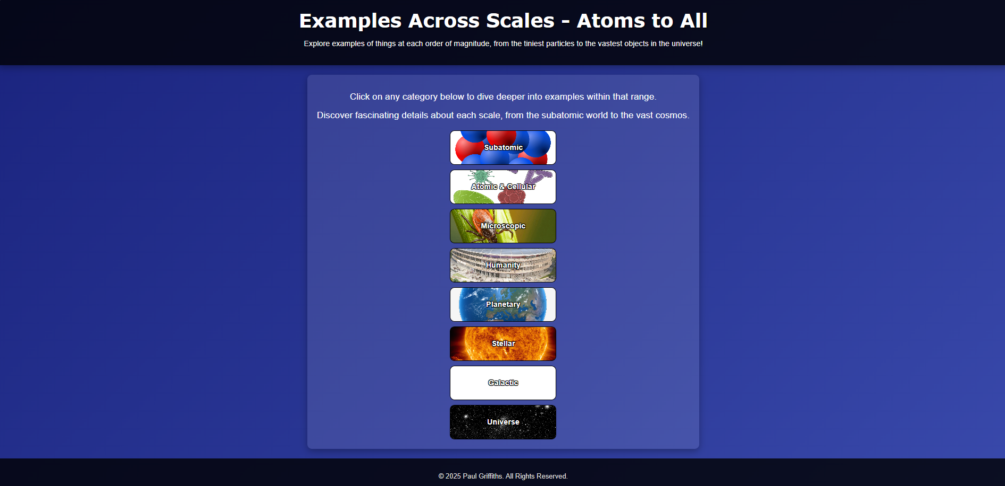
Page 1 - Homepage

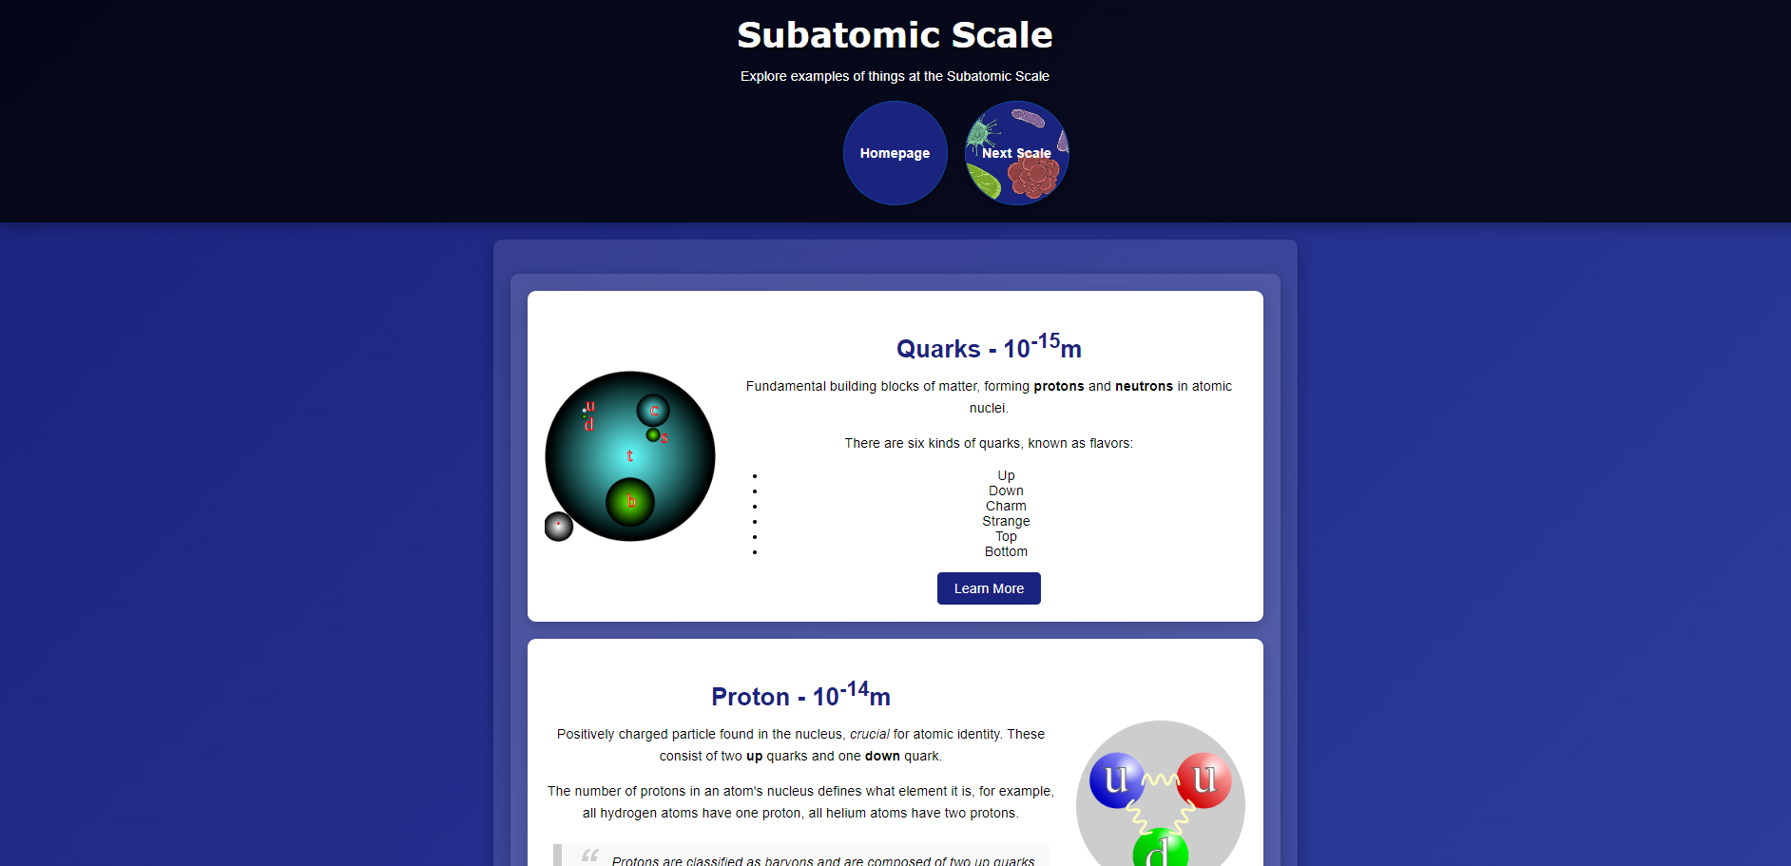
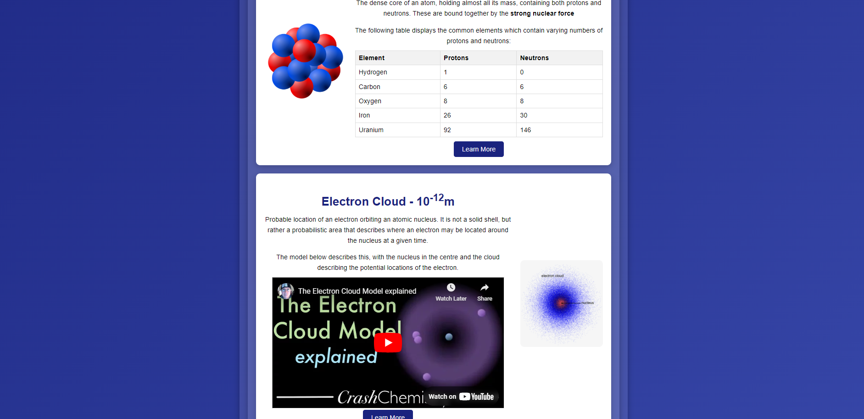
Page 2 – Subatomic

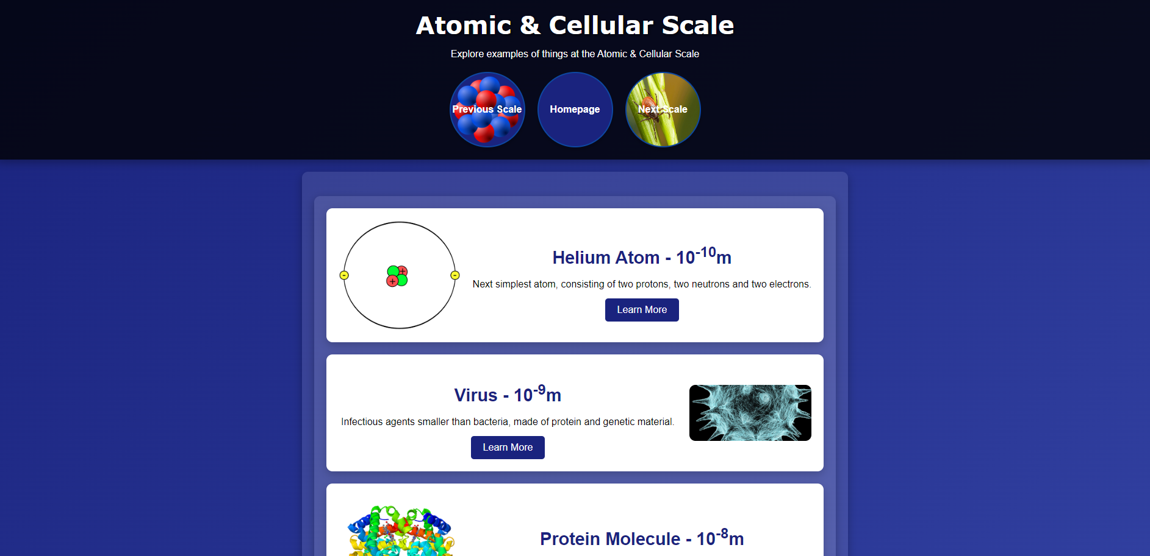
Page 3 - Atomic & Cellular

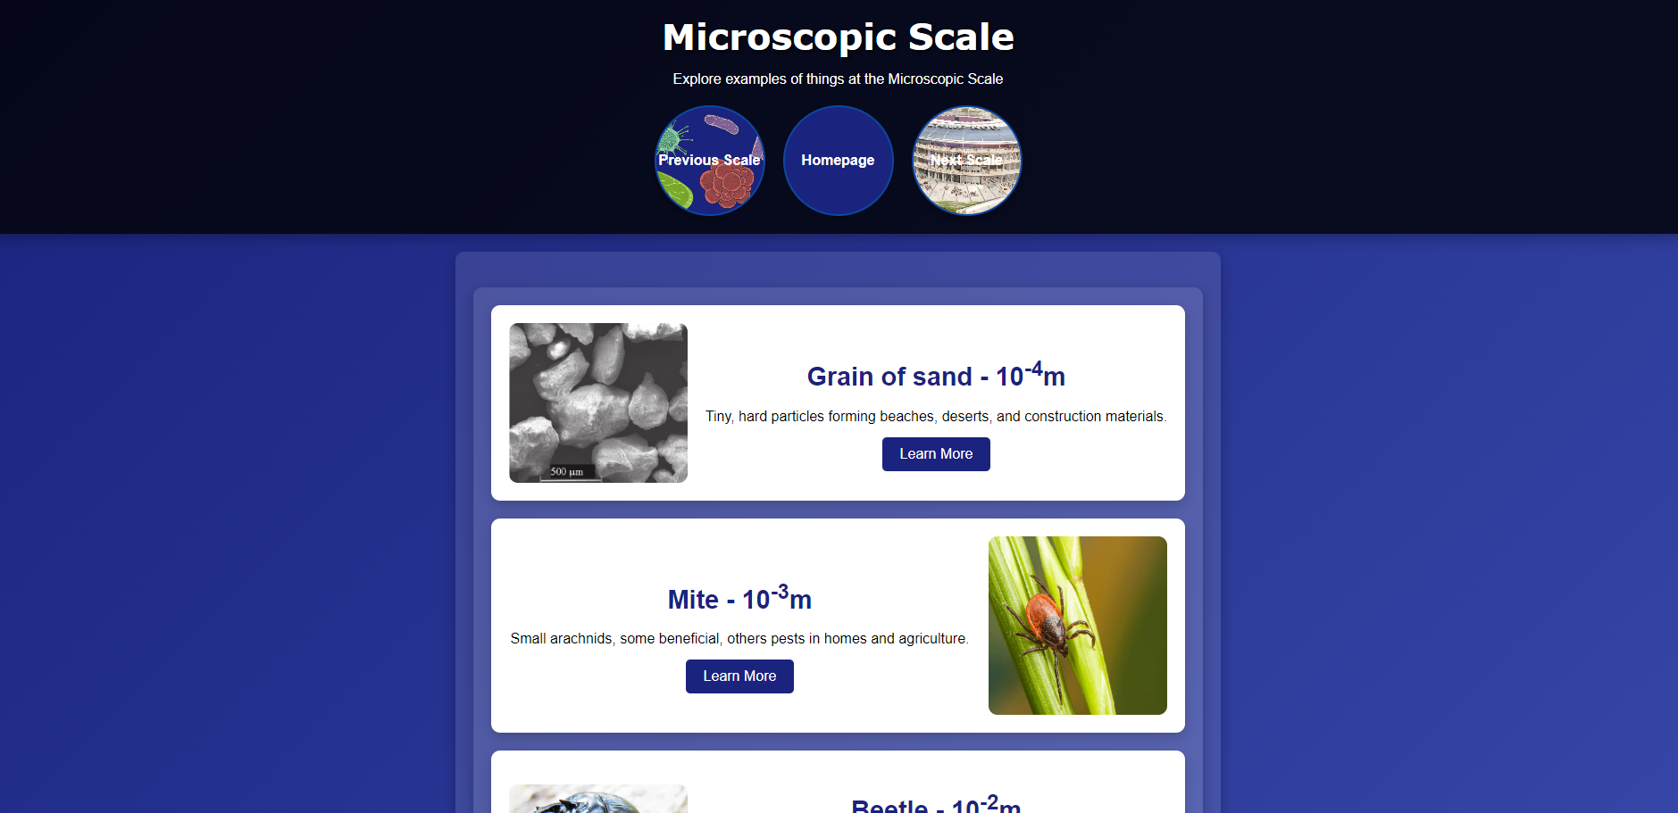
Page 4 – Microscopic

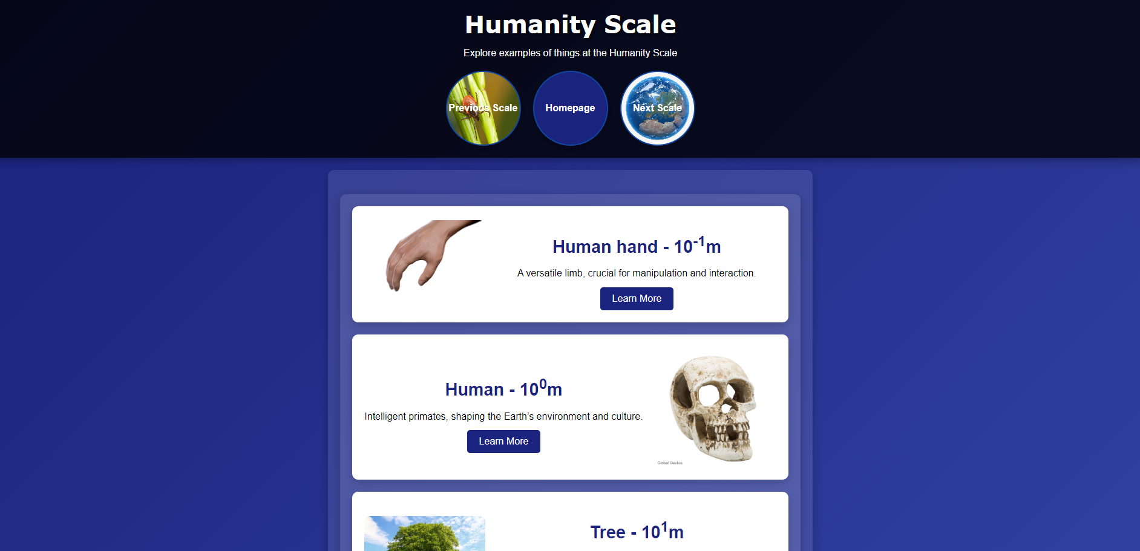
Page 5 – Humanity

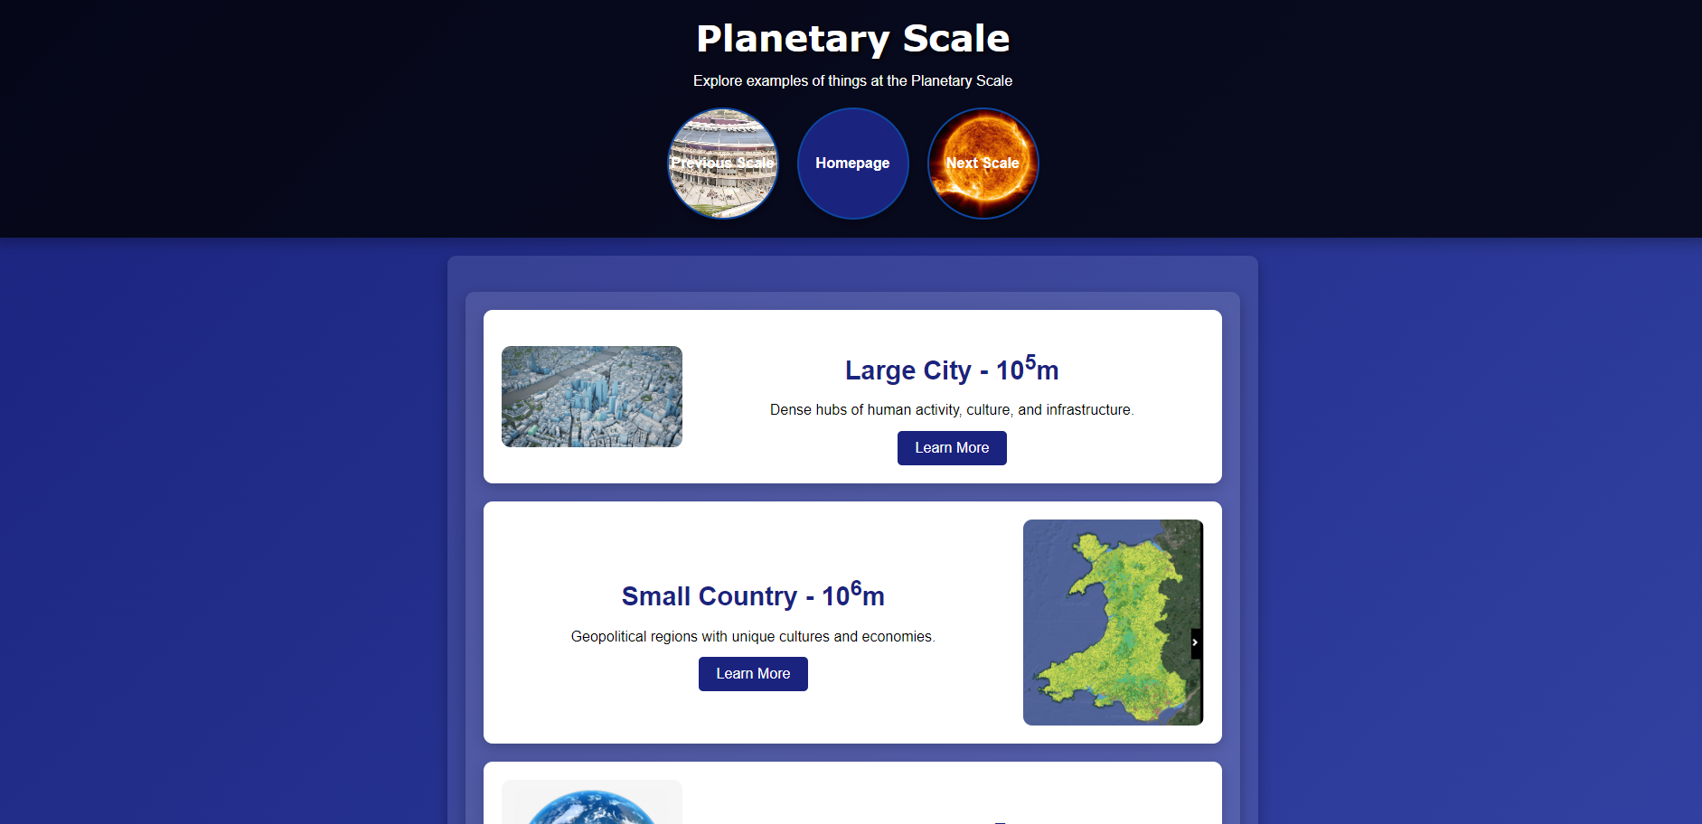
Page 6 – Planetary

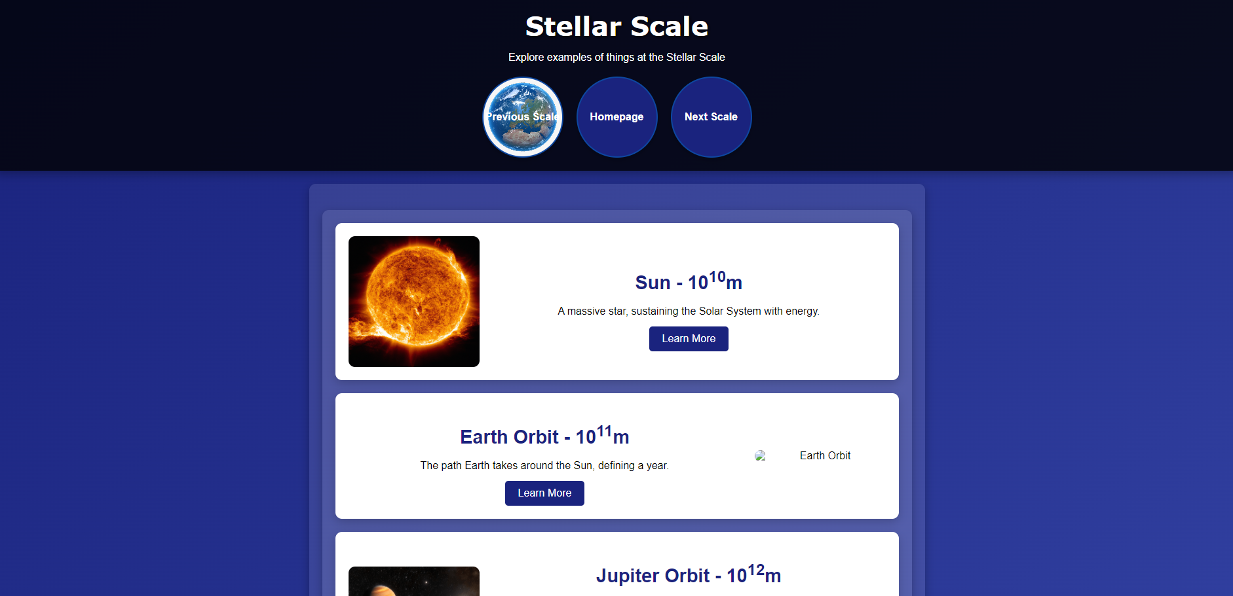
Page 7 – Stellar

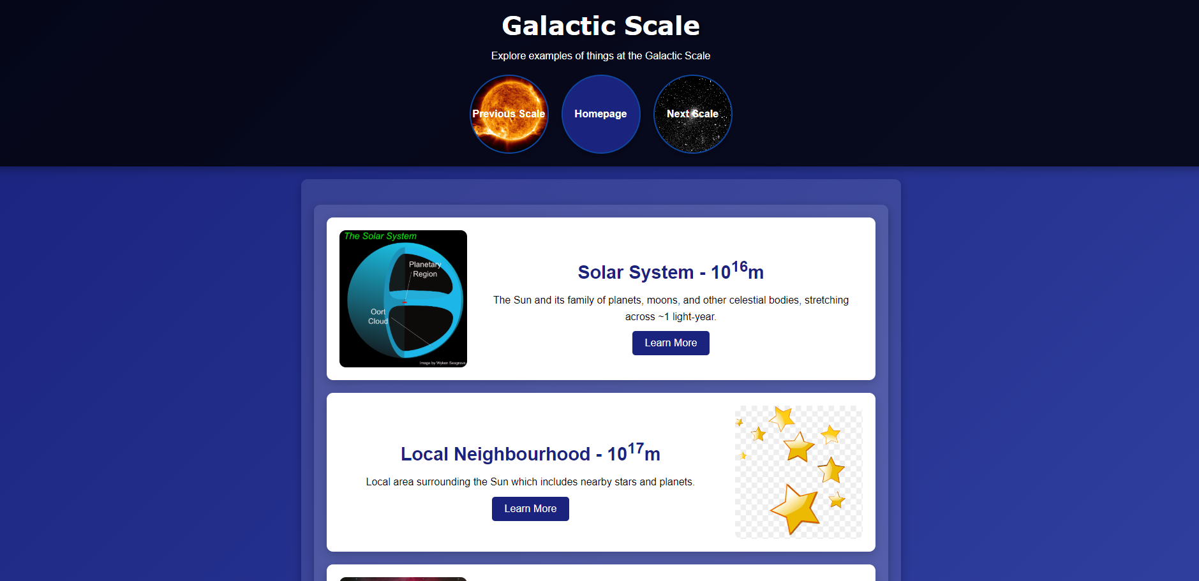
Page 8 – Galactic

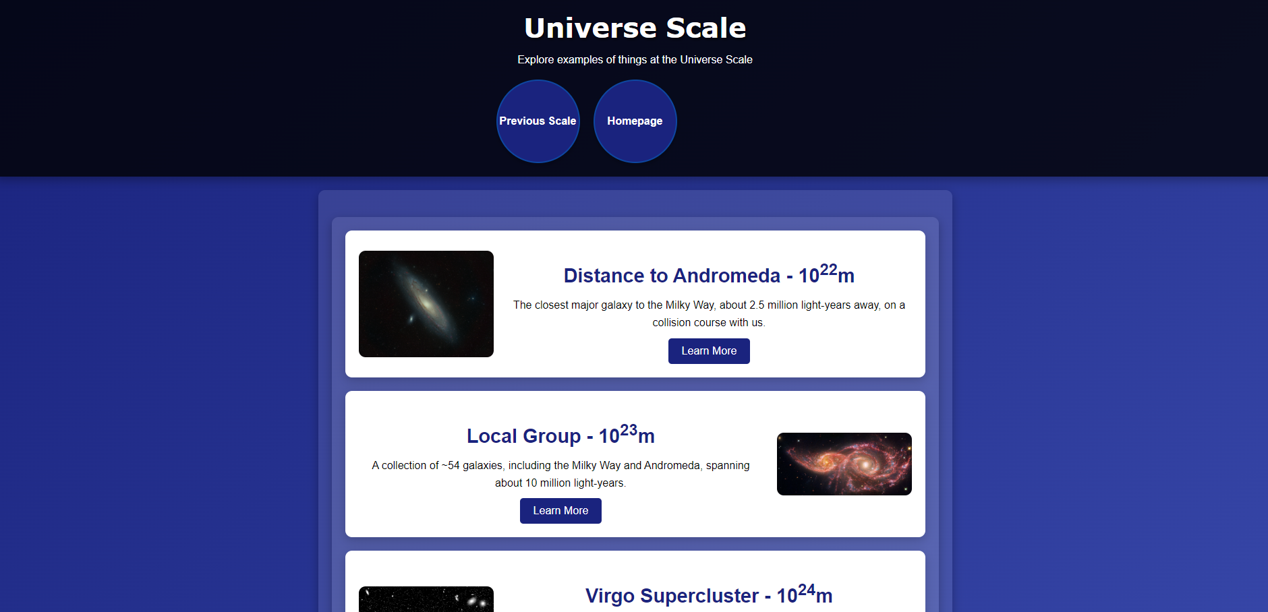
Page 9 – Universe

The HTML code was validated using the W3C Markup Validation Service [1]. Errors found and fixed included:
- Image file names containing spaces – this could have caused issues with images displaying correctly and was resolved by amending the name of the image files to use hyphens instead
- The iframe element used for the YouTube video contained the frameborder attribute, which is obsolete in HTML5 – this was resolved simply by removing it
After correcting these errors, the HTML code validated successfully with no warnings.

The CSS code was validated using the W3C CSS Validation Service [2]. There were no errors found.

Evaluation

In this section I will describe three important terms in web development and then relate them to my website.
Usefulness (Usability and Utility)
Usability is a term that describes how easy it is to use a website while utility refers more to whether or not the website has the necessary functionality to meet the user’s needs. [3] It is defined by the ISO 9241-11 standard as “the extent to which a system, product or service can be used by specified users to achieve specified goals with effectiveness, efficiency and satisfaction in a specified context of use”. [4] Usability can be broken down into five separate components: [3]
- Learnability – How easy is it for users to complete tasks when they first use the website?
- Efficiency – Once the website is learned, how quickly can it be used?
- Memorability – When users return after a period away, how well can they remember how to use it?
- Errors – How many and how severe are the errors that the user makes?
- Satisfaction – How pleasing is the website to use?

An example of a study on this is ‘Website usability, consumer satisfaction and the intention to use a website: The moderating effect of perceived risk’ by Daniel Belanche, Luis Casalo & Miguel Guinaliu. [5] This paper focused on the effect that usability has on consumer satisfaction and intention to use a website. Findings of this paper were:
- Website usability affects consumer satisfaction and consequently use of the website
- However, the link between usability and website use is indirect, with satisfaction being the intermediate step
- The effect of usability on satisfaction can be moderated by the perception of risk
These findings show the importance of ensuring that a website has good usability.

With regards to my website, it succeeds at providing utility given that the purpose is to provide information about objects at different scales. The website offers a range of examples with links to further information.
The website also shows good usability. The navigation is intuitive, using buttons with clear labels and images. The header buttons on each scale page allow for easy movement between scales and back to the homepage. The layout is consistent and visually appealing making it easy to read. The alternating layout of the cards adds visual interest. The information is clearly presented with interesting descriptions and links for further reading. The use of images, bolding, lists, tables and blockquotes further improves readability. In terms of the five terms described above:
- Learnability: The site is easy to learn. A user can quickly understand how to navigate and find information.
- Efficiency: Users can efficiently find information about specific scales and examples by clicking on the header buttons
- Memorability: The consistent design and clear navigation make it easy for users to remember how to use the site.
- Errors: Users are unlikely to make mistakes as the layout is very clear and can be recovered in one click
- Satisfaction: The design is visually appealing and engaging

In terms of recommendations, I could include more content at each scale, especially the humanity and planetary scales. I would also introduce more interactivity such as the ability to visually zoom in or out as the scales change.

Search Engine Optimisation (SEO)
Search Engine Optimisation (SEO) is the practice of improving the visibility and ranking of a website in search engine results. [6] SEO is important when it comes to bringing in traffic to a website. Key aspects include: [7]
- Keyword Research: Identifying keywords that users are likely to search for
- On-Page Optimisation: Optimising website content and structure to target users and search engines
- Off-Page Optimisation: Building credibility for the website through link-building from other websites, improving authority and ranking
- Technical SEO: Ensuring that the website is technically sound and easily crawlable by search engines

An example of a study on this is ‘Search Engine Optimization (SEO): A Study of important key factors in achieving a better Search Engine Result Page (SERP) Position’ by Muhammad Iqbal, Muhammad Noman Khalid, Dr Amir Manzoor, Malik Munib Abid & Nazir Ahmed Shaikh. [8] This paper studies the concept of Search Engine Optimisation and describes guidelines for developers to increase the visibility of their websites to search engines. Link-building is also discussed. Key findings of this paper include:
- High SERP rankings drive significant traffic to a website
- Multiple factors contribute to SERP visibility
These findings highlight the importance of making sure that a website has good keyword visibility. Also, it shows that using many techniques to achieve this is necessary – it is unwise to rely on only one technique.

With regards to my website, On-Page SEO techniques have been used throughout.
Each page has a unique title that includes relevant keywords such as atomic and universe. The homepage contains a description of the website’s content and contains more relevant keywords.
Examples of keywords on the homepage include scales, atoms and order of magnitude Other keywords are present in the scales pages such as hydrogen, bacteria and atomic.
Images used have alt text that includes keywords such as quark, proton, etc.
The URLs used are short and also include relevant keywords.
With regards to keyword density, keywords are used naturally within the content and ‘keyword stuffing’ has been avoided which can be detrimental to SEO.

Accessibility
Accessibility refers to websites being designed in a way that people with disabilities can use them. If a website is designed in this way, people with disabilities should be able to perceive, understand, navigate, interact and contribute to it. Accessibility encompasses all disabilities that affect interaction with the web, including visual, auditory and neurological. [9]
The Web Content Accessibility Guidelines (WCAG) describe a range of recommendations for making web content accessible. The four principles of this are that websites should perceivable, operable, understandable and robust. [10]

An example of a study on this is ‘Why Web Accessibility Is Important for Your Institution’ by Francisco Filipe, Ivan Pires & Antonio Gouveia. [11] This paper is a systematic literature review and aims to study the methods of evaluating accessibility. Findings of this paper include:
- Accessible websites reach a wider audience, showing that there is a significant population of people living with disabilities that accessibility guidelines help
- There is a need for institutions to adopt accessibility as part of their web development processes
- Improved accessibility can actually improve SEO and overall quality
These findings make clear the benefits of keeping accessibility in mind when developing a website.

With regards to my website, I have fulfilled the four principles of WCAG 2.1 as described below
- Perceivable
  - All images have descriptive alt text
  - The contrast between the text and background colours was checked using a contrast checker [12]. This was found to be sufficient, passing the standards for both normal and large text
  - Header buttons enlarge when hovered over with the text changing colour to make it clear that the button is ready to be pressed
  - Header buttons contain images to make the purpose and destination of the buttons clear
- Operable
  - The website can be navigated fully using only a keyboard
  - There are no time limits
  - There is no flashing of colours
  - Navigation is clear and consistent, making it easy to find the desired information
- Understandable
  - The text content is easy to read and understand. The font sizes are large enough and the language used is clear
  - Navigation and layout is predictable, meaning that the website is predictable
  - Tables and lists have been used where appropriate
- Robust
  - The website has a simple layout, helping it to be compatible with assistive technologies
  - The code has been validated to ensure compatibility

In conclusion, the development of 'Examples Across Scales' has been a good learning experience, reinforcing the importance of usability, accessibility and SEO in creating successful websites.

References

[1] "W3C Markup Validation Service." https://validator.w3.org/ (accessed 04/01/2025)
[2] "W3C CSS Validation Service." https://jigsaw.w3.org/css-validator/ (accessed 04/01/2025)
[3] Jakob Nielsen. "Usability 101: Introduction to Usability." NN Group. https://www.nngroup.com/articles/usability-101-introduction-to-usability/#:~:text=Definition%20of%20Useful%20%3D%20usability%20%2B%20utility.%20On,users%20can%20do%20on%20the%20site%2C%20people%20leave. (accessed 02/01/2025).
[4] "ISO 9241-11:2018
Ergonomics of human-system interaction
Part 11: Usability: Definitions and concepts." ISO. https://www.iso.org/standard/63500.html (accessed 05/01/2025).
[5] D. Belanche, L. V. Casaló and M. Guinalíu, "Website usability, consumer satisfaction and the intention to use a website: The moderating effect of perceived risk," Journal of retailing and consumer services, vol. 19, no. 1, pp.124–132, 2012. doi: 10.1016/j.jretconser.2011.11.001. (accessed 04/01/2025)
[6] Christopher Lara. "What is SEO? Understanding Search Engine Optimization and SEO Basics." Thee Digital. https://www.theedigital.com/blog/what-is-seo (accessed 02/01/2025).
[7] "The Key Components of SEO: Understanding Optimization and Ranking Techniques." Crevand. https://www.crevand.com/what-are-the-key-components-of-seo/ (accessed 02/01/2025).
[8] M. Iqbal, et al., "Search Engine Optimization (SEO): A Study of important key factors in achieving a better Search Engine Result Page (SERP) Position," Sukkur IBA Journal of Computing and Mathematical Sciences (Online), vol. 6, no. 1, 2022. doi: 10.30537/sjcms.v6i1.924. (accessed 04/01/2025)
[9] "Introduction to Web Accessibility." W3C. https://www.w3.org/WAI/fundamentals/accessibility-intro/ (accessed 03/01/2025).
[10] Alastair Campbell (Nomensa), Chuck Adams (Oracle), Rachael Bradley Montgomery (Library of Congress), Michael Cooper (W3C) and Andrew Kirkpatrick (Adobe), "Web Content Accessibility Guidelines (WCAG) 2.2." w3. https://www.w3.org/TR/WCAG22/ (accessed 04/01/2025).
[11] F. Filipe, I. M. Pires and A. J. Gouveia, "Why Web Accessibility Is Important for Your Institution," Procedia computer science, vol. 219, pp.20–27, 2023. doi: 10.1016/j.procs.2023.01.259. (accessed 04/01/2025)
[12] "WebAIM Contrast Checker." https://webaim.org/resources/contrastchecker/ (accessed 04/01/2025)

Appendices

- HTML Code (index.html)
<!DOCTYPE html>
<html lang="en">
<head>
<link rel="stylesheet" href="styles.css">
<meta charset="UTF-8">
<meta name="description" content="Examples at Scale">
<meta name="keywords" content="HTML, CSS">
<meta name="author" content="Paul Griffiths">
<meta name="viewport" content="width=device-width, initial-scale=1.0">
<title>Examples Across Scales - Atoms to All</title>
</head>
<body>
<header>
<h1>Examples Across Scales - Atoms to All</h1>
<p>Explore examples of things at each order of magnitude, from the tiniest particles to the vastest objects in the universe!</p>
</header>
<main>
<p>Click on any category below to dive deeper into examples within that range.</p>
<p>Discover fascinating details about each scale, from the subatomic world to the vast cosmos.</p>
<div class="button-container">
<a href="subatomic.html" class="scale-button" style="background-image: url('images/nucleus.png');">Subatomic</a>
<a href="atomic.html" class="scale-button" style="background-image: url('images/bacteria.png');">Atomic & Cellular</a>
<a href="microscopic.html" class="scale-button" style="background-image: url('images/mite.png');">Microscopic</a>
<a href="humanity.html" class="scale-button" style="background-image: url('images/stadium.png');">Humanity</a>
<a href="planetary.html" class="scale-button" style="background-image: url('images/earth.png');">Planetary</a>
<a href="stellar.html" class="scale-button" style="background-image: url('images/sun.png');">Stellar</a>
<a href="galactic.html" class="scale-button" style="background-image: url('images/orion-arm.png');">Galactic</a>
<a href="universe.html" class="scale-button" style="background-image: url('images/virgo.png');">Universe</a>
</div>
</main>
<footer>
<p>© 2025 Paul Griffiths. All Rights Reserved.</p>
</footer>
</body>
</html>
- HTML Code (subatomic.html)
<!DOCTYPE html>
<html lang="en">
<head>
<meta charset="UTF-8">
<meta name="viewport" content="width=device-width, initial-scale=1.0">
<title>Subatomic Scale</title>
<link rel="stylesheet" href="styles.css">
</head>
<body>
<header>
<h1>Subatomic Scale</h1>
<p>Explore examples of things at the Subatomic Scale</p>
<div class="header-buttons">
<a href="#" class="header-button hidden" style="background-image: url('images/hidden.jpg');">Previous Scale</a>
<a href="index.html" class="header-button" style="background-image: url('images/home.png');">Homepage</a>
<a href="atomic.html" class="header-button" style="background-image: url('images/bacteria.png');">Next Scale</a>
</div>
</header>
<main>
<div class="things-container">
<div class="thing-card alternating-layout">
<img src="images/quark.png" alt="Quark">
<div class="thing-details">
<h2>Quarks - 10<sup>-15</sup>m</h2>
<p>Fundamental building blocks of matter, forming <strong>protons</strong> and <b>neutrons</b> in atomic nuclei.</p>
<p>There are six kinds of quarks, known as flavors: </p>
<ul>
<li>Up</li>
<li>Down</li>
<li>Charm</li>
<li>Strange</li>
<li>Top</li>
<li>Bottom</li>
</ul>
<a href="https://en.wikipedia.org/wiki/Quark" target="_blank">Learn More</a>
</div>
</div>
<div class="thing-card alternating-layout reverse">
<img src="images/proton.png" alt="Proton">
<div class="thing-details">
<h2>Proton - 10<sup>-14</sup>m</h2>
<p>Positively charged particle found in the nucleus, <i>crucial</i> for atomic identity. These consist of two <b>up</b> quarks and one <b>down</b> quark.</p>
<p>The number of protons in an atom's nucleus defines what element it is, for example, all hydrogen atoms have one proton, all helium atoms have two protons.</p>
<blockquote cite="https://en.wikipedia.org/wiki/Proton">
<p>Protons are classified as baryons and are composed of two up quarks and one down quark.</p>
</blockquote>

<a href="https://en.wikipedia.org/wiki/Proton" target="_blank">Learn More</a>
</div>
</div>
<div class="thing-card alternating-layout">
<img src="images/nucleus.png" alt="Atom nucleus">
<div class="thing-details">
<h2>Atom nucleus - 10<sup>-13</sup>m</h2>
<p>The dense core of an atom, holding almost all its mass, containing both protons and neutrons. These are bound together by the <strong>strong nuclear force</strong></p>
<p>The following table displays the common elements which contain varying numbers of protons and neutrons:</p>
<table>
<thead>
<tr>
<th>Element</th>
<th>Protons</th>
<th>Neutrons</th>
</tr>
</thead>
<tbody>
<tr>
<td>Hydrogen</td>
<td>1</td>
<td>0</td>
</tr>
<tr>
<td>Carbon</td>
<td>6</td>
<td>6</td>
</tr>
<tr>
<td>Oxygen</td>
<td>8</td>
<td>8</td>
</tr>
<tr>
<td>Iron</td>
<td>26</td>
<td>30</td>
</tr>
<tr>
<td>Uranium</td>
<td>92</td>
<td>146</td>
</tr>
</tbody>
</table>

<a href="https://en.wikipedia.org/wiki/Atomic_nucleus" target="_blank">Learn More</a>
</div>
</div>
<div class="thing-card alternating-layout reverse">
<img src="images/electron.png" alt="Electron cloud">
<div class="thing-details">
<h2>Electron Cloud - 10<sup>-12</sup>m</h2>
<p>Probable location of an electron orbiting an atomic nucleus. It is not a solid shell, but rather a probabilistic area that describes where an electron may be located around the nucleus at a given time.</p>
<p>The model below describes this, with the nucleus in the centre and the cloud describing the potential locations of the electron.</p>
<iframe width="560" height="315" src="https://www.youtube.com/embed/FMlZq9NG_lo?si=2bM1bnk47qYLcpgf" title="YouTube video player" allow="accelerometer; autoplay; clipboard-write; encrypted-media; gyroscope; picture-in-picture; web-share" referrerpolicy="strict-origin-when-cross-origin" allowfullscreen>
</iframe>
<a href="https://en.wikipedia.org/wiki/Electron_cloud" target="_blank">Learn More</a>
</div>
</div>
<div class="thing-card alternating-layout">
<img src="images/hydrogen.png" alt="Hydrogen Atom">
<div class="thing-details">
<h2>Hydrogen Atom - 10<sup>-11</sup>m</h2>
<p>The simplest form of matter, defining the chemical elements. A single proton makes up the nucleus, which one electron orbits.</p>
<a href="https://en.wikipedia.org/wiki/Hydrogen" target="_blank">Learn More</a>
</div>
</div>
</div>
</main>
<footer>
<p>© 2025 Paul Griffiths. All Rights Reserved.</p>
</footer>
</body>
</html>
- HTML Code (atomic.html)
<!DOCTYPE html>
<html lang="en">
<head>
<meta charset="UTF-8">
<meta name="viewport" content="width=device-width, initial-scale=1.0">
<title>Atomic & Cellular Scale</title>
<link rel="stylesheet" href="styles.css">
</head>
<body>
<header>
<h1>Atomic & Cellular Scale</h1>
<p>Explore examples of things at the Atomic & Cellular Scale</p>
<div class="header-buttons">
<a href="subatomic.html" class="header-button" style="background-image: url('images/nucleus.png');">Previous Scale</a>
<a href="index.html" class="header-button" style="background-image: url('images/home.png');">Homepage</a>
<a href="microscopic.html" class="header-button" style="background-image: url('images/mite.png');">Next Scale</a>
</div>
</header>
<main>
<div class="things-container">
<div class="thing-card alternating-layout">
<img src="images/helium.png" alt="Helium Atom">
<div class="thing-details">
<h2>Helium Atom - 10<sup>-10</sup>m</h2>
<p>Next simplest atom, consisting of two protons, two neutrons and two electrons.</p>
<a href="https://en.wikipedia.org/wiki/Helium" target="_blank">Learn More</a>
</div>
</div>
<div class="thing-card alternating-layout reverse">
<img src="images/virus.png" alt="Virus">
<div class="thing-details">
<h2>Virus - 10<sup>-9</sup>m</h2>
<p>Infectious agents smaller than bacteria, made of protein and genetic material.</p>
<a href="https://en.wikipedia.org/wiki/Virus" target="_blank">Learn More</a>
</div>
</div>
<div class="thing-card alternating-layout">
<img src="images/protein.png" alt="Protein Molecule">
<div class="thing-details">
<h2>Protein Molecule - 10<sup>-8</sup>m</h2>
<p>Large biological molecules, essential for cellular functions.</p>
<a href="https://en.wikipedia.org/wiki/Protein" target="_blank">Learn More</a>
</div>
</div>
<div class="thing-card alternating-layout reverse">
<img src="images/dust.png" alt="Dust Particle">
<div class="thing-details">
<h2>Dust Particle - 10<sup>-7</sup>m</h2>
<p>Tiny particles, often seen floating in sunlight or accumulating on surfaces.</p>
<a href="https://en.wikipedia.org/wiki/Dust" target="_blank">Learn More</a>
</div>
</div>
<div class="thing-card alternating-layout">
<img src="images/bacteria.png" alt="Bacteria">
<div class="thing-details">
<h2>Bacteria - 10<sup>-6</sup>m</h2>
<p>Single-celled microorganisms, foundational to ecosystems and health.</p>
<a href="https://en.wikipedia.org/wiki/Bacteria" target="_blank">Learn More</a>
</div>
</div>
<div class="thing-card alternating-layout reverse">
<img src="images/red-blood-cell.png" alt="Red Blood Cell">
<div class="thing-details">
<h2>Red Blood Cell - 10<sup>-5</sup>m</h2>
<p>Oxygen-transporting cells in the blood, vital for life.</p>
<a href="https://en.wikipedia.org/wiki/Red_blood_cell" target="_blank">Learn More</a>
</div>
</div>
</div>
</main>
<footer>
<p>© 2025 Paul Griffiths. All Rights Reserved.</p>
</footer>
</body>
</html>

- HTML Code (microscopic.html)
<!DOCTYPE html>
<html lang="en">
<head>
<meta charset="UTF-8">
<meta name="viewport" content="width=device-width, initial-scale=1.0">
<title>Microscopic Scale</title>
<link rel="stylesheet" href="styles.css">
</head>
<body>
<header>
<h1>Microscopic Scale</h1>
<p>Explore examples of things at the Microscopic Scale</p>
<div class="header-buttons">
<a href="atomic.html" class="header-button" style="background-image: url('images/bacteria.png');">Previous Scale</a>
<a href="index.html" class="header-button" style="background-image: url('images/home.png');">Homepage</a>
<a href="humanity.html" class="header-button" style="background-image: url('images/stadium.png');">Next Scale</a>
</div>
</header>
<main>
<div class="things-container">
<div class="thing-card alternating-layout">
<img src="images/sand.png" alt="Grain of sand">
<div class="thing-details">
<h2>Grain of sand - 10<sup>-4</sup>m</h2>
<p>Tiny, hard particles forming beaches, deserts, and construction materials.</p>
<a href="https://en.wikipedia.org/wiki/Sand" target="_blank">Learn More</a>
</div>
</div>
<div class="thing-card alternating-layout reverse">
<img src="images/mite.png" alt="Mite">
<div class="thing-details">
<h2>Mite - 10<sup>-3</sup>m</h2>
<p>Small arachnids, some beneficial, others pests in homes and agriculture.</p>
<a href="https://en.wikipedia.org/wiki/Mite" target="_blank">Learn More</a>
</div>
</div>
<div class="thing-card alternating-layout">
<img src="images/beetle.png" alt="Beetle">
<div class="thing-details">
<h2>Beetle - 10<sup>-2</sup>m</h2>
<p>Diverse insects, known for their hard exoskeletons and varied habitats.</p>
<a href="https://en.wikipedia.org/wiki/Beetle" target="_blank">Learn More</a>
</div>
</div>
</div>
</main>
<footer>
<p>© 2025 Paul Griffiths. All Rights Reserved.</p>
</footer>
</body>
</html>

- HTML Code (humanity.html)
<!DOCTYPE html>
<html lang="en">
<head>
<meta charset="UTF-8">
<meta name="viewport" content="width=device-width, initial-scale=1.0">
<title>Humanity Scale</title>
<link rel="stylesheet" href="styles.css">
</head>
<body>
<header>
<h1>Humanity Scale</h1>
<p>Explore examples of things at the Humanity Scale</p>
<div class="header-buttons">
<a href="microscopic.html" class="header-button" style="background-image: url('images/mite.png');">Previous Scale</a>
<a href="index.html" class="header-button" style="background-image: url('images/home.png');">Homepage</a>
<a href="planetary.html" class="header-button" style="background-image: url('images/earth.png');">Next Scale</a>
</div>
</header>
<main>
<div class="things-container">
<div class="thing-card alternating-layout">
<img src="images/hand.png" alt="Human hand">
<div class="thing-details">
<h2>Human hand - 10<sup>-1</sup>m</h2>
<p>A versatile limb, crucial for manipulation and interaction.</p>
<a href="https://en.wikipedia.org/wiki/Hand" target="_blank">Learn More</a>
</div>
</div>
<div class="thing-card alternating-layout reverse">
<img src="images/human.png" alt="Human">
<div class="thing-details">
<h2>Human - 10<sup>0</sup>m</h2>
<p>Intelligent primates, shaping the Earth’s environment and culture.</p>
<a href="https://en.wikipedia.org/wiki/Human" target="_blank">Learn More</a>
</div>
</div>
<div class="thing-card alternating-layout">
<img src="images/tree.png" alt="Tree">
<div class="thing-details">
<h2>Tree - 10<sup>1</sup>m</h2>
<p>Essential organisms, providing oxygen, shade, and habitats.</p>
<a href="https://en.wikipedia.org/wiki/Tree" target="_blank">Learn More</a>
</div>
</div>
<div class="thing-card alternating-layout reverse">
<img src="images/building.png" alt="Large Building">
<div class="thing-details">
<h2>Large Building - 10<sup>2</sup>m</h2>
<p>Architectural marvels housing people and businesses.</p>
<a href="https://en.wikipedia.org/wiki/Building" target="_blank">Learn More</a>
</div>
</div>
<div class="thing-card alternating-layout">
<img src="images/stadium.png" alt="Stadium">
<div class="thing-details">
<h2>Stadium - 10<sup>3</sup>m</h2>
<p>Vast venues for sports, concerts, and large events.</p>
<a href="https://en.wikipedia.org/wiki/Stadium" target="_blank">Learn More</a>
</div>
</div>
<div class="thing-card alternating-layout reverse">
<img src="images/town.png" alt="Small town">
<div class="thing-details">
<h2>Small town - 10<sup>4</sup>m</h2>
<p>Communities with homes, businesses, and local governance.</p>
<a href="https://en.wikipedia.org/wiki/Town" target="_blank">Learn More</a>
</div>
</div>
</div>
</main>
<footer>
<p>© 2025 Paul Griffiths. All Rights Reserved.</p>
</footer>
</body>
</html>

- HTML Code (planetary.html)
<!DOCTYPE html>
<html lang="en">
<head>
<meta charset="UTF-8">
<meta name="viewport" content="width=device-width, initial-scale=1.0">
<title>Planetary Scale</title>
<link rel="stylesheet" href="styles.css">
</head>
<body>
<header>
<h1>Planetary Scale</h1>
<p>Explore examples of things at the Planetary Scale</p>
<div class="header-buttons">
<a href="humanity.html" class="header-button" style="background-image: url('images/stadium.png');">Previous Scale</a>
<a href="index.html" class="header-button" style="background-image: url('images/home.png');">Homepage</a>
<a href="stellar.html" class="header-button" style="background-image: url('images/sun.png');">Next Scale</a>
</div>
</header>
<main>
<div class="things-container">
<div class="thing-card alternating-layout">
<img src="images/city.png" alt="Large City">
<div class="thing-details">
<h2>Large City - 10<sup>5</sup>m</h2>
<p>Dense hubs of human activity, culture, and infrastructure.</p>
<a href="https://en.wikipedia.org/wiki/City" target="_blank">Learn More</a>
</div>
</div>
<div class="thing-card alternating-layout reverse">
<img src="images/country.png" alt="Small Country">
<div class="thing-details">
<h2>Small Country - 10<sup>6</sup>m</h2>
<p>Geopolitical regions with unique cultures and economies.</p>
<a href="https://en.wikipedia.org/wiki/Country" target="_blank">Learn More</a>
</div>
</div>
<div class="thing-card alternating-layout">
<img src="images/earth.png" alt="Earth">
<div class="thing-details">
<h2>Earth - 10<sup>7</sup>m</h2>
<p>Our home planet, teeming with life and diversity.</p>
<a href="https://en.wikipedia.org/wiki/Earth" target="_blank">Learn More</a>
</div>
</div>
<div class="thing-card alternating-layout reverse">
<img src="images/jupiter.png" alt="Jupiter">
<div class="thing-details">
<h2>Jupiter - 10<sup>8</sup>m</h2>
<p>The largest planet in our Solar System, with massive storms and many moons.</p>
<a href="https://en.wikipedia.org/wiki/Jupiter" target="_blank">Learn More</a>
</div>
</div>
<div class="thing-card alternating-layout">
<img src="images/moon.png" alt="Moon’s Orbit">
<div class="thing-details">
<h2>Moon’s Orbit - 10<sup>9</sup>m</h2>
<p>The Moon orbits Earth, influencing tides and nocturnal illumination.</p>
<a href="https://en.wikipedia.org/wiki/Orbit_of_the_Moon" target="_blank">Learn More</a>
</div>
</div>
</div>
</main>
<footer>
<p>© 2025 Paul Griffiths. All Rights Reserved.</p>
</footer>
</body>
</html>

- HTML Code (stellar.html)
<!DOCTYPE html>
<html lang="en">
<head>
<meta charset="UTF-8">
<meta name="viewport" content="width=device-width, initial-scale=1.0">
<title>Stellar Scale</title>
<link rel="stylesheet" href="styles.css">
</head>
<body>
<header>
<h1>Stellar Scale</h1>
<p>Explore examples of things at the Stellar Scale</p>
<div class="header-buttons">
<a href="planetary.html" class="header-button" style="background-image: url('images/earth.png');">Previous Scale</a>
<a href="index.html" class="header-button" style="background-image: url('images/home.png');">Homepage</a>
<a href="galactic.html" class="header-button" style="background-image: url('images/orion-arm.png');">Next Scale</a>
</div>
</header>
<main>
<div class="things-container">
<div class="thing-card alternating-layout">
<img src="images/sun.png" alt="Sun">
<div class="thing-details">
<h2>Sun - 10<sup>10</sup>m</h2>
<p>A massive star, sustaining the Solar System with energy.</p>
<a href="https://en.wikipedia.org/wiki/Sun" target="_blank">Learn More</a>
</div>
</div>
<div class="thing-card alternating-layout reverse">
<img src="images/earth-orbit.png" alt="Earth Orbit">
<div class="thing-details">
<h2>Earth Orbit - 10<sup>11</sup>m</h2>
<p>The path Earth takes around the Sun, defining a year.</p>
<a href="https://en.wikipedia.org/wiki/Earth%27s_orbit" target="_blank">Learn More</a>
</div>
</div>
<div class="thing-card alternating-layout">
<img src="images/jupiter-orbit.png" alt="Jupiter Orbit">
<div class="thing-details">
<h2>Jupiter Orbit - 10<sup>12</sup>m</h2>
<p>Jupiter’s orbit, the path of the largest planet in our Solar System, spans about 778 million km from the Sun.</p>
<a href="https://en.wikipedia.org/wiki/Jupiter%27s_orbit" target="_blank">Learn More</a>
</div>
</div>
<div class="thing-card alternating-layout reverse">
<img src="images/kuiper.png" alt="Kuiper Belt">
<div class="thing-details">
<h2>Kuiper Belt - 10<sup>13</sup>m</h2>
<p>A region of icy bodies, dwarf planets, and comets beyond Neptune, spanning about 50 AU from the Sun.</p>
<a href="https://en.wikipedia.org/wiki/Kuiper_belt" target="_blank">Learn More</a>
</div>
</div>
<div class="thing-card alternating-layout">
<img src="images/oort-start.png" alt="Start of Oort Cloud">
<div class="thing-details">
<h2>Start of Oort Cloud - 10<sup>14</sup>m</h2>
<p>The beginning of a vast, spherical shell of icy objects surrounding the Solar System, influencing long-period comets.</p>
<a href="https://en.wikipedia.org/wiki/Oort_cloud" target="_blank">Learn More</a>
</div>
</div>
<div class="thing-card alternating-layout reverse">
<img src="images/oort-middle.png" alt="Middle of Oort Cloud">
<div class="thing-details">
<h2>Middle of Oort Cloud - 10<sup>15</sup>m</h2>
<p>The densest region of the Oort Cloud, lying thousands of AU from the Sun, marking the edge of the Sun’s gravitational influence.</p>
<a href="https://en.wikipedia.org/wiki/Oort_cloud" target="_blank">Learn More</a>
</div>
</div>
</div>
</main>
<footer>
<p>© 2025 Paul Griffiths. All Rights Reserved.</p>
</footer>
</body>
</html>

- HTML Code (galactic.html)
<!DOCTYPE html>
<html lang="en">
<head>
<meta charset="UTF-8">
<meta name="viewport" content="width=device-width, initial-scale=1.0">
<title>Galactic Scale</title>
<link rel="stylesheet" href="styles.css">
</head>
<body>
<header>
<h1>Galactic Scale</h1>
<p>Explore examples of things at the Galactic Scale</p>
<div class="header-buttons">
<a href="stellar.html" class="header-button" style="background-image: url('images/sun.png');">Previous Scale</a>
<a href="index.html" class="header-button" style="background-image: url('images/home.png');">Homepage</a>
<a href="universe.html" class="header-button" style="background-image: url('images/virgo.png');">Next Scale</a>
</div>
</header>
<main>
<div class="things-container">
<div class="thing-card alternating-layout">
<img src="images/solar-system.png" alt="Solar System">
<div class="thing-details">
<h2>Solar System - 10<sup>16</sup>m</h2>
<p>The Sun and its family of planets, moons, and other celestial bodies, stretching across ~1 light-year.</p>
<a href="https://en.wikipedia.org/wiki/Solar_System" target="_blank">Learn More</a>
</div>
</div>
<div class="thing-card alternating-layout reverse">
<img src="images/neighbourhood.png" alt="Local Neighbourhood">
<div class="thing-details">
<h2>Local Neighbourhood - 10<sup>17</sup>m</h2>
<p>Local area surrounding the Sun which includes nearby stars and planets.</p>
<a href="https://en.wikipedia.org/wiki/Local_Interstellar_Cloud" target="_blank">Learn More</a>
</div>
</div>
<div class="thing-card alternating-layout">
<img src="images/orion-nebula.png" alt="Orion Nebula">
<div class="thing-details">
<h2>Orion Nebula - 10<sup>18</sup>m</h2>
<p>A stellar nursery in the Orion constellation, where young stars form from collapsing clouds of gas and dust.</p>
<a href="https://en.wikipedia.org/wiki/Orion_Nebula" target="_blank">Learn More</a>
</div>
</div>
<div class="thing-card alternating-layout reverse">
<img src="images/orion-arm.png" alt="Orion Arm Width">
<div class="thing-details">
<h2>Orion Arm Width - 10<sup>19</sup>m</h2>
<p>The approximate span of the Orion Arm, a minor spiral arm of the Milky Way containing our Solar System.</p>
<a href="https://en.wikipedia.org/wiki/Orion_Arm" target="_blank">Learn More</a>
</div>
</div>
<div class="thing-card alternating-layout">
<img src="images/milky-way-centre.png" alt="Milky Way Centre Distance">
<div class="thing-details">
<h2>Milky Way Centre Distance - 10<sup>20</sup>m</h2>
<p>The heart of the Milky Way, housing a supermassive black hole, Sagittarius A*, surrounded by dense star clusters.</p>
<a href="https://en.wikipedia.org/wiki/Galactic_Center" target="_blank">Learn More</a>
</div>
</div>
<div class="thing-card alternating-layout reverse">
<img src="images/milky-way.png" alt="Milky Way">
<div class="thing-details">
<h2>Milky Way - 10<sup>21</sup>m</h2>
<p>Our galaxy, a barred spiral structure with hundreds of billions of stars, spanning ~100,000 light-years.</p>
<a href="https://en.wikipedia.org/wiki/Milky_Way" target="_blank">Learn More</a>
</div>
</div>
</div>
</main>
<footer>
<p>© 2025 Paul Griffiths. All Rights Reserved.</p>
</footer>
</body>
</html>

- HTML Code (universe.html)
<!DOCTYPE html>
<html lang="en">
<head>
<meta charset="UTF-8">
<meta name="viewport" content="width=device-width, initial-scale=1.0">
<title>Universe Scale</title>
<link rel="stylesheet" href="styles.css">
</head>
<body>
<header>
<h1>Universe Scale</h1>
<p>Explore examples of things at the Universe Scale</p>
<div class="header-buttons">
<a href="galactic.html" class="header-button" style="background-image: url('images/orion-arm.png');">Previous Scale</a>
<a href="index.html" class="header-button" style="background-image: url('images/home.png');">Homepage</a>
<a href="#" class="header-button hidden" style="background-image: url('images/hidden.jpg');">Next Scale</a>
</div>
</header>
<main>
<div class="things-container">
<div class="thing-card alternating-layout">
<img src="images/andromeda.png" alt="Distance to Andromeda">
<div class="thing-details">
<h2>Distance to Andromeda - 10<sup>22</sup>m</h2>
<p>The closest major galaxy to the Milky Way, about 2.5 million light-years away, on a collision course with us.</p>
<a href="https://en.wikipedia.org/wiki/Andromeda_Galaxy" target="_blank">Learn More</a>
</div>
</div>
<div class="thing-card alternating-layout reverse">
<img src="images/local-group.png" alt="Local Group">
<div class="thing-details">
<h2>Local Group - 10<sup>23</sup>m</h2>
<p>A collection of ~54 galaxies, including the Milky Way and Andromeda, spanning about 10 million light-years.</p>
<a href="https://en.wikipedia.org/wiki/Local_Group" target="_blank">Learn More</a>
</div>
</div>
<div class="thing-card alternating-layout">
<img src="images/virgo.png" alt="Virgo Supercluster">
<div class="thing-details">
<h2>Virgo Supercluster - 10<sup>24</sup>m</h2>
<p>A massive grouping of galaxy clusters, part of the larger Laniakea Supercluster, spanning hundreds of millions of light-years.</p>
<a href="https://en.wikipedia.org/wiki/Virgo_Supercluster" target="_blank">Learn More</a>
</div>
</div>
</div>
</main>
<footer>
<p>© 2025 Paul Griffiths. All Rights Reserved.</p>
</footer>
</body>
</html>

- CSS Code (styles.css)
body {
font-family: 'Arial', sans-serif;
margin: 0;
padding: 0;
text-align: center;
background: linear-gradient(135deg, #1a237e, #283593, #3949ab);
color: #fff;
min-height: 100vh;
display: flex;
flex-direction: column;
}

header {
background: rgba(0, 0, 0, 0.8);
padding: 20px;
box-shadow: 0 5px 15px rgba(0, 0, 0, 0.3);
}

header h1 {
margin: 0;
font-size: 2.5em;
font-family: 'Verdana', sans-serif;
text-shadow: 2px 2px 5px rgba(0, 0, 0, 0.7);
}

main {
margin: 20px auto;
max-width: 900px;
padding: 20px;
background: rgba(255, 255, 255, 0.1);
border-radius: 10px;
box-shadow: 0 5px 15px rgba(0, 0, 0, 0.3);
}

main p {
margin: 15px 0;
font-size: 1.2em;
}

.button-container {
display: flex;
flex-direction: column;
align-items: center;
gap: 10px;
margin-top: 20px;
}

.scale-button {
display: flex;
align-items: center;
justify-content: center;
width: 220px;
height: 70px;
background-size: cover;
background-position: center;
background-repeat: no-repeat;
border: 2px solid #000;
color: white;
text-shadow: -1px -1px 1px #000, 1px -1px 1px #000, -1px 1px 1px #000, 1px 1px 1px #000;
font-size: 1rem;
text-decoration: none;
background-color: white;
border-radius: 10px;
transition: all 0.3s ease;
font-weight: bold;
}

.scale-button:hover {
transform: scale(1.1);
color: #ff0;
text-shadow: -2px -2px 3px #000, 2px -2px 3px #000, -2px 2px 3px #000, 2px 2px 3px #000;
box-shadow: 0 8px 20px rgba(0, 0, 0, 0.7);
}

footer {
margin-top: auto;
padding: 15px;
background: rgba(0, 0, 0, 0.8);
color: #ddd;
font-size: 0.9em;
text-shadow: 1px 1px 2px rgba(0, 0, 0, 0.5);
}

.header-buttons {
display: flex;
justify-content: center;
gap: 20px;
margin-top: 20px;
}

.header-button {
width: 120px;
height: 120px;
background-color: #1a237e;
color: white;
font-size: 1em;
font-weight: bold;
text-align: center;
border: 2px solid #0d47a1;
border-radius: 50%;
text-decoration: none;
box-shadow: 0 4px 8px rgba(0, 0, 0, 0.2);
transition: all 0.2s ease;
background-size: cover;
background-position: center;
display: flex;
align-items: center;
justify-content: center;
}

.header-button:hover {
transform: scale(1.1);
background-color: #0d47a1;
box-shadow: 0 6px 12px rgba(0, 0, 0, 0.3);
color: #ffcc00;
}

.hidden {
visibility: hidden;
}

.things-container {
display: flex;
flex-direction: column;
gap: 20px;
margin: 20px auto;
padding: 20px;
max-width: 900px;
background: rgba(255, 255, 255, 0.1);
border-radius: 10px;
box-shadow: 0 5px 15px rgba(0, 0, 0, 0.3);
}

.thing-card {
display: flex;
align-items: center;
gap: 20px;
background: #fff;
border-radius: 10px;
overflow: hidden;
text-decoration: none;
color: #000;
transition: all 0.3s ease;
box-shadow: 0 5px 15px rgba(0, 0, 0, 0.2);
padding: 20px;
}

.alternating-layout {
flex-direction: row;
}

.alternating-layout.reverse {
flex-direction: row-reverse;
}

.thing-card img {
width: 200px;
height: auto;
border-radius: 10px;
}

.thing-details {
flex: 1;
}

.thing-details h2 {
font-size: 1.8em;
font-weight: bold;
color: #1a237e;
margin-bottom: 10px;
}

.thing-details p {
font-size: 1em;
margin-bottom: 10px;
line-height: 1.6;
}

.thing-details a {
display: inline-block;
color: #fff;
background: #1a237e;
text-decoration: none;
padding: 10px 20px;
border-radius: 5px;
transition: background 0.3s ease;
}

.thing-details a:hover {
background: #3949ab;
}

table {
width: 100%;
border-collapse: collapse;
margin: 10px 0;
text-align: left;
}

th, td {
border: 1px solid #ddd;
padding: 8px;

}

th {
background-color: #f2f2f2;
font-weight: bold;
}

blockquote {
background: #f9f9f9;
border-left: 10px solid #ccc;
margin: 1.5em 10px;
padding: 0.5em 10px;
font-style: italic;
}

blockquote:before {
color: #ccc;
content: open-quote;
font-size: 4em;
line-height: 0.1em;
margin-right: 0.25em;
vertical-align: -0.4em;
}

blockquote::after {
color: #ccc;
content: close-quote;
font-size: 4em;
line-height: 0.1em;
margin-right: 0.25em;
vertical-align: -0.4em;
}

blockquote p {
display: inline;
}

