Title: Applying NIST and ISO 27001 Frameworks to Secure NatureGarden's Information Infrastructure
Name: Mehul Prafulbhai Tank
Student ID: 2410391
Subject: Data Security, Governance and Compliance

Abstract
Companies deal with an abundance of cyber security risks in the interconnected business world we live in. The interconnectedness of the global economy, expansive wireless infrastructures, and mobility aspects of BYOD create a much greater attack surface. NatureGarden (NG), a multinational organization that specializes in health and wellness, is exposed to risks due to reliance on wireless networks and cloud services. Due to the absence of a formal information security policy, there are risks of breaches of data, infringement of intellectual property, and violations of regulatory compliance.
This report applies two globally recognized security frameworks, which are the NIST Cybersecurity Framework and ISO/IEC 27001, to develop an efficient layered suite of information security, governance and compliance for NG. The business case is developed from current best practices and will draw on technical controls from both academic literature and professional standards to develop a realistic path to reduce NG’s risk posture.
Security technologies such as identity and access management; protection of network traffic; encryption; intrusion detection and prevention systems (IDPS); contingency management; and compliance (including regulatory compliance such as GDPR) are explored. Visual diagrams and tables will provide an illustration of the security layers, policies and risk assessments. Finally, evolving the cybersecurity regulatory environment needs to be considered including security postures (to achieve continuous security improvement features) and challenges of establishing "functional artefacts".

Introduction
In today's rapidly digitizing world with increasingly sophisticated cyber threats, organizations must ensure that they develop effective information security strategies to protect critical assets. NatureGarden (NG) is a multinational health and wellness company that operates from a global marketplace characterized by a high level of interconnectivity using cloud computing, wireless networks, and bring-your-own-device (BYOD) policies; These technologies and opportunities enable both operational flexibility and business expansion, but create an environment of increased cyber security threats such as data breaches, intellectual property theft, and regulatory violations.
In body, NG does not have a formalized information security governance framework and this presents a risk to the organization, particularly in a world of increasing cyber threats and a system of complex legislative and regulatory obligations and compliance with the General Data Protection Regulation (GDPR). To mitigate this risk, NG should take a holistic approach using internationally recognized cybersecurity frameworks and standards, to manage risk, provide technical controls, and foster a continual improvement environment focused on cyber-resilience.
This report outlines a plan moving forward to improve NG's cybersecurity posture based on the National Institute of Standards and Technology (NIST) Cybersecurity Framework (CSF) and the ISO/IEC 27001 standards. These standards offer two complementary methods: NIST CSF offers a value and risk approach and is more conducive to organizations that vary in their maturity level; ISO/IEC 27001 provides a detailed structure for implementing and maintaining an Information Security Management System (ISMS).By applying these two frameworks together, NG has the opportunity to implement a layered security structure that can be understood by stakeholders with the realities they face, by identifying key risks faced and conducting continual compliance to legal and regulatory obligations.

Literature Review
Cybersecurity frameworks provide structure for organizations to manage growing digital risk. Some popular cybersecurity frameworks include, but are not limited to: the NIST Cybersecurity Framework (CSF) and ISO/IEC 27001. NIST CSF is a risk-based voluntary framework published by the United States National Institute of Standards and Technology to provide guidance based upon existing standards and best practices. NIST CSF tends to be the path of choice for many organizations within various industries since it is risk-based and flexible enough to be manipulated [1]. ISO 27001 has an established structure for determining an Information Security Management System (ISMS) and offers internationally accepted guidance for risk assessment, controlling selection and auditing [2].
There is a lot of literature available that recognizes the practical benefits of these frameworks. ISO 27001 has an avenue that prescribes a control-based approach, whereas "NIST CSF's process is flexible and best used in conjunction with other frameworks and standards to fit the organization's maturity level." Integrating both NIST CSF and ISO 27001 helps organizations leverage NIST's risk management lifecycle while achieving an ISO certification for governance and assurance tooling. For organizations like NatureGarden, when you have to rely heavily on wireless and have a BYOD employee, this dual approach alleviates the necessity of ensuring your technology is not only sufficiently covered but also covering its legal and procedural compliance [3].
Further reading supports the necessity of controls such as multi-factor authentication (MFA), endpoint detection and response (EDR) and continuous monitoring, as foundational to defence-in-depth in the current cyber threat climate. The European Union Agency for Cybersecurity (ENISA) and the UK National Cyber Security Centre have both published reports acknowledging current threats to organization such as ransomware and supply-chain attacks that are forcing organization to adopt a layered and proactive approach to security [4], [5]. Furthermore, NIST's guidance recognized the usefulness of Intrusion Detection and Prevention Systems (IDPS) as essential tools to detect and respond to anomalies [6].
Those same foundational information security principles reappear in multiple academic textbooks which reiterates encryption, access control, and risk management principles as line of defence to consider in an overall defence-in-depth implementation strategy around its foundation of layering security controls as shown [7]. The Open Web Application Security Project (OWASP) identified the most critical risks that organizations needed to protect against including injection flaws, broken authentication, misconfigurations - that could potentially all be layered using risk frameworks [8]. Looking ahead, emerging decentralized applications enabled by technologies like blockchain are starting to affect security models and offer new opportunities for data integrity management and identity systems [9].

Methodology
This report employs a qualitative method founded on framework comparison, risk analysis, and design evaluation. Key academic literatures, professional standards, and the academic lectures reviewed provided insights into the central principles of NIST CSF and ISO 27001. In turn a comparison was made to match these frameworks with NG's operational structure and infrastructure, and the identified business threats.
The decision to select NIST CSF and ISO/IEC 27001 was based on their respective complementary capabilities today; risk-based flexibility and international compliance credentials. The layered security architecture was built from the recommended controls of both frameworks and was tailored to the wireless-first and bring-your-own-device (BYOD) context of NG. Some of the specific tools and mechanisms (IDPS, encryption, NAC) were selected from best practices aligned with guidance from Whitman & Mattord (2019) and Stallings (2017).
A hypothetical threat and risk model was used to demonstrate probable attacks and their impact to NG. Practically the report highlights recommendations rather than theory to ensure they can be implemented in the reality of NG by executives and IT leadership.
NatureGarden (NG) is a global brand that sells health and wellness products. NG undertakes much of its business from its digital operations and relies on a system of cloud-based IT systems providing 95% of its connectivity through wireless infrastructure. NG conducts business with customers on a global scale in a fast-paced market. Digital interaction with customers through websites and social media is a prerequisite to business continuity. NG, like many organizations, must adapt to the changing work habits of employees and customers through the permitting personal devices (BYOD) to access corporate resources.
This digital transformation has outpaced the development of formal cybersecurity policies for NG. As it stands now, NG has no governance framework for information security, leaving it vulnerable to many risks. Possible risks include unauthorized access to data, theft of intellectual property (IP), weak authentication, general failure to comply with data protection regulations (GDPR), and limited ability to prevent cyber-attacks caused by losses of central control on personal devices and external services.
The intent of this report is to provide a complete security governance and compliance strategy for NG's context. Two bodies of knowledge are being applied to aid in this process; namely the NIST Cybersecurity Framework which provides a functional and risk-based management framework for cybersecurity and ISO/IEC 27001 that supplies a systematic approach to designing, implementing, monitoring and continuing to improve an Information Security Management System (ISMS). The two bodies of knowledge are complementary and supply actionable practices that could be mapped directly to NG's needs.
The report will use materials from Weeks 7 & 8 lectures, specifically protection mechanisms such as authentication, firewalls, encryption, intrusion detection and prevention, and wireless security. Along with risk management approaches for NG together with contingency planning, the proposed approach will help NG be able to identify threats proactively, deal with compliance obligations, and ultimately secure NG's sensitive assets.
Frameworks Overview: NIST & ISO/IEC 27001
1 NIST Cybersecurity Framework (CSF) The NIST CSF is an organized and flexible approach for entities to address cyber risk. Guided by five overarching functions: Identify, Protect, Detect, Respond, and Recover. Each function has a set of categories and subcategories related to security controls and best practices in the industry.
- Identify refers to the ability to define the entity's environment, including its physical assets, digital assets, by-products, risk, and people's fixed and portable devices and terminal endpoints. In NG, this would mean identifying the wireless and cloud infrastructure assets, BYOD endpoints, and intellectual property.
- Protect concerns the implementation of safeguards, like firewalls, secure access controls and encryption protocols. This function protects the asset which encompasses, both staff and client’s data.
- Detect represents the methods (systems, tools, IT systems) to identify anomalies or breaches. This means having incident detection components such as intrusion detection systems, event logging or behaviour analysis.
- Respond ensures NG has the capacity to manage and contain a cybersecurity event. This means NG should be determined to establish incident response capacity by establishing an Incident Response Team and ensuring communication protocols are established.
- Recover aids parties returning to normal capabilities (and services) that were impaired due to the cybersecurity incident. This also means disaster recovery planning and continuously learning from the organization to hasten resilience.
2 ISO/IEC 27001:2013 Information Security Management System (ISMS)
ISO/IEC 27001 is a worldwide standard specification for establishing, implementing, maintaining and improving an ISMS. It is the standard based on a continual improvement model and uses the Plan-Do-Check-Act (PDCA) cycle:
- Plan refers to evaluating risks, composing policies, and establishing objectives. For NG, this means analysing risks in areas such as BYOD, wireless networks, and exposure to the cloud.
- Do means carrying out controls, for example, access management, encryption, or security awareness training.
- Check is monitoring, measuring, and evaluating controls or incident records continually.
- Act makes clears actions to comply with requirements and liability when applicable, modify or develop policies, and performance improvement such as audits or management reviews.
Diagram 1: ISO/IEC 27001 ISMS Life Cycle Diagram
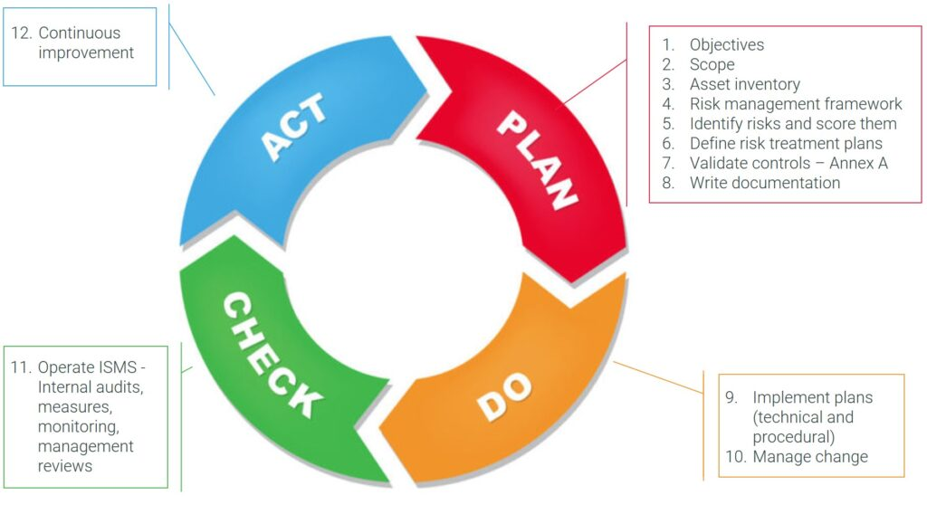
Diagram 1: The Information Security Management System (ISMS) life cycle follows the Plan-Do-Check-Act (PDCA) model, ensuring continuous improvement in information security practices.
Key Phases:
- Plan: Establish the ISMS, define the scope, and conduct a risk assessment.
- Do: Implement the risk treatment plan and controls.
- Check: Monitor and review the performance of the ISMS.
- Act: Take corrective actions and improve the ISMS.

Security Architecture
Proposed Multi-Layered Security Architecture for NatureGarden
Layer | Description and Security Controls
Governance Layer | Includes organizational security policies, ISO 27001 compliance, GDPR, SLAs with cloud providers, and the definition of roles and responsibilities.
Security Monitoring Layer | Encompasses centralized log management, Security Information and Event Management (SIEM) systems, and Intrusion Detection and Prevention Systems (IDPS).
Application & Data Layer | Enforces data encryption (AES-256, RSA), digital signatures, data loss prevention (DLP), and secure APIs.
Network Layer | Involves UTM firewalls, Virtual LANs (VLANs), Virtual Private Networks (VPNs), and application-layer filtering for traffic segmentation and control.
Endpoint Layer | Includes anti-malware, mobile device management (MDM), access control enforcement, and multi-factor authentication (MFA) across user devices.

Diagram 2: Layered Security Architecture Diagram
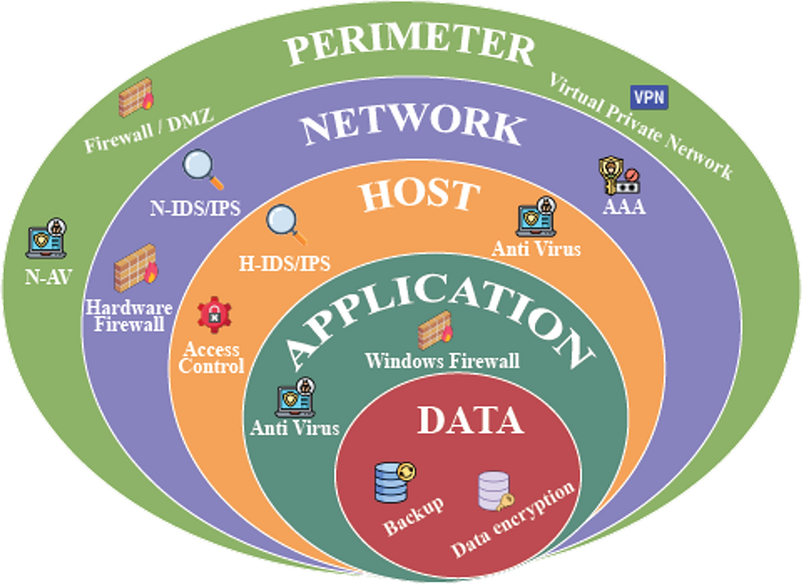
Diagram 2: Layered security, or defence-in-depth, involves multiple security measures to protect information across various layers.
Key Layers:
- Perimeter Security: Firewalls, intrusion detection/prevention systems.
- Network Security: VLANs, network segmentation.
- Endpoint Security: Antivirus, endpoint detection and response.
- Application Security: Secure coding practices, application firewalls.
- Data Security: Encryption, data masking.

1 Identity and Access Management Access management is essential, with BYOD likely to be the model adopted by NG. NG should implement Multi-Factor Authentication (MFA), which combines a user thinks they know (password), they have (mobile token), and they are (biometrics).
A Role-Based Access Control (RBAC) should be implemented, which permits access based on job responsibilities to reduce the amount of unnecessary data that individuals can access. This access should be restricted by regularly reporting on accounts and access use audits. Together, these processes will enable NG to utilize the least privilege principle.
2 Network and Wireless Security Given that 95% of NG's environment is wireless, complete wireless security is necessary, which includes:
• WPA3 encryption for all wireless connections
• MAC address whitelisting
• No SSID broadcasting for all internal networks
• Physically limit the wireless signal range
• Network Access Control (NAC) which monitors, and quarantines any non-compliant devices for reporting and remediation
NG should also adopt a demilitarized zone (DMZ) architecture to separate all external-facing systems (secure web servers, social media web connectors, etc.) from their core infrastructure. Firewalls must utilize stateful packet inspection, include intrusion prevention functions.
3 Intrusion Detection and Prevention Systems (IDPS) Host-Based (HIDPS) and Network-Based (NIDPS) systems will need to be implemented.
• NIDPS will monitor inbound and outbound traffic patterns and report any anomalies
• HIDPS will monitor their cloud-based assets, and identify any unauthorized access and configuration changes
4 Compliance and Legal Aspects
• GDPR, ISO/IEC 27001, UK Cyber Essentials and local data protection laws
• Third-party SLAs with defined roles and responsibilities, security requirements, audit rights and timeframes for response

Risk Assessment and Management
Threat | Likelihood | Impact | Controls
BYOD Data Leakage | High | High | NAC, MDM, Role-Based Access Control
Cloud Service Breach | Medium | High | Strong SLAs, VPN Tunnels, Cloud Access Auditing
Insider Misuse | Medium | High | Least Privilege Access, Logging, User Monitoring
Phishing and Social Eng. | High | Medium | Security Awareness Training, MFA, Email Filters

Critical Evaluation
The Importance of Evolving Cybersecurity Standards
The ever-changing cyber threat environment. For practitioners, adversaries are integrating artificial intelligence, enhancing social engineering techniques and utilizing ever more sophisticated malware. Meaning, static and old security policies are not good enough. At NatureGarden (NG) we need to align with emerging cybersecurity frameworks and processes to remain ever resilient.

Diagram 3: Risk Matrix (Likelihood vs Impact)
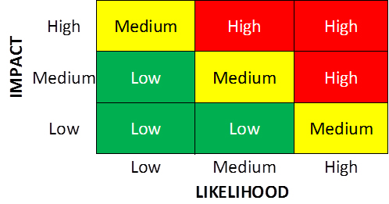

Diagram 3: A risk matrix will help you understand, assess and prioritize risks based on how probable risk factors influence potential impact (benefit or harm).
- Likelihood: Chance of a risk occurring.
- Impact: Impact when risk occurs.
1 Responding to emerge threats
NIST and ISO/IEC 27001 have evolved over time to reflect the challenges of cloud security, remote works and advanced persist threats (APT). NG needs to systemically monitor and recognize updates to either standard. As an example, in the ISO/IEC 27001 2022 revision added two new controls specifically concerned with threat intelligence, physical monitoring and secure software development are these not a good fit for any organization that supports BYOD users in cloud dependent work practices.
In addition, with the continual logistics of ransomware, phishing-as-a-service, zero-day exploits the best defence is a proactive defence. And new defensive tools like endpoint detection and response (EDR), zero trust architecture and automated threat model have become mainstream tools available for organizations. Greater considerations will need to be made around moving away from a perimeter security model to a more dynamic, identity-based security model.
2 Benefits of implementation of new standards
• It strengthens organizational resiliency as the onboarding of new controls and capabilities helps improve the organization’s ability to detect and respond to new threats.
• It ensures compliance with regulators. Updated standards will assist organizations to continue to comply with regulations (related to cyber security) such as GDPR and HIPAA which could help, in regards to compliance, avoid financial (legal) penalties as well as reputational risks and other risks associated with compliance.
• It promotes business continuity. When organizations have whole systems that are continuously updated, it leads to improved ongoing service availability, and therefore ongoing trust of those receiving or relying on those services.
• It builds trust with stakeholders. Investors, clients, regulators, and other stakeholders tend to have higher levels of trust and confidence in organizations that have a modern cybersecurity program that has been externally audited.
3 Barriers to adoption the implementation of new standards, despite the benefits, is not without challenges, which include:
• Cost: Implementation of new tools and trained resources takes time and resource investment.
• Cultural barriers: Employees can resist changing decades-old processes.
• Integration: Legacy infrastructure may not be compatible with new controls.
NG needs to build a flexible model of governance and incident response, and foster an organizational culture of security first, starting from the leadership and permeating through all levels of the organization.

Conclusion
This report has described the holistic way to improve NatureGarden's cybersecurity posture utilizing two international frameworks (NIST Cybersecurity Framework and ISO/IEC 27001). It has demonstrated how these models can help mitigate the expanded risk around cloud technologies, wireless networks, and BYOD policies.
The proposed multi-layered architecture implements a defence-in-depth strategy based on NG's context. The guidance provided in this report on areas such as identity and access management, encryption, wireless security, and contingency planning includes a mix of best practice and practice solutions based on the Week 7 & 8 lecture content.
The emphasis for a critical evaluation included the importance of flexibility. Security controls must be flexible as the threats are ever evolving. This can only happen with commitment to not just implementation sub-systems, but also continuous education and education, and policies that will need to change as per the adaptions in the framework itself.
NatureGarden's significant investment in people, process, and technology can see them using structured frameworks (NIST & ISO) to their fullest extent to safeguard its digital assets, meet compliance commitments and build trust with customers and partners.

References
[1] National Institute of Standards and Technology, “Framework for Improving Critical Infrastructure Cybersecurity,” NIST, Apr. 2018.
Available: https://nvlpubs.nist.gov/nistpubs/CSWP/NIST.CSWP.04162018.pdf
[2] ISO/IEC, “ISO/IEC 27001:2022 Information Security Management Systems — Requirements,” International Organization for Standardization, 2022.
Available: https://www.iso.org/standard/82875.html
[3] European Union, “General Data Protection Regulation (GDPR),” 2016.
Available: https://gdpr.eu
[4] ENISA, “ENISA Threat Landscape 2023,” European Union Agency for Cybersecurity, 2023.
Available: https://www.enisa.europa.eu/publications/enisa-threat-landscape-2023
[5] UK National Cyber Security Centre (NCSC), “Cyber Essentials,” 2024.
Available: https://www.ncsc.gov.uk/cyberessentials/overview
[6] K. Scarfone and P. Mell, “Guide to Intrusion Detection and Prevention Systems (IDPS),” NIST Special Publication 800-94, May 2007.
Available: https://nvlpubs.nist.gov/nistpubs/Legacy/SP/nistspecialpublication800-94.pdf
[7] M. E. Whitman and H. J. Mattord, Principles of Information Security, 6th ed., Cengage Learning, 2019.
Official page: https://www.cengage.com/c/principles-of-information-security-6e-whitman/
[8] OWASP, “OWASP Top Ten Security Risks,” Open Web Application Security Project, 2021.
Available: https://owasp.org/Top10/
[9] S. Nakamoto, “Bitcoin: A Peer-to-Peer Electronic Cash System,” 2008.
Available: https://bitcoin.org/bitcoin.pdf

