BMSP6002
Digital Business
Assignment 2
Nia-Mai Hopcroft
2003405

Context Page

- Introduction,
- Airbnb landscape,
- Business model canvas
- Strategic Formulation Framework
- Tools / systems (ERP, CRM, SCM)
- Conclusion
- References

Introduction
In this report, I aim to analyse Airbnb through their business model canvas, financial landscape, strategic formulation framework, and the tools and systems Airbnb use to be successful and recommendations for Airbnb for future growth. Instead of staying in a hotel, Airbnb lets you stay in someone's home. The properties are not owned by Airbnb. Essentially, it serves as an intermediary between those seeking to rent space and those seeking to rent space. Airbnb has is a very popular business which is used all around the world including 220 countries with over 5.6 million listings of properties. (Erika Rawes, Tyler Lacoma, 2021) It goes without saying that Airbnb is one of the world's most successful travel technology companies in the last decade. In addition to ideal timing, solid execution, reinvestment of profits, and several rounds of outside investment, its success can be attributed to many factors. (Zaidi, 2022)
Airbnb’s Landscape
In this component of my assignment, I will be understanding Airbnb’s financial landscape and how Airbnb has evolved over the years. Financial landscape does interpret many old and new risks within any business. It all depends on the sharing economy around the world. A wide acceptance that the poor, like others, need and use a variety of financial services for a number of purposes has been influenced by events that affect financial services for the poor. One modification has been a change from a tight focus on the institution and its performance to a much broader focus on clients—understanding their behaviour, their demands for financial services, and how different providers might better address these needs. (Joanna Ledgerwood, Alan Gibson, 2013)
For the quarter that ended September 30, Airbnb's net income increased 46% year over year to $1.2 billion, representing its highest-ever quarter. According to CEOs, hosts who joined Airbnb before the pandemic have remained "as strong, if not even stronger" in terms of "stickiness" and "engagement." Airbnb's numbers may astound analysts who believed extended stays of a month or more would be a temporary blip. (o'neill, 2022)
It is a question of how Airbnb is so successful from using other individual’s properties to gain their financial success. There are many research topics involved concerning Airbnb’s pricing. According to studies, Airbnb hosts lose roughly 50% of additional income as a result of ineffective pricing. This finding is mostly explained by the fact that hosts have difficulty determining their fees. Airbnb has made tools for hosts to enhance their pricing procedure in order to resolve this issue. Teruel-Gutierrez, & Maté-Sánchez-Val, M. (2021)
Airbnb was founded in 2008 however in 2011 over 1 million user-booked nights on Airbnb were completed. A year later, in January 2012, they had 5 million reservations, and in June 2012, they had 10 million. HotelTonight was purchased by Airbnb in 2019 for $400 million. In 2011, Airbnb started to expand internationally, and this is when it really started to gain traction. Airbnb served as the Rio Olympic Games' official alternative lodging provider in 2015. (Deane, 2022)
Covid-19 has impacted the sharing economy’s financial landscape. It provides a basic understanding of the sharing economy in the context of smart tourism cities through the convergence of information technology innovations, business models, and touristic experiences which is a prime case for Airbnb as they provided an idea of ‘smart tourism’ for example Airbnb is a tremendous idea of a successful business because they came up with the idea of using technology to make a website for anyone to use and rent out their space. Yi, Yuan, G., & Yoo, C. (2020).
During the covid-19 pandemic all travel was standstill, which defiantly impacted the business Airbnb. The pandemic left many individuals out of jobs and Airbnb wouldn’t have been able to pay their hosts because they lost out on business all over the world. However, Airbnb could have been useful for healthcare workers that left their homes to keep their families safe however it couldn’t have been a substantial income for the hosts. 41% of hosts now temporarily augment their income with another job or source of income as a result of these revenue reductions. In addition, hosts have become creative with their homes, giving month-long stays in 47% of cases and offering discounted rates to first responders and other front-line staff members, such as medical professionals. For three, six, or twelve-month rentals, some hosts listed their properties through Zillow, Craigslist, or Apartments.com which led to Airbnb losing custom. (Lane, 2020)
Airbnb’s Business Model Canvas
Managers can design and visualise their business models using the business model canvas, a strategic planning tool. The fundamental components of a firm are clearly identified by the business model canvas template. It condenses a business plan into a more manageable size. (Team, 2022)
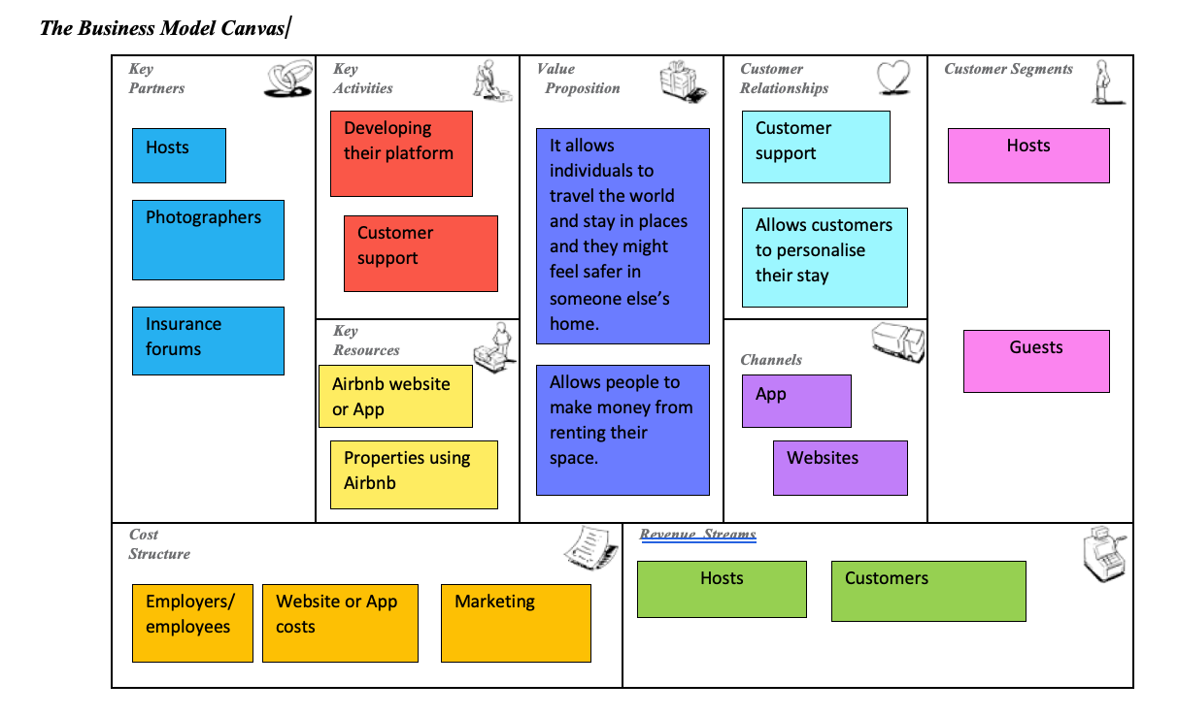
Investors
Adapted from (Pereira, 2022) and (Oakley, 2018).
- Key Partners: Key partnerships within Airbnb would be the individuals involved with production or problem-solving platforms for example hosts, professional photographers to take picture of the space hosts would like to rent out, insurance forums for Airbnb to use to protect their hosts and guests and investors within Airbnb. Key partnerships also involve the suppliers and partners that let Airbnb run their successful business for example the hosts using Airbnb to rent out their properties.
- Key Activities: This is a very important part of the company must do to keep their business safe and how it makes their business model triumphant for example they must keep up to date with any technological changes like upgrades to their software system like updates on their app to keep their customers and hosts using their business.
- Key resources: Key resources are assets required to offer and deliver different elements for example the key resources for Airbnb would be their computer software used within their business for their website and app for hosts and guests to use which provided them with an uncomplicated way to book their stay at hosts properties. If their computer software has any problems, it leads to there being uses within hosts being able to advertise their properties and guests being able to book their accommodation.
- Value Proposition: Value proposition is regarding the seek to work out customer issues and assure their customer needs. Airbnb would use value proposition within their business by providing all kinds of accommodation for their guests to stay around the world, also they would provide customer service staff to help hosts and guests with any problem they might have whether it being a technical issue or an issue within their booking.
- Customer Relationships: Customer relationships is about how to accept and maintain each customer segment for example Airbnb would have many different segments for their business to run successfully. They could have customer service sections to help with any booking issues for customers.
- Channels: there are many different channels used within business model canvases for example sales forces, web sales and partner sites. Airbnb would use partner sites to analyse the prices of each location and suggest a recommended price for hosts to advertise their property for customers. Web sales would be used within Airbnb when they look at the time of year is most popular for individuals to book certain countries. Sales forces within Airbnb would be employees persuading customers on where to stay and giving them advice on the properties on the Airbnb website.
- Customer segments: there are many different parts to customer segments for example, mass marketing, niche markets, segment diversified and multi sided platforms. Airbnb does use multi sided platforms for example their website and apps for hosts and customers to book and advertise and also, they use social media platforms to advertise their company for example an advert on Facebook while scrolling through the feed.
- Cost structure: This structure within the business model canvas is about cost-driven and value driven cost structure. Fixed costs for Airbnb would be the rental leases and payments for hosts whereas variable costs for Airbnb are the services that they provide for customers.
- Revenue streams: Revenue streams are made up from value proposition provided to customers, sales, usage fees and subscription fees. Airbnb would use revenue streams for usage fees and sales made from their company.
Strategic Formulation Framework
Strategic formulation framework is a tool that can be used during specific stages of the strategic management cycle, most commonly during the formulation and evaluation of strategies. A strategic framework involves categorizing your goals into different groups. Choosing a framework for your plan can help you stay focused on your objectives. It adds clarity to your strategic procedures and gives you the ability to manoeuvre through the chaos of reality. There are many different strategic frameworks. (Wright, 2022)

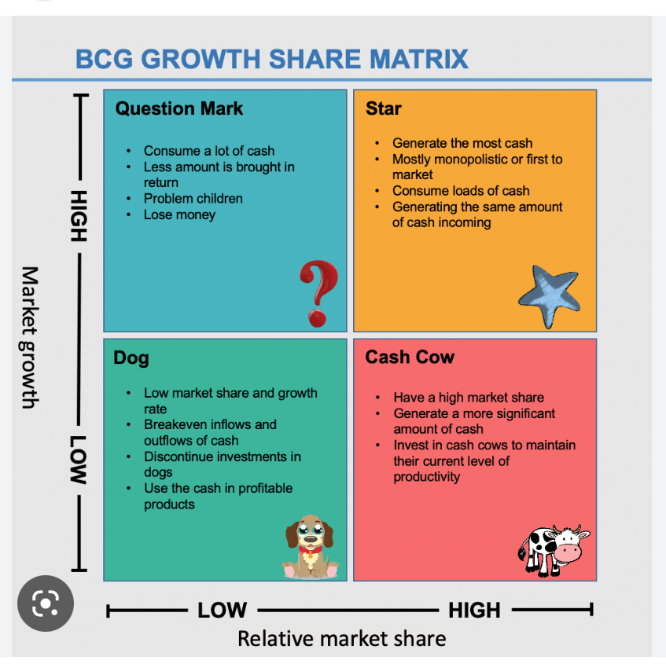
Adapted from (Boston, 2020)
I have decided to place Airbnb as a business within the Boston Consulting Group Matrix growth share matrix in Star because Airbnb does generate a lot of money within the travel industry and is monopolistic and one of the first people to the market. Airbnb does have high market growth and high relative market share.
There are many benefits and limitations within the Strategic Formulation Framework. It allows businesses to analyse their business and plan how they can be successful and what part of the market they can put themselves in for future reference. Business is a complex idea. One year a company may be doing well, the next it may be in debt. Organizations that lack a solid foundation, concentration, and vision will struggle to catch the next wave in an environment where industries and global marketplaces are continuously shifting. Using the SFF can allow businesses to be dependable. (Ong, 2015)
The limitations of using the strategic formulation framework would be it can be very time consuming for businesses like Airbnb to make and follow matrixes like the BCG growth share matrix and the Grand Strategy Matrix. It could also be excessive in costings to create these different types of matrix because Airbnb would have to pau their staff to create these matrixes and have staff that understand them to ensure they are following the right SFF.
Grand strategy matrix

An American management theorist Paul Joseph DiMaggio developed the grand strategy matrix in 1980. The matrix was initially employed by managers as a tool for making strategic decisions and first appeared in the Strategic Management Journal. Based on their competitive position and the expansion of their industry, firms can design workable alternative plans with the help of the grand strategy matrix. (Cuofano, 2023)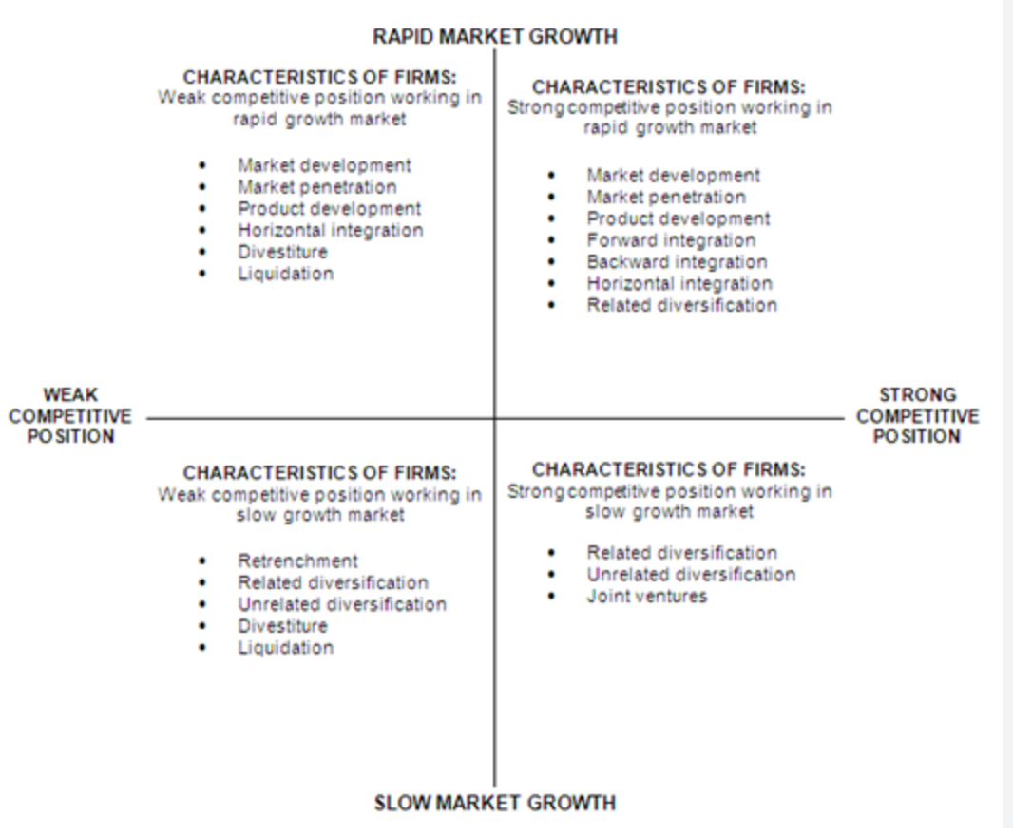
Adapted from (Kasi, 2010)
I have placed Airbnb in the second quadrant which is strong competitive position working in rapid growth market because Airbnb is a very successful business. Their market development is always improving, and they are gaining more and more success every year. Airbnb has good market penetration be4cause they came up with an idea nobody else had which was an easy way for individuals to make money and for customers to book accommodation all around the world. Airbnb uses forward integration as a business strategy to use their product (their website) to expand their business further in future.
If Airbnb did use the Grand Strategy Matrix, it would help them analyse their success and allow them to look at their competitors and use the matrix to examine how they can develop as a company and raise future growth. The limitations to these matrixes would be how time consuming they are to make, and they would need professionals to make these matrixes for Airbnb which Airbnb might think what is the point paying that money when they are already so successful in the travel industry.
Tools/ systems
There are many different tools and systems to help Businesses be successful. It can range in different ways within Digital Business. The main Tools and systems I am going to focus on are Enterprise resource planning system, customer relationship management and supply chain management system. There can be social aspects to tools and systems within digital business for example podcasts, blogs, videos, social media networks and professional posting sites like LinkedIn.
Enterprise Resource Planning systems
ERP refers to a system of integrated applications that helps organizations manage finance, human resources, procurement, distribution, and supply chain activities. A business management system (ERP) integrates all the business processes required to run a company into one system that also facilitates resource management. (Perkins, 2022)
Airbnb could use Enterprise resource planning in their business to manage the different aspects of their company for example finances and human resources. ERP is in the background within businesses but is very important in all businesses. Airbnb I would say is very advanced within ERP because rely a lot on technology for their business and the future of ERP would be all their business aspects being online to free up space and business intelligence expanding over time.
Customer relationship Management
In a business, customer relationship management (CRM) refers to managing all business relationships and interactions with clients, current and prospective. Its goal is straightforward: to foster stronger commercial ties. This approach aids in streamlining business procedures, increasing productivity, and maintaining client relationships. (Sydorenko, 2022).
CRM would be used within Airbnb when they select their target groups for their business. CRM is very important for a business like Airbnb because they rely on good relationships with hosts and guests and for guests to leave good reviews about Airbnb and the hosts which makes good customer relationships and encourages more individuals to use Airbnb in future.
Peer to Peer could be used within customer relationship management because it is related to customers for example peer to peer – customer to customer.
Supply Chain Management Systems
An Supply Chain Management system is the software your business employs to control the flow of materials, information, and resources for any product or service you sell, from the acquisition of raw materials to final delivery. In order to transform raw materials into finished, customer-ready products, a supply chain consists of an organization and a facility that work together. In supply chain management (SCM), all of these activities are controlled by inter-organizational solutions.
Airbnb’s supply chain management system is a business function that correlates all the networking sites for Airbnb which would be their website and app. Their SCM system wouldn’t be as big as other major companies because they are mainly technological however it does have some SCM systems like hosts, guests, photographers, and individuals who work within Airbnb.
Conclusion
During this report I have analysed the major sections I have learnt during the digital business module. I have created a business model canvas for Airbnb and examined how Airbnb could use these useful techniques within their business to gain future growth.
The recommendations I would like to make would be for Airbnb to use a business model canvas in future because I found that it was very helpful to look at Airbnb in that way within their business and it would make it easier for them as a company. I would also like to recommend Airbnb to look at their financial landscape in future for market share growth nonetheless they are a very successful company, and they can grow much more in the future.

References
CFI Team (November 2022) Business model canvas template, the executive summary of a business. https://corporatefinanceinstitute.com/resources/management/business-model-canvas-template/
Cuofano, Gennaro (January 2023) What is a grand strategy matrix? The GSM in a nutshell. Received from https://fourweekmba.com/grand-strategy-matrix/
Deane, Steve (January 2022) 2022 Airbnb Statistics: usage, demographics, and revenue growth. Received from https://www.stratosjets.com/blog/airbnb-statistics/
Hederson-Boston, Bruce (February 2020) Make wiser investing decisions BCG growth share matric – explained with examples. Received from https://bstrategyhub.com/make-wiser-investing-decisions-bcg-matrix-explained-with-examples/
Kasi (December 2010) Grand Strategy Matrix. Received from https://mba-tutorials.com/grand-strategy-matrix/
Lane, Lea (June 2020) How bad are covid-19 pandemic effects on Airbnb guests, hosts? Received from https://www.forbes.com/sites/lealane/2020/06/09/how-bad-are-covid-19-pandemic-effects-on-airbnb-guests-hosts/
Ledgerwood, Joanna et all (February 2013) the evolving financial landscape. https://elibrary.worldbank.org/doi/10.1596/978-0-8213-8927-0_ch1
O’Neill, Sean ( November 2022) Airbnb posts best quarter yet relentless on travel demand. Received from https://au.finance.yahoo.com/news/airbnb-posts-best-quarter-yet-221000416.html?guccounter=1&guce_referrer=aHR0cHM6Ly93d3cuZ29vZ2xlLmNvLnVrLw&guce_referrer_sig=AQAAADWy8Aa58BdQ2eWljiF5UxMZm2HE1S2QT6iL8XNTd9H0Ikp5aingmCLtl-qeV8QNdK0e1X6HyKpkRThefDWZCOH7o_KxP4cdXAqQue0FKWZyZ0JDC8rN2jiaYLqVuac1qkiY5VLuNoC8ldJ-uFSTioXx3H4gLqVTDFzXhGO8Ymh1
Oakley, Denis (October 2018) what is airbnb’s business model? Received from https://www.denis-oakley.com/what-is-airbnbs-business-model/
Ong, Cara (January 2015) 5 benefits of strategic planning. Received from https://envisio.com/blog/benefits-of-strategic-planning/
Pereira Daniel (July 2022) Airbnb business model. Received from https://businessmodelanalyst.com/airbnb-business-model/
Perkins, Bart (September 2022) What is ERP? Enterprise resource planning systems explained. Received from https://www.cio.com/article/272362/what-is-erp-key-features-of-top-enterprise-resource-planning-systems.html
Rawes, Erika et all (December 2021) What is Airbnb? What to know before becoming a guest or host. Received from https://www.digitaltrends.com/home/what-is-airbnb/#dt-heading-airbnbs-origins
Sydorenko, Natalie (September 2022) what is customer relationship management (CRM). Received from https://snov.io/glossary/customer-relationship-management-crm/
Teruel-Gutierrez, & Maté-Sánchez-Val, M. (2021). The impact of Instagram on Airbnb’s listing prices in the city of Barcelona. The Annals of Regional Science, 67(3), 737–763. https://doi.org/10.1007/s00168-021-01064-z
Wright, Tom (April 2022) The 5 best strategic frameworks for your organisation. Received from https://www.cascade.app/blog/best-strategy-frameworks
Yi, Yuan, G., & Yoo, C. (2020). The effect of the perceived risk on the adoption of the sharing economy in the tourism industry: The case of Airbnb. Information Processing & Management, 57(1), 102108–. https://doi.org/10.1016/j.ipm.2019.102108
Zaidi, Taz (October 2022) What Is Airbnb? [How It Works, Makes Money, FAQ] received from https://trvlguides.com/articles/what-is-airbnb

