LEVEL 7 ASSESSMENT

Research Methods and Professional Development

ACFA7004

Student name: L. Sai Vishnu Vardhan
Student ID number: 2412185
Table of Contents
1. Introduction 2
1.1 Context and Background 2
1.2 Research Problem 3
1.3 Research Aim and Objectives 3
1.4 Significance of the Research 4
2. Literature Review 5
2.1 Machine Learning Approaches for Fraud Detection 5
2.2 Explainable Artificial Intelligence (XAI) in Fraud Detection 5
2.3 Cost-Sensitive Learning in Fraud Detection 6
2.4 Integration of Explainability and Cost Awareness 7
2.5 Literature Gap 7
3. Research Methodology 8
3.1 Research Approach 8
3.1.1 Research Philosophy – Positivism 8
3.1.2 Research Approach – Deductive 8
3.1.3 Research Strategy – Experimental 8
3.1.4 Research Choice – Quantitative 9
3.1.5 Time Horizon – Cross-Sectional 9
3.2 Research Methods and Materials 9
3.2.1 Dataset Selection and Preprocessing 9
3.2.2 Model Selection and Cost Sensitivity 9
3.2.3 Explainability with SHAP 10
3.2.4 Evaluation Metrics 10
4. Expected Outcome 11
4.1 Anticipated Results 11
4.2 Practical Implications 11
4.3 Academic Contribution 12
4.4 Limitations 12
4.5 Risk Mitigation 12
5. Timeline 13
Timeline Table : 13
6. References 14

1. Introduction

1.1 Context and Background
Financial fraud remains a big issue in the modern digital economy, with organisations facing billions in losses owing to illegal or dishonest transactions annually. As the scope of financial services develops and transaction patterns become more complex, existing rule-based fraud detection systems are proving ineffective due to their limited adaptability and high false positive rates [1]. Consequently, machine learning (ML) approaches have grown popular in fraud analytics because they can analyse massive volumes of transactional data and uncover non-obvious, non-linear fraud trends [4].
Among these, ensemble models like Random Forest and XGBoost have proven solid performance in fraud classification tasks. These models effectively handle complicated feature interactions and reduce overfitting, making them suited for real-time fraud detection applications [1], [5]. However, such models are often attacked for their lack of interpretability, as they operate as black-box systems that provide limited visibility into the rationale behind their predictions [3].
To solve this, explainable artificial intelligence (XAI) approaches such as SHapley Additive exPlanations (SHAP) have been introduced. SHAP assigns a contribution value to each feature in a prediction, helping decision-makers to grasp the reasoning behind the model’s outputs [3]. LIME, another prominent method, constructs local surrogate models to deliver instance-level explanations. These strategies have been applied to fraud detection systems to promote transparency and support regulatory compliance [2], [10].
While explainability helps make ML predictions more transparent, another crucial part of fraud detection is financial cost optimisation. Cost-sensitive learning tries to lower the overall financial loss by penalising false positives and false negatives based on their impact [6], [11]. For example, a false negative could result in a direct monetary loss, whereas a false positive could undermine customer trust and experience. However, most ML models currently focus exclusively on accuracy, overlooking the cost consequences of categorisation errors [11].
Although cost-sensitive models have shown potential, they are generally built outside of explainability frameworks. As a result, there is limited research that merges cost-based optimisation with XAI approaches to build fraud detection systems that are both economically efficient and interpretable [12]. This study intends to overcome that gap by building a fraud detection framework that blends cost-sensitive learning with SHAP-based visual explanations.

1.2 Research Problem
Despite substantial breakthroughs in ML and XAI, current fraud detection systems still face practical limits. First, most high-performing ML models lack transparency, making it difficult for fraud analysts and compliance officers to comprehend or defend automated judgements [3], [10]. As fraud detection sometimes includes high-stakes decision-making, institutions want models that provide clear, interpretable reasoning.
Second, there is a gap between model projections and their financial consequences. Many present systems try to maximise overall accuracy or F1-score but fail to integrate cost dynamics such as the difference in financial impact between false positives and false negatives [6], [11]. Even when cost-sensitive learning is applied, it is rarely linked with user-facing explainability tools.
Furthermore, explainable methods like SHAP and LIME are often employed for analysing feature influence but not for quantifying cost outcomes. Few studies attempt to illustrate how the interpretation of a prediction relates to its economic implication for the institution [9], [12]. This reduces the credibility and utility of ML systems in real-world fraud operations.

1.3 Research Aim and Objectives
Aim: To create and evaluate a cost-sensitive and interpretable machine learning model for fraud detection by SHAP based cost-optimised training approach and evaluate performance using relevant classification and financial indicators.
Objectives:
- To design, implement and test a cost-sensitive machine learning model utilising Random Forest and XGBoost for fraud detection on a publically available transaction dataset.
- To employ SHAP (SHapley Additive Explanations) to understand the model predictions and produce user-friendly visual explanations for fraud categorisation.
- To evaluate the model performance utilising accuracy, recall, F1-score, AUC, and predicted cost-savings by simulating alternative threshold values.

1.4 Significance of the Research
The significance of this research rests in its new integration of explainability and cost-awareness in fraud detection. By combining SHAP with cost-sensitive learning, the proposed approach not only predicts fraudulent activity but also delivers interpretable insights into how these predictions effect financial outcomes [3], [6]. This can boost institutional trust in AI systems and enable better decision-making processes.
Furthermore, the project presents a lightweight, student-implementable framework using Jupyter and Python libraries, making it accessible to researchers and small institutions without requiring significant infrastructure [1], [3], [12]. Unlike existing models that focus on prediction accuracy in isolation, this work adds to the creation of a comprehensive fraud detection system that is technically strong, financially conscious, and openly explainable.
Finally, this research tackles a major literature gap: the lack of fraud detection systems that connect feature-level explanations to cost-based outcomes. It provides a platform for more accountable AI systems that can help both operational and strategic decision-making in fraud analytics [10], [12].

2. Literature Review

2.1 Machine Learning Approaches for Fraud Detection
Financial fraud detection has seen substantial progress with the implementation of machine learning (ML) approaches. Traditional systems, dependent on static rule-based algorithms, often fail to keep up with developing fraud practices and typically result in high false positive rates [1]. ML models, particularly ensemble-based classifiers like Random Forest and XGBoost, have gained appeal for their capacity to process massive transaction datasets, handle non-linearity, and enhance fraud detection accuracy [1], [5].
Random Forest is preferred for its simplicity, resistance to overfitting, and capability to deal with noisy data, while XGBoost is generally acknowledged for its gradient boosting efficiency and performance scaling [5]. Both techniques have shown superior performance compared to standard classifiers such as logistic regression and decision trees in various fraud detection situations [4], [6].
Some researchers have also examined deep learning models such as CNNs and RNNs to detect complicated fraud patterns, notably in sequence-based transactional data [8]. However, despite great predictive accuracy, deep models frequently suffer from poor interpretability and high resource needs, restricting their real-time use [7].
A significant problem in using ML to fraud detection is the imbalanced nature of datasets, where illicit transactions comprise a small percentage. Though some research have utilised resampling algorithms or class weighting to address this, the underlying evaluation remains focused on accuracy, F1-score, or AUC—neglecting the real-world financial penalty associated with different forms of misclassifications [4], [6].

2.2 Explainable Artificial Intelligence (XAI) in Fraud Detection
As ML systems expand in complexity, the demand for interpretability has increased, especially in sensitive industries like banking. Explainable Artificial Intelligence (XAI) strategies aim to make model predictions intelligible for human users. Among these, SHapley Additive Explanations (SHAP) and Local Interpretable Model-Agnostic Explanations (LIME) are frequently employed in financial applications [3], [10].
SHAP values are grounded in cooperative game theory and allocate the contribution of each feature to a given prediction. In fraud detection, SHAP has been used to explain feature importance across multiple ML models, including XGBoost and neural networks [3]. For instance, in a recent study, SHAP successfully recognised transaction amount, location, and time of transaction as important fraud indicators across several datasets [10].
LIME works by perturbing the input data and developing an interpretable model around each prediction. It has been employed in fraud detection scenarios to provide local explanations, especially in black-box models such as deep neural networks [3], [9]. However, LIME’s rely on random sampling and sensitivity to input perturbation sometimes lead to inconsistent outcomes in crucial domains like banking [9].
While XAI techniques promote transparency and regulatory compliance, they are generally adopted post hoc and in isolation from the model's learning objectives. This results in explanations that are descriptive but not always actionable in terms of company strategy [10]. There is a rising need to integrate explainability into the model design, especially where forecasts influence decisions including financial risk.

2.3 Cost-Sensitive Learning in Fraud Detection
One of the key drawbacks of traditional ML classifiers in fraud detection is the assumption that all misclassifications are equally meaningful. In practice, the financial impact of a false negative (fraud undiscovered) is often significantly bigger than a false positive (legal transaction incorrectly identified) [6], [11].
Cost-sensitive learning (CSL) tackles this by changing model training to account for misclassification costs. This is achieved either by changing the loss function, applying cost matrices, or introducing instance-dependent cost logic [6], [11]. Some contemporary approaches include dynamic cost-sensitive learning, where costs are computed per instance based on its risk profile and transactional features [11].
In one prominent study, instance-dependent cost modelling was merged with XGBoost to reduce total financial loss owing to misclassification, exceeding baseline classifiers in cost-efficiency [11]. However, despite technical developments, most CSL models remain difficult to interpret and are rarely linked to stakeholder decision-making processes.
Furthermore, many fraud detection systems approach cost-sensitive learning and explainability as independent processes. This fragmentation limits the operational value of the system—analysts may comprehend feature influence (via SHAP), but cannot connect this influence to actual cost impact [11], [12]. There remains a crucial need to develop fraud detection models that are not just cost-aware but also explainable in ways that reflect financial logic.

2.4 Integration of Explainability and Cost Awareness
While SHAP and CSL have independently showed potential in improving fraud detection systems, very few research attempt to incorporate them into a cohesive framework. Existing XAI research typically focus on feature ranking or sensitivity analysis, without tying these outputs to operational results like cost reduction or financial justification [3], [10], [12].
Recent efforts like SEFraud and LIOCAD offer partial answers by integrating graph-based anomaly detection or one-class models with interpretability layers [9], [12]. However, they stop short of linking those arguments to simulated or genuine company loss. Similarly, while federated learning frameworks offer greater privacy and some degree of decentralised explainability, their integration with cost-sensitive techniques is yet to mature [2].
This divergence not only lowers the usability of fraud detection technologies but also weakens stakeholder confidence. Financial institutions want interpretable data that explain not simply how a choice was taken, but also why that decision helps save money or avert loss. Without this relationship, the operational utility of ML models is substantially reduced.

2.5 Literature Gap
Although machine learning and explainable AI systems have improved tremendously in fraud detection, a crucial gap remains at their interaction with financial reasoning. Most present systems either focus on accuracy or interpretability but do not explain how those predictions decrease or increase financial loss. While SHAP can show which features lead to a forecast, few models translate that explanation into cost-saving insights for decision-makers [3], [10], [12].
Furthermore, current CSL models lack transparency. Even when cost-sensitive logic is employed, analysts are often left with numerical conclusions that do not explain the why behind a decision. Very few research provide a clear visual or numerical relationship between model explanations and the simulated financial impact of fraud predictions [11], [12].
This research tackles that gap by presenting an explainable and cost-aware fraud detection approach. The system merges SHAP-based feature attribution with instance-level cost simulation to provide more transparent, trustworthy, and financially informed decisions. By analysing both model accuracy and cost consequences inside an interpretable interface, the study seeks to make fraud detection not just smarter, but also more actionable for financial stakeholders.

3. Research Methodology
This section discusses the conceptual, strategic, and procedural aspects of the proposed investigation. It follows the study Onion model developed by Saunders et al., aligning each methodological choice with the study objectives and practical execution plan. The project is fully quantitative, focused on constructing a fraud detection model that is both cost-sensitive and interpretable using SHAP.

3.1 Research Approach
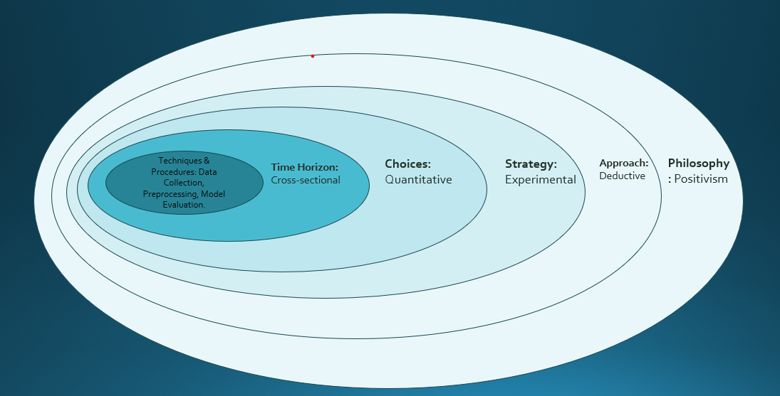
Fig. 3.1 “Soundar’s Research Onion”

3.1.1 Research Philosophy – Positivism
This research uses a positivist perspective, which is appropriate for data-driven experiments where reality is quantified by observable and quantifiable data. Fraud detection is an objective problem with obvious consequences (fraud vs. legitimate), making this philosophy suited for creating statistically verified models [4].

3.1.2 Research Approach – Deductive
The work follows a deductive method, starting with a review of current ideas (cost-sensitive learning and explainable AI) and using them to develop hypotheses and models. These models are tested using open-source transaction datasets to validate or reject assumptions relating to performance, interpretability, and financial cost [6].

3.1.3 Research Strategy – Experimental
An experimental strategy is adopted to test the effect of algorithmic changes (e.g., SHAP, cost-weighting, threshold tuning) on fraud classification performance. This includes controlled experimentation with multiple models, parameters, and performance metrics [1], [5].

3.1.4 Research Choice – Quantitative
The study is purely quantitative, using numerical measures such as precision, recall, AUC, and simulated cost metrics. There is no qualitative input from users or organisations.

3.1.5 Time Horizon – Cross-Sectional
This is a cross-sectional study, analysing a static dataset at a single point in time. The objective is to extract actionable insights and evaluate the proposed model using a snapshot of financial transaction data [6].

3.2 Research Methods and Materials

3.2.1 Dataset Selection and Preprocessing
The project will use a publicly available transaction dataset. These datasets contain labelled data with features like transaction amount, time, device type, and customer metadata.
Data preprocessing steps will include:
- Handling missing values
- Encoding categorical features (e.g., One-Hot Encoding)
- Feature scaling using standardisation
- Splitting into training and test sets (80:20)
- Optional undersampling or weight adjustments for class imbalance

3.2.2 Model Selection and Cost Sensitivity
Two ensemble models will be implemented:
- Random Forest: known for robustness and interpretability
- XGBoost: recognised for speed and boosting-based performance [1], [5]
Both models will be adapted for cost-sensitive learning by:
- Assigning higher misclassification penalties to false negatives
- Tuning decision thresholds to optimise F1-score and cost impact
- Optionally applying class_weight or customised cost matrices [6], [11]
This approach allows the model to minimise total financial loss, not just improve statistical accuracy.

3.2.3 Explainability with SHAP
Once trained, both models will be interpreted using SHAP (SHapley Additive Explanations) to visualise:
- Global feature importance across the dataset
- Local explanations for individual fraud predictions
- Force plots and decision plots to support interpretability [3], [10]
SHAP values will also be connected to simulated financial cost outcomes:
- How much did each feature increase/decrease fraud probability?
- What was the expected cost impact of each decision?
This links technical transparency with practical decision support for fraud analysts.

3.2.4 Evaluation Metrics
Performance will be assessed using a combination of classification and cost-based metrics:
Metric | Purpose
Precision | How many flagged frauds were actually fraud?
Recall | How many real frauds were correctly flagged?
F1-Score | Balance between precision and recall
AUC-ROC | Overall discriminative ability
Cost Savings Estimate | Simulated loss reduction using a custom formula
Cost simulation will assume average costs per error:
- False Negative (missed fraud): e.g., $200
- False Positive (blocked legit): e.g., $20
A threshold-tuning script will be written to find the point where cost loss is minimised, supporting objective 3.

4. Expected Outcome
This project is anticipated to develop a machine learning-based fraud detection platform that is both cost-aware and explainable. By integrating Random Forest and XGBoost with cost-sensitive learning techniques and SHAP-based interpretability, the model should give balanced fraud detection performance combined with clear, user-friendly visual insights for each prediction.

4.1 Anticipated Results
The model is predicted to generate competitive fraud detection results, with balanced performance across precision, recall, F1-score, and AUC. These measurements will provide a thorough insight of how well the model distinguishes between fraudulent and non-fraudulent transactions. Additionally, by applying cost-sensitive learning, the model is predicted to reduce financial loss associated with false positives and false negatives.
Threshold tuning strategies may further improve performance by determining the appropriate moment of decision-making that maximises cost reductions without compromising model integrity. While exact figures will depend on the dataset and parameter adjustments, it is anticipated that the cost-saving simulation would demonstrate considerable improvements when compared to a baseline accuracy-focused model.
SHAP visualisations will be developed to interpret both global and individual forecasts. These visualisations will highlight which features had the biggest influence on fraud classification and how strongly they contributed to the conclusion. For analysts and decision-makers, these outputs should bring transparency and explainability to the system.

4.2 Practical Implications
The model is created with simplicity and accessibility in mind. Since it will be developed in Jupyter Notebook using open-source libraries, it can be easily adopted by other researchers, students, or even small financial organisations wishing to test out machine learning in fraud analytics without the requirement for high-end infrastructure.
Its lightweight design makes it excellent for testing and internal evaluation in contexts where full deployment is not yet viable. More crucially, the model presents a way to tie ML outputs to simulated financial effect, allowing business users not just comprehend what the model predicts, but why the forecast matters in financial terms.
Additionally, the project encourages responsible AI adoption by fostering openness, justice, and accountability—particularly critical in businesses where decisions can severely influence customers and stakeholders.

4.3 Academic Contribution
This study contributes to the academic area by addressing an obvious research gap: the lack of integrated solutions that combine explainability with cost-based evaluation in fraud detection. By connecting machine learning outputs with cost reasoning and visualising those decisions using SHAP, the research presents a unique template for future studies.
It will also serve as a practical reference for students and early-career researchers who seek to experiment with interpretable and financially-informed ML systems utilising freely available tools and datasets.

4.4 Limitations
Several limitations must be acknowledged in the scope of this research:
- Synthetic Cost Simulation: Since true financial loss estimates are not available, the study uses projected costs for false positives and false negatives. These may not reflect actual institutional losses.
- Dataset Constraints: The project uses publicly available datasets that are anonymised and may not represent current fraud strategies or geographic variances.
- No Live Deployment: The project will remain inside a research/testing framework and will not be integrated into real-time systems. Hence, real-world latency, user input, and dynamic adaptability are out of scope.
- Interpretability Complexity: While SHAP enhances understanding, explanations can become difficult to interpret when the number of features expands or when predictions contain several interacting elements.
- Threshold Stability: Threshold tuning will be handled statically during evaluation, without dynamic adjustments depending on time or user feedback.

4.5 Risk Mitigation
To reduce the impact of these limitations:
- All assumptions about cost values will be clearly stated and documented
- Multiple models and evaluation strategies will be tested to confirm robustness
- SHAP plots will be used to validate that the model is not relying on biased or irrelevant features
- The overall framework will be kept modular, so future users can plug in updated datasets or cost functions if needed

5. Timeline
- This project will be performed over a six-month academic period from 18th February 2025 to 30th August 2025. The timeline below reflects a well-balanced schedule, ensuring simultaneous literature work, devoted development time, and space for review. The data collecting and experimental phase begins in mid-June, aligning with internal planning and resource access.

Timeline Table :
Task No. | Task Description | Start Date | End Date
1 | Finalising Topic, Title & Objectives | 18 Feb 2025 | 28 Feb 2025
2 | Literature Review (Ongoing) | 18 Feb 2025 | 15 Aug 2025
3 | Research Methodology Planning | 01 Mar 2025 | 31 Mar 2025
4 | Data Collection and Preprocessing | 15 Jun 2025 | 30 Jun 2025
5 | Model Design, Implementation & SHAP | 01 Jul 2025 | 31 Jul 2025
6 | Model Testing and Evaluation | 01 Aug 2025 | 15 Aug 2025
7 | Report Drafting, Proofreading, Submission | 16 Aug 2025 | 30 Aug 2025

This revised timeline reflects your modified start for data collection while maintaining continuous academic progress. Literature research continues throughout to support each stage, and ample time is allocated in August for completing and editing the report.
Gantt Chart:
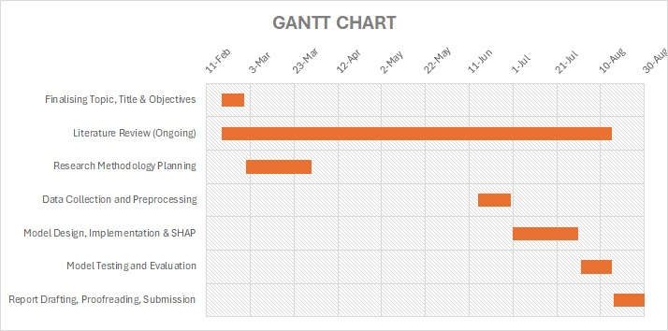

6. References
[1] L. Sahin, A. Bulkan, and E. Duman, “A cost-sensitive decision tree approach for fraud detection,” Expert Systems with Applications, vol. 40, no. 15, pp. 5916–5923, 2013.
[2] M. Riegler et al., “Transparency and privacy: The role of explainable AI and federated learning in financial fraud detection,” IEEE Access, vol. 10, pp. 20424–20435, 2022.
[3] P. Psychoula, D. Singh, and I. G. Moise, “Explainable machine learning for fraud detection,” in 2020 IEEE International Conference on Big Data (Big Data), pp. 1883–1892.
[4] M. N. Patel and H. Prajapati, “A survey on detection of fraudulent credit card transactions using machine learning algorithms,” in 2021 International Conference on Intelligent Technologies (CONIT), pp. 1–5.
[5] H. Ali, K. Khan, and F. Khan, “Predicting fraudulent card transactions using machine learning methods,” Journal of Computer Science and Technology, vol. 36, no. 5, pp. 1134–1144, 2021.
[6] S. Kundu and J. Nasraoui, “Fraud detection in online payment transaction using machine learning algorithms,” in Proceedings of the 2022 IEEE World AI Congress, pp. 145–151.
[7] V. Ramesh and G. V. Suresh, “Online payment fraud detection model using machine learning techniques,” Procedia Computer Science, vol. 193, pp. 515–524, 2021.
[8] M. S. Ahmed, H. A. Hashim, and R. J. Qahwaji, “A survey of deep learning-based online transactions fraud detection systems,” International Journal of Advanced Computer Science and Applications (IJACSA), vol. 12, no. 8, pp. 526–534, 2021.
[9] M. M. Khan et al., “Locally interpretable one-class anomaly detection for credit card fraud detection,” in 2021 20th IEEE International Conference on Machine Learning and Applications (ICMLA), pp. 438–445.
[10] M. Zhang et al., “SEFraud: Graph-based self-explainable fraud detection via interpretative mask learning,” in 2023 IEEE International Conference on Data Mining (ICDM), pp. 1061–1066.
[11] Y. Liu, B. Zhang, and J. Zhou, “Instance-dependent cost-sensitive learning for detecting transfer fraud,” in Proceedings of the 2022 IEEE Conference on Data Science and Advanced Analytics (DSAA), pp. 1–10.
[12] S. Chattopadhyay and T. Yu, “Explainable machine learning for fraud detection,” IEEE Computer, vol. 54, no. 6, pp. 44–53, 2021.

