Intercultural Competence
Report

Foreign Languages and Cultural Awareness
BMIH5003

Alexandra Paunescu
2125393
Word count: 1,098 words

Executive Summary:

Diversity Hotel & Spa must have a thorough understanding of the cultural and leadership dynamics in Spain for its expansion. Spain's cultural diversity is characterised by long-standing traditions, a strong collective mindset, and a prevalent focus on empathy, all of which significantly impact the workplace and customer interactions.
This report examines the cultural values of Spain, based on the extensive analysis carried out by the GLOBE Project. The study indicates that Spanish workplaces have a strong hierarchical structure, emphasising collective accomplishments and valuing interpersonal connections. The Spanish culture emphasises generosity and community, which are important factors to consider in the hospitality industry.
Spain's hotel industry poses distinct challenges and opportunities, notably due to traditional practices like the siesta and preference for in-person communication. Leaders at Diversity Hotel & Spa must effectively manage the tension between the brand's global standards and the specific customs and values of the local community. Maintaining this balance is essential for delivering excellent service to guests and promoting a positive work environment for staff.
The successful integration of Diversity Hotel & Spa into the Spanish market requires a culturally intelligent and sensitive leadership approach. Managers must navigate the convergence of global hospitality standards and the unique Spanish cultural landscape. Cultural congruence will support management practises, improve customer service, and promote staff well-being, contributing to the long-term success of the hotel in Spain.
This executive summary highlights the importance of cultural understanding in effectively managing and operating the Diversity Hotel & Spa's new venture in Spain.
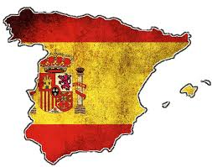
Content Table:
- Introduction
- Spain - Culture Overview
  - Historical Context Influencing Current Practices
  - Key Cultural Characteristics and Traditions
  - Business Etiquette and Practices
- GLOBE Project/Country Analysis: Spain
- The Significance of Cultural Intelligence and Sensitivity
  - Importance in the Hotel Industry
  - Implications for Customer Service
  - Influence on Staff Relations and Morale
  - Role in Effective Communication and Operations
- Application of Cross-Cultural Communication Theories/Models
  - Hofstede's Dimensions of Culture
  - Hall’s Context Communication Models
- Conclusion
- Recommendations
  - Training and Development Initiatives
  - Staffing and Hiring Strategies
  - Operational Adjustments
  - Communication and Feedback Mechanisms
- References
  - List of Cited Works and Further Readings
  - Cultural Sensitivity Training Modules
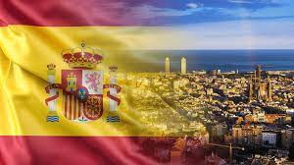Introduction:
Diversity Hotel & Spa's global expansion into Spain signifies a promising move into a market abundant in culture and historical significance. Successful international expansion requires both replicating the brand's strengths and adapting to the local environment. This report examines the cultural landscape of Spain and its impact on leadership, management, and hotel operations. By gaining insight into Spain's customs, traditions, and business etiquette, the General Manager can develop strategies that effectively connect with the local workforce and clientele. The alignment of global brand values and local cultural understanding is crucial for the hotel's success in Spain.

Culture Overview

The Spanish Culture article (2021) shows that Spain, situated on the Iberian Peninsula, possesses a wealth of historical, artistic, and traditional elements that have significantly influenced its present-day cultural identity. Spanish culture places great importance on family and community, with familial connections often influencing business interactions and collective decision-making.
Spain's regional identities, such as Andalusia's flamenco and the Basque celebrations in the north, have historically shaped its national culture. The regional diversity in Spain has led to a variety of traditions that collectively shape the Spanish culture (spanishpod101, 2021).

According to Allain (2022), in the business context, Spaniards prioritise in-person interactions and emphasise the establishment and upkeep of robust interpersonal connections. Trust and personal rapport are crucial in business transactions, often prioritised over purely transactional interactions. Spain is well-known for its unique practices, such as the 'siesta', a mid-afternoon break that reflects the country's emphasis on work-life balance and affects working hours and business operations.
Additionally, there is a clear presence of respect for hierarchy and status, without compromising personal relationships. Spanish professionals desire leaders who possess both authority and approachability. Understanding cultural complexities is crucial for the Diversity Hotel & Spa as it enters the Spanish market. This knowledge will help the company navigate the business landscape successfully (Nevaer, 2010).

GLOBE Project

Country Analysis - Spain:
Spain's cultural dynamics, as evaluated by the GLOBE Project, offer profound insights into its organizational and leadership behaviours:
- Power Distance: Spain registers a high score in this dimension. It highlights a strong respect for organisational hierarchies. Spanish professionals prefer clear instructions from their superiors and appreciate a hierarchical decision-making process (O’Connell, Prieto and Gutierrez, 2007).
- Collectivism vs. Individualism: Spain tends to lean towards collectivism rather than individualism. This emphasises the significance of group unity, solidarity, and prioritising collective objectives over individual accomplishments. The workplace values team harmony and collaboration (spanishpod101, 2021).
- Uncertainty Avoidance: According to Rabotin (2011) Spain's avoidance score indicates a well-balanced approach. Spaniards value a structured work environment and demonstrate adaptability and resilience when confronted with unexpected challenges.
- Assertiveness: The Spanish workforce displays a tendency to avoid confrontations, as indicated by their moderately low assertiveness score. A preference for a diplomatic and harmonious communication style that prioritises agreement rather than disagreement is desired (O’Connell, Prieto and Gutierrez, 2007).
- Performance Orientation: The culture maintains a balance between performance and the methods used to achieve it. While performance is crucial, how results are achieved, particularly about dynamics within relationships, is considered equally important (O’Connell, Prieto and Gutierrez, 2007).
- Future Orientation: Spain has a high score, indicating an intense focus on generosity, kindness, and community within the workplace (Ollier‐Malaterre, Haar, Sunyer and Russo, 2020).
- Humane Orientation: Spain scores high, emphasizing the importance of generosity, kindness, and community in the workplace (Ollier‐Malaterre, Haar, Sunyer and Russo, 2020). 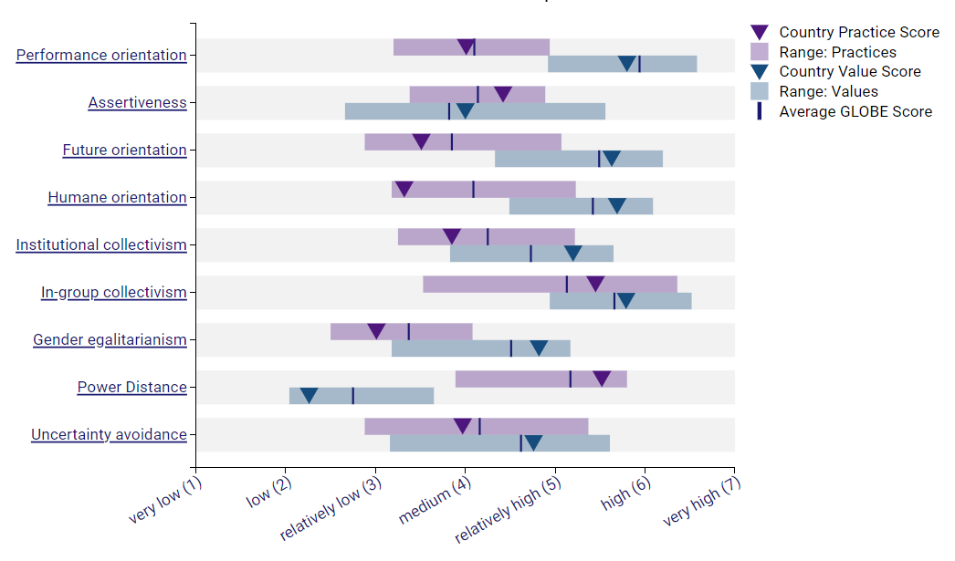

4. The Significance of Cultural Intelligence and Sensitivity:

According to Frías-Jamilena, Sabiote-Ortiz, Martín-Santana,and Beerli-Palacio (2018), service excellence plays an essential role in the hotel industry, particularly in culturally diverse countries such as Spain, where cultural intelligence is of great importance. This capability helps in fulfilling a wide range of customer expectations, thereby fostering positive experiences and fostering customer loyalty. Spain's focus on cultivating relationships necessitates that customer service is culturally sensitive. This improves guest satisfaction and boosts staff interactions. Barkley, and Eggertsson (2017) state that implementing a culturally sensitive leadership style aligned with Spanish values promotes a harmonious workplace, increases staff satisfaction, and reduces instances of miscommunication. Additionally, comprehending Spain's inclination towards direct interactions can improve communication efficiency and overall operational effectiveness.

5. Application of Cross-Cultural Communication Theories/Models:
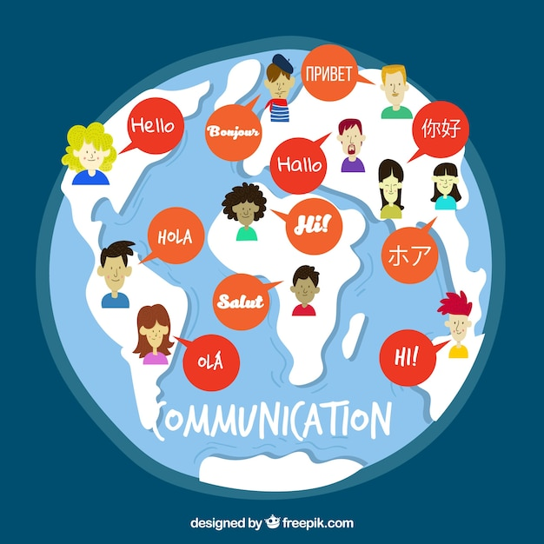
To effectively navigate Spain's complex cultural landscape, the Diversity Hotel & Spa should utilise established frameworks such as Hofstede's Dimensions and Hall's Context Communication. Spain exhibits high levels of uncertainty avoidance and power distance, which emphasise the importance of effective communication and adherence to hierarchical structures (Rabotin 2011). The culture blends competitiveness with a focus on collaboration and collective accomplishments. Spain's communication style is high context, emphasising non-verbal cues and shared experiences. Understanding these details can greatly improve guest interactions in the hotel. By utilising these theories, the hotel can predict challenges, devise effective strategies, and cultivate harmonious interactions both internally and with guests (Guirdham and Guirdham, 2017).

Conclusion:
Spain's cultural diversity and unique business customs pose both advantages and disadvantages for the expansion of the Diversity Hotel & Spa. The hotel's operations and leadership approach must take into account the country's focus on interpersonal relationships, respect for hierarchy, and preference for face-to-face interactions. By utilising insights from the GLOBE Project and relevant cross-cultural communication models, the hotel can effectively navigate potential challenges and optimise its likelihood of achieving success. It is crucial to integrate cultural intelligence and sensitivity into the hotel's practises. This approach will enhance operations and improve guest experiences, strengthening the brand's position in the Spanish market.

Recommendations for the General Manager:

To effectively manage cultural differences and minimise miscommunications with customers at the Diversity Hotel & Spa in Spain, According to Evason (2018) the General Manager should take into account the following actions:
- Understanding Cultural Norms:
  - it is essential to familiarise oneself with fundamental Spanish customs and social etiquette. It should be noted that Spaniards tend to prefer having dinner late and engaging in social activities until late at night.
  - Learning essential Spanish phrases can foster appreciation for the local language, thereby cultivating positive relationships with both personnel and visitors.
- Building Relationships:
  - Allocate time to cultivate interpersonal connections with customers. In Spain, engaging in casual conversation and showing personal interest can greatly contribute to the establishment of trust and rapport.
  - Non-verbal communication, including body language, is equally significant as verbal communication in expressing respect and attentiveness.
- Service Customization:
  - Tailor services to accommodate local customs. Providing a "siesta service" with noise-reduced rooms during customary rest periods could be well-received.
  - Staff should be trained to pay attention and be responsive to the cultural preferences of Spanish customers, including their preferences in dining and leisure activities.
- Conflict Avoidance and Resolution:
  - Understand the Spanish inclination to avoid public confrontations. Promote a tactful and efficient method for addressing customer complaints or disputes through direct and private means.
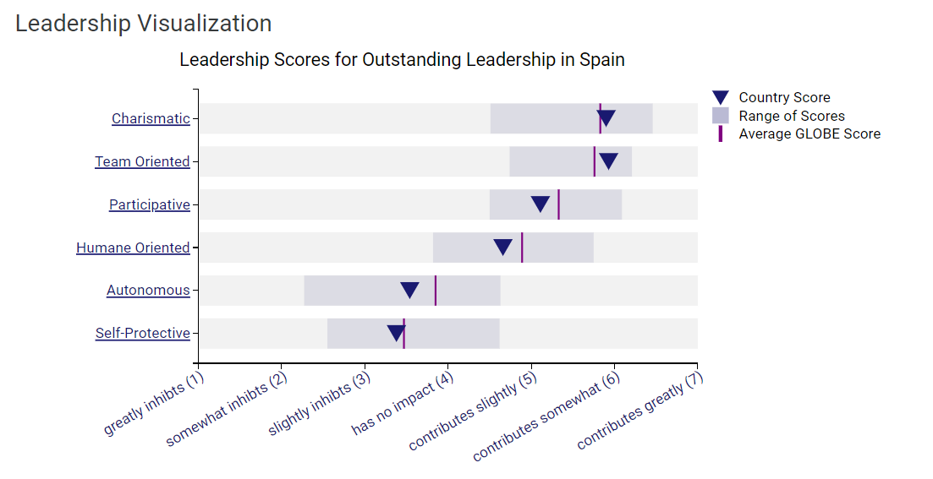
  - Customer-facing staff should receive training in conflict de-escalation techniques that are in line with Spanish communication styles.

Implementing these recommendations will facilitate the hotel's assimilation into the Spanish market and promote a workplace that appreciates and acknowledges cultural diversity. This will result in improved guest satisfaction and staff confidence.

Reference List

- Allain, S., 2022. How to Succeed in Spanish Business Culture: Tips for Navigating the Challenges. Online Available at: https://mylanguagebreak.com/spanish-business/
- Barkley, D.L. and Eggertsson, M., 2017. USING HOFSTEDE'S MODEL TO IMPROVE MULTICULTURAL MANAGEMENT IN THE EUROPEAN UNION. Journal of International Management Studies, 17(1).
- Evason, N., 2018. Cultural Atlas. Spanish Culture: Etiquette. Online Available At: https://culturalatlas.sbs.com.au/spanish-culture/spanish-culture-etiquette
- Frías-Jamilena, D.M., Sabiote-Ortiz, C.M., Martín-Santana, J.D. and Beerli-Palacio, A., 2018. The effect of Cultural Intelligence on consumer-based destination brand equity. Annals of Tourism Research, 72, pp.22-36.
- Guirdham, M. and Guirdham, O., 2017. Communicating across cultures at work. Bloomsbury Publishing.
- Nevaer, L., 2010. Managing Hispanic and Latino employees: A guide to hiring, training, motivating, supervising, and supporting the fastest growing workforce group. Berrett-Koehler Publishers.
- O’Connell, J.J., Prieto, J.M. and Gutierrez, C., 2007. Managerial culture and leadership in Spain. In Culture and Leadership Across the World (pp. 657-688). Psychology Press.
- Ollier‐Malaterre, A., Haar, J.M., Sunyer, A. and Russo, M., 2020. Supportive organizations, work–family enrichment, and job burnout in low and high humane orientation cultures. Applied Psychology, 69(4), pp.1215-1247.
- Rabotin, M.B., 2011. Culture savvy: Working and collaborating across the globe. American Society for Training and Development.
- Spanishpod101.com, 2021. The Spanish Culture: A Guide to the Peculiarities of Spain. Online available at: https://www.spanishpod101.com/blog/2021/04/23/spanish-culture/

