write a report about the role that social media tools such as LinkedIn and Facebook can have in the recruitment of staff.

Digital Sills
Module Code; LCLM4002
Student Name: Joaquim Marcos De Sousa Freire
Student ID. 2415568

Table of Contents
Introduction 3
Role of LinkedIn in Recruitment 3
Role of Facebook in Recruitment 4
Advantages of Using Social Media for Recruitment 5
Disadvantages of Using Social Media for Recruitment 6
Conclusion 7
References 8

Introduction
In this digital age, social media platforms, such as LinkedIn and Facebook, have changed the face of recruitment. These platforms are meant for social networking and the Human Resources (HR) processes (Moore, 2023). They have unique advantages by extending the outreach to potential recruits, boosting the visibility of job postings, and boosting brand reputation. This report addresses the key positions that both LinkedIn and Facebook have in the present recruitment strategies and uncovers their unmatched benefits, such as greater accessibility for job seekers and improved communication channels. Moreover, it covers these platforms' challenges regarding data privacy and application volume.

Figure 1: This depicts the Facebook and LinkedIn. Source (Ajay, 2021)

Role of LinkedIn in Recruitment
As a social network for professionals, LinkedIn has suitably optimised its services to meet the needs of both recruiters and candidates searching for jobs (Hosain and Liu, 2020). LinkedIn has a place for nearly 700 million people to network professionally and advance their careers. Its role in recruitment is multifaceted:
Professional Profiles: The users of LinkedIn can create a thorough profile that accommodates professional experience, skills, education, and much more (Anderson, 2024). It is an invaluable tool for recruiters who need a quick way to verify a candidate’s qualifications.
Advanced Search Capabilities: The platform provides powerful search tools that enable recruiters to filter candidates based on specific criteria such as location, industry, and past work experience (Kostrzewska, 2024). This precision helps identify the ideal candidates efficiently.
Recruitment Tools: LinkedIn's suite of recruitment tools includes LinkedIn Recruiter, which gives access to an extensive set of profiles and makes it easier to focus on recruitment campaigns (LTS, 2018). These are the tools that are intended to promote the effectiveness of recruiting with the use of data-driven insights.
Networking Opportunities: Professional groups and forums supported by LinkedIn always conduct industry-specific discussions. These groups are created by recruiters so that they can interact with potential candidates, know industry trends, and create contacts with passive candidates (Davis et al., 2020).
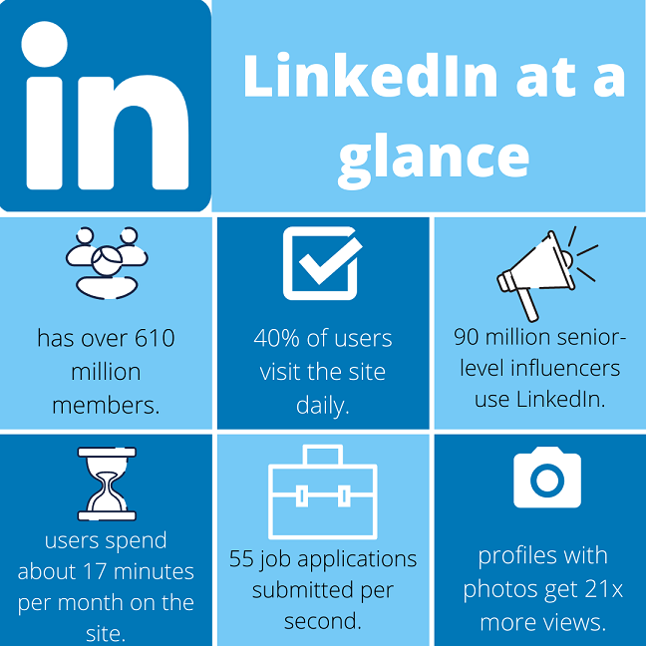
Figure 2: This depicts the number of employers using LinkedIn. Source (UOS, 2020)

Role of Facebook in Recruitment
Although LinkedIn focuses on professional networking, Facebook offers a broader reach due to its vast and diverse user base. This platform enables recruiters to tap into varied demographic, making it particularly useful for roles requiring a wide-ranging skill set or for companies looking to enhance their diversity (Golovko and Schumann, 2019).
Informal Engagement: Facebook’s casual and social nature allows companies to present relatable and engaging brand image (West, 2024). It can appeal to younger demographics and help portray the company's culture and work environment.
Job Posting Integration: Facebook Jobs is a feature that allows employers to post job openings directly on their company pages and in the marketplace. This integration provides high visibility and facilitates easy application processes for candidates (Hosain, 2023).
Community Engagement: Businesses use Facebook to build communities around their brands, which can be leveraged for recruitment (West, 2024). Companies can attract candidates already interested in the brand and its values, engaging with followers through content, updates, and interactions.
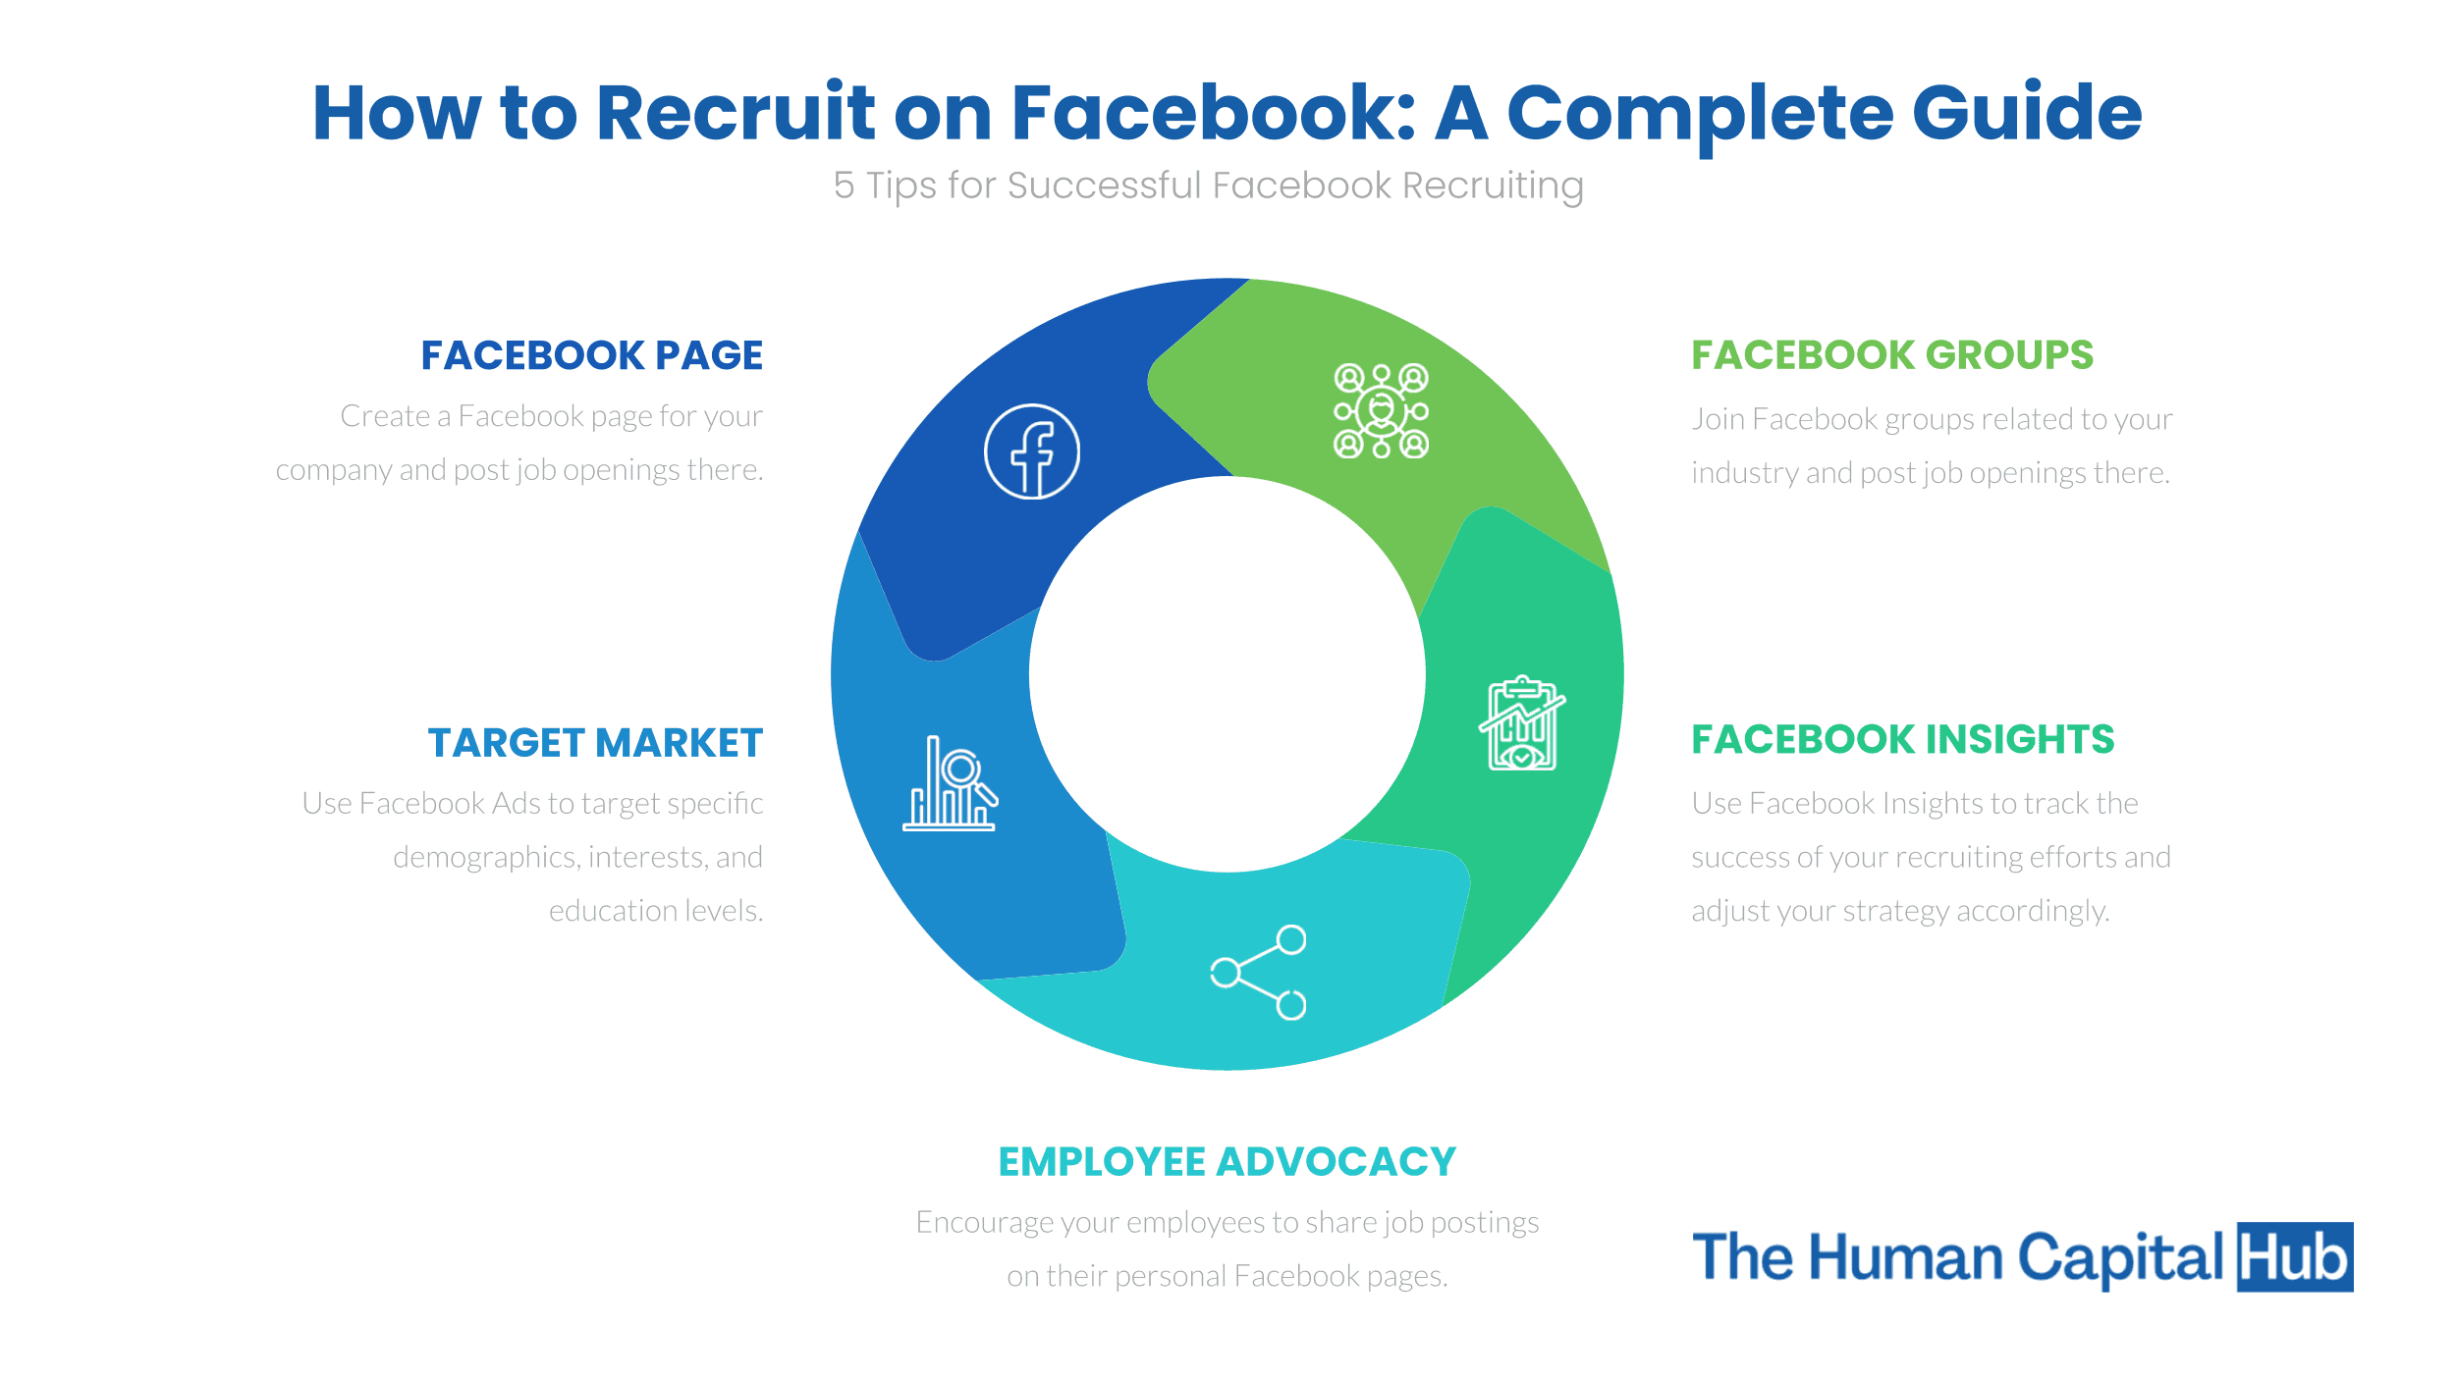
Figure 3: This depicts complete guidance to recruitment via Facebook. Source (THCU, 2024)

Advantages of Using Social Media for Recruitment
Social media recruitment offers several benefits that traditional methods may lack social media platforms have a global reach, enabling companies to attract talent worldwide. This is particularly beneficial for organisations seeking niche roles or a diverse group of candidates. Furthermore, many social media tools offer free or low-cost options for job postings, which can reduce the overall cost of recruitment (Bajaj, 2023). Regular updates and engagement on social media help build a positive employer brand that attracts quality candidates (Whitman, 2024). Additionally, social media facilitates immediate communication with candidates, speeding up the recruitment process and improving the candidate experience.
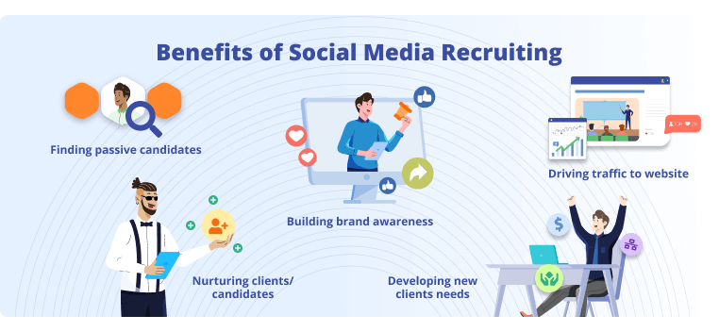
Figure 4: This depicts the benefits of social media. Source (GAMP, 2024)

Disadvantages of Using Social Media for Recruitment
Despite the advantages, there are several challenges associated with using social media for recruitment. Popular social media posts can attract applications, many of which may not be from suitable candidates. It can increase the workload for HR teams in filtering applications. Furthermore, there are concerns regarding the privacy of candidates, as social media profiles often contain personal information that is not typically shared in a professional context (Moore, 2023). The informal nature of social media can lead to biases in recruitment, whether conscious or unconscious. Companies must ensure that their social media recruitment strategies are inclusive and fair to all candidates. Negative comments or feedback on social media can impact a company’s reputation. It is crucial for businesses to actively manage their social media presence and address any issues promptly.
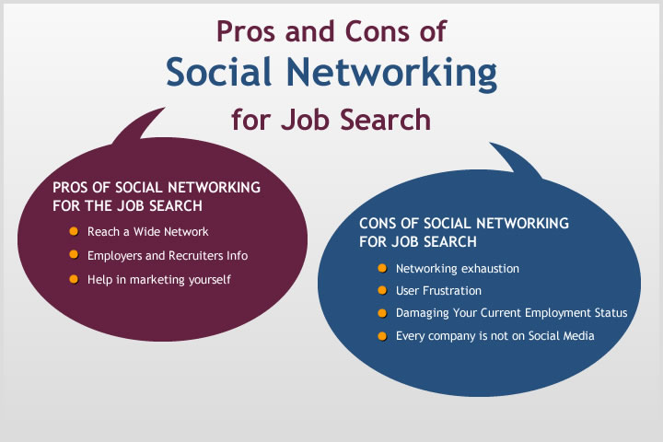
Figure 5: This depicts the cons and pros of social media. Source (Lewis, 2013)

Conclusion
LinkedIn and Facebook have made a tremendous difference in the recruitment landscape, introducing dynamic, direct connection points between employers and potential candidates. However, these platforms have many advantages, as products are cheap and can help enhance employer branding and internationalise talent recruitment. However, the process can be cumbersome and time-consuming due to handling large volumes of apps and the growing importance of maintaining data privacy in a digital era. However, if these social media tools are used effectively, organisations must strategically blend them with traditional recruitment approaches. This balanced approach optimises team hiring, and the recruitment strategy relies on the best digital and conventional techniques.

References
Anderson, B. (2024). How to Add Skills to Your LinkedIn Profile — and Why It’s Important | LinkedIn. [online] www.linkedin.com. Available at: https://www.linkedin.com/business/talent/blog/talent-acquisition/skills-on-linkedin-profile.
Bajaj, A. (2023). 6 Advantages of Social Media Recruitment. [online] Gohire. Available at: https://gohire.io/blog/advantages-of-social-media-recruitment.
Davis, J., Wolff, H.G., Forret, M.L. and Sullivan, S.E., (2020). Networking via LinkedIn: An examination of usage and career benefits. Journal of Vocational Behavior, 118, p.103396.
Golovko, D. and Schumann, J.H., (2019). Influence of company Facebook activities on recruitment success. Journal of Business Research, 104, pp.161-169.
Hosain, M.S., (2023). Integration of social media into HRM practices: a bibliometric overview. PSU Research Review, 7(1), pp.51-72.
Hosain, S. and Liu, P., (2020). Recruitment through LinkedIn: Employers’ perception regarding usability. Asian Journal of Management, 11(1).
Kostrzewska, M., (2024). Recruitment 5.0: the impact of the social media channel Linkedin on communication between recruiters and candidates. Scientific Papers of Silesian University of Technology. Organization & Management/Zeszyty Naukowe Politechniki Slaskiej. Seria Organizacji i Zarzadzanie, (199).
LTS (2018). Recruiting Solutions for the Perfect Hire. [online] Linkedin.com. Available at: https://business.linkedin.com/talent-solutions.
Moore, J. (2023). By James Moore, Director of Recruitment The digital age has ushered in a remarkable transformation in the way organizations approach recruitment. In this era of connectivity and information-sharing, social media has emerged as a powerful tool that transcends the boundaries of traditional hiring meth. [online] Linkedin.com. Available at: https://www.linkedin.com/pulse/role-social-media-recruitment-beyond-traditional-search-james-moore.
Moore, T. (2023). Social media recruiting - the pros and cons. [online] That’s Good HR. Available at: https://thatsgoodhr.com/the-pros-and-cons-of-recruiting-through-social-media/.
West, C. (2024). 24 Facebook statistics marketers should know in 2024. [online] Sprout Social. Available at: https://sproutsocial.com/insights/facebook-stats-for-marketers/.
Whitman, M. (2024). Building a Strong Employer Brand: Strategies for Attracting Top Talent. [online] TeamBuilder Search. Available at: https://teambuildersearch.com/building-a-strong-employer-brand/.

