

Advanced processes

Iwan Dyer
P149128
M6X00408

Introduction
This report will look to compare the processes of friction stir welding and plasma coating. This report will look into the history, the science behind the processes and will conclude with comparing the advantages and disadvantages of the process. The final comparison will look into cost, defects, how well the repair cracks, if it improves or worsens the surface finish and the overall cost of the process.

Contents

Introduction 1
Plasma spray coating 1
Plasma spray process 1
Advantage and disadvantage 2
New market opportunities 2
Friction stir welding 2
Friction stir welding process 2
Advantages and disadvantages 4
New market opportunities 4
Comparison 4
Conclusion 5
References 5

Plasma spray coating

Plasma spray process

Plasma spray coating is a form of fracture repair or coating process used in defect repair. Before the part is ready to undergo the process, the part must first ether undergo light grit blasting or chemical cleaning (English, n.d.). The plasma gun consists of a tungsten cathode and a copper anode, both of which are water cooled to stop them over heating or expanding drastically (Stevenson, 2019). The copper anode is shaped as a constricting nozzle so that the gas that is pushed though accelerates the gas as it is pushed though a smaller and smaller diameter (Aleksandrovich, 2015). The gas is inputted behind the cathode it is pushed around it towards the nozzle when it reaches that the potential difference between the anode and cathode make an electric arc. The electricity are super heats the gas (normally being hydrogen, helium, nitrogen or argon) and making it a plasma, the flame produced by this reaction is called a neutral plasma flame (English, n.d.). A neutral plasma flame consists of plasma that does not carry a current. Once the plasma leaves the nozzle powered form of the martial that is being used as a coats the martial is spayed in front of the plasma. The plasma will then will rapidly heat the dust and propel it forward to the martial. The motel/ softened martial then coats the martial filling in any gaps or fractures that might be present in the surface of the martial. The distance from the work peace to the nozzle can be between 25mm to 150mm apart (C.M.Cotell, 1994).

Advantage and disadvantage
Most of the time plasma coating is used in a normal atmosphere although it can be used in both a low-pressure environment known as LPPS or in a vacuum chamber know as VPS. One of the big advantages of plasma coating is that I can use very high melting point, materials such as Chromium Carbide and Aluminium-Graphite Composite can be used (Aleksandrovich, 2015). Due to this another large advantage of plasma coating is the wide amount of martials that can be used to coat the work piece. This process is widely considered a cold process due in fact to the work pieces low temperate, this itself gives advantages to the processes the part does not expand from the heat making sure that that any defects on the surface to not propagate further from thermal expansion, it also would stop any effect of unwanted heat treating from this process keeping the part’s properties intact. The process even gives a good quality surface finish to the work piece. Even though this process has many advantages there is 2 large draw backs to this process, one is the cost which is quite high and the other being complexity of the process.

New market opportunities

Plasma spray coating could be a great investment for a company looking for a finishing process or even process to repair defective parts as if the coating them. This is same as the material used repair the material and if a different material is used it becomes a coating and can have many applications such as rust protection (S.Black, 2009). The only downside would be that this process does not have the ability to fix larger cracks or breaks.

Friction stir welding

Friction stir welding process
Friction stir welding is a process that where a none consumable tool is used to mix two solid state materials together. The two work pieces are heated by the friction that is the tool creates in the material. As the tool spins it draws the 2 material together mixing them without making them molten because of this the process is considered a cold process. (TWI, n.d.) The tool consists of a “pin” being a smaller diameter part of the tool that is plunged in to the center of the weld line and a shoulder being a smooth flat circler head where a great deal of the friction is created, due to this design the weld is made inside the part and on a cross section analysis tend to look like a tapered cone. (Soni, 2017) This form of welding unlike some types of welding doesn’t need extra material added to it to make the weld as the only materials need are those undergoing the welding process. (Terry Khaled, 2015) The after it is plunged into the work piece the tool moves along the weld line at a constant rate. The speed that it rotates at is depended on the tool used and the material that the work piece is comprised of, so is the force applied along with the move speed across the weld line (Vyas, 2017). In FST there are 3 zones the first is the “nugget” secondly is the thermo-mechanically affected zone and finally there is a heat affected zone. Fundamentally the “nugget” is an area where the microstructural grains of metal grow undergo deformation at the same time, this leads to some increased weld strength (Judy Schneider, 2002). The “nugget” is formed where the advancing side overtakes the retreating side and they mix together. The “nugget” on cross sectional analysis can clearly show that the grains transition from the elongated grains to an equiaxed central grain, shown in figure 1 below.
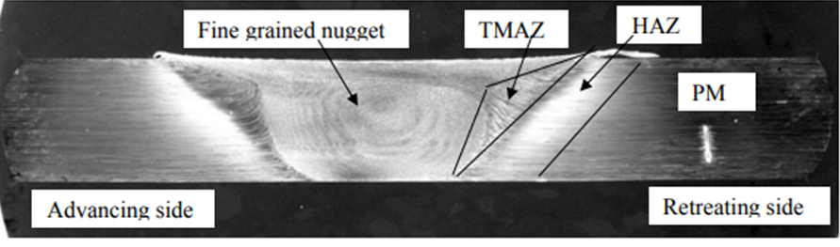 (Judy Schneider, 2002)
Figure 1

Figure ………. Also clearly shows both the thermos-mechanical affected zone and the heat affect zone. The thermos-mechanical affected zone as the name would subggest is effected both the stirring motion of the tool and the heat that is produced from the friction. This double effect leads to microscopic deformation of the material (Judy Schneider, 2002). The heat affected zone is also clearly shown in figure 2 show below.
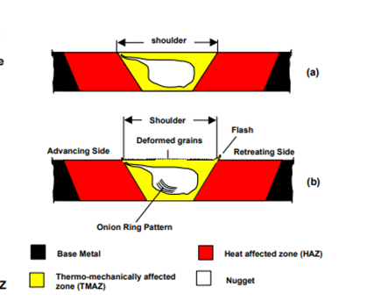 (Terry Khaled, 2015)
Figure 2

The heat effected zone is very easy to explain it is the zone that is only effect by the heat generated by the friction welding. The tool itself as no interaction with the heat effect zone.
The affect that the friction weld has on the strength of the material is hard to discern as generally is increases the harness of the nugget and thermomechanical affected zones and decreases the hardness of the heat effected zone (Terry Khaled, 2015). Though this generalization is far from the full truth for example if an aluminum 2000s alloy is used it can ether cause the heat effect zone to become weaker or keep it almost identical the percent material. This is because of cooling the speed of the tool for applied or the material used, but as a generalization the weakest part of the weld will be the heat effected zone.

Advantages and disadvantages
Friction stir wedding has a few advantages over traditional welding there is never any sort of solicitation cracking due to it being a solid-state process. Very high-quality welds are easily achieved with this method and the tool very rarely has to be replaced. It also has very low amount of distortion from the original material when compared to traditional welding and this leads to less stress in the material. (TWI, n.d.)
The disadvantages of friction stir welding begin with the price of the machine this very high when compared to process such as arc welding. Being a machined process, it is much less feeble than traditional methods of welding. Also the process requires that the part has a significant amount of clamping force it to stop the force that the tool is plunged in to it from deforming the part (Terry Khaled, 2015).

New market opportunities
Fiction stir welding is already used by some very high profile business such as Space X and Lockheed martin facility, this itself should show how much the investment in the process could benefit a company (GTC, 2018). The process itself leads to the possibly of creating parts that are incredibly difficult to do with normal welding method such as mixing two alloys on a weld line, without reducing the strength of the materials.

Comparaison

Friction stir welding and plasma spray coating are very different process though they both have one thing in common, that being that they can be used in some way to repair damaged materials. Plasma coating is the most obvious form of defect repair out of the two, its primary objective is to repair and protective a material (S.Black, 2009). This is different to friction stir welding as its main objective is to fuse two material together in to one solid mass, though this itself could be seen as or used as a type of repair method. This is because if a part had a complete failure where the part ether cracked though at some point or split in 2 friction stir welding could be used to put the parts back together without having to alter the shape or properties to much (Terry Khaled, 2015). Plasma coating cannot do this however it can be sued to apply rust protection or add material to a defective surface finish so that it can undergo another process to increase the quality of the finish. Both of these process have some very useful advantages and some pretty big disadvantages, one key advantage they both have it that they can be used to apply a material that is different to the work piece, in the case of FSW it is being able to combine to material within the weld (Soni, 2017). Another thing they have in common is the fact both process are considered a cold process this is due to the fact that nether of the base materials melt or get very hot this leads to there being no heat fractures in the part from expansion and contraction (Choudhury, 2017). The shared disadvantages of theses process is the cost of installation and with FSW the machines are incredibly expensive and there must be enough clamping force on the bed to make sure that the parts do not move even slightly otherwise it will make a defect in the weld, and with plasma coating there is the same issue and the problem only gets worse if the type of coating must be done in a none stranded atmosphere (S.Black, 2009).

Conclusion
In conclusion there are many advantages and disadvantages to both processes, even though they share some common traits their uses are very different. Both proved some great benefits to any company that uses them but the start-up cost is very high compared to their traditional methods. But the benefits far out way the cost of set up for example arc welding, the traditional form of friction stir welding, cannot weld together two different material together which FSW can. For plasma coating there isn’t a lot of process that can add material to an existing part without heating the part to a very high temperature, which could add stress to the part.

References

Aleksandrovich, A., 2015. Handbook of Nanoceramic and Nanocomposite Coatings and Materials. 1st ed. s.l.:s.n.
C.M.Cotell, 1994. Surface Engineering. In: F.A.Sprague, ed. ASM Handbook. s.l.:s.n., pp. p 497-509.
Chonudhury, A., 2017. Principles of Textile Finishing. 1st ed. s.l.:s.n.
Choudhury, A. K. r., 2017. Principles of Textile Finishing. s.l.:s.n.
Dorfman, M. R., n.d. Handbook of Environmental Degradation of Materials. 3rd ed. s.l.:s.n.
English, G., n.d. gordonengland. [Online]
Available at: https://www.gordonengland.co.uk/ps.htm
[Accessed 10 11 2019].
GTC, 2018. Friction stir welding. [Online]
Available at: https://gentool.com/capability/friction-stir-welding/
[Accessed 12 11 2019].
Judy Schneider, P., 2002. THERMO-MECHANICAL PROCESSING IN FRICTION STIR WELDS, s.l.: s.n.
S.Black, 2009. Sustainable Textiles, s.l.: s.n.
Soni, N., 2017. Defects Formation during Friction Stir Welding. 7(3), p. 121/125.
Stevenson, P., 2019. poral medical. [Online]
Available at: https://www.gordonengland.co.uk/ps.htm
[Accessed 10 11 2019].
Terry Khaled, P., 2015. AN OUTSIDER LOOKS, s.l.: s.n.
TWI, n.d. What is Friction Stir Welding. [Online]
Available at: https://www.twi-global.com/technical-knowledge/faqs/faq-what-is-friction-stir-welding
[Accessed 10 11 2019].
Vyas, K., 2017. Inderesting Engineering. [Online]
Available at: https://interestingengineering.com/friction-stir-welding-principle-benefits-and-applications
[Accessed 10 11 2019].

Ref
http://www.portalmedical.co.uk/surface-technology/
https://www.gordonengland.co.uk/ps.htm
http://fab.cba.mit.edu/classes/961.04/projects/RegXuProj/MasProjII.htm
https://www.asminternational.org/documents/10192/22533690/06125G_Sample_BuyNow.pdf/9df4cbc0-c1fa-4772-91c2-920224484442

https://www.twi-global.com/technical-knowledge/faqs/faq-what-is-friction-stir-welding
https://ntrs.nasa.gov/archive/nasa/casi.ntrs.nasa.gov/20030093622.pdf
https://interestingengineering.com/friction-stir-welding-principle-benefits-and-applications
https://www.faa.gov/aircraft/air_cert/design_approvals/csta/publications/media/friction_stir_welding.pdf
file:///C:/Users/p149128/Downloads/metals-09-00507.pdf
https://pdfs.semanticscholar.org/1ee3/20399850cc8464dd7081c57152972df62322.pdf

