Computer Architecture

University of Wales Trinity Saint David

Mihail Tutunaru 1910014

Renuga J.

Table of Contents

Introduction…………………………………………………………………………3
What is a computer……………………………………………………………..4
First Scenario……………………………………………………………………….7
Second Scenario………………………………………………………………….10
References…………………………………………………………………………..11

Introduction

In this report will be explained structure of a computer, hardware components from inside, software components, how they are chosen by builder for a good manner of functionality and few examples about hardware configuration in nowadays.
In nowadays these machines called computers become powerful and easily accessible for everyone every day with a huge impact on economy and not only. Every time tomorrow will appear a computer more powerful and better than the old one from yesterday and the prices for these machines will never stop to fluctuate. With time prices for previous generations will go down. All what appears now it’s expensive but with time the price is going down.
Our subject “Computer Architecture” tells us about all units of a computer, how all of these units works and what they can do together. Before buying a computer “a laptop or a desktop” we should know all basic functional units. Of course, we need to know about software, about the operating system, because through the operating system and software we can operate with that PC. Bellow I’m going to discuss about computers, about components of a computer, about software, and trying to make some configurations.

What is a computer

A computer is an electronic device that manipulates information, or data. It has the ability to store, retrieve, and process data. You may already know that you can use a computer to type documents, send email, play games, and browse the Web. You can also use it to edit or create spreadsheets, presentations, and even videos. Below is a picture of a computer with each of the main components. In the picture below, you can see the desktop computer, flat-panel display, speakers, keyboard, and mouse.
Let’s see how a computer desktop is look like:

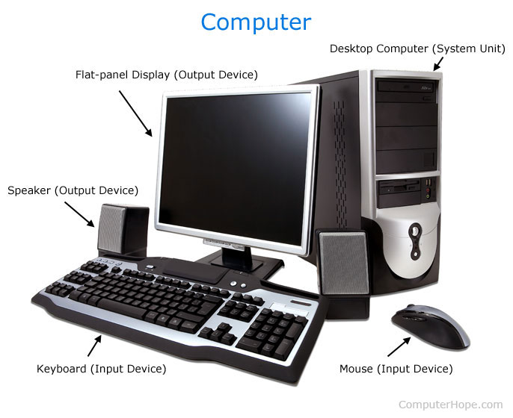
Figure 1.

Every component, named peripheral components, from picture above are created to work dependent with Central Unit. Every computer has input unit and output unit.
What is input unit?
keyboard (when a key is pressed, the corresponding letter/digit is translated to its corresponding binary code & transmitted to memory/processor), mouse, scanner, joysticks, microphones.

Output unit:
Send processed result to user, example : printers, monitors, speakers.

Let’s go a little bit deeper in Central Unit to see what can contain that box called case.

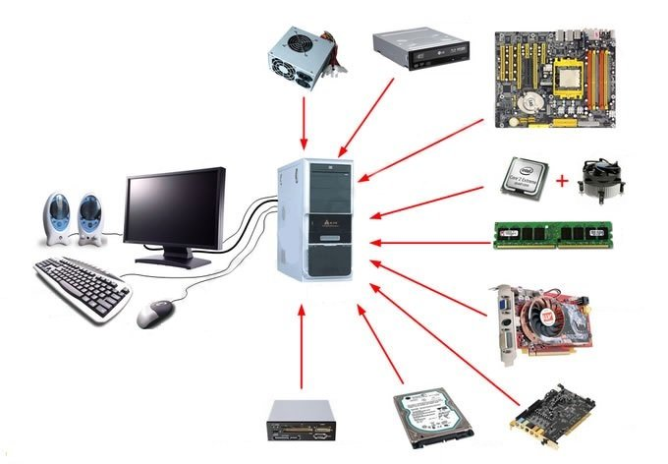
Figure 2.

Starting from the top to right: power supply, DVD/CD rom drive, motherboard, processor(CPU)+fan, ram memory, video graphic card, sound card, hard disk drive, internal all in one reader.
On the left side there is a monitor, a keyboard, speakers and mouse.

- The first one on top, the power supply, is one of the most important hardware component because protect all internal and peripheric components against electric shockwaves and supply them with the right electric tension. All components which we described above have micro-devices, and these micro-devices need a small voltage, and the power supply transforms 220v into 12v or 24v depending of component.

- DVD/CD rom drive it’s a device which can read a CD or a DVD disc. These devices are no more longer so popular, and almost nobody buys a DVD/CD rom drive. Because today flash drive can easy keep a much mor information than a CD or DVD disc. It’s more easy to use, it’s faster, it’s smaller and has a lot of capacity.

- Motherboard is the main board where all the components are connected between them and provides connectors for other peripherals. It has slots for future connections as a standard. Unlike a backplane, a motherboard usually contains significant sub-systems such as the central processor, the chipset's input/output and memory controllers, interface connectors, and other components integrated for general purpose use and applications.

- Processor is the brain of the entire unit, with this hardware all the information introduced in the computer must pass through this Control Process Unit. Processor gives “orders” to all devices in the case.

- RAM memory also called volatile memory because information stays temporary only, is accessible only on power supply. These little board help the Processor with the flux of information which can be flowed.

- Graphic Card is an expansion card which generates a feed of output images to a display device (such as a computer monitor). Frequently, these are advertised as discrete or dedicated graphics cards, emphasizing the distinction between these and integrated graphics. At the core of both is the graphics processing unit (GPU), which is the main part that does the actual computations, but should not be confused with the video card as a whole, although "GPU" is often used to refer to video cards.

- Sound card is an internal expansion card that provides input and output of audio signals to and from a computer under control of computer programs. The term sound card is also applied to external audio interfaces used for professional audio applications.

- Hard Disk Drive is where all the memory is stoked. Is an electro-mechanical data storage device that uses magnetic storage to store and retrieve digital data using one or more rigid rapidly rotating platters coated with magnetic material. HDDs are a type of non-volatile storage, retaining stored data even when powered off.

- Internal all in one reader is a device for accessing the data on a memory card such as a CompactFlash (CF), Secure Digital (SD) or MultiMediaCard (MMC). Most card readers also offer write capability, and together with the card, this can function as a pen drive.

First Scenario

An elderly relative wants a low cost desktop PC with a fairly small form factor but a full size
keyboard and a decent sized monitor to help with their eyesight.
They will not be playing any games. They only need to run simple software to perform
word-processing functions, check email, surf the net etc, however they do want to be able
to watch on line youtube content as well as perform simple skype type video calls with
family abroad.

First task is to search the components which are not expensive, not brand new with latest technology, because previous generation components also can do all tasks required.

Motherboard:

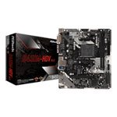

ASRock B450M-HDV R4.0, AMD B450, AM4, DDR4, M.2, Realtek GbE, USB 3.1 Gen1, MicroATX
56 £
In this case the cheapest option is first motherboard because can support a configuration more than enough for activities asked for. Audio and video board are integrated in motherboard and their capacity of functionality are enough for requirements.

CPU

Because of the MB (motherboard) chosen before, the CPU should be compatible with, that’s mean should be an AMD socket compatible.
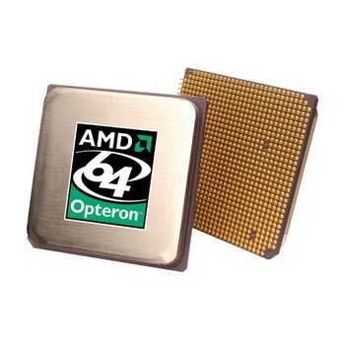

AMD Opteron 64 252, Socket 940, Troy Core, 2.6GHz, 1MB Cache, 92.6W, CPU, OEM
47 £
The cooling fan system is included in AMD price CPU.

RAM

The most important thing when you chose a RAM is the size of memory and the frequency.
The size of memory should be chosen optimal for the processor, in this example must be more than 2 Gb and maximum 8 Gb because like I said before, the quantity of information is set by RAM memory. That’s mean, if is lower than 2 Gb, the speed of action taken by computer will be slower (operation latency), if is bigger than 8 Gb, the quantity of information will be more than processor support and can be physically damaged. DDR1, DDR2, DDR3 slot type was stopped to be produced by many manufacturers for evolution reasons and now are hard to find it and the prices are indirect proportional with the market.

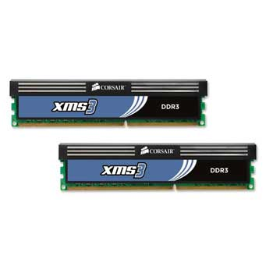

8GB (2x4GB) Corsair DDR3 XMS3, PC3-10600 (1333), Non-ECC Unbuffered, CAS 9-9-9-24, 1.50V
48 £
HDD

Internal storage can be chosen in function with number and size of application what do you prefer to run on computer. The cost of this product increase with the size of storage. The connection with motherboard is not so important in my opinion because the data transferred is the same.
My optimal choice will be a 500Gb HDD.


500GB Seagate BarraCuda ST3500413AS, 3.5" HDD, SATA III - 6Gb/s, 7200rpm, 16MB Cache, 8.5ms, NCQ
23 £

PC Case

Some of cases comes from providers with a standard power source (450W-power) included which is enough for chosen components when we chose the cheap way, also may include all the connection cables from inside, screws and fans.

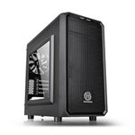
Thermaltake Versa H15 Micro ATX Gaming Case, micro-ATX, Windowed, USB 3.0, 120mm Fan, Black
35 £

Peripheric components

With peripheric components is usually understand all the devices from outside Central Unit (outside Pc Case) which are necessary for a normal functionality.
Monitor/ display chosen with a medium size of display and medium pixel rate. (normal 22’ LCD)
Keyboard, mouse and web camera.

OS

Microsoft Windows 10 Home, Creators Update, 32/64-bit, Engl International, USB Pendrive, 1 License, Retail
107 £

Configuration Price list for case 1.:
ASRock B450M-HDV R4.0
AMD Opteron 64 252
8GB (2x4GB) Corsair DDR3 XMS3
500GB Seagate BarraCuda ST3500413AS
Thermaltake Versa H15 Micro ATX Gaming Case
Microsoft Windows 10 Home
Monitor – 22 inch LCD
Keyboard, mouse and regular webcam can be included in price as gift for new customers.

All prices include VAT. : 316.00 £

For the second example I’ll use information from the first one like tabels and pictures, prices etc.

Scenario 2

A graduate youngster needs a computer with a high video configuration and high speed on running graphic applications plus a particular sound transmission. (budget 2500 £)
Using most of information from first example, the system configuration can be like next one:
Dell UltraSharp 30’ Monitor with PremierColor: UP3017 – 850 £
This monitor model is the optimum chosen product for graphic.
Few of tech Specifications:
Colour Support - 1.07 billion colours
Aspect Ratio - 16:10
Pixel Pitch - 0.251 mm
Contrast Ratio - 1000:1
Energy Consumption per Year - 120 kWh
Vertical Refresh Rate - 50 - 86 Hz
Interfaces:
• DisplayPort (HDCP)
• Mini DisplayPort (HDCP)
• 2 x HDMI (HDCP)
• DisplayPort output (MST)
• 2 x USB 3.0 upstream (Type B)
• 4 x USB 3.0 downstream (Type A)
• Audio line-out
For Central unit I chose a bundle: Intel Core i9 9900K Overclocked Bundle priced at 1045 £
with next specifications:

Processor Intel Core i9 9900K "Coffee Lake" Eight Core with HT overclocked to 4.9GHz
Motherboard ASUS ROG MAXIMUS XI HERO
CPU Cooler Corsair Hydro H100x
Memory 32GB Corsair Vengeance LPX 3000MHz DDR4

At this bundle I add a performant video card suitable with monitor technical properties.
GPU (Graphic Process Unit) Nvidia Geforce NTX 2070 with 8Gb memory, running on 256 bits – price 550 £
A strong PSU (Power Source Unit) is necessary for this type of configuration:
Seasonic PRIME GX 650 Watt Full Modular 80 cost – 115 £
And finaly a Pc case at price of 50 £
The total price for configuration satisfying second example is: 2,610 £

References

Anon., n.d. Dell. [Online]
Available at: https://www.dell.com/
[Accessed 04 2020].

Anon., n.d. Nvidia. [Online]
Available at: https://www.nvidia.com/
[Accessed 04 2020].

Anon., n.d. SCAN. [Online]
Available at: https://www.scan.co.uk/
[Accessed april 2015].

