

Student Learning Log

Student Name: VICTORIA CHILIANU
Student ID Number: 2208500
The Module Title: Managing Hotel Administration (BMIH6004)
Lecturer’s Name: KATHRYN ROBERTS
Word count: 1356

Acknowledgement of AI tool use
I acknowledge the use of Google Scholar (https://scholar.google.com/) on 11 February 2025 to write my notes into submission format using the prompt(s):
- Please provide me with materials on reflective models and their applications in hospitality and tourism.
i.e.,
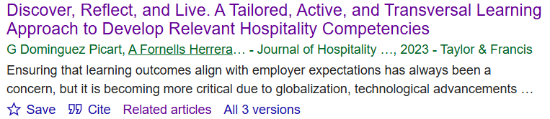
- Please provide me with materials on the role of human resource practices in the hospitality industry.
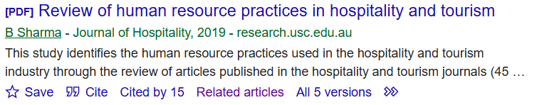
- Please provide me with materials on effective financial management.
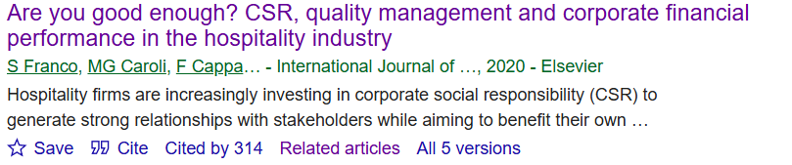
I confirm that I have not presented any AI-generated text as my own work. I confirm I have copies of my drafts, notes, and other resources I used before, and after the use of AI tools which I may be asked to provide in evidence.

I acknowledge the use of ChatGPT (https://chatgpt.com/) on 11 February 2025 to write my notes into submission format using the prompt:
- Please summarise the main concepts, findings, and discussions in books, reports, and academic articles.
i.e.,
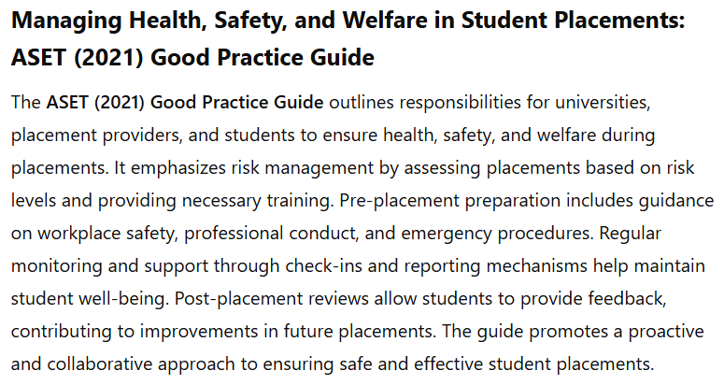
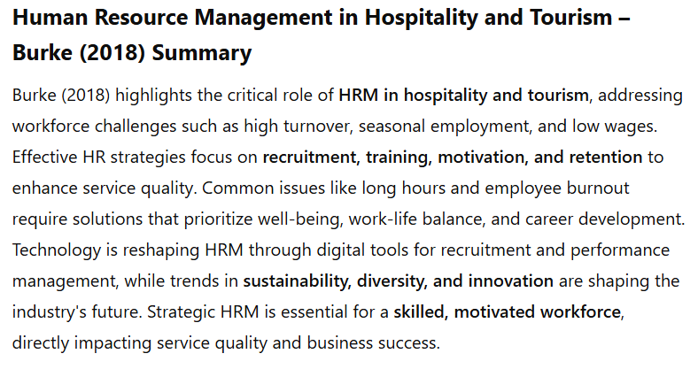
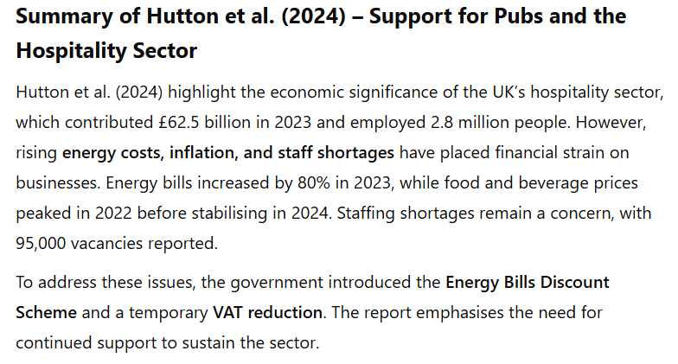
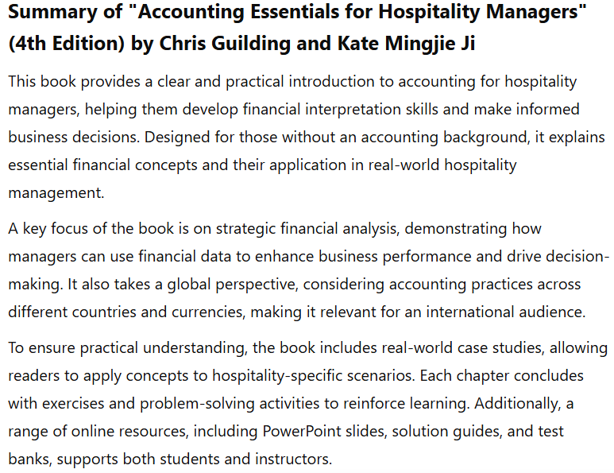
I confirm that I have not presented any AI-generated text as my own work. I confirm I have copies of my drafts, notes, and other resources I used before, and after the use of AI tools which I may be asked to provide in evidence.

I acknowledge the use of Grammarly (https://www.grammarly.com/) on 11 February 2025 to check my work using the prompt:
- Please check the text for readability, grammar, and syntax.
i.e.,
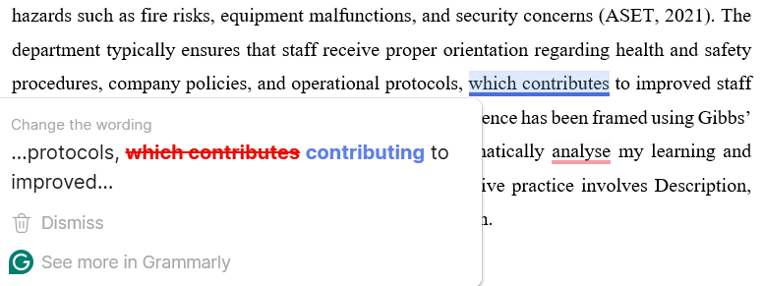
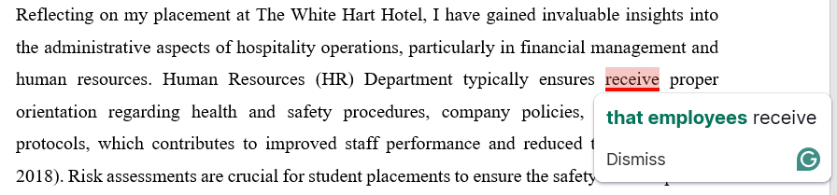
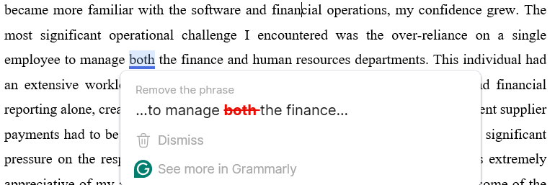
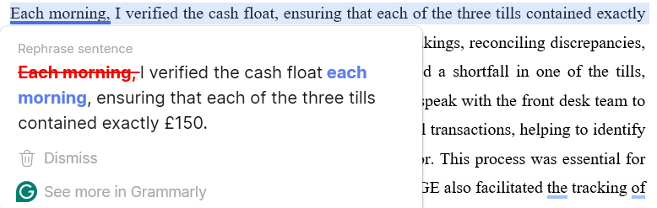
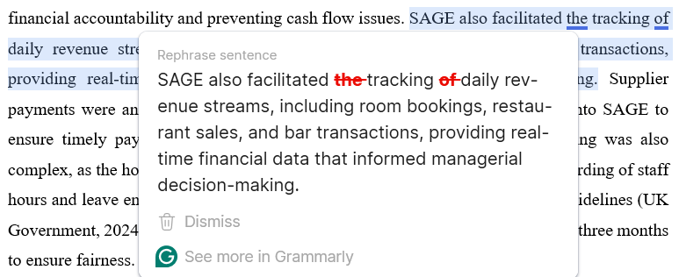
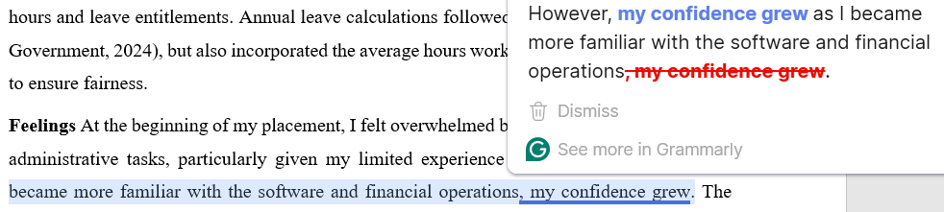
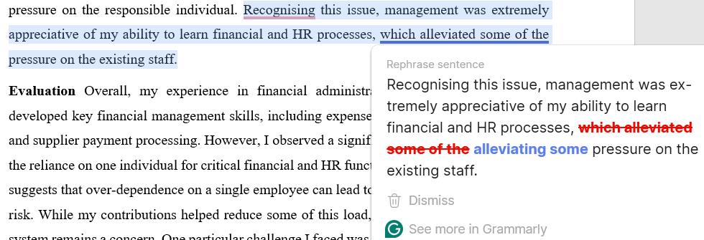
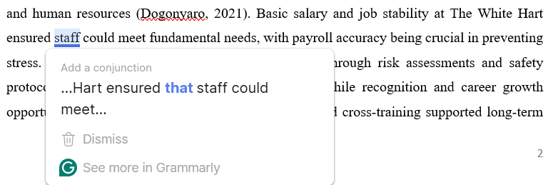
I confirm that I have not presented any AI-generated text as my own work. I confirm I have copies of my drafts, notes, and other resources I used before, and after the use of AI tools which I may be asked to provide in evidence.

I acknowledge the use of the Snipping Tool (https://markuphero.com/) on 11 February 2025 to edit photographic material:
- Facilitate the inclusion of relevant images and screenshots, enhancing the document's clarity and visual appeal.
(i.e., Acknowledgement of AI tool and Appendices).
I confirm that I have not presented any AI-generated text as my own work. I confirm I have copies of my drafts, notes, and other resources I used before, and after the use of AI tools which I may be asked to provide in evidence.

Reflecting on my placement at The White Hart Hotel, I have gained invaluable insights into the administrative aspects of hospitality operations, particularly in financial management and human resources. The Human Resources (HR) Department typically ensures that employees receive proper orientation regarding health and safety procedures, company policies, and operational protocols, contributing to improved staff performance and reduced turnover (Burke, 2018). Hotel administration encompasses various operations, including financial record-keeping, payroll management, risk assessments, and staff induction processes. Risk assessments are crucial for student placements to ensure the safety and compliance of operations, identifying potential hazards such as fire risks, equipment malfunctions, and security concerns (ASET, 2021). My exposure to risk assessments (see Appendix 1) and induction processes reinforced their importance in maintaining compliance and operational efficiency. I participated in the student induction session, which covered essential safety procedures such as fire evacuation routes and manual handling guidelines (see Appendix 2). The structured induction checklist ensured that all aspects were documented, mitigating potential liability issues. My experience has been structured using Gibbs’ Reflective Cycle (1988), a widely recognised framework for systematic reflection in professional and academic settings. This model provides a structured approach to analysing experiences through six stages: Description, Feelings, Evaluation, Analysis, Conclusion, and Action Plan. According to Dominguez et al. (2023), reflective practice is essential for continuous learning and professional growth, as it enables individuals to assess their experiences and implement improvements critically. This framework deepened my self-awareness and decision-making, improving my ability to find practical solutions for future challenges.
Structured reflection is a valuable tool for self-improvement, as it encourages critical thinking and professional development.
My goal was to accomplish the following objectives:
- Develop a comprehensive understanding of financial management processes, including revenue tracking, expense management, and payroll processing in a hospitality setting.
- Gain hands-on experience with financial software to improve financial accuracy, reporting, and forecasting for hospitality operations.
- Enhance knowledge of HR management, particularly in payroll administration, employee scheduling, and leave entitlements.
- Identify key financial administration and HR management challenges and propose strategies for improving efficiency and risk mitigation.
- Assess the impact of financial decision-making on operational efficiency and staff productivity within the hospitality industry.
- Investigate best practices for improving financial transparency and compliance in hotel management.
During my placement, I managed the hotel’s financial transactions through the SAGE50 accounting software, ensuring accurate recording of revenue, expenses, and payroll processing. Sage is a cloud-native accounting software that provides visibility, flexibility, and efficiency in managing finances and operations (Sage Group, 2025a). I verified the cash float each morning, ensuring the three tills contained exactly £150. This process involved counting the previous night’s takings, reconciling discrepancies, and preparing the bank deposit. On one occasion, I noticed a shortfall in one of the tills, requiring me to meticulously check transaction records and speak with the front desk team to identify the cause. The SAGE50 system allowed me to track all transactions, helping to identify the missing amount and ensure it was adequately accounted for. This process was essential for financial accountability and preventing cash flow issues (see Appendix 3). The software also facilitated tracking daily revenue streams, including room bookings, restaurant sales, and bar transactions, providing real-time financial data that informed managerial decision-making. Supplier payments were another crucial aspect of my role, requiring meticulous entry into SAGE50 to ensure timely payments and avoid supply chain disruptions (see Appendix 4). Payroll processing was also complex, as the hotel operates on an hourly wage system, requiring accurate recording of staff hours and leave entitlements (see Appendix 5). Annual leave calculations followed government guidelines (UK Government, 2024) but also incorporated the average hours worked over the past three months to ensure fairness.
At the beginning of my placement, I felt overwhelmed by the volume of financial and administrative tasks, particularly given my limited experience with SAGE50. However, my confidence grew as I became more familiar with the software and financial operations. The most significant operational challenge I encountered was the over-reliance on a single employee to manage the finance and human resources departments. This individual had an extensive workload, handling payroll, supplier payments, staff contracts, and financial reporting alone, creating significant operational risk. I recall an instance where urgent supplier payments had to be processed while simultaneously managing payroll, leading to considerable pressure on the responsible individual. Recognising this issue, management highly appreciated my ability to learn financial and HR processes, alleviating some pressure on the existing staff.
Overall, my experience in financial administration was highly valuable. I developed key financial management skills, including expense tracking, payroll calculations, and supplier payment processing. However, I observed a significant challenge in the business: the reliance on one individual for critical financial and HR functions. Sharma's (2019) research suggests that over-dependence on a single employee can lead to delays and increased business risk. While my contributions helped reduce some of this load, the long-term viability of this system remains a concern. One particular challenge I faced was processing payroll adjustments for staff members who worked extra shifts. Due to a lack of digital integration between scheduling and payroll systems, adjustments had to be manually entered, increasing the risk of human error.
Guilding and Mingjie Ji (2022) provide an updated comprehensive overview of financial and managerial accounting principles tailored to the hospitality industry, focusing on financial reporting, cost control, budgeting, and performance evaluation to enhance strategic decision-making. Franco et al. (2020) regard effective financial management as essential for ensuring a hotel’s profitability and long-term durability. Additionally, economic pressures led to cost-cutting measures, including reduced staff hours and higher room rates and food and beverage prices, due to rising utility, supplier, and wage costs (Hutton et al., 2024). At the White Hart Hotel, reduced staff hours may affect service quality, potentially leading to lower guest satisfaction and fewer returning customers. Likewise, higher prices may reduce occupancy and revenue. A balanced approach ensures cost efficiency and guest experience. Accordingly, the experience reinforced the importance of using software like SAGE50 to streamline administrative processes and improve financial transparency.
Key insights from the Personnel Resourcing and Development lectures underscored the significance of employee motivation and well-being within the hospitality sector (Lee, 2023), particularly in relation to Maslow’s Hierarchy of Needs. The theory provided a valuable framework for understanding staff engagement, particularly in financial management and human resources (Dogonyaro, 2021). Basic salary and job stability at The White Hart ensured that staff could meet fundamental needs, with payroll accuracy crucial in preventing stress. Job security and compliance were reinforced through risk assessments and safety protocols. Effective teamwork improved operations, while recognition and career growth opportunities boosted motivation. Skill development and cross-training supported long-term career aspirations. Addressing these needs holistically enhanced staff retention, service quality, and overall business sustainability.
In contrast to my Level 4 placement, which focused on Hotel Administration and Front Office Operations, this placement provided deeper financial and HR management exposure. While my previous experience involved basic reservation systems and introduced fundamental financial concepts, which I could now apply practically in revenue tracking and payroll administration, my Level 6 placement required more responsibility in financial decision-making and compliance. The placement experience at The White Hart Hotel has given me a deeper understanding of financial and HR management within a hospitality setting. I gained practical experience with SAGE50 accounting software, payroll processing, and risk assessments, reinforcing the importance of compliance and operational efficiency. However, I observed challenges, including over-reliance on a single employee for finance and HR functions, highlighting the need for better workload distribution and digital integration. Economic pressures have also led to cost-cutting measures, potentially impacting service quality and guest satisfaction.
To enhance financial management at The White Hart Hotel, optimising SAGE50, standardising reconciliation, and conducting audits will improve transparency within six months. Addressing the HR workload, hiring an HR and finance assistant, integrating digital payroll, and cross-training staff will enhance efficiency within twelve months. Strengthening risk management through regular assessments, updated inductions, and structured document management will ensure compliance. Balancing cost efficiency with service quality will involve strategic pricing, guest feedback monitoring, and staff engagement within nine months. These improvements will enhance financial oversight, operational efficiency, and guest satisfaction, ensuring long-term sustainability and regulatory compliance.

References
Arnott, L. (2019) The White Hart Hotel Health & Safety Risk Assessment. The White Hart Hotel. Unpublished.
ASET (2021) Good Practice Guide for Managing Student Placements' Health, Safety, and Welfare. Available at: https://www.asetonline.org/wp-content/uploads/2023/04/Good-Practice-Guide-for-Managing-Health-Safety-and-Welfare-for-Student-Placements.pdf (Accessed: 11th February 2025).
Burke, R. J. (2018) ‘Human resource management in the hospitality and tourism sector’, In Handbook of Human Resource Management in the Tourism and Hospitality Industries. Cheltenham, UK: Edward Elgar Publishing, Chapter 1, pp. 3-39. Available at: https://doi.org/10.4337/9781786431370.00007 (Accessed: 11th February 2025).
Davies, S. (2020) Accounting software for hospitality. 11 February. Available at: https://www.youtube.com/watch?v=nFtFywqGyTE (Accessed: 12th February 2025).
Dogonyaro, H. (2021) Employee retention strategy in the hospitality industry. PhD thesis. Walden University. Available at: https://www.proquest.com/dissertations-theses/employee-retention-strategy-hospitality-industry/docview/2545629862/se-2?accountid=130472 (Accessed: 16th February 2025).
Dominguez Picart, G., Fornells Herrera, A., Ferreras-Garcia, R. and Sales-Zaguirre, J. (2023) ‘Discover, reflect, and live. A tailored, active, and transversal learning approach to develop relevant hospitality competencies’, Journal of Hospitality & Tourism Education, pp. 1-12. Available at: https://doi.org/10.1080/10963758.2023.2200004 (Accessed: 11th February 2025).
Franco, S., Caroli, M.G., Cappa, F. and Del Chiappa, G. (2020) Are you good enough? CSR, quality management and corporate financial performance in the hospitality industry, International Journal of Hospitality Management, 88, p.102395. Available at: https://doi.org/10.1016/j.ijhm.2019.102395 (Accessed: 16th February 2025).
Guilding, C. and Mingjie Ji. K. (2022) Accounting essentials for hospitality managers. 4th Ed. London: Routledge.

Hutton, G., Panjwani, A., Murray, A., Sandford, M. and Masala, F. (2024) Support for pubs and the hospitality sector (House of Commons Library briefing paper 0132). Available at: https://researchbriefings.files.parliament.uk/documents/CDP-2024-0132/CDP-2024-0132.pdf (Accessed: 16th February 2025).
Lee, H. (2023) 'Employee Engagement' [Recorded lecture]. BMIH5005: Personnel Resourcing and Development. University of Wales Trinity Saint David. 10 October. Available at: Personnel Resourcing and Development (HMID 5005) Lecture - Group B (Every Tuesday 9_00 am -1_00 pm)-20231010_085551-Meeting Recording.mp4 (Accessed: 5th March 2025).
Sage Group (2025a) Cloud finance software that drives clarity. Available at: https://www.sage.com/en-gb/sage-business-cloud/intacct/industries/hospitality/ (Accessed: 12th February 2025).
Sage Group (2025b) Powerful desktop accounting with Sage 50 Accounts. Available at: https://www.sage.com/en-gb/products/sage-50-accounts/#gate-34cb21d1-ff25-4472-b10d-bf9d006f07e6 (Accessed: 12th February 2025).
Sharma, B. (2019) ‘Review of human resource practices in hospitality and tourism’, Journal of Hospitality, 1(1), pp. 15-30. Available at: http://htmjournals.com/jh/index.php/jh/article/view/4 (Accessed: 12th February 2025).
UK Government (2024) Guidance. Holiday pay and entitlement reforms from 1 January 2024: April 2024 update. Available at: https://www.gov.uk/government/publications/simplifying-holiday-entitlement-and-holiday-pay-calculations/holiday-pay-and-entitlement-reforms-from-1-january-2024 (Accessed: 12th February 2025).


Appendices
Appendix 1: Internal Data on Health and Safety Risk Assessment – The White Hart Hotel

The Company-wide risk assessment captures and quantifies the health and safety hazards and risks throughout The White Hart Hotel.
Last reviewed – April 2019. (Developed by Lauren Arnott)
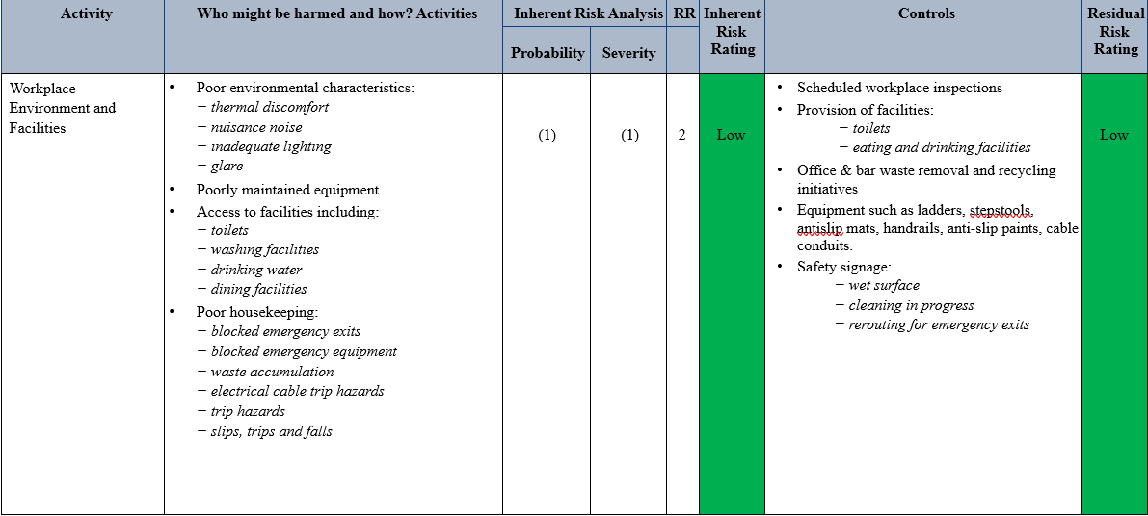
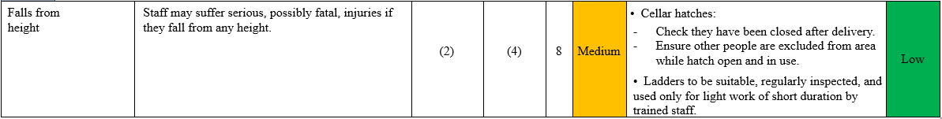
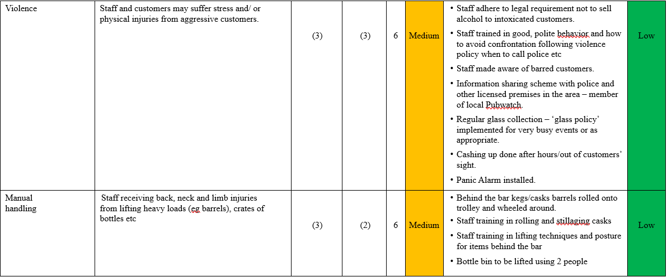
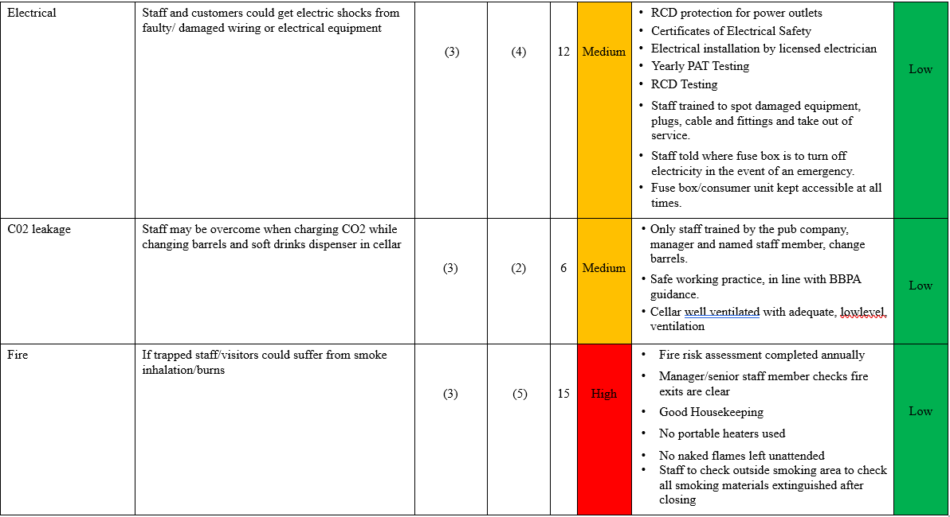
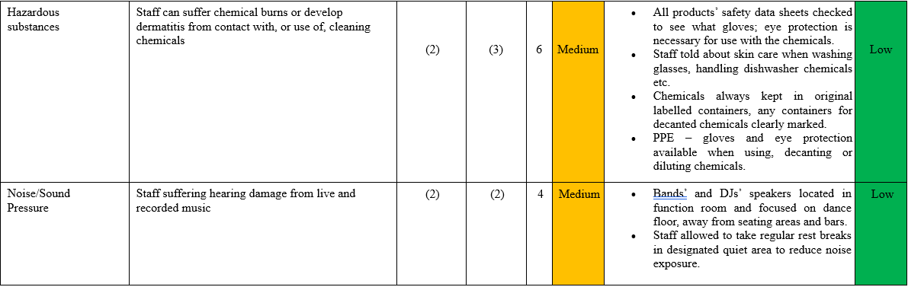
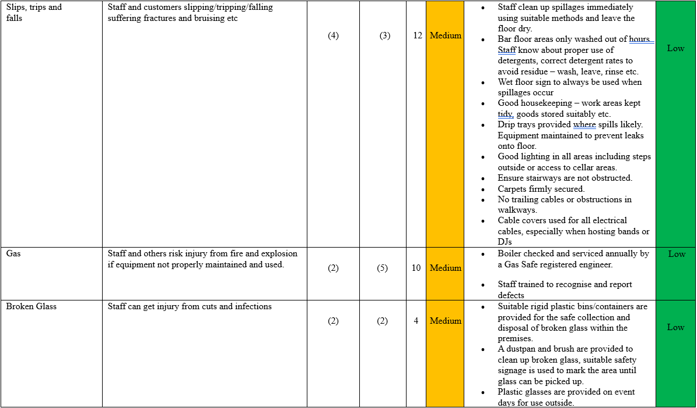

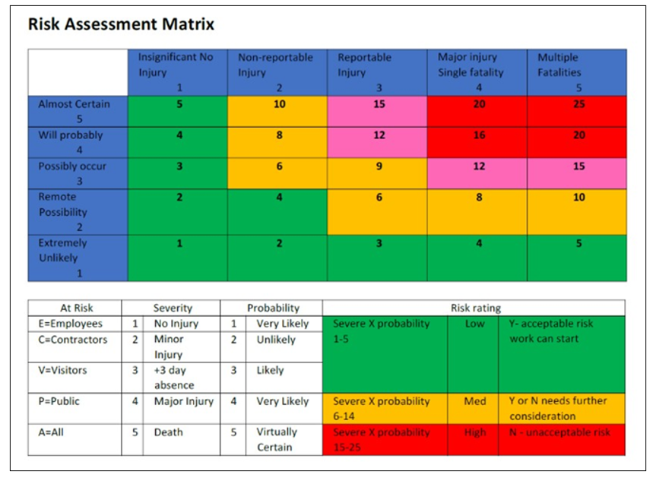
Source: Arnott, 2019
Appendix 2: Student Placement Induction Checklist
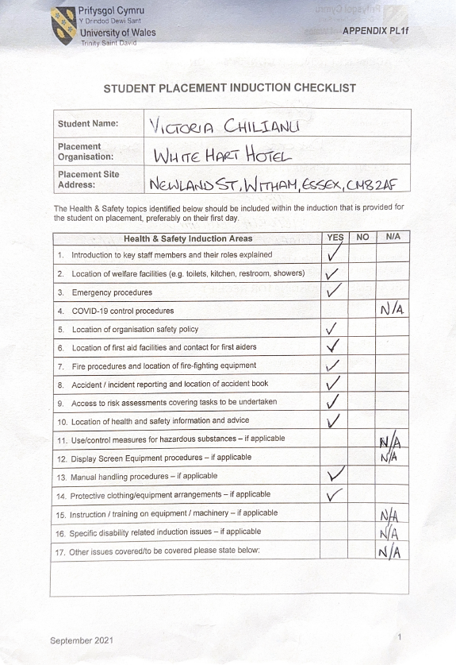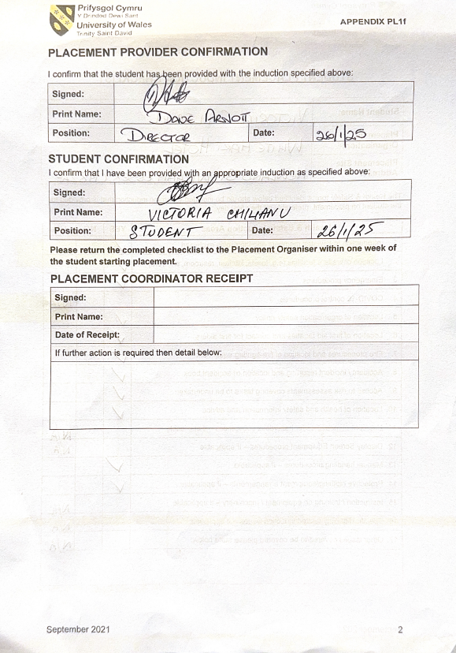
Source: Developed by Author
Appendix 3: External Data on Cash Flow Management
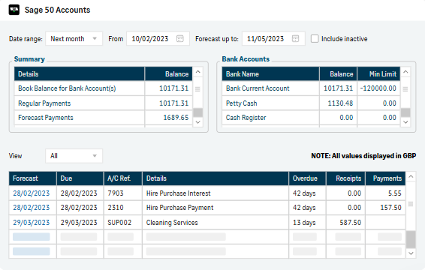
Source: Sage Group, 2025b

Appendix 4: External Data on Supplier Payments
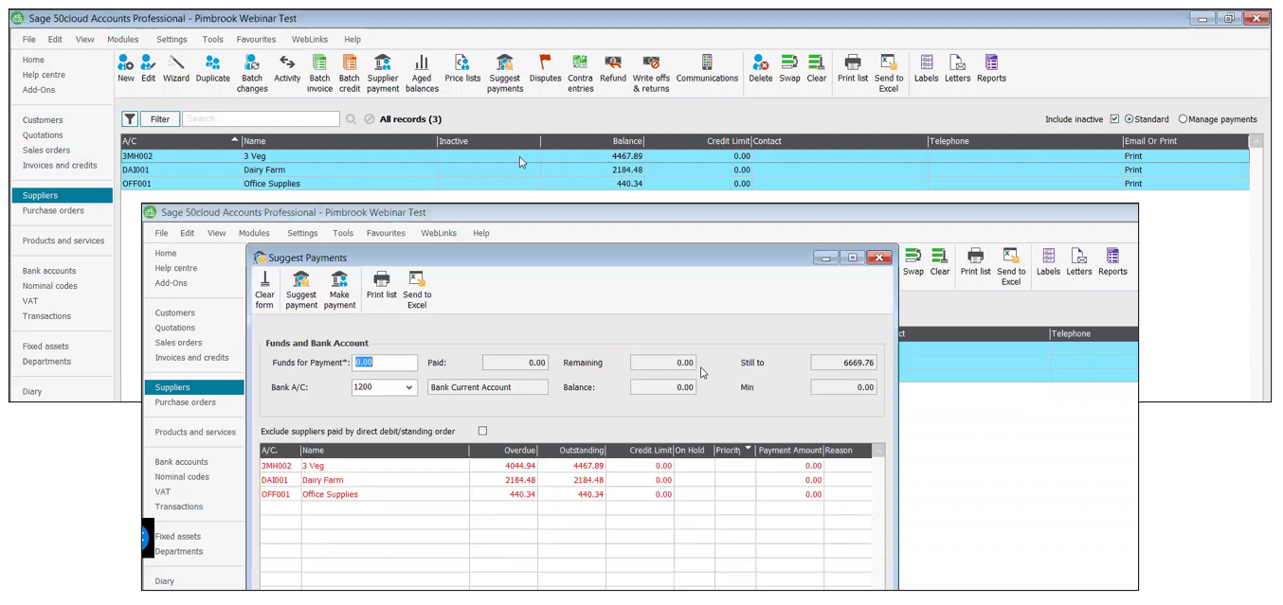
Source: Davies, 2020
Appendix 5: External Data on Payroll Processing
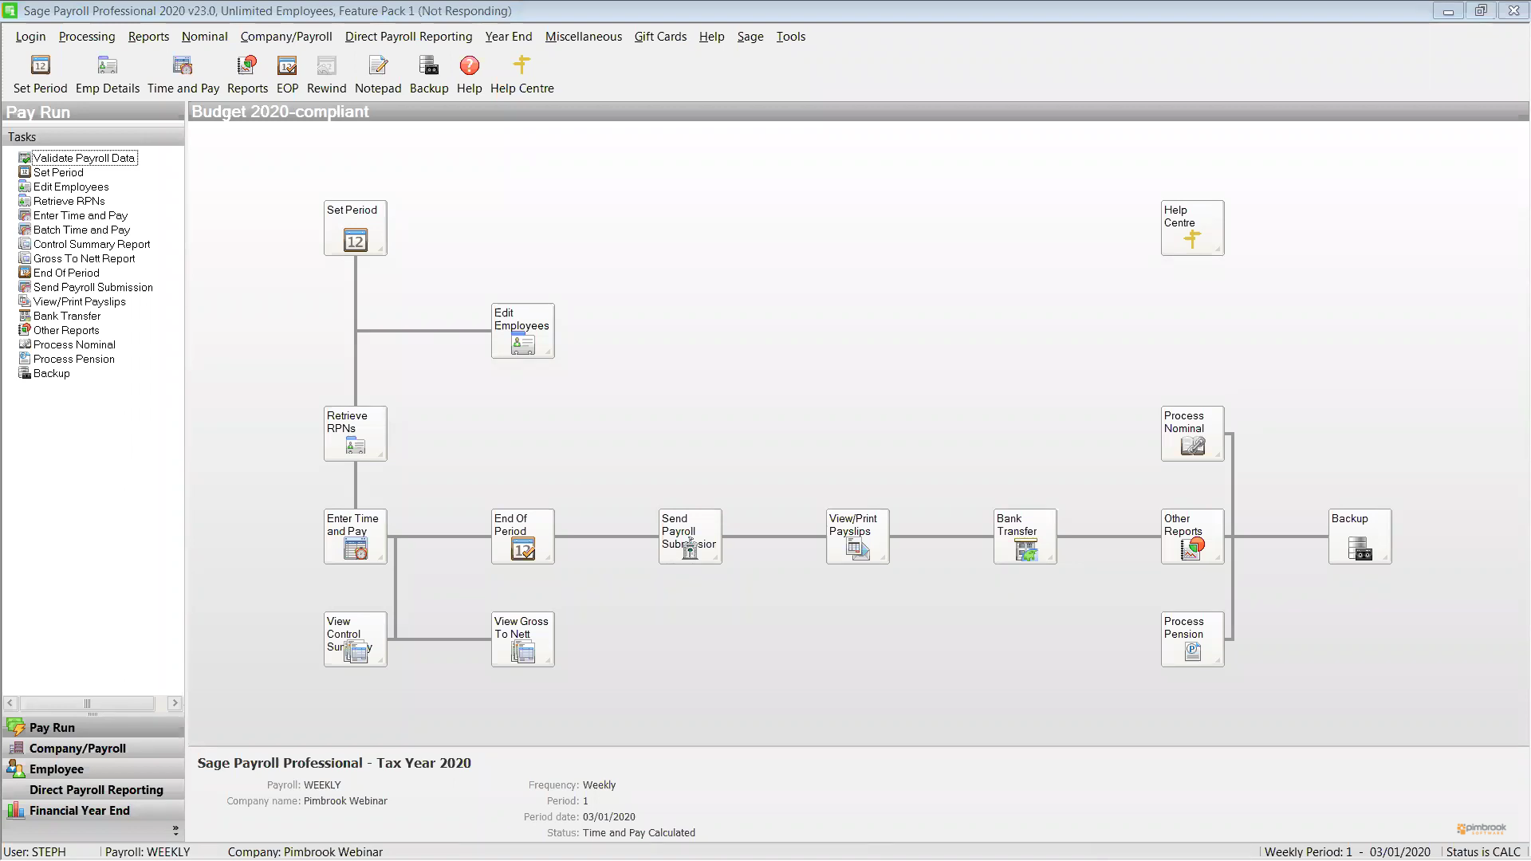
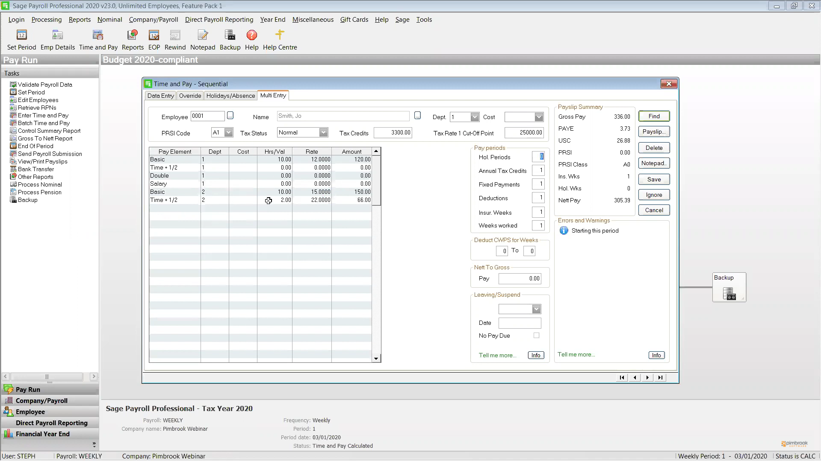
Source: Davies, 2020

