Student Name: Chloe Mason
P Number: 1902424
Programme of Study: BA Set Design
Module: ADFM4018

Word count- 1605 words

Introduction: 152 words
Task 1: 659 words
Task 2: 602 words
Evaluation: 192 words

Interpreting a Screenplay

I will begin my essay by explaining the layout of my sketchbook. The Green side, has general notes and my work for task 1 and the Pink side has all my work for task 2. Throughout this essay I will be giving you a tour of all the work I have completed these past 2 week.

To begin any task you have to learn and research into the subject, so my task begins by learning the basics of interpreting a screenplay. By taking notes and help from lectures I soon picked up the basics and I was on my way. To help me further, I looked into Joseph Campbel, suggested to me by one of my lecturers. Campbel and the Hero’s Journey, really is a theory on how to break down most screenplays and once you’ve learned this theory you can never un-learn it, just like riding a bike.

Task 1

‘Little Man’, wow what a screenplay: romance, heart break, thrilling and a plot twist to leave anyone wondering who is the ‘Little man’. The ‘little man’ being one of my first screenplays ever to break down was smooth sailing. I began to highlighting and break down the script into categories:
*Action/Hero props
*Dressing
*SFX
*Graphics
*Scree Graphics
Following, this I learnt how to create a breakdown sheets and breakdown scenes that feature Elliot’s flat (at end of sketchbook). I will take these skills that I learnt into other projects and into my future career in the film industry.

Firstly, I wrote down all key dialogue from the screenplay to help aid me throughout my designs, making sure not to miss any key details. After reading through the screenplay multiple times and getting into the mind of the character. Looking deep into characters is something that can easily be overlooked, and creating a scene that gives a subliminal message to the audience can make the difference between a B and Q showroom and Van Gogh’s bedroom.

From the beginning, I really wanted to create a design that question Elliots sanity that makes the plot twist even more confusing. Creating detailed mood boards and highlighting key points about each room in Elliot’s flat really helped channel my creative ideas for this task, looking at filmmakers such as Wes Anderson helped my ideas further. One of my first idea I wrote in my book was to add a green ceiling and for the paint to be slightly chipped away. This would represent the little man living above him and his ‘green walls’ in his flat creeping into Elliot’s life always looming over him, always watching, which I kept through all my designs. Without, speaking too in-depth I will speak briefly about my other design as they hold the same design ideas throughout and are explained further in my sketchbook and will mainly focus heavily on one design to give you a taste of how I come up with these ideas.

My design for Elliot’s Living room has minimal surfaces in places such as the floor and the table. Pops of colour on the walls, such as a red square pattern and a abstract painting. The couch is leather, the light is cold and uncomfortable like Elliot’s mood in the scene. Also, an uncomfortable big lamp to make the scene between Elliot and Tim seem unsettling as the lamp looms over them, a feeling of being watched. Clothes are chucked across the room, however, due to the room being so minimal does little to dirty the room. This would make a passionate scene between the two seem passionless. This can represent something missing about Elliot himself as Tim begins to question Elliots reluctant to let himself go and to trust other.
On the contrary, in another scene between Elliot and his brother, Ryan, the living room is completely changed. Beer bottles are scattered across the room, they smoking a joint together. For this complete flip in mood I creating the outer corners of the room darker. The big lamp brings warm light to the centre of the room and messy objects (beer bottles and ashtrays) to the centre, creates a completely different space less minimal and full of life as Elliot is comfort in his brother company.

Throughout, my designs I continued to maintain similar designs from one room to the next. Key features I add:
* Bedroom- Have a see-through wardrobe that shows his suits for his work can visually show the audience his profession as a lawyer.
* Throughout the flat I places lightbulbs that dangle from the ceiling a similar feature in the little mans flat.
* Large window without blinds creates an unpleasant feeling of being watched
* Bathroom- having the toilet facing the mirror, Elliot watching himself, this can make for a questionable scene, as who is really watching Elliot... the little man or his subconscious?

Task 2

The main focus of this task is teamwork and working well with your partner in order to achieve a well made annotated and dressed set. My partner being Rosie. Key point about working with Rosie: we live in the same accommodation so communication wasn’t halted, our ideas bounced off each other ,and we helped to push each other to achieve the best possible out come.

Firstly, we chose the script, ‘My Week With Marilyn’. I speak briefly in my book of the plot of the characters and breakdown their journeys throughout the screenplay using Joseph Campbel hero journey. We agreed that this script would be easy to collect research on as we can base our dressing from 1950’s style dressing rooms and historical images of Marilyn Monroe in her dressing room. Together we considered different scenes to create as we had lots of ideas. However, we chose ‘Marilyn Dressing room’, as it shows Marilyn’s ups and downs throughout the screenplay as she struggles with her mental state leading her to take vast amounts of pills and champagne to maintain her stressful day to day life.

Together, we opened up a Pinterest board to collect images and ideas, discussed and used this as inspiration for our props. Rosie jumping into the research and I began the production of props. I struggled with photoshop but Rosie was on hand to create the difficult props as we split the create of our pill bottles. I focused on creating: fake Prince and the showgirl script, coloured pill bottles and book covers which Marilyn had in her own personal library and I made sure they was published in the write time period. The fake script was the most difficult as I could not find the original screenplay of the film so I had to create my own finding key features to add from the ‘My week with Marilyn’ script. Also, Rosie wrote down any handwritten notes on our props and she also knew the location of every charity shop within a 10 mile radius, as I had no clue where to go and collected most of props from my accommodation and university, such as makeup, dresses and furniture . In no time we had all our props together.

Sourcing the right location was tricky. Together, we found 3 locations within the university, but we new they wasn’t suitable for what we planned. I tried to create a quick 3D design of what the scene could have looked like in the round reading room, however, this still wasn’t right. Until, we search our accommodation and we found the perfect location, had the perfect sofa within the room so their was no need for moving too many things around. We made quick sketches of the layout and highlighted key problems within the room, such as plugs and radiators. Finally, we brought together our props and dressed the set and took our pictures.

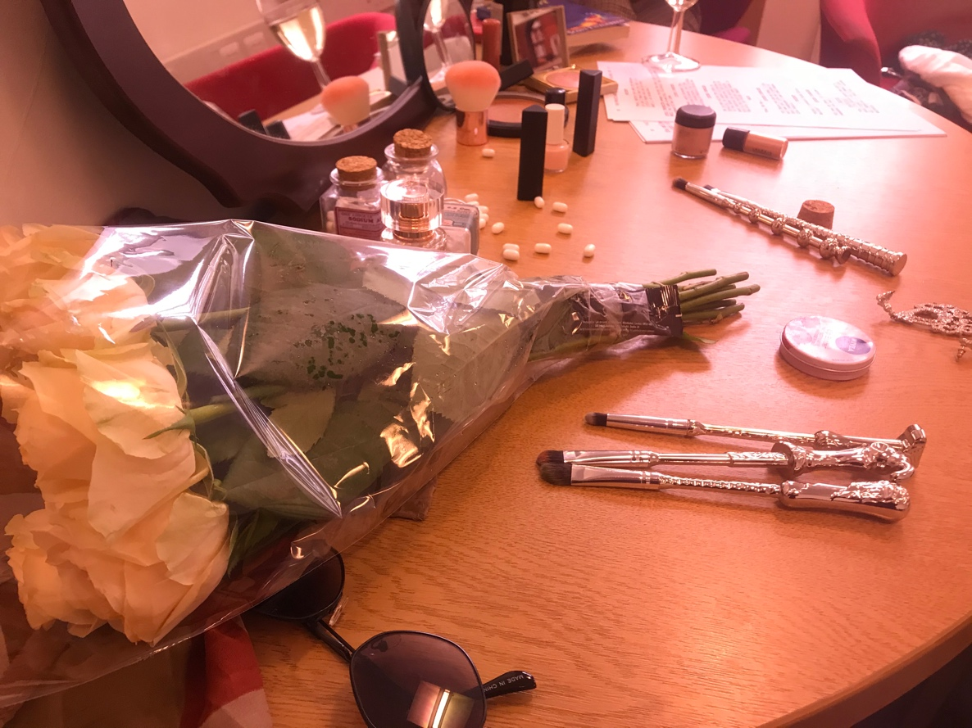
Overall, my favourite images taken by both of us are show here. The pink filter and flowers shown in Rosie’s image creates a youthful romantic touch but pills scattered in the background show a deeper darker meaning to Marilyn’s life.

(Rosies final image)

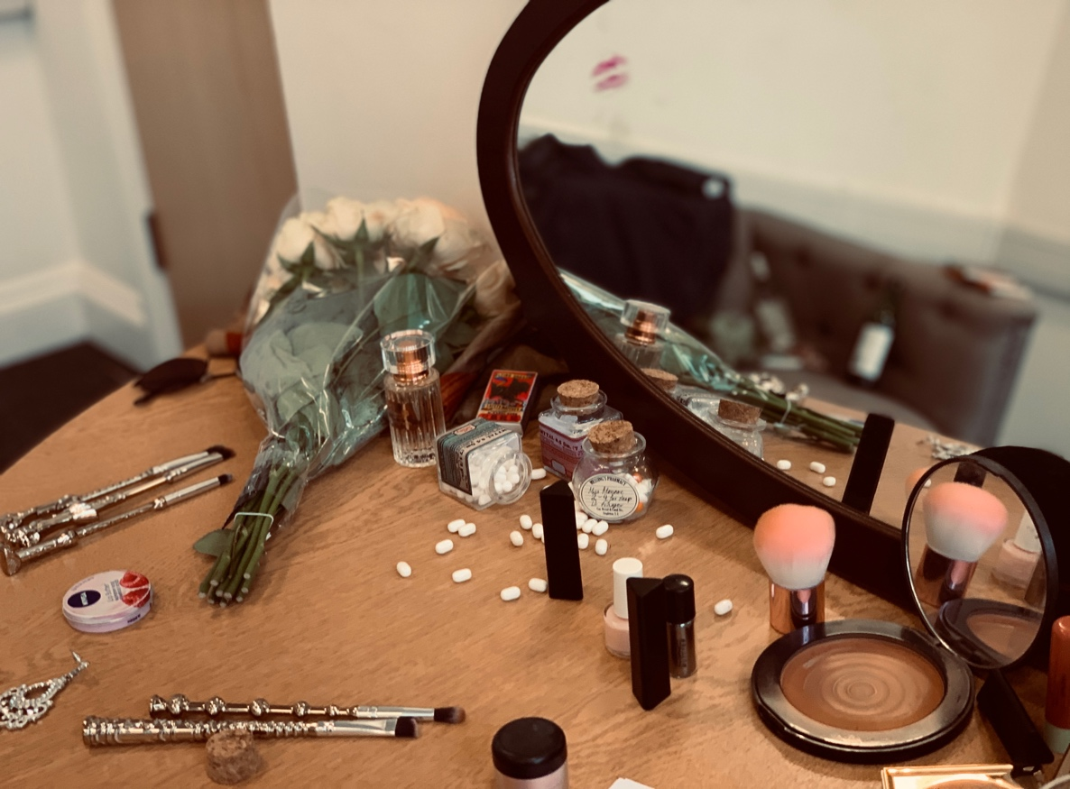
(My final Image)

The idea behind this image was to play off the scene where Colin and Marilyn meet for the first time as he sees her through the reflection of the mirror. By adding a lipstick kiss to the mirror could foreshadow a love connection between them. However, the pills scattered around the dressing table and the champagne bottles in the mirror reflection can show something deeper going on with Marilyn.

Evaluation

This project has allowed me to find my own personal style of showcasing my designs as I found it highly effective to create digital design on my iPad. As my iPad is portable I could create my designs anywhere: on the train home, in class and in my dorm. On the one hand, finding this way of creating my designs was tricky as both sides of my sketchbook show very different ways of working, as the green side shows very detailed break down of each design and the pink side being very minimal and me being very practical in producing as many 3D props as I can leaving me little time to explain in detail in my sketchbook the process of me creating these props. However, having Rosie on hand to research into the history behind the screenplay was highly useful and gave us both a taste of how a small production would work. In the future, I feel that I need to make time to finish areas of my sketchbook. However, I have enjoyed this quick fire task and feel that I can work effectively under pressure and with others.

