Maryam Sajid
2443184
LCHS4003 - Introduction to Health and Social Care

Task 1 : Midwifery Services (Poster)
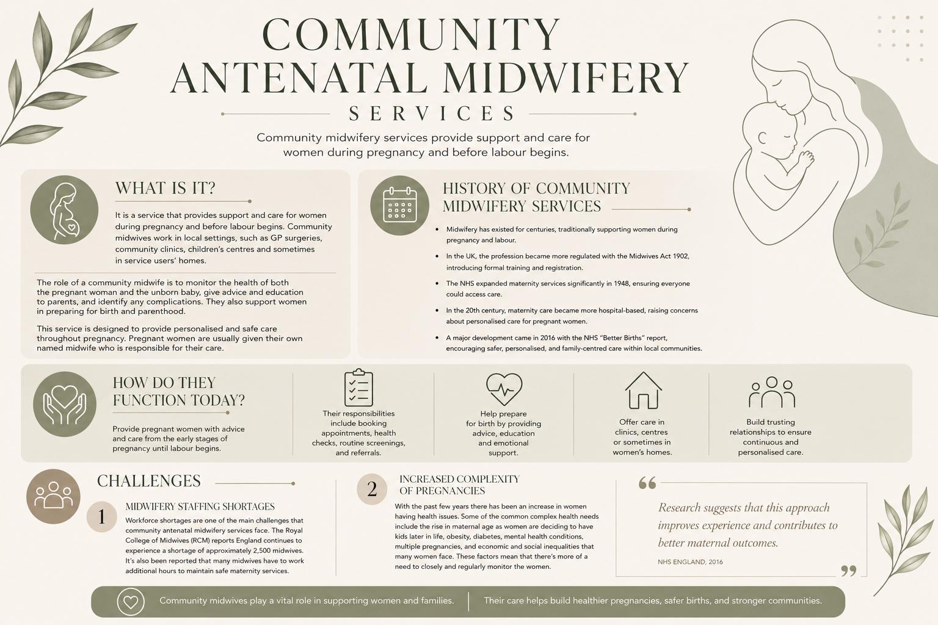

REFERENCES:

NHS England (2016) Better Births: Improving Outcomes of Maternity Services in England. Available at: https://www.england.nhs.uk/publication/better-births-improving-outcomes-of-maternity-services-in-england-a-five-year-forward-view-for-maternity-care/ (Accessed: 27 October 2025).
NHS England (2025) National Maternity Review. Available at: https://www.england.nhs.uk/mat-transformation/implementing-better-births/mat-review/ (Accessed: 27 October 2025).
Royal College of Midwives (2024) Midwives give 100,000 hours of free labour to the NHS per week to keep England’s maternity services safe. Available at: https://rcm.org.uk/media-releases/2024/06/midwives-give-100000-hours-of-free-labour-to-the-nhs-per-week-to-keep-englands-maternity-services-safe-says-rcm/ (Accessed: 27 October 2025).
Royal College of Midwives (2024) How to Fix the Midwifery Staffing Crisis. Available at: https://rcm.org.uk/media-releases/2024/02/rcm-tells-politicians-how-to-fix-the-midwifery-staffing-crisis-with-new-pre-election-guide/ (Accessed: 27 October 2025).
Royal College of Midwives (2025) Safe Staffing = Safe Care. Available at: https://rcm.org.uk/safestaffing/ (Accessed: 27 October 2025).
Harrogate and District NHS Foundation Trust (2025) Community Midwifery Services. Available at: https://www.hdft.nhs.uk/services/maternity-services/community-midwifery-services/ (Accessed: 27 October 2025).

Task 2 : Community Disabilities Services

Community disability services play a major role in aiding individuals with disabilities such as physical disabilities, learning disabilities, sensory impairments and long-term health conditions. This helps those with disabilities to live independently and comfortably in their communities. Community disability services provide a variety of support for those with disabilities, which includes education, assistance in healthcare, employment, advocacy, social activities and independent living support. The aim of this is to push for equality, inclusion for all and a better quality of life while allowing individuals with disabilities to fully participate in society. It is stated that society generally viewed disability through a medical model, focusing on an individual’s impairment rather than the barriers they faced within society (Shakespeare, 2018).
Community disability services can be originally traced back to the nineteenth and very early twentieth century where many disabled people were often excluded from society and usually placed in long-term institutional care. During this time, a lot of disabled people were made to live in asylums, hospitals and residential institutions where they were mainly kept from society.
Community disability services play a major role in aiding individuals with disabilities such as physical disabilities, learning disabilities, sensory impairments and long-term health conditions. This helps those with disabilities to live independently and comfortably in their communities. Community disability services provide a variety of support for those with disabilities, which includes education, assistance in healthcare, employment, advocacy, social activities and independent living support. The aim of this is to push for equality, inclusion for all and a better quality of life while allowing individuals with disabilities to fully participate in society.
Community disability services can be originally traced back to the nineteenth and very early twentieth century where many disabled people were often excluded from society and usually placed in long-term institutional care. During this time, a lot of disabled people were made to live in asylums, hospitals and residential institutions where they were mainly kept from society.
This day and age, community disability services are operated through numerous partnerships including the NHS, voluntary organisations, charities and social care providers. These services are individually tailored to each individual and their needs and this may include occupational therapy, physiotherapy, speech and language therapy, personal assistance, respite care, supported employment programmes and community activities. The NHS claims that “assessments are often carried out to identify the support required, and personalised care plans are developed in collaboration with service users and their families” (NHS England, 2024).
Although there are many benefits of community disability services it's also important to note that they do face several challenges. For example, funding pressures within health and social care organisations have resulted in there being an increase in demand and the need for more resources. There are numerous local authorities that struggle to provide their services when needed due to the high demand which results in individuals being put on waiting lists. It is claimed that in many areas in the United Kingdom service users may experience delays in receiving assessments or specialist interventions, potentially affecting their quality of life and independence (The King’s Fund, 2023).
Community disability services have a huge significance in the enhancement of the quality of life for individuals with disabilities. This is due to the fact that these services enable those with disabilities to have a peaceful, inclusive and ‘normal’ life without fear of facing prejudice.
REFERENCES:

Department of Health (2001) Valuing People: A New Strategy for Learning Disability for the 21st Century. London: The Stationery Office.
Equality Act 2010. c.15. London: The Stationery Office.
NHS England (2024) Learning Disability and Autism Programme. Available at: https://www.england.nhs.uk/learning-disabilities/ (Accessed: 27 October 2025).
Office for National Statistics (2023) Outcomes for Disabled People in the UK. Available at: https://www.ons.gov.uk (Accessed: 27 October 2025).
Shakespeare, T. (2018) Disability: The Basics. London: Routledge.
The King’s Fund (2023) Social Care 360. Available at: https://www.kingsfund.org.uk (Accessed: 27 October 2025).

